Supplemental Information S1- SSD approach

Table S1A: List of quality criteria met for all the studies included in the SSDs.
Technical parameters
- Particle size reported*  - Particle shape reported*  - Polymer type reported*  - Source of MP reported*  - Data reported as mass or count* | - Test medium vehicle  - Administration route reported  - Test species reported  - Sample size reported  - Control group used  - Exposure duration reported  - At least one replicate
Applicability for risk assessment
- 3 or more concentrations of MPs tested (not including control)
- Organismal endpoints and/or sub-organismal endpoints with relationship to organismal /population level effects*
*As described in de Rujiter et al. 2020

Each study was also scored for additional criteria described in de Rujiter et al. (2020), and none of the studies used here met all their quality criteria. Detailed scores for the studies used in the SSDs can be found in the ToMEx (Hampton et al., this issue).

Assessment factors
Assessment factors for converting various effect metrics to NOECs for ecotoxicological risk assessment are described in Wigger et al (2020). To test the validity of these assessment factors on microplastics toxicity data, two approaches were employed. SSDs were constructed using each effect metric (e.g., NOEC, LOEC, HONEC) and the median HC50s were compared to define an average ratio. An additional approach utilized linear regression, in which data were grouped by taxa, exposure duration category (i.e., acute or chronic – species-dependent), particle size bins (i.e. 1 to <10 nm, 10 to <100 nm, 100 to < 1,000 nm, 1 to <10 µm, 10 to <100 µm, 100 to < 1,000 µm, 1,000 to <5,000 µm), and effect type (e.g., fitness, metabolism, etc.) and averaged. Averaged effect concentrations for grouped data were compared using linear regression with NOEC as the independent variable and each other effect metric as the dependent variable. Both analyses only utilized data that passed all ‘red criteria’ quality criteria. The resulting coefficient and associated statistics for the linear regression are described in Table S1A.
In several cases, assessment factors derived using empirical data using SSD ratios and linear regression were in agreement with the default assessment factors recommended by Wigger et al (2020), (.e.g. HONECs and LOECs based on mass). In some cases, assessment factors either could not be derived (e.g. EC50/EMT50 for all exposure metrics), or the resulting coefficients were not statistically significant (e.g., HONECs for mass and particle count). In some cases in which statistically significant correlations were obtained, derived assessment factors were lower or higher than the default assessment factors (e.g., LOEC based on particle count or volume). Due to the inconclusive nature of the derived assessment factors and generally limited data for performing such calculations, default assessment factors were employed (Wigger et al 2020). The analysis performed here provides additional confidence that the assessment factors utilized are reasonable, however additional research is encouraged to improve the reliability of assessment factors for microplastics risk assessment.

Table S1B: Assessment factors (AFs) used to convert LOECs, LC and EC values to estimated NOECs.
Unit​ | Effect Metric​ | AFs used in the current study | AFs calculated​  using SSDs | AFs calculated​  using Correlation  (mean ± standard error) | Correlation R², p-value
Mass​ | NOEC​ | 1 | 1.0​ | 1 | NAª
Mass​ | HONEC​ | 1​ | 12.7​ | 1.74 ±2.86 | R² = 0.27, p = 0.65
Mass​ | LOEC​ | 2​ | 3.7​ | 2.4 +- 0.42 | R² = 0.91, p = 0.03
Mass​ | EC50/EMT50​ | 10​ | 26.8​ | Not enough data | NA
Count​ | NOEC​ | 1​ | 1.0​ | 1 | NAª
Count​ | HONEC​ | 1​ | 0.7​ | 13.6 ±7.32 | R² = 0.77, p = 0.32
Count​ | LOEC​ | 2​ | 2.3​ | 3.92 +- 0.09 | R² = 0.997, p = 2.2 x 10⁻⁶
Count​ | EC50/EMT50​ | 10​ | 1364.7​ | Not enough data | NA
Volume​ | NOEC​ | 1​ | 1.0​ | 1 | NAª
Volume​ | HONEC | 1 | 6.8​ | Not enough data | NA
Volume​ | LOEC​ | 2​ | 3.0​ | 1.1 +- 0.04 | R² = 0.996, p = 9x10⁻⁵
Volume​ | EC50/EMT50​ | 10​ | 0.2​ | Not enough data | NA
ªAll effect metrics were compared to NOECs, so no assessment factor is necessary for a NOEC.
Table S1C: Assessment factors applied to convert acute to chronic doses. Data in unshaded rows are based on Wigger et al. 2020. Data in shaded rows were agreed upon by the authors of this study.
Organism Group | Chronic Exposure (days) | Acute to Chronic AF
Algae | ≥3 | 10
Crustacea | ≥21 | 10
Mollusca | ≥28 | 10
Fish | ≥28 | 10
Annelida | ≥21 | 10
Cnidaria | ≥21 | 10
Echinodermata | ≥21 | 10
Insects | ≥21 | 10
Rotifera | ≥21 | 10

Table S1D: Raw data used to generate the SSD curves for food dilution and tissue translocation. See Excel file

Figure S1: SSD curves generated to populate the framework with critical thresholds. For food dilution, SSD curves were based on effect data for particle size between 1 – 5,000 µm; (A) thresholds 1 and 2 were derived using all endpoints, (B) thresholds 3-4 were derived using organismal and population level endpoints. For tissue translocation, SSD curves were based on data particle size between 1 – 83 µm; (C) thresholds 1 and 2 were derived using all endpoints, (D) thresholds 3-4 were derived using organismal and population level endpoints.

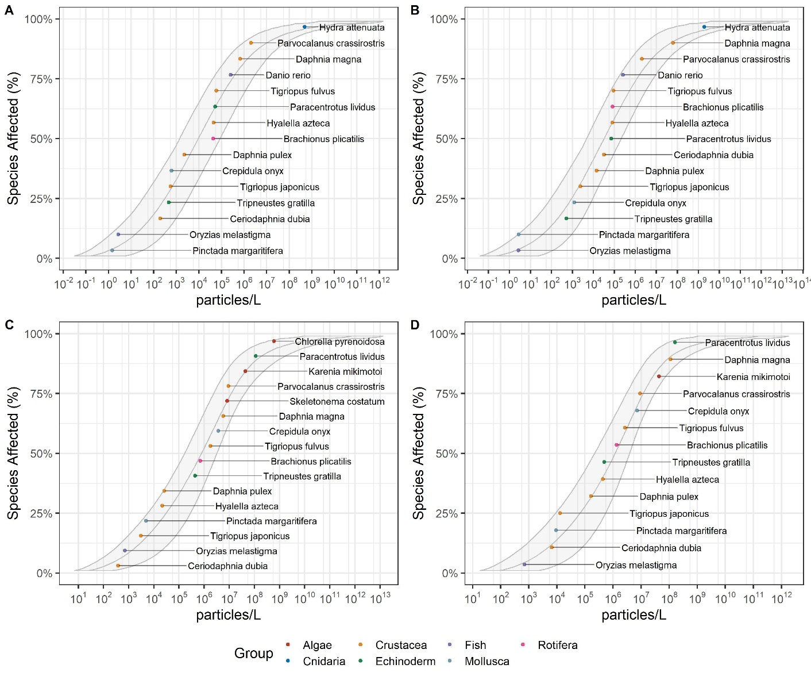

Supplemental Information S2 – Tissue translocation
Microplastics particokinetic data for aquatic species were mined from the literature to estimate probability potentials for tissue translocation. 27 studies were found, reporting data from a total of 19 unique species, 7 organism groups, 8 exposure types, 21 tissues, 16 polymers, 5 shapes (Table S2). Of the studies, 5 were field observations, and 22 were lab-based. Unmodified polystyrene was the most commonly used polymer (14 studies), followed by polyethylene (3 studies). Spherical particles were the most commonly used (18 studies), followed by fragments (5 studies), and fibers (2 studies). The majority of studies were on fish (19 studies), followed by mussels (3 studies), with a single study each for crabs, crustaceans, mollusk, oyster, and shrimp. Particles ranged from 24 nm to 1,500 µm in length (mean 66, median 7.8) (Figure SI-6).

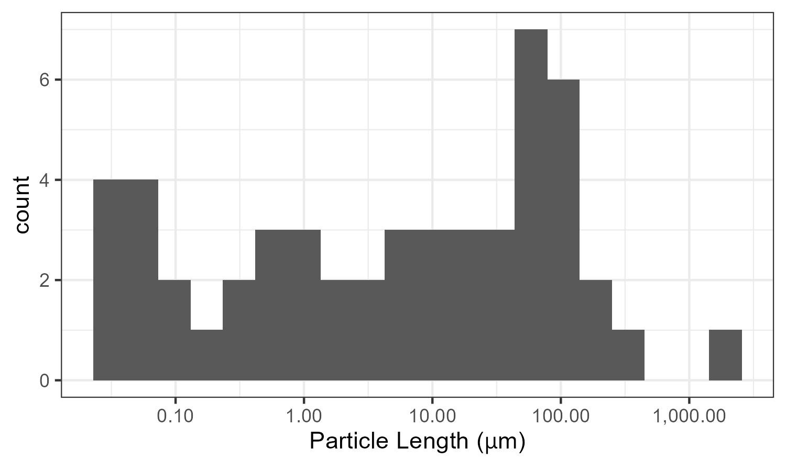
Figure S2A. Histogram of particle lengths in tissue translocation studies (N = 27 studies, 52 observations).

Probability of tissue translocation in aquatic organisms was estimated using a binomial logistic regression model with tissue translocation observation (binary, yes = 1, no = 0) as the response variable, and particle length (µm) as the predictor variable. Particle length was significantly correlated with observed translocation (p = 0.034). A model for predicting the probability of tissue translocation is described in equation SX1.
Equation SX1 probability of tissue translocation = 11 + exp(0.014 * particle length[µm] + 1.24)

Model parameters for the binomial regression were as follows: intercept = 1.24 (+- 0.40 [standard error]; p = 0.002); exp(particle length [µm]) = -0.014 +- 0.007 [standard error]; p = 0.034). The residual deviation was 58.7 on 50 degrees of freedom, while the null deviance was 67.1 on 51 degrees of freedom. The model is visually represented in figure S2B. The particle length corresponding to the 50th percentile probability of translocation is 83 µm.

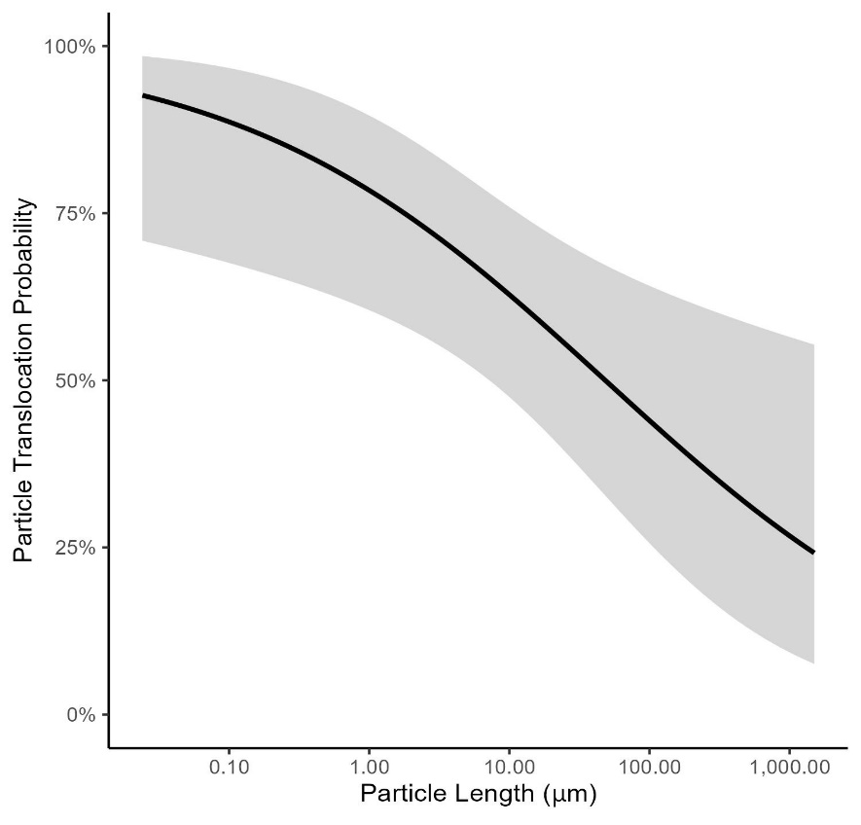
Figure S2B: Binomial logistic regression fit (black line = fit; gray ribbon = 95% CI) for probability of tissue translocation of plastic particles (y-axis; %probability) by particle length (x-axis; µm). Particle size is significantly correlated with probability of tissue translocation via gastrointestinal uptake (p = 0.034).

Table S2: Summary of tissue translocation studies used for the modeling exercise.

Paper/ doi | Lab or field | Polymer | Shapes | Size (µm) | Organism Group | Tissue translocation observed (Y/N) | Exposure  route
Abassi et al, 2018  10.1016/j.chemosphere.2018.04.076 | Field | Not characterized | Fiber, fragment | 100.00 | Fish | Y | Not reported
Abassi et al, 2018  10.1016/j.chemosphere.2018.04.077 | Field | Not characterized | Fiber, fragment | 100.00 | Shrimp | Y | Not reported
Akhbarizadeh et al, 2018  10.1016/j.envpol.2017.09.028 | Field | Not characterized | Fiber, fragment, pellet | 100.00 | Fish | Y | Not reported
Al-Sid-Cheikh, M. et al 2018  10.1021/acs.est.8b05266 | Lab | PS | Sphere | 0.25 | Mollusk | Y | Water
Al-Sid-Cheikh, M. et al 2018  10.1021/acs.est.8b05266 | Lab | PS | Sphere | 0.02 | Mollusk | Y | Water
Brennecke et al, 2015  10.1016/j.marpolbul.2015.05.001 | Lab | PS | Fragment | 70 | Crab | Y | Sediment
Browne et al, 2008  10.1021/es800249a | Lab | PS | Sphere | 3.00 | Mussel | Y | Water
Browne et al, 2008  10.1021/es800249a | Lab | PS | Sphere | 9.60 | Mussel | Y | Water
Brun et al, 2018  10.1039/C8EN00002F | Lab | PS | Sphere | 0.03 | Fish | Y | Water
Collard et al, 2017  10.1016/j.envpol.2017.07.089 | Field | PE, Cotton, ABS | Fragment | 39.00 | Fish | Y | field
Collard et al, 2018  10.1016/j.scitotenv.2018.06.313 | Field | PET, PP, PAN, PEVA | Fiber, fragment | 28.00 | Fish | Y | field
Cui et al, 2017  10.1038/s41598-017-12299-2 | Lab | PS | Sphere | 0.05 | Crustacean | Y | Water
De Sales-Ribeiro et al, 2020  10.1038/s41598-020-69062-3 | Lab | Propretary composition (cospheric) | Sphere | 1.63 | Fish | Y | Food
De Sales-Ribeiro et al, 2020  10.1038/s41598-020-69062-3 | Lab | Nylon | Fiber | 1500.00 | Fish | N | Food
De Sales-Ribeiro et al, 2020  10.1038/s41598-020-69062-3 | Lab | PE | Fragment | 220.00 | Fish | N | Food
Ding et al, 2018  10.1016/j.envpol.2018.03.001 | Lab | PS | Sphere | 0.10 | Fish | Y | Water
Grogorakis et al, 2016  10.1016/j.chemosphere.2016.11.055 | Lab | Not reported | Sphere | 63.00 | Fish | N | Food
Grogorakis et al, 2017  10.1016/j.chemosphere.2016.11.056 | Lab | PEST | Fiber | 50.00 | Fish | N | Food
Jovanovic et al, 2018  10.1016/j.marpolbul.2018.03.016 | Lab | PVC high molecular weight | Fragment | 75.00 | Fish | Y | Food
Jovanovic et al, 2018  10.1016/j.marpolbul.2018.03.016 | Lab | PA | Fragment | 111.00 | Fish | N | Food
Jovanovic et al, 2018  10.1016/j.marpolbul.2018.03.016 | Lab | PE | Fragment | 23.00 | Fish | Y | Food
Jovanovic et al, 2018  10.1016/j.marpolbul.2018.03.016 | Lab | PS | Fragment | 51.00 | Fish | Y | Food
Jovanovic et al, 2018  10.1016/j.marpolbul.2018.03.016 | Lab | MDPE | Fragment | 54.00 | Fish | Y | Food
Jovanovic et al, 2018  10.1016/j.marpolbul.2018.03.016 | Lab | PVC low molecular weight | Fragment | 87.00 | Fish | N | Food
Kashiwada, 2006  10.1289/ehp.9209 | Lab | PS | Sphere | 0.04 | Fish | Y | Water
Kim et al, 2020  10.1371/journal.pone.0239128 | Lab | PE | Sphere | 20.00 | Fish | N | Food
Kim et al, 2020  10.1371/journal.pone.0239128 | Lab | PE | Sphere | 32.00 | Fish | N | Food
Kim et al, 2020  10.1371/journal.pone.0239128 | Lab | PE | Sphere | 75.00 | Fish | N | Food
Kim et al, 2020  10.1371/journal.pone.0239128 | Lab | PE | Sphere | 150.00 | Fish | N | Food
Kim et al, 2020  10.1371/journal.pone.0239128 | Lab | PE | Sphere | 300.00 | Fish | N | Food
Lovmo et al, 2017  10.1016/j.dci.2016.06.016 | Lab | PS | Sphere | 0.50 | Fish | Y | intubation_orally
Lovmo et al, 2017  10.1016/j.dci.2016.06.016 | Lab | PS | Sphere | 1.00 | Fish | N | intubation_orally
Lu et al, 2016  10.1021/acs.est.6b00183 | Lab | PS | Sphere | 5.00 | Fish | N | Water
Lu et al, 2016  10.1021/acs.est.6b00183 | Lab | PS | Sphere | 20.00 | Fish | Y | Water
Magni et al, 2018  10.1016/j.scitotenv.2018.03.075 | Lab | PS | Sphere | 1.00 | Mussel | Y | Water
Magni et al, 2018  10.1016/j.scitotenv.2018.03.075 | Lab | PS | Sphere | 10.00 | Mussel | Y | Water
Mattsson et al, 2017  10.1038/s41598-017-10813-0 | Lab | PS + charge | Sphere | 0.05 | Fish | Y | Trophic chain
Mattsson et al, 2017  10.1038/s41598-017-10813-0 | Lab | PS + charge | Sphere | 0.18 | Fish | Y | Trophic chain
Petrie & Ellis, 2006  10.1016/j.fsi.2005.07.006 | Lab | Latex | Sphere | 0.10 | Fish | Y | Intubation
Petrie & Ellis, 2006  10.1016/j.fsi.2005.07.006 | Lab | Latex | Sphere | 0.50 | Fish | Y | Intubation
Petrie & Ellis, 2006  10.1016/j.fsi.2005.07.006 | Lab | Latex | Sphere | 1.00 | Fish | Y | Intubation
Petrie & Ellis, 2006  10.1016/j.fsi.2005.07.006 | Lab | Latex | Sphere | 3.00 | Fish | Y | Intubation
Petrie & Ellis, 2006  10.1016/j.fsi.2005.07.006 | Lab | Latex | Sphere | 10.00 | Fish | N | Intubation
Pitt et al, 2018  10.1016/j.aquatox.2017.11.017 | Lab | PS | Sphere | 0.05 | Fish | Y | Water
Sussarellu et al, 2016  10.1073/pnas.1519019113 | Lab | PS | Sphere | 2.00 | Oyster | N | Water
Sussarellu et al, 2016  10.1073/pnas.1519019113 | Lab | PS | Sphere | 6.00 | Oyster | N | Water
van Pomeren et al, 2017  10.1016/j.aquatox.2017.06.017 | Lab | PS | Sphere | 0.03 | Fish | Y | Water
van Pomeren et al, 2017  10.1016/j.aquatox.2017.06.017 | Lab | PS | Sphere | 0.05 | Fish | Y | Water
van Pomeren et al, 2017  10.1016/j.aquatox.2017.06.017 | Lab | PS | Sphere | 0.25 | Fish | N | Water
van Pomeren et al, 2017  10.1016/j.aquatox.2017.06.017 | Lab | PS | Sphere | 0.70 | Fish | N | Water
von Moos et al, 2012  10.1021/es302332w | Lab | HDPE | Fragment | 80.00 | Mussel | Y | Water
Zeytin et al, 2020  10.1016/j.marpolbul.2020.111210 | Lab | Propretary composition (cospheric) | Sphere | 5.00 | Fish | Y | Food

Supplemental Information S3- Data alignment
Monodisperse laboratory-based effect concentrations (e.g. 40-µm polyethylene fragments) were re-scaled to a default polydisperse size range (e.g. 1 - 5,000 µm) according to Kooi et al (2021) and Koelmans et al (2020). A portion of laboratory effect studies (n = 45 out of a total of 163) used particles having a certain size range (e.g. authors specify 20 – 200 µm, etc.) and were considered polydisperse. Of the studies that passed screening criteria, polydisperse effect studies accounted for 9 out of 28 studies total. We verified the effect of the uncertainty in the exponent values using the interquartile range for surface water in Kooi et al (2021) for these 9 lab-studies using a sensitivity analysis, which turned out to be marginal for the tissue translocation thresholds (3 – 27% difference) and somewhat significant for the food dilution tiers (12 to 70%).Re-scaling effect concentrations (EC) to a default size range allows direct comparison to exposure concentrations (C) for a default size range (which may also be re-scaled) (equation 1) (Kooi et al 2021).
Equation 1 ${EC}_{env}(or C_{env})={CF}_{bio (or meas)}* {EC}_{poly} (or C_{meas})$
Where EC_{env} and C_{env} are the environmentally realistic effect concentration and occurrence concentrations, respectively; CF_{bio (or meas)} is a dimensionless correction factor the bioaccessible effect concentration (bio) or the environmentally-monitored concentration (meas); and EC_{poly} and C_{meas} are the polydisperse microplastic effect concentration and (unaligned) environmental concentration, respectively. Environmental concentrations are aligned to an upper (UL,D; µm) and lower default size range (LL,D; µm) based on the power law slope of the particle occurrence in the environment based on size (a, unitless), with the upper limit (UL, meas; µm) and lower limit (LL, meas; µm) defined by the size limits of quantification of the monitoring method employed (equation 2).
Equation 2 ${CF}_{bio (or meas)}=\frac{L_{UL,D}^{1-a}-L_{LL,D}^{1-a}}{L_{UL, bio (or meas)}^{1-a}-L_{LL, bio (or meas)}^{1-a}}$
Equation 2 is used to align both measured environmental concentrations and polydisperse effect concentrations to a default size range (1 – 5,000 µm). Conversion of a monodisperse effect concentration (EC_{mono}) to a polydisperse effect concentration (EC_{poly}) requires consideration of the ecologically relevant metric (ERM) x believed to be responsible for the observed toxicological effects (where x = volume for food dilution or x = surface area for translocation) (equation 3). In the case of studies that used a size range of particles (e.g. 20 – 200 µm), the polydisperse effect concentration was converted to a polydisperse effect concentration of a default size range (1 – 5,000 µm) using equations 1 and 2, with L_{UL,D} and L_{LL,D} respectively corresponding to the lower and upper limits of the lengths of particles used in the laboratory experiment (e.g. 20 and 200 µm).
Equation 3 $EC_{poly}*μ_{x,poly}^{env}=EC_{mono}*μ_{x,mono}$
or
$$EC_{poly}*μ_{x,poly}^{env}=EC_{poly}*μ_{x,poly}^{lab}$$
Where µ_{x, poly} is the mean value for ERM x for polydisperse particles within a given bioaccessible size distribution, and µ_{x, mono} is the mean value for ERM x for the monodisperse effect concentration from the literature test data. In the case of the polydisperse laboratory effect concentrations, the equation to the right is used, with $μ_{x,poly}^{lab}$ calculated for the size range tested in the laboratory (e.g. 20 - 200 µm) with the appropriate exponent value. For the calculation of µ_{x, poly} for different types of effect metrics ‘x’, the reader is referred to the Supporting Information.Exponent values were not reported in any of the laboratory studies that used polydisperse particles, and deriving values from reported histograms was outside of the scope of this project, therefore the default alpha values for marine surface waters were used instead (Kooi et al 2021). Since laboratory studies often prepare mixtures using cryomilling and other processes that may not necessary be representative of the marine environment, a sensitivity analysis was performed using the interquartile range of alpha values observed in the marine environment (Table S4A) as a proxy for the range to be expected among polydispersions used in the laboratory. When the suspected effect mechanism depends on ingestion of the particle, particles that are too large to be ingested by the organism of interest (i.e. wider than the mouth opening) are considered biologically unavailable (i.e. food dilution mechanism of action) and are excluded from alignment. Further, in the case of toxicity depending on tissue translocation, particles too large to be translocated through tissue (>83 µm) are considered biologically unavailable and excluded from alignment. In the case of organisms that have mouth openings smaller than 83 µm, their mouth opening size is used as the upper limit for alignment.

Detailed example of data alignment conversion

Alignment of Monodisperse Effect Concentrations to Polydisperse Environmental Concentrations
To convert a monodisperse effect concentration to the effect concentration for a polydisperse mixture of microplastic particles, a correction must occur which takes into consideration the ecologically relevant metric (ERM) (Koelmans et al 2017). For a given ERM, the threshold may be related to both mono- or polydisperse particles interchangeably so long as the total magnitude of ERM remains the same using equation S1 (Koelmans et al, 2020).
Equation S1. $EC_{poly}*μ_{x,poly}=EC_{mono}*μ_{x,mono}$
In the literature, effect concentrations often are expressed with unit particle count/liter. Note that in the case of particle count , $μ_{x,mono}$ as well as $μ_{x,poly}$ would simply equate to 1, which implies that for this case no conversion is needed. However, toxicologically relevant particle effect mechanisms do not require number concentrations but require input in terms of particle dose metrics such as L, W, H, V, A, SSA (Kooi et al, 2021). These particle characteristics follow a power law regime in the marine environment, and for these ERMs $μ_{x,poly}$ may be calculated using equations S2, S3, or S4 depending on the alpha value (Kooi et al 2021).
Equation S2. (in case $α$ ≠ {1,2}): $μ_{x,poly}=\frac{1-a_{x}}{2-a_{x}}\frac{X_{UL}^{2-a_{x}}-X_{LL}^{2-a_{x}}}{X_{UL}^{1-a_{x}}-X_{LL}^{1-a_{x}}}$

Equation S2 is not valid when $α$ =1 or $α$ =2. In case $α$ =1, the equation for the average of the power law distribution is:

Equation S3. (in case $α$ = 1): $μ_{x}=\frac{x_{UL}-x_{LL}}{ln\left(\frac{x_{UL}}{x_{LL}}\right)}$
And for $α$ =2 the equation for the average of the power law distribution is:
Equation S4. (in case $α$ = 2): $μ_{x}=\frac{ln\left(\frac{x_{UL}}{x_{LL}}\right)}{x_{LL}^{-1}-x_{UL}^{-1}}$
Where $a_{x}$ relates to the power law distribution of microplastic particles in the marine environment (i.e. particle length; 2.07; Kooi et al 2021), and UL and LL are the upper and lower limits of ERM x as defined by chosen bioaccessibility criteria for the species/life stage/effect metric, respectively. In the case of bioaccessibility relating to ingestible size ranges, X_{UL} would be the maximum ingestible particle for the ERM of interest (e.g. volume), with the corresponding length input in the volume equation as the limiting factor, which corresponds to the average mouth size opening. In the case of ingestion with an ERM of volume, X_{LL} would be the volume of the particle with length, width, and height corresponding to the lower default size range (1 µm). In the case of bioaccessibility relating to tissue translocation potential, X_{UL} would be the ERM of interest (e.g. surface area) calculated with the maximum translocatable particle length as input, which is 83 µm or the average mouth size (whichever is smaller). Note that here we assumed ingestion to be length-restricted, which differs from the approach employed in Koelmans et al (2020), which posited that ingestion is width-restricted. The rationale in Koelmans et al (2020) for defining ingestion bioaccessibility by width is that a particle with ellipsoid shape may be plausibly ingestible by an organism with a mouth size opening smaller than the length of the particle (i.e. being ingested length-wise), while particle orientation and transport in tissues is significantly more restricted, with the longest dimension (length) relating to the maximum bioaccessible particle. A less conservative approach was employed here based on expert’s consensus.
Once $μ_{x,poly}$, $μ_{x,mono}$, and $EC_{mono}$ are calculated, the bioaccessible polydisperse effect concentration $EC_{poly}$ may then be calculated using equation S5:
Equation S5. $EC_{poly}=\frac{EC_{mono}*μ_{x,mono}}{μ_{x,poly}}$
After the bioaccessible, polydisperse effect concentration is calculated, in order to relate a polydisperse threshold effect concentration to an environmentally relevant (e.g. 1 - 5,000 um) range of particles ($EC_{env}$; particles/L) a further correction must occur using equation S6 (Kooi et al 2021).
Equation S6. $EC_{env}=EC_{poly}*CF_{bio}$
Where $CF_{bio}$ is a dimensionless correction factor for the bioaccessible effect concentration. Equation S6 rescales the bioaccessible effect concentration (particles/L) to an environmentally relevant concentration for the microplastics default (D) size range (e.g. 1 to 5,000 um) according to the power law distribution for length (L) with slope $α_{L}$ in the marine environment (i.e. 2.07) (Kooi et al, 2021). $CF_{bio}$ is calculated using equation S7. (Kooi et al 2021):
Equation S7. $CF_{bio}=\frac{L_{UL,D}^{1-a}-L_{LL,D}^{1-a}}{L_{UL,B}^{1-a}-L_{LL,B}^{1-a}}$

Conversion of effects concentration data to unit of Volume
To illustrate the data alignment of converting monodisperse effect concentrations to polydisperse, environmentally realistic concentrations, a real example from the literature is used. Take for example, a NOEC of 562 particles/L for a chronic toxicity study for Daphnia magna conducted using 40 µm-long polyethylene fragments (Jaikumar et al 2018). Daphnia magna have an average body length of 0.5 cm, and an estimated maximum ingestible particle length of 115 µm particles based on average mouth size opening (Jâms et al 2020).
In the case of an ERM of interest being volume, $μ_{x,mono}$ is equivalent to the average volume of the monodisperse particle (i.e. $μ_{v,mono}$), calculated using equation S8.
Equation S8. $μ_{v,mono}=V_{i}=\frac{4}{3}πabc$
Where $V_{i}$ is the volume for a given particle i, and a, b, and c are radii along the principal axes, corresponding to one-half times the length, width, and height of an ellipsoid. When available, laboratory-measured particle sizes were used for all length, height, and width calculations, with producer-reported sizes in combination with standard assumptions based on particle shapes used when empirical data were unavailable. Equation S6 can be applied to fragments, thin films, microbeads, spheres, or fibers given a known length to width ratios (width [µm] = length [µm] * R_{i} [unitless ratio])] for such shapes, with the height assumed to be equivalent to 0.67 x width (Kooi et al 2021). Width to length ratios differ for microplastics differ by compartment, with averages ranging from 0.67 to 0.77 (Kooi et al 2021). Averaged values may be used to estimate the volume of polydisperse environmental mixtures of microplastics. For the example of a 40 µm PE fragment, the length was reported by the authors ($L_{i}=40μm$) (Jaikumar et al 2018), however the width was not directly reported, so a default value of 0.77 * length is used, which is the average length-to-width ratio for marine surface water microplastics (i.e. $R_{i}=0.77;unitless$) (Kooi et al 2021). Accordingly, $μ_{v,mono}$ is calculated using equation S6 ($μ_{v,mono}=$ 13,300 um³).
Using equations S2 (or S3 or S4), $μ_{v,poly}$ is calculated using the volume of particles that are bioaccessible, with the maximum ingestible length corresponding to the mouth opening size and (i.e. 115 µm for adult Daphnia). The height and width of particles would both correspond to the lower and upper widths of ingestible particles within the default size distribution for adult Daphnia (i.e. 1 and 115 µm, respectively). (Kooi et al 2021). The upper and lower bioaccessibility limits in volume for this example are V_{UL} = 7.96 x 10⁵ µm³ and V_{LL} = 0.524µm³, respectively. $μ_{v,poly}$ may now be calculated given these limits, using an alpha value of 1.48 for volume in the marine surface water environment (Kooi et al 2021), which equates to $μ_{v,poly}$ = 793 µm³.
Now that $μ_{v,poly}$, $μ_{v,mono}$, and $EC_{mono}$ are known for this example for volume, the bioaccessible polydisperse effect concentration $EC_{poly}$ for the volume ERM may then be calculated using equation S5 $EC_{poly, V}$= 9,443 particles/L. Again, to relate this bioaccessible, polydisperse effect threshold ($EC_{poly,v}$) to an environmentally relevant polydisperse mixture of particles for the volume ERM, an additional correction must be applied (equation S6) to rescale the effect threshold to the environmental size range of interest (e.g. 1-5,000 µm) using $CF_{bio}$, identical as for particles $EC_{env,v}$ = 9,501particles/L.

Conversion of effects concentration data to unit of Surface Area
For surface area as an ERM, $μ_{sa,mono}$ is equivalent to the average surface area ($SA$) of the monodisperse particle for the effect threshold, calculated using equation S9.
Equation S9. $μ_{sa,mono}=SA=4π(\frac{(ab)^{1.6}+(ac)^{1.6}+(bc)^{1.6}}{3})^{1/1.6}$
With a, b, c being equal to 0.5x length, 0.5x width, and 0.5x height, respectively. For the example of a 40 µm PE fragment, the length was reported ($a=0.5*40=20 μm$), however the width was not reported by the authors, so again a default value of 0.77 times the length is used ($b=0.5x 0.77x 40=15.4 μm$), which is the average length:width ratio for marine surface water, and the height is assumed to be 0.67 times the width ($c=0.5x0.77x0.67x40=10.3 μm$) (Kooi et al 2021). Surface area is calculated for this example and equates to $μ_{sa,mono}$ = 2,880 µm².
Since the probability distribution of ERM $sa$ (surface area) follows a power law regime, the mean ERM value for the polydisperse particles, $μ_{sa,poly}$, can be calculated using equation S2 (or S3 or S4 depending on the alpha value). For surface area of environmentally disperse particles, X_{UL} and X_{LL} are calculated using the equation for the surface area of an ellipsoid (equation S9), with bioaccessibility limited by tissue translocation. The maximum value for ERM sa (i.e. , X_{UL}) is calculated based on maximum lengths, widths, and heights corresponding to the upper translocatable length (i.e. 83 µm) of a sphere, therefore, (a = 0.5 x 83 = 41.5 $μm$; b = 0.5 x 83 = 41.5 µm; c = 0.5 x 83 = 41.5 µm).the lower surface area would simply correspond to the lower default size range based on a lower length, width, and height of 1 µm for a sphere(a = 0.5, b = 0.5, c = 0.5. Accordingly, SA_{UL} = 2.16 x 10⁴µm² and SA_{LL} = 3.1 µm².$μ_{sa,poly}$ may now be calculated given these limits, using an alpha value of 1.98 for surface area in the marine surface water environment (Kooi et al 2021), which equates to: $μ_{sa,poly}$ = 261 µm².
Now that $μ_{v,poly}$, $μ_{v,mono}$, and $EC_{mono}$ are known for this example for surface area, the bioaccessible polydisperse effect concentration $EC_{poly}$ for the surface area ERM may then be calculated, and equates to: $EC_{poly_SA}=$ 6,220 particles/L.
Again, to relate this bioaccessible, polydisperse effect threshold ($EC_{poly,sa}$) to an environmentally relevant polydisperse mixture of particles for the surface area ERM, an additional correction must be applied to rescale the threshold to the size range of interest (e.g. 1-5,000 µm) using $CF_{bio}$, identical as for particles. Therefore, $EC_{env ,sa}$ = 6,258 Particles/L.

Conversion of effects concentration data to unit of Mass
In the case of an ERM of interest being total mass, $μ_{x,mono}$ is equivalent to the average mass of the monodisperse particle (i.e. $μ_{m,mono}$), calculated as follows (equation S10):
Equation S10. $μ_{m,mono}=m=pV*\frac{1}{1e12}*1e6$
Where m is the mass (µg), p is density (g/cm³), V is volume (µm³) - which is calculated by the cube of the radius of each particle (i.e. 1/2 * length, or 40 µm for this example), and additional conversion factors for g to µg (1 x 10⁶) and cm³ to µm³ (1 x 10⁻¹²). For the example of a 40 µm polyethylene fragment, the volume is estimated to be ~ $207 µm^{3}$, and the density of polyethylene is estimated to be 0.935 g/cm³. Accordingly, $μ_{mass,mono}$ is calculated to be 0.0124 µg for this example.
Since the probability distribution of ERM $m$ (mass) follows a power law regime, the mean ERM value for the polydisperse particles, $μ_{m,poly}$, can be calculated by first calculating the lower and upper bioaccessible masses of particles based on the width of the bioaccessible particle. The X_{UL} and X_{LL} are respectively defined as the upper and lower limit in ERM $m$ (mass) for which the mean is calculated, and $a_{m}$ is the power law exponent of mass. In the case of marine surface water, an $a_{m}$ of 1.32 is utilized (Kooi et al., 2021).
For mass, X_{UL} and X_{LL} are mass-based upper and lower limits of bioaccessibility. For this example, bioaccessibility is defined by tissue translocation (83 µm) based on the length of particles. To estimate mass-based limits based on translocatable size, the volume of translocatable particles is first calculated using the equation for the volume of an ellipsoid (Equation S8), then multiplied by the average density of particles in the 1-5,000 µm distribution in the environmental compartment of interest (e.g. surface marine water: 1.10 g/cm^3) (Kooi et al 2021). Following the same calculations described above for volume using translocation limits (i.e. V_{UL} = 2.99 x 10⁵ µm³ and V_{LL} = 0.524 µm³) in equation S10 results in M_{UL} = 0.33 µg and M_{LL} = 5.8 x 10⁻⁷ µg. $μ_{m,poly}$ may now be calculated given these limits, using an alpha value of $a_{m}$ of 1.32 for the marine surface water environment (Kooi et al. 2021), equating to: $μ_{m,poly}$ = 0.0023 µg.
Now that $μ_{m,poly}$, $μ_{m,mono}$, and $EC_{mono}$ are known for this example for mass, the bioaccessible polydisperse effect concentration $EC_{poly}$ for the mass ERM may then be calculated, which is equivalent to: 3,096 particles/L based on a tissue translocation-limited bioaccessibility. Again, to relate this bioaccessible, polydisperse effect threshold ($EC_{poly,m}$) to an environmentally relevant polydisperse mixture of particles for the mass ERM, an additional correction must be applied to rescale the threshold to the size range of interest (e.g. 1-5,000 um) using $CF_{bio}$, identical as for particles. Accordingly, $EC_{env,m}$ = 3,116 particles/L.

Specific Surface Area
In the case of an ERM of interest being specific surface area, $μ_{ssa,mono}$ is equivalent to the surface area of a 40 µm PE fragment (i.e. $μ_{sa,mono}$) divided by the mass (i.e. $μ_{m,mono}$), calculated as follows:
Equation S11 $μ_{ssa,mono}=SSA=\frac{SA}{m}$
Where SA is the surface area (µm²) of the particle, and m is the mass (µg). Accordingly, $μ_{ssa,mono}$ = 2.32 x 10⁵ µm²/µg.

Since the reciprocal of the probability distribution of ERM $ssa$ (specific surface area) follows a power law regime, the mean ERM value for the polydisperse particles, $μ_{ssa,poly}$, can be calculated by first calculating $μ_{1/ssa,poly}$ then taking the inverse to obtain the $μ_{ssa,poly}$ using equation S11. In equation S2, X_{UL} and X_{LL} are respectively defined as the inverse of the upper and lower limit in ERM $ssa$ (i.e. 1/ssa) for which the mean is calculated, and $a_{1/ssa}$ is the power law exponent of the inverse of the specific surface area. For example, marine surface water has an $a_{1/ssa}$ of 1.98 (Kooi et al 2021). For specific surface area, X_{UL} and X_{LL} correspond (respectively) to the specific surface area of the upper and lower limits of bioaccessible particles based on particle length as a limiting factor. To calculate the specific surface area of the upper and lower bioaccessible particles (determined by length for tissue translocation) within the 1-5,000 µm distribution, the translocatable surface area limits are divided by the translocatable mass-based limits as calculated above. For this example, the inverse specific surface area limits are equivalent to: 1/SSA_{UL} = 1.52x 10⁻⁵ µg/µm² and ; 1/SSA_{LL} = 1.83x 10⁻⁷ µg/µm².
$μ_{1/SSA,poly}$ may now be calculated given these limits, using an alpha value of $a_{1/ssa}$ of 1.98 for the marine surface water environment (Kooi et al 2021). Note that 1/SSA is used in equation S2, so the inverse must be taken to derive $μ_{SSA,poly}$, which equates to 1.19 x 10⁶ µm²/µg. Now that $μ_{ssa,poly}$, $μ_{ssa,mono}$, and $EC_{mono}$ are known for this example for specific surface area, the bioaccessible polydisperse effect concentration $EC_{poly}$ for the specific surface area ERM based on tissue translocation may then be calculated, equivalent to:110.particles/L.
Again, to relate this bioaccessible, polydisperse effect threshold ($EC_{poly,ssa}$) to an environmentally relevant polydisperse mixture of particles for the specific surface area ERM with translocation as a bioaccessible limit, an additional correction must be applied to rescale the threshold to the size range of interest (e.g. 1-5,000 um) using $CF_{bio}$, identical as for particles. Accordingly, $EC_{Env,ssa}$= 110.3 particles/L.

Aligning Occurrence Data for Risk Characterization
Given an upper limit (UL) and lower limit (LL) of the measured (M) and default size range (D), a dimensionless correction factor ($CF_{meas}$) for measured environmental concentrations may be calculated, which rescales the measured (M) number concentrations for a certain size range to the number concentration for the microplastics default (D) size range (e.g. 1 to 5,000 µm) according to the power law distribution for length (L) with slope $α_{L}$ (Koelmans et al., 2020).
The following equation (equation S12) for $CF_{meas}$ is identical to the rescaling equation for effect concentrations ($CF_{Bio}$) as discussed above (equation S6) except the bioaccessible fraction of particles is denoted as UL,B and LL,B on the denominator (Koelmans et al., 2020; Kooi et al., 2021).
Equation S12. $CF_{Meas}=\frac{L_{UL,D}^{1-a}-L_{LL,D}^{1-a}}{L_{UL,M}^{1-a}-L_{LL,M}^{1-a}}$
As an example, a measured marine surface water concentration of 10 particles/L for particle size ranges 300 – 5,000 µm is used. To compare this unaligned concentration to the environmentally relevant (1 – 5,000 um) effect threshold (EC_{env}) in particles/L (calculated above), $CF_{meas}$ is first calculated using equation S11, which equates to 470.3. The resulting correction factor ($CF_{meas}$; unitless) is then multiplied by the measured concentration ($C_{Meas};i.e. 10 particles/L$) to obtain a rescaled exposure number concentration using equation S4, which equates to 4,703 particles/L.
This measured rescaled environmental concentration $C_{env}$ may then be directly compared to the rescaled effect thresholds for various ERM $EC_{env,x}$ to determine if risk is present using the traditional risk quotient formula (effect concentration divided by environmental concentration), whereby a ratio greater than one is indicative of a likelihood risk, and a ratio less than one is indicative of a low likelihood of risk.

Table S3A. Example of Various ERM alignments for a theoretical toxicity value with corresponding environmentally-realistic effect concentration (EC_{env}) and risk characterization (EC_{env} / C_{env}) for illustrative purposes only
ERM | EC_{env} | EC_{env} / C_{env}
Volume (ingestion-limited) | 9,500 | 0.50
Surface Area (translocation-limited) | 6,300 | 0.75
Mass (translocation-limited) | 3,100 | 1.5
Specific Surface Area (translocation-limited) | 110 | 43

In this example, the rescaled environmental concentration is lower than the rescaled effect thresholds for all ERMs except for mass and specific surface area with bioaccessibility limited by translocatable particles, therefore if risk occurs for this species, it would most likely occur through an inflammation based mechanism (i.e. ERM = specific surface area) or mass-based ERM (for which there is currently no evidence to support this ERM) (Koelmans et al., 2021) limited in bioaccessibility by tissue translocation. Note that the different ERMs presented here have varying weights of evidence for their biological relevance and plausibility, empirically determined through studies demonstrating effects observed were directly related to hypothesized mechanisms (e.g. for food dilution, ingestion must be proven and nutrient-deficiency impacts must be associated with observed endpoint) (Koelmans et al., 2020). Since there are no evidence whatsoever for particles being an ERM, they are not presented as such in the table and again are only mentioned above as a simple, theoretical example.

Supplemental Information S4- Sensitivity Analyses

Sensitivity Analysis of Polydisperse Laboratory Alignments
The effect of assumed alpha values for alignments for polydisperse laboratory exposures in the calculation of $μ_{x,poly}^{lab}$ was tested by running three scenarios based on plausible distribution values of microplastics in marine surface waters based on the interquartile range describe in Kooi et al (2021) and are listed in Table S4A. The upper and lower interquartile ranges for length alpha distributions in marine surface waters were extracted from Figure 5 in Kooi et al. (2021) using an online tool (WebPlotDigitizer). The upper and lower values are 2.66 and 2.09, respectively, with a median value of 2.2, thus corresponding to a percentage difference of +21% and -6%, respectively. These same relative upper and lower bounds (i.e., +21% and –6%) were applied to the surface area, volume, and mass distribution values to estimate the sensitivity of such assumptions in deriving $μ_{x,poly}^{lab}$ for thresholds derived in the main manuscript. The effect of using these values in the derivation of thresholds is summarized in Table S4B.

Table S4A. Parameters used in sensitivity analysis for alignment of polydisperse laboratory exposures in calculation of $μ_{x,poly}^{lab}$
parameter | default | Upper value | Lower value
length | 2.07 | 2.50 | 1.95
surface area | 1.50 | 1.82 | 1.41
volume | 1.48 | 1.79 | 1.39
mass | 1.32 | 1.60 | 1.24

Table S4B. Sensitivity analysis of estimated distribution parameters for polydisperse laboratory experiment
Threshold | Tissue Translocation Particles/L (surface-area aligned) Default values | Tissue Translocation Particles/L (surface-area aligned) Lower values | Tissue Translocation Particles/L (surface-area aligned)  Upper values | Food Dilution  Particles/L (volume-aligned) Default values | Food Dilution Particles/L (volume-aligned)  Lower values | Food Dilution Particles/L (volume-aligned)  Upper values
#1 | 57.2 | 59.4 | 58.4 | 0.3 | 0.2 | 0.2
#2 | 311 | 316 | 298 | 2.6 | 2.6 | 2.6
#3 | 890 | 927 | 767 | 5.0 | 5.2 | 5.2
#4 | 4,110 | 4,320 | 3,480 | 34 | 36 | 36

For tissue translocation, polydisperse laboratory assumptions were of negligible impact for tiers 1 and 2 (0.1% to 4.2% absolute difference), with limited impact for tiers 3 and 4 (4.4% to 14.8% absolute difference). For food dilution, polydisperse laboratory assumptions were of negligible impact for tiers 1 and 2 (1.2% to 2.7% absolute difference), with limited impact for tiers 3 and 4 (5.3% to 7.3% difference).
One reason for the larger effect on tiers 3 and 4 for both food dilution and tissue translocation, is the greater proportion of polydisperse laboratory study effect thresholds using in the calculations. For food dilution, polydisperse studies accounted for 7 out of 18 studies for tiers one and two and 49 out of 289 total effect thresholds; and for tiers 3 and 4, accounted for 7 out of 18 studies and 49 out of 125 total effect thresholds. For tissue translocation, polydisperse studies accounted for 7 out of 19 studies for tiers one and two and 49 out of 280 total effect thresholds; and for tiers 3 and 4, accounted for 7 out of 17 studies and 49 out of 109 total effect thresholds.

Sensitivity Analysis of Distribution Alignments
The effect of assumed alpha values for alignments for environmental distributions (i.e.,$μ_{env, poly}$) in the calculation of thresholds was tested by running three scenarios based on plausible distribution values of microplastics in marine surface waters based on the interquartile range describe in Kooi et al. (2021) and are listed in Table S4A. The effect of using these values in the derivation of thresholds is summarized in Table S4C.

Table S4C. Sensitivity analysis of estimated distribution parameters for environmental polydisperse values
Threshold | Tissue Translocation Particles/L (surface-area aligned) Default values | Tissue Translocation Particles/L (surface-area aligned) Lower values | Tissue Translocation Particles/L (surface-area aligned)  Upper values | Food Dilution  Particles/L (volume-aligned) Default values | Food Dilution Particles/L (volume-aligned)  Lower values | Food Dilution Particles/L (volume-aligned)  Upper values
#1 | 57.2 | 37.3 | 206 | 0.3 | 0.03 | 0.04
#2 | 312 | 199 | 1140 | 2.6 | 0.5 | 0.6
#3 | 890 | 556 | 3430 | 5.0 | 0.9 | 1.1
#4 | 4,110 | 2580 | 15,700 | 34 | 7 | 8

Sensitivity Analysis of Bioaccessibility Alignments
In determining the maximum bioaccessible particles for both ingestion and tissue translocation, several decisions must be made. The bioaccessible limit of the particle may be determined by the width or length of the particle restricted by the mouth size opening of the organism (food dilution) or translocatable size (tissue translocation).
The most conservative assumption is that fibers with lengths equivalent to the upper default size (e.g., 5,000 um) are bioaccesible so long as their widths are smaller than or equal to the bioaccessibility limit. One may argue that fibers of such length are unlikely to be ingested. A less conservative assumption would be that the maximum bioaccessible width, length, and height are equivalent to consider the case in which spheres are bioaccessible (some percentage of microplastics in the environment are spheres, so this is a plausible assumption). Spheres are not the dominant morphology in the environment, and in fact the average width to length ratio for all microplastics in the marine surface water environment is ~0.67 (Kooi and Koelmans 2021). Accordingly, a less conservative assumption would be to estimate the maximum bioaccessible particle dimensions based on the length (equivalent to mouth size opening or tissue translocatable limit), and estimate the width and height based on their average ratios in the environment (height is ~0.77 * width; Kooi et al 2021). Each of these scenarios are evaluated for all tiers and both tissue translocation and food dilution (Table S4D). Note that in all cases, the lower size limit is always calculated using the equation for a sphere with length, width, and height defined as the lower size limit (e.g. 1 µm). This is due to the inability to extrapolate below 1 µm based on the available alignment data.

Table S4D. Sensitivity analysis of bioaccessibility assumptions based on shape.
Tier | Food Dilution  Particles/L (volume-aligned) Spheres | Food Dilution  Particles/L (volume-aligned) Fibers | Food Dilution  Particles/L (volume-aligned)  Fragments | Tissue Translocation  Particles/L (surface-area aligned)  Spheres | Tissue Translocation  Particles/L (surface-area aligned)  Fibers | Tissue Translocation  Particles/L (surface-area aligned) Fragments
#1 | 0.3 | 0.3 | 0.3 | 60 | 6.8 | 75.5
#2 | 2.6 | 1.4 | 3.4 | 310 | 40.0 | 410
#3 | 5.0 | 3.2 | 6.6 | 890 | 118 | 1170
#4 | 34 | 15.9 | 44.7 | 4110 | 544 | 5420

Sensitivity Analysis of Endpoints
The thresholds calculated in this manuscript are based on all effect types, including everything from changes in behavior to mortality. There is a gradient of effect severities which correlates with the concentrations at which they occur (Coffin et al., this issue). For instance, mortality occurs typically at higher concentrations than developmental changes holding other variables constant. The sensitivity of those data selections are examined below by restricting the effects data to be only fitness-level (i.e. reproduction, development, fitness) endpoints vs. all endpoint types. Note that by using fitness-level endpoints, fewer species and data are used. For instance, tiers 1/2 and 3/4 for both food dilution and tissue translocation have ~30% and ~7% less data overall, respectively.

Table S4E: Sensitivity analysis of endpoints used to calculate thresholds
Tier | Food Dilution  All endpoints (particles/L) | Food Dilution  Fitness endpoints only  (particles/L) | Food Dilution  Mortality only  (particles/L) | Tissue Translocation  All endpoints (particles/L) | Tissue Translocation  Fitness endpoints only  (particles/L) | Tissue Translocation  Mortality only  (particles/L)
#1 | 0.3 | 0.4 | 892 | 57.2 | 37 | 104
#2 | 2.6 | 6.9 | 3350 | 310 | 279 | 1468
#3 | 5.0 | 20.5 | 31,400 | 890 | 1110 | 21,600
#4 | 34 | 118 | 44,300 | 4,110 | 4,950 | 69,600

Sensitivity Analysis of Studies
To demonstrate the relative importance of each study on the outcome of the SSD-derived thresholds, a sensitivity analysis was performed using the ‘leave-one-out method’ in which we recalculate the results of our meta-analysis K − 1 times, each time leaving out one study. This allowed us to identify studies influencing the overall estimate of our meta-analysis the most and assess if this influence may distort our pooled effect (Viechtbauer and Cheung 2010). Each study was individually removed one-at-a-time and an SSD was built to demonstrate each study’s relative importance in the resulting thresholds (Figure S4).

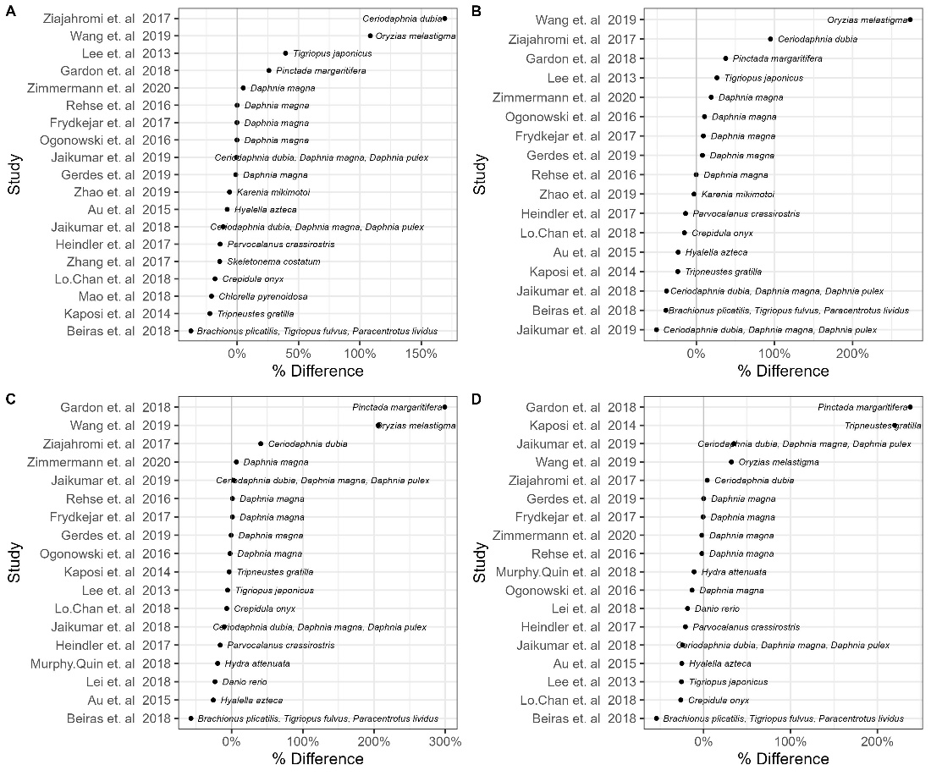
Figure S4. Percentage difference of thresholds calculated using SSDs (x-axis, %) when each study is removed (y-axis) for thresholds 2 and 3 for tissue translocation (A and B, respectively) and for thresholds 2 and 3 for food dilution (C, and D, respectively).

