Impact of polyester and cotton microfibers on growth and sublethal biomarkers in juvenile mussels

Supplementary information
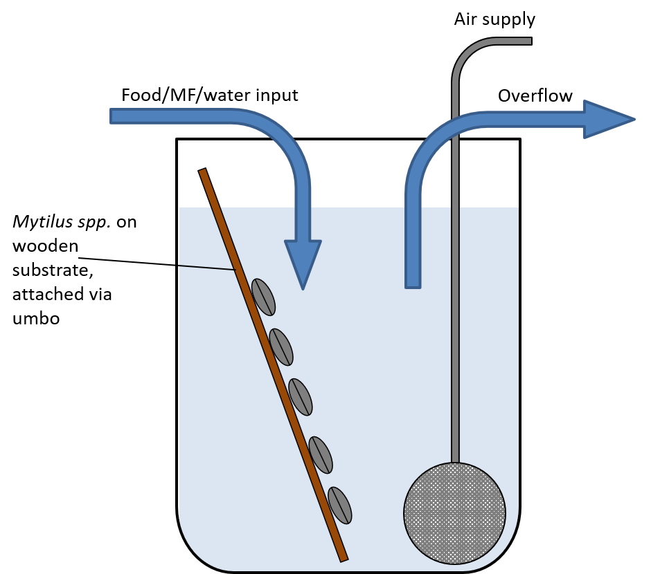
Methods

SI1. Diagram of mussel aquaria, with mussels attached to wooden spatula via mussel umbo. Mussels were kept in this way to keep them suspended in the water column to allow for more exposure to food, to facilitate easy handling reducing handling stress, and allowing faeces to travel to the bottom of the beaker (keeping the area around the mussels cleaner).

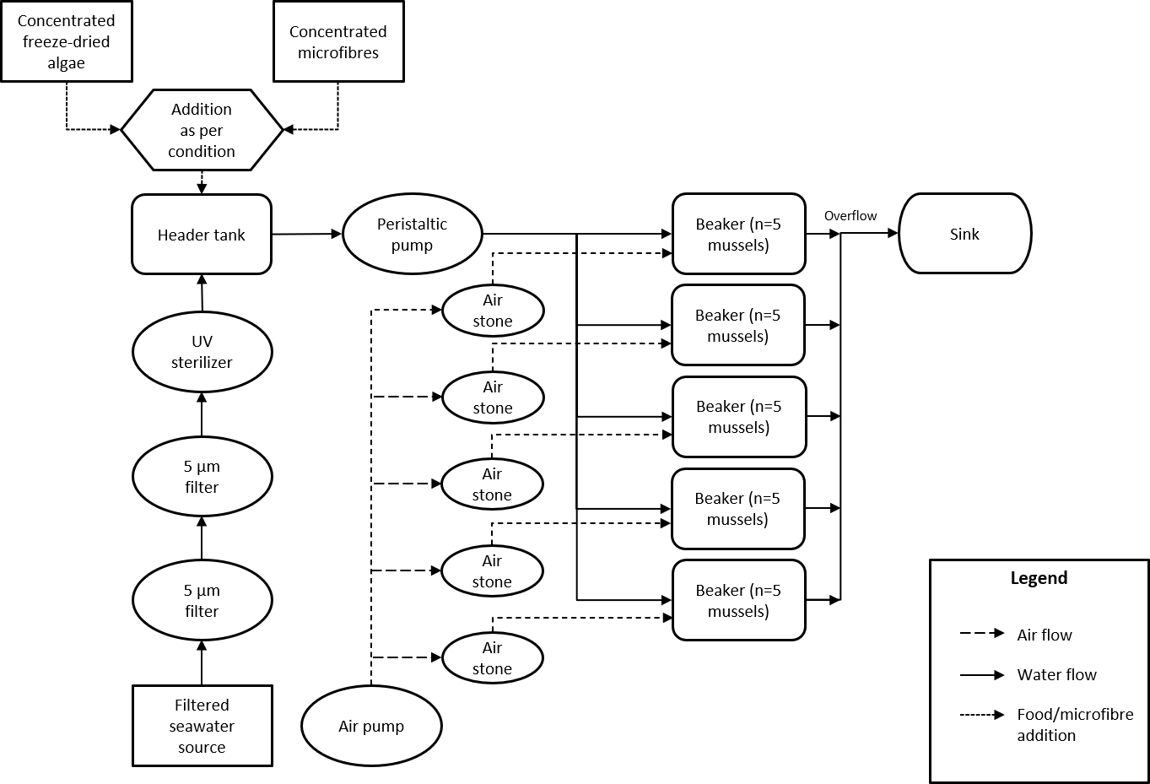
SI2. Mussel experimental setup flow chart for each experimental condition.

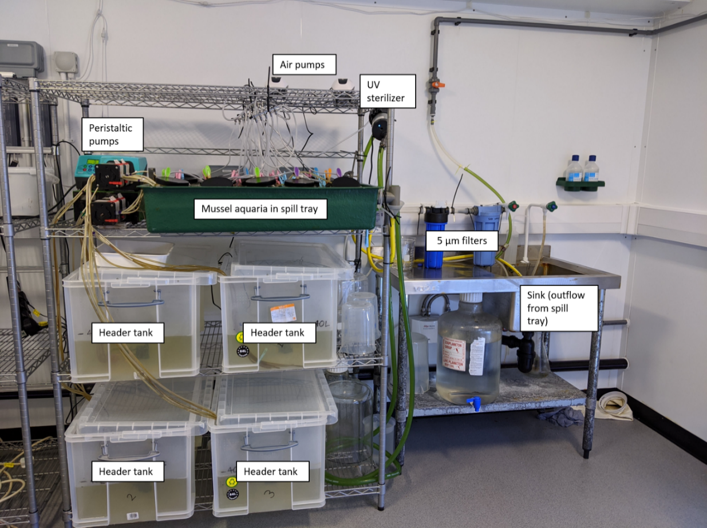
SI3. Mussel experimental setup
Calculation of header tank algal concentration
The microalgal concentration used was based on initial experiments to ascertain the clearance rate and food uptake of juvenile mussels in the size range tested. 9 mussels (shell length approx. 1cm) were placed into 3 1 L beakers (3 mussels per beaker, n=3), filled with 1 L filtered seawater and left to acclimate for 1 hour. 0.349 mL microalgae solution (Instant Algae Shellfish Diet 1800, Reed Mariculture) was added to each beaker, mixing gently until homogenous. 10 mL solution (n=3) was removed from each beaker at t = 0, 15, 30, 45, 60 mins (gently mixing solution each time before removing sample). Each sample was filtered onto Whatman GF/F filter papers, which were placed into falcon tubes with 10 mL 90% acetone solution and left at -20 °C overnight. All solutions were read using a fluorometer and chlorophyll-a concentration was calculated using a standard curve. The average concentration for each sample was calculated (µg/L) and mussel clearance rate was subsequently calculated using the methods in Widdows and Staff (2006) and the formula from Coughlan (1969):

$$Clearance Rate=\frac{V}{nt} . {(log}_{e}conc_{0}-\log_{e}{conc_{t})}$$
V = Volume (L)
n = number of mussels
t = time of measurement (hours)
conc₀ = algal concentration at time 0
conc_{t} = algal concentration at time t

Mussel clearance rate was calculated as 0.113 L hr⁻¹ mussel⁻¹. Using an environmentally relevant algal concentration of 10 µg/m³ (unpublished data), and the dispense speed of algal solution into to the header tanks, it was calculated that the header tanks should be maintained at an algal concentration of 0.74 µg L⁻¹ to provide mussels with a constant concentration of algae to maintain maximum clearance rate.

Results
A: Cotton microfibre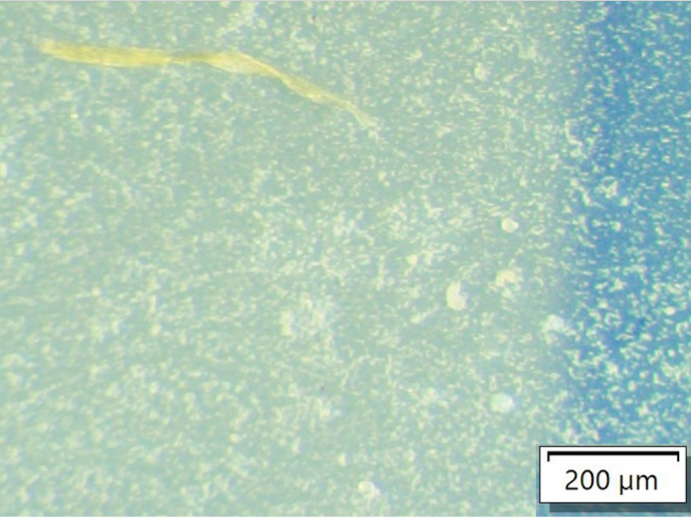 | B: Polyester microfibre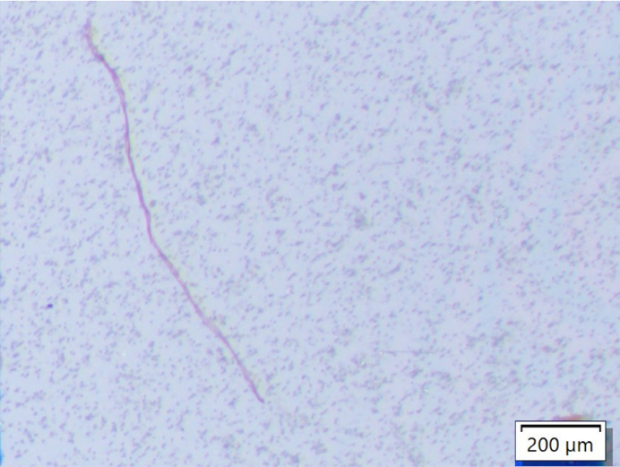
SI4. Experimental microfibres identified within mussel soft tissue digests. A = cotton fibre, B = polyester fibre.

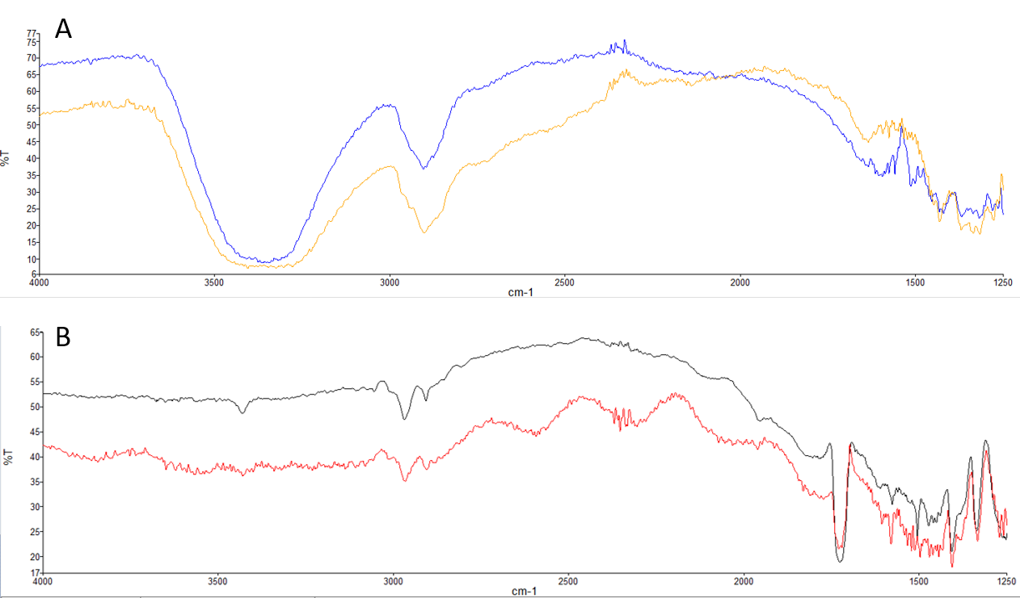
SI5. Example experimental microfibre FT-IR spectra pre-exposure and post-exposure (identified within mussel digests). A = cotton microfibres (yellow = pre-exposure, spectral match = 0.892; blue = post-exposure, spectral match = 0.782), B = Polyester microfibres (black = pre-exposure, spectral match = 0.897, red = post-exposure, spectral match = 0.673).

SI6. Relative growth (increase in shell length, µm) per mussel in each experimental exposure group. Mean result with standard error in brackets.
Day | 0 | 11 | 21 | 32 | 44 | 59 | 72 | 86 | 93
Control | 0 | 179.6 (± 107) | 350 (± 160) | 670.1 (± 210) | 739.2 (± 220) | 837.5 (± 210) | 847.5 (± 220) | 886.1 (± 210) | 938.5 (± 230)
Polyester 10 L⁻¹ | 0 | 102.3 (± 90) | 261.2 (± 60) | 449.5 (± 83) | 596.9 (± 84) | 680.9 (± 76) | 730.6 (± 88) | 816.7 (± 90) | 906.3 (± 89)
Polyester 100 L⁻¹ | 0 | 116.9 (± 100) | 163.7 (± 130) | 310 (± 87) | 414 (± 120) | 462 (± 93) | 524.7 (± 91) | 556 (± 110) | 644.1 (± 88)
Cotton 100 L⁻¹ | 0 | 143.3 (± 98) | 186.1 (± 110) | 451.8 (± 120) | 507.6 (± 130) | 584.1 (± 120) | 627.4 (± 140) | 718.6 (± 120) | 778.4 (± 130)

SI7. Clearance rate per mussel for each experimental exposure group (L h⁻¹ mussel⁻¹). Mean result with standard error in brackets.
Day | Control | Polyester 10 L⁻¹ | Polyester 100 L⁻¹ | Cotton 100 L⁻¹
30 | 0.037 (± 0.004) | 0.055 (± 0.012) | 0.05 (± 0.014) | 0.073 (± 0.012)
44 | 0.05 (± 0.015) | 0.008 (± 0.002) | 0.031 (± 0.01) | 0.042 (± 0.005)
58 | 0.016 (± 0.003) | 0.033 (± 0.006) | 0.036 (± 0.005) | 0.026 (± 0.009)
72 | 0.012 (± 0.005) | 0.013 (± 0.001) | 0.011 (± 0.005) | 0.008 (± 0.001)
86 | 0.015 (± 0.004) | 0.023 (± 0.004) | 0.019 (± 0.002) | 0.011 (± 0.005)
93 | 0.018 (± 0.003) | 0.019 (± 0.003) | 0.016 (± 0.003) | 0.025 (± 0.005)

SI8. Respiration rate per mussel for each experimental exposure group (µmol O₂ L⁻¹ h⁻¹). Mean result with standard error in brackets.
Day | Control | Polyester 10 L⁻¹ | Polyester 100 L⁻¹ | Cotton 100 L⁻¹
22 | 11.48 (± 1.23) | 19.3 (± 3.06) | 8.55 (± 4.55) | 9.09 (± 2.81)
37 | 5.69 (± 0.70) | 9.11 (± 1.08) | 7.84 (± 1.62) | 6.77 (± 1.07)
51 | 6.67 (± 1.73) | 10.78 (± 1.04) | 9.41 (± 2.35) | 8.78 (± 2.49)
65 | 4.75 (± 0.54) | 5.70 (± 0.90) | 6.62 (± 0.90) | 5.76 (± 1.99)
79 | 4.42 (± 0.40) | 5.29 (± 0.68) | 5.27 (± 1.25) | 6.02 (± 1.85)
93 | 4.74 (± 0.63) | 4.52 (± 0.32) | 4.00 (± 0.73) | 4.63 (± 1.31)

References
Coughlan, J. (1969) ‘The estimation of filtering rate from the clearance of suspensions’, Marine Biology, 2(4), pp. 356–358. doi: 10.1007/BF00355716.
Widdows, J. and Staff, F. (2006) ‘Biological Effects of contaminants: measurement of scope for growth in mussels’, in ICES Techniques in Marine Environmental Sciences.

