Supplementary Information File for: “Matrix Matters: novel insights for the extraction, preparation, and quantitation of microplastics in a freshwater mesocosm study”

Jeanne M. Hankett*^{1Τ}, Jennifer L. Holtz*¹, Imari Walker-Franklin², Kathryn Shaffer³, Jerome Jourdan¹, Derek C. Batiste¹, Jessie M. Garcia¹, Christine Kaczan¹, Wendel Wohlleben⁴, Lee Ferguson²
1. BASF Corp, 1609 Biddle Ave. Wyandotte, MI 48124, USA
2. Duke University, 534 Research Drive, Durham, NC 27708-0287, USA
3. University of California, Santa Barbara, MRL Building, Santa Barbara, CA 93117, USA
4. BASF SE, B7, Carl-Bosch-Strasse 38, 67056 Ludwigshafen am Rhein, DE
* Co-first authors; authors contributed equally to this project

^{Τ} = Corresponding author: Jeanne M. Hankett
Email address: jeanne.hankett@basf.com

SI File Contents
I. Particle Size Analysis of Virgin Stock Material (Polyurethane and Polypropylene Microplastics) By Stereoscope Microscopy 3
II. Detailed Sample Extraction Methodology 9
III. Sample Preparation Statistics (Weights and Percent Recoveries) 16
IV. Details for the Method used to Crush Prepared Field Samples & Transfer Filter and Samples to Pyrolysis Cups (The Original Intended Method to Perform Quantitative Pyrolysis GC/MS) 17
V. Details of the Buoyancy Extraction to Isolate Polyurethane Microplastics for Quantitation by Pyrolysis GC/MS 20
VI. Cryomilling Methodology to Generate Diluted Microplastics Standards 22
VII. Sample Preparation Improvement Studies 23
VIII. Inspection of Polypropylene Mesocosm Samples for Microplastics and Confirmation of Lack of Plastic Particles 31
IX. Supplemental Information for Pyrolysis GC/MS Experiments 34
X. Supplemental Information on Sediment Leachables Studies 40

Particle Size Analysis of Virgin Stock Material (Polyurethane and Polypropylene Microplastics) By Stereoscope Microscopy

Quantitation Software
Photoshop, Image-Pro Plus 5.1 and Excel software were used to conduct analysis of particle size diameters by stereoscope microscopy: A white drawing tool in Photoshop was used to separate touching particles before converting the images to binary using a threshold filter (adjusted until pixel noise appeared); see Figures 2 – 7 middle). The binary images were then processed in Image-Pro Plus 5.1 (Media Cybernetics) in the following manner: A median filter was applied, image converted to Grayscale 8, threshold filter was applied (inverts the image to white particles on black background), and particles were counted/measured using Clean Borders. A Limited Watershed filter was then applied that separated any touching particles missed by Photoshop. Data was saved as a *.cnt file for import into an Excel template that shows frequency and cumulative distributions and particle sizing statistics.

Size Distribution Analysis
Cryomilled polypropylene (PP) and cross-linked polyurethane (PU) stock materials were analyzed by stereoscope microscopy for size distribution analysis at Wyandotte, MI BASF laboratories to compare virgin material to microplastics extracted from mesocosm sediment samples. Table S1 provides a summary of size distribution analysis for both polymer types.
Table S1. Summary of Size Distribution Analysis of Virgin Model Secondary Microplastics by Stereoscope Microscopy
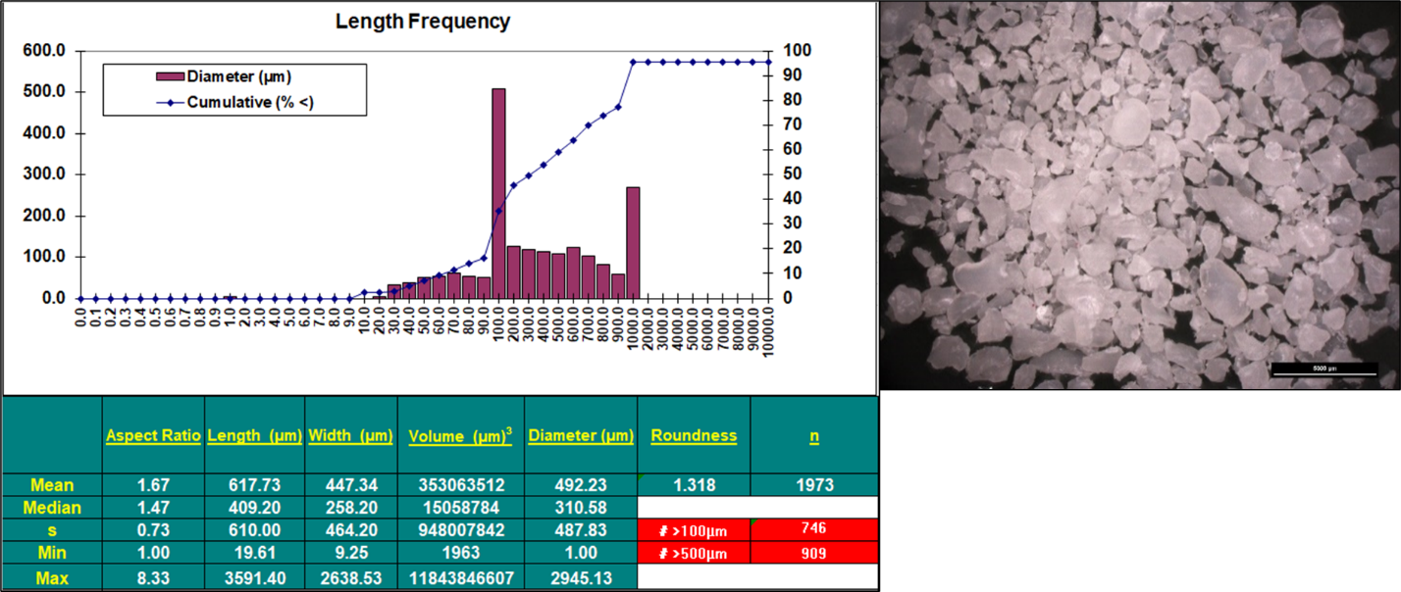

Figure S1a. PP virgin microplastics reference material analyzed by stereoscope microscopy. Particles were analyzed under reflected light (top) and size distributions and statistics based on image analysis of binary images (in red) are shown in Figure S1b.

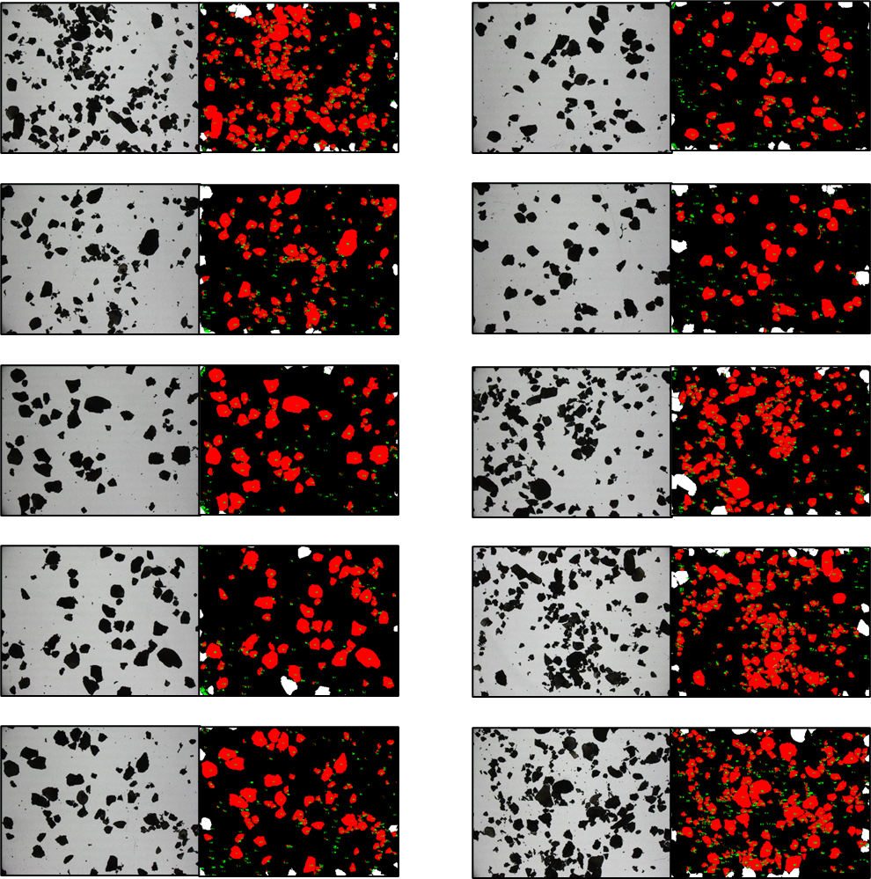

Figure S1b. PP virgin microplastics reference material analyzed by stereoscope microscopy. Ten field of view images of particles and corresponding binary images after watershed split (red).

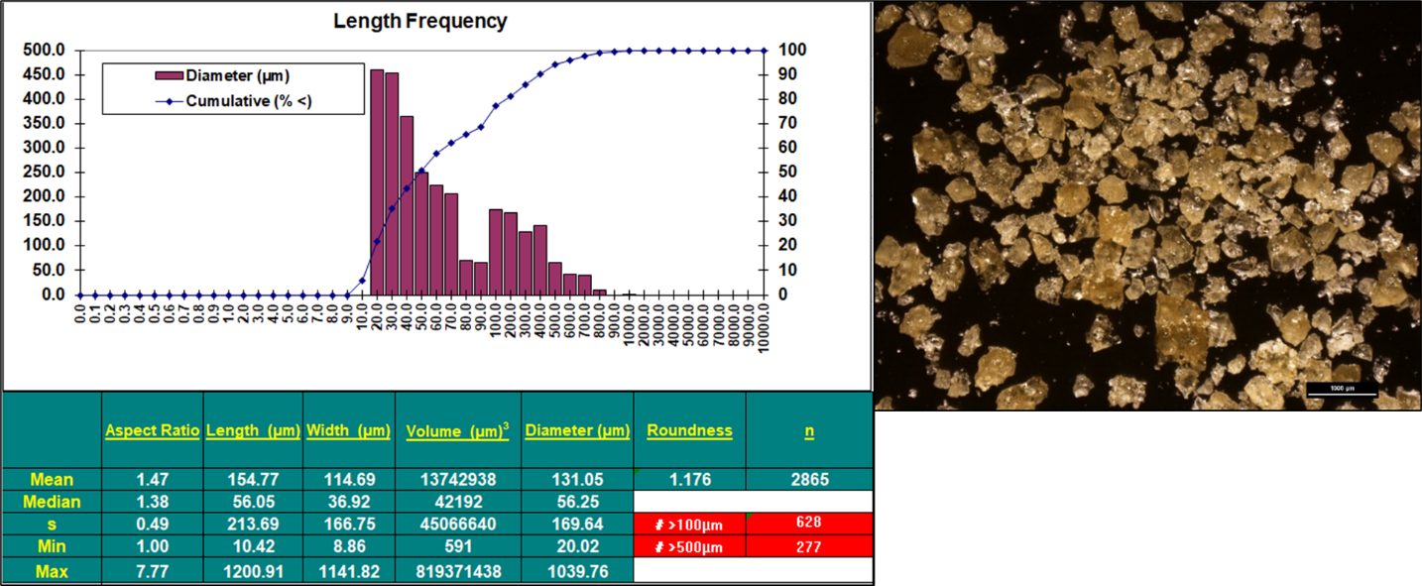
Figure S2a. PU virgin microplastics reference material analyzed by stereoscope microscopy. Particles under reflected light (top) and size distributions and statistics based on image analysis of binary images (in red) shown in Figure S2b.

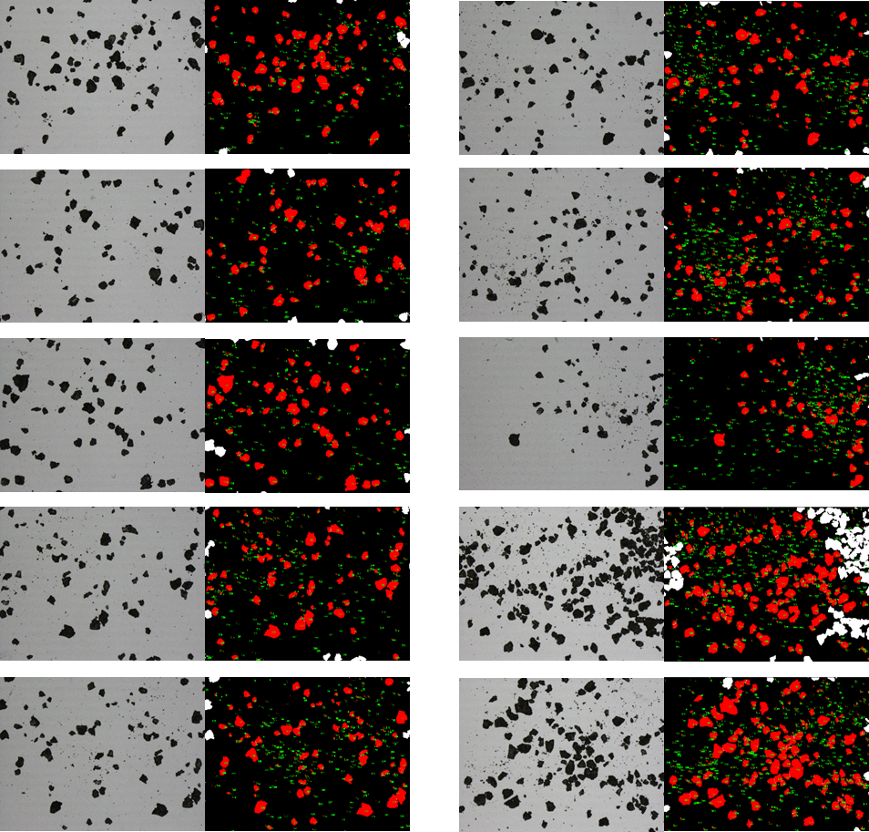
Figure S2b. PU virgin microplastics reference material analyzed by stereoscope microscopy. Ten field of view images of particles and corresponding binary images after watershed split (red).

Further Discussion on Particle Size in Sediment vs. Virgin Stock
To compare direct size measurements via light microscopy, the size distribution of virgin PU material was of mean 155 µm length, median 56 µm length, minimum of 10 µm length and a maximum of 1.2 mm. The hand-picked particles from the PU sample box ranged between < 100 µm in length to > 500 µm. Most particles were between 100 µm to 350 µm in length. Thus, with a small number of particles picked from sediment samples, these particle sizes are roughly representative of the sizes distributed throughout the stock material. From a qualitative perspective, we did not observe a heavy bias towards small or large particles settling in the sediment. However, it is important to note that particle picking can easily exclude particle sizes smaller than 50 µm, and therefore conclusions regarding the lowest size fraction of this material should not be generated.
In contrast, the virgin PP particles were determined to be mean length of 617 µm, median length 409 µm, min of 20 µm and max length of 3.6 mm. On average, the PP virgin stock material contained higher numbers of particles > 500 µm than the PU material.

Detailed Sample Extraction Methodology
Sample Preparation Materials
- Pyrex® Drying Dish, 90 x 50, no. 3180
- 150 ml glass beakers, cat. no. 10754-950 VWR™, and Pyrex® 150 ml glass beakers no. 1003
- 250 ml glass beakers, cat. no. 10536-390, VWR™
- Graduated glass pipettes, assorted sizes, VWR™
- Zinc chloride, anhydrous, free-flowing, RediDry reagent grade ≥ 98%, Sigma Aldrich®
- Ferrous sulfate • 7 H₂O, granular, Analytical Reagent, Mallinckrodt® AR
- Sodium thiosulfate, 99%, Aldrich®
- Metal sieve size no. 6 (3.35 mm, 0.123 inch mesh size) steel & brass, 6BS8H952164 USA Standard Testing; 8” diameter
- Alconox Alcojet® Detergent Powder
- Anodisc® Alumina Filters 47: 0.2 um pore size, 47 mm diameter
- Glass Filtration setup: 300 ml glass funnel, 1000 ml Ground Joint Flask, 47 mm spring clamp, 47 mm Glass Frit Funnel, Glasssco®
- 30% hydrogen peroxide, ACS Reagent, BDH® VWR Chemicals
- Nitrile gloves, Kimtech®
- Microbalance, Mettler Toledo® XPE205 with static detect
- Teflon™ magnetic stir bars, various sizes
- MColorpHast™ pH indicator strips, non-bleeding. pH 0-6.0. MilliporeSigma®
- 25% Sodium hydroxide, diluted with deionized water from 50% sodium hydroxide in aqueous, BDH® VWR Chemicals
- Deionized (DI) water, MilliQ® Filtration System, 18.2 MΩ
- Metal spatulas, various sizes. Metal forceps, various sizes. Teflon™ forceps to handle filters
- Diaphram vacuum, GAST® Model DOA-P704-AA
- Glass desiccator, 10” diameter
- Plastic desiccator with vacuum port, 9” diameter
- 60 mm glass petri dishes, various manufacturers
Additional detailed information on mesocosm samples and extraction methodology can be found in this section. Table S2 summarizes the total number of samples utilized for this study. Samples categorized as “no sediment” were virgin microplastics spiked into a beaker and run through the sample extraction process without the presence of sediment.

Table S2. Samples and Spiked Samples Extracted for this Study
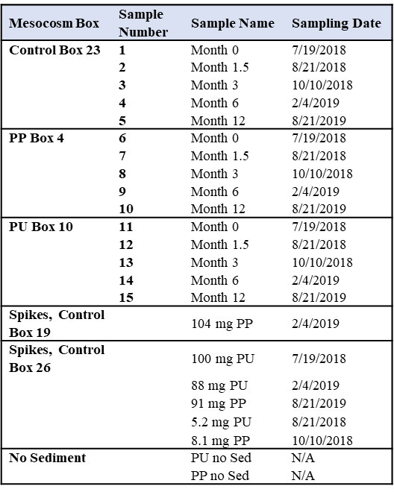
The following steps were conducted on mesocosm and lab-spiked samples to prepare sediment samples for quantitative analysis by pyrolysis GC/MS and stereoscope microscopy:
Spiked samples were generated by weighing out cryomilled virgin plastic stock and adding plastics directly to control box sediment vials. Control Box 19 and 26 vials were used for spikes. Spiked vials were stored for several days, either refrigerated or at room temperature before undergoing sample preparation. Mesocosm samples and spiked samples were extracted in the same manner.
Sample Preparation Precautions
Care was taken to reduce events of microplastic contamination as follows:
- A laboratory in a building with low dust levels was chosen to conduct experiments
- Alconox Alcojet® biodegradable / interference free soap was used to clean all glassware, washable equipment, and metal tools. Equipment was rinsed several times by tap water, followed deionized water. Depending on the nature of equipment, isopropanol was also used for rinsing prior to the addition of deionized water. No equipment or tools were dried using paper towels or other wipes. Glassware and metalware were dried in air under aluminum foil at either 51 °C in an oven or at room temperature.
- All tools and other equipment (glassware, pipettes, etc.) were stored underneath foil to reduce dust collection for the duration of the experiments. Aluminum foil was only removed minutes before using glassware/equipment/tools.
- Efforts were made to eliminate the use of plastic containers wherever possible. To store solvents and liquids, glass beakers and glass jars were used except for deionized water squeeze bottles.
- Only glass and metal implements were used during sample preparation excepting pipette bulbs on glass pipettes and Teflon® forceps which were used to handle delicate Anodisc® filters.
- Any containers with plastic lids were lined with aluminum foil prior to storing materials.
- Nitrile gloves were used to handle glassware and tools. Gloves were changed frequently whenever dust collection was observed.
- Bench tops and other surfaces were periodically cleaned and wiped down with deionized water and isopropanol to reduce dust collection. Dust levels were monitored by eye.
- Samples in-progress were stored long-term outside of the hood with aluminum foil covers to avoid contamination.
- The use of rubber was minimized to pipette bulbs and chemical carriers. The use of adhesives (marking tape, etc.) was minimized throughout the duration of experiments.
- A laminar flow bench / cabinet was not available, so sample preparation steps were conducted on a cleaned bench, excepting Fenton reactions, which were conducted in a chemical hood.
- Once filtered samples were completed, they were loosely covered with aluminum foil and dried in an oven at 51 °C. Filters were transferred to cleaned glass petri dishes and stored covered until quantitation.
- A single individual conducted all sample transfer steps as to not add additional human error into sample preparation.
The detailed Sample Preparation Method used follows:
- Quantitative transfer of field-collected sediment in vials to glass dishes
  - Pyrex® dishes were cleaned, dried, and transferred to a glass desiccator to remove residual water overnight. Dishes were weighed on an analytical microbalance after waiting for weights to stabilize.
  - Sediment sample vials were shaken by hand to loosen material and poured into the appropriately labeled Pyrex® dish.
  - A squirt bottle with DI water was used to remove residual contents of the sample vial along with a cleaned metal spatula.
  - The sample vials were repeatedly rinsed until visually clean. On occasion the use of metal forceps to remove rocks or other material was required. All tools used were also rinsed off with DI water into the Pyrex® dishes.
  - The resulting Pyrex® dish containing the sample and water rinse was covered loosely with aluminum foil and placed in an oven to dry for an average of 2.5 days at 51 °C.
  - Upon individual inspection for sample dryness, Pyrex® dishes were placed in a glass desiccator for 1+ days to complete drying. Sample weights were recorded only after the weights appeared stabilized when measured on the microbalance.

- Quantitative transfer of dried sediment samples to the first density gradient
  - Pre-prepared 33% zinc chloride solution in water was poured into a clean glass beaker and covered in foil. A glass pipette was used to transfer the solution. Small amounts of zinc chloride solution were added to the Pyrex® dish to rinse off the sides and bottom of the receptacle. A metal spatula was used to scrape the sides of the glass dish as needed. The sediment was stirred by hand inside the dish.
  - The resulting slurry, with repeated rinses, was poured over a metal sieve, size #6, which was set on top of a clean 150 ml low-form glass beaker.
  - After the quantitative transfer and rinsing of materials caught in the sieve, the slurry was mixed well in the beaker with a metal spatula (which was further rinsed off), and more zinc chloride solution was added to the beaker until a volume of approximately 110-125 ml was achieved.
  - The density gradient beaker was labeled, covered in foil, and sonicated for one hour.
  - The beaker was placed on the bench top, covered for as long as overnight until the following step.

- Application of vacuum to increase settling of organics in density gradients
  - Photographs of each of the density gradients were obtained. Foil coverings were removed and beakers (up to 7 at a time) were placed in a plastic desiccator with a vacuum port.
  - A vacuum was applied to samples (as much as 24 millibars of vacuum) for one to two hours at a time for a total of two hours.
  - The beakers were removed from the vacuum apparatus and re-covered with foil to sit overnight on a bench top.
  - Any remaining large, easily removed floating organics were removed by hand with the aid of metal forceps. The forceps were rinsed with zinc chloride solution back into the beaker, following particle picking. The transferred organics were examined by stereoscope microscopy to ensure no visually apparent microplastics were removed.

- Quantitative transfer of the microplastics and top layers of density gradients to new beakers
  - The top layers of each density gradient beaker were transferred to a clean, labeled 150 ml glass beaker by glass pipette and/or metal spoon as appropriate, transferring a total of 30 to 60 ml of the density gradient in the process.
  - Careful attention was paid to the sides of the density gradient beakers. DI water and/or zinc chloride solution was used to repeatedly rinse off the sides of beakers since the microplastics tended to stick to glass walls.
  - The transfer of the top layer of density gradient was repeated until:
    - The sides of glass were swept multiple times
    - Random pipetting in the center and multiple areas of the gradient surface was completed dozens of times
    - The reflection of light on the surface of the density gradient revealed no breaks in surface tension excepting obvious organics (e.g. grass fragment)
  - If the volume of liquid transferred was greater than 40 ml, then the beaker was covered and heated at 51 °C overnight in the oven to reduce the volume of water below 40 ml.

- Digestion of trace organic matrices with Fenton reaction
  - To digest remaining organics and biofilms, a Fenton reaction was conducted in each sample beaker. The Fenton reaction was conducted in batches for 3-5 samples at a time:
    - A cleaned Teflon stir bar was added to each beaker, followed by approximately 40 mg of ferrous sulfate.
    - The mixture was stirred at medium speeds until the ferrous sulfate dissolved.
    - Approx. 10 g of 30% hydrogen peroxide was added to each beaker, pouring slowly into the mixture.
    - Samples were reacted for approximately 30 minutes with stirring. At 30 minutes, the pH was checked using pH strips (rinsing off the strips into the beaker after measuring). The pH was adjusted to 4 using drops of sodium hydroxide solution at 10-20% strength.
    - Samples were stirred and reacted for a remaining 1.5 hours for a total of 2 h at full strength.
    - Approximately 0.375 g of sodium thiosulfate was added to each beaker to react out the hydrogen peroxide and reduce the pH
    - The beakers were left stirring for approx. 30 minutes at low pH
    - After 30 minutes, the pH was measured and adjusted again. For Control Box 23 samples, the pH was adjusted to pH 4. For all other samples, pH was adjusted to 4.5
    - The beakers were left stirring for a few hours, periodically checking pH to ensure the pH stabilized.

- Generation of a second density gradient
  - After the pH stabilized for the day, 33% zinc chloride solution was poured into the beakers to reach a total volume of 110 – 125 ml.
  - The stir speed was changed to low, and samples were left to stir overnight uncovered in hood.
  - The next day the pH was checked for each beaker again. If pH was < 4, additional NaOH was added to reach pH 4 with sample stirring.

- Allowance for inorganics to settle in density gradients
  - With the increase in pH, the formation of crystals occurred (Fenton sludge is common – and in this case we saw elements from Fenton sludge reacting with those of the zinc solution and oxygen). The beakers became cloudy. To allow the majority of Fenton sludge and crystals to settle, the beakers were covered in foil (beaker sides rinsed), and placed on the bench top to sit overnight.
  - By the next day the amount of suspended inorganics was highly reduced. However, in many cases the pH dropped again. As such, the pH was recorded.
  - Discretion was left to the analyst to determine the amount of time the microplastics could spend in the low pH/zinc chloride solutions vs. adjusting pH so all samples would be of the same final higher pH. Given that a drastic increase in inorganic solids was observed at pH >5, and keeping in mind the time for microplastic exposure to very low pHs should be minimized to avoid chemical damage, it was decided that the final samples may have varying low pHs, but must have minimal floating inorganics present before the samples could be transferred to filters.

- Quantitative transfer of chemically prepared microplastics and the top layers of the density gradients to the final filters
  - A clean glass vacuum filtration setup was assembled and connected to the diaphragm pump.
  - An Anodisc® filter was pre-weighed and clamped into the assembly.
  - The top layers of the density gradient along with microplastics were transferred to the Anodisc® filter in a similar manner to step #4.
  - Upon completion of the transfer, the Anodisc® filter was rinsed with DI water several times. Care was taken not to push microplastics into the sides of the glass apparatus.
  - The top portion of the apparatus (the cup) was removed. The bottom of this cup was rinsed off with DI water onto the Anodisc® filter for any materials that had stuck to the glass cup.
  - The glass frit portion with Anodisc® filter was removed from the apparatus, loosely covered in foil, and placed in the oven at 51 °C until the filter was fully dry.
  - After drying, the filter was weighed on a microbalance and transferred to clean 60 mm glass petri dishes for further analysis.

Representative Images of Samples Prepared by Preceding Instructions
The impact of gentle vacuum applied to samples (Step #3) is represented by photographs of PU Box 10 Samples below in Figure S3.
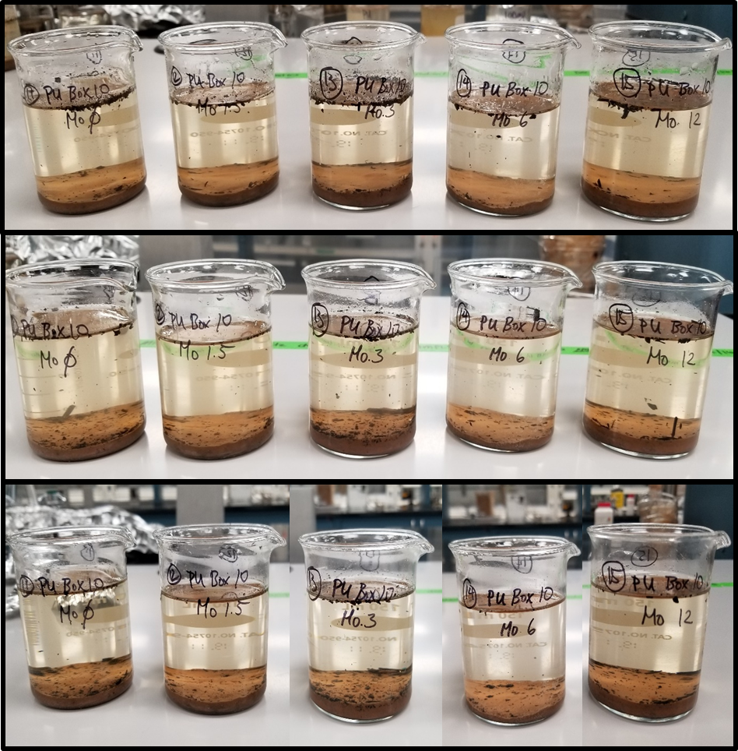
Figure S3. PU Box 10 samples in density gradients before (top row) immediately after vacuum application (middle row) and two days after vacuum (bottom) prior to Fenton digestion. A decrease in the number of floating “organics”, seen as black fragments floating on the top of liquid in the photographs, can be observed for each sample.
Representative photographs showing the final state of PU Box 10 Samples once filtered are found in Figure S4.
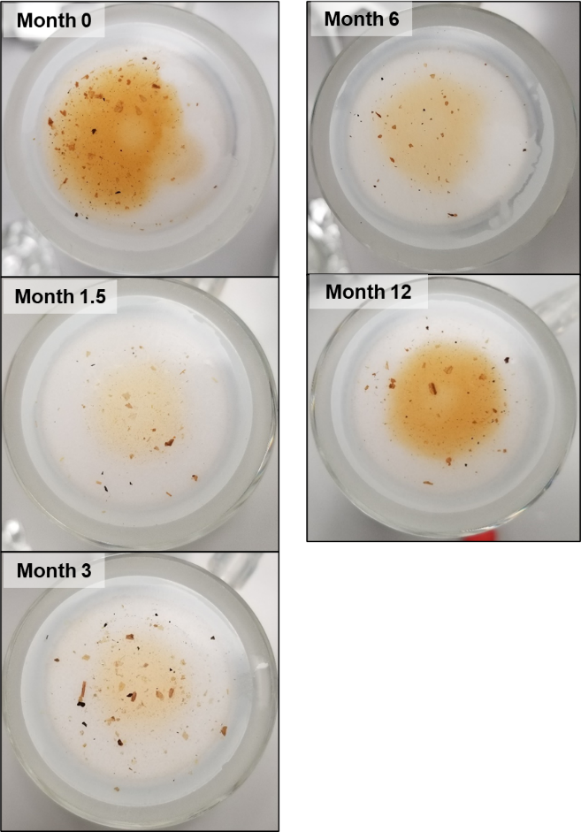
Figure S4. Isolated PU Box 10 samples collected at months 0, 1.5, 3, 6, and 12 through the mesocosm experiments after the final filtration step. The filter is still mounted on the filtration apparatus here.

Sample Preparation Statistics (Weights and Percent Recoveries)
Table S3 provides information on sample weights and spike recoveries for mesocosm samples and microplastic spike samples, respectively.

Table S3. Samples Prepared by the Outlined Extraction Procedure, with Respective Weights and Percent Recoveries as Appropriate.
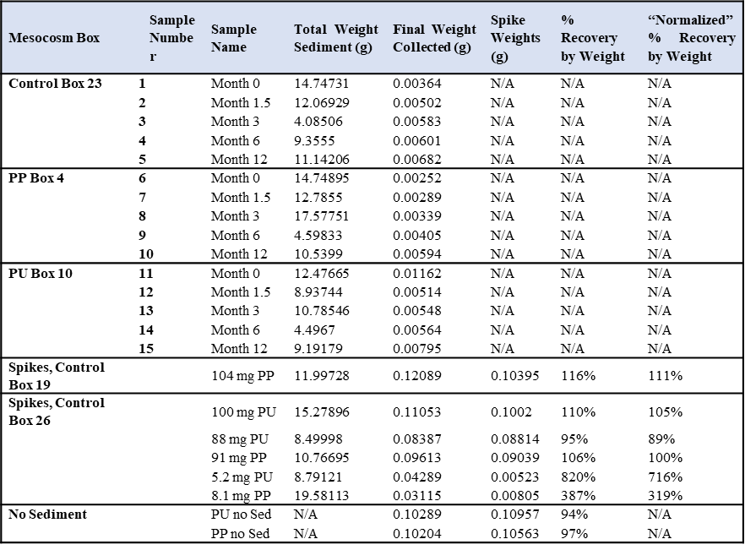

Details for the Method used to Crush Prepared Field Samples & Transfer Filter and Samples to Pyrolysis Cups (The Original Intended Method to Perform Quantitative Pyrolysis GC/MS)
A novel sample transfer method was used to quantitatively transfer filters and all contents stored in petri dishes into pyrolysis cups. The procedure was conducted by a microscopist with 30+ years of experience with handling microscopic samples. Briefly, filters and petri dish contents were temporarily added into glass vials, pulverized, and transferred to sample cups. No plastic instruments were used during this process. Careful attention was paid towards transferring any visible microplastics. Details for the transfer method are shown below in captions for representative images.
Materials
- Clear screw thread vials, Kimble Chase
- Petri dishes, various manufacturers
- Glass funnel
- Glass rod
- Metal tools
- Pyrolysis cups: Eco-Cup LF, Frontier Lab
Procedure
The Anodisc® filter, sample, and residuals were transferred into a glass funnel inside a glass vial with an opening large enough to accommodate the funnel. The funnel was covered with a glass petri dish to prevent friable material from escaping when using a glass rod to break the brittle filter. The glass rod was used to pulverize the Anodisc® and filtered contents via mortar and pestle. A metal spatula was used to transfer small amounts of ground sample to the steel pyrolysis capsule (inside a capsule holder inside the 2nd vial) via a glass pipette (seen protruding from the 2nd vial in Figure S5). The steel rod shown in the lower right of the right image had a diameter just smaller than the capsule opening and was used to pack the powder into the capsule. The materials and the transfer process are captured in Figure S5 and Figure S6. Percent recoveries by total weight for this transfer method are listed in Table S4 and Table S5.
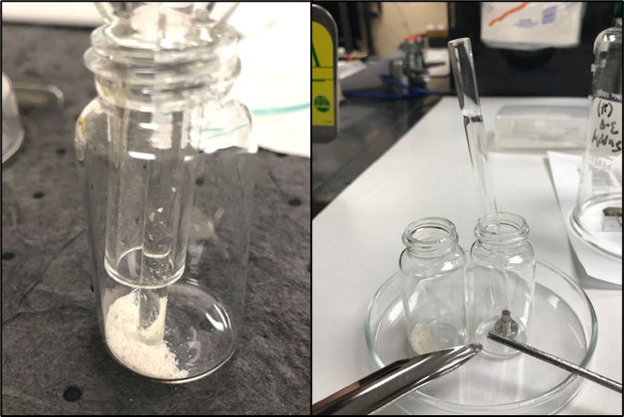
Figure S5. Anodisc® filter for Pyr-GCMS prep is crushed for transfer to pyrolysis vials. The Anodisc® filter and residuals in the glass funnel inside a glass vial (left). A metal spatula (lower left of right image) was used to transfer small amounts of ground sample to the pyrolysis capsule (inside a capsule holder inside the 2nd vial) via a glass pipette (seen protruding from the 2nd vial).

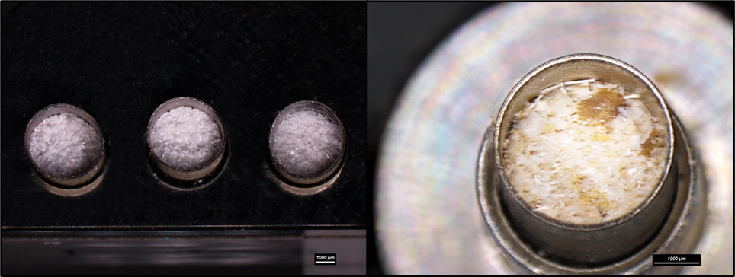
Figure S6. Images of a representative Anodisc® filter prepared for pyrolysis GC/MS analysis. A 47mm Anodisc filter filled 3 capsules approximately 85%. A 13mm Anodisc filter will fill a single capsule.
Table S4. Percent Recoveries from Sample Transfer by Weight for Polypropylene Samples
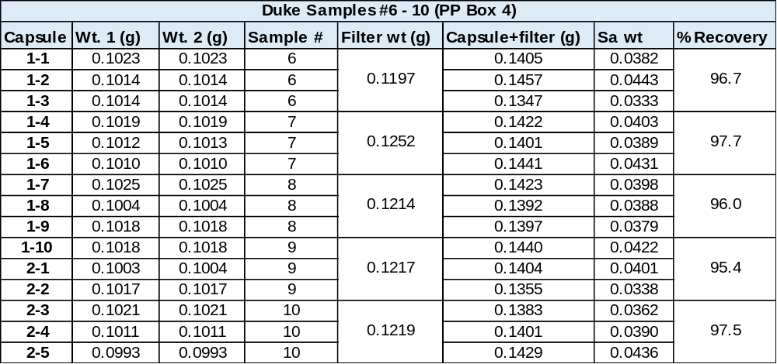
Table S5. Percent Recoveries from Sample transfer by Weight for Polyurethane Samples
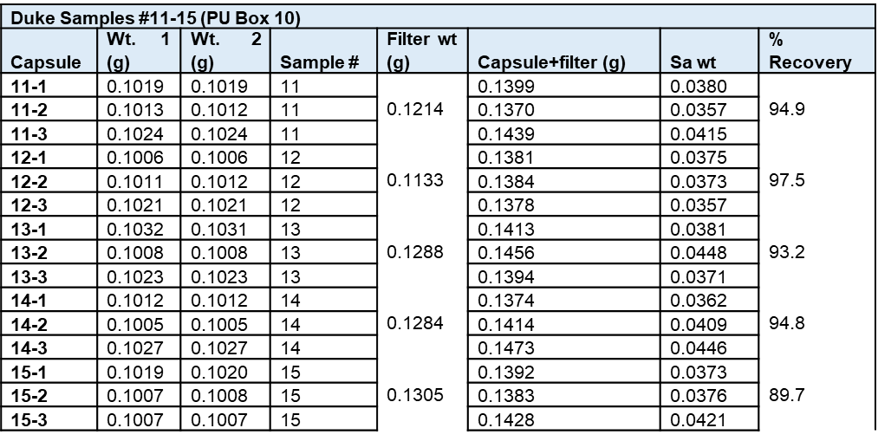

Details of the Buoyancy Extraction to Isolate Polyurethane Microplastics for Quantitation by Pyrolysis GC/MS
The separation of polyurethane microplastics from crushed Anodisc® filters and residual inorganic material was conducted prior to quantitation of samples by pyrolysis gas chromatography mass spectrometry due to pyrolysis complications from inorganic content (presumed acid) in the Anodisc® filters. The following procedure allowed for the microplastics to be isolated by bouyancy in an organic solvent and particle picked.

Materials
- 19x65mm clear screw thread vials, Kimble Chase
- Digital micropipette 20-200µl, Labsystems Finnpipette
- Micropipette tips, 200µl, VWR
- Chloroform, ≥99.8%, Sigma-Aldrich
- Pyrolysis cups: Eco-Cup LF, Frontier Lab

Procedure

- The crushed samples were transferred into glass vials inside a fume hood with the hood ventilation turned off to prevent sample loss.
- Chloroform was added to the vial until it was approximately ¾ full (about 15 ml).
- The vial was closed and gently agitated by hand. Care was taken for agitation to be gentle enough that chloroform did not touch the plastic lining inside the cap.
- A micropipette tip was cut at an angle so the opening was larger than expected largest microplastic size and attached to the micropipette.
- Microplastics were visually pipetted out at the 20µl setting. When the liquid drawing was complete, the analyst visually inspected for microplastics and released as much liquid as possible back into the vial without releasing the microplastics.
- The remaining liquid was discharged into a pyrolysis cup along with any microplastics. The pyrolysis cup was secured in aluminum foil on the bench top to prevent the cup from tipping over.
- This was repeated until all visible microplastics were pipetted out of the vial, waiting for evaporation to add more chloroform when the pyrolysis cup reached approximately 2/3 full.
- After visible microplastics were removed, random pipetting was conducted by drawing 50µl of chloroform from the surface of the vial’s contents and discharging this into the pyrolysis cup.
- Finally, a new pipette tip was used to draw clean chloroform and flush the used pipette tip to ensure any residual microplastics that may have been trapped in the original tip were transferred to the pyrolysis cup.

Quality Assurance and Quality Control
Percent recovery of the particle-picking method was calculated after conducting spike recovery experiments in triplicate using the procedure written above. PU particles were spiked by count from the 100 mg PU spike sample, along with crushed Anodisc® filter and inorganic material from the filters. Fifteen 30-800µm diameter PU microplastic particles were placed in each of three clean vials. Microplastic particles from each vial were recovered and placed into their respective pyrolysis cup. The samples were then imaged with a stereomicroscope to count the number of microplastic particles recovered. The recovery of vial 1 and vial 3 were 100%, with all 15 particles recovered and the recovery of vial 2 was 93.3% with 14 of the 15 particles recovered. The average recovery rate was therefore 97.78%. The images in Figure S7 show the recovered microplastic particles from the spike experiments.
In addition to the percent recovery tests, quality assurance tests were performed for transferring model crushed samples from a pyrolysis cup into a glass vial for the density gradient particle-picking method. It was found that overturning the pyrolysis cup contents into the vial, then tapping the pyrolysis cup into the vial, was sufficient to transfer all material. Visual inspection of the vial showed that all microplastics present in the pyrolysis cups were also present in the vial.

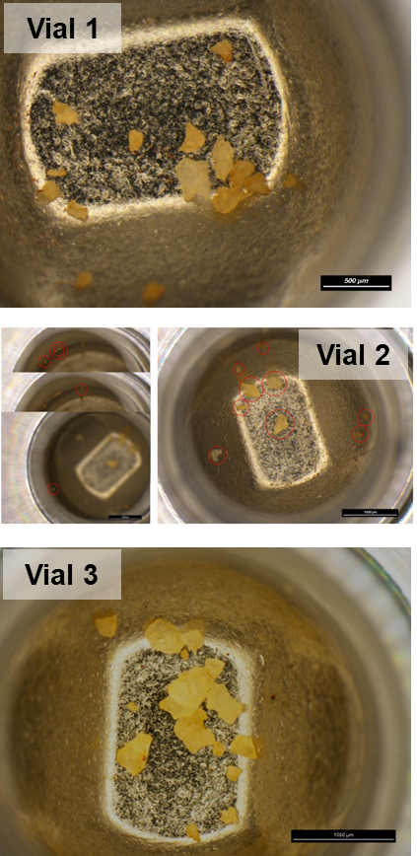
Figure S7. Representative images of particle picked PU microplastics for the three quality control test samples used to evaluate the particle bouyancy mathod.

Cryomilling Methodology to Generate Diluted Microplastics Standards
Pyrolysis GC/MS calibration standards were generated by adding virgin PU microplastics to calcium carbonate and cryomilling the mixtures. The cryomilling procedure was performed using a SpexPrep 6775 Freezer Mill with SPEX 6751 grinding vials (polycarbonate), impactors, and end plugs. The following program parameters were used:
Pre-cool time = 15 minutes
Run time = 5 minutes
Cool time = 5 minutes
Cycles =3
Rate = 15 CPS

Procedure
Each calibration stock standard mixture was cryomilled twice (the cryomill program was run twice). After the first program was run, the cryomill tube was allowed to heat up to room temperature and visually assessed. If material was trapped between the vial walls and the cap, the tube was manually opened and scraped with a metal tool to move any trapped material to the main section of the vial before the second round of cryomilling. Cryomilling vials, impactors, and plugs were cleaned using a washing procedure: Alconox® Alcojet solution was used, with scrubbing, to clean all parts. Parts were rinsed with tap water, followed by isopropanol, and finally DI water and left to air dry under aluminum foil. After cryomilling, contents of the vial were transferred, with scraping of the inside of the vials, to petri dishes that were cleaned in the same fashion as the tubes. The resulting power was further mixed by hand using metal tools, and then transferred to cleaned 5 ml glass vials for storage.

Sample Preparation Improvement Studies
Additional Sample Preparation Materials for Improved Extraction Methodology
- Sodium bromide, ACS Reagent, > 99%, Sigma Aldrich
- Sodium tungstate dihydrate, ACS Reagent, > 99%, Sigma Aldrich
- Sodium iodide, ACS Reagent, > 99.5%, Sigma Aldrich
- Calcium chloride anhydrous, Sigma Aldrich
- Anodisc® Alumina Filters 13: 0.2 um pore size, 13 mm diameter
Investigations on crystal formation in original samples
Fenton sludge from the samples was isolated, dried in air, and analyzed by SEM-EDS to determine elemental content (Figure S8). Interestingly, the crystals formed were determined to be zinc complexes with oxygen, sodium, chloride, iron, with small amounts of carbon present in the crystal structures. Elements aluminum (likely originating from the original sediment matrix), and sulfur were also present. The characteristic rose-like shape, combined with EDS results, confirms the inclusion of iron in many of these crystal structures. Crystal complexes studied were on the order of hundreds of microns in size and were slightly iridescent to the human eye. The large concentration of zinc, a transition metal, in the inorganic solids provided inspiration to explore density gradients without transition metals for the future. The exploration for improved sample preparation will be discussed in depth later.
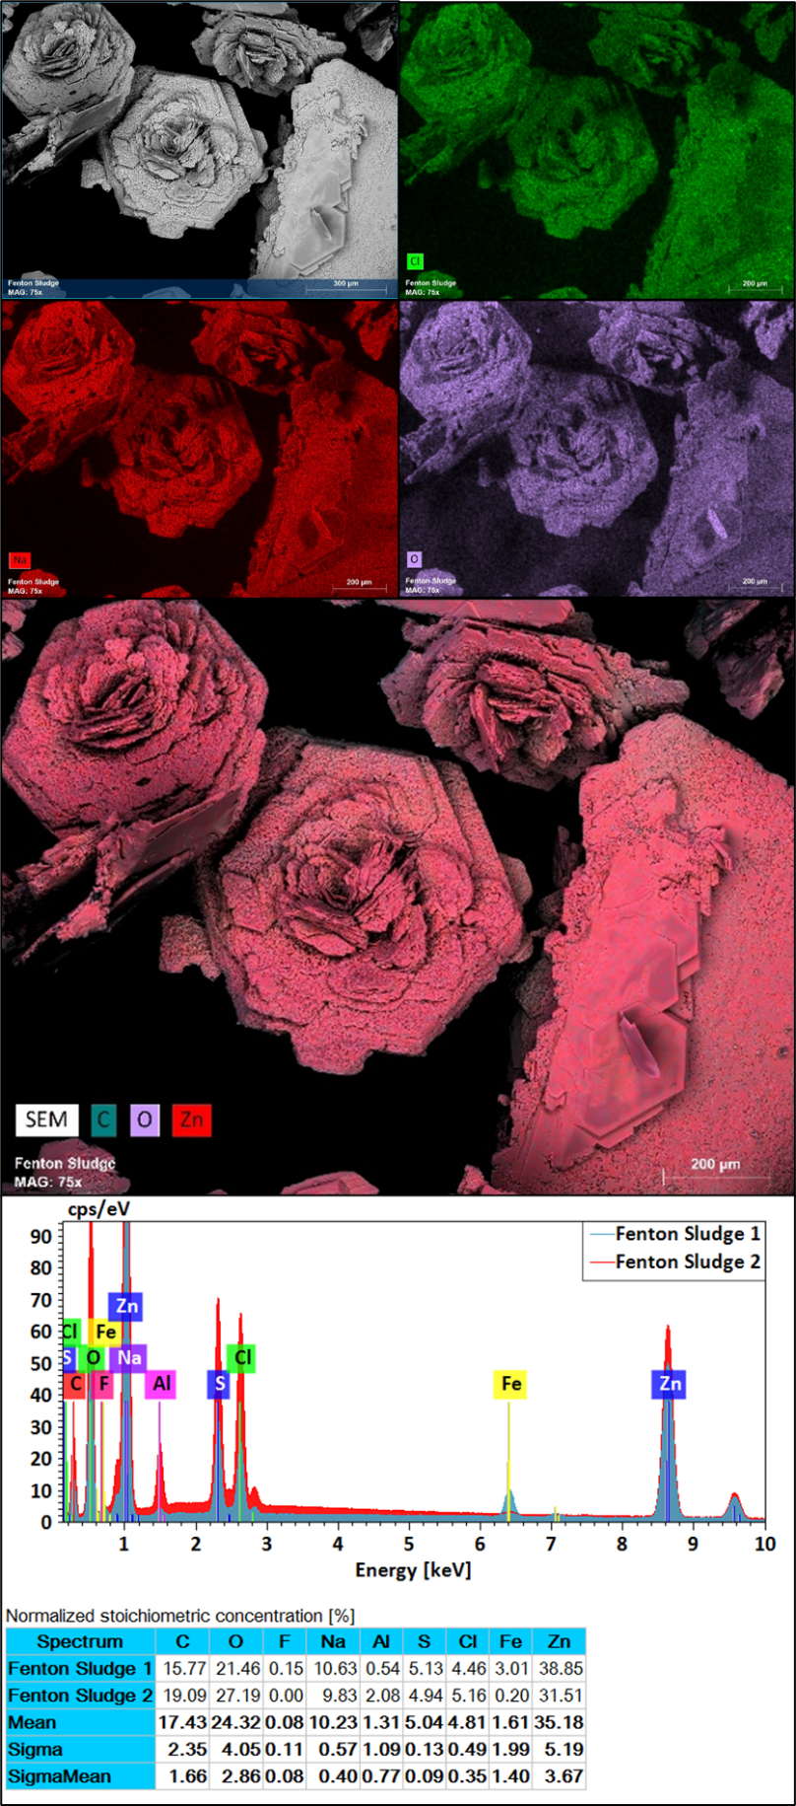
Figure S8. The zinc chloride “Fenton Sludge” crystals and corresponding SEM, x-ray maps and (semiquantitative) element identification.

As discussed in the main paper, systematic experiments were conducted to improve the sample preparation method for future extractions. Changes to density gradients and Fenton Reagent process were of particular interest. The following text summarizes additional information deemed useful during exploratory method development and final parameters for the optimized sample preparation conditions.
Optimized Methodology Changes
Overall Method Changes
Tested changes aimed to simplify the sample preparation process and improve reproducibility of the method. Overall, the improved sample preparation method steps can be outlined as follows:
- Quantitatively transfer a field sample to a Griffin beaker using DI water, sieving in the process
- Evaporate the water at 51 °C until the volume of water is at an acceptable level
- Conduct the Fenton reaction using weights below, adjust pH to 4 after 30 minutes, and let the sample react overnight
- Heat the sample for 30 minutes to quench the Fenton reaction
- Adjust the pH to 7 using sodium hydroxide; wait for the pH to remain stable over 1 hour
- Add a density gradient: quantitatively transfer the sample and Fenton sludge to a separatory funnel primed with density gradient of one’s choice
- Let the sample settle overnight and drain the solids from the separatory funnel
- Transfer remaining liquid and microplastics via dripping to a filter held in vacuum apparatus. Rinse the separatory funnel with excess density gradient solution and water (note that the more density gradient is added, the more likely inorganic solids would build up on an Anodisc® filter – consider sieve stacking or alternate filter types).

Brief Discussion on Use of Separatory Funnels
Separatory Funnels can allow for streamlining of density gradients. Additional density gradient solution could be added to a funnel after the Fenton sludge is removed through the bottom. The use of a separatory funnel also reduces human error and allows for the capture of the surface layer of the gradient on a filter with rinsing of the glassware. Previously, Fenton crystal issues, ergonomics, and sediment-plugged separatory funnels were problematic enough to prevent the use of this equipment. However, once these physical issues were optimized it was deemed beneficial to utilize the separatory funnel over siphoning off the supernatant of samples in beakers.

Density Gradients
Of the tested density gradients: sodium bromide, calcium chloride, sodium iodide, and sodium tungstate, the latter two density gradients appeared to generate the least amount of undesired inorganic contamination on the microplastics and filters. Noteably, sodium iodide, tungstate, and bromide did not appear to induce complex crystals or induce major crashing out of inorganics as observed with zinc chloride and calcium chloride. A density of 1.28 g/ml was used for comparative studies. This lower density was deemed to behave similarly in performance to > 1.4 g/ml solutions. The authors recommend minimizing the concentration of salt solutions wherever feasible.
Fenton Reaction
Alternate methods to quench the Fenton reaction were explored, including using heat. It was discovered that the Fenton reaction could be fully quenched by heating the samples at 50 °C for 60 minutes. In addition to fully quenching the Fenton reaction by using heat, and adjusting the pH to neutral after the reaction has completed, the quantity of Fenton reaction components (ferrous sulfate and 30% hydrogen peroxide) was adjusted to reduce the amount of residual organics remaining in the final sample. For the mock samples tested, an improved quantity of Fenton reaction components was: 8.6 g of 30% hydrogen peroxide, 34.4 g ferrous sulfate, and 7.1 ml of DI water added per 1 g of dried sediment.
Samples shown in Figure S9 were prepared at the optimized sample preparation conditions for density gradient and Fenton reaction concentrations. The formation of crystals was reduced compared to the case of zinc chloride, and the formation of new crystal complexes was not readily apparent. Sodium bromide appeared to more easily crust on microplastics during the final filtration steps than sodium iodide and sodium tungstate.
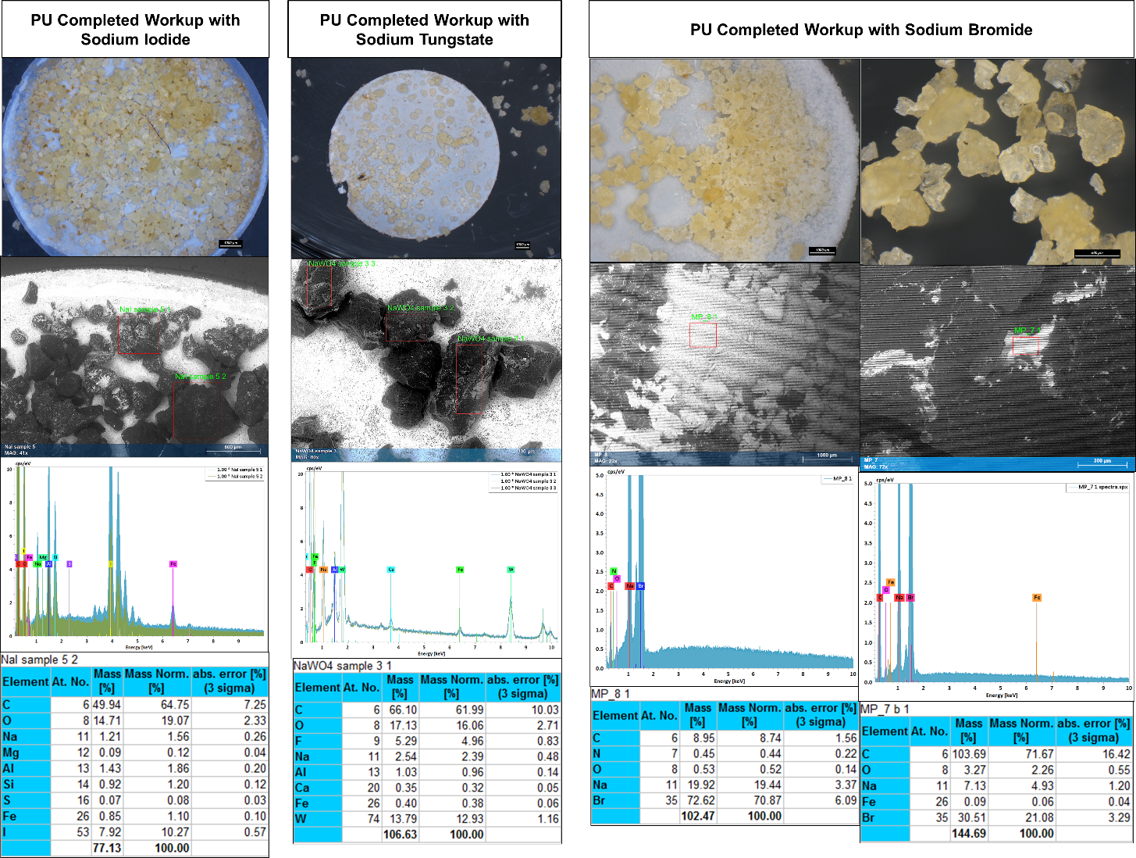
Figure S9. Additional representative images comparing PU microplastics prepared using sodium iodide, tungstate, or sodium bromide density gradients. (top row) stereomicroscope images of plastics and/or filters, (second row) SEM images of microplastics with inorganic solids (third and fourth row) EDS semi-quantitative results analyzing the respective areas boxed in red in the SEM images.
Calcium Chloride Experiments
Given that calcium chloride has fewer safety handling concerns and is significantly cheaper than zinc chloride, the use of calcium chloride in place of zinc chloride as a density gradient was investigated in combination with the original sample preparation procedure. An interesting trend was observed: a high-density gradient (around 1.4 g/ml) required high concentrations of calcium chloride in water and upon addition to the Fenton reaction, white solids would appear and float on the surface. If the pH was adjusted to increase acidity, the solution would turn yellow and yellow solids would crash out onto the beaker, tool, and filter surfaces.
SEM-EDS was used to characterize the solids that crashed out on the alumina filters (Figures S10a, S10b) and the collected particles that would crash out in the beakers at lower or higher pH (Figures S11a, S11b).
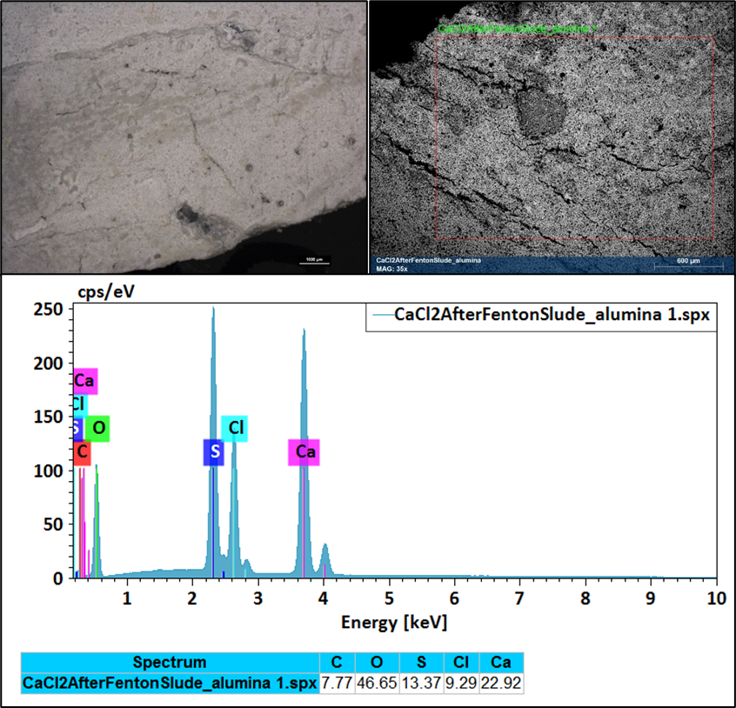
Figure 10a. Images and characterization of unknown inorganic film on alumina filter formed from using a calcium chloride density gradient after the Fenton reaction. Solids are under stereomicroscope view (top left), Variable Pressure SEM analysis via backscattering electron mode (VP-BSE) (top right) and EDS general scan (bottom). 20keV used.
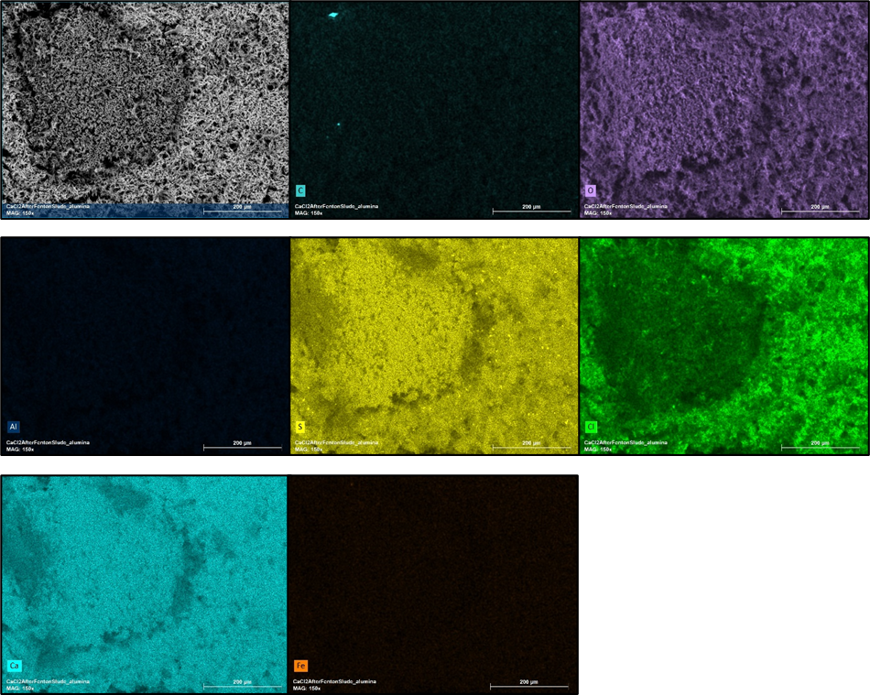
Figure S10b. Additional solids found after the Fenton reaction and calcium on alumina filter. X-ray dot maps show distribution of elements C, O (top row), Al, S, Cl (2nd row), Ca and Fe (bottom row). 150X magnification, 20keV used.
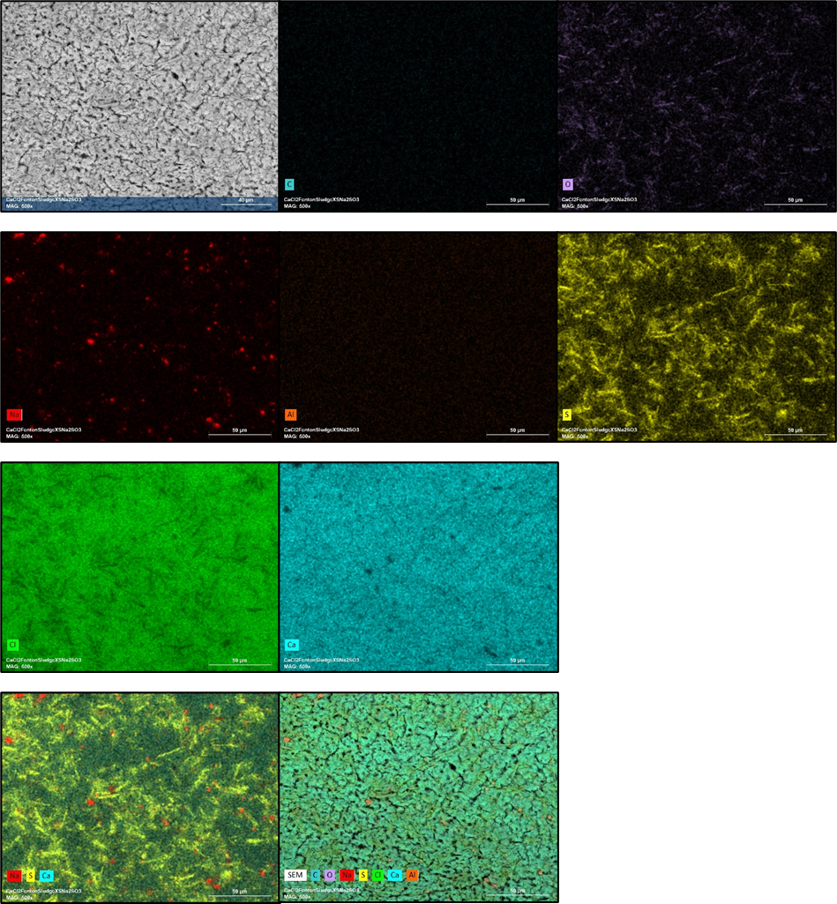
Figure 11a. Solids extracted from a beaker after the Fenton reaction and addition of calcium chloride, using excess sodium thiosulfate (to lower pH). X-ray dot maps show distribution of elements C, O (top row), Na, Al, S, (2nd row), Cl and Ca (3rd row) and Overlays (bottom row). 150X magnification, 20keV.
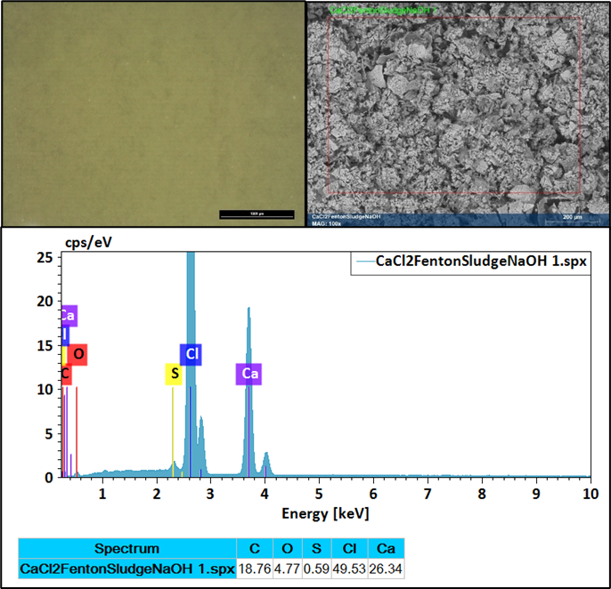
Figure 11b. Solids extracted from beaker after Fenton reaction and addition of calcium chloride, sodium hydroxide (for higher pH). Yellow solids were viewed under the stereomicroscope (top left) and VP-BSE image was obtained after vacuum-drying (top right). EDS showed mainly Ca and Cl with trace S. 20 keV.

In all cases (Figures S10-11) calcium and chloride remain the dominant elements in the solid materials. Sulfur and oxygen are also present to different degrees, indicating that these elements are integrated in formed solids. The presence of any available remaining oxygen (either in the form of peroxides or in other aqueous forms) from the Fenton reaction may have facilitated the formation of solid oxides. The solids that crashed out of solution could not be redissolved at higher or lower pHs, or with excess water added, providing additional evidence that new compounds were generated. For these very limited studies, no appropriate workaround was generated to reduce solids formation, including the dilution of the calcium chloride density gradient. The use of calcium chloride for a density gradient was not tested with the improved sample preparation method.

Inspection of Polypropylene Mesocosm Samples for Microplastics and Confirmation of Lack of Plastic Particles
To determine if the lack of visible polypropylene microplastics counted on Anodisc® filters was accurate, crushed prepared PP mesocosm field samples were transferred from pyrolysis cups and underwent the same chloroform density gradient procedure as the PU mesocosm samples, excepting that an increased volume of the supernatant from the density gradient was then transferred to cleaned petri dishes for imaging. This procedure included particle picking any suspicious particles. This procedure was repeated for a blank sample, using only the transfer of chloroform to a vial and further transferring the solution to a clean petri dish. Representative stereoscope images are shown below in Figure S12. No microplastics were identified by stereoscope microscopy, but select suspicious particles were picked to analyze by SEM-EDS. Representative results are shown in Figure S13. All suspicious particles were determined to be of natural origin and/or of inorganic content.
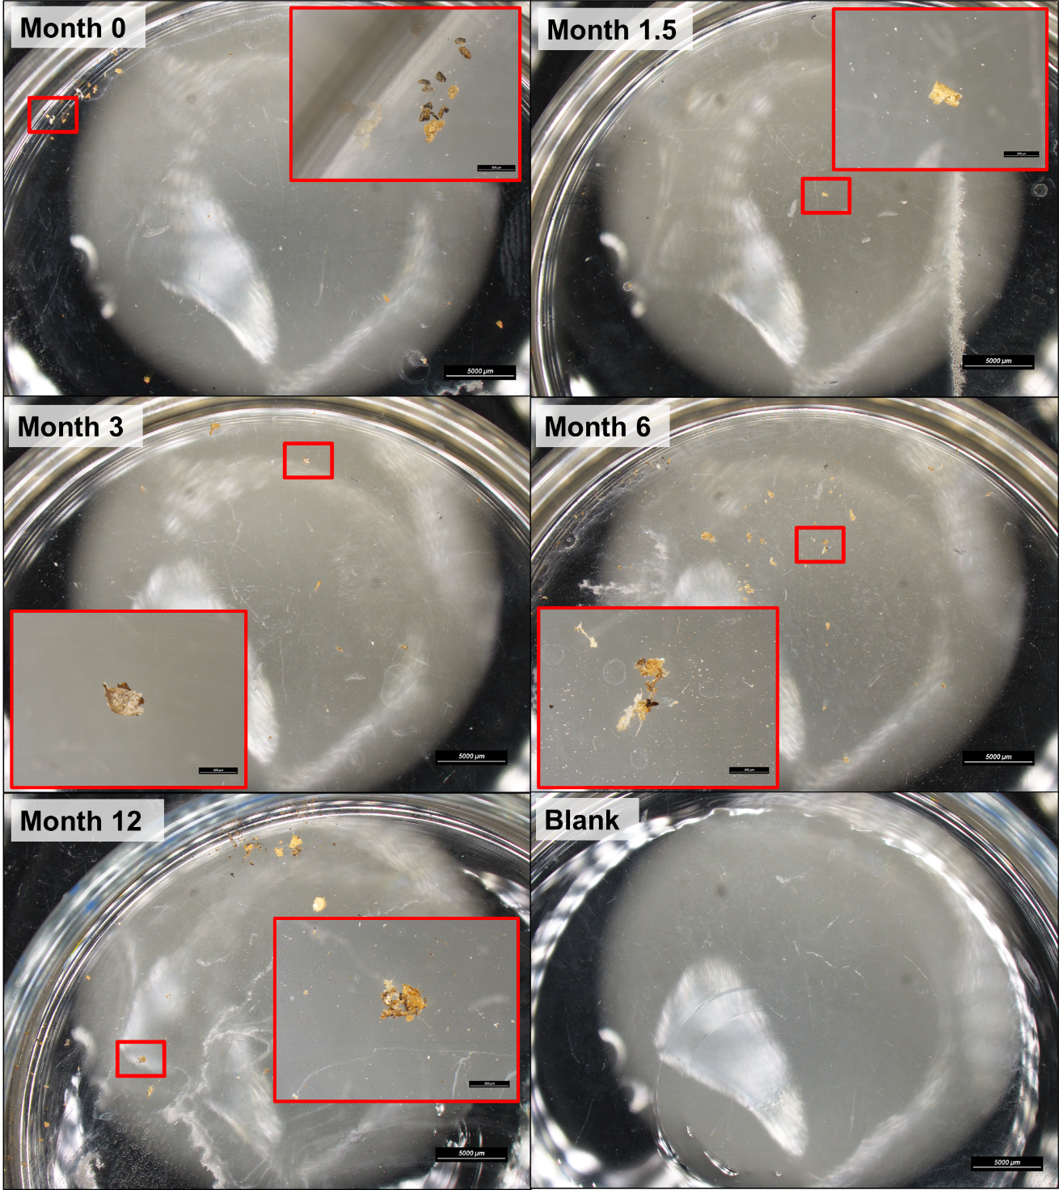
Figure S12. Representative stereoscope images of particles picked from PP mesocosm samples for further analysis by stereoscope microscopy, plus a representative image of the laboratory blank sample.

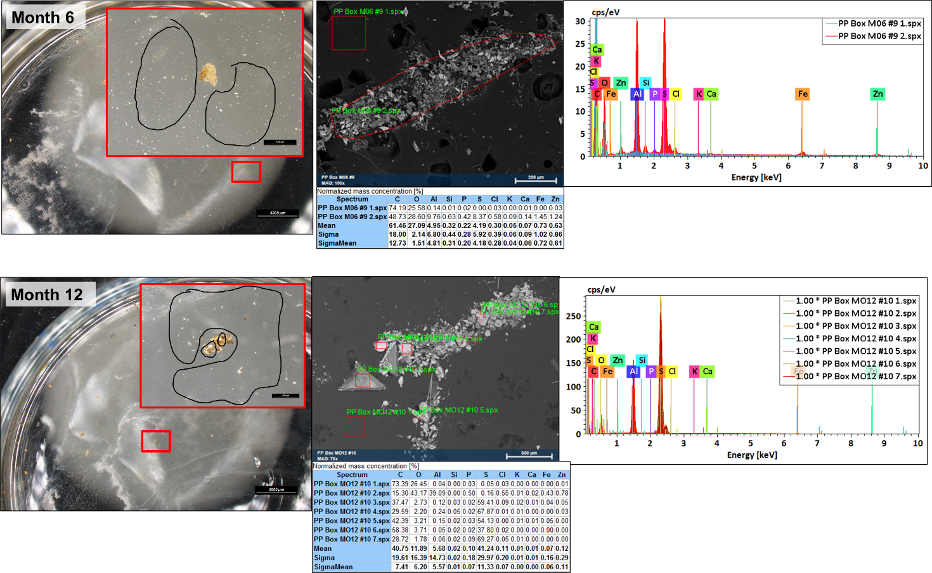
Figure S13. Representative SEM EDS results on suspicious particles demonstrate that the particles could not be confirmed as non-anthropogenic in nature.

Supplemental Information for Pyrolysis GC/MS Experiments

Materials
- Calcium carbonate, ≥ 99.0%, powder, ACS Reagent, Sigma Aldrich
- Quartz reaction disks, Frontier Laboratories
Qualitative Results
An evolved gas analysis (EGA) was performed on the PP and PU virgin model microplastics to determine the optimum analytical parameters for pyrolysis. The instrument employed for EGA consisted of a Frontier 3030D Pyrolyzer on an Agilent 7890 gas chromatograph with an Agilent 5977A mass spectrometer. A deactivated tube was used in place of an analytical column to facilitate direct transfer to the mass spectrometer. The temperature of the sample was ramped from 100°C to 800°C in the pyrolyzer, and the evolved gas was analyzed as it was generated using a plot of mass spec detector response versus temperature.
Thermograms are shown in Figures S14 and S15. The EGA thermogram for the PU virgin model microplastics was analyzed to determine the bulk chemistry of the material, and it was found to be consistent with polyester polyurethane. Mass ion m/z=198 was extracted to determine the temperature range at which MDA evolved. A pyrolysis temperature of 600°C appeared sufficient for completely pyrolyzing the sample for quantitative analysis, and this temperature was chosen for subsequent experiments with pyrolysis GC/MS using mass ion m/z=198 as the quant ion.
Similarly, the EGA thermogram for the PP virgin model microplastics was analyzed to characterize its bulk chemistry, and it was ion extracted for mass ion m/z=126 to determine the temperature range at which the PP trimer polypropylene trimer 2,4-dimethyl-1-heptene evolved. A composite mass spectrum for the first peak of the thermogram was consistent with polypropylene. The second, later evolving peak was hydrocarbon-like, and the combined results suggest the material is a thermoplastic olefin. A pyrolysis temperature of 600°C appeared sufficient to pyrolyze most of the PP trimer, but subsequent runs exhibited sample carry-over. A pyrolysis temperature of 800°C was shown to fully pyrolyze the sample. We did not proceed with quantitative pyrolysis GC/MS method development for this PP model microplastic because it was not recovered from spiked sediment following the sample preparation procedure.

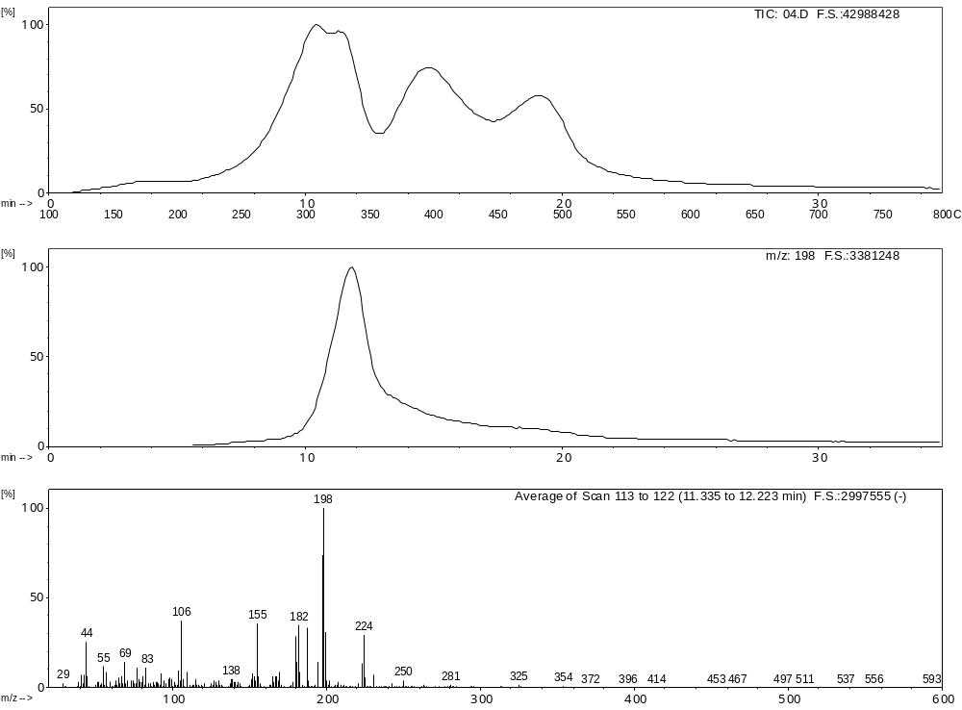
Figure S14. Evolved Gas Analysis (EGA) Thermogram of PU Virgin Model Microplastic.

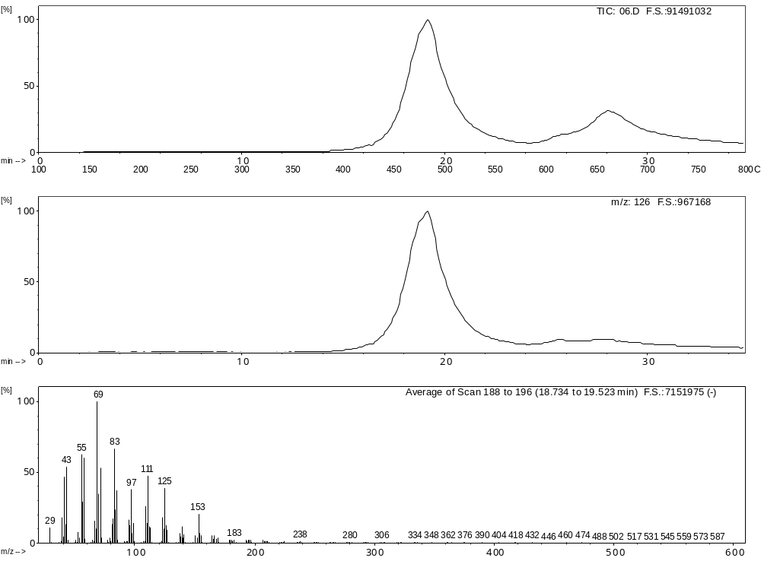
Figure S15. Evolved Gas Analysis (EGA) Thermogram of PP Virgin Model Microplastic.

The instrument employed for pyrolysis GC/MS consisted of an Agilent 7890B gas chromatograph and an Agilent 5977A mass spectrometer equipped with a Frontier 3030D pyrolyzer. Conventional pyrolysis was performed at 600 °C for 1 minute, while holding the interface temperature at 300 ºC. The carrier gas was helium (99.999% purity) at a flow rate of 1.2 mL/min, and the injection was split 100:1. An Agilent HP-5MS® ultra-inert capillary column (30 m long, 250 μm ID, 0.25 μm film thickness) was employed for separation of sample pyrolyzates. The GC inlet temperature was 320 °C. The GC oven temperature was programmed from 40 °C and held for 2 min, subsequently ramped at 20 °C/min to 320 °C, and then held at the maximum temperature for 13 min. The mass spectrometer transfer line was kept at 320 °C. The ion source was held at 230 °C, and the EM volts were 1290. Electron ionization (EI) mass spectra were recorded in the range of m/z 29-650 in SIM/Scan mode, selected ion monitoring for mass ions m/z = 106, m/z = 182, m/z = 197, and m/z=198 for ions specific to PU and PP fragmentation.
Figure S16 shows stacked pyrograms of PP and PU virgin model microplastics versus microplastic particles exposed to the chemical preparation process, using similar sample weights (0.2mg) for a semi-quantitative comparison. Figure S17 shows stacked pyrograms of PP and PU microplastic particles exposed to the chemical preparation process versus particles spiked in sediment and run through the entire sample preparation method, using similar sample weights (0.2mg) for a semi-quantitative comparison. The variation seen in total abundance can be attributed to typical variance when weighing small sample masses with an analytical balance. Differences were not observed in the nature and relative abundance of the pyrolyzates involved in quantitation. These results indicate that there were no major chemical changes to the PP and PU microplastics during the sample preparation process, nor from the limited exposure to the sediment.
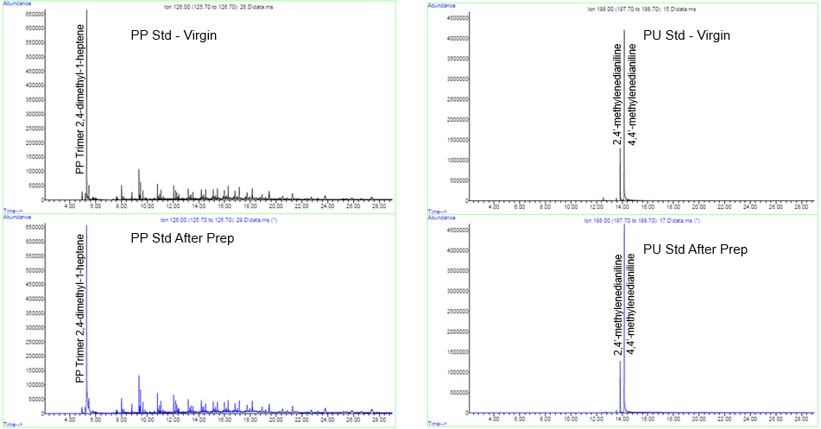
Figure S16. – Quant Ions Before and After Sample Prep Procedure Showing No Effect
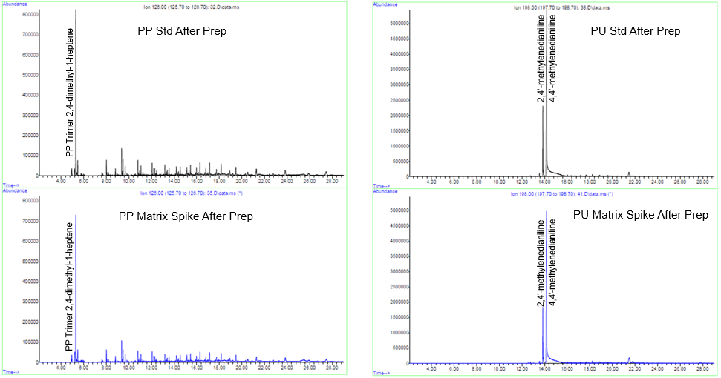
Figure S17. Quant Ions Before and After Matrix Spike Showing No Effect

Polypropylene trimer 2,4-dimethyl-1-heptene (m/z=126 at 5.31 minutes) was chosen for quantitation of PP by pyrolysis because of its relative abundance in the pyrogram for virgin PP. However, isomerization of the polypropylene trimer was seen when alumina was pyrolyzed with PP, and the 2,3-dimethyl-2-heptene (m/z=126 at 5.23 minutes) became the most abundant isomer generated. A distribution of peaks containing m/z=126 spectrally similar to these two isomers was observed in the retention time range from approximately 5-6 minutes. The generation of the second isomer proved to be reproducible, with consistent ion ratios between the main peak and its isomer, but further work would need to be done to validate a quantitation method involving the summation of these two peaks to account for the isomerization effect when analyzing microplastics on Anodisc® filters.
Alumina exhibited a significant reactivity towards MDI in the PU sample, and a quantitative conversion to MDA was observed. This result indicates that the hydrolysis of MDI during pyrolysis is mainly caused by the surface hydroxy groups of alumina. For PU analysis, we aimed to quantify the amine ion, pending full conversion of isocyanate groups to amine groups. Moreover, the quantitation of the amine ensures better accounting of the PU microplastic considering some of the isocyanate groups undergo hydrolysis conversion to amine from environmental factors.

Supplementary Information on Quantitative Results for PU
To prepare calibration standards, PU was cryo-milled with powdered calcium carbonate. Two stock standards were generated – the first at a 1:100 ratio of PU to calcium carbonate by weight, and the second an aliquot of the first stock standard was used to generate a 1 in 10,000 concentration of PU in calcium carbonate. The stock standards were then used to prepare calibration standards in the weight range from 0.0005 mg to 0.0799 mg of PU. Resulting calibration curves had a coefficient of determination ranging from 0.987 to 0.993. Figure S18 show the calibration curves used for quantitation of PU model microplastics by pyrolysis GC/MS for this project.
Seven replicate measurements of a calibration standard had a relative standard deviation of 3.9%. This is a measure of the reproducibility of measurements made on virgin PU samples of similar concentration that have been cryo-milled with calcium carbonate. This method would be the preferred method for sample homogenization and subsampling following the sample preparation procedure if the amount of microplastics isolated is sufficient. However, due to the low amounts of microplastics isolated from the sediment, this procedure was not feasible. The microplastics were instead particle picked following sample preparation, added to the pyrolysis sample cup, and then calcium carbonate was weighed into the cup. After determining that the average mass accuracy of spiked samples following this procedure was 96.7% with 8.3% relative standard deviation, we repeated the mass accuracy analysis using virgin model PU microplastics to determine the contribution of the sample preparation to the high %RSD for the method. Table S6 shows the results for the virgin PU, which had a %RSD of 8.7%, not including the outlier. This shows that the relatively high %RSD in the sample spikes was not likely associated with residual matrix and/or sample preparation reagents and is mostly associated with variation from the ultramicrobalance given that replicates of the calibration standard measured on an analytical balance did not exhibit as much variation. The fact that the Reproducibility Test 6 sample is an outlier exemplifies the need for replicate measurements when measuring samples using this technique.
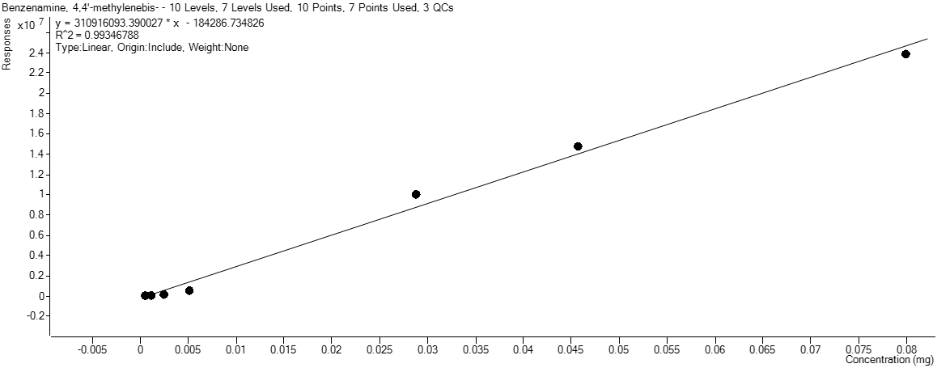
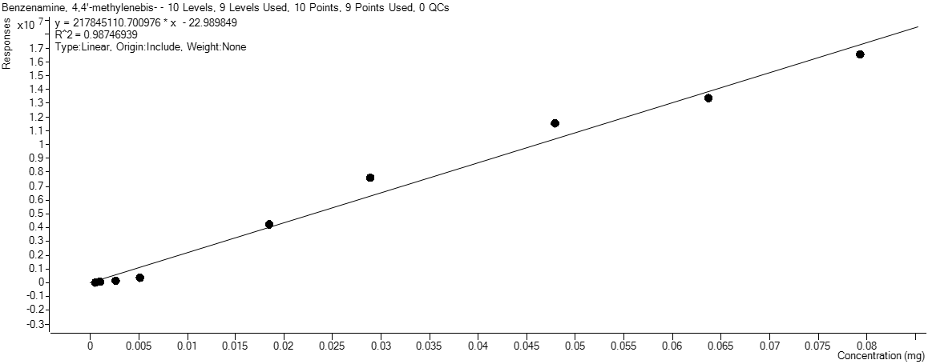
Figure S18. Calibration Curves used for PU Microplastic Quantitation by GC/MS

Table S6. Method Reproducibility Study on Virgin PU Microplastics
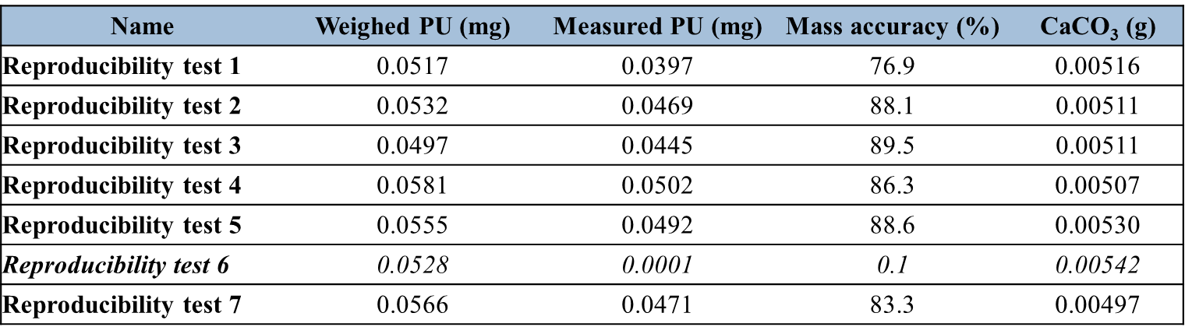
Demonstration of Successful Pyrolysis of PU Sample using Improved Samples Preparation Method with NaI Gradient
As discussed in the main paper, after running PU plastic and a 13 mm Anodisc® filter through the entire improved sample preparation process using the sodium iodide the plastic and the filter were crushed together and pyrolyzed. Figure S19 shows an extracted ion pyrogram for m/z=198, which reveals that the MDA functional group remains intact during pyrolysis of samples with Anodisc®, and quantitation can be performed using py GC/MS following the sodium iodide gradient.
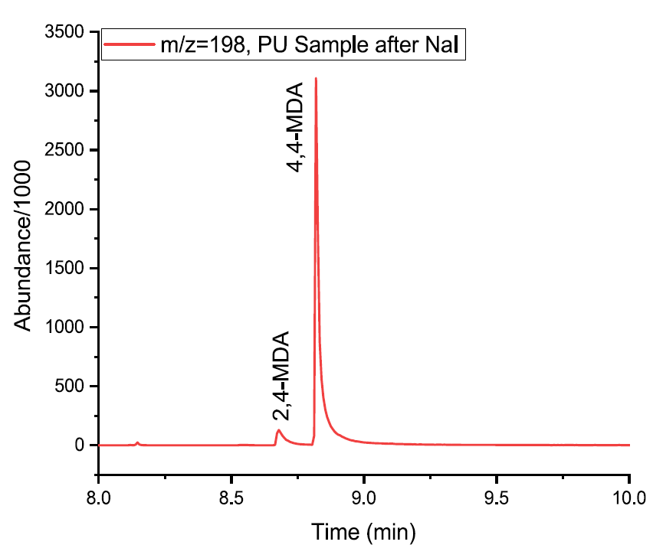
Figure S19. Pyrogram of PU sample with crushed 13 mm filter after NaI density gradient showing 4,4ʹ MDA Recovery

Supplemental Information on Sediment Leachables Studies
The following data demonstrates the qualitative analysis of model microplastic-associated molecules in mesocosm sediment by HPLC/HR-MS, using specific chemicals as markers. As mentioned in the main paper, no evidence of 3-cyano-4-methoxy-N-methyl-2-pyridone was found in control box samples as seen in Figure S20.

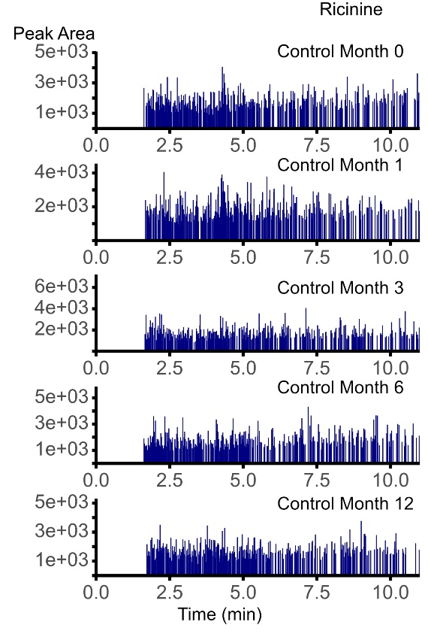
Figure S20. HPLC/HR-MS on leachables solution obtained from select sediment samples
Interestingly, ions associated with Bis(2,2,6,6-tetramethyl-4-piperidinyl)sebacate and 2,2,6,6-Tetramethyl-4-piperidinol (TMPO) were observed in every sample, including sediment controls, after the sediment extraction process was conducted. Therefore, no conclusions could be generated regarding the presence or lack thereof of compounds associated with polypropylene located in sediment. (Table S7)

Table S7. Bis(2,2,6,6-tetramethyl-4-piperidinyl)sebacate (m/z 241.35) was detected in all samples including the control boxes. The single-charged m/z ion was undetected in the PP spiked into sediment at 10, 50 and 100 mg and the PP sediment samples grabbed from the mesocosm (data not shown). TMPO (m/z 158.2) was detected in all samples including the control boxes.
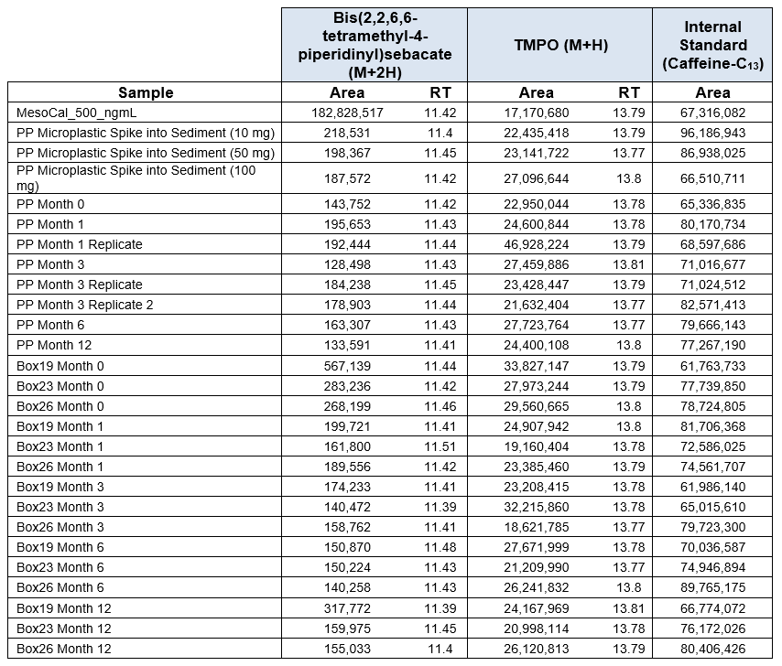

Table S8. Analytes used as surrogate, internal and target standards.
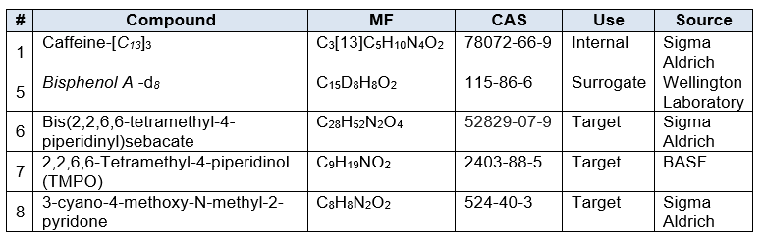

Table S9. Percent surrogate recovery from 200 ng BPA-d₈ /mL of spiked into sediment and internal standard performance of 100 ng Caffeine-C₁₃/mL of extract.
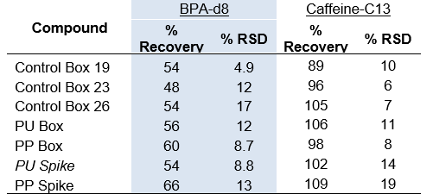

pH and Carbon Measurements of Mesocosm Sediments
The pH of several additional samples of frozen mesocosm sediment was obtained after completing all other experiments by BASF. One pH value was obtained from several combined sediment samples in vials from a “control box” mesocosm. Method ISO 10390 was used to obtain the pH value. The effects of carbon dioxide absorption on the pH measurement were avoided by using boiled distilled water cooled to room temperature under nitrogen and performing the pH measurement under flowing nitrogen gas. The pH of the mesocosm sediment was determined to be 5.89. As previously discussed, the composition of the sediment consisted of sand, pebbles, clay, dirt, and other organic components accumulated from the mesocosm itself. The original composition of the sediment was 30% sandhills soil, 45% fill soil, and 25% topsoil and soils were obtained from Sand and Soils in Durham, NC. The DOC (dissolved organic carbon in mg/L) of the different soils vastly differed over years from 2015 – 202 and between soil types. Values varied from 5.23 to 110.05 mg/L. The percent OC (organic carbon) of air-dried soil types varied from 0.85% to 1.68%.
At this time, we are not generating major conclusions regarding the pH of the soil and the affinity of leachable molecules to be sequestered by the mesocosm sediment. It is reasonable to expect, given the water pH of 7- 10 and a more acidic pH for sediment with low carbon content, that some polar leachable molecules may have a greater affinity for the sediment than the water. But due to the poor percent recoveries from sediment for the relatively non-polar BPA in our surrogate spike studies, we cannot extrapolate our findings to potential trends. Of our two surrogate molecules, the polar caffeine molecule was observed to be extracted more efficiently than the non-polar BPA molecule (Table S8).

