Supplementary Material

Status quo of operation procedures for soil sampling to analyze microplastics

Kristof Dorau*¹, Martin Hoppe¹, Jan Köser¹, Georg Scheeder¹, Daniel Rückamp¹, Katrin Scholz², Elke Fries¹

¹ Federal Institute for Geosciences and Natural Resources (BGR), Stilleweg 2, 30655 Hannover, Germany
² German Environment Agency (UBA), Wörlitzer Platz 1, 06844 Dessau-Roßlau, Germany

*Corresponding author: Kristof.Dorau@bgr.de

Figures: 5
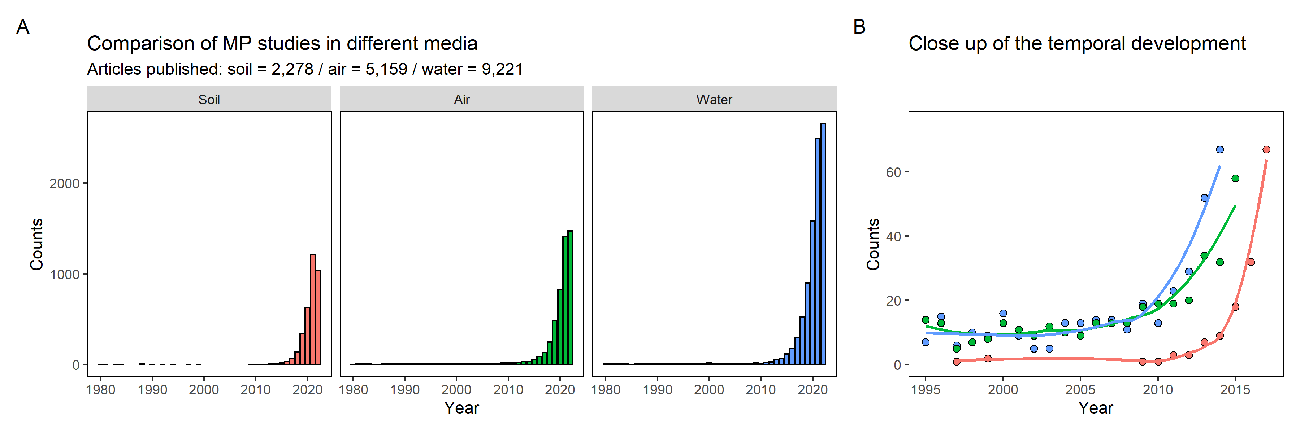

Figure S1
Articles per year addressing MPs research for the media soil, air, and water (A) and magnification of the development trend over time (B).
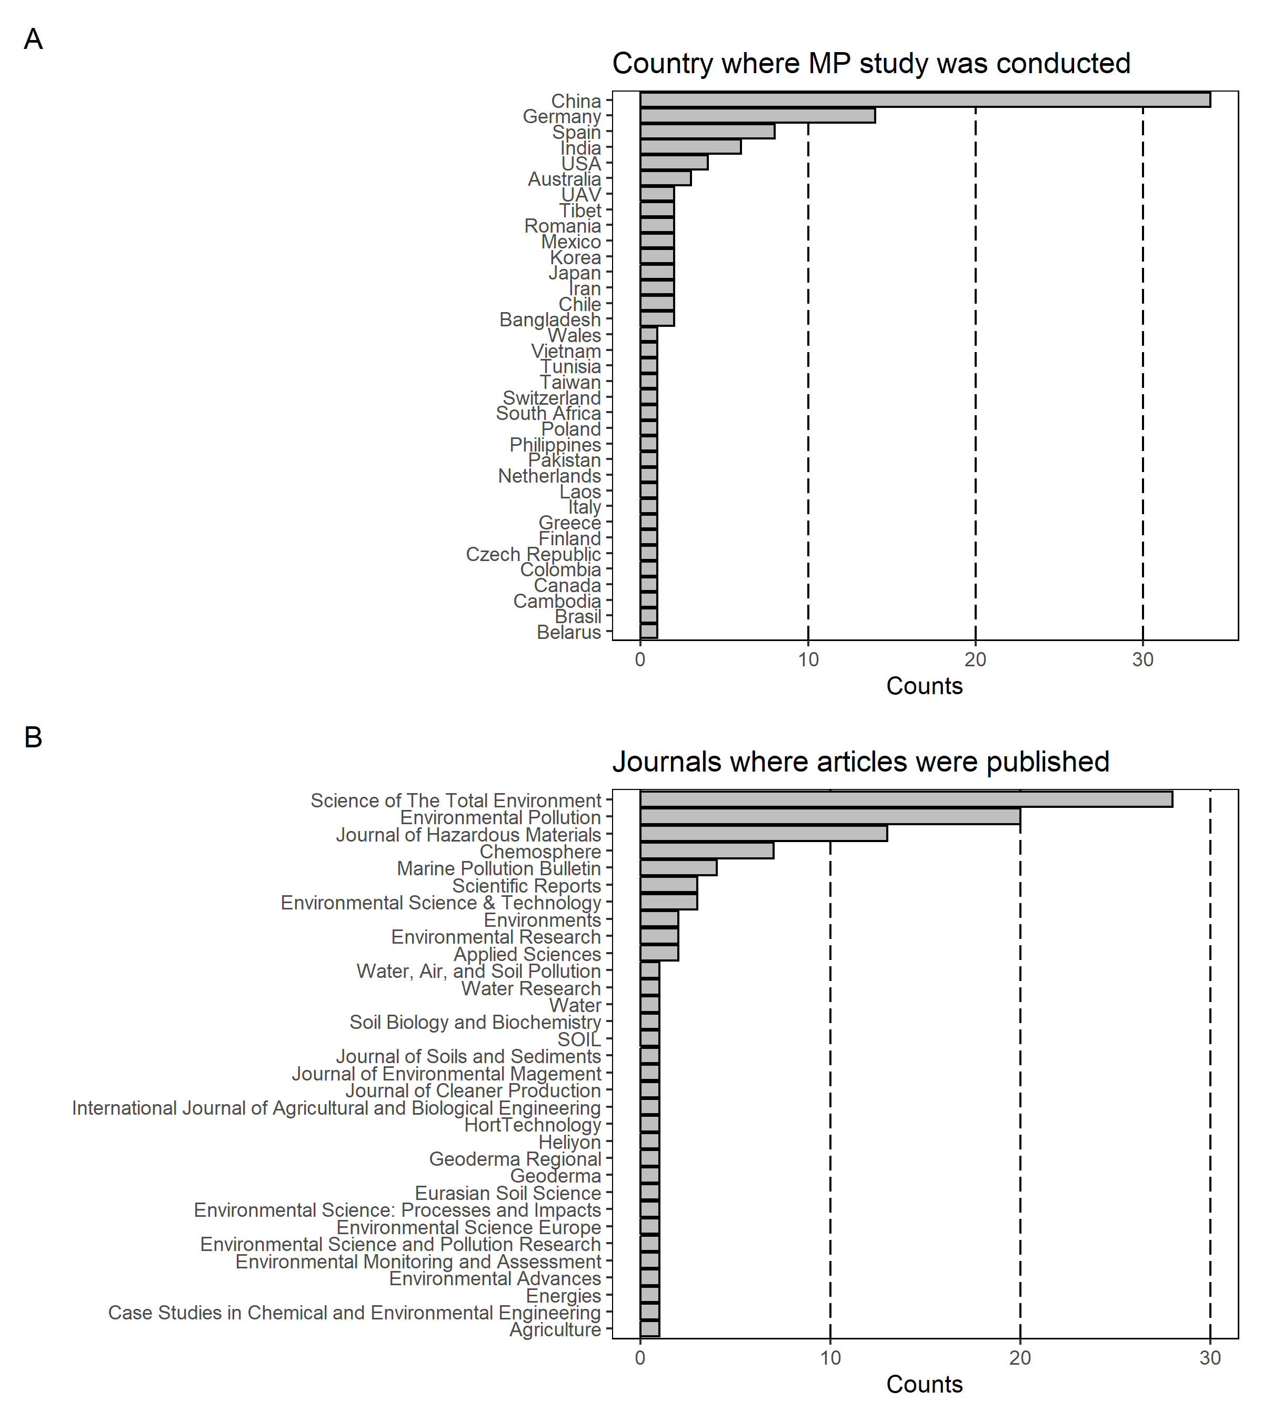

Figure S2
Metadata of research articles that investigate MPs in soil.
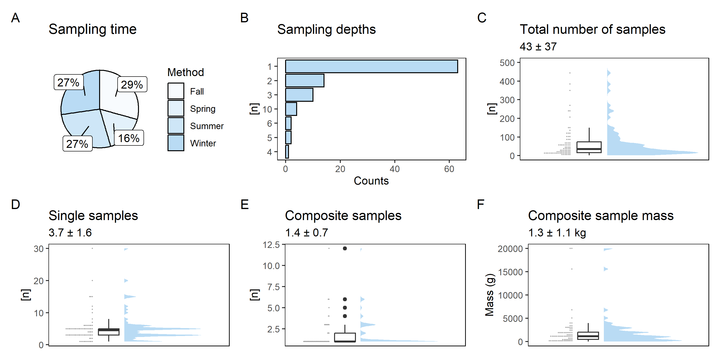

Figure S3
Metrics about procedures regarding sampling time (A), number of sampling depths under investigation per article (B), number of samples investigated per article (C), number of single samples (D), the number of samples merged into composite samples (E), and the final mass of each composite sample (F).
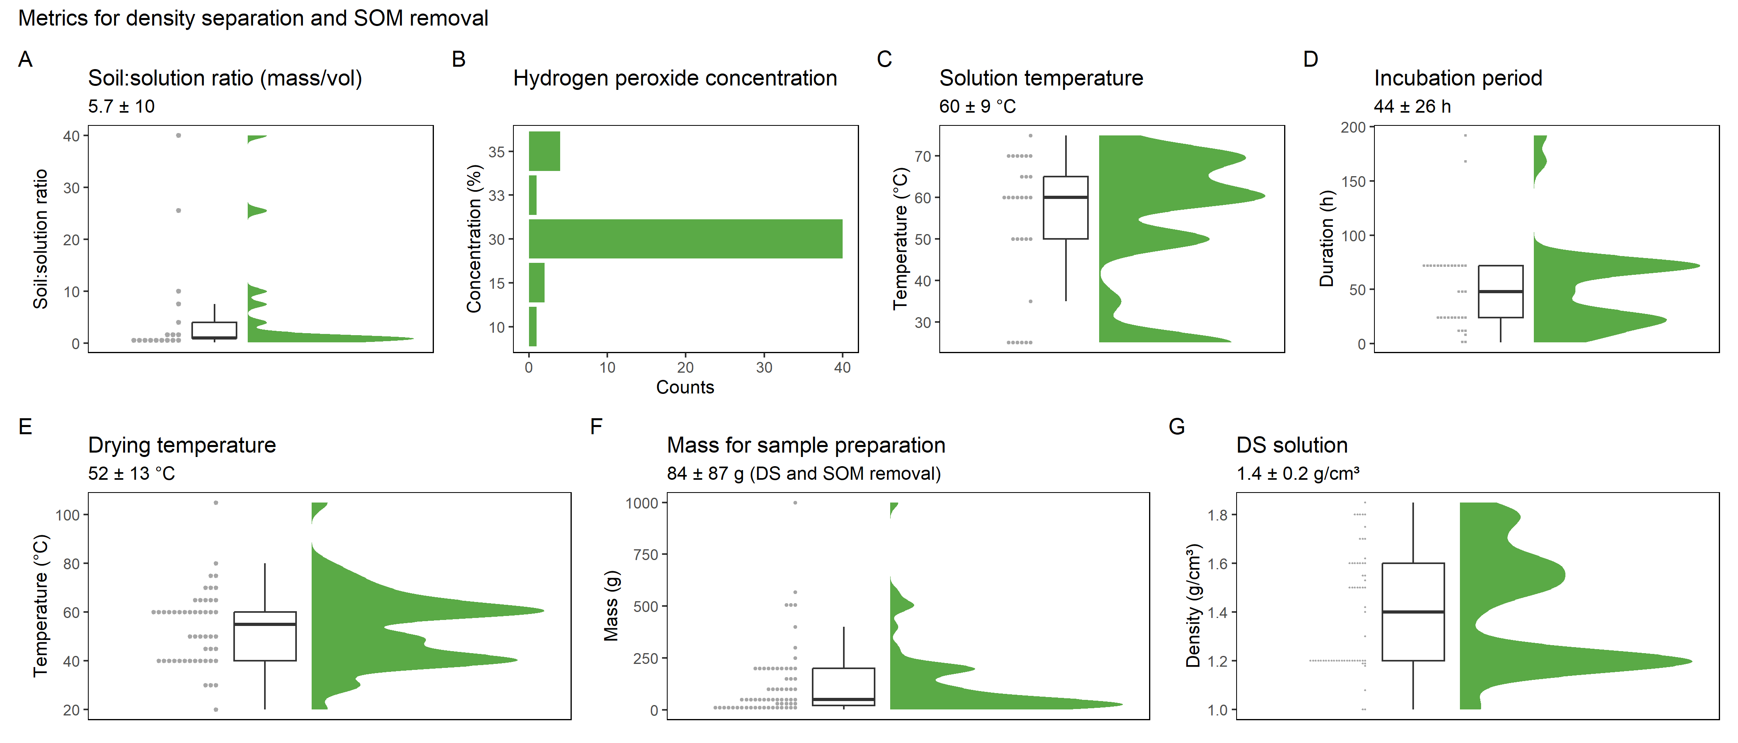

Figure S4
Metrics for the density separation (DS) procedure and soil organic matter (SOM) removal by application of hydrogen peroxide.
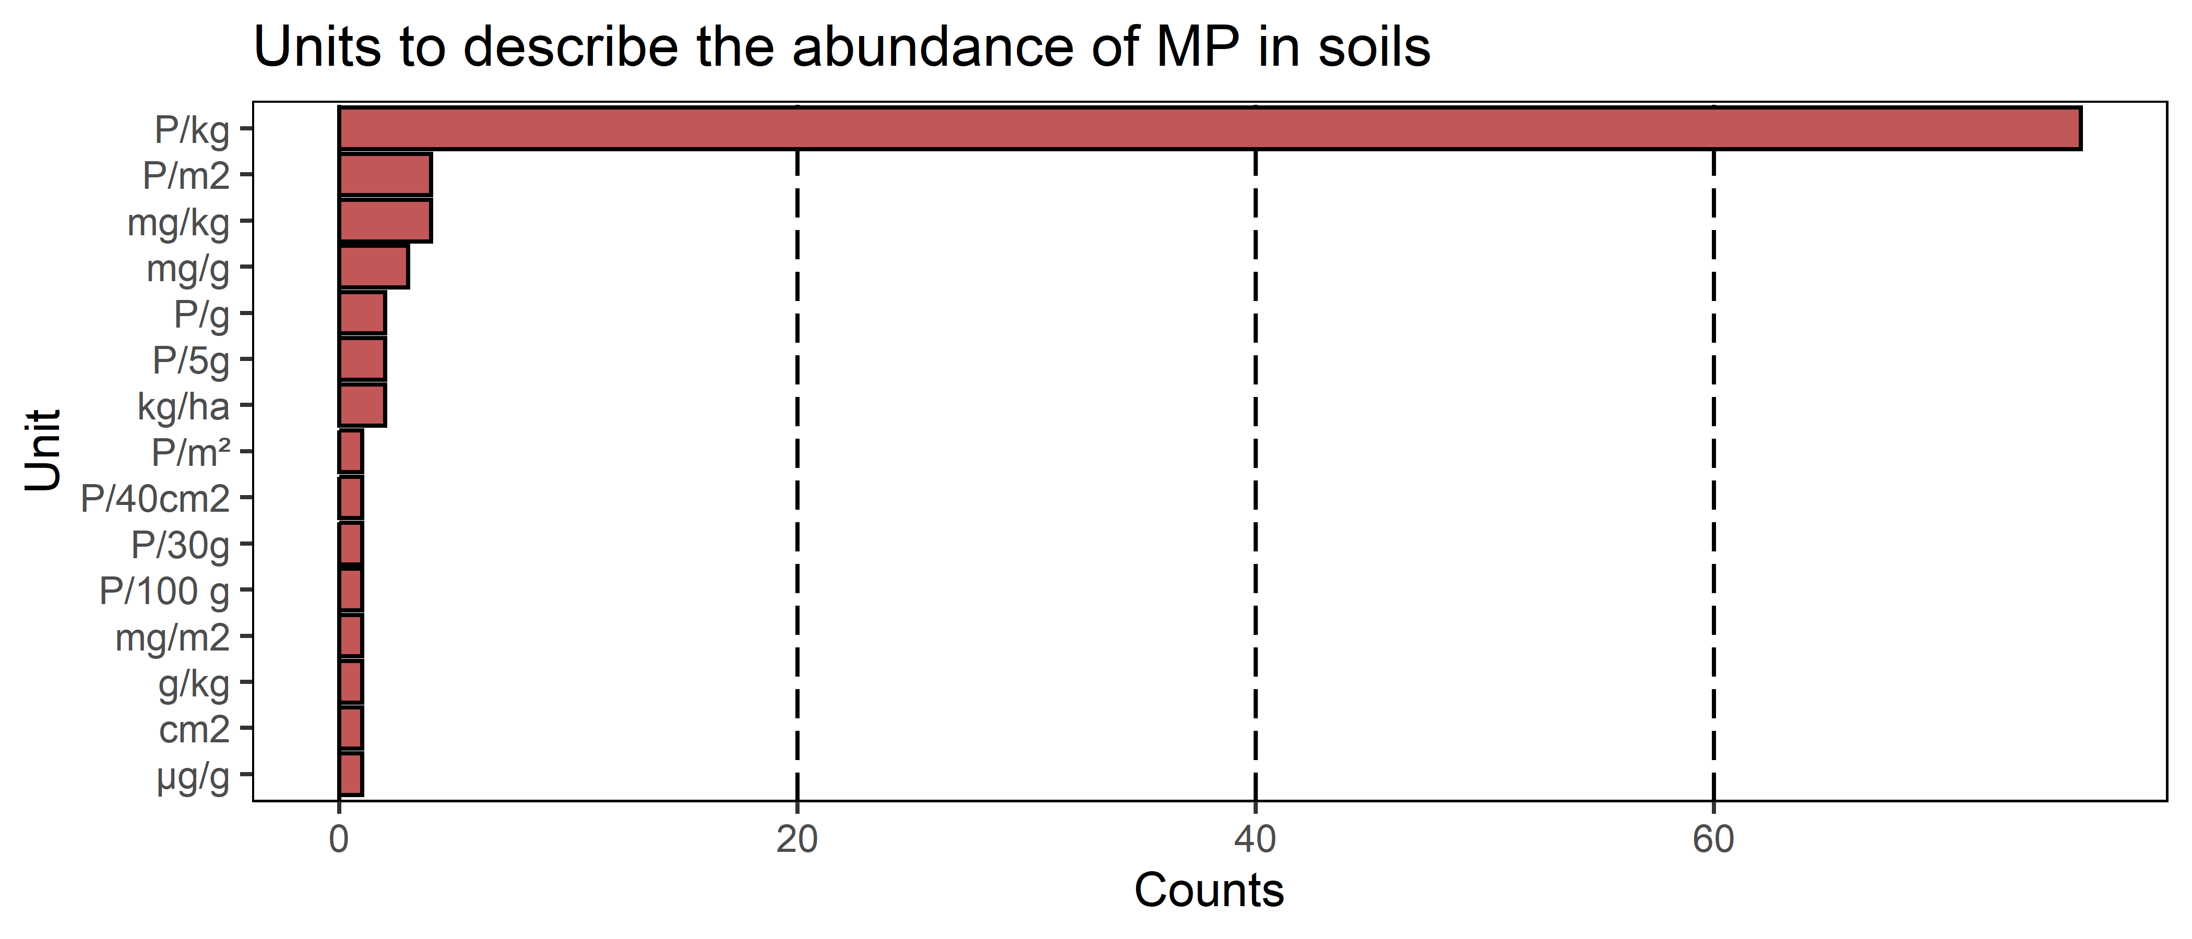

Figure S5
Most common units employed for the 106 articles within this structured review.

Table S1
Overview of groups and categories of sampling strategies for MPs research.
Group | Category | Comment | Unit
Input pathway | Pathway | Entry of MP into soils, either localized or diffuse. | [-]
Input pathway | Group | More specialized information about the depositional environment or process. | [-]
Input pathway | Source | Who is responsible for MP pollution. | [-]
Study site | Size | Area of the study site for which the sample is representative. | [m²]
Study site | Soil classification | Description of the soil type/order under investigation. | [-]
Study site | Soil management | Information about management practices (e.g., compost, sewage sludge). | [-]
Study site | Land use | Land use classification (e.g., pasture, arable land). | [-]
Study site | Soil properties | Soil properties that were measured concomitantly with MP contents (e.g., pH, texture). | [-]
Sampling design | Sketch | Sketch of the sampling design included (e.g., location and/or distance of the sampling plots). | [-]
Sampling design | DIN/ISO/CEN | Sampling based on an existing technical note. | [-]
Sampling design | Sampling time | Season of the year when sampling was conducted. | [-]
Sampling design | Sampling device | Tool used to excavate the soil sample (e.g., spade, auger). | [-]
Sampling design | Sampling design | Design for soil sampling (e.g., random, raster, transect). | [-]
Sampling design | Sampling depth | Depth from which the sample was obtained. | [cm]
Sampling design | Depths | Number of depths differentiated for the study. | [n]
Sampling design | Single sample | Single samples per composite sample taken per field. | [n]
Sampling design | Composite sample | Representative composite samples per field. | [n]
Sampling design | Composite sample mass | Mass per composite sample. | [kg]
Sampling design | Total number of samples analyzed | Number of individual samples from which particle counts or mass were derived. | [n]
Sampling design | Storage | Device used to transport or store the sample (e.g., aluminum box, glass bottle). | [-]
Sampling design | Homogenization in the field | How the bulk sample was mixed in the field (e.g., by hand, mixing and quartering). | [-]
Sample preparation | Homogenization in the laboratory | How the bulk sample was mixed in the laboratory (e.g., mortar, sample splitter). | [-]
Sample preparation | Drying | Drying procedure (e.g., oven drying, freeze drying, air drying). | [-]
Sample preparation | Drying temperature | Drying temperature. | [°C]
Sample preparation | Mesh size | Diameter of the mesh used to physically sieve the soil sample. | [mm]
Sample preparation | Density separation (DS) | Mass of soil taken for density separation and/or soil organic matter removal. | [g]
Sample preparation | DSP solution | Density of the solution used for density separation. | [g/cm³]
Sample preparation | Pretreatment | Extracting agent used to remove soil organic matter (e.g., H₂O₂, Fenton’s reagent). | [-]
Analytical methods | Method | Spectroscopic or thermogravimetric (e.g., ATR-FTIR, SEM, Pyr-GC‒MS). | [-]
Analytical methods | Polymers | Characteristic polymers under investigation. | [-]
Analytical methods | Unit | Unit of the particle count or mass (e.g., P/kg, P/m²). | [-]
Analytical methods | Analytical result | Quantification of polymers as either counts (particles/weight) or contents (mass/weight). | [-]
Analytical methods | Reference material | Application of a recovery test or a reference soil (known MP content). | [-]
Analytical methods | LOQ/LOD and size information | Lowest possible concentration or particle size the method can detect. | [-]

Table S2
Summary statistics of groups and categories of sampling strategies for MPs research. For each category, the data were calculated from the raw data (white background) and from processed data by outlier removal (gray background). Outliers were identified by the interquartile range (IQR: 1.5 times higher than the 75th and 1.5 times lower than the 25th percentile of the data). IQR data are discussed in this manuscript.
Group | Category | Unit | Cases | Mean | Median | SD | Min | Max | 25th perc. | 75th perc.
Study site | Size | m² | 48 | 1032750 | 100 | 4865419 | 0.04 | 32000000 | 5.5 | 3125
Study site | Size | m² | 39 | 736 | 25 | 1452 | 0.04 | 5130 | 2.1 | 550
Sampling design | Single samples | n | 74 | 5.1 | 4.5 | 4.6 | 1 | 30 | 3 | 5
Sampling design | Single samples | n | 65 | 3.7 | 3.0 | 1.6 | 1 | 7 | 3 | 5
Sampling design | Mixed sample | n | 79 | 1.78 | 1 | 1.7 | 1 | 12 | 1 | 2
Sampling design | Mixed sample | n | 72 | 1.36 | 1 | 0.7 | 1 | 3 | 1 | 1
Sampling design | Total samples | n | 80 | 79 | 35 | 143 | 2 | 1100 | 16 | 73
Sampling design | Total samples | n | 72 | 43 | 30 | 37 | 2 | 150 | 15 | 60
Sampling design | Mixed sample mass | g | 73 | 2155 | 1150 | 3674 | 10 | 20000 | 500 | 2000
Sampling design | Mixed sample mass | g | 68 | 1321 | 1000 | 1073 | 10 | 4000 | 408 | 2000
Sample preparation | Drying temp. | °C | 50 | 53.5 | 55 | 15.3 | 20 | 105 | 40 | 60
Sample preparation | Drying temp. | °C | 49 | 52.4 | 50 | 13.5 | 20 | 80 | 40 | 60
Sample preparation | Analytic mass | g | 65 | 125 | 50 | 174 | 0.05 | 1000 | 20 | 200
Sample preparation | Analytic mass | g | 60 | 84 | 50 | 87 | 0.05 | 400 | 18 | 150
Sample preparation | Treatment volume | mL | 26 | 84 | 50 | 75 | 10 | 250 | 30 | 100
Sample preparation | Treatment volume | mL | 25 | 77 | 50 | 68 | 10 | 200 | 30 | 100
Sample preparation | Treatment temp. | °C | 32 | 54 | 60 | 16 | 25 | 75 | 50 | 66
Sample preparation | Treatment temp. | °C | 26 | 60 | 60 | 9 | 3 | 75 | 52 | 70
Sample preparation | Treatment duration | h | 37 | 51 | 48 | 40 | 1 | 192 | 24 | 72
Sample preparation | Treatment duration | h | 35 | 44 | 48 | 26 | 1 | 72 | 24 | 72
Particle counts | Aeolian | P/kg | 25 | 16.1 | 0.44 | 68 | 0.00002 | 340 | 0.20 | 0.89
Particle counts | Aeolian | P/kg | 19 | 0.42 | 0.32 | 0.33 | 0.00002 | 1.1 | 0.17 | 0.63
Particle counts | Marine | P/kg | 142 | 1020 | 106 | 2948 | 1.3 | 16867 | 41.5 | 351
Particle counts | Marine | P/kg | 97 | 147 | 84 | 167 | 1.3 | 800 | 40.0 | 179
Particle counts | Fluvial | P/kg | 93 | 3868 | 469 | 12260 | 0.37 | 84824 | 90 | 1563
Particle counts | Fluvial | P/kg | 71 | 420 | 322 | 454 | 0.37 | 2004 | 38 | 633
Particle counts | Agriculture | P/kg | 175 | 7927 | 306 | 55354 | 0.23 | 690000 | 38.5 | 2154.5
Particle counts | Agriculture | P/kg | 139 | 854 | 231 | 1199 | 0.23 | 6235 | 25.0 | 1322.0
Particle counts | Urban | P/kg | 71 | 11444 | 4518 | 27830 | 100 | 218182 | 1150 | 11882
Particle counts | Urban | P/kg | 61 | 6176 | 3877 | 6481 | 100 | 26761 | 1100 | 10572

