Supplementary material
Tracks of Travel: Unveiling Tire Particle Concentrations in Swiss Cantonal Road Soils
Dominika Kundel¹ & Andrea Wiget¹, Andreas Fliessbach¹, Moritz Bigalke², Collin J. Weber²
¹ FiBL Switzerland, Department of Soil Sciences, Ackerstrasse 113, 5070 Frick (Switzerland)
² Institute of Applied Geosciences, Department of Soil Mineralogy and Soil Chemistry, Schnittspahnstr. 8, 64287 Darmstadt (Germany)

Corresponding author: Collin J. Weber (collin.weber@tu-darmstadt.de)

Table S1. Sampling sites, street and traffic data combined with mean TWP and pollutant concentrations
ID | Sampling site | Locationª | Traffic and street data |  |  |  | Mean TWP data |  |  | Mean trace metal concentrations  (mg kg⁻¹) |  |  |  | Mean PAH concentrations  (ug kg⁻¹)
ID | Sampling site | Locationª | DTV (2015)^{b} | Speed limit | Renovation year^{c} | Topping grain size^{d} | TWP  kg⁻¹ | mg TWP kg⁻¹ | Feret diameter (µm) | Cd | Cu | Zn | Pb | BAP^{e} | PAK (16EPA)^{f}
1 | Subingen | 47.198066, 7.602399 | 8913 | 80 | 1969 | 11 | 69269 | 0.07 | 84.2 | 0.6 | 30.9 | 157.7 | 81.3 | 2368.5 | 20430.9
2 | Burgaeschi | 47.174183, 7.673967 | 280 | 60 | 2015 | 16 | 43250 | 0.11 | 86.5 | 0.2 | 20.1 | 61.9 | 19.7 | 69.4 | 566.0
3 | Buchegg-Schlacht | 47.128173, 7.500856 | 1982 | 80 | 2004 | 16 | 92498 | 0.05 | 90.1 | 0.2 | 23.3 | 78.0 | 26.7 | 1044.8 | 6718.8
4 | Schnottwil | 47.094657, 7.406697 | 2320 | 80 | 2019 | 16 | 141679 | 0.05 | 94.6 | 0.2 | 20.2 | 73.1 | 17.7 | 284.1 | 1604.7
5 | Buchegg-Bib | 47.146240, 7.458397 | 1246 | 50 | 2020 | 11 | 64777 | 0.07 | 87.3 | 0.2 | 25.2 | 105.6 | 34.4 | 992.6 | 9313.5
6 | Lueterkofen-Ichertswil | 47.171547, 7.503083 | 1696 | 80 | 2013 | 16 | 180360 | 0.13 | 103.8 | 0.3 | 21.3 | 104.3 | 46.6 | 1738.3 | 12628.3
7 | Ruettenen | 47.234242, 7.534736 | 2030 | 80 | 1972 | 16 | 87184 | 0.03 | 88.8 | 0.4 | 24.6 | 89.6 | 35.2 | 3127.9 | 35105.7
8 | Welschen-rohr | 47.271500, 7.508500 | 2182 | 80 | 2019 | 11 | 107084 | 0.09 | 101.6 | 0.4 | 29.6 | 106.4 | 41.7 | 1503.6 | 14983.6
9 | Nuglar | 47.470700, 7.698900 | 1199 | 80 | 2001 | 16 | 214213 | 0.17 | 117.4 | 0.6 | 38.1 | 162.2 | 54.2 | 7656.4 | 82844.9
10 | Hochwald | 47.452552, 7.638824 | 911 | 50 | 2002 | 16 | 109862 | 0.05 | 91.1 | 1.6 | 20.8 | 103.7 | 41.7 | 265.9 | 2326.7
11 | Seewen | 47.420945, 7.664262 | 2188 | 80 | 2011 | 16 | 274650 | 0.11 | 103.4 | 0.7 | 31.5 | 117.8 | 42.4 | 5169.4 | 44176.0
12 | Stuesslingen | 47.391600, 7.970800 | 1480 | 50 | 1960 | 32 | 27514 | 0.13 | 88.3 | 0.4 | 28.5 | 90.1 | 41.1 | 327.3 | 3143.0
13 | Subingen2 | 47.191625, 7.629238 | 5321 | 80 | 1991 | 11 | 71573 | 0.21 | 93.4 | 0.3 | 21.6 | 89.1 | 42.1 | 3056.3 | 30007.6
14 | Etziken | 47.191597, 7.655092 | 1350 | 80 | 2000 | 11 | 30089 | 0.06 | 84.5 | 0.2 | 18.9 | 58.4 | 42.2 | 186.6 | 1191.8
15 | Hofstetten | 47.472712, 7.501995 | 1300 | 80 | 2007 | 16 | 154990 | 0.04 | 94.3 | 2.0 | 26.1 | 104.5 | 49.7 | 1486.2 | 10690.9
ª Locations given in WGS84 coordinates; ^{b} Daily traffic value as of 2015, ^{c} Last street renovation year; ^{d} Largest grain (mm) in asphalt surface layer; ^{e} Benzo[a]pyrene; ^{f} PAH concentrations according 16 EPA list.

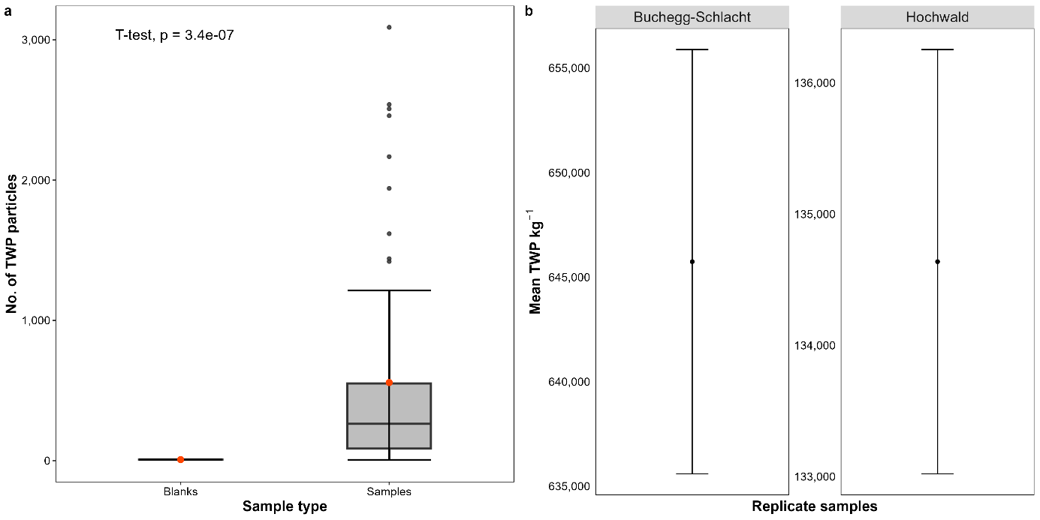
Figure S1: Quality control results. a: TWP concentration in Blank samples (n = 6) and environmental soil samples (n = 60); b: Mean TWP concentration in replicate samples from two sampling sites Buchegg-Schlacht (n = 3) and Hochwald (n = 3) with standard deviations.

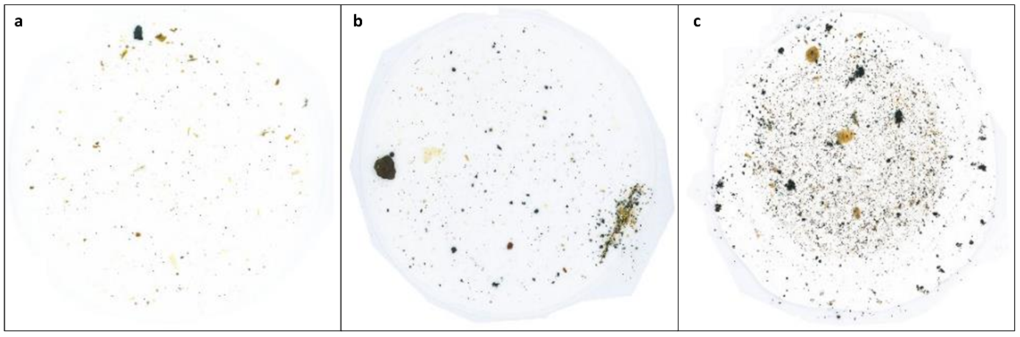
Figure S2: Examples of roadside soil samples after extraction used for LDIR analysis. a) Sampling site Hochwald (5 m distance); b) Sampling site Lüterkofen-I. (2 m distance); c) Sampling site Seewen (1 m distance).

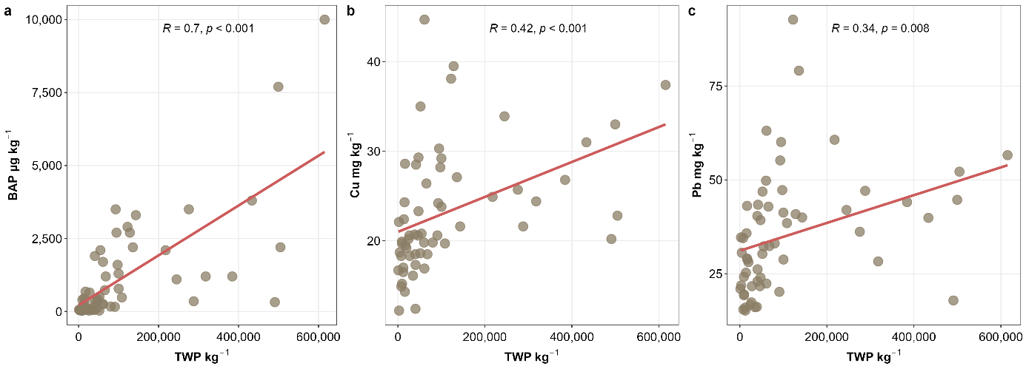
Figure S3: Relationship between chemical constituents and tire wear particle concentrations with linear regression in roadside soils. a: Benzo[a]pyrene (BAP) concentration (µg kg⁻¹); b: Copper (Cu) concentration (mg kg⁻¹), c: Lead (Pb) concentration (mg kg⁻¹) all combined with tire wear particle concentration (TWP kg⁻¹) (n=60); Regression R and p values given in plots.

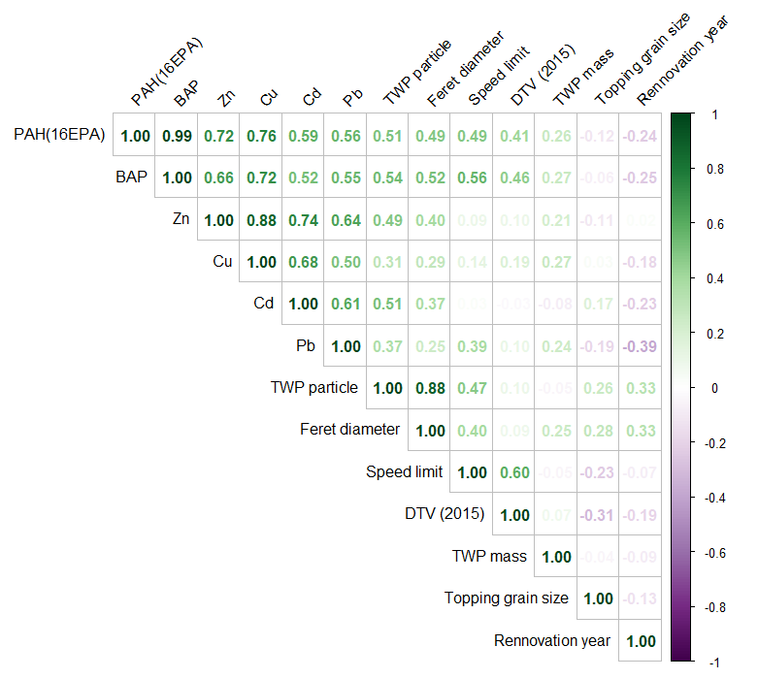
Figure S4: Spearman correlation matrix of TWP concentration as particle counts (TWP kg⁻¹) and estimated masses (mg TWP kg⁻¹) and feret diameter (µm), with soil pollutants including trace metals (Cd, Cu, Zn, Pb given in mg kg⁻¹), Benzo[a]pyrene (BAP) and Polycyclic aromatic hydrocarbons (PAH 16 EPA) given in µg kg⁻¹, combined with road data including speed limit at sampling site, daily traffic volume (DTV) from 2015 per site, topping grain size as well as latest road renovation year. Spearman correlation coefficients displayed in green for positive correlations and purple for negative correlations. Colour intensity increasing with increasing correlation coefficient. Insignificant (p ≥ 0.01) correlations not shown.

