Supplementary information for:

Microplastics in human feces: A pilot study exploring links with dietary habits

Alice Refosco^{a*}, Jutta Dierkesª, Tanja Kögel^{b}, Simon Nitter Dankel^{c}, Johnny Laupsa-Borge^{c,e}, Alessio Gomiero^{d}, Damaris Benny Danielª

ª Centre for Nutrition, Department of Clinical Medicine, University of Bergen, Norway
^{b} Institute of Marine Research, Bergen, Norway
^{c} Department of Clinical Science, University of Bergen, Norway
^{d} Norce Research, Stavanger, Norway
^{e} Bevital, Bergen, Norway

*Corresponding author: Alice Refosco

Table S 1. Summary of previous studies investigating MP presence in human fecal samples
Number of participants | Fecal/stool samples | Extraction protocol (*) | Identification | Lower detection size (LDS), Upper detection size(UDS)/ Limit of detection (LOD) and quantification (LOQ) | Polymers | Particle size studied (µm) | Reference
15 (60 stool samples) | 10 g liquefied and homogenized | H₂O₂ 30 %, 25 °C  Fraction < 50 µm: NAOH (only qualitative analysis)  Fraction > 50µm:  - Lipase  - HCl 5% + imidazolium-based ionic liquid | Fraction < 50µm: ATR-FTIR  Fraction > 50µm: FTIR | LDS: 5 µm (ATR-FTIR for qualitative analysis)  50 µm included in results  LOQ: 0.085–3.0 particles/g | PE, PP, PVC, PS, PET, PA, PU, PMMA, POM, polyester | 5 – 5000 | [1]
30 | 25 g (homogenized) | -KOH 10%, 2 weeks | Visual inspection – FTIR for selected particles | NA | PET, PA, PEC, HDPE, EP | 200 – 4900 | [2]
8 | 7 g (liquefied and homogenized) | - Shaker at 150 rpm for 12 h  - 30% H₂O₂, 25 °C, two weeks  - 0.05 M NaOH, 25 °C  - Biological fibers were dissolved in Imidazolium salt | ATR-FTIR | LDS: 50 µm | PE, PP, PVC, PS, PET, PA, PU, PC, POM | 50 – 500 | [3]
121 | 1 – 5 g (dry feces) | - Fenton's reagent, less than 5 h, 40 °C  - 65% HNO₃, 50 °C  - Ultrasonic treatment (100 KHz), 10 – 15 min | Raman | LDS: 1 µm (CN and CA filters) | PP, PE, PET, Polyester, PS, PC, PA, PVC, PMMA | 1.4 – 678 | [4]
69 | NA | - 65% HNO₃, 48 h  - 110 °C, 3 h | Py-GC/MS | Calculated LOD and LOQ for each polymer | PE, PVC, PET, PA6 | - | [5]
11 | 1 g (dry feces) | - Fenton's reagent, 5 h, RT  - 65% HNO₃, 50 °C, 30 min  - 70 °C, 10 min | RAMAN | LDS: 1 µm (CN and CA filters) | HDPE, LDPE, LLDPE, PP, PS, PET | NR | [6]
3 | 1 g | - H₂O₂ 35%, 40 °C, 24 h  - KOH 2M, 40 °C, 24 h  - Acetate buffer, cellulase, 40 °C, 48 h | ATR-μFTIR | LDS: 10 µm (PTFE filter) | PE, PET, PES, PA, polyacrylate | 150 - 1777 | [7]
102 | NR (dry feces) | - Fenton's reagent, less than 5 h, 40 °C  - 65% HNO₃, 50 °C, 30 min | Raman | LDS: 1 µm (CN and CA filters) | PET, PA, PP, PE, PC, PVC, POM, PTFE, EVA, PS, PMMA, PBT, AS, PES, TPU | 1.7 – 393 | [8]
23 | 25 g | - Fenton's reagent, less than 5 h, 40 °C  - 69% HNO₃, 40 °C, 2 h | ATR – FTIR | LDS: 10 µm (filter) | PET, PP, PE | NR | [9]
78 | 3 g (wet feces) | - 10 g chloroform solution, ultrasound 10 min (x 3)  - 10 g hexafluoroisopropanol solution, ultrasound 10 min (x 3)  - 10 g xylene solution, 150 °C, 10 min (x3) | py-GC/MS | NR | PS, PE, PP, PVC, PET, PA66 | - | [10]
87 | NR | - 69% HNO₃, 1 h | LDIR | LDS: 20; UDS: 500 µm (LDIR) | PVC, PC, PLA, fluororubber, PET, EVA, PTFE, PE, PS, PVB, CPE, PP, PMMA, PU, EAA, ABS, POM | NR | [11]
11 | 1 g (dry feces) | - Fenton's reagent, 5 h, RT  - 69% HNO₃, 50 °C, 2 h  - incubation 70°C, 10 min | Raman | LDS: 0.8 µm (CN-CA filters) | PP, HDPE, PS, PET | NR | [12]
24 | 3 g (wet feces) | - H₂O₂ 30 %, 20 days | FTIR | NR | PP, PET, PS, PE, PVC, PC, PA, PU | 100 – 5000 | [13]
86 | 1 g (wet feces) | - H₂O₂ 30 %, 50 °C, 72 h  - potassium formate, ultrasonic treatment, 30 min | LDIR (> 20µm)  TD-GC/MS (< 20µm)  ATR-FTIR (>500µm) | LDS: 0.22 µm(filter) | PVC, PP, PE, PS, PET, PA, PU, PTFE, PC, PAM | 0.22 – 446 | [14]
NA: not reported; FTIR: Fourier transform infrared spectroscopy; ATR-FTIR: Attenuated Total Reflection-FTIR; RT: room temperature; PE: polyethylene; HDPE: high density polyethylene; LDPE: low density polyethylene; LLDPE: linear low-density polyethylene; µPP: polypropylene; PVC: polyvinyl chloride; PS polystyrene; PET: polyethylene terephthalate; PA polyamide; PU: polyurethane; PC: polycarbonate; PMMA: polymethyl methacrylate; POM: polyoxymethylene; EVA: ethylene vinyl acetate; PTFE: poly(tetrafluoroethylene); PBT: poly(butylene terephthalate); AS: acrylonitrile styrene; PES: poly(ether sulfone); TPU: thermoplastic urethanes; CN: cellulose nitrate; CA: cellulose acetate; EP: ethylene propylene; PEC: polyethylene chlorinated; Py-GC/MS: pyrolysis-gas chromatography coupled with mass spectrometry; LDIR: laser direct infrared spectroscopy; PVB: polyvinyl butyral; CPE: chlorinated polyethylene; PLA: polylactic acid; EAA: ethylene acrylic acid copolymer; ABS: acrylonitrile butadiene styrene; TD-GC/MS: thermal desorption-gas chromatography−mass spectrometry; PAM: polyacrylamide; py-GC/MS: pyrolysis gas chromatography−mass spectrometry
(*) If no time if specified, it was not provided.

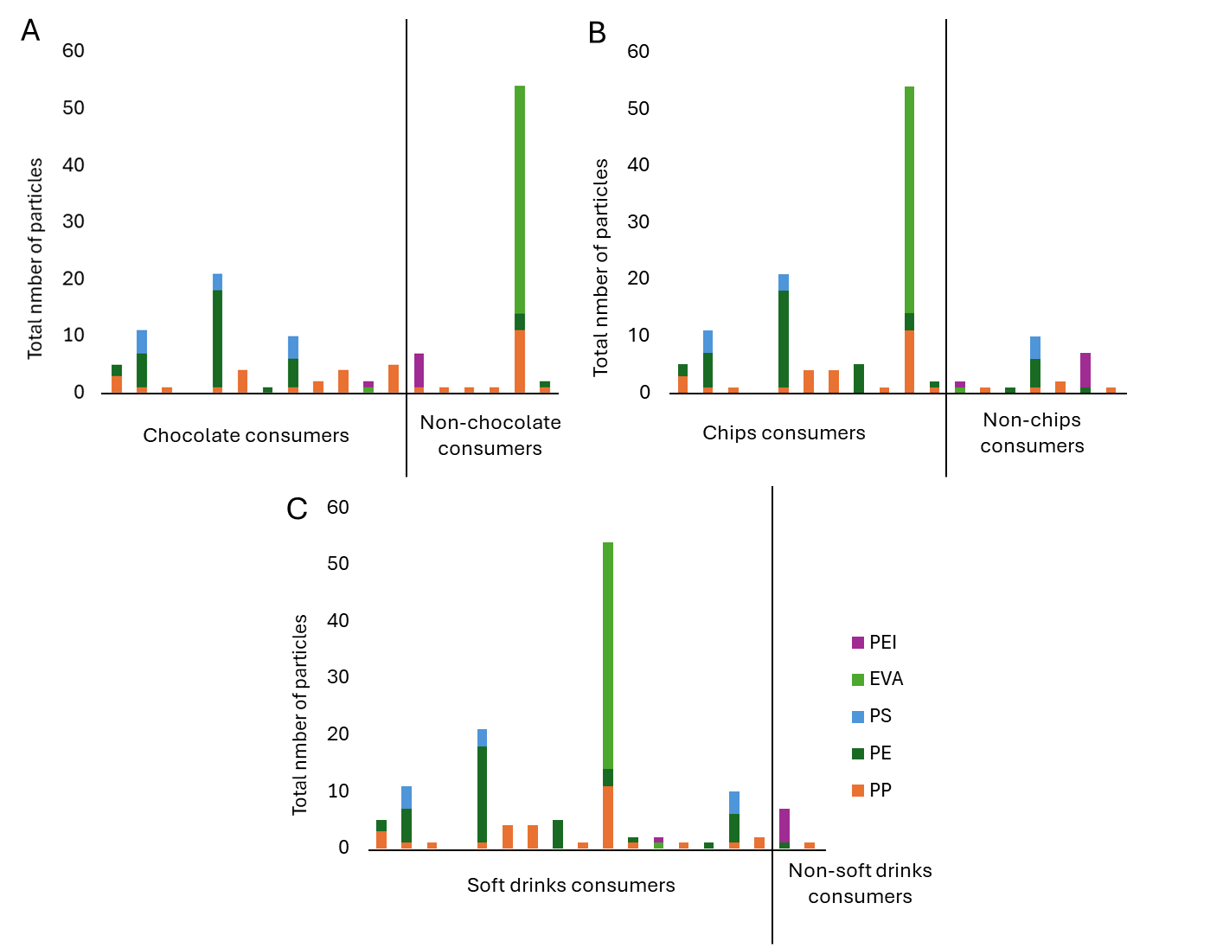
Figure S 1. Microplastic abundance in each fecal sample, according to their reported consumption of chocolate, chips and soft drink.

References
1. Hartmann, C., Lomako, I., Schachner, C., El Said, E., Abert, J., Satrapa, V., Kaiser, A.M., Walch, H., and Koppel, S., Assessment of microplastics in human stool: A pilot study investigating the potential impact of diet-associated scenarios on oral microplastics exposure. Sci Total Environ, 2024. 951: p. 175825.
2. Hasanah, U., Amqam, H., Septami, A.E., Chalid, M., and Aris, A.Z., Plasticizing Pregnancy: Microplastics Identified in Expectant Mothers' Feces. Environ Health Insights, 2024. 18: p. 11786302241235810.
3. Schwabl, P., Koppel, S., Konigshofer, P., Bucsics, T., Trauner, M., Reiberger, T., and Liebmann, B., Detection of Various Microplastics in Human Stool: A Prospective Case Series. Ann Intern Med, 2019. 171(7): p. 453-457.
4. Hong, Y., Feng, Y., Yan, T., Zhang, L., Zhao, Q., Zhao, Q., Huang, J., Huang, S., and Zhang, Y., Take-out food enhances the risk of MPs ingestion and obesity, altering the gut microbiome in young adults. J Hazard Mater, 2024. 476: p. 135125.
5. Ke, D., Zheng, J., Liu, X., Xu, X., Zhao, L., Gu, Y., Yang, R., Liu, S., Yang, S., Du, J., Chen, B., He, G., and Dong, R., Occurrence of microplastics and disturbance of gut microbiota: a pilot study of preschool children in Xiamen, China. EBioMedicine, 2023. 97: p. 104828.
6. Luqman, A., Nugrahapraja, H., Wahyuono, R.A., Islami, I., Haekal, M.H., Fardiansyah, Y., Putri, B.Q., Amalludin, F.I., Rofiqa, E.A., Götz, F., and Wibowo, A.T., Microplastic Contamination in Human Stools, Foods, and Drinking Water Associated with Indonesian Coastal Population. Environments, 2021. 8(12).
7. Santini, S., Exposito, N., Sierra, J., Cincinelli, A., and Rovira, J., Set up and validation of a method to analyse microplastics in stool and small intestine samples. MethodsX, 2024. 12: p. 102777.
8. Yan, Z., Liu, Y., Zhang, T., Zhang, F., Ren, H., and Zhang, Y., Analysis of Microplastics in Human Feces Reveals a Correlation between Fecal Microplastics and Inflammatory Bowel Disease Status. Environ Sci Technol, 2022. 56(1): p. 414-421.
9. Schwenger, K.J.P., Ghorbani, Y., Bharatselvam, S., Chen, L., Chomiak, K.M., Tyler, A.C., Eddingsaas, N.C., Fischer, S.E., Jackson, T.D., Okrainec, A., and Allard, J.P., Links between fecal microplastics and parameters related to metabolic dysfunction-associated steatotic liver disease (MASLD) in humans: An exploratory study. Sci Total Environ, 2024. 953: p. 176153.
10. Song, Y., Zhang, J., Shen, X., Yang, L., Jia, Y., Song, F., Huang, Y., Han, B., Zhou, S., Zhang, N., and Ma, G., Microplastics in stools and their influencing factors among young adults from three cities in China: A multicenter cross-sectional study. Environ Pollut, 2025. 364(Pt 2): p. 125168.
11. Wang, Y., Zhu, Y., Capapelo, J.J., Wu, Y., Shi, L., Yang, Y., Chen, P., He, S., and Li, J., Exploring alternatives for detecting microplastics in the human body: questionnaire survey. Sci Rep, 2024. 14(1): p. 23458.
12. Wibowo, A.T., Nugrahapraja, H., Wahyuono, R.A., Islami, I., Haekal, M.H., Fardiansyah, Y., Sugiyo, P.W.W., Putro, Y.K., Fauzia, F.N., Santoso, H., Götz, F., Tangahu, B.V., and Luqman, A., Microplastic Contamination in the Human Gastrointestinal Tract and Daily Consumables Associated with an Indonesian Farming Community. Sustainability, 2021. 13(22).
13. Zhang, N., Li, Y.B., He, H.R., Zhang, J.F., and Ma, G.S., You are what you eat: Microplastics in the feces of young men living in Beijing. Sci Total Environ, 2021. 767: p. 144345.
14. Zhu, L., Wu, Z., Dong, J., Zhao, S., Zhu, J., Wang, W., Ma, F., and An, L., Unveiling Small-Sized Plastic Particles Hidden behind Large-Sized Ones in Human Excretion and Their Potential Sources. Environ Sci Technol, 2024. 58(27): p. 11901-11911.

