Supplemental Information

The impact of a large textile laundry facility on the overall influx of microplastics and their removal in two wastewater treatment plants in the Netherlands
Cheryl Bertelkamp^{1,2}, Eelco Pieke³, Sanne Brekelmans³, Corine Houtman^{3,4}, Andre Struker¹, Olivia Traast¹, Marieke Voeten¹, Jan Peter van der Hoek^{1,4,5}
¹ Waternet, Korte Ouderkerkerdijk 7, 1096 AC Amsterdam, The Netherlands, currently working at PWN Waterleidingbedrijf Noord-Holland, Rijksweg 501, 1991 AS Velserbroek (cheryl.bertelkamp@pwn.nl)
² Water Research Australia, 250 Victoria Square, Adelaide SA 5000, Australia
³ Het Waterlaboratorium N.V., J.W. Lucasweg 2, 2031BE Haarlem, The Netherlands
⁴ Amsterdam Institute for Life and Environment (A-LIFE), Vrije Universiteit Amsterdam, 1081 HV, Amsterdam, The Netherlands
⁵ Delft University of Technology, Department of Water Management, Stevinweg 1, 2628 CN Delft, The Netherlands

S1 – Method validation

S1.1 Sample or aliquot analyzed?
In some cases, aliquots of the sample filter were necessary as samples could contain up to 400 manually detected particles in just 6% of the filter. The cases where only an aliquot of the sample was analyzed, rather than the entire sample, are shown in Table S1.1. For these samples, there is an inherent uncertainty associated with the extrapolation of results to estimate total microplastic loads. Although expertise-based efforts were made to ensure representative subsampling, error due to subsampling could still occur and should be considered when evaluating the reported microplastic counts.
Table S1.1 – Percentage of filter analyzed for all samples
Sample name | Datum | Aliquot 5 mm | Aliquot 1mm | Aliquot 250 µm | Aliquot 125 µm | Aliquot 50 µm
West-Blank | 3-5-2022 | 100 | 100 | 100 | 100 | 100
West-Influent | 3-5-2022 | 100 | 100 | 10 | 10 | 10
West -Effluent | 2-5-2022 | 100 | 7 | 21 | 100 | 100
Horstermeer-Blank | 2-5-2022 | 100 | 100 | 100 | 100 | 100
Horstermeer-Influent | 3-5-2022 | 100 | 100 | 10 | 10 | 10
Horstermeer-Before 1STEP | 2-5-2022 | 100 | 100 | 100 | 100 | 100
Horstermeer-Effluent | 2-5-2022 | 100 | 100 | 100 | 100 | 100
Kerk en Zanen Influent | 25-4-2022 | 100 | 100 | 36 | 35 | 7
ITLF-Blank | 25-4-2022 | 100 | 100 | 100 | 100 | 100
ITLF-prior to rotating drum filter | 25-4-2022 | 100 | 100 | 100 | 18 | 10
ITLF- after rotating drum filter | 25-4-2022 | 100 | 100 | 100 | 18 | 47
ITLF-BASIN | 25-4-2022 | 100 | 100 | 18 | 7 | 7
West-Blank | 14-10-2022 | 100 | 100 | 100 | 100 | 100
West-Influent | 14-10-2022 | 100 | 100 | 4 | 8 | 6
West-Effluent | 14-10-2022 | 100 | 100 | 100 | 16 | 7
Horstermeer-Blank | 6-9-2022 | 100 | 100 | 100 | 100 | 100
Horstermeer-Influent | 6-9-2022 | 100 | 100 | 7 | 14 | 14
Horstermeer-Before 1STEP | 6-9-2022 | 100 | 100 | 100 | 100 | 50
Horstermeer-Effluent | 6-6-2022 | 100 | 100 | 100 | 100 | 100
Kerk en Zanen Influent | 1-9-2022 | 100 | 100 | 100 | 100 | 100
ITLF-BLANK | 1-9-2022 | 100 | 100 | 100 | 100 | 100
ITLF-prior to rotating drum filter | 1-9-2022 | 100 | 20 | 100 | 16 | 8
ITLF-after rotating drum filter | 1-9-2022 | 100 | 100 | 100 | 100 | 8
ITLF-BASIN | 1-9-2022 | 100 | 100 | 100 | 8 | 7
100% means the complete filter is analysed, 28% means only 28% of the filter was analysed.
S1.2 Minimum reporting limit (MRL)
A minimum reporting limit (MRL) was determined from the blank results obtained from two setups: tap and pump. Given the absence of comparable data from other laboratories, there is presently no means to account for the disparities among the blanks. Consequently, it was decided to merge all laboratory blanks into a unified dataset (n = 12) and assume that the determination of microplastics is independent of sample volume. This consolidation serves to mitigate potential margin of error and incorporates a buffer in determining a plausible MRL.
The relatively modest dataset size (n=12) engenders statistical uncertainty. Consequently, it is not feasible to ascertain whether this dataset conforms to a normal distribution. For the purpose of defining an MRL, the validation employs the three sigma rule. This rule is predicated on the presumption that when data conform to a normal distribution, a quantification limit (x̅ ± 3s) can be established with a predictive interval possessing a 99.7% confidence level. However, this rule is applicable solely to normally distributed data. In instances where the data deviate from normal distribution, the aforementioned confidence diminishes to a maximum of 88.8%, in accordance with Chebyshev's inequality principle.
Since there are currently not enough supported statistical tools to evaluate the limit of detection within this method, the three sigma rule is applied to ensure that the LOD can be established. In the absence of reliable LOD determinations from previous microplastic studies, a certainty of at least 88.8% will be sufficient to report a reliable quantification value.
The formula for determining the MRL is as follows:
$$MRL= mean+ 3*S_{RW}$$
MRL = minimum reporting limit determined under reproducibility conditions
S_{rw} = Standard deviation of n ≥ 8 measurements of a sample at MRL level
The formula has been applied for the calculation of fibers, particles, and the total number of plastics, as shown in Table S1.
The MRL obtained from this validation are 506 fibers and 161 fragments, respectively.
Table S1. Quality parameters for determining the MRL based on all blanks (n = 12)
Parameter | Fibers | Particles | Total
Mean $(\overline{x}$) | 280 | 66 | 346
Stdev (s) | 75 | 32 | 104
$\overline{x}$ + 3s | 506 | 161 | 658

S1.3 Reporting Limit
The minimum reporting limit must be higher than the limit of detection (LOD).
This is determined by the following formula:
$$MRL ≥LOD$$
For samples that were collected with a pump:
Reporting Limit for fibres = 506 fibres
Reporting Limit for particles = 161 particles
For samples collected from locations with a tap (Table S2):
Reporting Limit for fibres = 254 fibres
Reporting Limit for particles = 20 particles
Table S2. Quality parameters for determining the MRL based on all blanks from the tap
Date | Pump/tap | Volume | Fibres | Particles
4/20/20 | Tap | 1000L | 83 | 0
4/23/20 | Tap | 1000L | 63 | 0
4/24/20 | Tap | 1000L | 54 | 0
6/4/20 | Tap | 1000L | 134 | 6
6/4/20 | Tap | 1000L | 147 | 12
6/4/20 | Tap | 1000L | 171 | 8
Mean ($\overline{x}$) |  |  | 108.67 | 4.33
Stdev (s) |  |  | 48.43 | 5.13
$$\overline{x}+3s$$ |  |  | 254 | 20

S1.4 Repeatability
To establish repeatability, 7 samples of 1000 L 10 μm filtered drinking water, identical to the blanks, were sampled, and 100 particles of 700 μm were added to each. These samples were evaluated for the number of particles after treatment using stereomicroscopy.
Repeatability was calculated using the following formula:
Where:
$${Sr}_{rel}= \frac{Sr}{} ×100$$
Sr rel = Repeatability in percentage (%)
Sr = Standard deviation determined from the results of the repeatability study
= Mean measured value determined from the results of the repeatability study
The value for repeatability of this method is 12.63% (Table S3). Based on results from chemical research, it can be assumed that relative standard deviation values between 10% and 30% are acceptable, especially for methods under development.
Table S3. Quality Parameters
Parameter | Value
Mean (%) | 80.71
Stdev (%) | 10.19
Accuracy (%) | 80.05
Repeatability/S_{r,rel} (%) | 12.63

S1.5 Reproducibility
Reproducibility was assessed using the same test as repeatability, but different parameters were altered, namely analyst and days (Table S4). Fourteen samples (each comprising 7 samples) were analyzed by two analysts and also on different days.
Reproducibility was calculated using the following formula:
$${Sw}_{rel}= \frac{Sw}{} ×100$$
Where:
Sw rel. = Reproducibility in percentage (%).
Sw = Standard deviation determined from the results of the validation study.
= Mean measured value of the validation sample
Since the validation of this method primarily aimed for consistent results, the low standard deviation between measurements from both analysts and high repeatability, 80% of the exact value, demonstrate that this method ensures acceptable precision.
Table S4. Percentage reproducibility
Parameter | Value
Mean (%) | 92.71
Stdev / S_{w} (%) | 5.64
Reproducibility / S_{w,rel} (%) | 6.08

S1.6 Recovery
Recovery was determined under repeatability conditions, which deviates from the validation procedure. The calculation of the degree of agreement between the true value and the measured values was obtained by analyzing 7 samples of 1000 L 10 μm filtered drinking water. These samples were identical to the blanks, and 100 particles of 700 μm were added to each. These samples were evaluated for the number of particles after treatment using stereomicroscopy.
To calculate recovery the following formula was used:
$$Recovery \left(\%\right)= \frac{}{} ×100$$
Where:
= Added number of beads
= Number of counted beads after processing and analysis
The result yielded a recovery of 80.05%, as shown in Table S3. Due to the lack of standardization in the validation procedures of microplastics studies, no requirement was set for recovery.

S1.7 Memory Effect
The memory effects represents the situation in which residuals from a previous sample measurement retain and are detected in a subsequent sample. This represents an undesirable contamination of later measurements. The memory effect was determined by performing a blank determination after determining repeatability with plastic beads. The mean and standard deviation of the repeatability are known.
Evaluation criterion of the results are: G can be neglected if it meets:
$$G= < \frac{1}{3} × Sw$$
To calculate the memory effect, the following formula was used:
$$G=X_{1}- X_{avg}$$
Where:
G = the memory effect
$X_{1}$ = the number of plastic beads in the clean sample
$X_{avg}$ = the average number of plastic beads in the contaminated sample (here: sample from repeatability)
The result showed that 2 particles were found in the clean sample, indicating a memory effect of 2. Additionally, an acceptable memory effect of 1.88 was determined, rounded to whole particles, thus equivalent to 2 particles. Since the memory effect in this validation was equal to the maximum acceptable number of particles, it can be concluded that this does not affect the results of samples. However, it is advisable to optimize the cleaning procedure since the memory effect is equal to the maximum acceptable particles, leaving little room for error margin.
S1.8 Advantages and limitations of the method
The developed method offers several advantages: it enables morphological characterization of particles, is relatively low-cost and accessible, and is non-destructive, preserving samples for further analysis. In addition, sampling and analysis can handle a large range of liquid volumes.
However, the method also presents certain limitations. It does not allow for chemical identification of polymer types, and it is time-consuming due to the requirement for manual sorting and classification. Additionally, the resolution is limited to particles larger than 50 µm. The approach is also susceptible to bias and human error, which require trained analysts, and the classification process can be subjective.

S2 – Fibre/particle distribution
The percentage of microplastic particles and fibres entering the WWTPs (in number of particles/fibres per m³) is presented in Table S5.

Table S5 – Percentage of microplastic particles and fibres entering the WWTPs (in number of particles/fibres per m³)
WWTP Kerk en Zanen |  |  | WWTP West |  | WWTP Horstermeer
 | M1 | M2 | M1 | M2 | M1 | M2
Particles | 35,311 (5.7%) | 98,000 (10.4%) | 381,757 (11.5%) | 475,587 (4.4%) | 376,064 (8.9%) | 190,000 (7.2%)
Fibres | 583,624 (94.3) | 845,000 (89.6%) | 2,949,821 (88.5%) | 10,252,723 (95.6%) | 4,210,650 (91.8%) | 2,640,150 (93.3%)
TOTAL | 618,935 | 943,000 | 3,331,578 | 10,728,310 | 4,586,714 | 2,830,150

S3 – Colour distribution of particles and fibres

Figure S1 shows the distribution of coloured fibres and particles in the different samples. It can be observed that for all three WWTPs the white fibres are the most prevalent compared to the coloured and black fibres. For the particles, the most dominant group is white particles followed by yellow and grey. For the WWTP effluent (West and Horstermeer) similar trends were observed with white fibres being the predominant group compared to coloured and black fibres. For particles, white particles are the most dominant group followed by grey and red/pink particles. These results are in line with the study of Conley et al. (2019) who demonstrated that both the influent and effluent of three WWTPs consisted for the largest part of white/yellow/clear fibres/particles, followed by black, blue/green and red. A possible explanation for the large number of white particles/fibres could be the pre-treatment of the sample with H₂O₂.

Wash water from the industrial laundry facility collected in the basin is characterized by mainly white and coloured fibres (white: 85.8 – 91.9%, coloured: 8.0 – 11.1%). For the particles, white particles were the most dominant group (95.5%) followed by smaller contributions of yellow (1.7%), grey (1.0%) and red/pink (1.7%) particles.

Figure S1 – Colour distribution of particles and fibres

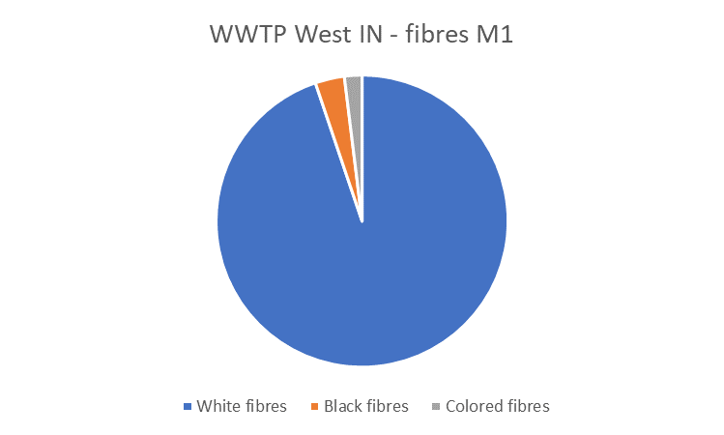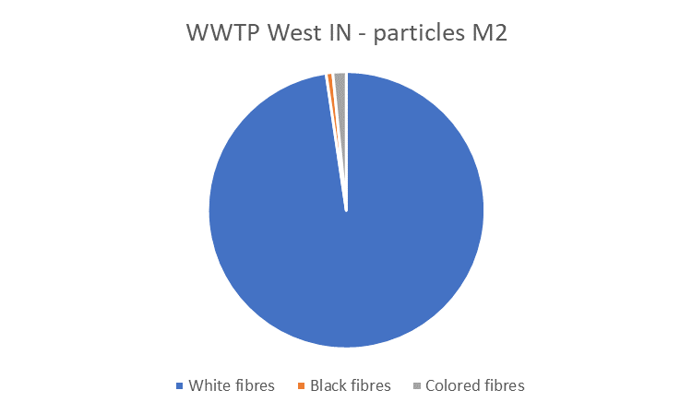
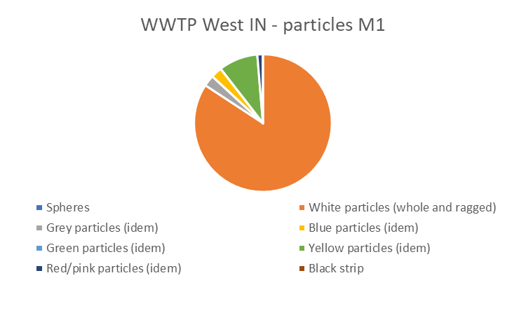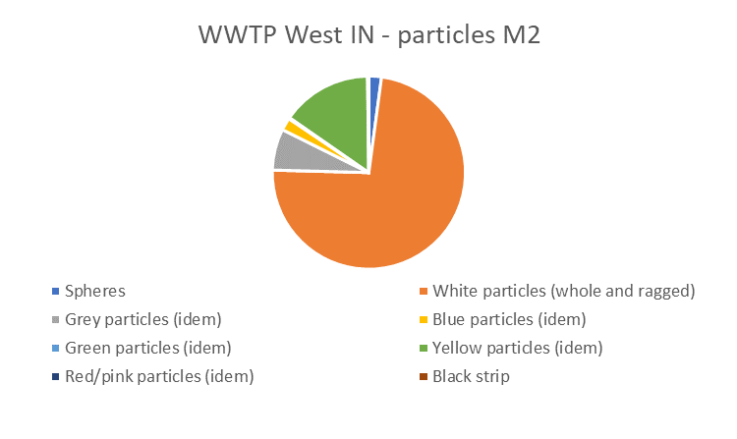

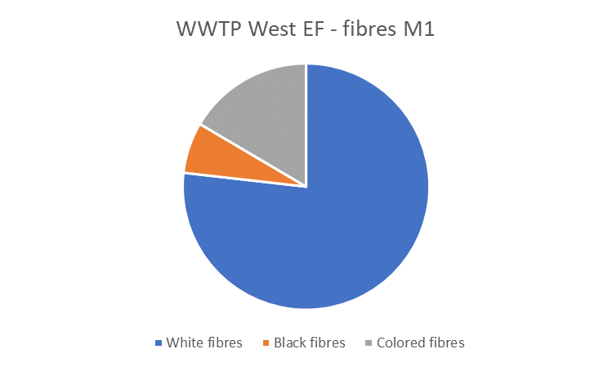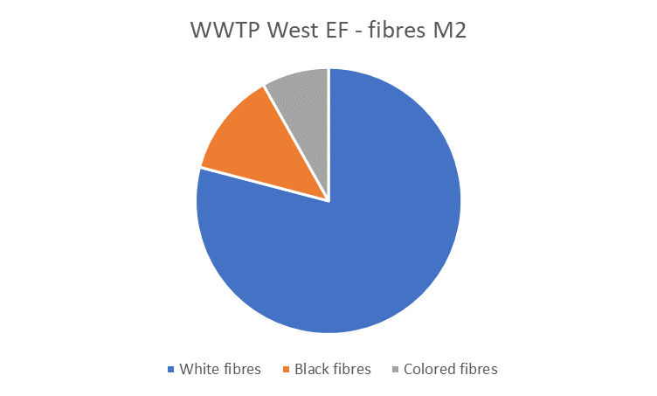

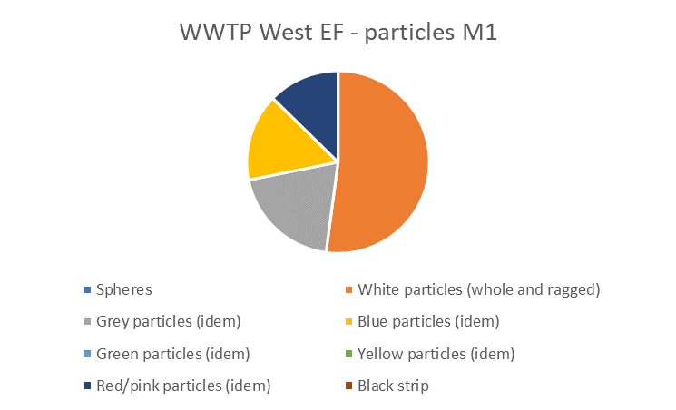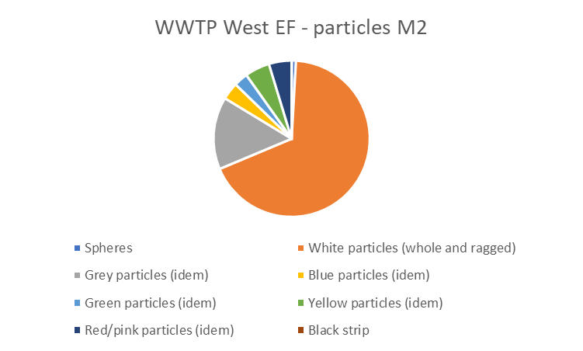

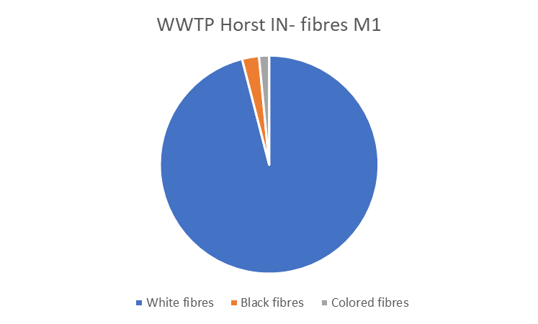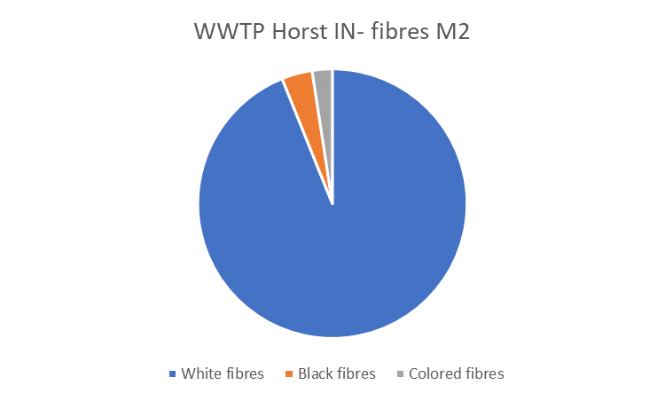

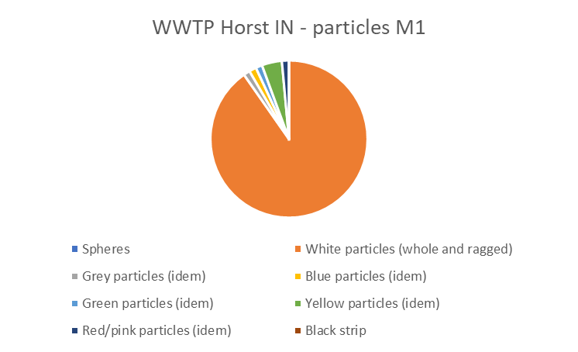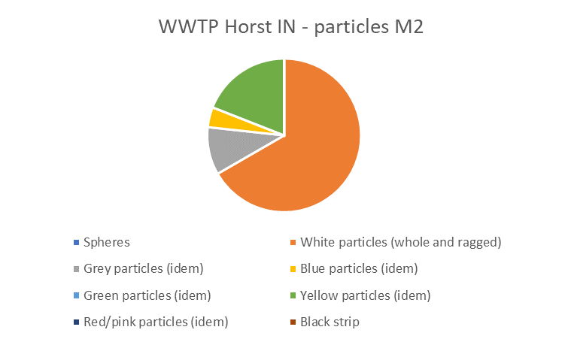

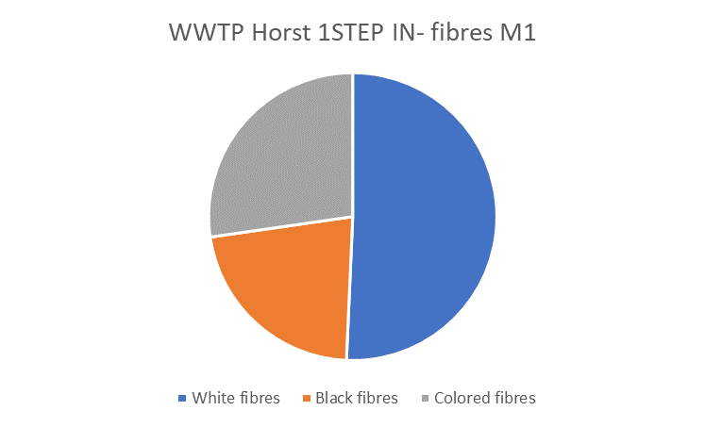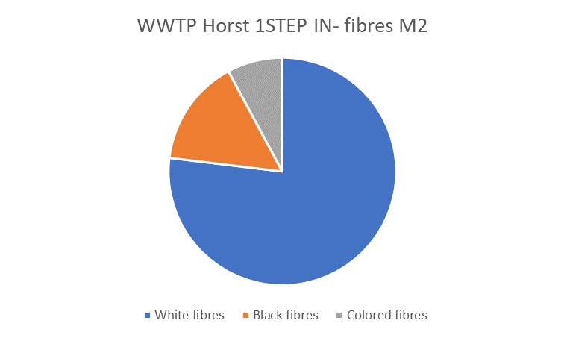

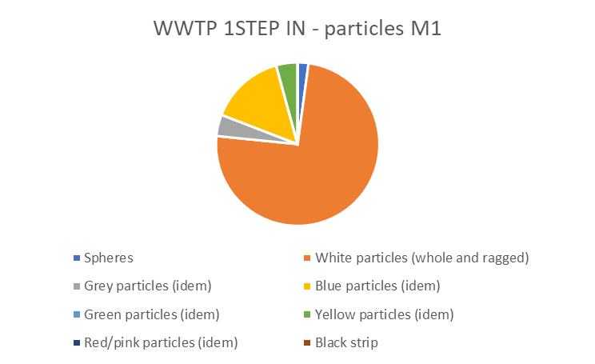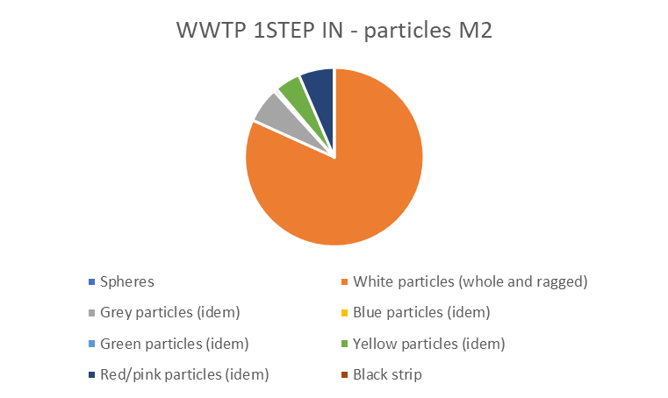

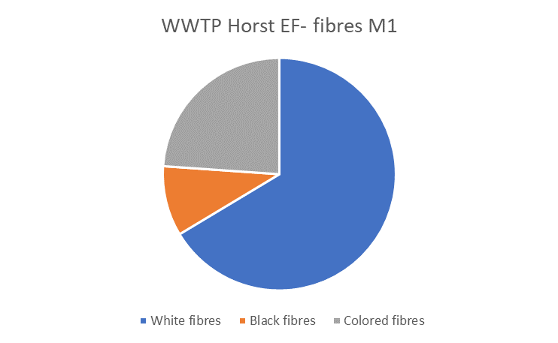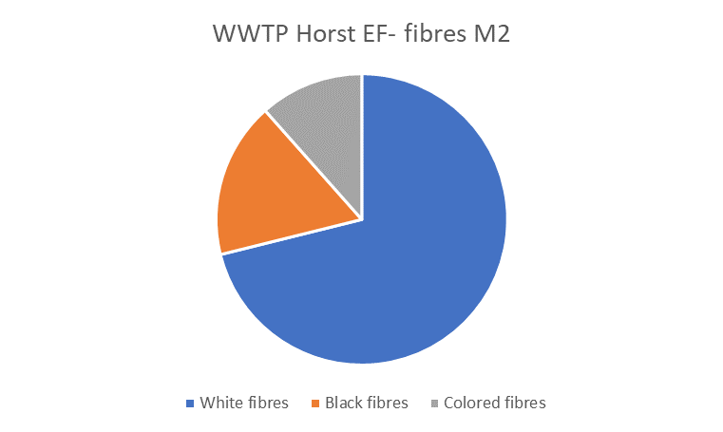

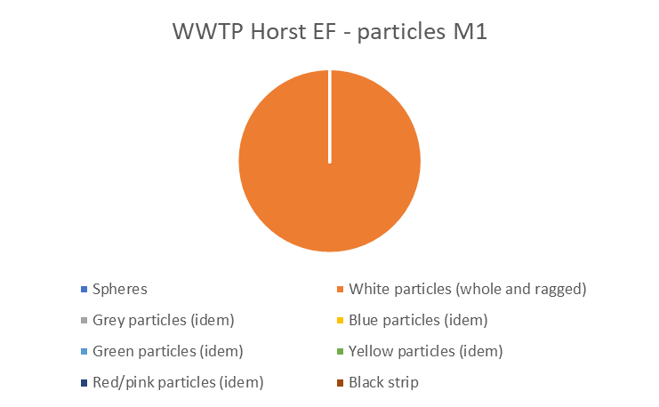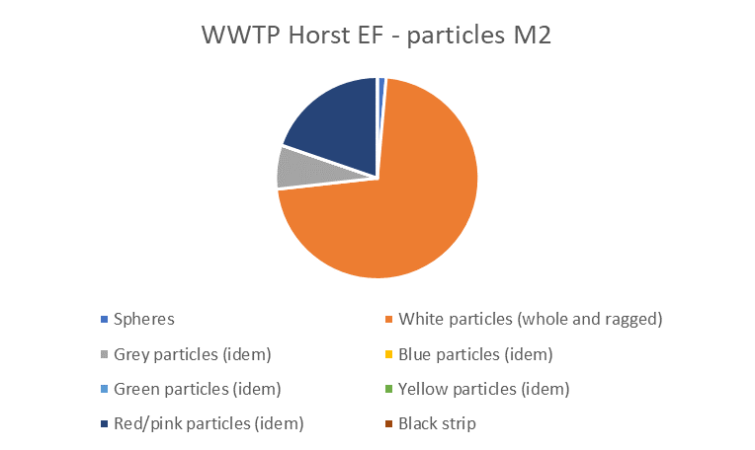

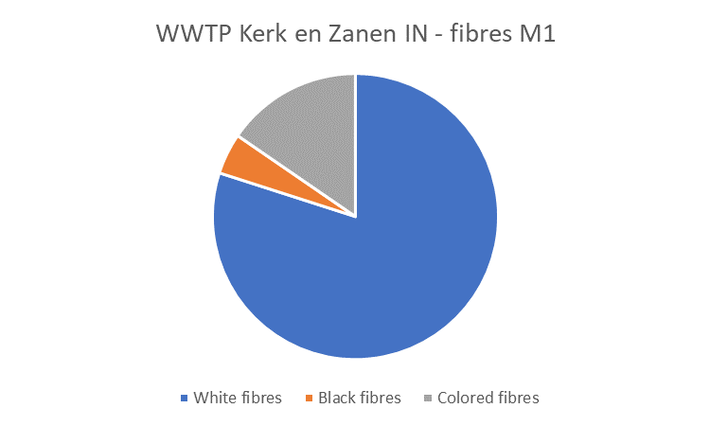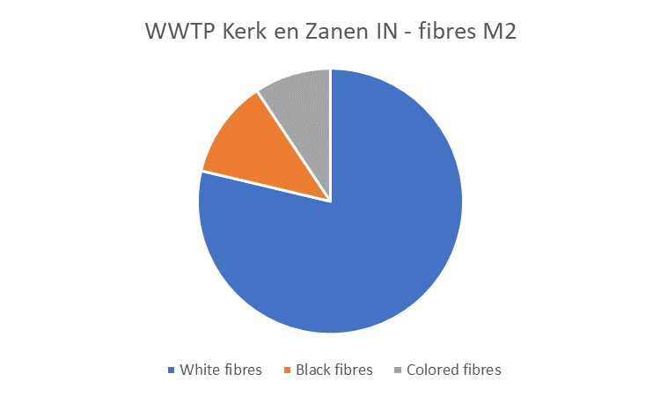

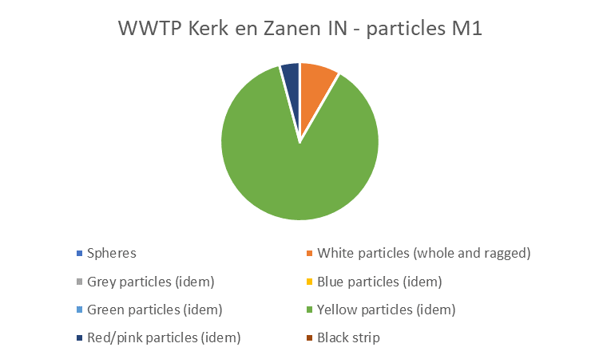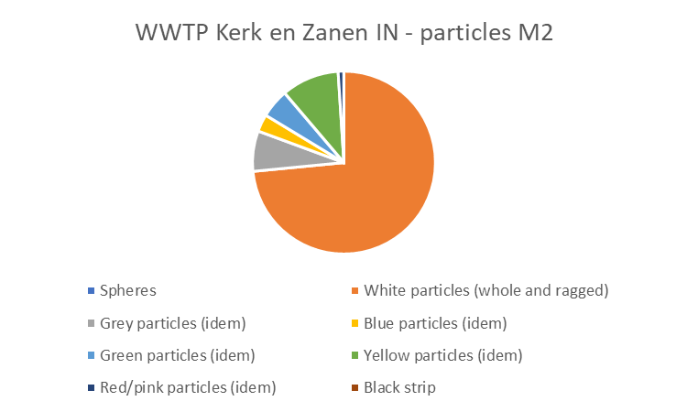

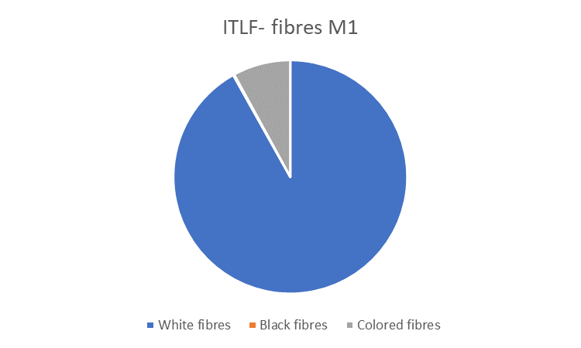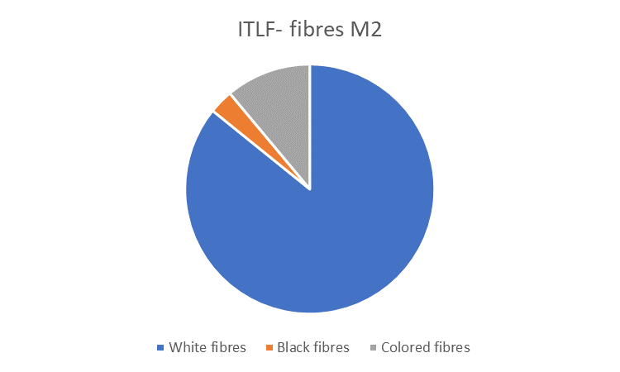

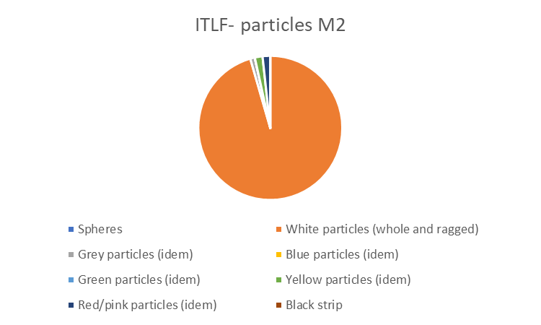
Not detected

