Figure S1: Normality plots for microplastic loading in aquatic organisms grouped by habitat
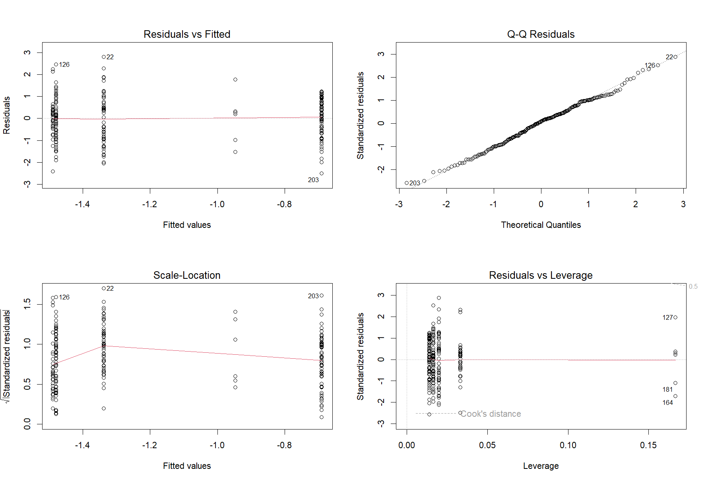

Figure S2: Normality plots for microplastic loading in aquatic organisms grouped by feeding strategy
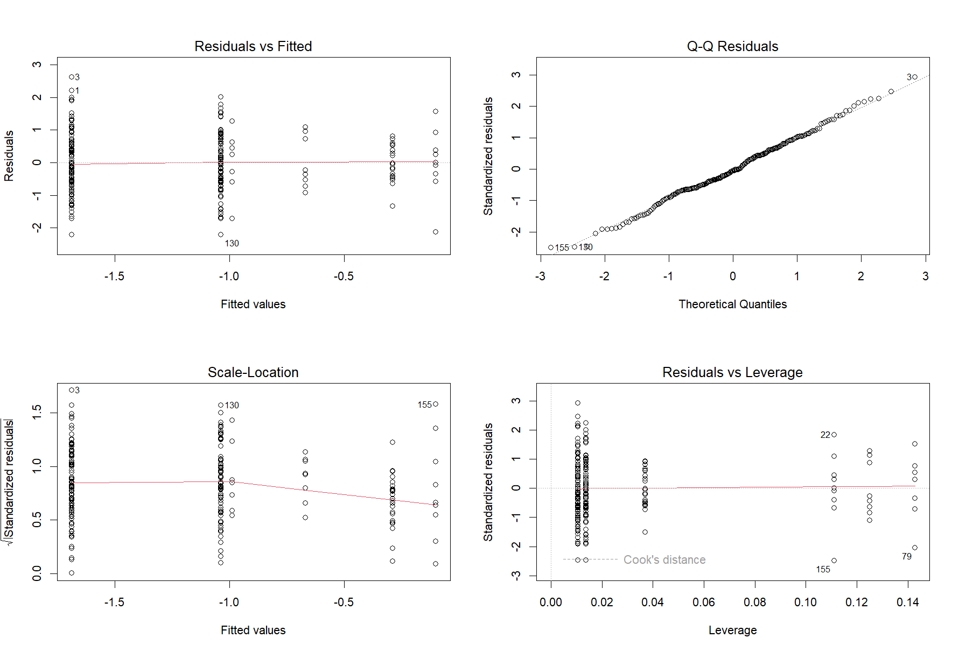

Figure S3: Normality plots for microfibre proportions in aquatic organisms grouped by environment
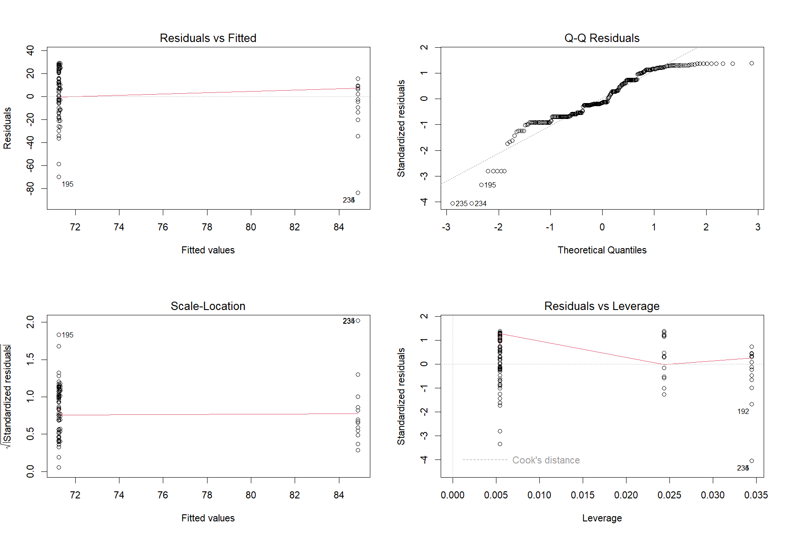

Figure S4: Normality plots for microfibre proportions in aquatic organisms grouped by habitat
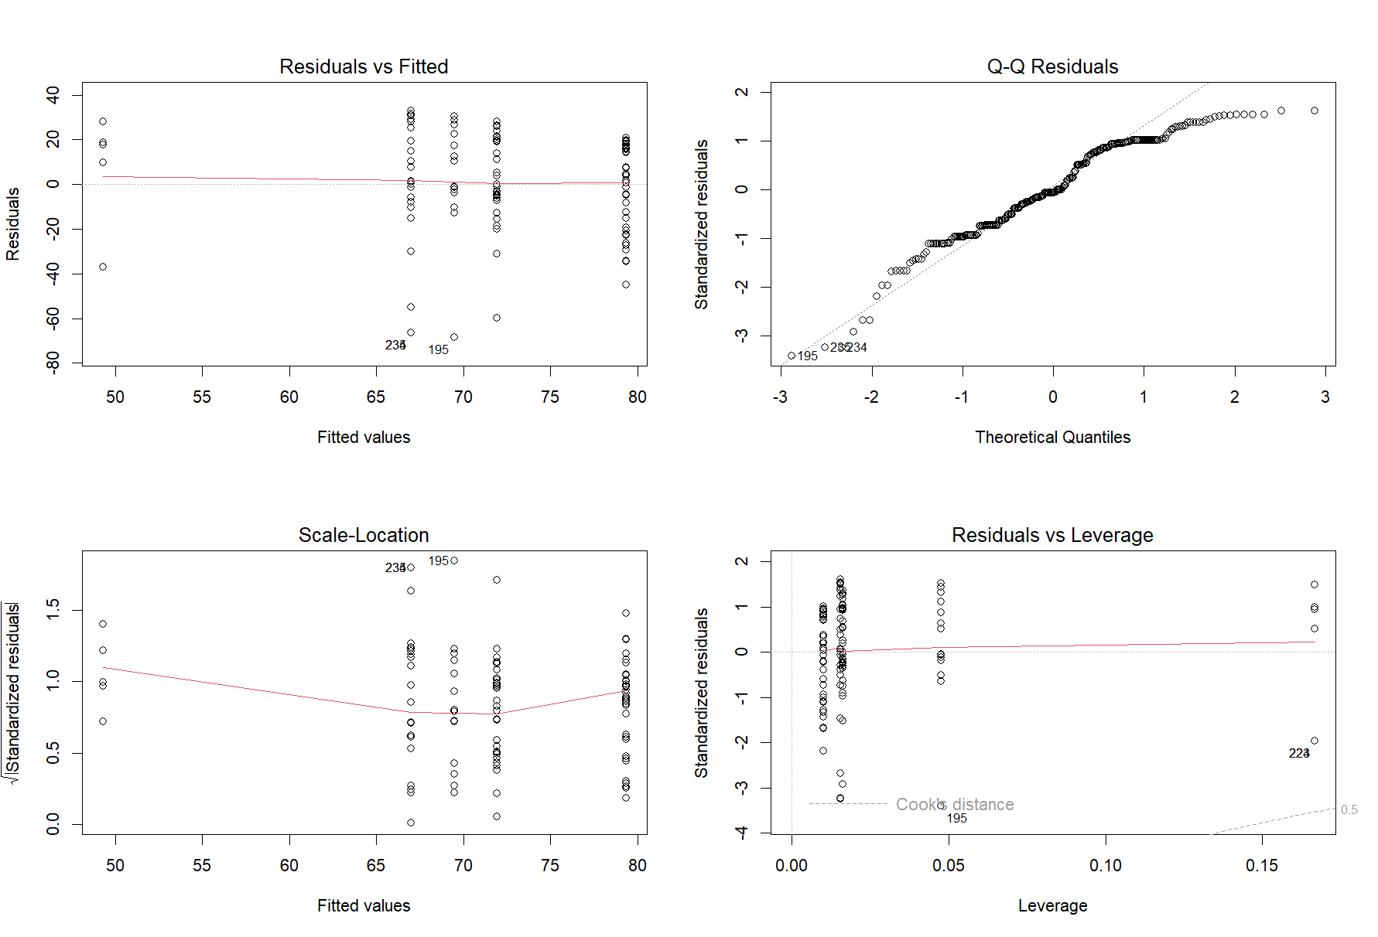

Figure S5: Normality plots for microfibre proportions in aquatic organisms grouped by feeding strategy
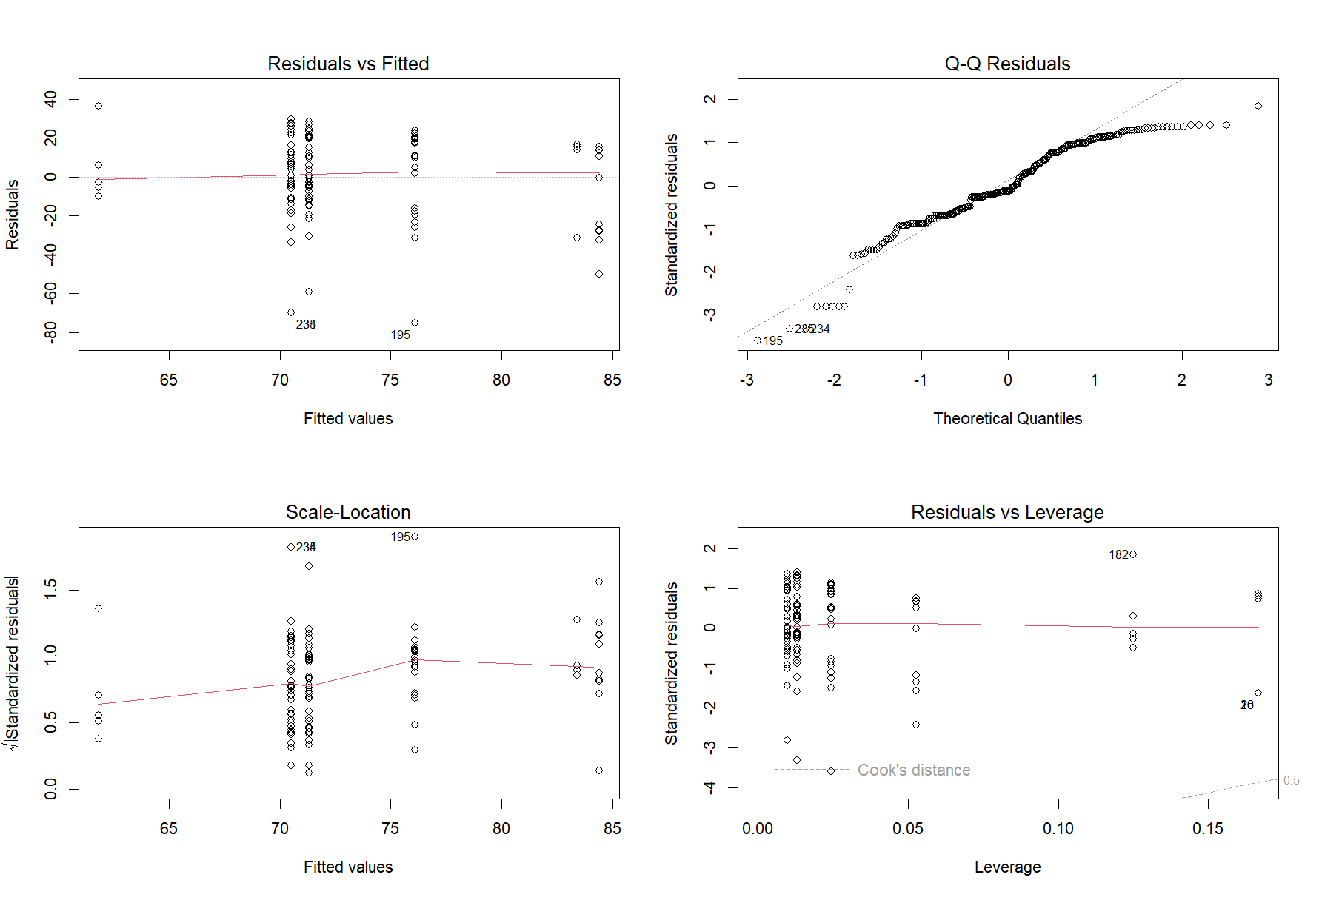

Figure S6: Normality plots for non-plastic particle proportions in aquatic organisms grouped by environment
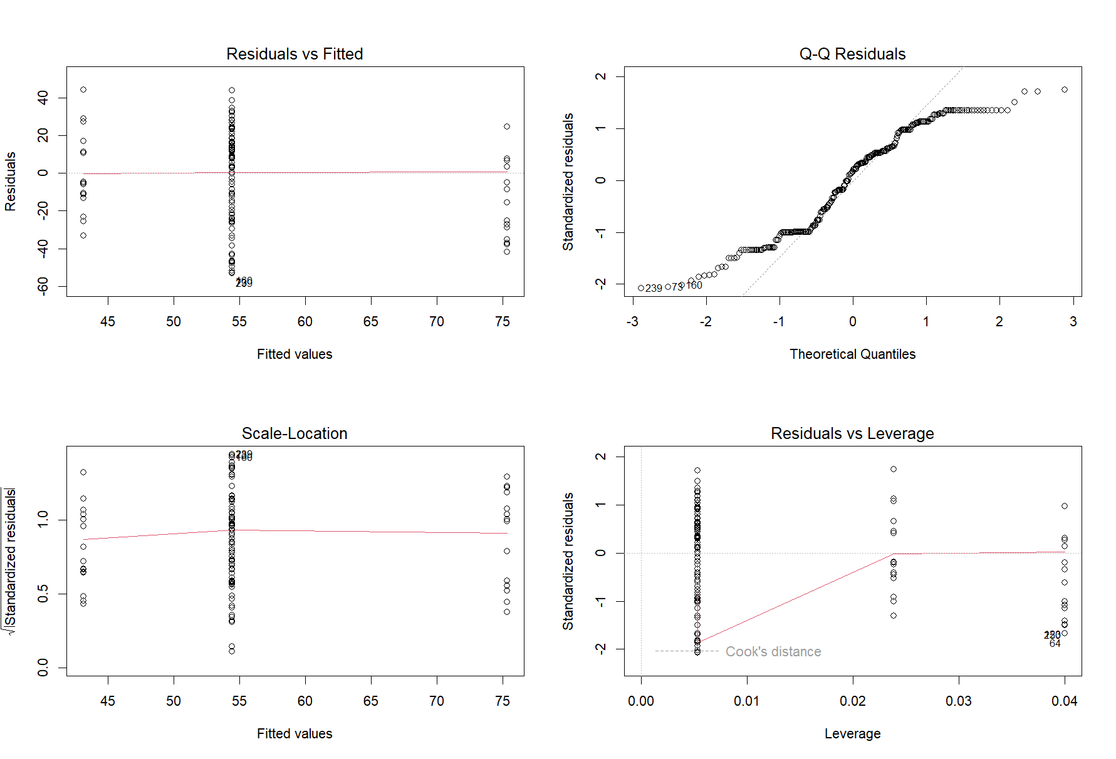

Figure S7: Normality plots for non-plastic particle proportions in aquatic organisms grouped by habitat
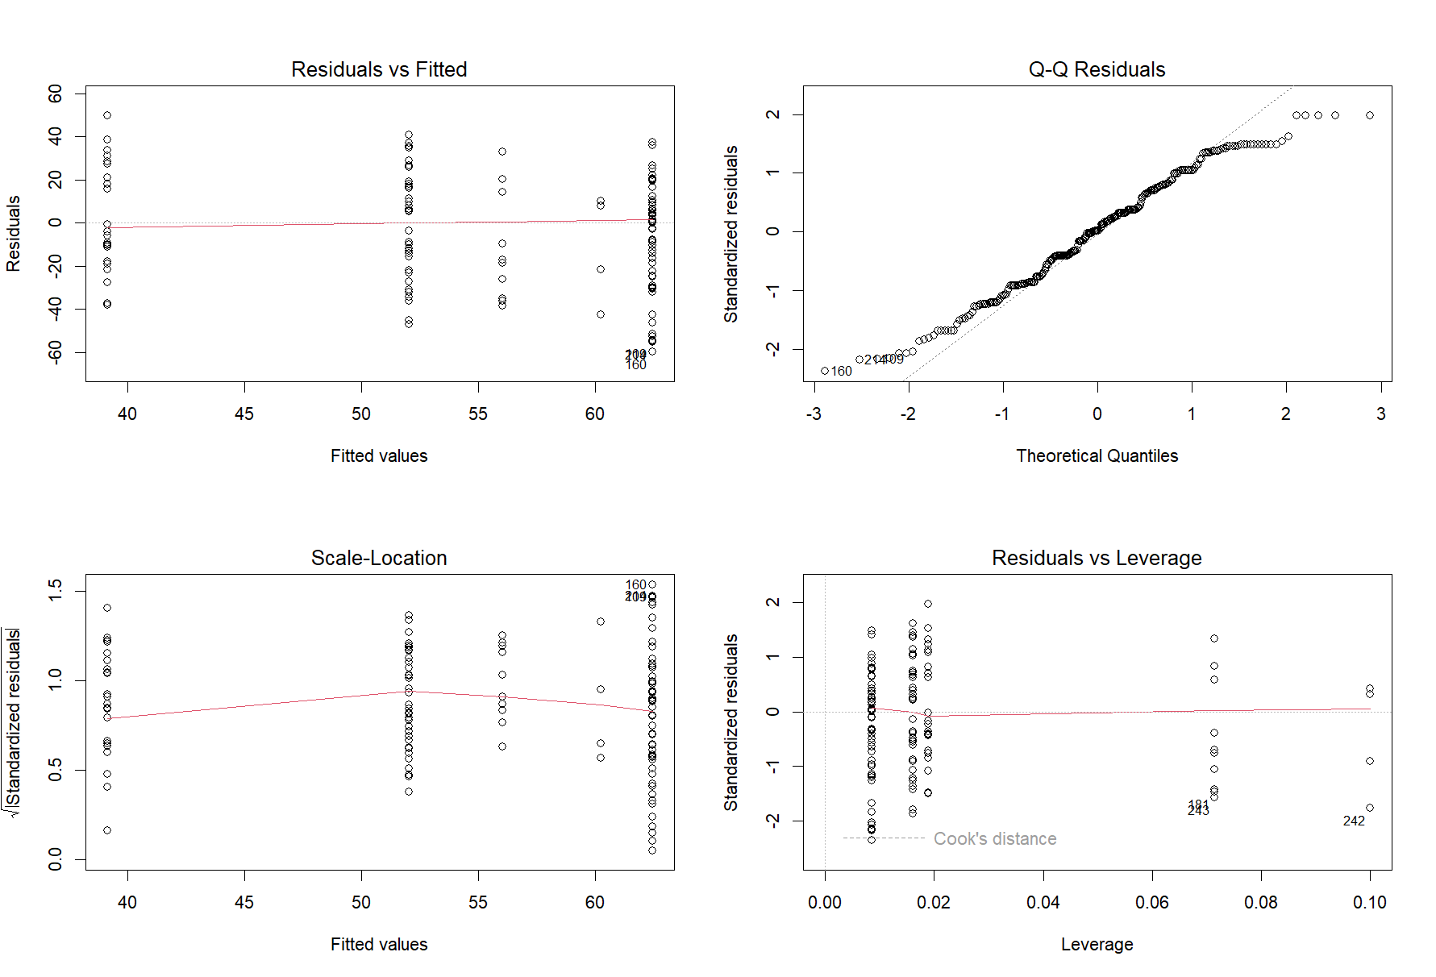

Microplastic loading and non-plastic particle proportions references
Aierken, R. et al. (2024) ‘Microplastics Prevalence in Different Cetaceans Stranded along the Western Taiwan Strait’, ANIMALS, 14(4). Available at: https://doi.org/10.3390/ani14040641.
Alomar, C. et al. (2017) ‘Microplastic ingestion by Mullus surmuletus Linnaeus, 1758 fish and its potential for causing oxidative stress’, Environmental Research, 159, pp. 135–142. Available at: https://doi.org/10.1016/j.envres.2017.07.043.
Aranda, D.A. et al. (2024) ‘A non-invasive method of microplastics pollution quantification in green sea turtle Chelonia mydas of the Mexican Caribbean’, Marine Pollution Bulletin, 200, p. 116092. Available at: https://doi.org/10.1016/j.marpolbul.2024.116092.
Athey, S.N. et al. (2020) ‘The Widespread Environmental Footprint of Indigo Denim Microfibers from Blue Jeans’, Environmental Science & Technology Letters, 7(11), pp. 840–847. Available at: https://doi.org/10.1021/acs.estlett.0c00498.
Athukorala, A. et al. (2024) ‘Pervasive Microplastic Ingestion by Commercial Fish Species from a Natural Lagoon Environment’, Water, 16(20). Available at: https://doi.org/10.3390/w16202909.
Avio, C.G. et al. (2020) ‘Distribution and characterization of microplastic particles and textile microfibers in Adriatic food webs: General insights for biomonitoring strategies’, Environmental Pollution, 258, p. 113766. Available at: https://doi.org/10.1016/j.envpol.2019.113766.
Aytan, U. et al. (2022) ‘Plastic Occurrence in Commercial Fish Species of the Black Sea’, Turkish Journal of Fisheries and Aquatic Sciences, 22(7). Available at: https://doi.org/10.4194/TRJFAS20504.
Baechler, B. et al. (2020) ‘Microplastic Exposure by Razor Clam Recreational Harvester-Consumers Along a Sparsely Populated Coastline’, Frontiers in Marine Science, 7. Available at: https://doi.org/10.3389/fmars.2020.588481.
Bertoli, M. et al. (2022) ‘Microplastics accumulation in functional feeding guilds and functional habit groups of freshwater macrobenthic invertebrates: Novel insights in a riverine ecosystem’, Science of the Total Environment, 804. Available at: https://doi.org/10.1016/j.scitotenv.2021.150207.
Bessa, F. et al. (2018) ‘Occurrence of microplastics in commercial fish from a natural estuarine environment’, Marine Pollution Bulletin, 128, pp. 575–584. Available at: https://doi.org/10.1016/j.marpolbul.2018.01.044.
Bottari, T. et al. (2022) ‘Anthropogenic microparticles in the emerald rockcod Trematomus bernacchii (Nototheniidae) from the Antarctic’, Scientific Reports, 12(1). Available at: https://doi.org/10.1038/s41598-022-21670-x.
Bråte, I. et al. (2018) ‘Mytilus spp. as sentinels for monitoring microplastic pollution in Norwegian coastal waters: A qualitative and quantitative study’, Environmental Pollution, 243, pp. 383–393. Available at: https://doi.org/10.1016/j.envpol.2018.08.077.
Carreras-Colom, E. et al. (2020) ‘A closer look at anthropogenic fiber ingestion in Aristeus antennatus in the NW Mediterranean Sea: Differences among years and locations and impact on health condition’, Environmental Pollution, 263. Available at: https://doi.org/10.1016/j.envpol.2020.114567.
Carreras-Colom, E. et al. (2022) ‘An affordable method for monitoring plastic fibre ingestion in Nephrops norvegicus (Linnaeus, 1758) and implementation on wide temporal and geographical scale comparisons’, Science of the Total Environment, 810. Available at: https://doi.org/10.1016/j.scitotenv.2021.152264.
Capillo, G. et al. (2020) ‘Quali-quantitative analysis of plastics and synthetic microfibers found in demersal species from Southern Tyrrhenian Sea (Central Mediterranean)’, Marine Pollution Bulletin, 150. Available at: https://doi.org/10.1016/j.marpolbul.2019.110596.
Chinfak, N. et al. (2021) ‘Abundance, composition, and fate of microplastics in water, sediment, and shellfish in the Tapi-Phumduang River system and Bandon Bay, Thailand’, Science of the Total Environment, 781. Available at: https://doi.org/10.1016/j.scitotenv.2021.146700.
Colombo, C.V. et al. (2023) ‘Microplastics in commercial seafood: Pleoticus muelleri as a case study in an estuarine environment highly affected by human pressure (Southwestern Atlantic).’, Environmental Research, 216. Available at: https://doi.org/10.1016/j.envres.2022.114738.
Compa, M. et al. (2018) ‘Ingestion of microplastics and natural fibres in Sardina pilchardus (Walbaum, 1792) and Engraulis encrasicolus (Linnaeus, 1758) along the Spanish Mediterranean coast’, Marine Pollution Bulletin, 128, pp. 89–96. Available at: https://doi.org/10.1016/j.marpolbul.2018.01.009.
Compa, M. et al. (2022) ‘Anthropogenic particles in the zooplankton aggregation layer and ingestion in fish species along the Catalan continental shelf’, Estuarine, Coastal and Shelf Science, 277, p. 108041. Available at: https://doi.org/10.1016/j.ecss.2022.108041.
Cossi, P. et al. (2021) ‘First evidence of microplastics in the Marine Protected Area Namuncura at Burdwood Bank, Argentina: a study on Henricia obesa and Odontaster penicillatus (Echinodermata: Asteroidea)’, Polar Biology, 44(12), pp. 2277–2287. Available at: https://doi.org/10.1007/s00300-021-02959-5.
Courtene-Jones, W. et al. (2017) ‘Microplastic pollution identified in deep-sea water and ingested by benthic invertebrates in the Rockall Trough, North Atlantic Ocean’, Environmental Pollution, 231, pp. 271–280. Available at: https://doi.org/10.1016/j.envpol.2017.08.026.
Courtene-Jones, W. et al. (2019) ‘Consistent microplastic ingestion by deep-sea invertebrates over the last four decades (1976–2015), a study from the North East Atlantic’, Environmental Pollution, 244, pp. 503–512. Available at: https://doi.org/10.1016/j.envpol.2018.10.090.
Courville, J.M. et al. (2024) ‘A Quantitative Analysis of Microplastics in the Gastrointestinal Tracts of Odontocetes in the Southeast Region of the United States’, Environmental Toxicology and Chemistry, 43(6), pp. 1260–1273. Available at: https://doi.org/10.1002/etc.5854.
Crutchett, T. et al. (2020) ‘Plastic Ingestion in Sardines (Sardinops sagax) From Frenchman Bay, Western Australia, Highlights a Problem in a Ubiquitous Fish’, Frontiers in Marine Science, 7. Available at: https://doi.org/10.3389/fmars.2020.00526.
Della Torre, C. et al. (2023) ‘First comparative assessment of contamination by plastics and non-synthetic particles in three bivalve species from an Italian sub-alpine lake’, Environmental Pollution, 330. Available at: https://doi.org/10.1016/j.envpol.2023.121752.
Dias, B. et al. (2024) ‘The Ecological Implication of Microplastic in Crabs from a Tropical Lagoon: Ingested Microplastic in Mud Crab Scylla serrata’, Water, 16(23). Available at: https://doi.org/10.3390/w16233534.
Ding, J. et al. (2021) ‘Microplastics in four bivalve species and basis for using bivalves as bioindicators of microplastic pollution’, Science of the Total Environment, 782. Available at: https://doi.org/10.1016/j.scitotenv.2021.146830.
Duncan, E. et al. (2019) ‘Microplastic ingestion ubiquitous in marine turtles’, Global Change Biology, 25(2), pp. 744–752. Available at: https://doi.org/10.1111/gcb.14519.
Ergas, M. et al. (2023) ‘Cellulosic and microplastic fibers in the Antarctic fish Harpagifer antarcticus and Sub-Antarctic Harpagifer bispinis’, Marine Pollution Bulletin, 194. Available at: https://doi.org/10.1016/j.marpolbul.2023.115380.
Fagiano, V. et al. (2024) ‘First assessment of anthropogenic particle ingestion in Pontellid copepods: Pontella mediterranea as a potential microplastic reservoir in the Neuston’, Science of the Total Environment, 908. Available at: https://doi.org/10.1016/j.scitotenv.2023.168480.
Garcia-Garin, O. et al. (2021) ‘Ingestion of synthetic particles by fin whales feeding off western Iceland in summer’, Chemosphere, 279, p. 130564. Available at: https://doi.org/10.1016/j.chemosphere.2021.130564.
Gedik, K. and Eryaşar, A.R. (2020) ‘Microplastic pollution profile of Mediterranean mussels (Mytilus galloprovincialis) collected along the Turkish coasts’, Chemosphere, 260. Available at: https://doi.org/10.1016/j.chemosphere.2020.127570.

González-Aravena, M. et al. (2024) ‘Detection of plastic, cellulosic micro-fragments and microfibers in Laternula elliptica from King George Island (Maritime Antarctica)’, Marine Pollution Bulletin, 201. Available at: https://doi.org/10.1016/j.marpolbul.2024.116257.
Halstead, J. et al. (2018) ‘Assessment tools for microplastics and natural fibres ingested by fish in an urbanised estuary’, Environmental Pollution 234, pp. 552–561. Available at: https://doi.org/10.1016/j.envpol.2017.11.085.
Hipfner, J.M. et al. (2018) ‘Two forage fishes as potential conduits for the vertical transfer of microfibres in Northeastern Pacific Ocean food webs’, Environmental Pollution, 239, pp. 215–222. Available at: https://doi.org/10.1016/j.envpol.2018.04.009.
Iliff, S.M. et al. (2020) ‘Evidence of microplastics from benthic jellyfish (Cassiopea xamachana) in Florida estuaries’, Marine Pollution Bulletin, 159, p. 111521. Available at: https://doi.org/10.1016/j.marpolbul.2020.111521.
Jahan, S. et al. (2019) ‘Interrelationship of microplastic pollution in sediments and oysters in a seaport environment of the eastern coast of Australia.’, The Science of the total environment, 695, p. 133924. Available at: https://doi.org/10.1016/j.scitotenv.2019.133924.
Jamieson, A. et al. (2019) ‘Microplastics and synthetic particles ingested by deep-sea amphipods in six of the deepest marine ecosystems on Earth’, Royal Scoiety Open Science, 6(2). Available at: https://doi.org/10.1098/rsos.180667.
Jiang, R. et al. (2023) ‘The “Journey” of Microplastics across the Marine Food Web in China’s Largest Fishing Ground’, Water (Switzerland), 15(3). Available at: https://doi.org/10.3390/w15030445.
Jitkaew, P. et al. (2023) ‘Occurrence of microplastics in freshwater gastropods from a tropical river U-Taphao, southern Thailand’, PeerJ, 11. Available at: https://doi.org/10.7717/peerj.14861.
Jitkaew, P. et al. (2024) ‘Microplastics in estuarine fish (Arius maculatus) from Songkhla Lagoon, Thailand’, Regional Studies in Marine Science, 69. Available at: https://doi.org/10.1016/j.rsma.2023.103342.
Jittalerk, R. and Babel, S. (2024) ‘Microplastic contamination in Thai vinegar crabs (Episesarma mederi), giant mudskippers (Periophthalmodon schlosseri), and their surrounding environment from the Bang Pu mangrove forests, Samut Prakan province, Thailand’, Marine Pollution Bulletin, 198. Available at: https://doi.org/10.1016/j.marpolbul.2023.115849.
Lim, Y.C. et al. (2022) ‘Impacts of microplastics on scleractinian corals nearshore Liuqiu Island southwestern Taiwan’, Environmental Pollution, 306, p. 119371. Available at: https://doi.org/10.1016/j.envpol.2022.119371.

Lim, K. et al. (2023) ‘First evidence of microplastic ingestion by crescent perch (Terapon jarbua) in Malaysia’, Regional studies in Marine Science, 67. Available at: https://doi.org/10.1016/j.rsma.2023.103202.
Lopes, C. et al. (2023) ‘First evidence of microplastic ingestion in the ocean giant sunfish (Mola mola)’, Marine Environmental Research 190. Available at: https://doi.org/10.1016/j.marenvres.2023.106064.
López-Martínez, S., Perez-Rubín, C., Gavara, R., Handcock, R.N. and Rivas, M.L., 2022. ‘Presence and implications of plastics in wild commercial fishes in the Alboran Sea (Mediterranean Sea)’. Science of The Total Environment, 850, p.158025. Available at: https://doi.org/10.1016/j.scitotenv.2022.158027
Lourenço, P.M. et al. (2017) ‘Plastic and other microfibers in sediments, macroinvertebrates and shorebirds from three intertidal wetlands of southern Europe and west Africa.’, Environmental Pollution, 231, pp. 123–133. Available at: https://doi.org/10.1016/j.envpol.2017.07.103.
Lu, H.-C. et al. (2024) ‘Microplastics and other anthropogenic fibres in large apex shark species: Abundance, characteristics, and recommendations for future research’, Chemosphere, 349. Available at: https://doi.org/10.1016/j.chemosphere.2023.140957.
Lusher, A.L., McHugh, M. and Thompson, R.C. (2013) ‘Occurrence of microplastics in the gastrointestinal tract of pelagic and demersal fish from the English Channel’, Marine Pollution Bulletin, 67(1), pp. 94–99. Available at: https://doi.org/10.1016/j.marpolbul.2012.11.028.
Macieira, R. et al. (2021) ‘Microplastic and artificial cellulose microfibers ingestion by reef fishes in the Guarapari Islands, southwestern Atlantic’, Marine Pollution bulletin, 167. Available at: https://doi.org/10.1016/j.marpolbul.2021.112371.
Malloggi, C. et al. (2024) ‘The Occurrence of Microplastics in Donax trunculus (Mollusca: Bivalvia) Collected along the Tuscany Coast (Mediterranean Sea)’, Animals, 14(4). Available at: https://doi.org/10.3390/ani14040618.
Malthaner, L. et al. (2024) ‘First Data on Anthropogenic Microparticles in the Gastrointestinal Tract of Juvenile Scalloped Hammerhead Sharks (Sphyrna lewini) in the Gulf of California’, Fishes, 9(8). Available at: https://doi.org/10.3390/fishes9080310.
Mancuso, M. et al. (2023) ‘Monitoring of anthropogenic microplastic pollution in antarctic fish (emerald rockcod) from the Terranova Bay after a quarter of century.’, Science of the Total Environment, 904, p. 167244. Available at: https://doi.org/10.1016/j.scitotenv.2023.167244.
Marques, F. et al. (2021) ‘Major characteristics of microplastics in mussels from the Portuguese coast’, Environmental Research, 197. Available at: https://doi.org/10.1016/j.envres.2021.110993.
Martinez-Tavera, E. et al. (2021) ‘Microplastics and metal burdens in freshwater Tilapia (Oreochromis niloticus) of a metropolitan reservoir in Central Mexico: Potential threats for human health’, Chemosphere, 266. Available at: https://doi.org/10.1016/j.chemosphere.2020.128968.
Mboglen, D. et al. (2024) ‘First report of plastic and non-plastic microparticles in stomach of slandertail lanternshark and shortspine spurdog from the edge of East China Sea’, Marine Pollution Bulletin, 204. Available at: https://doi.org/10.1016/j.marpolbul.2024.116531.
McGoran, A. et al. (2020) ‘High prevalence of plastic ingestion by Eriocheir sinensis and Carcinus maenas (Crustacea: Decapoda: Brachyura) in the Thames Estuary’, Environmental Pollution, 265. Available at: https://doi.org/10.1016/j.envpol.2020.114972.
McGoran, A. et al. (2021) ‘Synthetic and Semi-Synthetic Microplastic Ingestion by Mesopelagic Fishes From Tristan da Cunha and St Helena, South Atlantic’, Frontiers in Marine Science, 8. Available at: https://doi.org/10.3389/fmars.2021.633478.
Morais, L. et al. (2020) ‘The sea anemone Bunodosoma cangicum as a potential biomonitor for microplastics contamination on the Brazilian Amazon coast’, Environmental Pollution, 265. Available at: https://doi.org/10.1016/j.envpol.2020.114817.
Munno, K. et al. (2024) ‘High microplastic and anthropogenic particle contamination in the gastrointestinal tracts of tiger sharks (Galeocerdo cuvier) caught in the western North Atlantic Ocean.’, Environmental Pollution, 344, p. 123185. Available at: https://doi.org/10.1016/j.envpol.2023.123185.
Muns-Pujadas, L. et al. (2023) ‘Revealing the capability of the European hake to cope with micro-litter environmental exposure and its inferred potential health impact in the NW Mediterranean Sea’, Marine Environmental Research, 186. Available at: https://doi.org/10.1016/j.marenvres.2023.105921.
Murano, C. et al. (2022) ‘Occurrence of microfibres in wild specimens of adult sea urchin Paracentrotus lividus (Lamarck, 1816) from a coastal area of the central Mediterranean Sea’, Marine Pollution Bulletin, 176. Available at: https://doi.org/10.1016/j.marpolbul.2022.113448.
My, T., Dat, N. and Hung, N. (2023) ‘Occurrence and Characteristics of Microplastics in Wild and Farmed Shrimps Collected from Cau Hai Lagoon, Central Vietnam’, Molecules, 28(12). Available at: https://doi.org/10.3390/molecules28124634.
Naidoo, T. et al. (2020) ‘Quantification and characterisation of microplastics ingested by selected juvenile fish species associated with mangroves in KwaZulu-Natal, South Africa’, Environmental Pollution, 257. Available at: https://doi.org/10.1016/j.envpol.2019.113635.
Nan, B. et al. (2020) ‘Identification of microplastics in surface water and Australian freshwater shrimp Paratya australiensis in Victoria, Australia’, Environmental Pollution, 259. Available at: https://doi.org/10.1016/j.envpol.2019.113865.
Neves, D. et al. (2015) ‘Ingestion of microplastics by commercial fish off the Portuguese coast’, Marine Pollution Bulletin, 101(1), pp. 119–126. Available at: https://doi.org/10.1016/j.marpolbul.2015.11.008.
Nunes, L. et al. (2021) ‘Intake of microplastics by commercial fish: A Bayesian approach’, Environmental Monitoring and Assessment, 193(7). Available at: https://doi.org/10.1007/s10661-021-09156-1.
Ojeda, M. et al. (2021) ‘Microplastics pollution in the intertidal limpet, Nacella magellanica, from Beagle Channel (Argentina)’, Science of the Total Environment, 795. Available at: https://doi.org/10.1016/j.scitotenv.2021.148866.
Ojeda, M. et al. (2024) ‘Microplastic ingestion in key fish species of food webs in the Southwest Atlantic (Marine Protected Area Namuncura / Burdwood Bank)’, Aquatic Toxicology, 267. Available at: https://doi.org/10.1016/j.aquatox.2023.106827.Páez-Osuna, F. et al. (2023) ‘Microplastics and heavy metals in shrimp Litopenaeus vannamei from the SAMARE lagoon, Gulf of California: Is it a case of combined MPs-Zn pollution in gills?’, Environmental Pollution, 336. Available at: https://doi.org/10.1016/j.envpol.2023.122479.
Oldenburg, K.S. et al. (2021) ‘Microfiber abundance associated with coral tissue varies geographically on the Belize Mesoamerican Barrier Reef System’, Marine Pollution Bulletin, 163, p. 111938. Available at: https://doi.org/10.1016/j.marpolbul.2020.111938.
Páez-Osuna, F. et al. (2023) ‘Microplastics and heavy metals in shrimp Litopenaeus vannamei from the SAMARE lagoon, Gulf of California: Is it a case of combined MPs-Zn pollution in gills?’, Environmental Pollution, 336, p. 122479. Available at: https://doi.org/10.1016/j.envpol.2023.122479.
Pagter, E. et al. (2020) ‘Differences in microplastic abundances within demersal communities highlight the importance of an ecosystem-based approach to microplastic monitoring’, Marine Pollution Bulletin, 160. Available at: https://doi.org/10.1016/j.marpolbul.2020.111644.
Parton, K. et al. (2020) ‘Investigating the presence of microplastics in demersal sharks of the North-East Atlantic’, Scientific Reports, 10(1). Available at: https://doi.org/10.1038/s41598-020-68680-1.
Pereira, R. et al. (2023) ‘Microplastic contamination in large migratory fishes collected in the open Atlantic Ocean’, Marine Pollution Bulletin, 186. Available at: https://doi.org/10.1016/j.marpolbul.2022.114454.
Pérez, A.F., Ojeda, M., Rimondino, G.N., Chiesa, I.L., Di Mauro, R., Boy, C.C. and Calcagno, J.A., 2020. ‘First report of microplastics presence in the mussel Mytilus chilensis from Ushuaia Bay (Beagle Channel, Tierra del Fuego, Argentina)’. Marine Pollution Bulletin, 161, p.111753. Available at: https://doi.org/10.1016/j.marpolbul.2020.111753.
Pittura, L. et al. (2022) ‘Microplastics and Brominated Flame Retardants in Freshwater Fishes From Italian Lakes: Implication for Human Health’, Frontiers in Water, 4. Available at: https://doi.org/10.3389/frwa.2022.902885.
Qu, J. et al. (2022) ‘Microplastics in Seawater, Sediment, and Organisms from Hangzhou Bay’, Marine Pollution Bulletin, 181. Available at: https://doi.org/10.1016/j.marpolbul.2022.113940.
Rapp, J. et al. (2021) ‘Microplastic ingestion in jellyfish Pelagia noctiluca (Forsskal, 1775) in the North Atlantic Ocean’, Marine Pollution Bulletin, 166. Available at: https://doi.org/10.1016/j.marpolbul.2021.112266.
Rasta, M. et al. (2021) ‘Microplastics in different tissues of some commercially important fish species from Anzali Wetland in the Southwest Caspian Sea, Northern Iran’, Marine Pollution Bulletin, 169. Available at: https://doi.org/10.1016/j.marpolbul.2021.112479.
Renzi, M. et al. (2020) ‘Litter in alien species of possible commercial interest: The blue crab (Callinectes sapidus Rathbun, 1896) as case study’, Marine Pollution Bulletin, 157. Available at: https://doi.org/10.1016/j.marpolbul.2020.111300.
Riani, E. and Cordova, M.R. (2022) ‘Microplastic ingestion by the sandfish Holothuria scabra in Lampung and Sumbawa, Indonesia’, Marine Pollution Bulletin, 175. Available at: https://doi.org/10.1016/j.marpolbul.2021.113134.
Ribeiro, V.V. et al. (2023) ‘Oysters and mussels as equivalent sentinels of microplastics and natural particles in coastal environments’, Science of The Total Environment, 874, p. 162468. Available at: https://doi.org/10.1016/j.scitotenv.2023.162468.
Robin, R. et al. (2020) ‘Holistic assessment of microplastics in various coastal environmental matrices, southwest coast of India’, Science of the Total Environment, 703. Available at: https://doi.org/10.1016/j.scitotenv.2019.134947.
Rodríguez-Romeu, O. et al. (2020) ‘Are anthropogenic fibres a real problem for red mullets (Mullus barbatus) from the NW Mediterranean?’, Science of the Total Environment, 733. Available at: https://doi.org/10.1016/j.scitotenv.2020.139336.
Sánchez-Guerrero-Hernández, M.J. et al. (2023) ‘Contamination from microplastics and other anthropogenic particles in the digestive tracts of the commercial species Engraulis encrasicolus and Sardina pilchardus.’, Science of the Total Environment, 860, p. 160451. Available at: https://doi.org/10.1016/j.scitotenv.2022.160451.

Santonicola, S. et al. (2023) ‘Research and characterization of fibrous microplastics and natural microfibers in pelagic and benthic fish species of commercial interest’, Italian Journal of Food Safety, 12(1). Available at: https://doi.org/10.4081/ijfs.2023.11032.
Savoca, S. et al. (2019) ‘Detection of artificial cellulose microfibers in Boops boops from the northern coasts of Sicily (Central Mediterranean)’, Science of The Total Environment, 691, pp. 455–465. Available at: https://doi.org/10.1016/j.scitotenv.2019.07.148.
Savoca, S. et al. (2020) ‘Plastics occurrence in juveniles of Engraulis encrasicolus and Sardina pilchardus in the Southern Tyrrhenian Sea’, Science of the Total Environment, 718. Available at: https://doi.org/10.1016/j.scitotenv.2020.137457.
Scott, N. et al. (2019) ‘Particle characteristics of microplastics contaminating the mussel Mytilus edulis and their surrounding environments’, Marine Pollution Bulletin, 146, pp. 125–133. Available at: https://doi.org/10.1016/j.marpolbul.2019.05.041.
Scotti, G. et al. (2023) ‘Anthropogenic fibers and microplastics in the pelagic gooseneck barnacle Lepas (Lepas) anatifera in Capo Milazzo Marine Protected Area (Tyrrhenian Sea): A first characterization’, Ecological Indicators, 152. Available at: https://doi.org/10.1016/j.ecolind.2023.110368.
Selvam, S. et al. (2021) ‘Microplastics and trace metals in fish species of the Gulf of Mannar (Indian Ocean) and evaluation of human health’, Environmental Pollution, 291. Available at: https://doi.org/10.1016/j.envpol.2021.118089.
Severini, M. et al. (2020) ‘Chemical composition and abundance of microplastics in the muscle of commercial shrimp Pleoticus muelleri at an impacted coastal environment (Southwestern Atlantic)’, Marine Pollution Bulletin, 161. Available at: https://doi.org/10.1016/j.marpolbul.2020.111700.
Sevillano-González, M. et al. (2022) ‘Assessment of microplastic content in Diadema africanum sea urchin from Tenerife (Canary Islands, Spain)’, Marine Pollution Bulletin, 175. Available at: https://doi.org/10.1016/j.marpolbul.2021.113174.
Tang, R. et al. (2022) ‘Microplastics in commercial clams from the intertidal zone of the South Yellow Sea, China’, Frontiers in Marine Science, 9. Available at: https://doi.org/10.3389/fmars.2022.905923.
Tee-hor, K., Nitiratsuwan, T. and Pradit, S. (2023) ‘Identification of anthropogenic debris in the stomach and intestines of giant freshwater prawns from the Trang River in southern Thailand’, PeerJ, 11. Available at: https://doi.org/10.7717/peerj.16082.
Tee-Hor, K., Nitiratsuwan, T. and Pradit, S. (2024) ‘Microplastic Contamination in the Tissue of Giant Freshwater Prawns Macrobrachium rosenbergii, Thailand’, Trends in Sciences, 21(3). Available at: https://doi.org/10.48048/tis.2024.7302.
Trindade, P. et al. (2023) ‘First record of plastic ingestion by a freshwater stingray’, Science of the Total Environment 880. Available at: https://doi.org/10.1016/j.scitotenv.2023.163199.
Truchet, D. et al. (2021) ‘Microplastics in bivalves, water and sediments from a touristic sandy beach of Argentina’, Marine Pollution Bulletin, 173. Available at: https://doi.org/10.1016/j.marpolbul.2021.113023.
Tsangaris, C. et al. (2020) ‘Using Boops boops (osteichthyes) to assess microplastic ingestion in the Mediterranean Sea’, Marine Pollution Bulletin, 158, p. 111397. Available at: https://doi.org/10.1016/j.marpolbul.2020.111397.
Vasanthi, R. et al. (2021) ‘Ingestion of microplastics and its potential for causing structural alterations and oxidative stress in Indian green mussel Perna viridis- A multiple biomarker approach’, Chemosphere, 283. Available at: https://doi.org/10.1016/j.chemosphere.2021.130979.
Wei, L., Wang, D., Aierken, R., Wu, F., Dai, Y., Wang, X., Fang, C., Zhao, L. and Zhen, Y., 2022. ‘The prevalence and potential implications of microplastic contamination in marine fishes from Xiamen Bay, China’. Marine Pollution Bulletin, 174, p.113306. Available at: https://doi.org/10.1016/j.marpolbul.2021.113306
Weir, E.M. et al. (2024) ‘Microparticles in Wild and Caged Biota, Sediments, and Water Relative to Large Municipal Wastewater Treatment Plant Discharges’, Environmental Toxicology and Chemistry, 43(5), pp. 1047–1061. Available at: https://doi.org/10.1002/etc.5836.
Wu, F. et al. (2023) ‘Microplastic contamination in the dominant crabs at the intertidal zone of Chongming Island, Yangtze Estuary’, Science of the Total Environment, 896. Available at: https://doi.org/10.1016/j.scitotenv.2023.165258.
Xu, X. et al. (2020) ‘Barnacles as potential bioindicator of microplastic pollution in Hong Kong’, Marine Pollution Bulletin, 154. Available at: https://doi.org/10.1016/j.marpolbul.2020.111081.

