Supplemental materials for “Size-specific distribution, morphology, and polymer composition of microplastic particles in surface water and sediments of Tokyo Bay”
Koji Ueda^{1, *}, Yutaka Kameda², Emiko Fujita², Gakushi Fujimura², Eiji Fukazawa², Yutaro Numazawa², Yuichi Iwasaki¹, Wataru Naito^{1, *}
¹Integrated Research Center for Nature Positive Technology, National Institute of Advanced Industrial Science and Technology (AIST), 16-1 Onogawa, Tsukuba, Ibaraki 305-8569, Japan
²Department of Civil and Environmental Engineering, Faculty of Creative Engineering, Chiba Institute of Technology (CIT), 2-17-1 Tsudanuma, Narashino, Chiba 275-0016, Japan
*Corresponding authors: Koji Ueda (ueda.koji@aist.go.jp), Wataru Naito (w-naito@aist.go.jp)

Fig. S1 Images of the glass vacuum filter holder (KG-25, Advantec, Japan) used for vacuum filtration. (a) Assembled view showing the connection to the upper reservoir. (b) Top view showing the PTFE gasket (arrows).
Fig. S2 Custom-designed stainless-steel plates used for drying PTFE membranes to prevent particle loss and membrane deformation such as curling.
Table S1 Research vessels used for microplastic particles sampling in Tokyo Bay during October–November 2023.
Table S2 Polymer types identified in this study and their density ranges.
Table S3 Summary of previous studies on microplastic particles collected from the surface water of Tokyo Bay.
Table S4 Size-fractionated concentrations and composition of microplastic particles in surface water samples collected from eight stations in Tokyo Bay in 2023, based on measured particle counts and estimated particle mass.
Table S5 Size-specific morphological composition of microplastic particles in surface water samples collected from eight stations in Tokyo Bay in 2023.
Table S6 Relative composition of microplastic polymer types by particle count in surface water samples collected from eight stations in Tokyo Bay during October–November 2023.
Table S7 Relative composition of microplastic polymer types by estimated mass in surface water samples collected from eight stations in Tokyo Bay during October–November 2023.
Table S8 Summary of previous studies on microplastic particles in sediment samples from Tokyo Bay.
Table S9 Size-fractionated concentrations and composition of microplastic particles in sediment samples collected from eight stations in Tokyo Bay in 2023, based on measured particle counts and estimated particle mass.
Table S10 Size-specific morphological composition of microplastic particles in sediment samples collected from eight stations in Tokyo Bay in 2023.
Table S11 Relative composition of microplastic polymer types by particle count in sediment samples collected from eight stations in Tokyo Bay during October–November 2023.
Table S12 Relative composition of microplastic polymer types by estimated mass in sediment samples collected from eight stations in Tokyo Bay during October–November 2023.

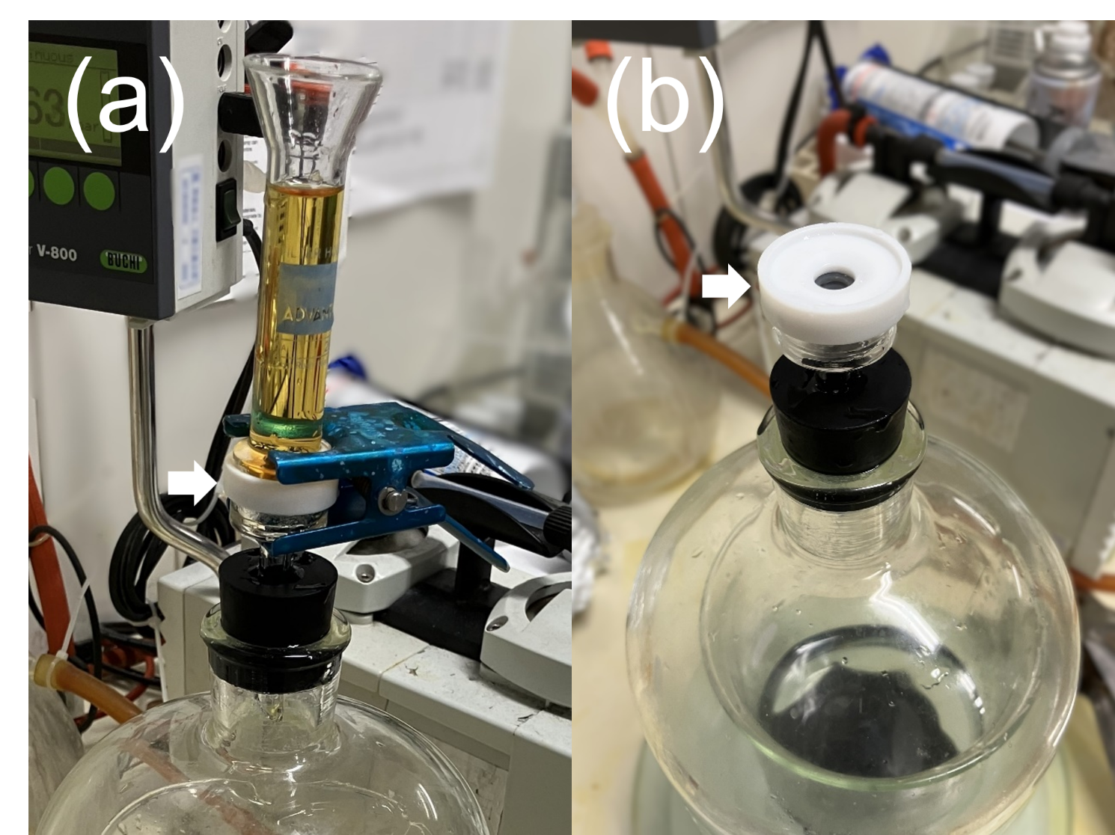

Fig. S1 Images of the glass vacuum filter holder (KG-25, Advantec, Japan) used for vacuum filtration. (a) Assembled view showing the connection to the upper reservoir. (b) Top view showing the PTFE gasket (arrows).

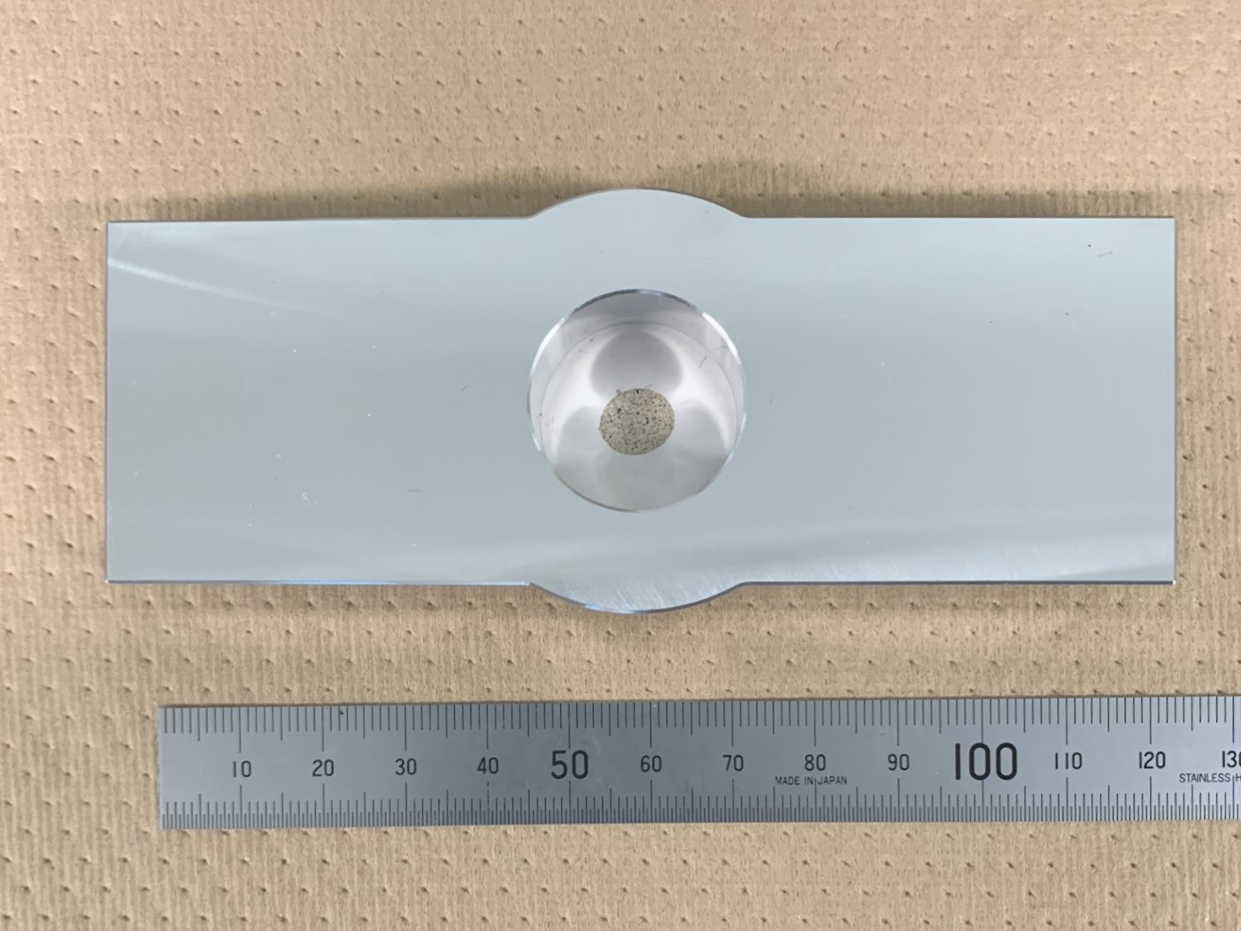
Fig. S2 Custom-designed stainless-steel plate used for drying PTFE membranes to prevent particle loss and membrane deformation such as curling.

Table S1 Research vessels used for microplastic particles sampling in Tokyo Bay during October–November 2023.
Sampling date  (YYYYMMDD) | Stations | Vessel name | Gross tonnage  (t) | Length  (m)
20231027 | St. 1, 2, 4 | Target | <5 | 6.14
20231108 | St. 3, 5, 6 | MAKOTOMARU | 2.0 | 8.5
20231129 | St. 7, 8 | Tokyo Bay · hⅡ | 1.5 | 6.77

Table S2 Polymer types identified in this study and their density ranges.
Polymer name | Abbreviation | Density (g/cm³)*
acrylonitrile-butadiene-styrene | ABS | 0.99-1.15 [1]
alkyd resin | alkyd | 1.10-1.46 [2]
polyacrylate styrene | AS | 1.08-1.1 [1]
epoxy resin | epoxy | 1.11-1.40 [2]
polyamide | PA | 1.12-1.14 [1]
polyethylene | PE | 0.91-0.97 [1]
polyethylene terephthalate | PET | 1.38-1.39 [1]
polymethyl methacrylate & polymethyl acrylate | PMMA | 1.17-1.20 [1]
polypropylene | PP | 0.90-0.91 [1]
polystyrene | PS | 1.04-1.07 [1]
polyurethane | PU | 1.20 [1]
polyvinyl acetate | PVAc | 1.19 [3]
polyvinyl chloride | PVC | 1.16-1.35 [1]
styrene-butadiene rubber | SBR | 0.93-0.94 [4]
Note: The average of the minimum and maximum reported density values was used for each polymer type in this study.

1. https://kayo-corp.co.jp/common/pdf/pla_propertylist01.pdf
2. https://kayo-corp.co.jp/common/pdf/pla_propertylist02.pdf
3. https://pubchem.ncbi.nlm.nih.gov/#query=Polyvinyl-acetate
4. https://kayo-corp.co.jp/common/pdf/rub_propertylist.pdf

Table S3 Summary of previous studies on microplastic particles collected from the surface water of Tokyo Bay.
Reference | Sampling date | Sampling method | Digestion | Density separation (g/cm³) | Size range (μm) | Concentration  (particles/L) | Identification | Main type | Main shape
Nakano et al. (2021) | May 2019,  Jan 2020 | 5 sites, Neuston net (350 µm mesh),  Depth of 0–75 cm | H₂O₂+  Fenton reaction | 1.5 (NaI) | ≥ 100 | 0.00004–0.0178 | ATR-FTIR | PE, PP | Fragment
Xu et al. (2022) | Dec 2020 | 2 sites, Double neuston net (inner net: 350 µm, outer net: 50 µm),  Depth of 0–75 cm | H₂O₂+  Fenton reaction | 1.6 (NaI) | 50–350  ≥ 350 | 3.06–3.22  0.00247–0.0205 | μ-FTIR  ATR-FTIR | Co-polymer, PE, PP  Co-polymer, PE, PP | Fragment  Fragment
Sato et al. (2024) | July 2021 | 2–6 sites, Double neuston net (inner net: 350 µm, outer net: 50 µm),  Depth of 0–75 cm | H₂O₂+ Fenton reaction | 1.6 (NaI) | 60–350  ≥ 350 | 0.80–11.5  0.00021–0.00334 | μ-FTIR  ATR-FTIR | Co-polymer, PE  Co-polymer, PE, PP | Fragment  Fragment
Sato et al. (2024) | July 2021 | 6 sites, Plankton pump with 60 µm mesh,  Depth of 200 cm | H₂O₂+ Fenton reaction | 1.6 (NaI) | 60–350 | 0.36–5.79 | μ-FTIR | Co-polymer, PE | Fragment
Ueda et al.  (2025) | Dec 2022 | 4 sites, Hand pump and filtered with 10µm mesh plankton net,  Depth of 30–50 cm | H₂O₂ | 1.7 (NaI) | ≥ 20  20–100  100–350  ≥ 350 | 0.698–27.3  0.545–23.7  0.116–3.31  0.0372–0.171 | μ-FTIR  μ-FTIR  μ-FTIR  μ-FTIR | PE, PET, PMMA, PP  PE, PET, PMMA, PP  PE, PET, PMMA, PP  PET | Fragment  Fragment  Fragment  Fiber
This study | Oct–Nov 2023 | 8 sites, Submersible pump and filtered with 10µm mesh plankton net,  Depth of 50 cm | H₂O₂ | 1.7 (NaI) | ≥ 20  20–100  100–350  ≥ 350 | 0.835–11.3  0.564–8.10  0.235–2.86  0.0325–0.349 | μ-FTIR  μ-FTIR  μ-FTIR  μ-FTIR | PE, PET, PMMA, PP  PE, PET, PMMA, PP  PE, PET, PMMA, PP  PET | Fragment  Fragment  Fragment  Fiber

Table S4 Size-fractionated concentrations and composition of microplastic particles in surface water samples collected from eight stations in Tokyo Bay in 2023, based on measured particle counts and estimated particle mass.
Station | Number-based concentrations (particles/L) |  |  |  |  | Estimated mass-based concentrations (µg/L)
Station | 20–100 µm | 100–350 µm | ≥ 350 µm | Total |  | 20–100 µm | 100–350 µm | ≥ 350 µm | Total
St. 1 | 8.10  (71.6%) | 2.86  (25.3%) | 0.35  (3.1%) | 11.31 |  | 0.30  (14.9%) | 1.55  (76.4%) | 0.18  (8.7%) | 2.03
St. 2 | 0.87  (65.2%) | 0.40  (29.9%) | 0.08  (4.9%) | 1.35 |  | 0.04  (0.5%) | 0.24  (2.9%) | 7.96  (96.6%) | 8.24
St. 3 | 1.66  (64.4%) | 0.71  (27.6%) | 0.21  (8.0%) | 2.58 |  | 0.09  (14.6%) | 0.50  (77.5%) | 0.05  (7.9%) | 0.64
St. 4 | 0.56  (67.5%) | 0.24  (28.6%) | 0.03  (3.9%) | 0.84 |  | 0.04  (15.8%) | 0.09  (41.3%) | 0.10  (42.9%) | 0.23
St. 5 | 0.97  (77.9%) | 0.24  (18.8%) | 0.04  (3.4%) | 1.25 |  | 0.05  (4.5%) | 0.15  (12.9%) | 0.98  (82.6%) | 1.19
St. 6 | 4.88  (83.8%) | 0.88  (15.1%) | 0.07  (1.1%) | 5.82 |  | 0.16  (30.7%) | 0.35  (66.9%) | 0.01  (2.3%) | 0.52
St. 7 | 2.74  (69.3%) | 1.11  (28.0%) | 0.11  (2.7%) | 3.95 |  | 0.17  (21.1%) | 0.50  (61.1%) | 0.15  (17.8%) | 0.82
St. 8 | 1.43  (74.8%) | 0.38  (19.8%) | 0.10  (5.4%) | 1.91 |  | 0.10  (14.2%) | 0.23  (33.6%) | 0.36  (52.2%) | 0.69
Mean ± SD | 2.36 ± 2.59  (71.8 ± 6.7%) | 0.85 ± 0.87  (24.1 ± 5.5%) | 0.12 ± 0.11  (4.1 ± 2.1%) | 3.63 ± 3.52 |  | 0.12 ± 0.09  (17.6 ± 11.1%) | 0.45 ± 0.47  (43.6 ± 25.1%) | 1.22 ± 2.74  (38.7 ± 35.9%) | 1.79 ± 2.66
Note: Percentages in parentheses indicate the proportion of microplastic particles in each category of each size relative to the total concentration.

Table S5 Size-specific morphological composition of microplastic particles in surface water samples collected from eight stations in Tokyo Bay in 2023.
Station | Number-based (%) |  |  |  |  |  |  |  |  | Estimated mass-based (%)
Station | 20–100 µm |  | 100–350 µm |  | ≥ 350 µm |  | Total |  |  | 20–100 µm |  | 100–350 µm |  | ≥ 350 µm |  | Total
Station | Frag. | Fib. | Frag. | Fib. | Frag. | Fib. | Frag. | Fib. |  | Frag. | Fib. | Frag. | Fib. | Frag. | Fib. | Frag. | Fib.
St. 1 | 98.3% | 1.7% | 82.9% | 17.1% | ND | 100% | 98.3% | 1.7% |  | 99.4% | 0.6% | 97.6% | 2.4% | ND | 100% | 89.4% | 10.6%
St. 2 | 99.1% | 0.9% | 85.7% | 14.3% | 35.0% | 65.0% | 91.5% | 8.5% |  | 99.98% | 0.02% | 90.2% | 9.8% | 99.7% | 0.3% | 99.6% | 0.4%
St. 3 | 100% | ND | 95.8% | 4.2% | ND | 100% | 90.8% | 9.2% |  | 100% | ND | 99.2% | 0.8% | ND | 100% | 91.4% | 8.6%
St. 4 | 100% | ND | 81.8% | 18.2% | 33.3% | 66.7% | 92.2% | 7.8% |  | 100% | ND | 95.1% | 4.9% | 90.7% | 9.3% | 94.0% | 6.0%
St. 5 | 99.1% | 0.9% | 85.7% | 14.3% | 23.6% | 76.4% | 94.0% | 6.0% |  | 99.8% | 0.2% | 98.6% | 1.4% | 99.2% | 0.8% | 99.2% | 0.8%
St. 6 | 98.2% | 1.8% | 74.1% | 25.9% | ND | 100% | 93.5% | 6.5% |  | 99.4% | 0.6% | 95.8% | 4.2% | ND | 100% | 94.7% | 5.3%
St. 7 | 100% | ND | 81.0% | 19.0% | ND | 100% | 97.1% | 8.0% |  | 100% | ND | 97.9% | 2.1% | ND | 100% | 80.9% | 19.1%
St. 8 | 100% | ND | 77.3% | 22.7% | 50.0% | 50.0% | 92.8% | 7.2% |  | 100% | ND | 97.7% | 2.3% | 96.0% | 4.0% | 97.2% | 2.8%
Mean ± SD | 99.3 ± 0.8% | 0.7 ± 0.8% | 83.0 ± 6.5% | 17.0 ± 6.5% | 17.7 ± 20.3% | 82.3 ± 20.3% | 92.9 ± 2.0% | 7.7 ± 1.1% |  | 99.8 ± 0.3% | 0.2 ± 0.3% | 96.5 ± 2.9% | 3.5 ± 2.9% | 48.2 ± 51.6% | 51.8 ± 51.6% | 93.3 ± 6.2% | 6.7 ± 6.2%
Note: Percentages in parentheses indicate the proportion of microplastic particles in each size category relative to the total concentration.
ND = Not detected.

Table S6 Relative composition of microplastic polymer types by particle count in surface water samples collected from eight stations in Tokyo Bay during October–November 2023.
Polymer type | St. 1 | St. 2 | St. 3 | St. 4 | St. 5 | St. 6 | St. 7 | St. 8 | Mean ± SD | Num. of  detected  stations
alkyd | ND | 1.8% | 8.0% | 10.4% | 1.3% | 0.2% | ND | ND | 2.7 ± 4.1% | 5
AS | ND | 0.2% | ND | ND | ND | 0.6% | ND | ND | 0.1 ± 0.2% | 2
epoxy | ND | 1.2% | 1.1% | ND | ND | 0.2% | ND | ND | 0.3 ± 0.5% | 3
PA | 1.9% | ND | ND | ND | 0.7% | 0.2% | ND | 1.8% | 0.6 ± 0.8% | 4
PE | 29.0% | 26.6% | 26.4% | 41.6% | 24.8% | 2.6% | 10.7% | 26.1% | 23.6 ± 11.9% | 8
PET | 11.7% | 10.8% | 20.7% | 19.5% | 16.1% | 4.1% | 16.0% | 7.2% | 13.3 ± 5.8% | 8
PMMA | 7.4% | 36.9% | 18.4% | 10.4% | 28.1% | 70.0% | 50.6% | 45.0% | 33.4 ± 21.5% | 8
PP | 49.4% | 18.8% | 20.7% | 11.7% | 27.6% | 21.8% | 22.7% | 16.2% | 23.6 ± 11.4% | 8
PS | ND | 0.6% | ND | ND | 0.7% | ND | ND | ND | 0.2 ± 0.3% | 2
PU | ND | ND | 1.1% | 1.3% | ND | ND | ND | ND | 0.3 ± 0.6% | 2
PVAc | ND | ND | 2.3% | 1.3% | ND | ND | ND | ND | 0.4 ± 0.9% | 2
PVC | 0.6% | 3.0% | 1.1% | 3.9% | 0.7% | 0.4% | ND | 3.6% | 1.7 ± 1.6% | 7
Note: ND = Not detected.

Table S7 Relative composition of microplastic polymer types by estimated mass in surface water samples collected from eight stations in Tokyo Bay during October–November 2023.
Polymer type | St. 1 | St. 2 | St. 3 | St. 4 | St. 5 | St. 6 | St. 7 | St. 8 | Mean ± SD | Num. of  detected  stations
alkyd | ND | 3.4% | 11.6% | 15.2% | 0.2% | 2.2% | ND | ND | 4.1 ± 6.0% | 5
AS | ND | 1.1% | ND | ND | ND | 1.2% | ND | ND | 0.3 ± 0.5% | 2
epoxy | ND | 0.1% | 24.3% | ND | ND | 0.05% | ND | ND | 3.1 ± 8.6% | 3
PA | 0.1% | ND | ND | ND | 2.5% | 0.2% | ND | 0.3% | 0.4 ± 0.9% | 4
PE | 24.9% | 0.9% | 18.6% | 20.2% | 1.9% | 0.9% | 9.3% | 7.0% | 10.5 ± 9.6% | 8
PET | 13.8% | 89.3% | 21.6% | 12.9% | 9.1% | 2.8% | 50.0% | 22.4% | 27.7 ± 28.6% | 8
PMMA | 7.9% | 1.9% | 6.8% | 6.9% | 3.3% | 80.3% | 30.3% | 65.9% | 25.4 ± 31.0% | 8
PP | 42.3% | 0.2% | 6.8% | 2.9% | 83.0% | 11.7% | 10.4% | 2.8% | 20.0 ± 28.7% | 8
PS | ND | 0.002% | ND | ND | 0.04% | ND | ND | ND | 0.01 ± 0.01% | 2
PU | ND | ND | 0.4% | 0.5% | ND | ND | ND | ND | 0.1 ± 0.2% | 2
PVAc | ND | ND | 0.1% | 0.8% | ND | ND | ND | ND | 0.1 ± 0.3% | 2
PVC | 11.0% | 3.1% | 9.8% | 40.6% | 0.1% | 0.6% | ND | 1.6% | 8.3 ± 13.7% | 7
Note: ND = Not detected.

Table S8 Summary of previous studies on microplastic particles in sediment samples from Tokyo Bay.
Reference | Sampling date | Sampling method | Digestion | Density separation (g/cm³) | Size range (μm) | Concentration  (particles/g D.W.) | Identification | Main type | Major shape
Matsuguma et al. (2017) | Jul. 2012 | 1 site, Gravity corer, 5 cm sliced intervals, sediment core 0–30 cm | H₂O₂ | 1.6 NaI | ≥ 315 | 1.845–5.385 | ATR-FTIR | PAK, PCL, PE, PEP, PET, PS | Fragment
Wang et al. (2021) | May 2019,  Jan 2020 | 3 sites, Ekman–Birge sampler, upper 0–5 cm sediment | H₂O₂ | 1.6 NaI | ≥ 25 | 53.3–148 | μ-FTIR | Copolymer, PA, PE, PP | Fragment
Hashim et al. (2024) | Jul. 2021 | 4 sites, Columnar mud collector, upper 0–5 cm sediment | H₂O₂ + Fenton reaction | 1.6 NaI | ≥ 20 | 11.5–21.1 | μ-FTIR | Copolymer, PA, PE, PP | –
This study | Oct–Nov 2023 | 8 sites, Ekman–Birge sampler, upper 0–10 cm sediment | H₂O₂ + Fenton reaction | 1.7 NaI | ≥ 20  20–100  100–350  ≥ 350 | 37–268  31–253  2 –41  0–9 | μ-FTIR  μ-FTIR  μ-FTIR  μ-FTIR | PE, PET, PMMA, PP  PE, PMMA, PP  PE, PP  PET | Fragment  Fragment  Fragment  Fiber

Table S9 Size-fractionated concentrations and composition of microplastic particles in sediment samples collected from eight stations in Tokyo Bay in 2023, based on measured particle counts and estimated particle mass.
Station | Number-based concentrations (particles/g D.W.) |  |  |  |  | Estimated mass-based concentrations (µg/g D.W.)
Station | 20–100 µm | 100–350 µm | ≥ 350 µm | Total |  | 20–100 µm | 100–350 µm | ≥ 350 µm | Total
St. 1 | 31  (84.1%) | 3  (6.8%) | 3  (9.1%) | 37 |  | 0.60  (19.0%) | 0.52  (16.6%) | 2.03  (64.4%) | 3.15
St. 2 | 118  (70.7%) | 41  (24.4%) | 8  (4.9%) | 167 |  | 5.80  (18.7%) | 23.72  (76.6%) | 1.46  (4.7%) | 30.97
St. 3 | 107  (95.9%) | 2  (2.0%) | 2  (2.0%) | 112 |  | 4.24  (86.4%) | 0.06  (1.2%) | 0.61  (12.4%) | 4.91
St. 4 | 133  (91.3%) | 11  (7.5%) | 2  (1.3%) | 145 |  | 3.95  (14.6%) | 3.35  (12.4%) | 19.77  (73.0%) | 27.07
St. 5 | 253  (94.3%) | 15  (5.7%) | 0  (0.0%) | 268 |  | 7.73  (27.1%) | 20.81  (72.9%) | 0  (0.0%) | 28.54
St. 6 | 75  (82.5%) | 7  (7.9%) | 9  (9.5%) | 91 |  | 3.22  (40.2%) | 3.63  (45.3%) | 1.16  (14.5%) | 8.01
St. 7 | 63  (64.7%) | 31  (32.4%) | 3  (2.9%) | 97 |  | 3.42  (19.4%) | 13.14  (74.7%) | 1.03  (5.8%) | 17.58
St. 8 | 43  (90.3%) | 5  (9.7%) | 0  (0.0%) | 48 |  | 2.81  (58.1%) | 2.02  (41.9%) | 0  (0.0%) | 4.83
Mean ± SD | 103 ± 71  (84.2 ± 11.5%) | 15 ± 15  (12.1 ± 10.8%) | 3 ± 3  (3.7 ± 3.3%) | 121 ± 74 |  | 3.97 ± 2.11  (35.4 ± 25.2%) | 8.41 ± 9.50  (42.7 ± 30.3%) | 3.26 ± 6.71  (21.9 ± 29.5%) | 15.63 ± 11.84
Note: Percentages in parentheses indicate the proportion of microplastic particles in each category of each size relative to the total concentration.

Table S10 Size-specific morphological composition of microplastic particles in sediment samples collected from eight stations in Tokyo Bay in 2023.
Station | Number-based (%) |  |  |  |  |  |  | Estimated mass-based (%)
Station | 20–100 µm |  | 100–350µm |  | ≥ 350 µm |  |  | 20–100 µm |  | 100–350µm |  | ≥ 350 µm
Station | Fragment | Fiber | Fragment | Fiber | Fragment | Fiber |  | Fragment | Fiber | Fragment | Fiber | Fragment | Fiber
St. 1 | 97.3% | 2.7% | 33.3% | 66.7% | ND | 100% |  | 96.9% | 3.1% | 77.0% | 23.0% | ND | 100%
St. 2 | 100% | ND | 90.0% | 10.0% | ND | 100% |  | 100% | ND | 99.3% | 0.7% | ND | 100%
St. 3 | 97.9% | 2.1% | ND | 100% | ND | 100% |  | 99.2% | 0.8% | ND | 100% | ND | 100%
St. 4 | 98.6% | 1.4% | 66.7% | 33.3% | 100 | ND |  | 99.2% | 0.8% | 97.9% | 2.1% | 100% | ND
St. 5 | 97.6% | 2.4% | 60.0% | 40.0% | ND | ND |  | 99.1% | 0.9% | 99.3% | 0.7% | ND | ND
St. 6 | 100% | ND | 80.0% | 20.0% | ND | 100% |  | 100% | ND | 95.7% | 4.3% | ND | 100%
St. 7 | 100% | ND | 81.8% | 18.2% | ND | 100% |  | 100% | ND | 94.9% | 5.1% | ND | 100%
St. 8 | 91.9% | 8.9% | 100% | ND | ND | ND |  | 99.9% | 0.1% | 100% | ND | ND | ND
Mean ± SD | 97.8± 2.9% | 2.2 ± 2.9% | 64.0 ± 33.0% | 36.0 ± 33.0% | 16.7 ± 40.8% | 83.3 ± 40.8% |  | 99.3 ± 1.0% | 0.7 ± 1.0% | 83.0 ± 34.4% | 17.0 ± 34.4% | 16.7 ± 40.8% | 83.3 ± 40.8%
Note: ND = Not detected.

Table S11 Relative composition of microplastic polymer types by particle count in sediment samples collected from eight stations in Tokyo Bay during October–November 2023.
Polymer type | St. 1 | St. 2 | St. 3 | St. 4 | St. 5 | St. 6 | St. 7 | St. 8 | Mean ± SD | Num. of  detected  stations
ABS | ND | ND | ND | ND | ND | 1.6% | ND | ND | 0.2 ± 0.6% | 1
alkyd | ND | ND | ND | 2.5% | 3.4% | 1.6% | 1.5% | 3.2% | 1.5 ± 1.4% | 5
epoxy | ND | ND | ND | ND | ND | ND | 1.5% | ND | 0.2 ± 0.5% | 1
PA | ND | ND | 8.2% | 1.3% | 1.1% | 1.6% | ND | 1.6% | 1.7 ± 2.7% | 5
PE | 18.2% | 73.2% | 36.7% | 12.5% | 33.3% | 42.9% | 42.6% | 64.5% | 40.5 ± 20.7% | 8
PET | 27.3% | 9.8% | 2.0% | ND | 1.1% | 7.9% | 13.2% | 1.6% | 7.9 ± 9.2% | 7
PMMA | 2.3% | 2.4% | 4.1% | 1.3% | 1.1% | 17.5% | 26.5% | ND | 6.9 ± 9.7% | 7
PP | 50.0% | 12.2% | 42.9% | 72.5% | 52.9% | 22.2% | 13.2% | 29.0% | 36.9 ± 21.3% | 8
PS | ND | 2.4% | 6.1% | 8.8% | 4.6% | 4.8% | ND | ND | 3.3 ± 3.3% | 5
PU | 2.3% | ND | ND | ND | 1.1% | ND | 1.5% | ND | 0.6 ± 0.9% | 3
PVC | ND | ND | ND | 1.3% | 1.1% | ND | ND | ND | 0.3 ± 0.6% | 2
Note: ND = Not detected.

Table S12 Relative composition of microplastic polymer types by estimated mass in sediment samples collected from eight stations in Tokyo Bay during October–November 2023.
Polymer type | St. 1 | St. 2 | St. 3 | St. 4 | St. 5 | St. 6 | St. 7 | St. 8 | Mean ± SD | Num. of  detected  stations
ABS | ND | ND | ND | ND | ND | 1.0% | ND | ND | 0.1 ± 0.3% | 1
alkyd | ND | ND | ND | 7.6% | 70.8% | 2.5% | 5.5% | 3.8% | 11.3 ± 24.2% | 5
epoxy | ND | ND | ND | ND | ND | ND | 13.7% | ND | 1.7 ± 4.9% | 1
PA | ND | ND | 11.6% | 0.9% | 0.6% | 1.0% | ND | 0.02% | 1.8 ± 4.0% | 5
PE | 3.8% | 80.9% | 31.0% | 4.0% | 8.6% | 59.1% | 21.5% | 65.8% | 34.3 ± 30.4% | 8
PET | 88.1% | 8.2% | 12.4% | ND | 0.04% | 12.1% | 16.3% | 1.7% | 17.3 ± 29.3% | 7
PMMA | 1.3% | 3.0% | 3.5% | 0.1% | 0.6% | 9.3% | 36.7% | ND | 6.8 ± 12.5% | 7
PP | 6.6% | 7.4% | 34.8% | 85.8% | 16.1% | 14.1% | 4.5% | 28.7% | 24.7 ± 26.9% | 8
PS | ND | 0.5% | 6.8% | 1.0% | 1.4% | 1.0% | ND | ND | 1.4 ± 2.3% | 5
PU | 0.2% | ND | ND | ND | 0.3% | ND | 1.7% | ND | 0.3 ± 0.6% | 3
PVC | ND | ND | ND | 0.5% | 1.7% | ND | ND | ND | 0.3 ± 0.6% | 2
Note: ND = Not detected.

