Supplementary Material

S-Table1. Number of reads and % of specific alignment per each condition.
Sample name | Number of reads | Feature (%) | No feature (%) | Ambiguos (%) | Aligned not unique (%)
1619585_S35 | 21909573 | 62,96395382208150 | 3,0254040373518400 | 7,335222939291280 | 2,667541920127540
1619592_S42 | 22867273 | 62,946672705267100 | 2,9846536899044000 | 7,072906179097510 | 2,6995767425731000
1619600_S50 | 23114741 | 64,29403471124590 | 3,350157970788460 | 7,247798804335270 | 2,5108008513630300
1619586_S36 | 23423387 | 63,970057851359300 | 3,0021730465526800 | 7,142752528398170 | 2,5885016573689900
1619591_S41 | 23733432 | 63,32987680290260 | 2,9870477722282800 | 7,163787233537940 | 2,651928819133120
1619587_S37 | 24679361 | 63,434677864584200 | 2,977747145315590 | 7,125606525840170 | 2,6461968464260000
1619590_S40 | 25065399 | 60,365779670854200 | 2,9490181991605700 | 7,013245843129410 | 2,9671956286855800
1619601_S51 | 25777202 | 64,394659652773 | 3,3608349094514600 | 7,175393080541050 | 2,5069112357234500
1619588_S38 | 26843116 | 63,5474222648617 | 2,9455981965360900 | 7,164263618834260 | 2,6342715919767900
1619596_S46 | 26917860 | 64,24240550375840 | 3,394691456532510 | 7,077637319465570 | 2,5285265720243500
1619584_S34 | 28320082 | 63,930194921444200 | 3,0277236727152900 | 7,089069862366270 | 2,5953011543474200
1619594_S44 | 28565258 | 64,34093028909900 | 3,37171056965728 | 7,1349699583282700 | 2,515238918291550
1619595_S45 | 28627181 | 64,12730323435240 | 3,401241090221780 | 7,128218174496430 | 2,5343237500929400
1619589_S39 | 28876555 | 61,11883976321910 | 2,908684034614560 | 6,862529101669650 | 2,9109947100496700
1619593_S43 | 29615239 | 64,331938404491 | 3,3235481083138300 | 7,196359644977150 | 2,514815384221800
1619597_S47 | 29991672 | 64,21533368527760 | 3,3713646745071200 | 7,060650453276290 | 2,5352651186939000
1619598_S48 | 30380409 | 59,988713114959200 | 3,1228606633343900 | 6,851546252614920 | 3,003687996909150
1619599_S49 | 31893244 | 62,51268998666280 | 3,2699994044226600 | 6,9587517889561200 | 2,725855881995850

S-Table 2. Primers used for qRT-PCR validation of differentially expressed genes.
Gene name | Forward sequence | Reverse sequence
β- Actin | GAAGATCAAGATCATTGCTCTTC | ATCCACATCTGCTGGAAGG
BAMBI | GTGTTGCTTATTATGTTGGC | GAAAGCTGTAGTGCAAAC
ZFP36 | CATCTCTGTTTCTGAGTGAC | GGATTACTTGATTACTGTCCC
FOSL1 | CAGGCGGAGACTGACAAACTG | TCCTTCCGGGATTTTGCAGAT
ADAMTS14 | CTGGAGGAACATGAGTAGTG | GGTTCTCACAGGAATGACTC
ADGRF1 | AATTCAAGGTTTTGAGTCGGT | AACTTCATACCCAGCAACGA
AXIN2 | TACACTCCTTATTGGGCGATCA | GGCTACTCGTAAAGTTTTGGT
ARRDC4 | AATTGATGCTCGAACTGCC | CCATACTGAACTGGCTGG

S-Table 3. GO list of genes for the family location with the relative expression in the treatment with PS-NH₂ for 24h compared to controls and to PS treatment
Gene acronym | Gene annotation | PS-NH₂ 24h vs CTRL | PS-NH₂ 24h vs PS
ASIC4 | Acid-Sensing (Proton-Gated) Ion Channel Family Member 4 | 1.4176 | 0.89964
SLC37A2 | Solute Carrier Family 37 Member 2 | 1.52529 | 1.40655
ABCC3 | ATP Binding Cassette Subfamily C Member 3 | 1.02399 | 0.85301
KCNE5 | Potassium Voltage-Gated Channel Subfamily E Regulatory Beta Subunit 5 | -2.30407 | -1.79592
TRPM1 | Transient Receptor Potential Cation Channel Subfamily M Member 1 | 5.37037 | 5.37037
UCP2 | Solute Carrier Family 25 Member 8 | 1.15989 | 1.08186
ARL17A | ADP Ribosylation Factor Like GTPase 17A | -1.56822 | -1.6398
BIN2 | Bridging Integrator 2 | 2.75049 | 2.17355
GAS2L2 | Growth Arrest Specific 2 Like 2 | -6.05152 | -5.63383

S-Table 4. GO list of genes for the family biological regulation (GO:0065007) at condition PS-NH₂ 24h compared to controls.
GOs name | PS-NH₂ 6h vs Ctrl | PS-NH₂ 24h vs CTRL
Biological regulation  GO:0065007 | KDR, ADGRF1, TWIST1, RASSF4, VIPR1, SCTR, AXIN2 | EGR1, DIPS2, AVPR2, LHX4, ADGRF1, ZFP36, NPAS4, ARID5B, KCNE, SIX2, ATOH8, FOSL1, HI-4, BAMBI, HHLA2, GAS2L2, TBX6, AXIN2, IGFBP5

S-Fig.1 RNA integrity analysis by Agilent TapeStation. Representative electropherogram and gel-like image on the left panel showing at the bottom the RNA Integrity Number (RIN) values for
each sample. RNA samples with RIN lower than 7 has been re-extracted. Description of the
samples with concentrations are shown in the right panel.

S-Fig.2 Green fluorescent PS-NH₂ and PS-COOH were detected interacting with Caco-2 cells after 2 hour-incubation, and continued to accumulate within 24 hours, as shown by confocal microscopy.

S-Fig.3 Confocal Z-stack orthogonal reconstruction of particle–cell interaction. Representative confocal images and corresponding orthogonal views (XY, XZ and YZ planes) were generated from Z-stack acquisitions. The orthogonal views of the Z-stack show the spatial distribution of the green fluorescent PS-NH₂ (A) and PS-COOH (B) relative to the cell membranes stained in red. The overlap of signals in the orthogonal planes is visible in yellow and indicates that intracellular localization is significantly more abundant in PS-COOH (B).

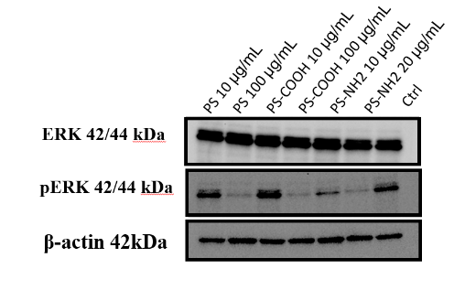
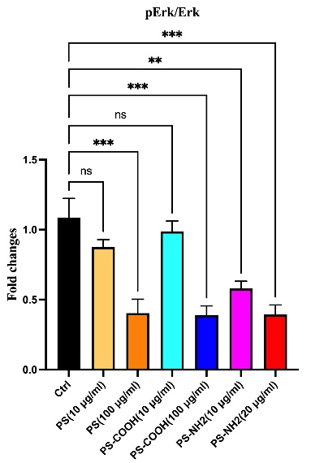
S-Fig.4 Western blot analysis of MAPK signalling pathway in Caco-2 cells, treated or not with the indicated concentrations of PS, PS-NH₂ and PS-COOH for 48 h. Left panel: Expression levels of ERK, pERK, and β-actin (loading control) were analyzed. Equal amounts of protein (20 μg) were loaded. Right panel: Densitometric quantification of pERK/ERK are shown. Data are represented as mean ± S.D. (n = 3); one-way ANOVA test followed by Tukey's multiple comparison test (* p ≤ 0.05; ** p ≤ 0.01; *** p ≤ 0.001).

