Supplementary file 3: Particle size distributions before and after nebulization
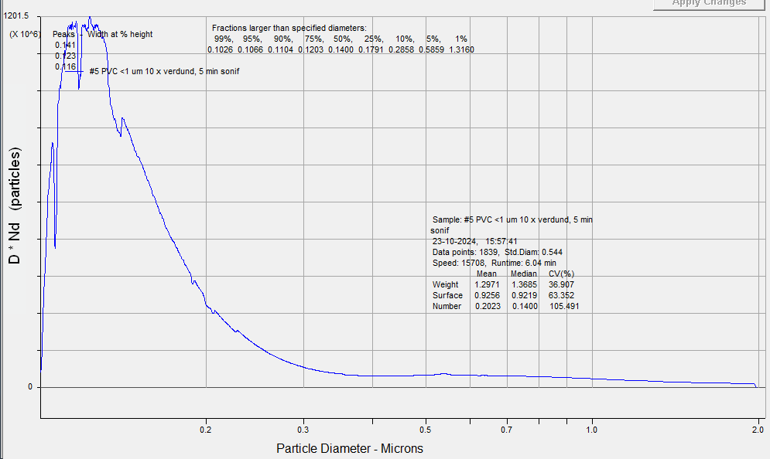
Figure S3.1: PVC <1 µm before nebulization

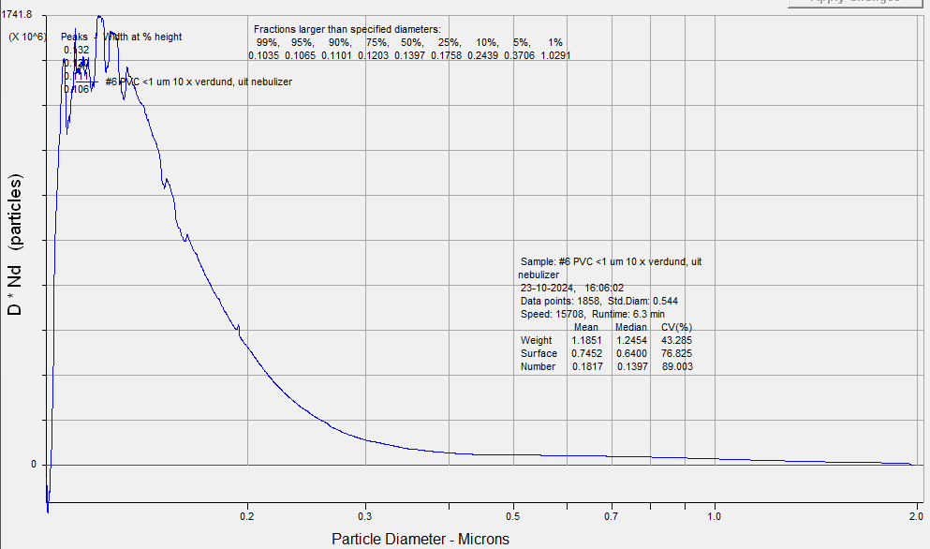
Figure S3.2: PVC <1 µm after nebulization
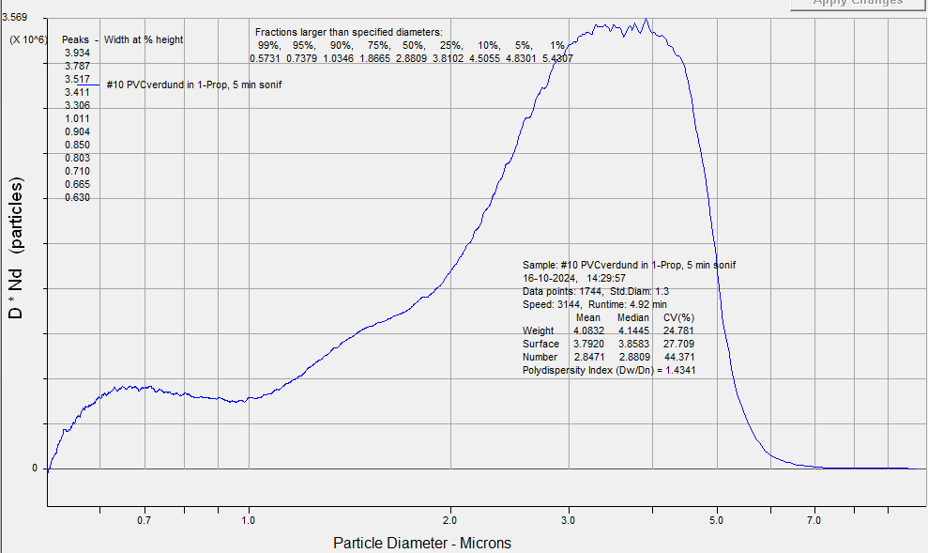
Figure S3.3: PVC 1-5 µm before nebulization

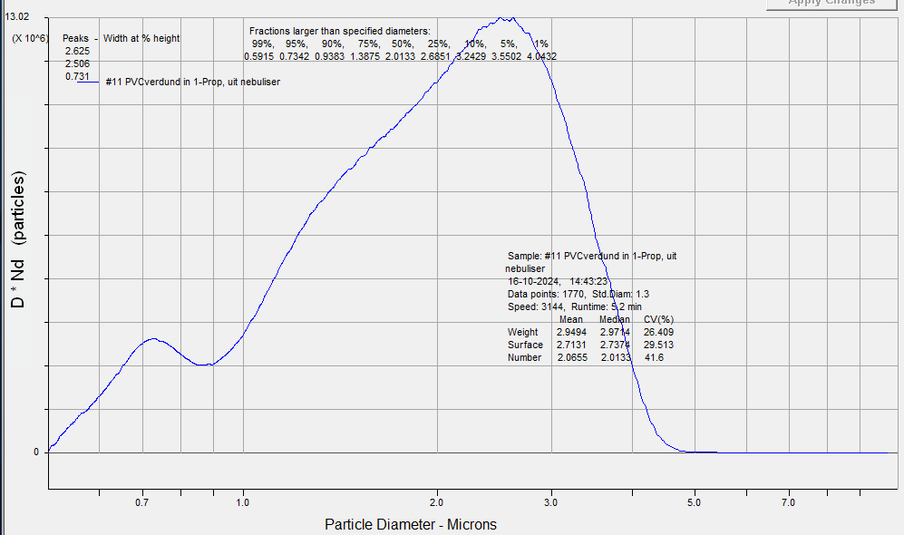
Figure S3.4: PVC 1-5 µm after nebulization
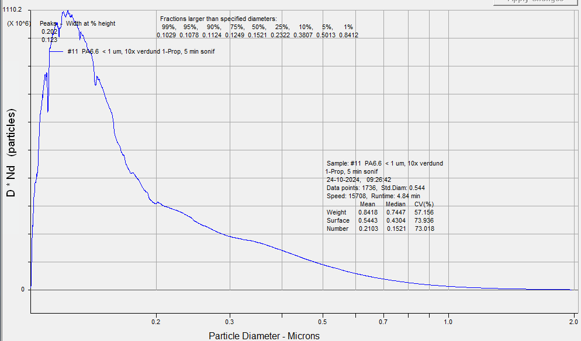
Figure S3.5: PA <1 µm before nebulization

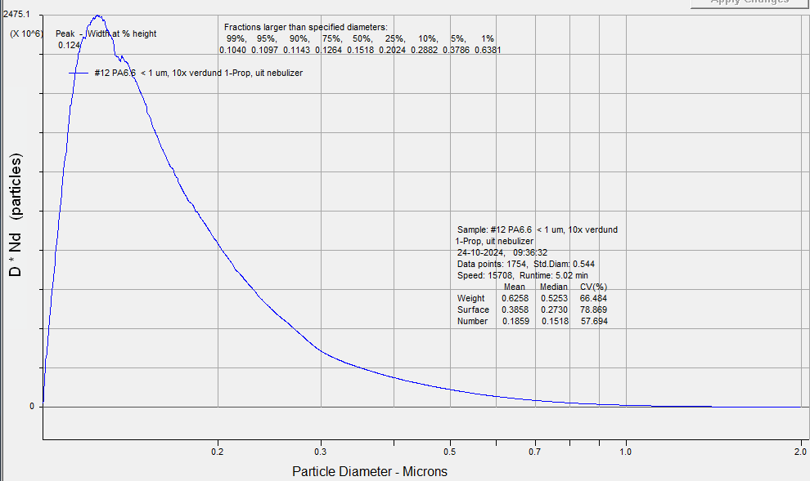
Figure S3.6: PA <1 µm after nebulization
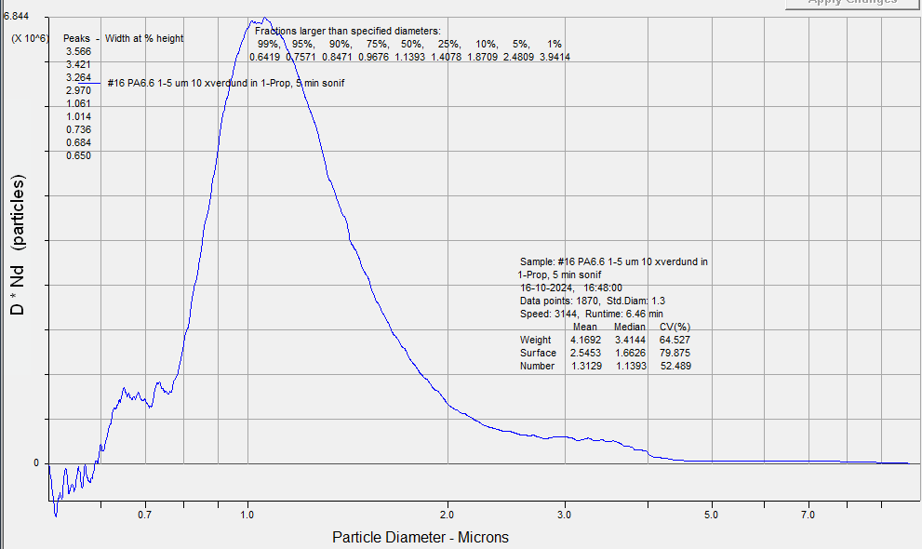
Figure S3.7: PA 1-5 µm before nebulization

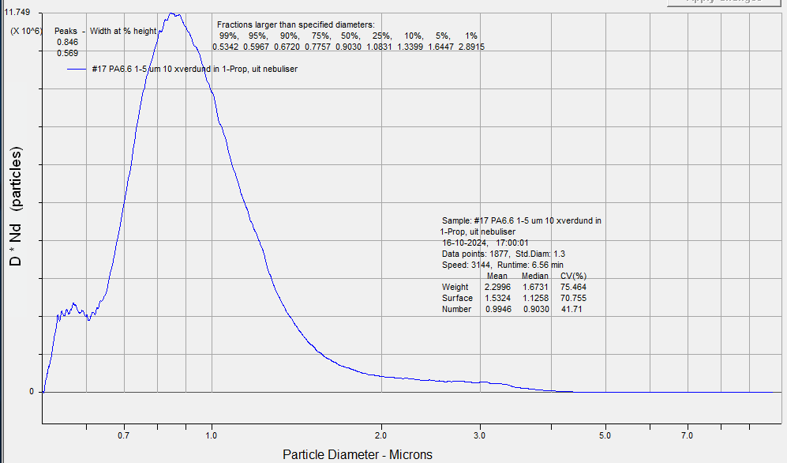
Figure S3.8: PA 1-5 µm after nebulization
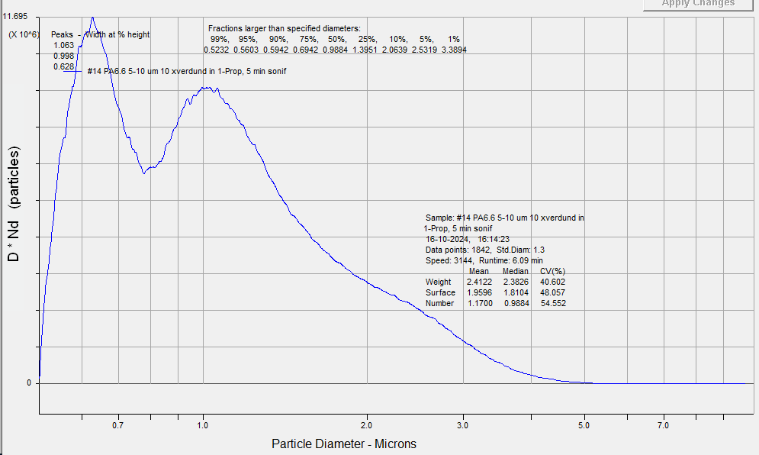
Figure S5.1: PA 5-10 µm before nebulization

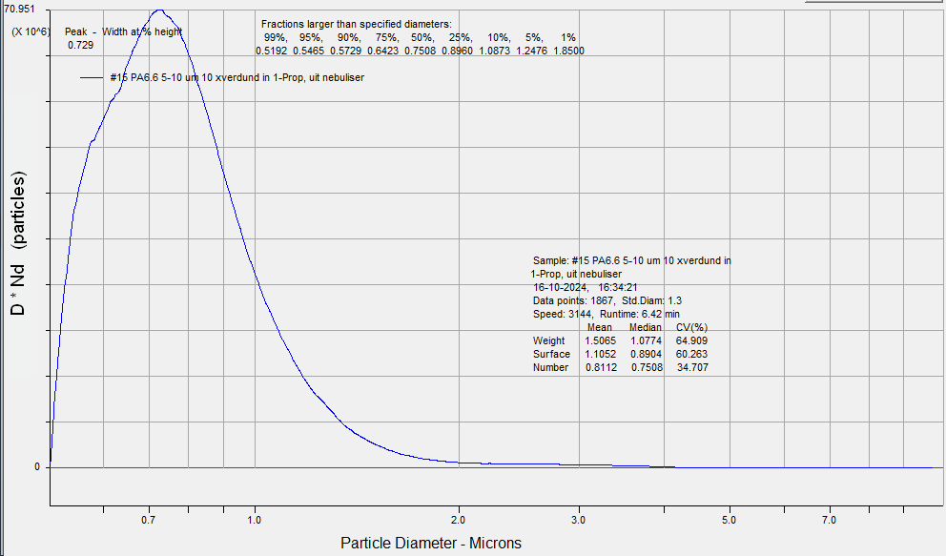
Figure S5.2: PA 5-10 µm after nebulization

