Supplementary Information

Microplastic ingestion induces changes in coelomocyte composition of Eisenia fetida
Johanna K. Fritsche^{1,6}, Max V. R. Döring^{2,6}, Anika Mauel³, Jürgen Senker³, Heike Feldhaar^{2,5,7,*}, Ruth Freitag^{1,4,7,*}, Valérie Jérôme¹
¹ Process Biotechnology, Faculty of Engineering Sciences, University of Bayreuth, Bayreuth, Germany
² Animal Population Ecology, Animal Ecology I, University of Bayreuth, Bayreuth, Germany
³ Inorganic Chemistry III and Northern Bavarian NMR Centre, University of Bayreuth, Bayreuth, Germany
⁴ Bayreuth Center for Molecular Biosciences (BZMB), Bayreuth, Germany
⁵ Bayreuth Center of Ecology and Environmental Research (BayCEER), Bayreuth, Germany
⁶ These authors contributed equally
⁷ These authors jointly supervised this work
Address: University of Bayreuth, 95440 Bayreuth, Germany
Corresponding authors*: ruth.freitag@uni-bayreuth.de, heike.feldhaar@uni-bayreuth.de

Supplementary methods
Method S1: Production of particles
Pellets made from PS 158N (INEOS Styrolution Group GmbH, Frankfurt am Main, Germany) and fluorescent PS plastic granulate (Magic Pyramid Brücher & Partner KG, Frechen, Germany) were used as raw materials. To obtain PS_{Irgafos} particles, pre-ground PS 158N powder and 0.5% w/w of the antioxidant Irgafos 168 (i.e., Tris(2,4-di-tert-butylphenyl)phosphite; BASF, Ludwigshafen, Germany) were mixed in a powder mixer for 10 min. The homogeneous mixture was subsequently extruded in a twin-screw extruder P11 (220 °C extrusion temperature, 110 rpm screw velocity, 2.2 mm nozzle width; Thermo Fisher Scientific, Schwerte, Germany) and the water-cooled strand was granulated with a Varicut Pelletizer (Thermo Fisher Scientific GmbH, Schwerte, Germany).
MPP of all materials (plain PS, PS_{red} and PS_{Irgafos}) were produced by milling the granules with an Ultra Centrifugal Mill ZM 300 (Retsch GmbH, Haan, Germany). The pellets were precooled with liquid nitrogen and milled with a 12 teeth rotor and a 200 µm distance sieve at a speed of 18000 rpm. The separation into several fractions was done with an Air Jet Sieve E200 LS (Hosokawa Alpine AG, Augsburg, Germany) by using the 200 µm, 125 µm, 75 µm and 20 µm sieve. We used the 20-75 µm fractions for the experiments.
Method S2: Size distribution of particles
The particles size distribution of each particles batch was measured by laser diffraction coupled with dynamic image analysis using a Microtrac FlowSync Particle Size Analyzer (3 lasers and 2 detectors, Microtrac Retsch GmbH, Haan, Germany). The measurement results in mean diameter d-values indicating the percentage of particles below a certain size. For example, a d₉₀ of 50 µm means that 90 % of the particles are below 50 µm. The here used PS MPP have a mean diameter d₅₀ of 60.21 µm (d₁₀ = 34.7 μm, d₉₀ = 84.6 μm), PS_{red} 57.0 μm (d₁₀ = 31.6 μm, d₉₀ = 83.9 μm) and PS_{Irgafos} 70.4 μm (d₁₀ = 41.6 μm, d₉₀ = 106.8 μm).
Method S3: Liquid-state nuclear magnetic resonance (NMR) spectroscopy
Liquid-state ¹H NMR spectroscopic experiments were performed using a Bruker Avance-III HD spectrometer (Bruker, Massachusetts, USA) equipped with a helium-cooled TCI-CryoProbe operating at a B₀ field of 16.4 T (ν₀ = 700.2 MHz). The polymer samples, and pure Irgafos 168 reference (BASF, Ludwigshafen, Germany) (7.5 mg each) were dissolved overnight in deuterated tetrahydrofurane (THF-d₈, purity 99.50%, Deutero, Kastellaun, Germany) and the obtained spectra were referenced to the residual solvent signals at 3.58 ppm and 1.73 ppm. To ensure quantitative ¹H NMR spectra, where the number of proton spins is proportional to the integral of the respective resonance, it is crucial that the nuclear spins recover fully to their thermal equilibrium between consecutive scans. Theoretically, this would require a recovery of longitudinal magnetization (Q) of 100% (Eq. S1) (1). Practically, for quantitative NMR spectroscopy recoveries Q above 99.3% are aimed for, that are achieved for 90° excitation pulses with repetition times t_{r} of 5 $∙$ T₁ between scans. In our experiments, we used single pulse excitation (SP) with a 30° excitation tip angle and acquisition times of 2.3 s. To determine the length of the recycle delays required for quantitative NMR measurements, one needs to know the longest spin lattice relaxation time T₁ of the different proton species present. These T₁ times were measured for polystyrene and Irgafos 168 with inversion recovery experiments and varied between 0.8 s (aliphatic protons) and 2.0 s (aromatic protons) (Fig. S1). To ensure minimum recoveries Q of 99.8% for all resonances of interest a recycle delay of 6 s was chosen (Eq. S1). For each NMR spectrum 800 scans were acquired. The spectra were analysed using TopSpin 3.6.1 (Bruker, Massachusetts, USA).

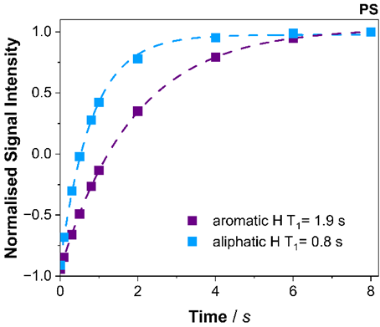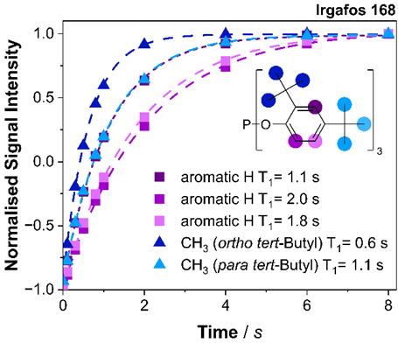
Fig. S1. ¹H inversion recovery experiments for PS (left) and pure Irgafos 168 (right) to measure the T₁ relaxation times of the different resonances. To determine T₁, the signal intensities I were measured as a function of the variable delay time t and fitted with the following equation $I\left(t\right)=I\left(0\right)∙(1-2∙A∙e^{\frac{-t}{T_{1}}}$), with the equilibrium signal intensity I(0) and the inversion efficiency factor A. Knowing the longest T₁ relaxation times of all proton species of interest is crucial to properly set experimental parameters such as recycle delays to ensure quantitative measurements.

$$Q=\frac{1-e^{\left(\frac{{-t}_{r}}{T_{1}}\right)}}{1-(e^{\left(\frac{{-t}_{r}}{T_{1}}\right)}∙cos⁡(α))}∙100\%=\frac{1-e^{\left(\frac{-8.3 s}{2 s}\right)}}{1-\left(e^{\left(\frac{-8.3 s}{2 s}\right)}∙ cos \left(30°\right) \right)}∙100\%= 99.8\% (Eq. S1)$$

With: Q recovery of longitudinal magnetization [%]
t_{r} repetition time (acquisition time + recycle delay) [s]
T₁ longest T₁ relaxation time in the sample [s]
α excitation pulse angle

The signals in the quantitative liquid-state ¹H NMR spectra of PS, PS with 0.5 wt% Irgafos 168, pure Irgafos 168 and the used deuterated solvent THF-d8 (Fig. S2 A) were assigned according to the literature (2,3). In liquid-state NMR spectroscopy, signals are distinguished by their chemical shifts and their splitting patterns. The chemical shift is determined primarily by the local electronic environment around a nucleus, whereas signal splitting arises from J couplings (scalar couplings), which are bond-mediated magnetic interactions between nearby nuclear spins transmitted through the electrons of chemical bonds. In both polymer spectra, signals that are typical for styrene monomers were detected with observed chemical shifts and J couplings that are fitting nicely to the values reported in the literature (4). Specifically, the H-1 and H-2 vinylidene proton resonances of the styrene monomer are detected as doublets of doublets at 5.18 ppm and 5.75 ppm, respectively, reflecting signal splitting caused by J couplings to two nonequivalent neighboring nuclei (Fig. S2 B). The other styrene ¹H signals, namely the H-3 vinylidene proton resonance (6.7 ppm) and the aromatic styrene proton resonances (between 7.2 ppm and 7.4 ppm), are masked by the aromatic resonances of PS.
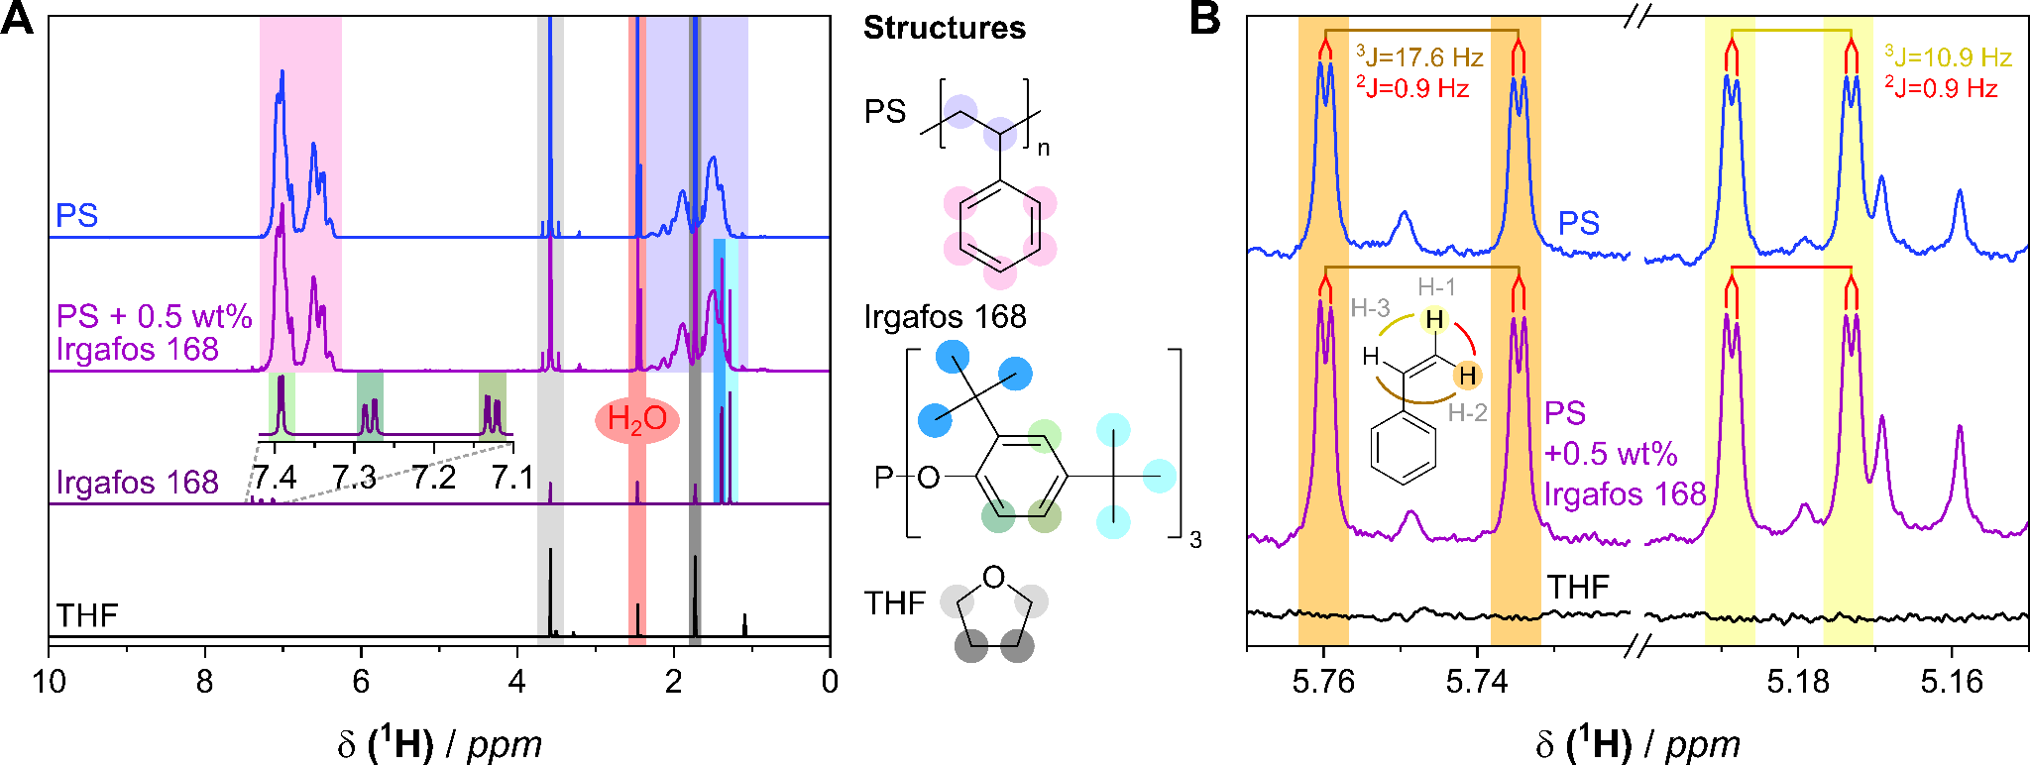
Fig. S2. A) ¹H liquid-state NMR spectra of the PS 158 N particles (PS), the PS 158 N particles additivated with 0.5 wt% of Irgafos 168 (PS_{Irgafos}), pure Irgafos 168 and the used deuterated solvent THF-d₈ with colour-coded signal assignment. The PS spectra are normalised to the aromatic PS resonances between 7.5 and 5.9 ppm. All spectra are shifted vertically for better overview. As all samples were dissolved in THF-d₈, the corresponding residual solvent signals are visible in all spectra (marked in light and dark grey). Additionally, water impurities are present in all spectra (marked in light red). Comparing the spectra, the overlap between the PS and Irgafos 168 resonances becomes obvious. B) Zoomed in ¹H liquid-state NMR spectra of the PS 158 N particles (PS), the PS 158 N particles additivated with 0.5 wt% of Irgafos 168 (PS_{Irgafos}) and the used deuterated solvent THF-d₈ to also show the signals of minority compounds. The spectra show the detected vinylidene ¹H NMR signals of the residual styrene monomer with colour coded signal assignment as well as their J couplings via two (²J coupling) or three bonds (³J coupling). Non-marked signals belong to impurities that were not assigned. The PS spectra are normalised to the aromatic PS resonances between 7.5 and 5.9 ppm, while the THF-d₈ spectrum is normalised to the residual solvent signals detected in the PS spectrum. All spectra are shifted vertically for better overview.

After signal assignment, the quantitative liquid-state ¹H NMR spectra were used to calculate the residual styrene monomer content in the PS particles with or without 0.5 wt% Irgafos 168 (Eq. S2) (Table S7). Determining the residual monomer content is crucial as styrene monomers were previously reported to increase the apparent toxicity of polystyrene particles (5). Thus besides the presence of Irgafos 168, different styrene levels in the PS and PS_{Irgafos} particles could potentially contribute to the observed modulation of cellular metabolic activity.
$$Styrene content [‰]= \frac{I_{S }}{I_{PS} / 5} ∙1000 ‰ (Eq. S2)$$
with I_{PS} for PS: $I_{PS}= I_{arom}-\left( 6∙I_{s}\right)$
with I_{PS} for PS + 0.5 wt% Irgafos 168: $I_{PS}= I_{arom}-\left( 6∙I_{s}\right)-\left(9∙I_{Irgafos}\right)$
To determine the styrene content, the doublet of doublets at 5.75 ppm (H-2), corresponding to one proton of the styrene monomer, was integrated (I_{S} in Eq. S2). The other aliphatic styrene resonances were not used due to overlap with the aromatic PS resonances (H-3) or with the resonances of other minority compounds in PS (H-1). Additionally, the aromatic resonances between 7.50 and 5.90 ppm (I_{arom} in Eq. S2) were integrated. The integral contains the five aromatic PS proton resonances (I_{PS} in Eq. S2) and the six styrene proton resonances (H-3 vinylidene proton and five aromatic protons) ($6∙I_{s}$ in Eq. S2). In case of the additivated PS sample (PS_{Irgafos}), the integral also contains the nine aromatic Irgafos 168 proton resonances ($9∙I_{Irgafos}$ in Eq. S2). However, subtracting the integral of the aromatic Irgafos 168 resonances assuming the presence of a maximum of 0.5 wt% (equivalent to 0.0808 mol%) of Irgafos 168 and a minimum of no Irgafos 168 does not change the resulting styrene content at the significant digits. Consequently, determining the exact amount of Irgafos 168 or its degradation products being present after extrusion is not necessary.

Table S1. Residual styrene content in ‰ that is present in the PS 158 N particles (PS) and the PS 158N particles with 0.5 wt% Irgafos 168 (PS_{Irgafos}) that were used for the entire study. The styrene proportions were determined via quantitative ¹H liquid-state NMR spectroscopy by using Eq. S2 and integrating the respective PS and styrene resonances.
Sample | Integral of Resonances |  | Styrene content
 | Aromatic PS Resonances | Styrene Resonance at 5.75 ppm | [‰]
PS | 5 | 0.00016 | 0.16
PS_{Irgafos} | 5 | 0.00020 | 0.20

Supplementary figures

B
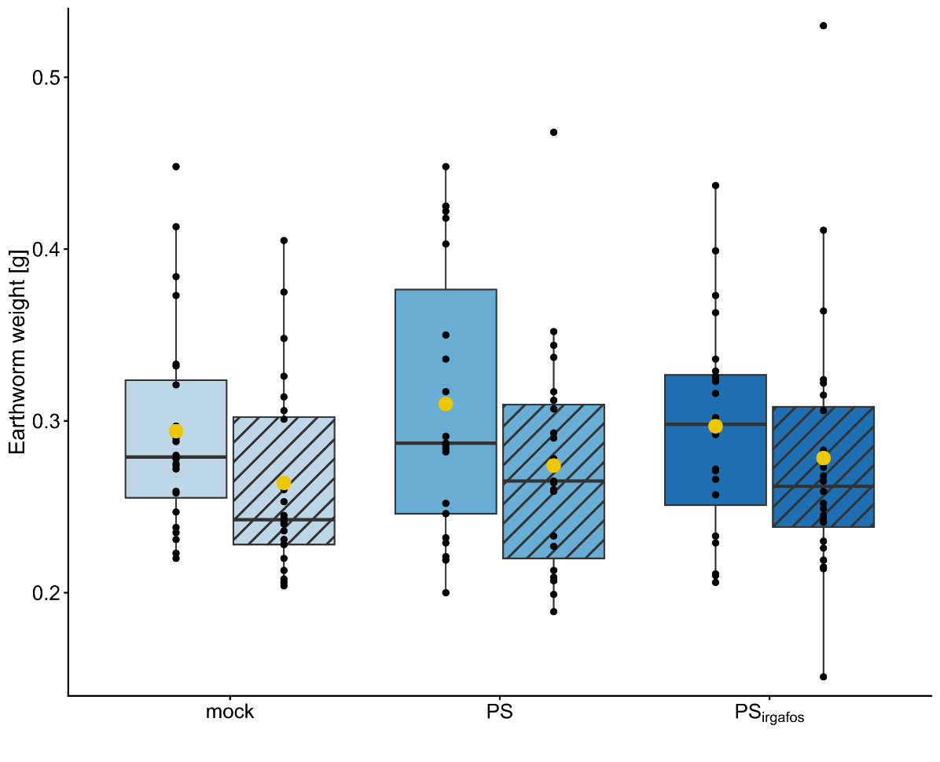
Fig. S3. Earthworm weights (g) at day 0 (without stripes) and at day 6 (with stripes) of the study. Earthworms were fed with only worm food (control, n = 24), worm food with 10% PS (PS, n = 23), or worm food with 10% PS with Irgafos 168 (PS_{Irgafos}, n = 24). Black dots represent individual earthworms and box plots show interquartile range (box), median (horizontal line), mean (yellow point), and maximum/minimum of the 1.5 x interquartile ranges (whiskers). The stripe pattern was created using the ggpattern package (version 1.2.1) (6).

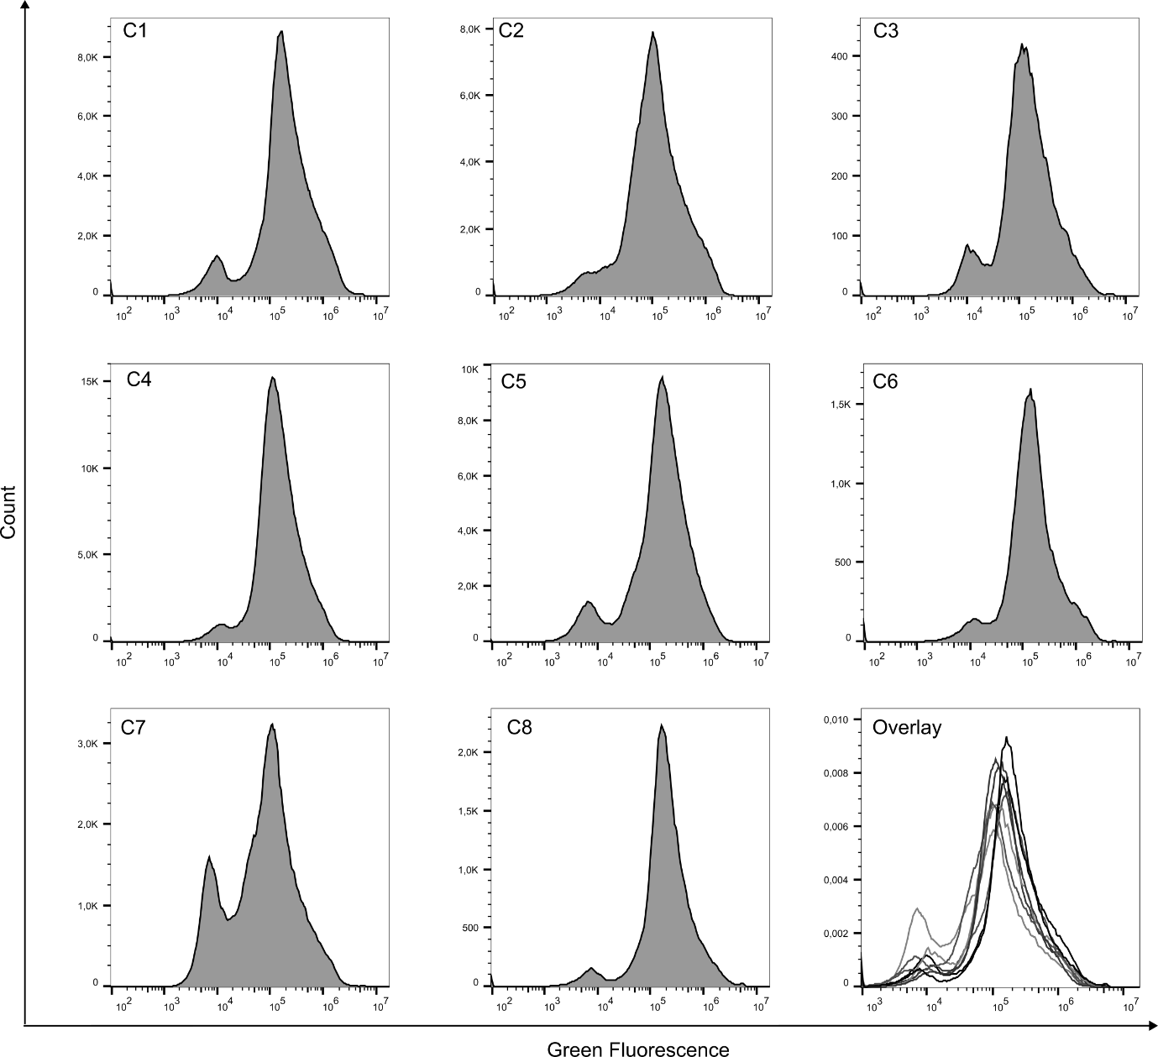
Fig. S4. Flow cytometric analysis of coelomocytes isolated from Eisenia fetida kept on filter papers for 24 h in the wet chamber (“control”, n = 8). histograms (green autofluorescence in gate “coelomocytes”) of isolated coelomocytes. Overlay of all histograms. Median green fluorescence intensity values are given in Table S5.
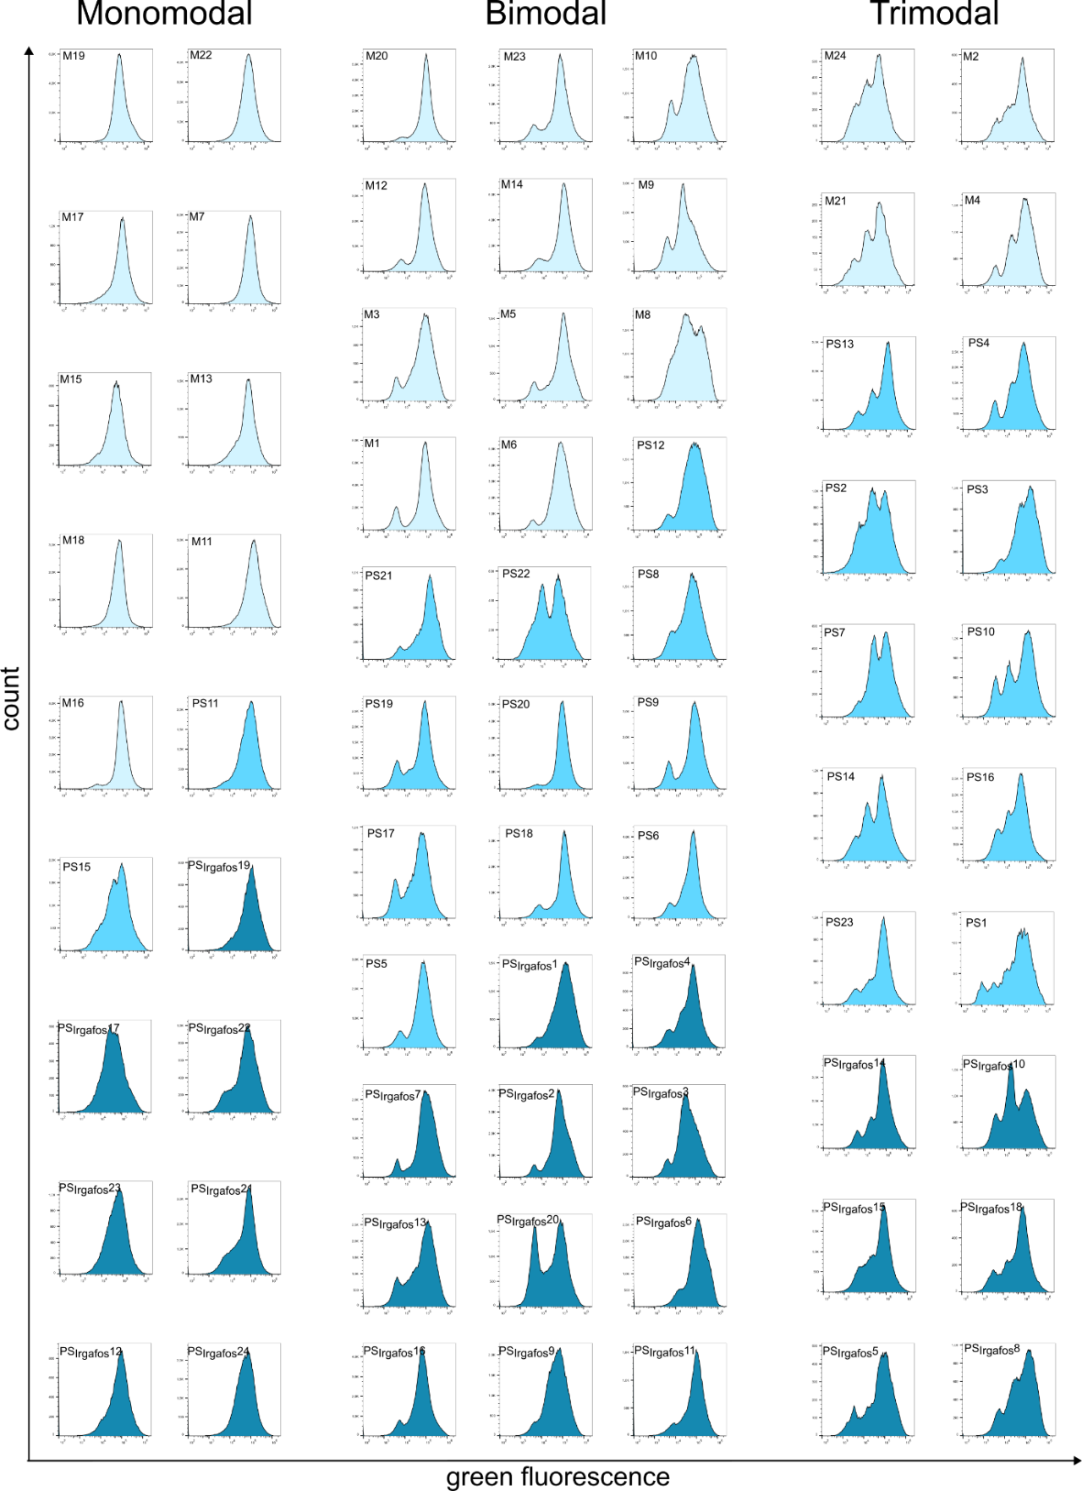
Fig. S5. Flow cytometric analysis of coelomocytes isolated from Eisenia fetida kept on filter papers in the wet chamber for 6 days (green autofluorescence in gate “coelomocytes”). Light blue represents untreated earthworms (mock), medium blue represents PS and dark blue represents PS_{Irgafos}. n_{mock} = 24; n_{PS} = 23; n_{PSIrgafos}: 24. Labels correlate with Table S4.
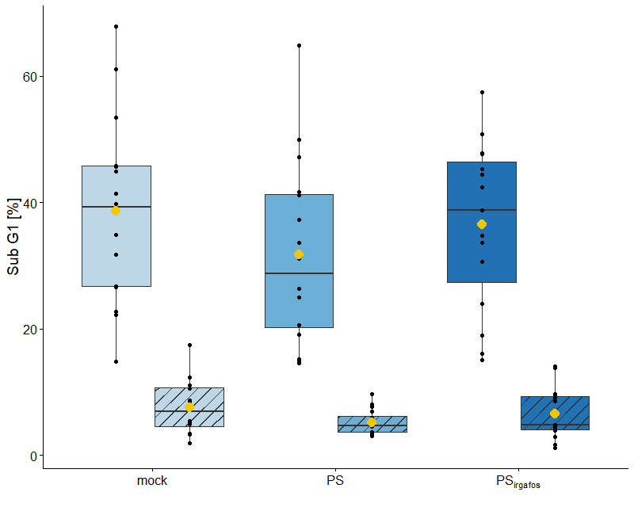
Fig. S6. Earthworms with ≥5% of cells within the sub-G1 gate were selected for further analysis. The sub-G1 population was identified based on DAPI fluorescence in the ungated cell population (See Fig. 1). Subsequently, the proportions of apoptotic amoebocytes and apoptotic eleocytes within the sub-G1 population were determined by applying the sub-G1 gate to the respective amoebocyte and eleocyte populations. Amoebocytes are shown without hatching, whereas eleocytes are indicated by hatched bars. Black dots represent individual earthworms and box plots show inter-quartile range (box), median (horizontal line), mean (yellow point), and maximum/minimum of the 1.5 x interquartile ranges (whiskers). n = 46. The stripe pattern was created using the ggpattern package (version 1.2.1) (6).

Supplementary tables
Table S2. Effects of experimental conditions on coelomocyte metrics in Eisenia fetida. Coelomocytes isolated from Eisenia fetida kept in wet-chambers for 24 h served as control. The other treatments are: mock-treated earthworms (6 days in a wet-chamber with food pellet), PS (6 days in a wet-chamber with food pellet containing 10 % PS MPP). PS_{Irgafos} (6 days in a wet-chamber with food pellet containing 10 % PS_{Irgafos} MPP). Values are expressed as mean ± standard deviation. n_{control} = 8, n_{mock} = 24, n_{PS} = 23, n_{PSIrgafos} = 24. fw = fresh weight.
 | Controlª | Mock | PS^{b} | PS_{Irgafos}^{b}
Isolated cells per mg fw | 648.2 ± 525.0 | 621.5 ± 411.8 | 481.4 ± 235.8 | 446.6 ± 272.9
Cell viability [%] | 82.8 ± 6.1 | 82.1 ± 9.0 | 75.9 ± 8.1 | 76.3 ± 9.9
Living cells per mg fw | 543.0 ± 462.0 | 513.6 ± 345.1 | 365.3 ± 184.3 | 328.8 ± 190.4
Amoebocytes [%]^{c} | 8.7 ± 5.3 | 7.8 ± 5.6 | 11.6 ± 5.1 | 9.2 ± 6.4
Intermediate cells [%]^{c} | 3.7 ± 2.2 | 16.0 ± 11.2 | 19.1 ± 10.9 | 20.4 ± 9.6
Eleocytes [%]^{c} | 87.4 ± 7.1 | 75.5 ± 14.6 | 68.8 ± 13.3 | 69.5 ± 12.1
Amoebocytes per mg fw^{d} | 55.1 ± 46.8 | 44.7 ± 49.7 | 54.3 ± 35.0 | 42.5 ± 44.1
Intermediate cells per mg fw^{d} | 23.3 ± 18.7 | 77.4 ± 59.0 | 85.2 ± 58.7 | 84.6 ± 67.9
Eleocytes per mg fw^{d} | 568.5 ± 480.6 | 495.4 ± 372.0 | 339.5 ± 188.6 | 316.4 ± 217.4
ª: Effects of husbandry outside soil. ^{b}: Effects of feeding Eisenia fetida on food containing microplastic particles. ^{c}: Relative values were determined in gate “coelomocytes”. Gating strategy as described in Fig. 5 was applied (Gate “coelomocytes” green autofluorescence). ^{d}: absolute values were determined in gate “coelomocytes”. Gating strategy as described in Fig. 5 was applied (Gate “coelomocytes” green autofluorescence) and divided by the final earthworm weight of the respective individual
Table S3. Eisenia fetida weight change and isolated cells after 6 days feeding trial.
Initial fresh weight of earthworms and fresh weight of earthworms prior to cell isolation (i.e., after six days incubation in the wet chamber), and total isolated cells counted with Luna counter. Total isolated cell count was assessed (living and dead cells). n_{mock} = 24, n_{PS} = 23, n_{PSIrgafos} = 24.
Weight [mg] |  |  |  |  |  |  | Total cells [10⁶]  (Living + dead)
Mock |  | PSª |  | PS_{Irgafos} |  |  | Mock | PSª | PS_{Irgafos}
Initial | final | Initial | final | Initial | final |  | Mock | PSª | PS_{Irgafos}
247 | 242 | 317 | 336 | 257 | 264 |  | 7.3 | 0.073 | 8.13
235 | 212 | 252 | 258 | 233 | 275 |  | 0.72 | 2.83 | 8.40
274 | 260 | 284 | 323 | 323 | 323 |  | 1.96 | 6.07 | 6.07
220 | 236 | 219 | 209 | 229 | 225 |  | 5.61 | 2.97 | 4.47
231 | 206 | 403 | 468 | 329 | 363 |  | 1.19 | 4.77 | 0.20
258 | 245 | 246 | 272 | 437 | 530 |  | 9.18 | 3.99 | 3.61
238 | 253 | 308 | 307 | 292 | 258 |  | 3.56 | 8.71 | 8.67
297 | 347 | 246 | 263 | 233 | 245 |  | 5.60 | 3.00 | 3.3
413 | 326 | 448 | 352 | 326 | 249 |  | 1.00 | 5.93 | 3.54
278 | 231 | 229 | 259 | 323 | 241 |  | 3.68 | 1.09 | 3.71
373 | 306 | 425 | 207 | 373 | 411 |  | 4.44 | 0.05 | 5.75
259 | 242 | 418 | 188 | 336 | 305 |  | 7.42 | 0.04 | 7.43
290 | 301 | 232 | 213 | 363 | 321 |  | 11.7 | 4.16 | 5.18
321 | 261 | 287 | 207 | 294 | 315 |  | 4.46 | 0.401 | 3.65
384 | 404 | 425 | 316 | 272 | 267 |  | 4.99 | 4.43 | 1.16
275 | 227 | 336 | 311 | 271 | 243 |  | 8.55 | 2.59 | 5.35
272 | 219 | 422 | 277 | 302 | 283 |  | 9.11 | 0.73 | 7.93
332 | 313 | 291 | 226 | 211 | 214 |  | 7.46 | 5.87 | 0.73
223 | 208 | 200 | 198 | 399 | 251 |  | 1.90 | 1.24 | 7.66
448 | 374 | 350 | 289 | 210 | 229 |  | 9.29 | 9.27 | 3.95
288 | 203 | 282 | 232 | 316 | 214 |  | 0.03 | 1.09 | 1.41
288 | 240 | 286 | 343 | 325 | 273 |  | 2.19 | 6.43 | 1.66
280 | 227 | 221 | 292 | 266 | 219 |  | 1.19 | 6.26 | 2.08
333 | 240 |  |  | 206 | 150 |  | 0.08 |  | 3.14
ª: One earthworm of the PS treatment was lost during the exposure period.
Table S4. Number of viable, dead, and sub-G1 cells in control, mock, PS, and PS_{Irgafos} treatments. Cell numbers were quantified from the complete coelomocyte population prior to the application of cell-type-specific gates. The flow cytometry gating strategy used for data analysis is illustrated in Figure 1. Individuals with a significant Sub G1 peak (>5% ) are written in italic.
Control |  |  |  | Mock
 | Viable [%] | Dead [%] | Sub G1 [%] |  | Viable [%] | Dead [%] | Sub G1 [%]
C1 | 71.8 | 26 | 1.8 | M1 | 70.5 | 25.9 | 3.3
C2 | 60.8 | 35.5 | 3.3 | M2 | 58.7 | 21.9 | 16.0
C3 | 72.8 | 24.6 | 2.3 | M3 | 68.1 | 27.8 | 4.7
C4 | 78.3 | 18.5 | 3.1 | M4 | 57.4 | 38.3 | 4.5
C5 | 63 | 32.3 | 4.6 | M5 | 71.6 | 18.5 | 9.6
C6 | 72.1 | 25.7 | 1.1 | M6 | 64.5 | 26.8 | 8.0
C7 | 44.4 | 52.8 | 2.0 | M7 | 72.5 | 5.69 | 18.5
C8 | 63.3 | 33.7 | 1.8 | M8 | 61.2 | 27.5 | 11.9
Mean ± SD | 65.8 ± 10.5 | 31.1 ± 10.4 | 2.5 ± 1.1 | M9 | 50.5 | 38.2 | 11.8
 |  |  |  | M10 | 41.7 | 54.6 | 4.2
 |  |  |  | M11 | 57.3 | 9.41 | 31.2
 |  |  |  | M12 | 76.9 | 18.6 | 4.6
 |  |  |  | M13 | 69.3 | 10.6 | 16.3
 |  |  |  | M14 | 49.2 | 46.3 | 4.5
 |  |  |  | M15 | 75.8 | 20 | 3.3
 |  |  |  | M16 | 73.6 | 14.3 | 10.0
 |  |  |  | M17 | 64.6 | 13.5 | 17.7
 |  |  |  | M18 | 73.4 | 4.64 | 19.6
 |  |  |  | M19 | 65.2 | 16.8 | 16.7
 |  |  |  | M20 | 64.3 | 27.3 | 4.4
 |  |  |  | M21 | 56.5 | 30.4 | 12.2
 |  |  |  | M22 | 67.5 | 10.4 | 19.7
 |  |  |  | M23 | 68.9 | 28.5 | 4.2
 |  |  |  | M24 | 58.7 | 27.4 | 14.4
 |  |  |  | Mean ± SD | 64.2 ± 9.0 | 23.5 ± 12.5 | 11.3 ± 7.2
PS |  |  |  | PS_{Irgafos}
 | Viable [%] | Dead [%] | Sub G1 [%] |  | Viable [%] | Dead [%] | Sub G1 [%]
PS1 | 59.5 | 20.6 | 15.4 | PS_{Irgafos}1 | 54.2 | 28.2 | 15.7
PS2 | 47.5 | 48.4 | 4.9 | PS_{Irgafos}2 | 72.7 | 21.5 | 4.8
PS3 | 55.6 | 26.2 | 16.4 | PS_{Irgafos}3 | 57.0 | 40.8 | 2.6
PS4 | 64.4 | 33.7 | 3.1 | PS_{Irgafos}4 | 51.6 | 30.2 | 14.0
PS5 | 69.0 | 23.2 | 7.1 | PS_{Irgafos}5 | 67.9 | 22.1 | 8.8
PS6 | 70.7 | 17.2 | 12.2 | PS_{Irgafos}6 | 44.6 | 52.3 | 3.4
PS7 | 56.3 | 39.7 | 4.4 | PS_{Irgafos}7 | 55.2 | 41.8 | 3.8
PS8 | 62.0 | 35.0 | 3.9 | PS_{Irgafos}8 | 57.1 | 40.1 | 4.3
PS9 | 48.5 | 46.9 | 4.7 | PS_{Irgafos}9 | 65.6 | 30.7 | 4.2
PS10 | 62.6 | 27.4 | 10.0 | PS_{Irgafos}10 | 48.9 | 47.6 | 4.6
PS11 | 63.8 | 25.7 | 9.0 | PS_{Irgafos}11 | 64.3 | 14.0 | 17.9
PS12 | 75.4 | 22.3 | 3.5 | PS_{Irgafos}12 | 69.2 | 9.45 | 16.9
PS13 | 61.3 | 26.7 | 11.8 | PS_{Irgafos}13 | 59.1 | 30.5 | 10.6
PS14 | 59.4 | 28.7 | 12.2 | PS_{Irgafos}14 | 61.4 | 35.0 | 4.4
PS15 | 56.4 | 35.7 | 8.9 | PS_{Irgafos}15 | 60.7 | 27.2 | 12.5
PS16 | 60.0 | 28.6 | 12.3 | PS_{Irgafos}16 | 57.2 | 38.4 | 4.1
PS17 | 74.6 | 21.8 | 4.9 | PS_{Irgafos}17 | 55.2 | 14.8 | 26.0
PS18 | 60.5 | 35.4 | 4.1 | PS_{Irgafos}18 | 64.3 | 21.8 | 13.1
PS19 | 68.9 | 17.9 | 12.2 | PS_{Irgafos}19 | 59.7 | 12.4 | 25.6
PS20 | 66.5 | 22.4 | 9.0 | PS_{Irgafos}20 | 51.1 | 27.8 | 21.6
PS21 | 56.3 | 27.7 | 14.2 | PS_{Irgafos}21 | 58.3 | 28.2 | 14.0
PS22 | 58.1 | 22.8 | 19.6 | PS_{Irgafos}22 | 54.6 | 34.8 | 11.7
PS23 | 65.4 | 24.2 | 11.2 | PS_{Irgafos}23 | 67.5 | 28.6 | 4.4
 |  |  |  | PS_{Irgafos}24 | 73.0 | 26.0 | 3.7
Mean ± SD | 61.9 ± 7.1 | 28.6 ± 8.4 | 9.4 ± 4.7 | Mean ± SD | 59.6 ± 7.4 | 29.3 ± 10.9 | 10.5 ± 7.3

Table S5. Median green fluorescence intensity (MFI; Figure S4) of coelomocyte populations (Amoebocytes and Eleocytes, in “Coelomocytes” gate; Fig. 1) from Eisenia fetida after 24 h incubation on filter papers (n = 8) in the wet chamber.
Earthworm | MFI_{Amobocytes} | MFI_{Eleocytes}
C1 | 8789 | 208461
C2 | 7413 | 126898
C3 | 10031 | 143980
C4 | 6788 | 193134
C5 | 7815 | 125048
C6 | 7177 | 200063
C7 | 10453 | 150908
C8 | 9571 | 151352

Table S6. Distribution of viable and apoptotic (Sub-G1)ª coelomocytes (Amoebocytes and Eleocytes^{b}) from Eisenia fetida following various treatments, assessed by DAPI staining.^{c}
Treatment | Amoebocytes |  | Eleocytes
Mock | Sub G1 [%] | viable [%] | Sub G1 [%] | viable [%]
M2 | 43.8 | 18.1 | 10.7 | 77.6
M5 | 23.4 | 11.1 | 6.9 | 85.7
M6 | 25.1 | 8.3 | 5.0 | 80.9
M7 | 46.4 | 42.3 | 13.9 | 82.1
M8 | 29.8 | 7.1 | 3.3 | 77.6
M9 | 26.3 | 18.1 | 6.6 | 69.8
M11 | 72.7 | 14.4 | 26.4 | 67.5
M13 | 39.9 | 39.3 | 10.8 | 82.8
M16 | 34.6 | 21.0 | 6.6 | 85.2
M17 | 48.7 | 26.1 | 13.8 | 79.7
M18 | 48.8 | 40.0 | 16.1 | 80.2
M19 | 62.7 | 23.9 | 11.0 | 80.3
M21 | 42.1 | 21.4 | 8.1 | 73.6
M22 | 47.4 | 42.0 | 16.5 | 78.7
M24 | 34.7 | 28.1 | 6.6 | 76.5
Mean ± SD | 41.8 ± 13.8 | 24.1 ± 12.1 | 10.8 ± 5.9 | 78.5 ± 5.1
PS
PS1 | 67.9 | 13.6 | 7.85 | 76.7
PS3 | 49.7 | 12.5 | 13.2 | 75.9
PS5 | 13.7 | 6.6 | 4.9 | 85.7
PS6 | 16.1 | 4.4 | 6.3 | 85.2
PS10 | 21.0 | 19.6 | 6.2 | 81.8
PS11 | 31.4 | 43.4 | 6.1 | 80.4
PS13 | 24.3 | 6.2 | 6.1 | 78.2
PS14 | 36.0 | 24.4 | 3.8 | 78.2
PS15 | 26.4 | 11.9 | 3.9 | 70.9
PS16 | 16.5 | 9.6 | 4.9 | 80.7
PS19 | 49.1 | 15.6 | 5.3 | 83.5
PS20 | 35.7 | 16.2 | 6.0 | 87.6
PS21 | 40.7 | 12.7 | 11.0 | 79.3
PS22 | 45.0 | 27.7 | 9.2 | 76.8
PS23 | 22.3 | 19.8 | 6.7 | 80.4
Mean ± SD | 33.1 ± 15.3 | 16.3 ± 10.0 | 6.7 ± 2.6 | 80.1 ± 4.3
PS_{Irgafos}
PS_{Irgafos}1 | 16.6 | 48.2 | 13.6 | 76.0
PS_{Irgafos}2 | 9.7 | 28.6 | 5.16 | 83.1
PS_{Irgafos}4 | 17.0 | 33.9 | 7.97 | 77.8
PS_{Irgafos}5 | 14.8 | 45.2 | 3.27 | 83.2
PS_{Irgafos}7 | 14.3 | 14.0 | 1.9 | 76.9
PS_{Irgafos}11 | 18.6 | 42.1 | 13.4 | 79.1
PS_{Irgafos}12 | 33.0 | 45.3 | 12.0 | 81.6
PS_{Irgafos}13 | 4.4 | 23.2 | 3.6 | 79.2
PS_{Irgafos}15 | 19.1 | 36.2 | 5.6 | 75.8
PS_{Irgafos}17 | 26.6 | 50.2 | 19.6 | 71.0
PS_{Irgafos}18 | 17.4 | 46.1 | 6.4 | 80.5
PS_{Irgafos}19 | 20.9 | 60.8 | 20.2 | 74.1
PS_{Irgafos}20 | 4.0 | 16.1 | 11.5 | 77.9
PS_{Irgafos}21 | 10.3 | 36.8 | 6.8 | 77.4
PS_{Irgafos}22 | 8.45 | 32.1 | 5.7 | 76.6
Mean ± SD | 15.7 ± 7.8 | 37.3 ± 13.0 | 9.1 ± 5.7 | 78.0 ± 3.3

ª : In this analysis, cellular subpopulations were not distinguished in the “dead” gate because it was not possible to identify distinct subsets based on cells green autofluorescence
^{b}: The gating in eleocytes and amoebocytes does not consider the uni-, bi- or trimodal cell distribution (Fig S5).
^{c} : Only individuals exhibiting a significant sub-G1 peak were considered (>5 %, see Table S4)

Table S7. Relative metabolic activity of coelomocytes after polystyrene (PS) or PS with 0.5 % Irgafos 168 (PS_{Irgafos}) ex vivo exposure at different concentrations and time points. Metabolic activities are expressed as mean ± standard deviation and are relative to the control (0 µg/ml) at the same time point. Significant p-values (p < 0.05) are bold. Z = Z-score.
Concentration [µg/ml] | Timepoint [h] | PS |  |  | PS_{Irgafos}
Concentration [µg/ml] | Timepoint [h] | metabolic activity [%] | Z | p | metabolic activity [%] | Z | p
0 | 24 | 100.0 ± 2.7 | - | - | 100.0 ± 4.6 | - | -
0 | 72 | 100.0 ± 5.4 | - | - | 100.0 ± 3.1 | - | -
0 | 144 | 100.0 ± 9.8 | - | - | 100.0 ± 4.6 | - | -
1 | 24 | 114.3 ± 3.4 | -3.496 | 0.004 | 72.6 ± 1.6 | 4.610 | <0.001
1 | 72 | 108.7 ± 5.1 | -2.012 | 0.113 | 93.9 ± 9.9 | 0.685 | 0.619
1 | 144 | 133.7 ± 31.0 | -3.910 | 0.001 | 83.6 ± 2.5 | 2.086 | 0.090
10 | 24 | 107.0 ± 2.9 | -2.071 | 0.105 | 80.8 ± 1.1 | 2.742 | 0.023
10 | 72 | 102.2 ± 2.5 | -0.261 | 0.866 | 71.9 ± 1.0 | 4.842 | <0.001
10 | 144 | 127.7 ± 4.4 | -4.191 | 0.001 | 90.4 ± 4.3 | 1.068 | 0.419
25 | 24 | 108.8 ± 3.9 | -2.525 | 0.043 | 61.8 ± 2.1 | 5.552 | <0.001
25 | 72 | 111.8 ± 5.2 | -2.774 | 0.025 | 110.7 ± 4.0 | -0.917 | 0.488
25 | 144 | 129.5 ± 15.5 | -4.090 | 0.001 | 78.5 ± 2.0 | 3.166 | 0.008
50 | 24 | 105.6 ± 4.3 | -1.500 | 0.246 | 81.6 ± 3.3 | 2.423 | 0.043
50 | 72 | 103.8 ± 1.5 | -0.736 | 0.610 | 84.2 ± 4.6 | 2.004 | 0.099
50 | 144 | 142.2 ± 4.9 | -4.914 | <0.001 | 74.3 ± 1.4 | 4.173 | <0.001
75 | 24 | 99.9 ± 1.6 | 0.073 | 0.952 | 81.4 ± 3.3 | 2.508 | 0.038
75 | 72 | 103.1 ± 3.1 | -0.580 | 0.698 | 75.1 ± 2.2 | 3.950 | 0.001
75 | 144 | 132.0 ± 3.6 | -4.493 | <0.001 | 77.3 ± 2.4 | 3.475 | 0.003
125 | 24 | 104.8 ± 10.1 | -1.972 | 0.119 | 80.5 ± 2.5 | 2.714 | 0.024
125 | 72 | 104.4 ± 3.2 | -0.938 | 0.508 | 70.6 ± 4.8 | 4.878 | <0.001
125 | 144 | 126.6 ± 1.9 | -4.148 | 0.001 | 83.7 ± 3.2 | 2.076 | 0.089
250 | 24 | 107.5 ± 3.0 | -2.202 | 0.083 | 63.9 ± 1.1 | 5.361 | <0.001
250 | 72 | 107.6 ± 2.9 | -1.909 | 0.128 | 73.4 ± 1.2 | 4.439 | <0.001
250 | 144 | 121.4 ± 1.9 | -3.612 | 0.003 | 91.4 ± 3.8 | 0.964 | 0.467
Z-score: These values indicate how many standard deviations a measured value differs from the mean value of the negative control group.

Supplementary references
- Rabenstein, D. L. (1984). Sensitivity enhancement by signal averaging in pulsed/fourier transform NMR spectroscopy. Journal of Chemical Education, 61(10), 909. https://doi.org/10.1021/ed061p909
- Ehret-Henry, J., Bouquant, J., Scholler, D., Klinck, R., & Feigenbaum, A. (1992). ¹H‐NMR for the safety control of food packaging materials: analysis of extracts from polyolefin samples. Food Additives & Contaminants, 9(4), 303–314. https://doi.org/10.1080/02652039209374076
- Vasilenko, I. V., Kostjuk, S. V., Kaputsky, F. N., Nedorezova, P. M., & Aladyshev, A. M. (2008). Effect of different aluminum alkyls on the metallocene/methylaluminoxane catalyzed polymerization of higher α‐olefins and styrene. Macro Chemistry & Physics, 209, 1255–1265. https://doi.org/10.1002/macp.200800024
- Nies, H., Bauer, H., Roth, K., & Rewicki, D. (1980). The complete ¹H spectral analysis of styrene. Journal of Magnetic Resonance, 39, 521–524. https://doi.org/10.1016/0022-2364(80)90038-4
- Zhang Y., Paul T., Brehm J., Völkl M., Jérôme V., Freitag R., Laforsch, C., & Greiner, A. (2023) Role of Residual Monomers in the Manifestation of (Cyto)toxicity by Polystyrene Microplastic Model Particles. Environmental Science & Technology, 57(27), 9925–9933. https://doi.org/10.1021/acs.est.3c01134
- FC, M., Davis, T. L., ggplot2 authors (2025). ggpattern: 'ggplot2' pattern geoms. https://CRAN.R-project.org/package=ggpattern

