Supplementary Information
  - Related manuscript: Microplastics in a Highway Stormwater System: Concentrations and Variability During Rainfall

Authors
Elly Lucia Gagginiª, Ann-Margret Strömvallª, Elisabeth Støhle Rødland^{b}, Ekaterina Sokolova^{c}, Yvonne Andersson-Sköld^{d,e}, Mia Bondelind^{a*}
ª Water Environment Technology, Department of Architecture and Civil Engineering, Chalmers University of Technology, SE-412 96 Gothenburg, Sweden
^{b} Norwegian Institute for Water Research, Økernveien 94, NO-0579 Oslo, Norway
^{c} Program for Air, Water and Landscape Sciences; Hydrology, Department of Earth Sciences, Uppsala University, SE-752 36 Uppsala, Sweden.
^{d} Swedish National Road and Transport Research Institute (VTI), Box 8072, SE-402 78 Gothenburg, Sweden
^{e} Division of Geology and Geotechnics, Department of Architecture and Civil Engineering, Chalmers University of Technology, SE-412 96 Gothenburg, Sweden

*Corresponding author: Mia.Bondelind@chalmers.se, Department of Architecture and Civil Engineering, Chalmers University of Technology, SE-412 96 Gothenburg, Sweden

Additional information about analytical methods
Table SI 1: List of marker compounds used for quantification of microplastic polymers by commercial laboratory.
Polymer type | Marker compound | Marker ion (m/z)
ABS | 2-Phenethyl-4-phenylpent-4-enenitrile | 170
PE | 1,20-Heneicosadiene | 82
PP | 2,4-Dimethyl-1-heptene | 126
PS | 2,4,6-Triphenyl-1-hexene | 91
SBR | 4-Phenylcyclohexene | 104
PMMA | Methyl methacrylate | 100
PC | Bisphenol A | 213
PVC | Napthalene | 128
PET | Benzoic acid | 122
N6 | Caprolactam | 113
N66 | Cyclopentanone | 84
NR | Dipentene | 93
BR | 4-vinylcyclohexene | 79

The compound 4-vinylcyclohexene (4-VCH) is not specific for BR but also receives contributions from butadiene-monomers in ABS and SBR, and some additional contribution from m/z 79 from 2,4-dimethyl-1-heptene for PP with approx. same retention time as 4-vinylcyclohexene. The contribution from these polymers is calculated and subtracted during data post-processing. Ratio of contribution is recalculated for each recalibration. Hence, reported BR is not the total mass of butadiene components found, as the contribution from polymers SBR and ABS is subtracted.

Information on the samples aggregated for MP analysis
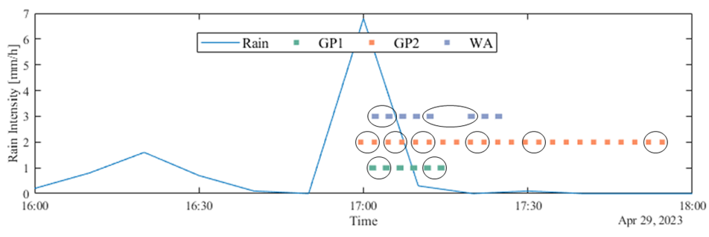
Figure SI 1: Image showing how bottles sampled on 2023-04-29 were aggregated for the MP analysis, as listed in Table 1. Black circles indicate which bottles were aggregated and analysed for MP.
Figure SI 2: Image showing how bottles sampled on 2023-05-17 were aggregated for the MP analysis, as listed in Table 1, with zoomed in views at certain times marked by brown (ca. 06:30 to 08:00), purple (ca. 14:30 to 15:00) and green (18:30 to 18:40) boxes for better visualization. Black circles and arrows indicate which bottles were aggregated and analysed for MP.

Tabulated measured MP concentrations in gully pots and wells of Testsite E18
Table SI 2: Microplastic polymer concentrations for the selected aggregated samples from the rain events on 2023-04-29 and 2023-05-17.
Name | Aggregated time samples | PE [µg/L] | PP [µg/L] | PS [µg/L] | ABS [µg/L] | PMMA [µg/L] | PC [µg/L] | PVC [µg/L] | PET [µg/L] | PA6 [µg/L] | PA 66 [µg/L] | PB [µg/L] | PI [µg/L] | SBR [µg/L] | SBR+BR [µg/L]ª
GP1^{b} 2023-04-29 | 17:02  17:04 | 1400 | <0.50 | <1.0 | <0.20 | <0.20 | <1.0 | <3.0 | <0.30 | <0.10 | <3.0 | <1.0 | 1000 | 1800 | 29 000
GP1 2023-04-29 | 17:12  17:14 | <0.10 | 11 | <1.0 | <0.20 | <0.20 | <1.0 | <3.0 | <0.30 | <0.10 | <3.0 | <1.0 | 3.8 | <0.20 | 7400
GP2^{c} 2023-04-29 | 16:59  17:02 | <0.10 | 49 | <1.0 | <0.20 | <0.20 | <1.0 | <3.0 | <0.30 | <0.10 | <3.0 | 3.6 | 2.8 | <0.20 | 54 000
GP2 2023-04-29 | 17:04  17:07 | <0.10 | 4.6 | <1.0 | <0.20 | <0.20 | <1.0 | <3.0 | <0.30 | <0.10 | <3.0 | <1.0 | <1.0 | <0.20 | 38 000
GP2 2023-04-29 | 17:09  17:12 | 170 | <0.5 | <1.0 | <0.20 | <0.20 | <1.0 | <3.0 | <0.30 | <0.10 | <3.0 | <1.0 | <1.0 | 340 | 21 000
GP2 2023-04-29 | 17:19  17:22 | <0.10 | 11 | <1.0 | <0.20 | <0.20 | <1.0 | <3.0 | <0.30 | <0.10 | <3.0 | <1.0 | 1.3 | <0.20 | 7000
GP2 2023-04-29 | 17:29  17:32 | <0.10 | 13 | <1.0 | <0.20 | <0.20 | <1.0 | <3.0 | <0.30 | <0.10 | <3.0 | <1.0 | <1.0 | 1.7 | 5300
GP2 2023-04-29 | 17:52  17:54 | <0.10 | 5.0 | <1.0 | <0.20 | <0.20 | <1.0 | <3.0 | <0.30 | 0.20 | <3.0 | <1.0 | <1.0 | <0.20 | 3200
WA^{d} 2023-04-29 | 17:02  17:04 | <0.10 | 11 | <1.0 | <0.20 | <0.20 | <1.0 | <3.0 | <0.30 | <0.10 | <3.0 | <1.0 | <1.0 | <0.20 | 35 000
WA 2023-04-29 | 17:12  17:19 | <0.10 | 12 | <1.0 | <0.20 | <0.20 | <1.0 | <3.0 | <0.30 | <0.10 | <3.0 | <1.0 | <1.0 | <0.20 | 26 000
GP1 2023-05-17 | 18:14^{c}  18:16 ^{c} | <0.10 | 5.4 | <1.0 | <0.20 | <0.20 | <1.0 | <3.0 | <0.30 | <0.10 | <3.0 | <1.0 | 7.0 | <0.20 | 24 000
GP1 2023-05-17 | 18:21 ^{c}  18:29 | <0.10 | 13 | <1.0 | <0.20 | <0.20 | <1.0 | 17 | <0.30 | <0.10 | <3.0 | 2.0 | 4.1 | 8.7 | 10 000
GP2 2023-05-17 | 06:54  06:57 | 190 | <0.50 | <1.0 | <0.20 | <0.20 | <1.0 | <3.0 | <0.30 | <0.10 | <3.0 | <1.0 | <1.0 | 270 | 8800
GP2 2023-05-17 | 06:59  07:04 | <0.10 | 55 | <1.0 | <0.20 | <0.20 | <1.0 | 3.2 | <0.30 | <0.10 | <3.0 | <1.0 | <1.0 | <0.20 | 12 000
GP2 2023-05-17 | 07:12  07:19 | <0.10 | 21 | <1.0 | <0.20 | <0.20 | <1.0 | <3.0 | <0.30 | <0.10 | <3.0 | <1.0 | <1.0 | <0.20 | 10 000
GP2 2023-05-17 | 07:57^{c}  08:27^{c} | <0.10 | 45 | <1.0 | <0.20 | <0.20 | <1.0 | <3.0 | <0.30 | <0.10 | <3.0 | <1.0 | <1.0 | <0.20 | 8200
GP2 2023-05-17 | 14:44^{c}  14:47^{c}  14:49^{c} | 5.8 | <0.50 | <1.0 | 1.2 | <0.20 | <1.0 | <3.0 | <0.30 | <0.10 | <3.0 | <1.0 | 5.9 | 10 | 3400
WA 2023-05-17 | 18:14^{c}  18:17^{c} | <0.10 | 4.3 | <1.0 | <0.20 | <0.20 | <1.0 | <3.0 | <0.30 | <0.10 | <3.0 | 1.6 | 1.0 | <0.20 | 22 000
WA 2023-05-17 | 18:24^{c}  18:37 | <0.10 | 2.4 | <1.0 | <0.20 | <0.20 | <1.0 | <3.0 | <0.30 | <0.10 | <3.0 | <1.0 | <1.0 | <0.20 | 18 000
Blank |  | <0.10 | 1.4 | <1.0 | 1.4 | <0.20 | <1.0 | <3.0 | 0.40 | <0.10 | <3.0 | <1.0 | <1.0 | <0.20
LoQ |  | 0.10 | 0.50 | 1.0 | 0.20 | 0.20 | 1.0 | 3.0 | 0.30 | 0.10 | 3.0 | 1.0 | 1.0 | 0.20
ª indicates calculated SBR+BR concentrations for the corresponding aggregated samples of the present study based on the results of Gaggini et al. (2025);
^{b} GP1 = sample collected in gully pot 1, see section 2.1; ^{c} GP1 = sample collected in gully pot 1, see section 2.1; ^{d} WA = sample collected in gully pot 1, see section 2.1.
^{c} Samples analysed for SBR+BR with marker combination excluding benzene (m/z 118 Da α-methylstyrene, m/z 117 Da ethylstyrene and m/z 91 Da butadiene trimer) in Gaggini et al. (2025) due to high level of benzene,

Metal concentrations on aggregated samples
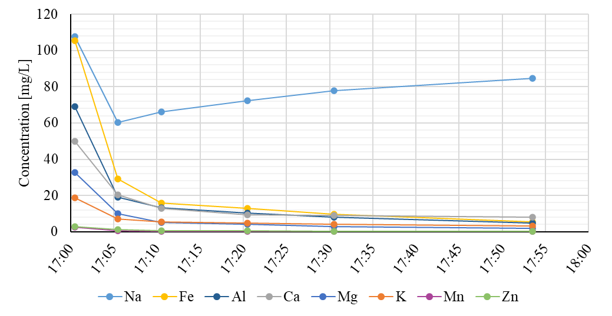
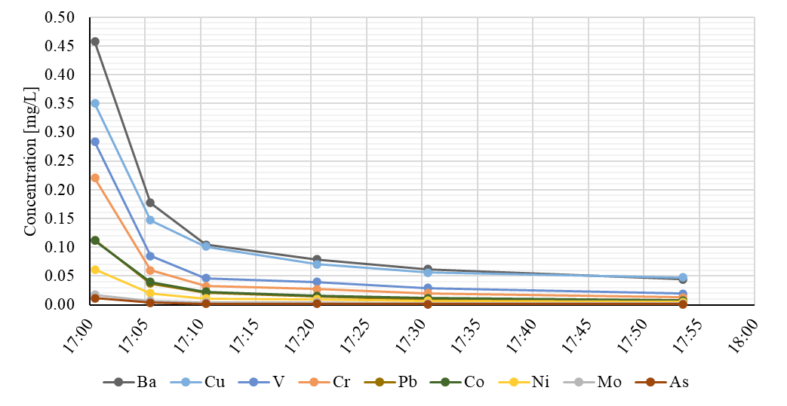
Figure SI 3: For location GP2, metal concentrations from rain on 2023-04-29. Calculated concentrations of total metals for the aggregated samples based on the results by Gaggini et al. (2025), with different y-axis between top and bottom figure.

References
Gaggini EL, Sokolova E, Rødland ES, Strömvall AM, Andersson-Sköld Y, Bondelind M. Tyre wear particles in a highway stormwater system during rain: quantification by automatic sampling and pyrolysis-GC/MS, and correlations with metals and solids. Environ Sci (Camb) 2025;11:3001–13. https://doi.org/10.1039/d5ew00656b.

