Mapping the plastic legacy with NIXVEGS: Machine-learning enabled microplastics prediction in sediments
Kristina Enders^{1,2*}, Robin Lenz^{1,2}, Franziska Fischer², Klaus Schwarzer³, Guntram Seiß⁴, Dieter Fischer², Matthias Labrenz^{1*}
¹ Leibniz Institute for Baltic Sea Research Warnemünde (IOW), 18119 Rostock, Germany
² Leibniz Institute for Polymer Research Dresden (IPF), 01069 Dresden, Germany
³ Christian-Albrechts-University of Kiel (CAU), 24118 Kiel, Germany
⁴ Federal Waterways Engineering and Research Institute (BAW), 22559 Hamburg, Germany
*Corresponding authors. Emails: enders-kristina@ipfdd.de, matthias.labrenz@io-warnemuende.de

Supplementary Information

Material and Methods

MP Sample collection
Sediment was collected at a total of 32 stations from May 14 – 16, 2018, using a Van Veen grab from aboard a ship (Klaashahn, IOW) in a transect from the Inner Schlei to the Baltic Sea opening ¹. The deliberate choice of the sampling locations aimed to balance grain size coverage (by consulting grain size maps of the Schlei ¹), spatial coverage (covering the entire extent and depths) and usage coverage (i.e. regions of more pristine and more anthropogenic character). After carefully opening the grab, the top 5 cm of sediment were transferred into a MP-free cleaned glass jars (one per sampling location and additionally also one sample of the 10-15 cm layer at S1, S2, S4, S10) and stored dark at 4°C. Of the 32 stations, 28 samples were later analyzed for MP, two only for sediment properties, and two were lost.
We used data on sediment properties from a second sample set, collected at 183 stations by an earlier sediment survey on courtesy of Kiel University. Information on sampling and analysis of this sub-dataset can be found in ¹. Principal procedural steps were comparable between the two studies. A van Veen grab was used to obtain 161 samples, whereas the 22 samples were taken using a gravity corer. For each core sample, sediment grain size measurements from the upper 5 cm were averaged for comparability to the grab samples.

Sample preparation
The detailed MP extraction protocols, documentation of the technical equipment, method validation and general contamination prevention measures are documented in the respective method article ². We here report the essential procedural steps and refer to respective protocol modules (m1 – m6) as part of the modular decision tree (see Fig. 2 in ²) as they are identical as described in these published protocols. Samples were freeze dried (m1), homogenized (m2) and defined dry masses (160 g on average) transferred into a density separation using sodium polytungstate (1.8 g cm⁻³, m5). The application of the conical spiral conveyor (see Fig. 3 in ²) in a customized glass separation funnel under addition of a few droplets of hydrogen peroxide allowed a gentle release and separation of lighter particles. Density and pH (3 – 3.4) were checked regularly and readjusted if necessary. Remaining organic constituents in the filtered supernatant were then reduced by applying 30% hydrogen peroxide (m4.1). Samples were then filtered in the analytical laboratory (IPF Dresden) onto silicon filters with ~50 µm pore size using a custom-built glass filtration device ³ under a laminar flow cabinet (Telstar Aeolus V3) ⁴. In cases where samples contained too many particles and that would exceed the usage of more than 10 filters, samples were split using a glass sample splitter built at IPF which allows homogeneous subsampling of the poured to remaining fraction of averagely 52 to 48 $±$ 11% SD (SI, ⁵). Liquid sample splitters are commonly used in plankton research and were already applied in previous MP studies ⁶. For most samples, ≥ 50% or 100% were analyzed, which is favorable to reach a reasonable statistical robustness on MP numbers ⁷.
Larger MP suspects (> 1 mm) were picked and rinsed individually or in case of particle overloading a stacked sieve filtration was applied (m6) as otherwise µ-spectroscopic analysis would be impaired. These individually picked particles were then transferred between glass slides for single particle analysis.
Blanks covering the entire MP extraction (using an MP free sediment matrix, n = 8) and spectroscopic analysis pipeline (one blank per sample) were prepared in an identical manner to account for MP contamination in the laboratories.

Spectroscopic analysis
Smaller MP particles applied to the Si-filters were identified and quantified via particle analysis combined with Raman µ-spectroscopy using the semi-automated software GEPARD developed at the IPF Dresden (for more details see ^{3,8}). The software recognizes particles on a substrate, captures particle properties such as size dimensions, shapes and color, among others and induces a spectroscopic measurement at every particle center coordinate. As a standard for Raman spectroscopic measurements, a WITec alpha 300R Raman microscope (Oxford Instruments Group) with a 20x objective and a 532 nm excitation laser at 5 mW, 0.5 s integration time and 5 scans were used. Using Raman µ-spectroscopy not only polymers but also pigments can be identified. In some cases the Raman scatter is more sensitive to the pigment than its polymeric binder and masks the polymer type signals ⁹. A shortlist of identified pigments was selected (i.e., PO7, PO13, PO34, PY185, PR214, PR254, PG7) which are majorly used in relation with synthetic polymers and classified as ‘unknown’ polymers (0.4% of all MP). Conservative criteria were applied for this selection process and most identified pigments were not counted (see ‘polyDropList’ in MPDB_settings.py). Larger particles were individually measured with Raman spectroscopy or ATR-FTIR spectroscopy ¹⁰. Raman measurements were performed either with the WITec alpha 300R Raman microscope (20x objective, 532 nm excitation laser at 5 mW, 0.5 s integration time, 10 to 100 scans) or with the Renishaw inVia Qontor Raman microscope (10x, 20x or 50x objective, 532 nm excitation laser at 0.1- 15 mW, 0,5-10 s integration time, 20 or 50 scans). ATR-FTIR measurements were performed using a Bruker ATR microscope Hyperion 2000 (20× ATR objective), coupled to a FTIR spectrometer Vertex 70 (100 scans, 4 cm⁻¹ spectral resolution). Raman and FTIR spectra were identified using spectral reference databases. For Raman spectra, the WITec software TrueMatch and in-house curated databases for common polymers, pigments and dyes as well as selected inorganic and organic materials typical of environmental samples were used. For the FTIR spectra, the database search was performed using the Bruker OPUS software and the Hummel Polymer spectra library as well as in-house FTIR spectral libraries.

Geological and geochemical analysis
Based on homogenized and freeze-dried subsamples, grain size distribution was analyzed in two sample replicates with the laser-sizer Mastersizer 3000 (Malvern Panalytical) in wet dispersion mode. Priorly, organic matter was removed using 30% H₂O₂ as the physical and chemical instability of this fraction and conglomeration affect measurement accuracy and deviating physical properties hinder the consistency of the sediment fraction. During measurements 10s ultrasound was applied ensuring disintegration of particle conglomerates. Five consecutive measurements were performed and averaged for further statistical analysis. All grain size data were exported in log scale (0.0419 - 2096.5 µm) in 116 histogram intervals.
Total organic carbon (TOC) was calculated by subtraction of the total inorganic carbon (TIC) from the total carbon (TC). TIC and TC (TN [total nitrogen], TS [total sulphur]) determination was conducted on lyophilized, homogenized and ground sample material using the elemental analyzers multi-EA 4000 (Analytik Jena) and Euro-Vector EA (Hekatech). Averages were calculated from analytical duplicates.
The size distribution of organic matter was determined based on homogenized subsamples (5 – 40 g dw). Samples were transferred to centrifuge bottles filled with 1.8 g cm⁻³ sodium polytungstate which was priorly microfiltrated at 0.4 µm ¹¹. Bottles were gently shaken on a shaker table for 30 min to ensure complete wetting of the material. Thereafter samples were centrifuged at 2500g rcf for 20 minutes. The supernatant was then pipetted to a beaker. Centrifugation and pipetting were repeated until no further light fraction could be separated (up to 10 repetitions). Samples were then filtered onto a 0.4 µm filter using MilliQ water ¹². Sample material remaining on the filter was then rinsed off and size analyzed using the laser-sizer Mastersizer 3000 (Malvern Panalytics) in wet dispersion.
Hg analysis was performed using the direct mercury analyzer DMA-80 (MLS GmbH Milestone Lab).

Data analysis
This section details the data analytical procedures that were applied in the generation of estimates on the MP inventory of the Schlei sediments. The entire data analytical workflow of this study is available as open source code. Reproducibly executable jupyter notebooks and python scripts were used to develop statistical and geospatial models and are available, including documentation of individual functions, at https://github.com/robna/MPSchleiSediments. The infographic (Fig. S1) provides an overview of how the code is structured.
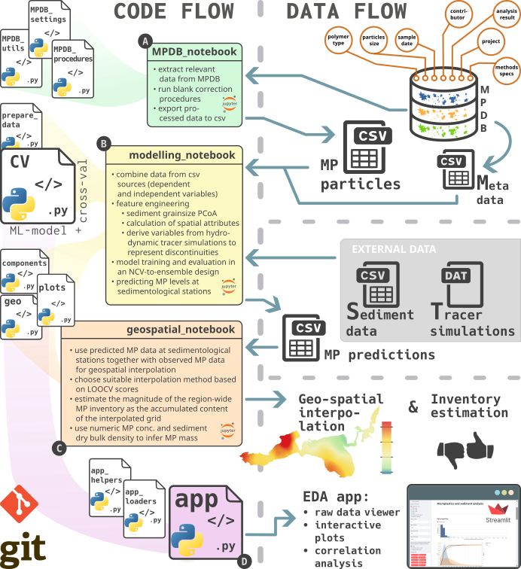
Figure S1: Overview of the analysis- (left panel) and data (right panel) flow. Raw data on MP samples and particles are stored in a public MP database (MPDB, ¹³). Data analysis was conducted in a collection of jupyter notebooks (A, B, C). For better readability of the notebooks, specific functions, integrating the MP- with sediment-, hydrodynamic tracer simulation- and geo data, were outsourced into python scripts. The functions in the scripts are then called from the notebooks. A) the MPDB_notebook queries MP particle data from the MPDB. Processing to account for potential contamination identified in blank controls happens here too. The extracted dataset is passed on as a csv file. B) the modelling_notebook ingests the data provided from A and establishes a machine learning model selection-validation-prediction pipeline and provides predictions of MP at sedimentological stations, as well as a detailed analysis of the model’s validity. C) the geospatial_notebook uses the predictions from B and interpolates it to grid data covering the entire Schlei area. The summarized interpolated MP amounts give an estimation of the total MP inventory. D) an interactive exploratory data analysis webapp (EDA app) provides detailed insights into the dataset.

Model conception
The general modeling steps can be summarized as follows:
- Dataset assembly: data management, preparation and feature engineering for response and predictor variable generation
- Model selection: A nested cross-validation (NCV) and hyperparameter optimization approach was used to explore a finite grid of empirical models for their suitability to explain the dependence of response variables (numeric and gravimetric MP abundances) on predictor variables (geographic, spatio-temporal discontinuity and sediment properties).
- Evaluation and prediction: A derived model ensemble from step 2 was used for prediction of the respective response variable at 187 sites where the same predictor variables were available from a prior sediment survey ¹.
- Geospatial interpolation: The predicted response variables were used to estimate the MP load of the entire studied system using geospatial interpolation.

Dataset assembly
Two subsets of sample data, sharing the same structure, were assembled from the pool of available data sources. The model set contained all samples with complete response and predictor variables, suitable for model training. The prediction set consisted of samples with only complete predictor information.

Response variable generation
Any MP-related datum, aggregated at sample level from the obtained MP particle data, may be considered a potential response (commonly also referred to as dependent variable or target variable). We used the total particle- and mass-based MP abundances per kg sediment dw ($Concentration$ (Fig. S2), $MassConcentration$, see EDA app: sample domain data) as response variables for predictive modeling and spatial interpolation.
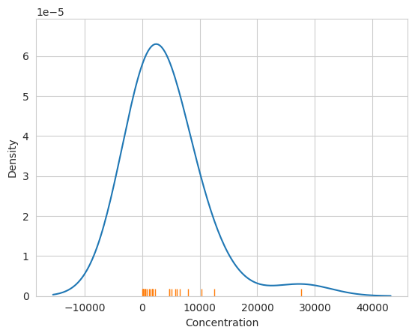
Figure S2: Kernel density estimation of the right-skewed response variable MP $Concentration$

Database
The recently published MPDB, a MP-specific database ¹³, was used to store and access MP related particle-, spectroscopic- and metadata (Fig. S1). This warrants data integrity, consistency and effective data management from the single MP particle (e.g., polymer type, size) to sample level (e.g., methods specifics, sampling dates and coordinates). The MPDB was developed for particle-based MP analysis workflows following the FAIR principles and is findable by international databases via the IOW-META database (for more details see ¹³). All relevant information that was extracted from the MPDB for the model development can also be seen in the EDA app.
The MPDB notebook contains the necessary functions to query the relevant entries from the MPDB. This includes the procedures of aggregating the particle-based raw data into sample-based data, according to the principles described in ¹³. During this process, samples which were only analyzed in part, i.e., which had been sub-sampled before spectroscopic measurement, were extrapolated by replicating the respective entries on the particle level. The exact steps of this process can be inferred from the respective function ‘particle_amplification’.
Blank correction was done by matching MP phenotypes between environmental and blank samples (see also ¹³ under 3.4. Data sanitation - Phenotyping and Blank Subtraction). In short, MP particle phenotypes were characterized by having the same sample, polymer type, shape and color properties. Particle size was used as a continuous selection criterion, to facilitate matches on individual particle level, i.e., smallest absolute difference in 2D geometric mean, between blank- and sample particles of the same phenotype, implied a match.
Two types of blanks were used: analysis blanks (one per environmental sample) and process blanks (n = 8). For the latter, synthesized average blank samples were created for the blank subtraction process on each environmental sample. For details of the implementation of this concept the reader is referred to code and documentation in the notebook and function script. In total, 12225 MP particles were found in the samples of which 237 particles were removed by the blank correction process.

Particle size, volume and mass and approximation
MP particle sizes were acquired by the open-source software GEPARD particle detection software ³. We advanced and validated (based on > 100 manual particle height measurements) the particle height determination algorithm in GEPARD to enable an accurate determination of all three spatial dimensions needed for more accurate conversion to volume hence mass based data. The relevant changes can be comprehended in the GEPARD repository.
Particle heights up to 20 µm, however, could not be reliably determined in this manner, due to vertical resolution limitations of the microscopic measurements. For these particles a function "height_vol_dens_mass" was implemented, which estimates the height by re-sampling from a distribution generated from 50 manually measured particle heights in this size range. For the individually measured larger MP, size dimensions were retrieved by the respective microscope software, a Zeiss microscope (Axio Imager Z2, Carl Zeiss Microscopy GmbH) or using a ruler in case of long fibers.
Particle volumes were calculated from particle size measurements in three dimensions. Volumes of irregular shaped particles $V_{irr}$ were calculated as ellipsoids based on particle length $l$, width $w$ and height $h$, according to Eq. 1. Fibers were approximated as cylindrical volumes $V_{fib}$ (Eq. 2).
$$V_{irr}=\frac{πlwh}{6} \left(1\right)$$
$$V_{fib}=\frac{πlw^{2}}{4} \left(2\right)$$
Particle volumes were then multiplied by the density of the identified polymer type to yield particle masses (see “densities” in settings.py for used values). For data exploratory purposes, other MP size parameters (median, mode, mean, etc.) were calculated from the volume and number-based particle distributions and are available for investigations in the provided EDA app.

Data preparation
Before modeling the MP response variables, we consolidated the available sample set based on theoretical considerations. This resulted in exclusion of samples S05 and S30 from the dataset used for model building, as they were considered environmental outliers. In both cases, spatio-temporal discontinuities could explain these deviations, however, at a much more localized scale, i.e., without effecting stations close by. Station S05 is situated in the fluvially coined outflow region from the tributary “Füsinger Au”, leading to a local spot of lower MP concentrations, visible as negative deviation from Inner Schlei proxy-normalization curve (see Fig 2 B). This indicates that the riverine MP load is much lower compared to the Inner Schlei levels, leading to local dilution effects. In contrast, station S32 deviates positively from the Outer Schlei proxy-normalization curve. Situated in a lagoon-like embayment “Wormshöfter Noor”, S32 is having limited exchange with the main part of the Schlei, but likely receives increased MP input from local sources (harbor, shipyard). Instead, these outlier stations were used in the prediction set, along with all other samples with no available MP data.
In sampling locations for which a sample of the deeper sediment layer (10 - 15 cm) existed aside the 0 - 5 cm sample, data of the two samples were vertically merged i.e., combined into single samples per station. The combination was done by:
- merging MP particle related data
- summing analyzed sample mass
- taking the mean of sediment data.

Predictor variable generation
Predictors in the context of this study are vectors of all non-MP-related properties with values for each station. This includes variables from three categories: geographic features, sediment properties and variables describing the spatio-temporal discontinuity of the studied system.
During model training, the predictors are composed in a “feature matrix” individually for each model configuration candidate in the grid search. For every candidate the predictor variables (columns) selected by the exhaustive feature selection algorithm contain the values for the 26 training samples (rows). Similarly, a “feature matrix” is created for the prediction step, however, containing the predictor variable values for the 187 sediment-only station (i.e. where no MP content was analyzed).

Geographic features
The selected geographic features were:
- $Dist_Land$, measured as the shortest distance in meters between a sample’s location and the shoreline
- $Depth$, the water depth in meters at a sample’s location. For the prediction dataset , the values were sampled from a bathymetry map (digital elevation model (DEM), 5 m grid, provided on courtesy of Federal Waterways Engineering and Research Institute [BAW]). The DEM is based on comprehensive bathymetric measurements using echosounder and multibeam echosounder surveys conducted over two decades by German waterways institutions (Federal Maritime and Hydrographic Agency [BSH], Federal Waterway and Shipping Administration [WSV]). Line soundings conducted by the BSH are data from a single transducer along the ship's route. The resolution along the route is < 1 m, the resolution for several parallel voyages is usually between 20 and 50 m. The fairways are surveyed by the WSV using multibeam sounding or a multiple transducer system (beams with several independent transducers), which generally achieves a resolution of < 1 m both along and across the route. A real resolution of 5 m can be assumed within the fairway, as each grid point was served at least once by one of the newer multibeam soundings, while outside the fairway a real data density of about 20 m of the primary data points can be assumed. As the gradients outside the fairway are predominantly flat, the linearly interpolated DEM can be considered being sufficiently representative of the bathymetry. The horizontal position is determined by differential GPS, i.e. GPS with additional correction by a land-based reference station.
To control for the validity of the DEM derived depth values we show them sampled at the locations of our MP stations against the in-situ measured depth values available there (Fig. S3). Both types are in good agreement (R² = 0.81, linear regression) with only one deviating value (S29) being about 4 m deeper in the DEM depth. Without S29, the other stations are approximated by a linear regression of R² = 0.97.
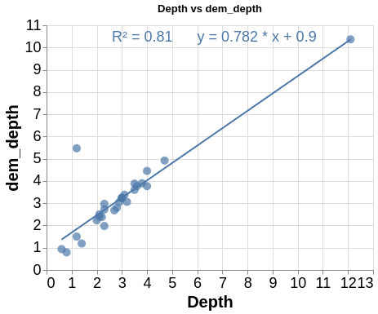
Figure S3: Control of validity of DEM sampled depth values. X-axis shows depths in meters manually measured at the MP stations, y-axis shows depths sampled from the DEM at the same coordinates.

Sediment grain size properties
From the vast possibilities of potential granulometric proxies, we chose sediment characteristics based on three key considerations:
- Empirical evidence: Prior studies have consistently demonstrated a strong correlation between microplastic concentrations and sediment grain size, as well as related particulate properties, because both microplastics and sediment particles respond to similar hydrodynamic forces.
- Practical availability: These parameters are routinely measured in sediment surveys, making them readily available and far less labor-intensive to obtain than direct microplastic measurements. This ease of acquisition is essential when scaling up to regional inventories.
- Methodological rigor: We began with a broad list of candidate predictors and then curated a shortlist based on their availability across all sampling stations and their potential relevance.
Grain size variables were generated using GRADISTAT ¹⁴ on the log-scaled binned volume-based grain size distributions as obtained by the laser sizer. Of the large number of calculated distribution moments of GRADISTAT, only median grain size in µm $SED_D50$ and the share below 63 µm in percent $perc_MUD$ was used. In addition, using a multidimensional scaling technique on the raw grain size data of 116 size bins, a 2D representation of grain size was calculated and used as predictor variables ($PCo1$, $PCo2$). They were created from a principal coordinate analysis (PCoA) using Bray-Curtis dissimilarity ¹⁵ as a distance measure, to map the compositional, zero-inflated grain size data to the two-dimensional space which retains the largest share of dissimilarity between samples (here 77.3% and 12.1% for $PCo1$ and $PCo2$ , respectively). By definition the two are uncorrelated to each other.
$PCo1$ is highly correlated to variables like perc_MUD or SED_D50, i.e. some of the most common sediment properties descriptors used in sedimentological studies, which aligns with similar observations in the literature ^{16,17}. We tested if $PCo2$ correlated with more of the various sediment variables obtained through GRADISTAT (such as kurtosis, skewedness, sorting, etc.), but no strong correlations were observed. As $PCo2$ had 12.1% explanatory value in the PCo-Analysis, we still included it as potential predictor to see its potential explanatory influence on the MP model. However, in only 4% of the ensemble members it was among the used predictor variables, as selected through the exhaustive feature selection of NIXVEGS (Nested Iterative (stratified) X-Validation-to-Ensemble-modeling through Grid Search).
Some of the 183 samples from the sediment-only survey used as prediction stations had missing values either in $TOC$ ($n=26$) or the grain size variables $SED_D50$, $perc_MUD$, $PCo1$ and $PCo2$ ($n=11$). They were imputed by regressions from those variables available (Eq. 3 - Eq. 7).
$$\text{TOC}=0.477 e^{0.039 \text{perc_MUD}} R^{2}=0.77 \left(3\right)$$
$$\text{SED_D50}=-99.342 ln\left(\text{TOC}\right)+235.451 R^{2}=0.75 \left(4\right)$$
$$\text{perc_MUD}=27.147 ln\left(\text{TOC}\right)+22.62 R^{2}=0.83 \left(5\right)$$
$$\text{PCo1}=-0.274 ln\left(\text{TOC}\right)+0.337 R^{2}=0.82 \left(6\right)$$
$$\text{PCo2}=-0.01 \text{TOC}+0.051 R^{2}=0.05 \left(7\right)$$
As can be seen in Eq. 3 - Eq. 7, most of the missing variables could be regressed from strong correlations to one of the available granulometric variables used in the model. No such correlation was found for $PCo2$ (Eq. 7). With a R² close to zero, the imputed values were practically equivalent to a mean imputation of all available PCo2 values.

Spatio-temporal discontinuity
To enable MP predictions via natural particulates proxies despite spatio-temporal discontinuities, it was necessary to introduce another class of predictor variables. A numeric model ¹⁸ was used to simulate the hydrodynamic behavior of the Schlei. It was set to a point at shore near the location of the highest granulometric normalized MP particle concentrations (S8 and S10). The so-identified simulation release point, in fact, coincided with the approximate point of discharge of the WWTP facility which has been found to emit unusually high amounts of meso- and microplastics. With the postprocessing method PARTRACE spherical drifters were released at location (latitude=54°31'31.499"N, longitude= 9°36'11.582"E, Fig. 2 A and Fig. 3 D) into the hydrodynamic field and then traced forward. The transport behavior of the particles depends on the turbulence-advection regime and their own sinking rates (determined by their density and size). The hydrodynamic model covers the Schlei from Schleimünde to Schleswig and is based on the unstructured finite volume code UnTRIM (Unstructured Tidal Residual Mudflat model ¹⁹). The horizontal resolution of the mesh is adapted to the bathymetry and the vertical resolution varies between 0.5 m and 1 m.
The particle tracing software PARTRACE was developed by BAW²⁰. The aim of this method is to trace idealized particles with defined sinking velocity. The particles are driven by the vertically averaged flow field of the Schlei hydrodynamic model. An idealized correction for the vertical structure of the flow (logarithmic profile) is assumed. The vertical movement of the particles is driven by vertical turbulence and sinking velocity, which depends on the density and size of the particles.
The hydrodynamic simulation period was 2017-05-01 to 2018-07-01. Particle tracing was simulated for three different periods: 2017-06-01 to 2017-08-01, 2017-10-15 to 2017-12-15 and 2018-04-01 to 2018-06-01. These three seasons were selected to assess the influence of wind- and wave-induced turbulence on MP redistribution and determine which period would be most determining for the model. The stormiest season ('autumn') preceding sampling was expected to have the strongest influence, while the most recent period ('spring') could also be a key determinant. In contrast, 'summer' represented the calmest conditions with minimal water turbulence and was included as a reference contrasting the two others.
Five different particle types were released with a density of 1.113 kg m⁻³ and different radii (300 µm, 100 µm, 50 µm, 18 µm) and passive tracer (no advection, i.e. equivalent to radius of 0 µm). The chosen density was derived from the mean density of all polymer particles identified in this study.
The resulting tracer paths were used to infer knowledge about how the tracers had moved through the system in respect to the sampling locations in four different implementations (see Table S1). Six variables (Disco1 to Disco6) were generated using varying settings of these implementations (see Table S2). Tracks of location, depth and time step of each tracer are provided in the data sources. Each of them was varied according to the following settings: simulated particle size and season, influence radius and sedimentation behavior.
Table S1: Discontinuity predictor variables derived from tracer simulations. Four main variable types were created, each with various alterations of simulation parameters. The function “get_wwtp_influence” is used for the calculations.
 | Type | Description | Range / Unit | Meaning | Varied Parameters
Distance aggregates | tracer_mean_dist | mean straight-line distance of all drifters at all time steps to each sampling station | 10^{2.8} – 10^{4.5} m | low values indicate high connectivity /  low discontinuity | - sedimentation [True, False]  - True: arrest drifters at location for all following time steps when valid  sedimentation was observed  - False: use tracks as simulated (never arrest drifters at sediment contact)  - drifter sizes  [0, 18, 50, 100, 300, all sizes]  - only include drifter simulations of the selected drifter particle size in µm volume-based ESD  - season  [spring, summer, autumn, all seasons]  - only include drifter simulations from the selected season  - buffer radius [222, 444]  - radius in meters around each station used as an event horizon  - only for buffer aggregating variable types  - specific to sampling site density
Distance aggregates | endpoints_mean_dist | mean straight-line distance of drifter locations  at last time step to each sampling station | 10^{2.8} – 10^{4.5} m | low values indicate high connectivity /  low discontinuity
Buffer aggregates | cummulated_residence | summed occurrences of presence of all drifters at all time steps inside station buffer zones | 0 – 10^{5.9} observations | high values indicate high connectivity /  low discontinuity
Buffer aggregates | mean_time_travelled | mean of time steps of all drifters at first entrance to station buffer zones | 10^{0.7} – 10^{2.7} timesteps  [3 h] | low values indicate high connectivity /  low discontinuity

Table S2: Discontinuity predictor variables with varied parameters in tracer simulations. See Table S1 for more information.
Variable | Type | Sedimentation | Drifter size | Season | Buffer radius
$$Disco1$$ | mean_time_travelled | False | 0 µm | allseasons | 222
$$Disco2$$ | mean_time_travelled | False | 18 µm | allseasons | 222
$$Disco3$$ | mean_time_travelled | True | 18 µm | autumn | 222
$$Disco4$$ | mean_time_travelled | True | 18 µm | allseasons | 444
$$Disco5$$ | cumulated_residence | False | 0 µm | allseasons | 222
$$Disco6$$ | cumulated_residence | False | 18 µm | autumn | 222

Model selection and evaluation
Through NIXVEGS (implemented in a jupyter notebook, Fig. 1, Fig. S4) we create a model which has) predictive capabilities for estimating the response variable $Concentration$ for samples in the prediction set. Theoretically it is founded on the principles of cross-validation (CV) ²¹, or NCV ²² more specifically, and grid-search (GS), i.e. the exhaustive optimization of a given parameter space with respect to a given performance metric. NIXVEGS is structurally similar to the NCV proposed by ²³, but extends the concept by creating a predictive ensemble in parallel to the generalization performance measure, and by adaptations specifically addressing the problems and needs arising under small dataset conditions.
The NIXVEGS modeling pipeline was implemented in a jupyter notebook with the goal to design a model selection, evaluation and prediction protocol, suitable for small datasets (i.e. n_{samples} ~ 30, an n_{predictors} in the same order of magnitude), which is typical for MP field data.

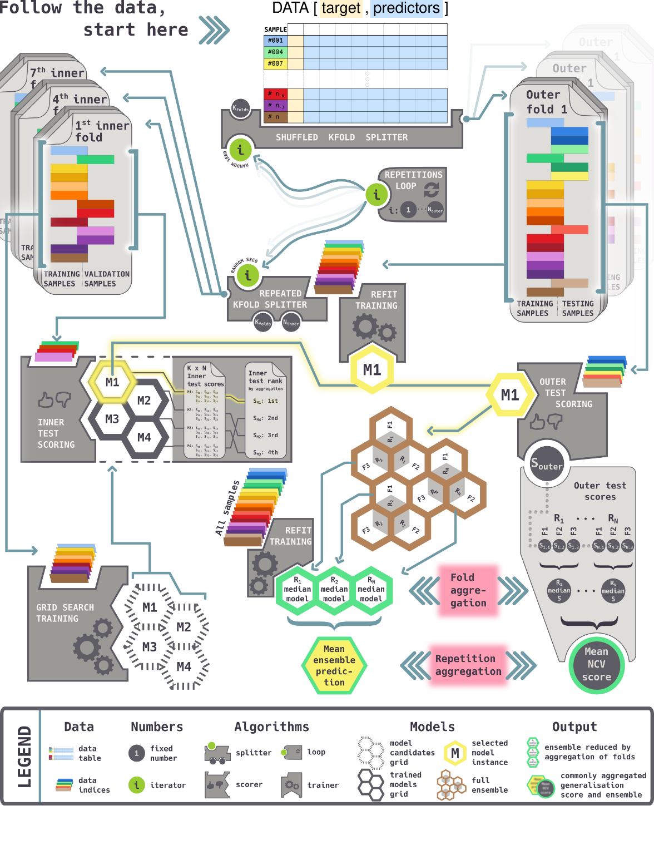
Figure S4: NIXVEGS model components and workflow: NIXVEGS performs selections of predictor variables, suitable model classes and hyperparameter settings synchronously with model training and validation. The final generalization score (“Mean NCV score”) indicates how the pipeline would perform on unseen data. The same logic of how the score (S) is aggregated is then used to construct an ensemble from individual trained model instances (M), which had been selected as the best performing ones, based on their respective inner test scores. For clarity, the infographic represents a simplified procedure of just three repetitions (R) and three folds (F), for the inner and outer cross-validations, respectively.

NIXVEGS’ adjustable components are:
- CV scheme:
  - number of repetitions for the outer and inner loop
  - number of folds for the outer and inner CV
- scoring scheme:
  - selection scorer: evaluation metric used to select a “best” model in the grid-search procedure, see Table S3
    - inner fold aggregator of the selection scorer: median, interquartile mean (iqm), or mean
  - generalization scorer: evaluation metric used as the final generalization score, see Table S3
    - outer fold aggregator: median, iqm, or mean
    - repetitions aggregator: median, iqm, or mean
- model candidate configurations:
  - predictor variable sets: feature selection from allowed variable combinations
  - model class: generalized linear models (GLM), gradient boosting for linear regressors (XGBlinear), gradient boosting for tree regressors (XGBtree), random forests (RF)
  - model hyperparameter values: depending on model class

The tested model algorithms included two from the linear ones. A GLM has previously been used to model MP concentrations, based on granulometric proxies ²⁴. In the present study the GLM was implemented for a gamma distribution with a log link using the TweedieRegressor class of the scikit-learn library with power=2 and a L2 regularization parameter alpha=0. A linear gradient boosting model, here referred to as XGBlinear, was implemented using the XGBRegressor class from the xgboost library. It was set up with hyperparameters to resemble the settings of the GLM model, however, allowing ensembles of up to 300 base estimators with the fixed hyperparameter set: booster=gblinear, objective=reg:gamma, n_estimators=300, reg_alpha=0, reg_lambda=0. The hyperparameters for the two linear models were held fixed as they were chosen on theoretical considerations of the modelled response variable and based on residual analysis using our EDA app. This could also further reduce computational time. Only predictor variable composition was varied. Two model classes of tree-based estimators were included for comparison to the linear models. XGBtree was also implemented from the XGBRegressor class of the xgboost library, sharing the same hyperparameters as XGBlinear, but using booster=gbtree. Additional decision-tree-related hyperparameters were varied and optimized in NIXVEGS based on the following allowed values: tree_method=exact, learning_rate=[0.1, 0.25], max_depth=[2, 3], min_child_weight=[5, 7]. A RF model, implemented using the RandomForrestRegressors class of the scikit-learn library, was allowed to vary in the following hyperparameters: n_estimators=[10, 100, 300], max_depth=[None, 2, 4], max_features=[None, 1/3]. The hyperparameter range was narrowed based on sample and predictor size as well as their selection frequency. For the specific roles of the hyperparameters, we refer to the respective library documentation. All non-mentioned hyperparameters were left at their default values.
In order to identify viable predictors, while also keeping computational cost for model training within practical limits, the EDA app was used for screening the large number of possible discontinuity and granulometric proxy variables. Six discontinuity variables were selected which demonstrated sufficient spatio-temporal separation of the identified sub-regions (compare Fig. 2). For geographic and sediment variables, an initially high number of candidates was reduced to four granulometric proxies ($SED_D50$, $perc_MUD$, $PCo1$ and $PCo2$) and two geospatial properties ($Dist_Land$, $Depth$) by excluding those being infrequently selected by NIXVEGS’ feature selection or being not available at the majority of stations (incl. the sediment-only prediction stations). In result, a set of 12 predictor variables was available for the automated feature selection inside NIXVEGS. For model parsimony and avoidance of potential collinearities, only one predictor for each per class (granulometric proxies and discontinuity variables) was allowed per model candidate. As an exception, $PCo2$ was allowed in combination with any other granulometric proxy as it is, by definition, uncorrelated to the first principal coordinate of grain sizes $PCo1$. NIXVEGS’ feature selection algorithm was to exhaustively test all possible combinations of two or three predictor variables for linear-based models. For tree-based models all possible sets of five predictors were tested, to allow more flexibility in feature variability for tree-building. For elaboration on the role of manual pre-selections in the context of information leakage see the following section.
The CV and scoring schemes were chosen manually under consideration of the small dataset size and modeling goal. We used $100$ and $10$ randomized repeats, each with $k=3$ folds splitting for the outer and inner CV loop, respectively. Generally, a higher number of splits, such as $k=10$, may be preferred for performance evaluations ²⁵, but owing to the small dataset size this would lead to very low numbers of samples in the test sets. This would lead to scores that reflect more the favorable or unfavorable composition of the test set, rather than the model’s ability to predict unseen data correctly. We used the coefficient of determination (R², Eq. 8) as scorer for both, the selection and generalization scoring scheme. It can be regarded as a variant of the mean squared error (MSE), normalized by the sample variance. Thus, models minimizing a sum-of-squares loss, will be rewarded a better score. In particular, we argue that, because R² accounts for the sample variance, its use as evaluation metric in small dataset scenarios is preferable to using MSE, as it facilitates comparability of scores produced by test sets of possibly significantly different sample variance. The aggregation of the inner and outer folds’ test scores was implemented as median. Using the median, instead of the (more commonly used) mean for the aggregation of folds, was chosen deliberately to adapt to the small sample number. Situations with such limited data resources will likely lead to few train/test-set combinations yielding egregiously bad test scores. These will affect a mean-aggregated score over proportionately, as the upper end of the score’s scale is bound to 1.0, meaning perfect prediction, while the lower end is open towards negative infinity. Median (and also iqm) aggregation is more robust in such situations. Despite the use of median R² as the main scoring scheme, we report the evolution of scores (and their standard deviations) over the increasing number of NIXVEGS’ outer repetitions for all aggregations of multiple scorers listed in Table S3.
Table S3: Regression metrics used in model evaluation, with $y$ as observed values of targeted response variable and $\hat{y}$ being its prediction, $n$ as the number of samples and $ϵ$ being an arbitrarily small positive number to avoid division by zero.
Metric | Definition | Range and meaning
Coefficient of determination | $${\text{R}}^{2}\left(y,\hat{y}\right)=1-\frac{\sum_{i=1}^{n}{{\left(y_{i}-{\hat{y}}_{i}\right)}^{2}}}{\sum_{i=1}^{n}{{\left(y_{i}-\overset{‾}{y}\right)}^{2}}} \left(8\right)$$  $$\text{with }\overset{‾}{y}=\frac{1}{n}\sum_{i=1}^{n}{y_{i}} \left(9\right)$$ | ${\text{R}}^{2}=1$ (perfect prediction)  $1>{\text{R}}^{2}>0$ (imperfect prediction)  ${\text{R}}^{2}=0$ (pred. == obs. mean)  $0>{\text{R}}^{2}>-∞$ (worse than mean)
Mean absolute percentage error | $$\text{MAPE}\left(y,\hat{y}\right)=\frac{1}{n}\sum_{i=1}^{n}{\frac{​|y_{i}-{\hat{y}}_{i}|}{max\left(ϵ,|y_{i}|\right)}} \left(10\right)$$ | $\text{MAPE}=0$ (perfect prediction)  $0<\text{MAPE}<∞$ (increasingly imperfect)  in percent of the response variable unit
Median absolute percentage error | $$\text{MedAPE}\left(y,\hat{y}\right)=$$  $$\text{median}\left(\frac{​|y_{1}-{\hat{y}}_{1}|}{max\left(ϵ,|y_{1}|\right)},…,\frac{​|y_{n}-{\hat{y}}_{n}|}{max\left(ϵ,|y_{n}|\right)}\right) \left(11\right)$$ | $\text{MedAPE}=0$ (perfect prediction)  $0<\text{MedAPE}<∞$ (increasingly imperfect) in percent of the response variable unit
Mean absolute error | $$\text{MAE}\left(y,\hat{y}\right)=\frac{1}{n}\sum_{i=1}^{n}{|}y_{i}-{\hat{y}}_{i}| \left(12\right)$$ | $\text{MAE}=0$ (perfect prediction)  $0<\text{MAE}<∞$ (increasingly imperfect)  in response variable unit
Median absolute error | $$\text{MedAE}\left(y,\hat{y}\right)=$$  $$\text{median}\left(|y_{1}-{\hat{y}}_{1}|,…,|y_{n}-{\hat{y}}_{n}|\right) \left(13\right)$$ | $\text{MedAE}=0$ (perfect prediction)  $0<\text{MedAE}<∞$ (increasingly imperfect) in response variable unit
Mean squared error | $$\text{MSE}\left(y,\hat{y}\right)=\frac{1}{n}\sum_{i=1}^{n}{{\left(y_{i}-{\hat{y}}_{i}\right)}^{2}} \left(14\right)$$ | $\text{MSE}=0$ (perfect prediction)  $0<\text{MSE}<∞$ (increasingly imperfect) in response variable unit squared
When the GS had trained and selected the best models, their outer test set scores were calculated and aggregated first across folds within repetitions (outer fold aggregator), then across repetitions (repetitions aggregator), to obtain the final NCV generalization score. Afterwards, the model instances were not discarded, but used to recruit members for an ensemble, following the same logic as for the previous score aggregation. This process can be understood graphically in Fig. S4. In effect, this procedure integrates the steps of selecting between different model classes, with the optimization of their respective hyperparameters and the choice of the most suitable predictor variables set (i.e. feature selection).

Rational for the chosen model design
In contrast to classical hypotheses-driven statistical modeling, there are few prerequisites to a dataset when applying data-driven machine learning techniques, but a strong emphasis on posterior performance evaluation under avoidance of information leakage. This concept of information leakage refers to the notion, that for building a machine learning pipeline, any decision that has influence on the resulting model output becomes part of the model itself. This includes the parameters used to set up the model algorithm before fitting (often called hyperparameters), the way to choose which predictor variables are used (feature selection), or even the choice of the model algorithm itself.
In effect, all of the before listed aspects become essentially hyperparameters of the modeling pipeline. The combinations that can be created thereof, form a grid of possible model configurations in which the optimum shall be searched for. Any decision for or against a certain configuration, when taken under consideration of the entire available data, is potentially biased towards the statistical peculiarities of the dataset ²⁶. In other words, when all available information has leaked into the decision-making process, none is available to independently evaluate the decision.
It is important to note that the concept of avoiding information leakage has practical limitations. The grid of possible configurations is theoretically infinite. Some of the parameters to be chosen are real numbers and can thus be chosen arbitrarily dense or wide. On the other hand, the choice of which components (i.e., model algorithm classes or derived predictor variables) should or should not be variably tried out by the grid search is already a decision. Thus, when the pipeline is set up, a manual pre-restriction of the variable components is inevitable. This would also be the case if other methods, such as randomized search or Bayesian methods, were chosen instead of an exhaustive grid search CV.
CV provides an efficient way for either model evaluation, or to decide on a certain model configuration. When it is nested, it provides both under the best possible utilization of a confined dataset. It has been demonstrated that NCV, using k-fold splitting, can offer an almost unbiased estimate of the true generalization performance ²². The cross-validatory scheme itself also comes with a range of setup parameters, that need to be chosen depending on the dataset and type of problem, as there is no general optimal setting ²³. These include the number of folds to split, how samples can be selected for a particular fold (e.g., using stratification), and how often to repeat the whole procedure in independent randomized trials that can be aggregated to reduce the evaluation variance.
In practice, the decision on which aspects of the modeling pipeline are allowed to adapt to the available data is likely based on knowledge about the problem to be modelled and its data structure, as well as relevant domain knowledge. This does not need to invalidate the estimated generalization performance. In fact, it has been shown on a range of modeling problems from real-life datasets, that many model decisions taken under consideration of all available data in a non-nested CV had negligible effects on the biasedness of the estimated generalization performance as compared to the computationally more expensive NCV ²⁷. Nevertheless, the importance of NCV is elevated specifically with decreasing dataset size and increasing model flexibility ²⁶ and is therefore seen as an indispensable component of NIXVEGS.

Sensitivity analysis and adaptations for small datasets
For validation of our model results, NIXVEGS provides the CV scores. Various CV settings were evaluated, including the number of folds k, the type of scorer and the use of a stratification scheme (Fig. 3 F).
For large ML-datasets, often higher values of $k$ in k-fold CV are generally preferred as they reduce bias in performance estimation and provide a reliable CV score ^{25,28}. However, when datasets are small (as in our case n_{samples}=26) and are skewed, stochastic instability in drawing of the sets can become a problem. With higher k, test sets become smaller and may not represent the observed data distribution , leading to erratic CV scores. Conversely, with lower k, the informational content of the training sets diminishes, making it less likely that the correct response distribution is learned during training. This can be observed in our data testing different values of k: the score is highly variable over different values of k (Fig. 3 F, non-stratified). We tested different stratification schemes (i.e., tertile and $\frac{n}{k}$-quantile) to evaluate performance estimation more independent of the described sensitivities towards k arising from small datasets. At k=3 there was highest agreement between the different cases tested in the sensitivity analysis. When using stratification, however, only minor score deviations are observed for lower or higher k as compared to unstratified k-fold. Strict stratification schemes, i.e., higher number of quantile strata, imply a higher confidence in the representativeness of distribution in the available data. With the small dataset at hand, it seemed more balanced to implement a weaker tertile stratification (Fig. 3 F). Based on this sensitivity analysis, we use a repeated stratified k-fold CV scheme, with $k=n_{folds}=\left[3,3\right]$ drawn from $s=n_{strata}=\left[3,3\right]$, repeated $r=n_{repetitions}=\left[100...500,10\right]$ times and scored using $scorer=\left[R^{2},R^{2}\right]$, for the outer and inner CV of NIXVEGS, respectively (Fig. 3 F). This setup results in 300 to 1500 unique aggregable splits which is approximately on par with what a leave-two- or leave-three-out scheme would achieve (325 and 2600, respectively), but with the advantage that it allows for a more balanced response variable distribution.

Prediction

EPM_{ensemble}
The ensemble of models, generated as described above, is composed of $N_{\text{outer repetitions}}=100$ members. Before predicting, every ensemble member was refit on the entire model set of samples. The prediction was then carried out by each member individually using the prediction set of samples. The individual predictions were then aggregated according to the repetitions aggregator, for each sample. Since the entire ensemble was re-trained on the complete dataset, members that completely overlapped in their chosen predictor variables set, model class and corresponding hyperparameters were consequently identical models. The aggregated ensemble prediction, thus can be regarded as the weighted arithmetic mean of all unique model configurations, where the frequency of occurrence of a configuration in the ensemble constitutes its weighting factor. We use this logic also to infer the relative importance of partial configuration aspects in the ensemble, i.e., the model class (Fig. S4).

EPM_{single}
To obtain a predictive model instance, a non-nested grid search CV with the same CV scheme previously used in the inner NCV loop, is applied to the same grid of configurations, selecting a ‘best candidate’ configuration. This configuration is then fitted to all available data before prediction. We refer to this model as single empirical predictive model (EPM_{single}). It may seem counterintuitive, at first glance, that the EPM_{single}, as a model realized from one point on the configuration grid, shall be adequate to make predictions when its generalization performance has been calculated as an aggregate of model performances from potentially very different configurations. This becomes ever more salient the larger and the more diverse the configuration grid is (e.g., as in the present case with $n_{configs}=728$, allowing for different algorithm classes, their respective hyperparameters and predictor sets to be selected). In comparison, the EPM_{ensemble}, which consists of models with the exact configurations that took part in the score construction, and whose predictions are aggregated in the same way as the score itself, may give the impression of being more directly related to the reported generalization performance, and thus more fit for prediction. It is, however, the EPM_{single} that is derived purely from first principals, i.e. the idea that model selection is an integral part of the model fitting procedure ²⁶. This implies, that for making predictions the procedure should adapt to the full data available, just as during performance evaluation it had to adapt to each reduced set of training data. This logic would hold even if the very configuration found for the EPM_{single} was not present among those selected in the evaluation.
The reasons for creating the EPM_{ensemble} are therefore different and can be summarized as follows:
- the members of the ensemble have been selected as the optimal adaptations of the modeling procedure to various facets of the data available
- the aggregation of their predictions gives a weighted sum, where configurations that fitted more facets get a larger say
- it has been demonstrated that model ensembling can reduce instability, especially when datasets are small ²⁹
- in effect, ensembling takes into account the limited confidence one can have that the response variable distribution of a small dataset is representative of the unknown true distribution.

MP mass concentration prediction
The calculation of MP mass concentration was based on the summed observed MP particle masses per sample. See also the section on size, volume and mass approximation for the determination of all three spatial dimensions needed for the conversion to volume hence mass based data.
$MassConcentration$ at the prediction stations was then approximated from the predicted numeric $Concentration$ via an empirical regression established from the model set samples ($R^{2}=0.910$, Eq. 15, $R^{2}=0.89$ in LOOCV, Eq. 3).
$$\text{MassConcentration}=0.1451⋅{\text{Concentration}}^{1.1894} \left(15\right)$$

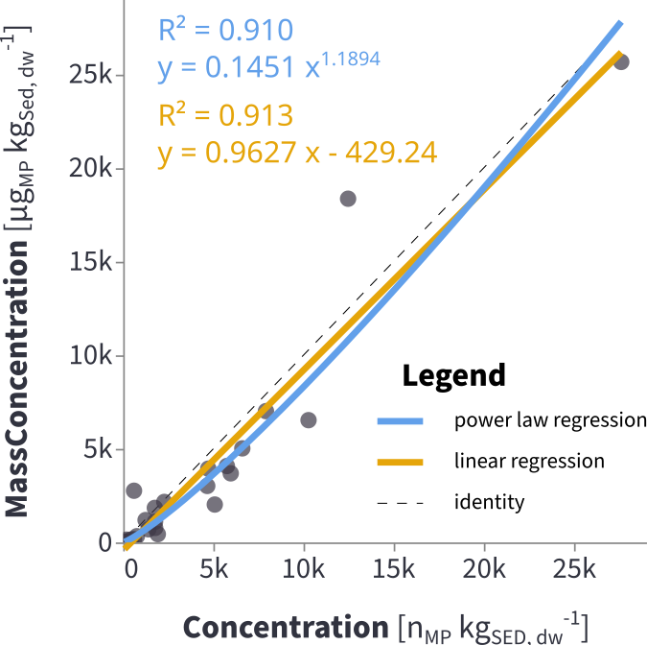
Figure S5: MP $MassConcentration$ estimated through regression from numeric $Concentration$. The power law regression (blue) was used for estimation of MP $MassConcentration$ at the predicted stations.
It should be noted, that this power law regression is very similar to a linear regression (which achieved a marginally higher $R^{2}$ of $0.913$). The theoretical consideration for this choice is that samples with high numeric $Concentration$ are more likely to include very rare, very large MP, which disproportionately increase $MassConcentration$. It also has the practical implication, that, in contrast to the linear equation, it avoids calculating negative values for $MassConcentration$ in cases of very low numeric $Concentration$
Both regressions are close to identicality of the concentrations of MP number and MP mass in µg, indicating that the mass of an average MP particle in this study is on the order of 1 µg.
An attempt to use the NIXVEGS modeling pipeline to directly predict MP $MassConcentration$ did not indicate that a generalization performance on unseen data would be able to get better than guessing the mean of the response ($R^{2}=0.01$ as median of three folds after 100 mean aggregated repetitions). This is surprising given that $MassConcentration$ is highly correlated to MP numeric $Concentration$ ($r=0.95$, $p≤0.01$, Fig. S5). We attribute this observation to the sporadic occurrence of very large MP particles. They easily dominate the MP volume and thus the mass of their sample. This introduces an additional variance for $MassConcentration$, that cannot the explained sufficiently by the predictive resources with the sample number being on the verge of meaningful exploitability.
Number- and mass-based MP values are complementary reporting units, usually originating from different analytical approaches, such as particle analytical techniques (e.g., Raman or FTIR microscopy) on the one hand, and mass spectroscopic techniques (e.g., pyrolysis GC/MS) on the other hand. When a reliable conversion is possible between the two, reporting of both quantities can avoid misinterpretations. For instance, mass-based MP inventory estimations are more intuitively interpreted in the context of the extent of the studied system, its inputs or affected population. Number-based MP concentration are important for ecotoxicological risk assessments or particle distribution dynamics.

Geospatial interpolation and inventory estimation
The predicted and observed values were used together ($n=213$ samples) to interpolate the response variables on a regular 10 m grid over the entire Schlei area. Three grids were independently interpolated: $Concentration$ and $MassConcentration$ as main response variable of interest and $SedDBD$ (sediment dry bulk density), which was used to infer the total estimated MP numbers and masses from the concentrations. As $SedDBD$ had not been measured on the samples, it was necessary to calculate it apriori. Two empirical equations, available in the literature (Eq. 18, Eq. 19 ^{30,31}), were suitable for $SedDBD$ approximation. These studies were also conducted in sediments of coastal waterways (lagoon, tidal channel, laboratory), covering comparable percentages of mud i.e., hydrodynamic ranges. The former used percent organic matter ($perc_OM$) and percent silt ($perc_SILT$, i.e., the fraction between 4 and 63 µm grain size), obtained according to Eq. 16 and Eq. 17. $SedDBD$ was then calculated at the sample locations as the mean output of both equations from the literature (Eq. 20).
$$\text{perc_OM}=\text{TOC}⋅2.22 \left(16\right)$$
$$\text{perc_SILT}=\text{perc_MUD}-\text{perc_CLAY} \left(17\right)$$
$${\text{SedDBD}}_{\text{vanRijn et al}}=\left(1-\frac{\text{perc_OM}}{100}\right)⋅\left(400⋅\frac{\text{perc_CLAY}}{100}+800⋅\frac{\text{perc_SILT}}{100}+1600⋅\frac{\text{perc_SAND}}{100}\right) \left(18\right)$$
$${\text{SedDBD}}_{\text{Jia et al}}=-8.86⋅\text{perc_MUD}+1518.91 \left(19\right)$$
$$\text{SedDBD}=\frac{{\text{SedDBD}}_{\text{vanRijn et al}}+{\text{SedDBD}}_{\text{Jia et al}}}{2} \left(20\right)$$

The interpolation procedure was implemented in a jupyter notebook and its associated script files. Several interpolation algorithms were tested and compared using a leave-one-out cross-validation (LOOCV) with $Concentration$ as target. Every of the 213 points, where either observed or predicted MP values were available, was withheld in turns, while the grid was interpolated on the remaining data points. The resulting grid was then sampled at the coordinates of the held-out point. The sampled values were used to calculate error metrices against the original values (Table S4). For the final numeric- and mass inventory estimation, we used the OK interpolation.

Table S4: Interpolation algorithms.
 | Description | Implementation | Settings | Ref
NN | Nearest Neighbor interpolation. Every grid point is assigned the value of the closest sample point. Akin to assigning the target values to subareas generated by Voronoi tessellation. | interpol.py, function "scipy_griddata" using scipy library | method="nearest" | ³²
IDW | Inverse Distance Weighted interpolation. With the Euclidean distance $d_{i,j}$ between the sample and grid coordinates $i$ and $j$, respectively, weights were determined as $w=\frac{1}{d^{p}}$ (with $p$ as the weighting power) and multiplied with the sample values to obtain the weighted mean at each grid point. | interpol.py, function "numpy_simple_idw" | power=1.0 | —
OK | Ordinary Kriging. The empirical variogram was used to fit a theoretical variogram for the interpolation. | interpol.py, function "skgstat_ordkrig" using SciKit-GStat | n_lags: 10, maxlag: 7000, model: "spherical", min_points: 20, max_points: 30, mode: "exact", normalize: False, use_nugget: True | ³³

The total MP inventory estimates $E_{\text{inventory}}$ were then calculated according to Eq. 21,
EinventoryMP|Schlei=x,y​d2⋅l⋅SedDBDxy⋅MPconcxy 21
with $\left(x,y\right)$ being the coordinate points of the MP concentration grid $MPconc$ and $SedDBD$, $d$ the grid point distance and $l$ the relevant sediment layer thickness.

Vertical MP mixing
Comparing the volumetric median size of MP and sediments allows an evaluation with respect to vertical mixing and infiltration processes (Fig. S6 A). A segregation of the data is observed, with fine sediments featuring relatively larger median MP sizes (see also sample-aggregated cumulative size distributions in Fig. S6 B) and coarse sediments with relatively smaller median MP sizes (with sample-aggregated cumulative size distributions in Fig. S6 C). It is described that infiltration increasingly occurs when the ratio between the size medians of coexisting finer and coarser fractions is 0.32 or less ^{34,35}. Although Schlei samples almost approach this infiltration size ratio (Fig. S6 A, dashed infiltration line) with increasingly coarser sediment grain sizes, it does not fall below.
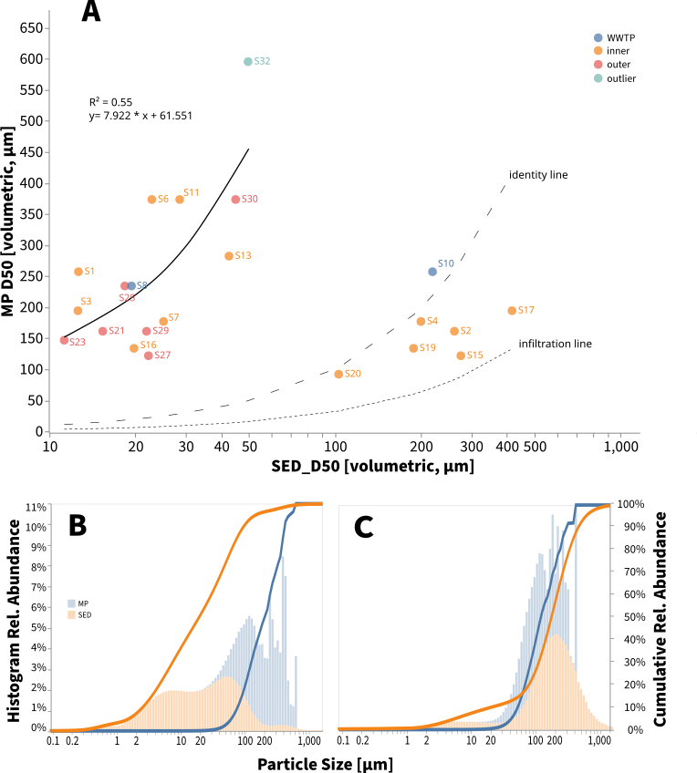
Figure S6: MP median versus sediment grain size median. For better projection of the fine sediment fraction the X-axis is shown in log-scale. Note that only samples with MP numbers > 50 are shown. (B, C) As two distinct clusters of stations are visible in (A) the respective smaller grained (B) and larger grained (C) samples are shown in size distribution plots: MP and sediment grain size histograms (bars, left y axis)with their cumulative relative abundance (lines, right y axis) show interchanged size ratiosof relatively larger and smaller MP within fine and coarse sediments, respectively.
The presence of additional factors in MP from environmental samples such angularity of particles and multimodal size distributions further counteract infiltration ³⁴. Thus, infiltration of MP in the studied size range appears not to be a dominating process in Schlei sediments. Equal MP levels found in greater depth are likely caused by hydrodynamic and anthropogenic sediment mixing as well as bioturbation.
Radiocarbon dating at four stations show varying degrees of mixing activities vertical across stratigraphic layers within fine sediment regions ¹. Wide extents of the Schlei surface sediments are composed of a thick sapropel layer, characterized by organic-rich, fine and unconsolidated sediments. The shallow waters of the Schlei (average depth 2.5 - 3 m), foster wind-driven wave-induced sediment mixing. In fine sediments median MP sizes positively correlate with median sediment grain sizes (R² = 0.55 in linear regression) and are roughly 10 times larger. This size difference (Fig. S6) is consistent with the finding that MP distribution on the sediment bed is mainly driven by bedload transport as opposed to direct deposition ²⁴. At a given bed shear stress, relatively larger MP sizes can be mobilized compared to quartz grains due to the lower relative densities of polymers. The above considerations support the assumption that within wide parts of the Schlei, MP are subjected to sediment mixing processes which allows an extension of the MP projection to a depth of 15 cm (Fig. 3 D).

References

(1) Schwarzer, K.; Ricklefs, K.; Höft, D. Sediment Inventory and Hydromorphology of the Schlei, (Original: Sedimentinventar Und Hydromorphologie Der Schlei); Institute of Geosciences, Kiel University, 2019; p 114. https://www.schleswig-holstein.de/DE/fachinhalte/M/meeresschutz/Downloads/Bericht_SedimentinventarHydromorphologieSchlei.pdf.
(2) Enders, K.; Lenz, R.; Ivar do Sul, J. A.; Tagg, A. S.; Labrenz, M. When Every Particle Matters: A QuEChERS Approach to Extract Microplastics from Environmental Samples. MethodsX 2020, 7, 100784. https://doi.org/10.1016/j.mex.2020.100784.
(3) Brandt, J.; Bittrich, L.; Fischer, F.; Kanaki, E.; Tagg, A.; Lenz, R.; Labrenz, M.; Brandes, E.; Fischer, D.; Eichhorn, K.-J. High-Throughput Analyses of Microplastic Samples Using Fourier Transform Infrared and Raman Spectrometry. Applied Spectroscopy 2020, 74 (9), 1185–1197. https://doi.org/10.1177/0003702820932926.
(4) Käppler, A.; Windrich, F.; Löder, M. G. J.; Malanin, M.; Fischer, D.; Labrenz, M.; Eichhorn, K.-J.; Voit, B. Identification of Microplastics by FTIR and Raman Microscopy: A Novel Silicon Filter Substrate Opens the Important Spectral Range below 1300 Cm-1 for FTIR Transmission Measurements. Analytical and Bioanalytical Chemistry 2015, 407 (22), 6791–6801. https://doi.org/10.1007/s00216-015-8850-8.
(5) Tagg, A. S.; Brandes, E.; Fischer, F.; Fischer, D.; Brandt, J.; Labrenz, M. Agricultural Application of Microplastic-Rich Sewage Sludge Leads to Further Uncontrolled Contamination. Science of The Total Environment 2022, 806, 150611. https://doi.org/10.1016/j.scitotenv.2021.150611.
(6) Enders, K.; Lenz, R. How to Find the Small Plastic in the Big Sea, The Identifcation and Characterisation of Microplastic Larger 10 Micrometer from the Atlantic Ocean. 2014, 98.
(7) Brandt, J.; Fischer, F.; Kanaki, E.; Enders, K.; Labrenz, M.; Fischer, D. Assessment of Subsampling Strategies in Microspectroscopy of Environmental Microplastic Samples. Frontiers in Environmental Science 2021, 8, 579676. https://doi.org/10.3389/fenvs.2020.579676.
(8) Bittrich, L.; Brandt, J. GEPARD - Gepard-Enabled PARticle Detection for Raman Microscopes. https://gitlab.ipfdd.de/gepard/gepard.
(9) Lenz, R.; Enders, K.; Stedmon, C. A.; Mackenzie, D. M. A.; Nielsen, T. G. A Critical Assessment of Visual Identification of Marine Microplastic Using Raman Spectroscopy for Analysis Improvement. Marine Pollution Bulletin 2015, 100 (1), 82–91. https://doi.org/10.1016/j.marpolbul.2015.09.026.
(10) Käppler, A.; Fischer, D.; Oberbeckmann, S.; Schernewski, G.; Labrenz, M.; Eichhorn, K.-J.; Voit, B. Analysis of Environmental Microplastics by Vibrational Microspectroscopy: FTIR, Raman or Both? Analytical and Bioanalytical Chemistry 2016, 408 (29), 8377–8391. https://doi.org/10.1007/s00216-016-9956-3.
(11) Kreyling, O.; Kölbl, A.; Spielvogel, S.; Rennert, T.; Kaiser, K.; Kögel-Knabner, I. Density Fractionation of Organic Matter in Dolomite-Derived Soils. Journal of Plant Nutrition and Soil Science 2013, 176 (4), 509–519. https://doi.org/10.1002/jpln.201200276.
(12) Wakeham, S. G.; Canuel, E. A. The Nature of Organic Carbon in Density-Fractionated Sediments in the Sacramento-San Joaquin River Delta (California). Biogeosciences 2016, 13 (2), 567–582. https://doi.org/10.5194/bg-13-567-2016.
(13) Čerkasova, N.; Enders, K.; Lenz, R.; Oberbeckmann, S.; Brandt, J.; Fischer, D.; Fischer, F.; Labrenz, M.; Schernewski, G. A Public Database for Microplastics in the Environment.
(14) Blott, S. J.; Pye, K. GRADISTAT: A Grain Size Distribution and Statistics Package for the Analysis of Unconsolidated Sediments. Earth Surface Processes and Landforms 2001, 26 (11), 1237–1248. https://doi.org/10.1002/esp.261.
(15) Bray, J. R.; Curtis, J. T. An Ordination of the Upland Forest Communities of Southern Wisconsin. Ecological Monographs 1957, 27 (4), 325–349. https://doi.org/10.2307/1942268.
(16) Su, Q.; Yu, H.; Xu, X.; Chen, B.; Yang, L.; Fu, T.; Liu, W.; Chen, G. Using Principal Component Analysis (PCA) Combined with Multivariate Change-Point Analysis to Identify Brine Layers Based on the Geochemistry of the Core Sediment. Water 2023, 15 (10), 1926. https://doi.org/10.3390/w15101926.
(17) Duquesne, A.; Carozza, J.-M. Improving Grain Size Analysis to Characterize Sedimentary Processes in a Low-Energy River: A Case Study of the Charente River (Southwest France). Applied Sciences 2023, 13 (14), 8061. https://doi.org/10.3390/app13148061.
(18) Seiß, G. Hydrodynamic Numerical Models Suitable for Application to the German Fairways and Ports at the Baltic Sea Coast. 2014.
(19) BAWiki. Mathematical Model UNTRIM.
(20) BAWiki. PARTRACE.DAT.
(21) Stone, M. Cross-Validatory Choice and Assessment of Statistical Predictions. Journal of the Royal Statistical Society: Series B (Methodological) 1974, 36 (2), 111–133. https://doi.org/10.1111/j.2517-6161.1974.tb00994.x.
(22) Varma, S.; Simon, R. Bias in Error Estimation When Using Cross-Validation for Model Selection. BMC Bioinformatics 2006, 7 (1), 91. https://doi.org/10.1186/1471-2105-7-91.
(23) Krstajic, D.; Buturovic, L. J.; Leahy, D. E.; Thomas, S. Cross-Validation Pitfalls When Selecting and Assessing Regression and Classification Models. Journal of Cheminformatics 2014, 6 (1), 10. https://doi.org/10.1186/1758-2946-6-10.
(24) Enders, K.; Käppler, A.; Biniasch, O.; Feldens, P.; Stollberg, N.; Lange, X.; Fischer, D.; Eichhorn, K.-J.; Pollehne, F.; Oberbeckmann, S.; Labrenz, M. Tracing Microplastics in Aquatic Environments Based on Sediment Analogies. Scientific Reports 2019, 9 (1), 15207. https://doi.org/10.1038/s41598-019-50508-2.
(25) Yates, L. A.; Aandahl, Z.; Richards, S. A.; Brook, B. W. Cross Validation for Model Selection: A Review with Examples from Ecology. Ecological Monographs 2023. https://doi.org/10.1002/ecm.1557.
(26) Cawley, G. C.; Talbot, N. L. C. On Over-Fitting in Model Selection and Subsequent Selection Bias in Performance Evaluation. Journal of Machine Learning Research 2010, 11 (70), 2079–2107. https://doi.org/10.5555/1756006.1859921.
(27) Wainer, J.; Cawley, G. Nested Cross-Validation When Selecting Classifiers Is Overzealous for Most Practical Applications. Expert Systems with Applications 2021, 182, 115222. https://doi.org/10.1016/j.eswa.2021.115222.
(28) Arlot, S.; Celisse, A. A Survey of Cross-Validation Procedures for Model Selection. Statist. Surv. 2010, 4 (none). https://doi.org/10.1214/09-SS054.
(29) Dietterich, T. G. Ensemble Methods in Machine Learning. In Multiple Classifier Systems; Goos, G., Hartmanis, J., Van Leeuwen, J., Eds.; Springer Berlin Heidelberg: Berlin, Heidelberg, 2000; Vol. 1857, pp 1–15. https://doi.org/10.1007/3-540-45014-9_1.
(30) Van Rijn, L. C.; Barth, R. Settling and Consolidation of Soft Mud–Sand Layers. Journal of Waterway, Port, Coastal, and Ocean Engineering 2019, 145 (1), 04018028. https://doi.org/10.1061/(ASCE)WW.1943-5460.0000483.
(31) Jia, J.-J.; Gao, S.; Xue, Y.-C. Sediment Dynamic Processes of the Yuehu Inlet System, Shandong Peninsula, China. Estuarine, Coastal and Shelf Science 2003, 57 (5–6), 783–801. https://doi.org/10.1016/S0272-7714(02)00406-7.
(32) Virtanen, P.; Gommers, R.; Oliphant, T. E.; Haberland, M.; Reddy, T.; Cournapeau, D.; Burovski, E.; Peterson, P.; Weckesser, W.; Bright, J.; van der Walt, S. J.; Brett, M.; Wilson, J.; Millman, K. J.; Mayorov, N.; Nelson, A. R. J.; Jones, E.; Kern, R.; Larson, E.; Carey, C. J.; Polat, İ.; Feng, Y.; Moore, E. W.; VanderPlas, J.; Laxalde, D.; Perktold, J.; Cimrman, R.; Henriksen, I.; Quintero, E. A.; Harris, C. R.; Archibald, A. M.; Ribeiro, A. H.; Pedregosa, F.; van Mulbregt, P.; SciPy 1.0 Contributors; Vijaykumar, A.; Bardelli, A. P.; Rothberg, A.; Hilboll, A.; Kloeckner, A.; Scopatz, A.; Lee, A.; Rokem, A.; Woods, C. N.; Fulton, C.; Masson, C.; Häggström, C.; Fitzgerald, C.; Nicholson, D. A.; Hagen, D. R.; Pasechnik, D. V.; Olivetti, E.; Martin, E.; Wieser, E.; Silva, F.; Lenders, F.; Wilhelm, F.; Young, G.; Price, G. A.; Ingold, G.-L.; Allen, G. E.; Lee, G. R.; Audren, H.; Probst, I.; Dietrich, J. P.; Silterra, J.; Webber, J. T.; Slavič, J.; Nothman, J.; Buchner, J.; Kulick, J.; Schönberger, J. L.; de Miranda Cardoso, J. V.; Reimer, J.; Harrington, J.; Rodríguez, J. L. C.; Nunez-Iglesias, J.; Kuczynski, J.; Tritz, K.; Thoma, M.; Newville, M.; Kümmerer, M.; Bolingbroke, M.; Tartre, M.; Pak, M.; Smith, N. J.; Nowaczyk, N.; Shebanov, N.; Pavlyk, O.; Brodtkorb, P. A.; Lee, P.; McGibbon, R. T.; Feldbauer, R.; Lewis, S.; Tygier, S.; Sievert, S.; Vigna, S.; Peterson, S.; More, S.; Pudlik, T.; Oshima, T.; Pingel, T. J.; Robitaille, T. P.; Spura, T.; Jones, T. R.; Cera, T.; Leslie, T.; Zito, T.; Krauss, T.; Upadhyay, U.; Halchenko, Y. O.; Vázquez-Baeza, Y. SciPy 1.0: Fundamental Algorithms for Scientific Computing in Python. Nat Methods 2020, 17 (3), 261–272. https://doi.org/10.1038/s41592-019-0686-2.
(33) Mälicke, M. SciKit-GStat 1.0: A SciPy-Flavored Geostatistical Variogram Estimation Toolbox Written in Python. Geosci. Model Dev. 2022, 15 (6), 2505–2532. https://doi.org/10.5194/gmd-15-2505-2022.
(34) Waldschläger, K.; Schüttrumpf, H. Infiltration Behavior of Microplastic Particles with Different Densities, Sizes, and Shapes—From Glass Spheres to Natural Sediments. Environmental Science & Technology 2020, 54 (15), 9366–9373. https://doi.org/10.1021/acs.est.0c01722.
(35) Schruff, T. Taking a Closer Look at the Causes and Impacts of Fine Sediment Infiltration into Gravel Beds : Development and Application of an Extended Theory of Fine Sediment Infiltration Based on Grain Scale Numerical Simulations. PhD Thesis, RWTH Aachen University, 2018, Vol. RWTH Aachen University. https://doi.org/10.18154/RWTH-2018-227229.

