Additional file 1
Remotely Mind-controlled Metasurface via Brainwaves
Ruichao Zhu¹, Jiafu Wang¹*, Tianshuo Qiu¹, Yajuan Han¹, Xinmin Fu¹, Yuzhi Shi², Xingsi Liu³, Tonghao Liu¹, Zhongtao Zhang¹, Zuntian Chu¹, Cheng-Wei Qiu³*, Shaobo Qu¹*
1 Shaanxi Key Laboratory of Artificially-Structured Functional Materials and Devices, Air Force Engineering University, Xi'an, Shaanxi 710051, China
2 National Key Laboratory of Science and Technology on Micro/Nano Fabrication, Department of Micro/Nano Electronics, Shanghai Jiao Tong University, Shanghai 200240, China
3 Department of Electrical and Computer Engineering, Faculty of Engineering, National University of Singapore, 4 Engineering Drive 3, Singapore 117583, Singapore.
Corresponding author. E-mail:
wangjiafu1981@126.com; chengwei.qiu@nus.edu.sg; qushaobo@126.com
The supplementary file includes:
Note S1. Modified equivalent circuit of PIN diodes via S-parameter measurement
Note S2. Biasing lines network
Note S3. Wearing mode of brainwave acquisition equipment
Note S4. Coding sequence display
Note S5. Application to attention monitoring
Note S6. Application to function-switching

Note S1. Modified equivalent circuit of PIN diodes via S-parameter measurement
In order to ensure the reliability of the meta-atom design, a metasurface sample was fabricated and measured to get the actual EM responses and hence to determine the accurate equivalent circuit. The measurement was carried out in a microwave anechoic chamber, as shown in figure S1(a). All the PIN diodes are powered on and off to demonstrate ‘0’ and ‘1’ states of the metasurface, respectively. EM responses under the two states were then measured. The sample is placed at the test board and a pair of X-band horn antennas are used as the receiving and transmitting antennas to measure the reflectivity under normal incidence. The reflected amplitude and phase are captured by Vector Network Analyzer (Agilent E8363B) and the measurement results are recorded in figure 2 of the text. According to the measured results, effective parameters of the equivalent circuit were modified and then used in the subsequent simulations. The modified equivalent circuit is shown in figure S1(b). The simulated amplitude and phase of reflection are shown in figure S1(c, d). After the modification, the simulated EM responses are basically consistent with the measured ones.
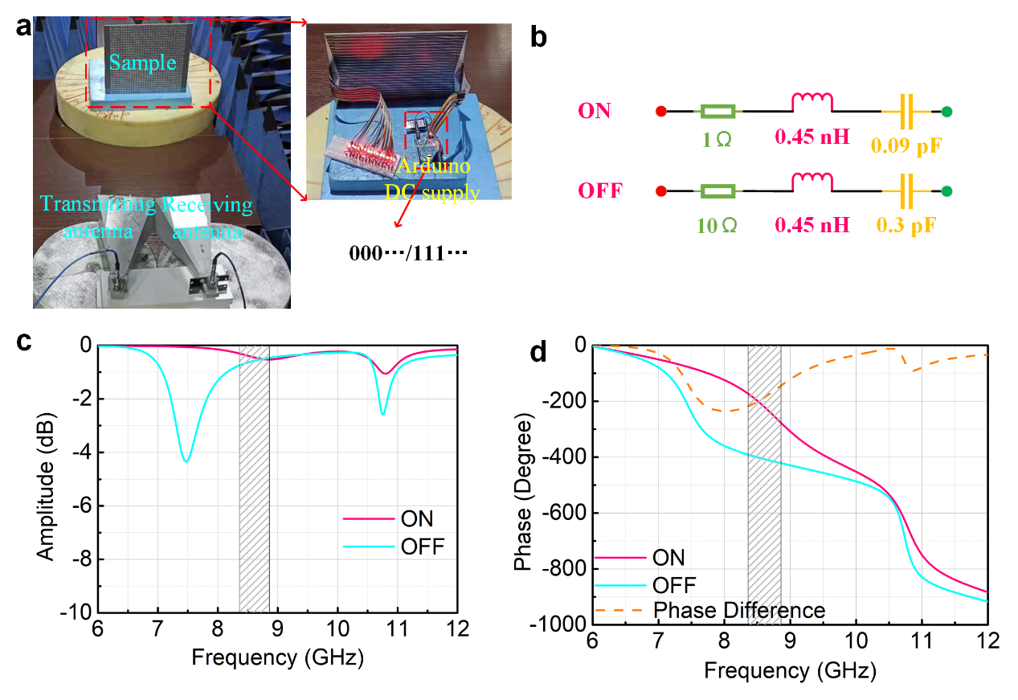
Figure S1. Modification on the equivalent circuit of PIN diodes via measured data: (a) measurement setup; (b) modified equivalent circuit of the PIN diodes; (c) simulated reflectivity using the modified equivalent circuit; (d) simulated reflected phase using the modified equivalent circuit;

Note S2. Biasing lines network
PIN diodes on the metasurface are all biased by metallized vias that connect the biasing lines on the bottom, as shown by the CAD graphs of the metasurface in Figure S2. Different voltages are input on the pins of the biasing lines, and each meta-atom is powered by metallized vias to control the on or off state of PIN diodes. Note that the middle layer of the metasurface is a reflecting ground plane, so the biasing lines network has almost no influence on the EM performances of the metasurface.
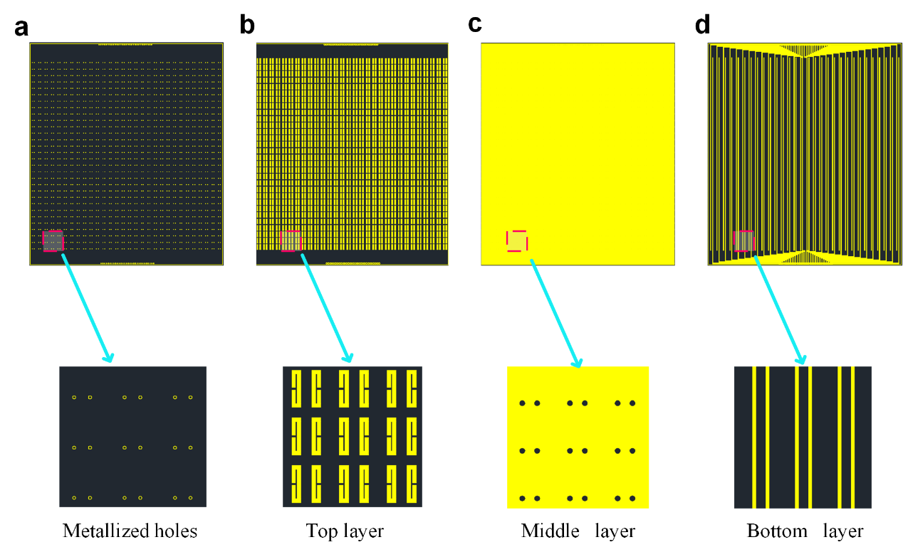
Figure S2. Fabrication and design of metasurface: (a) metallized holes; (b) unit in the top layer; (c) middle metal reflection surface; (d) biasing lines in bottom layer

Note S3. Wearing mode of brainwave acquisition equipment
The brainwave signal acquisition module is a commercial brainwave sensor module, namely, TGAM module. This module collects brainwave signals through three dry electrodes. Because of small number of electrodes and the dry electrodes collecting way, the module is convenient and simple for users to wear and use. The wearing mode of the module is illustrated in figure S3. The three dry electrodes consist of one patch-type and two clip-type ones. The patch electrode is attached to the forehead and the two clip electrodes are clamped on earlobes of the user. Therefore, the brainwave sensor module has high universality and applicability. In addition, the commercial brainwave sensor module has good versatility for different users with a low price.
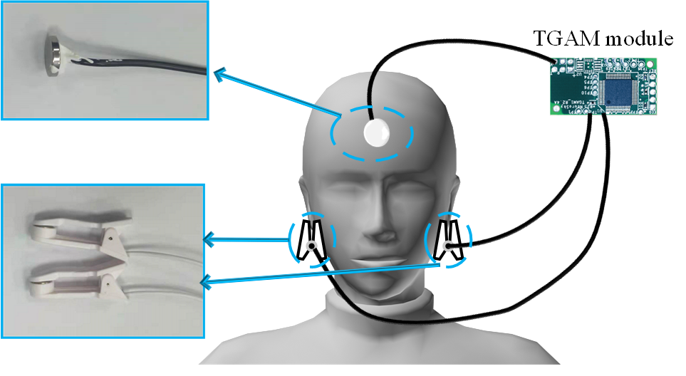
Figure S3. The wearing mode of brainwave acquisition equipment

Note 4. Coding sequence display
In order to observe the mind-control of coding sequence more intuitively, an LED array is adopted to visually display the coding state. The circuit design is shown in Figure S3a. When the output level is high, the LED light is on. Otherwise, the LED light is off. Figure S3 shows the LED array for different coding sequences, which can clearly display the coding sequences.
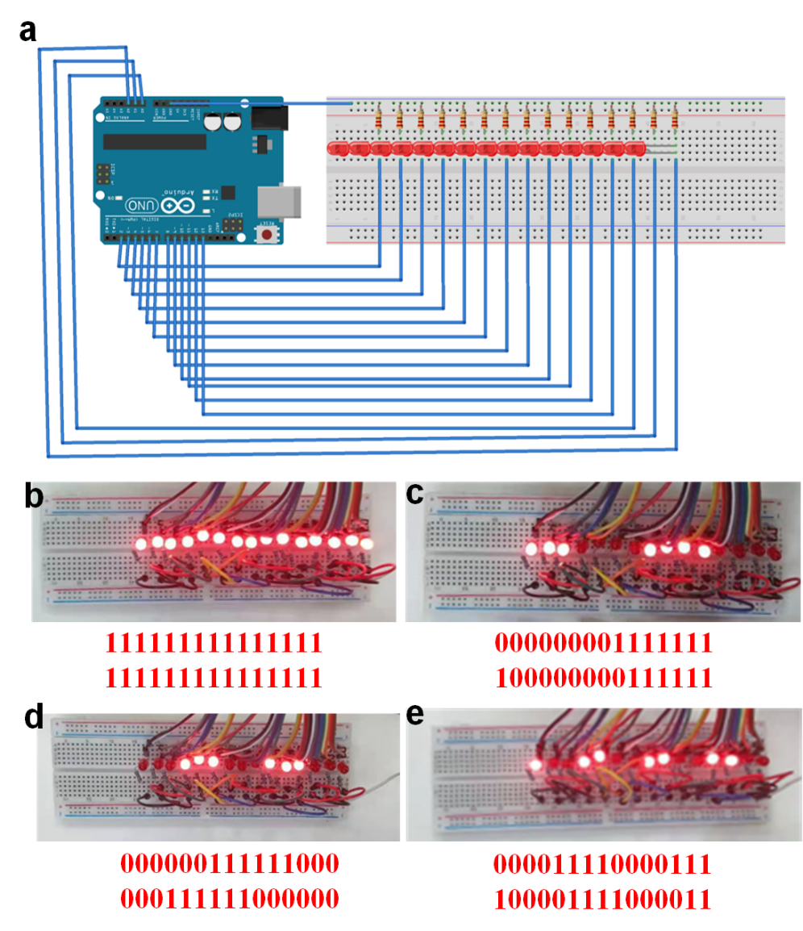
Figure S4. Coding sequence display using LED array: (a) circuit design; (b, c, d, e) different coding sequences displayed by the LED array

Note S5. Application to attention monitoring
The RMCM can sense brainwave variations in real time, and the attention intensity can be mapped to the far-field scattering pattern of the metasurface. Therefore, it is possible to monitor the attention intensity in real time by the received EM field intensity by an antenna fixed at a particular position. Here, some hypothetical application scenarios are proposed, such as fatigue monitoring and health monitoring, as illustrated in figure S5.
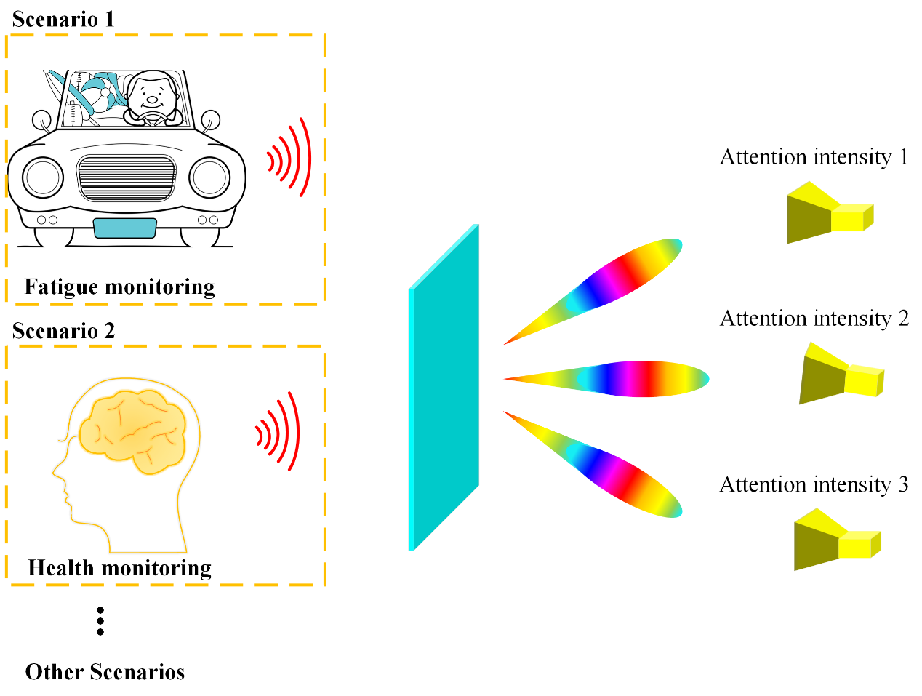
Figure S5. Diagram of Attention detection applications

Note S6. Application to function-switching
The mind-controlled system can directly act on the metasurface through human’s brainwaves. Therefore, the module can also be applied to function switch by controlling the attention intensity through the human’s mind. In the text, we constructed a 1-bit RMCM that can control the scattering patterns. As a demonstration, we verified the RMCM through simulations and measurements. In fact, the mind-control method can also be applied to other scenarios. Many scholars have done excellent works in 1- or 2-bit coding metasurface. [1-6] These works provide some attractive functions, such as beam deflection, beam splitting, beam diffusion, vortex beam generation, focusing, imaging and so on. Here, we extend our method to 2-bit coding sequences. In 2-bit coding case, switching among different functions can also be achieved by brainwaves. As done in the text, the attention intensity is also divided to four intervals, namely 0-25, 25-50, 50-75 and 75-100. Based on the threshold in these four intervals, we preset four functions corresponding to these four intervals and employ the mind-control module to switch among these four functions. Here, we use a 2-bit coding metasurface with the four functions of abnormal reflection, beam splitting, vortex beam generation and focusing. The corresponding phase profiles corresponding to these four functions are shown in figure S6. The brainwave module can directly act on metasurface through a preset coding sequence and thus makes the metasurface to switch to the corresponding function in real time.
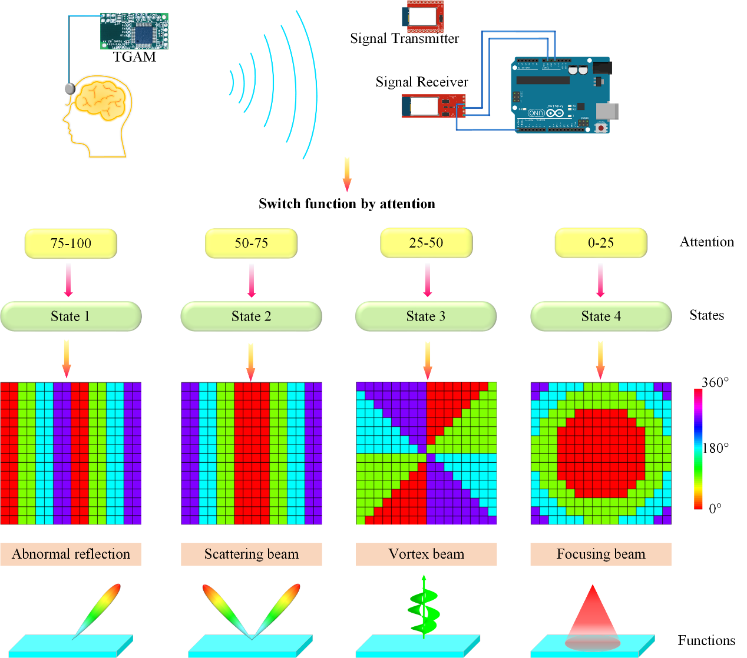
Figure S6. Application of the mind-control module to function switching

References
[1] Huang, C., Sun, B., Pan, W. et al. Dynamical beam manipulation based on 2-bit digitally-controlled coding metasurface. Sci Rep 7, 42302 (2017).
[2] Tran, N.M.; Amri, M.M.; Park, J.H.; Hwang, S.I.; Kim, D.I.; Choi, K.W. A Novel Coding Metasurface for Wireless Power Transfer Applications. Energies 2019, 12, 4488
[3] Wan, X., Zhang, Q., Yi Chen, T. et al. Multichannel direct transmissions of near-field information. Light Sci Appl 8, 60 (2019). https://doi.org/10.1038/s41377-019-0169-3
[4] Chen, K., Zhang, N., Ding, G., Zhao, J., Jiang, T., Feng, Y., Active Anisotropic Coding Metasurface with Independent Real-Time Reconfigurability for Dual Polarized Waves. Adv. Mater. Technol. 2020, 5, 1900930. https://doi.org/10.1002/admt.201900930
[5] Li, L., Jun Cui, T., Ji, W. et al. Electromagnetic reprogrammable coding-metasurface holograms. Nat Commun 8, 197 (2017). https://doi.org/10.1038/s41467-017-00164-9
[6] Jiaqi Han, Long Li, Hao Yi, and Yan Shi, "1-bit digital orbital angular momentum vortex beam generator based on a coding reflective metasurface," Opt. Mater. Express 8, 3470-3478 (2018)

