Additional file 1

A Through-Intact-Skull (TIS) chronic window technique for cortical structure and function observation in mice

Dongyu Li, Zhengwu Hu, Hequn Zhang, Qihang Yang, Liang Zhu, Yin Liu, Tingting Yu, Jingtan Zhu, Jiamin Wu, Jing He, Peng Fei, Wang Xi, Jun Qian and Dan Zhu

Ex vivo evaluation of the TIS window
Before evaluating the TIS window in vivo, we examined the effect of the reagents used in the establishment of the TIS window ex vivo. The results are shown in Fig. S1. After treatment with S1, S2 and S3, the transmittance of the skull in the 500-1000 nm band increased 10-fold from the original value of less than 5% to about 50%, rendering the grid paper beneath the skull visible (Fig. S1a and S1b). In addition, as shown in Fig. S1c, the 1951 United States Air Force (USAF) resolution test target yielded no visibility through the intact skull, whereas the resolution increased to 7.81 μm (which is close to the CCD pixel size of 6.45×6.45 μm2) after the application of the TIS window.
Figure S1. a Transmittance spectral of skulls before and during the optical clearing process through the TIS window. b Typical photographs of skulls before and after the TIS window establishment. c Images of a skull-covered central region of a 1951 USAF target.

Preliminary in vivo evaluation of the TIS window
Bright-field imaging at 550 nm, HSI for oxygen saturation (SO₂) imaging, and LSCI for cerebral blood flow (CBF) imaging were performed first during the core steps of the window establishment to preliminarily assess the efficacy of the TIS window in vivo.
As shown in Fig. S2a and S2b, no vasculature was visible at 550 nm before the optical clearing treatment, and this did not change much after PBS treatment. However, during optical clearing, even small cortical blood vessels became visible with promising contrast. HSI and LSCI findings both displayed clearer functional information of cortical blood vessels during the skull optical clearing procedure (Fig. S2c and S2d).
In addition, the LSCI images were quantitatively analyzed. As shown in Fig. S2e, only blood vessels with diameters as large as 77.8 μm were distinguishable through an intact skull, and blood vessels of skulls covered with PBS were identifiable at a diameter of 46.3 μm. However, the minimum resolvable vascular diameter was remarkably smaller during the TIS window establishment (20.8 μm). These numbers were determined using the smallest observable blood vessel in each blood flow image. Moreover, the contrast-to-noise ratio (CNR) got increasingly better after treatment with S1, S2, and S3 (Fig. S2f). Here, the resolution power of the imaging device, which only uses a 2× objective and an industrial CCD (512 pixels×512 pixels; pixel size: 6.45 μm×6.45 μm), was still limited.
Figure S2. a Typical 550-nm reflectance maps (at 550 nm) of cortical vessels under different conditions. b Signal intensity along the dashed lines in (a). c SO₂ images of the same ROI in (a). The white arrows indicate blood vessels that were indistinguishable with SO₂ imaging before S3 treatment. d Cerebral blood flow (CBF) images of the same ROI in (c). e Bar graph of the minimum resolvable vascular diameter in mice under different conditions based on CBF images. f Contrast-to-noise ratios (CNR) under different conditions based on LSCI images. *p<0.05, ***p<0.001, and N.S.: no significant difference. n=3.

Figure S3. Neutrophil accumulation near the injured area after TBI. The observation began 1 hour later than TBI for the TIS window establishment.

Figure S4. Representative 3D reconstructions of two-photon neuron imaging under different conditions.

Figure S5. a Two Representative regions of interest under two-photon microscopy through the TIS window and open-skull glass window. B Plots of the intensity distribution of the lines in (a).

Figure S6. Quantitative analysis of neural two-photon microscopy under different conditions. Each plot represents the intensity distribution at the corresponding dash line in the image above it.

Figure S7. Comparing the SOCW and TIS techniques via two-photon microscopy imaging of cortical neurons. a Two-photon images at various depths. The plots represent the intensity distributions at the lines in the corresponding images above them. b zoom-in images at the 150-μm depth. The plots represent the intensity distributions on the purple lines. The plots reveal a smaller full width at the half maximum of the imaged structure and a stronger signal intensity through the TIS window, pointing to a better imaging quality.

Figure S8. Comparing the USOCA and TIS techniques via two-photon microscopy imaging of cortical neurons. a Two-photon images at various depths. The plots represent the intensity distributions at the lines in the corresponding images above them. b zoom-in images at the 150-μm depth. The plots represent the intensity distributions on the purple lines. The plots reveal a smaller full width at the half maximum of the imaged structure and a stronger signal intensity through the TIS window, pointing to a better imaging quality.

Figure S9. Representative three-photon neural images of a Thy-1-EGFP-marked mouse cortex before and after the TIS window establishment.

Figure S10. Representative 3-week cortical vascular images after the TIS window establishment. The plots represent the signal intensities along the dashed lines in the LSCI images on each day.

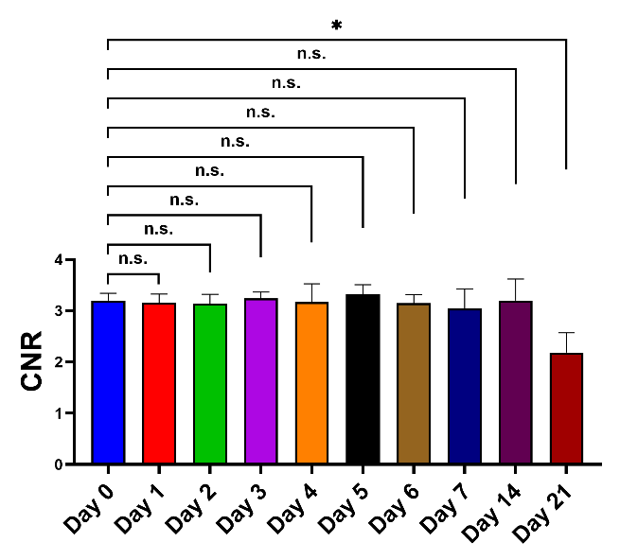
Figure S11. The 3-week contrast-to-noise ratios of cortical blood flow imaging through the TIS window.

Figure S12. Representative 2-week 3D reconstruction of two-photon neuron imaging after the TIS window establishment.

Figure S13. a Representative in vivo microglia images immediately, 1 hour, and 2 days after the TIS window establishment. b Representative microglia images in brain slices 2 and 21 days after the TIS window establishment. c Representative GFAP expression in astrocytes in brain slices 10 and 21 days after the TIS window establishment.

Figure S14. Representative images of H&E-stained brain slices 2 days after the TIS window establishment.

Figure S15. Photodamage threshold evaluation through TIS window using two-photon microscopy. a Representative image of neural dendrites at shallow surface of cortex before and after focused irradiation on large depth (700 μm) with the laser power of 250 mW. b Representative images of neural dendrites at shallow surface of cortex before and after focused irradiation on the brain surface with different laser power from 10 to 200 mW.

TIS window establishment
The long-term TIS window was designed to make the skull transparent without eliciting any transcranial surgery, as shown in Fig. S15a and S15b. the procedure was conducted in the following manner:
- First, we used the hydroxyl groups in ethanol and urea (S1) to dissolve the collagen in the skull.(1, 2)
- Second, we used sodium dodecylbenzenesulfonate (S2) as a degreasant to render the skull uniform.(3)
- Third, we employed a UV-curable adhesive (S3, RI=1.5) to perform refractive index matching.
- Fourth, we added a coverslip to the UV-curable adhesive to guarantee the flatness of its top surface, which is important in minimizing optical aberrations.
- Lastly, we used UV irradiation to solidify the UV-curable adhesive, binding the skull and the coverslip (Fig. S15c).
Ultimately, TIS provided a large field of view without causing craniotomy-related influences on the brain environment (Fig S15d).
Figure S16. The Through-Intact-Skull (TIS) technique. a Illustration of the TIS window establishment. b Details of steps 4 and 5 in (a). c A schematic of the TIS window. d Comparisons between the TIS window (1), open-skull glass window (2), and thinned-skull window (3).
Reference
1. J. M. Hirshburg et al., "Molecular basis for optical clearing of collagenous tissues," J Biomed Opt 15(5), 055002 (2010).
2. Y. G. Chen et al., "Coherent Raman Scattering Unravelling Mechanisms Underlying Skull Optical Clearing for Through-Skull Brain Imaging," Anal Chem 91(15), 9371-9375 (2019).
3. B. Yang et al., "Single-Cell Phenotyping within Transparent Intact Tissue through Whole-Body Clearing," Cell 158(4), 945-958 (2014).

