Additional file for

Lead halide perovskite sensitized WSe₂ photodiodes with ultrahigh open circuit voltages
Sung-Joon Lee^{1,2,4}†, Hung-Chieh Cheng¹†, Yiliu Wang³, Boxuan Zhou¹, Dehui Li³, Gongming Wang³, Yuan Liu¹, Jian Guo¹, Hao Wu¹, Dae Joon Kang²*, Yu Huang¹*, Xiangfeng Duan³*
¹Department of Materials Science and Engineering, University of California, Los Angeles, CA, USA.
²Department of Physics, Sungkyunkwan University, Suwon, Republic of Korea.
³Department of Chemistry and Biochemistry, University of California, Los Angeles, CA, USA.
⁴Current affiliation: Materials Science and Technology Division, U.S. Naval Research Laboratory, Washington, DC, USA.
†Sung-Joon Lee and Hung-Chieh Cheng authors contributed equally to this work.
*Correspondence: xduan@chem.ucla.edu, yhuang@seas.ucla.edu, djkang@skku.edu

Fig. S1. Material characterization of our as-exfoliated monolayer WSe₂ for device fabrication. a Photoluminescence spectrum of monolayer WSe₂ under 633-nm laser showed the bright single-peak emission at 751 nm as the indirect to direct bandgap transition from few-layer to monolayer WSe₂. b Raman spectrum of monolayer WSe₂ under 633-nm laser showed the softening of ${E_{2g}^{1}\&A}_{1g}$ modes and the change of spectral weight in monolayer WSe₂ as compared to the few-layer WSe₂ [55].
Fig. S2. Schematic illustrations of van der Waals integration of MAPbI₃ perovskite with WSe₂ field-effect transistors (FETs). Prefabricated WSe₂ FET (1), PbI₂ lamination (2), vapor-phase conversion of MAPbI₃ perovskite in CVD furnace (3) and MAPbI₃/WSe₂ FET (4).
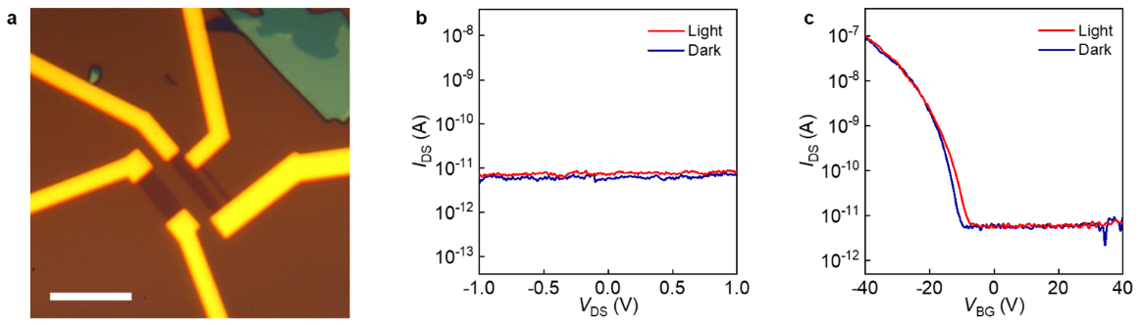
Fig. S3. Single-layer WSe₂ FET before MAPbI₃ integration. a Optical image of a single-layer WSe₂ FET before integration of MAPbI₃ perovskite. The white scale bar is 10 μm. b Output characteristics (I_{DS}-V_{DS}) of the device under white light illumination and in dark. c Transfer characteristics (I_{DS}-V_{BG}) of the device under white light illumination and in dark.
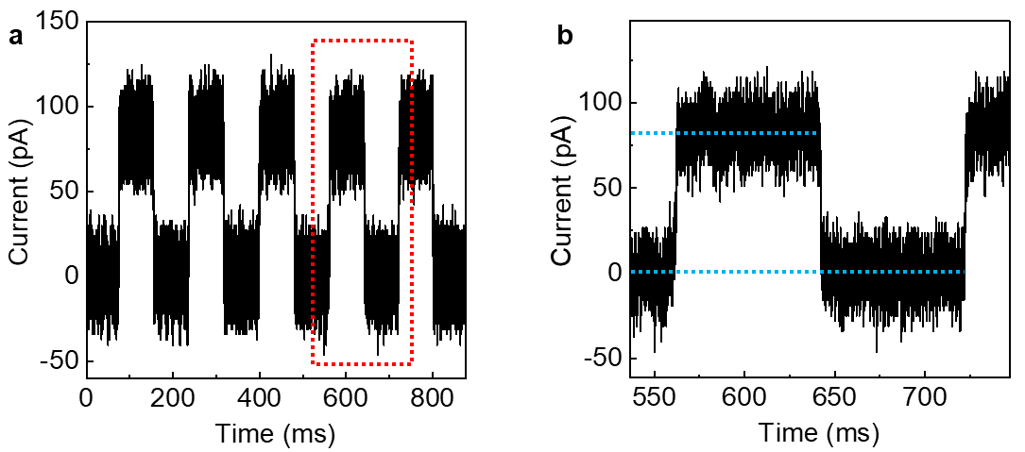
Fig. S4. a The time-domain photoresponse of the MAPbI₃/WSe₂ photodiode after negative lateral poling process measured under 532-nm laser illumination with 7 Hz of chopping frequency. b The photocurrent (I_{ph}) and response time (τ) estimated from the mean values of the current steps during on and off states. The I_{ph} and τ were extracted from part a (red dashed frame): I_{ph} ~ 83.3 pA and τ ~ 450 µsec at V_{DS} = 0 V.

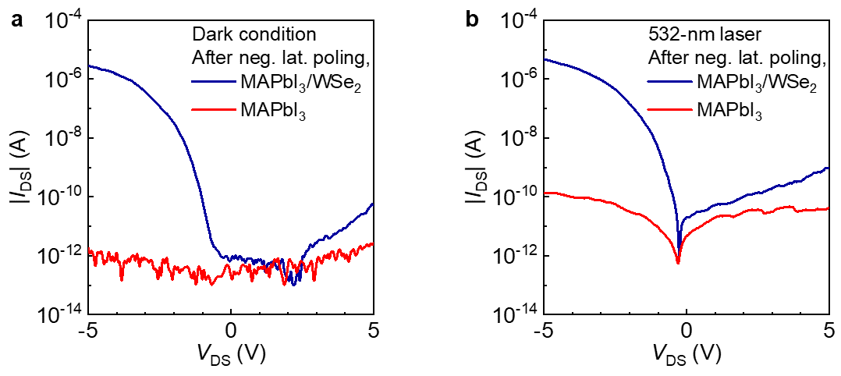
Fig. S5. Negatively-poled MAPbI₃/WSe₂ photodiodes. a, b Output characteristics (I_{DS}-V_{DS}) of MAPbI₃/WSe₂ FET and MAPbI₃ FET measured after negative lateral poling process in dark (a) and under 532-nm laser illumination (b), showing that the diode behaviors were prominent in the device integrated with WSe₂. All the measurements were conducted at 79 K.
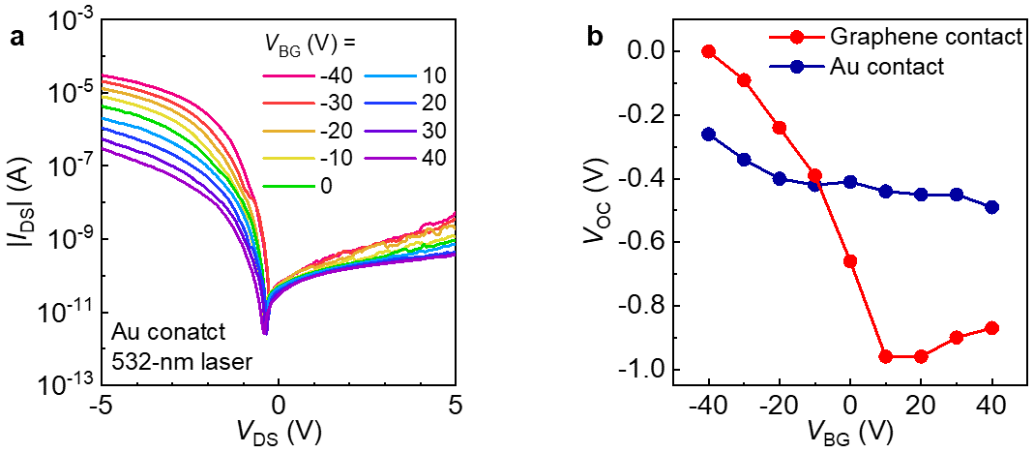
Fig. S6. Gate-tunable properties of MAPbI₃/WSe₂ FETs. a Gate-dependent output curves (I_{DS}-V_{DS}) of MAPbI₃/WSe₂ FET with Au contact electrodes under 532-nm laser illumination. b The comparison of gate-dependent open circuit voltage (V_{OC}) of MAPbI₃/WSe₂ FET either with graphene (red) or Au (blue) contact after negative lateral poling process.
Table S1. Summary of the photodiode parameters in different studies. Data are from this work and references.
Device structure | Layer  number | Contact | Wavelength  (nm) | V_{OC} (V) | EQE (%)  [effective area] | Source
MAPbI₃/WSe₂ | 1 | graphene | 532 | 1.08 | 91.3  [device area] | This work
MAPbI₃/WSe₂ | 1 | Au | 532 | 0.78 | 84.3  [device area] | This work
Split-gated WSe₂ | 1 | Cr/Au | 532 | 0.70 | 0.1  [device area] | [56]
Split-gated WSe₂ | 1 | Pd/Au and Ti/Au | 500-800 | 0.83 | 1.9  [split gate area] | [16]
Split-gated WSe₂ | 1 | Pd/Au and Ti/Au | 500-800 | 0.75 | 1.9  [split gate area] | [16]
Split-gated WSe₂ | 4 | Au | 405 | 0.73 | 30  [laser spot] | [46]
Split-gated WSe₂ | 1 | Au | 473 | 1.05 | 2.2  [laser spot] | [46]
Split-gated WSe₂ | 1 | graphite | 750 | N/A | 0.75  [laser spot] | [57]
Split-gated WSe₂ | 1 | Au | 522 | 0.6 | 0.2  [laser spot] | [15]
Split-gated WSe₂ | 1 | V/Au | 660 | N/A | 0.1  [laser spot] | [14]
AuCl₃/MoS₂ | ~75 | Pd and Cr/Au | 500 | ~0.5 | 15 at V_{DS} = 0.1 V  [device area] | [58]
Vertical diode structure  WSe₂ | N/A | Pt and graphite | 365 | N/A | 94  [device area] | [59]
Vertical diode structure  n-MoS₂/p-MoS₂ | ~50 | graphene/Au | 300 | 0.169 | 80.7  [device area] | [60]
Vertical diode structure  MoS₂/AsP | ~82/~73 | Cr/Au | 520 | 0.61 | 71  [device area] | [61]
Vertical diode structure  n-MoS₂/p-MoS₂ | ~50 | graphene/Au | 532 | 0.169 | 47.3  [device area] | [60]
Vertical diode structure  (PEA)₂SnI₄/MoS₂ | ~25 | graphite | 451 | N/A | 38.2  [device area] | [62]
Vertical diode structure  FA_{0.85}Cs_{0.15}PbI₃/PtSe₂ | ~18 | Au | 808 | 0.23 | 14.9  [device area] | [63]
Vertical diode structure  MoTe₂/MoS₂ | ~4/~10 | Pd/Au and Cr/Au | 637 | 0.51 | N/A | [64]

