Additional file 1

Chiral exceptional point and coherent suppression of backscattering in silicon microring with low loss Mie scatterer

Hwaseob Lee, Ali Kecebas, Feifan Wang, Lorry Chang, Sahin K. Özdemir*, Tingyi Gu*

*Corresponding author. Email: tingyigu@udel.edu, sko9@psu.edu

Supplementary Text
Sec 1: Directional reflection coefficients in notch embedded single mode waveguide
Sec 2: Mie scatterer defined non-Hermicity in MRRs
Sec 3: Empirical model for extracting the experimental reflection parameters
Sec 4: Interpretation of experimental data
Sec 5: Performance comparison
Figs. S1 to S5
References (S1 to S13)
Table S1

Section S1. Directional reflection coefficients in notch embedded single mode waveguide
Fig. S1. Width (W) and Depth (D) determined reflectance for symmetric and asymmetric Mie scatterers. (a) Schematics of the rectangular notch reflector as a typical symmetric Mie scatterer, and (b) right-angled triangular asymmetric reflector. The reflection coefficients with forward excitation and backward excitations are marked as r_{f} and r_{b} respectively. (c) Amplitude of the forward reflectivity (r_{f}) versus the notch depth D for the symmetric and (d) asymmetric notches. (e) Amplitude of the backward reflectivity (r_{b}) for the symmetric reflector and (f) asymmetric notch.
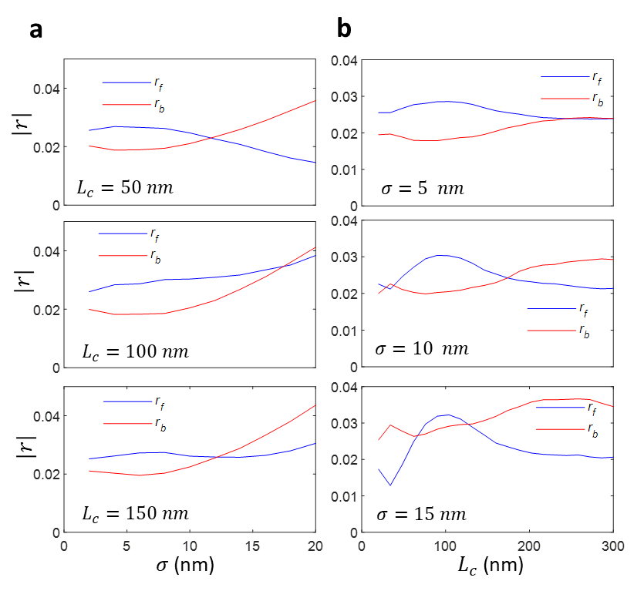
Fig. S2. Distributed Rayleigh scatterer induced asymmetric reflection. (a) The correlation length ($L_{c}$) dependent asymmetric reflectivity amplitude fixed roughness ($σ=10 nm$). (b) The roughness magnitude ($σ$) dependent asymmetric backscattering with fixed correlation length ($L_{c}=100 nm$).
Carried out by the three-dimensional full field simulation, Fig. S1 shows the embedded Mie scatterer geometry defined symmetric (Fig. S1a,c,e) and asymmetric reflectance (Fig. S1b,d,f). In three-dimensional Finite-Difference-Time-Domain simulation [S1], the conformal mesh with a spatial resolution (in $\hat{x}$ and $\hat{y}$ direction) less than 1/10 of the Mie scatterer dimension is applied. For the vertical direction ($\hat{z}$), the spatial resolution of the mesh is fixed as 1/5 of the simulated silicon waveguide thickness. The simulated waveguide structure is extended completely through PML region for the stable and accurate results. The wavelength of the incident light is in the telecommunication C band (1531 nm). The channel waveguide with width of 430 nm width is defined on 250 nm thick silicon-on-insulator substrate.
With the same methodologies, we simulate the directional reflectivity from the waveguides with fabrication-related sidewall roughness (E-beam lithography + F-ICP etching). The roughness distribution is asymmetric in parallel and symmetric in vertical direction to the direction of wave propagation as shown in Fig. S2 [S2]. We simulate the random geometry with correlation function ($σ$: roughness magnitude, $L_{c}$ : correlation length) [S3]. Fig. S2 confirms the random sidewall roughness generates mostly asymmetric reflectivity [r_{f} ≠ r_{b}].
Note r_{f/b} is presented as r_{CW/CCW} for the Mie scatterer embedded in the microring resonator (MRR).
Section S2: Mie scatterer defined non-Hermicity in MRRs
A MRR without the Mie scatterers is described by the Hamiltonian ${\text{H}}_{o}=\left(\begin{matrix}Ω_{0} & 0 \\ 0 & Ω_{0}\end{matrix}\right)$, where the diagonal elements $Ω_{0}=ω_{o}-jγ_{t}/2$ represent the complex energies of the degenerate CW and CCW modes, $γ_{t}$ representing all losses including both the intrinsic losses (γ₀, including material, bending, ring geometry dependent loss) and the resonator-waveguide coupling losses rates (γ_{c}). This system supports a DP with the degenerate eigenfrequencies $ω_{1,2}=ω_{o}-jγ_{t}/2$ and orthogonal eigenvectors $ψ_{1}={\left[\begin{matrix}1 & 0\end{matrix}\right]}^{T}$ and $ψ_{2}={\left[\begin{matrix}0 & 1\end{matrix}\right]}^{T}$ corresponding to CW and CCW modes.
2.1 MRR with single Mie scatterer
A first meta-atom introduced into the mode volume of the resonator will not only couple the CW and CCW modes through intermodal scattering, but it will also induce a complex frequency shift. Then the Hamiltonian describing the resonator with the first embedded meta-atom is given by
${\text{H}}_{1}=\left(\begin{matrix}Ω_{0}+ϵ_{111} & ϵ_{112} \\ ϵ_{121} & {Ω_{0}+ϵ}_{122}\end{matrix}\right)$ (S-1)
whose complex-valued elements $ϵ_{1km}$ describes the coupling strength of the particle-induced scattering into the same ($k=m$) or the counterpropagating ($k≠m$) mode. The diagonal elements $ϵ_{111}$ and $ϵ_{122}$ determine the frequency shift and the additional dissipation induced by the Mie scatterer to the CW and CCW modes whereas the off-diagonal elements $ϵ_{112}$ and $ϵ_{121}$ determine the coupling between them. The eigenfrequencies of this system are found as $ω_{±}=Ω_{0}+\left(ϵ_{111}+ϵ_{122}\right)/2±ξ/2$ where $ξ=\sqrt{{\left(ϵ_{111}-ϵ_{122}\right)}^{2}+4ϵ_{112}ϵ_{121}}$ implying a splitting of $ω_{+}-ω_{-}=ξ$. A nice property of Mie scatterers embedded in MRRs is that they induce negligible loss as the reflected light still complies with the total internal reflection on the waveguide sidewalls, and couples into the guided mode in the resonator. Without loss of generality, $ϵ_{1km}$ can be treated as real valued ($ϵ_{1km}=ϵ_{1kmr}+iϵ_{1kmi}$ where $\left|ϵ_{1kmi}\right|≪\left|ϵ_{1kmr}\right|$) [22].

2.1.1 Asymmetric Mie scatterer
It is easy to see that there exists a spectral degeneracy of $ω_{±}=Ω_{0}+ϵ$ when $ϵ_{111}=ϵ_{122}=ϵ$ and $ϵ_{112}ϵ_{121}=0$. Under these settings, the Hamiltonian describing the system becomes ${\text{H}}_{1a}=\left(\begin{matrix}Ω_{0}+ϵ & ϵ_{112} \\ 0 & Ω_{0}+ϵ\end{matrix}\right)$ or ${\text{H}}_{1b}=\left(\begin{matrix}Ω_{0}+ϵ & 0 \\ ϵ_{112} & Ω_{0}+ϵ\end{matrix}\right)$ which describes the cases in which there is no backscattering into the CW (or CCW) mode even though there is coherent backscattering into the CCW (or CW). The eigenvectors described by these Hamiltonians are also degenerate and are given as $ψ_{±}∝{\left[\begin{matrix}1 & 0\end{matrix}\right]}^{T}$. Thus, this spectral degeneracy is an EP.
2.1.2 Symmetric Mie scatterer
For a symmetric Mie scatterer (e.g., rectangular notch in Fig 1a), on the other hand, we have $ϵ_{111}=ϵ_{122}=ϵ_{1}$ and $ϵ_{112}=ϵ_{121}=ϵ_{1}^{'}$ which results in $ω_{±}=Ω_{0}+ϵ_{1}±ϵ_{1}^{'}$ with the corresponding orthogonal eigenvectors $ψ_{±}={\left[\begin{matrix}1 & ±1\end{matrix}\right]}^{T}$. Thus, the complex eigenfrequencies differ by ${2ϵ}_{1}^{'}$, which shows itself as two spectrally different resonance peaks in the reflection spectra of the resonator coupled waveguide system. This splitting has formed the basis for mode-splitting based particle detection systems [1]. Thus, for a single symmetric scatterer, the system does not have an EP. This is true even for the case $ϵ_{111}=ϵ_{122}=ϵ_{112}=ϵ_{121}.$
2.2 MRR with a Mie scatterer pair
2.2.1 General case of two Mie scatterers (Asym1 + Asym2)
A MRR with two embedded Mie scatterers will provide additional degrees of freedom to tune the system towards or away from its spectral degeneracies and help to counterbalance the fabrication imperfections. One can write a general Hamiltonian for such a system as
${\text{H}}_{2}=\left(\begin{matrix}Ω_{0}+ϵ_{111}+ϵ_{211} & ϵ_{112}+ϵ_{212}e^{-jΔφ} \\ ϵ_{121}+ϵ_{221}e^{jΔφ} & Ω_{0}+ϵ_{122}+ϵ_{222}\end{matrix}\right)=\left(\begin{matrix}Ω_{0}+χ_{1} & χ_{12} \\ χ_{21} & Ω_{0}+χ_{2}\end{matrix}\right)$ (S-2)
The eigenvalues of ${\text{H}}_{2}$ are $ω_{±}=Ω_{0}+\left(χ_{1}+χ_{2}\right)/2±ξ/2$ where $ξ=\sqrt{{\left(χ_{1}-χ_{2}\right)}^{2}+4χ_{12}χ_{21}}$ with the corresponding eigenvectors given as $ψ_{±}={\left[\left(χ_{1}-χ_{2}∓ξ\right)/2 χ_{21} 1\right]}^{T}$. This system has a spectral degeneracy for $ξ=0$ which is satisfied when $4χ_{12}χ_{21}=- {\left(χ_{1}-χ_{2}\right)}^{2}$. The eigenvectors associated with these degenerate eigenvalues are also degenerate and given by $ψ_{±}={\left[\left(χ_{1}-χ_{2}\right)/2 χ_{21} 1\right]}^{T}$. Thus, the spectral degeneracies of ${\text{H}}_{2}$ with $ξ=0$ are indeed EPs. Scattering properties of the Mie scatterers that leads to EPs can then be obtained from $ξ=0$. Since $χ_{12}χ_{21}$ is a complex number $χ_{12}χ_{21}=ϵ_{121}ϵ_{112}+ϵ_{212}ϵ_{221}+\left(ϵ_{121}ϵ_{212}+ϵ_{112}ϵ_{221}\right)\cos{Δφ}+j\left(ϵ_{112}ϵ_{221}-ϵ_{121}ϵ_{212}\right)\sin{Δφ}$ and ${\left(χ_{1}-χ_{2}\right)}^{2}$ is a positive real number, we need to set $Im\left(χ_{12}χ_{21}\right)=0$ and $Re\left(χ_{12}χ_{21}\right)=-{\left(χ_{1}-χ_{2}\right)}^{2}/4$. The former is satisfied for i) $Δφ=nπ$ which leads to $\left(ϵ_{121}ϵ_{112}+ϵ_{212}ϵ_{221}\right)-\left(ϵ_{121}ϵ_{212}+ϵ_{112}ϵ_{221}\right)=-{\left(χ_{1}-χ_{2}\right)}^{2}/4$, and for ii) $ϵ_{112}ϵ_{221}=ϵ_{121}ϵ_{212}=ϵ^{'}$ leading to $\cos{Δφ}=-\frac{1}{2}\left(\frac{{\left(χ_{1}-χ_{2}\right)}^{2}}{4ϵ^{'}}+\frac{ϵ_{112}^{2}+ϵ_{212}^{2}}{ϵ_{112}ϵ_{212}}\right)$. Clearly, an experimental ability to tune the optical phase delay between the Mie scatterers (i.e., the phase $Δφ$) may help to move the system closer to or away from the spectral degeneracy.
2.2.2 One symmetric and one asymmetric Mie scatterer (Sym + Asym)
The analysis presented above implies that having a symmetric and an asymmetric Mie scatterer will provide the necessary flexibility to move the system towards or away from an EP and study the associated processes. The Hamiltonian for such a system with one symmetric Mie scatterer (e.g., the first Mie scatterer with $ϵ_{111}=ϵ_{122}=ϵ_{1}$ and $ϵ_{112}=ϵ_{121}=ϵ_{1}^{'}$) and one asymmetric Mie scatterer with scattering properties defined, without loss of generality, as $ϵ_{211}=ϵ_{222}=ϵ_{2}$, $ϵ_{212}=ϵ_{2}^{'}$, and $ϵ_{221}=ϵ_{2}^{''}$ becomes
${\text{H}}_{2h}=\left(\begin{matrix}Ω_{0}+ϵ_{1}+ϵ_{2} & ϵ_{1}^{'}+ϵ_{2}^{'}e^{-jΔφ} \\ ϵ_{1}^{'}+ϵ_{2}^{''}e^{jΔφ} & Ω_{0}+ϵ_{1}+ϵ_{2}\end{matrix}\right)=\left(\begin{matrix}Ω_{0}+χ_{1}^{'} & χ_{12}^{'} \\ χ_{21}^{'} & Ω_{0}+χ_{2}^{'}\end{matrix}\right)$ (S-3)
whose eigenvalues are found $ω_{±}=Ω_{0}+ϵ_{1}+ϵ_{2}±ξ$ where $ξ=\sqrt{ϵ_{1}^{'2}+ϵ_{2}^{'}ϵ_{2}^{''}+\left(ϵ_{2}^{'}+ϵ_{2}^{''}\right)\cos{Δφ}-jϵ_{1}^{'}\left(ϵ_{2}^{'}-ϵ_{2}^{''}\right)\sin{Δφ}}$ . This system has a spectral degeneracy when $ξ=0$ with the associated eigenvectors found as $ψ_{±}={\left[0 1\right]}^{T}$ which is an EP. For this EP to emerge, scattering properties of the Mie scatterers should satisfy $ϵ_{2}^{'}-ϵ_{2}^{''}=0$ or $\sin{Δφ}=0$. For the former, the real part becomes $ϵ_{1}^{'2}+ϵ_{2}^{'2}+2{ϵ_{1}^{'}ϵ}_{2}^{'}\cos{Δφ}$ which may be made zero by tuning the Mie scatterer properties and the phase to satisfy $\cos{Δφ}=-(ϵ_{1}^{2}+ϵ_{2}^{'2})/2{ϵ_{1}^{'}ϵ}_{2}^{'}$. For the latter, we have $\sin{Δφ}=0$ and thus $ϵ_{1}^{'2}=ϵ_{1}^{'}(ϵ_{2}^{'}+ϵ_{2}^{''})-ϵ_{2}^{'}ϵ_{2}^{''}$.
2.2.3 Different symmetric Mie scatterers (Sym1 + Sym2)
It is easy to see that for two-symmetric Mie scatterers with $ϵ_{111}=ϵ_{122}=ϵ_{1}$, $ϵ_{211}=ϵ_{222}=ϵ_{2}$, $ϵ_{112}=ϵ_{121}=ϵ_{1}^{'}$ and $ϵ_{212}=ϵ_{221}=ϵ_{2}^{'}$ ), the Hamiltonian becomes
${\text{H}}_{2s}=\left(\begin{matrix}Ω_{0}+ϵ_{1}+ϵ_{2} & ϵ_{1}^{'}+ϵ_{2}^{'}e^{-jΔφ} \\ ϵ_{1}^{'}+ϵ_{2}^{'}e^{jΔφ} & Ω_{0}+ϵ_{1}+ϵ_{2}\end{matrix}\right)$ (S-4)
whose eigenvalues are $ω_{+/-}=Ω_{0}+ϵ_{1}+ϵ_{2}±ξ$ with $ξ=\sqrt{ϵ_{1}^{'2}+ϵ_{2}^{'2}+2ϵ_{1}^{'}ϵ_{2}^{'}\cos{Δφ}}$. The degeneracy will be observed when $ξ=0$, implying $\cos{Δφ}=-(ϵ_{1}^{'2}+ϵ_{2}^{'2})/2ϵ_{1}^{'}ϵ_{2}^{'}$. The eigenvectors associated with this degeneracy are $ψ_{±}∝{\left[\begin{matrix}0 & 1\end{matrix}\right]}^{T}$ which also implies that this degeneracy is an EP degeneracy. The opposite signs of the phases allow one to make one of the off-diagonal terms zero while keeping the other non-zero. If the symmetric Mie scatterers are identical (i.e., $ϵ_{111}=ϵ_{122}=ϵ_{211}=ϵ_{222}=ϵ_{1}$ and $ϵ_{112}=ϵ_{212}=ϵ_{121}=ϵ_{221}=ϵ_{1}^{'}$ ), it is easy to show that eigenvalues are $ω_{±}=Ω_{0}+2ϵ_{1}±2ϵ_{1}^{'}\cos{Δφ}$ with the corresponding eigenvectors found as $ψ_{±}∝{\left[\begin{matrix}1 & ±1\end{matrix}\right]}^{T}$ which is independent of $Δφ$. Therefore, although the eigenvalues become degenerate for $Δφ=\left(2n+1\right)π/2$, the eigenvectors remain orthogonal. Thus, we conclude that a system with two identical symmetric Mie scatterers exhibits only a DP (Fig. 1f). Note that by tuning the angle $Δφ$, one can vary the splitting between zero and the maximum value of $4ϵ_{1}^{'}$. Therefore, to obtain an EP, one needs to design the Mie scatterers to be sufficiently different to provide the asymmetry in the off-diagonal terms.
2.2.4 Identical symmetric Mie scatterers (Asym1 + Asym1)
One naturally asks what will happen if two identical asymmetric Mie scatterers with $ϵ_{111}=ϵ_{122}=ϵ_{211}=ϵ_{222}=ϵ$, $ϵ_{112}=ϵ_{212}=ϵ^{'}$, and $ϵ_{121}=ϵ_{221}=ϵ^{''}$. Hamiltonian in this case becomes:
${\text{H}}_{2s}=\left(\begin{matrix}Ω_{0}+2ϵ & ϵ^{'}\left(1+e^{-jΔφ}\right) \\ ϵ^{''}\left(1+e^{jΔφ}\right) & Ω_{0}+2ϵ\end{matrix}\right)$ (S-5)
whose eigenvalues are $ω_{±}=Ω_{0}+2ϵ±ξ$ with $ξ=\sqrt{2ϵ^{'}ϵ^{''}\left(1+\cos{Δφ}\right)}$. The degeneracy will be observed when $ξ=0$, implying $ϵ^{'}ϵ^{''}=0$ or $\cos{Δφ}=(n+1)π$. When $ϵ^{'}=ϵ^{''}=0$ or $\cos{Δφ}=(n+1)π$, the degeneracy is a DP (i.e., both off-diagonal elements are zero), when either $ϵ^{'}$ or $ϵ^{''}$ is zero, the degeneracy is an EP (i.e., unidirectional coupling between CW and CCW modes) but as we discussed above creating such Mie scatterers are challenging. Thus, having the phase $Δφ$ as the only tunable parameter does not allow creating an EP when the Mie scatterers are identical and asymmetric. It is easy to extend the above analysis to the case of two non-identical asymmetric Mie scatterers showing that the spectral degeneracy is an EP and phase can be tuned $Δφ$ to arrive at this EP.
2.2.5 Summary for inter-scatter phase defined EP
The exemplary results for the four cases discussed in sections 2.2.1-2.2.4, at which variation of eigenvalues with respect to Δφ, are plotted in Fig. S3.
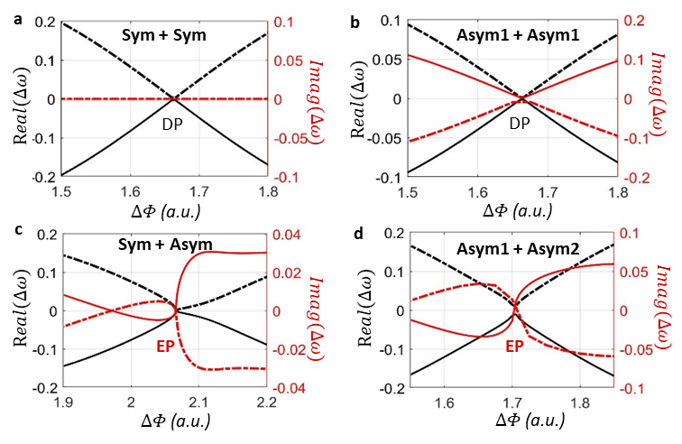
Fig. S3. Mie scatterer combinations and resulting non-Hermitian states. Splitting in the real and imaginary parts of the eigenfrequency as a function of the inter-Mie scatterers distance with (a) two symmetric scatterers, (b) identical asymmetric scatterers, (c) one symmetric and one asymmetric scatterer and (d) different asymmetric scatterers.
2.2.6 Additional note on the scatter geometry defined EP
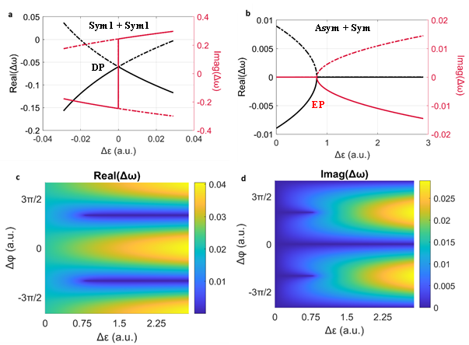
Variation of eigenvalues with respect to $Δφ$ and the effect of introducing asymmetry in one of the scatterers is demonstrated in Fig. S4. When the scatterers are identical and symmetric, eigenvalues of the system coalesce, and a DP degeneracy emerges when $Δφ=π/2$. When one of the scatterers is asymmetric with $ϵ_{2}^{''}=ϵ_{2}^{'}+Δε$, an EP degeneracy emerges when $Δφ=π$ and $ϵ_{1}^{'2}=ϵ_{2}^{'}+ϵ_{2}^{''}-ϵ_{2}^{'}ϵ_{2}^{''}$ conditions are satisfied simultaneously.

Fig. S4. Mie scatterer geometry defined non-Hermitian states. (a) Two identical scatterers and (b) two non-identical scatterers.
Supplementary Section 3: Empirical model for extracting the experimental parameters
Under slow varying approximation and two mode approximation, the field amplitude for clockwise (CW) and counterclockwise (CCW) propagating mode (a_{cw/ccw}) in an MRR (Fig. S5) can be described by a coupled harmonic oscillator model [S4-S7]:
$\frac{da_{cw}}{dt}=iΔωa_{cw}-\frac{γ_{t_cw}}{2}a_{cw}-iχ_{12}a_{ccw}+\sqrt{γ_{c1}}s_{1}$ (S-6-1)
$\frac{da_{ccw}}{dt}=iΔωa_{ccw}-\frac{γ_{t_ccw}}{2}a_{ccw}-iχ_{21}a_{cw}+\sqrt{γ_{c1}}s_{2}$ (S-6-2)
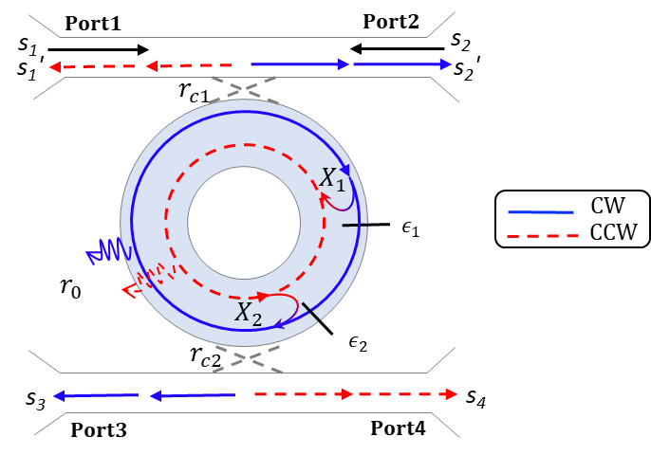
where 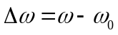is the laser frequency (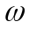) detuning from the cavity resonance (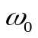). X₁₍₂₎ are the complex valued backscattering coefficient from CW to CCW mode (CCW to CW mode) [7], controlled by the notch geometry and inter-scatter distance. If each notch scatter is symmetric, then |X₁| = |X₂|. Random surface roughness or tilted triangular notches lead to asymmetric backscattering: |X₁| ≠ |X₂|. The total loss rate for the resonator (γ_{t} = γ₀ + γ_{c1}+ γ_{c2}) is the sum of intrinsic resonator loss rate (γ₀ from bending, scattering or linear absorption by mid-gap defect states in silicon) and the coupling loss to the bus (drop) waveguide (γ_{c1(2)}). As the asymmetric scatter induce different loss in CW and CCW mode, γ_{0_CW(CCW)} and γ_{t_CW(CCW)} are noted as intrinsic loss rate and total loss rate for CW(CCW) mode [S6-S7]. It is noted that γ_{0_CW} = γ_{0_CCW} and γ_{t_CW} = γ_{t_CCW} for symmetric notch scatters. s₁₍₂₎ is the excitation field amplitude injected from port 1(2). The reflection field amplitudes collected on port 1 and 2 can be expressed as 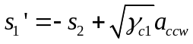and 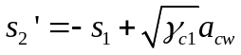. The transmission field amplitudes on port 3 and 4 are 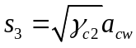 and 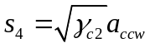, respectively.
Fig. S5. Illustration for the coupled harmonic oscillator model. CW: Clockwise propagating mode; CCW: counterclockwise propagating mode.

The transmittance and reflectance spectra can be derived by solving equation (S-1) in steady state condition, by substituting$\frac{da_{cw(ccw)}}{dt}=0$. With port 1 excitation (s₂ = 0), the normalized transmission spectra (T) on through port 2 and 3, and the reflection spectra on port 4 (R) can be derived as:
$T_{1→3}={\left|\frac{s_{3}}{s_{1}}\right|}^{2}={\left|\frac{\sqrt{γ_{c1}γ_{c2}}}{\frac{X_{12}X_{21}}{iΔω-γ_{t_ccw}/2}+iΔω-γ_{t_cw}/2}\right|}^{2}$ (S-7-1)
$R_{1→4}={\left|\frac{s_{4}}{s_{1}}\right|}^{2}={\left|\frac{-i\sqrt{γ_{c1}γ_{c2}}X_{12}}{X_{12}X_{21}+(iΔω-γ_{t_cw}/2)(iΔω-γ_{t_ccw}/2)}\right|}^{2}$ (S-7-2)
With port 2 excitation (s₁ = 0), the transmission and reflection spectra can be derived as:
$T_{2→4}={\left|\frac{s_{4}}{s_{2}}\right|}^{2}={\left|\frac{\sqrt{γ_{c1}γ_{c2}}}{\frac{X_{12}X_{21}}{iΔω-γ_{t_cw}/2}+iΔω-γ_{t_ccw}/2}\right|}^{2}$ (S-8-1)
$R_{2→3}={\left|\frac{s_{3}}{s_{2}}\right|}^{2}={\left|\frac{-i\sqrt{γ_{c1}γ_{c2}}χ_{21}}{X_{12}X_{21}+(iΔω-γ_{t_cw}/2)(iΔω-γ_{t_ccw}/2)}\right|}^{2}$ (S-8-2)
Assuming γ_{t_CW} is close to γ_{t_CCW} in the resonator, the transmission spectra are symmetric (T_{1→3} = T_{2→4}) and γ_{t} can be estimated by fitting the transmission spectra.
To minimize the uncertainties caused by grating coupler loss estimation, we compare the intensity ratios between output ports to obtain the best estimations of $χ_{1}$ and $χ_{2}$:
$\frac{R_{1→4}}{T_{1→3}}=|\frac{iχ_{12}}{iΔω-γ_{t_ccw}/2}|^{2}$ (S-9-1)
$\frac{R_{1→4}}{R_{2→3}}={\left|\frac{χ_{12}}{χ_{21}}\right|}^{2}$ (S-9-2)
From equation S-9-1, the value of $χ_{1}$ can be estimated at detuning Δω = 0:
$\left|χ_{12}\right|=\frac{γ_{t}}{2}\sqrt{\frac{R_{1→4}}{T_{1→3}}}$ (S-10)
We verify the impact of $χ_{1}$ phase on the measured transmission and reflection (Fig. S6). We select three examples of $<χ_{12}$ = 0˚, ±28˚, ±56˚, and plot the correspondent transmission (solid curves) and reflection (dashed curves) spectra based on equation S-7 (black) and S-8 (grey in Fig. S6a-c). Fig. S6d plots extracted data from the simulated spectra (Fig. S6a-c) and compared to the estimated value in equation S-10. With small phase, the empirical quality factor decreases with the measured reflectivity to transmission ratio, however, the trend might be inversed at large angle. It can be seen from Fig. S6c that the one of the split modes is much higher than the other, than thus the FWHM only encounters one of the split modes. The backscattering coefficient dependent transmission and reflection peaks are plotted in Fig. S6f. It is noted that the transmission spectra in Fig. 4 are highly symmetric, and thus the $<$X₁ is estimated to be between ±10˚ in those fabricated devices.
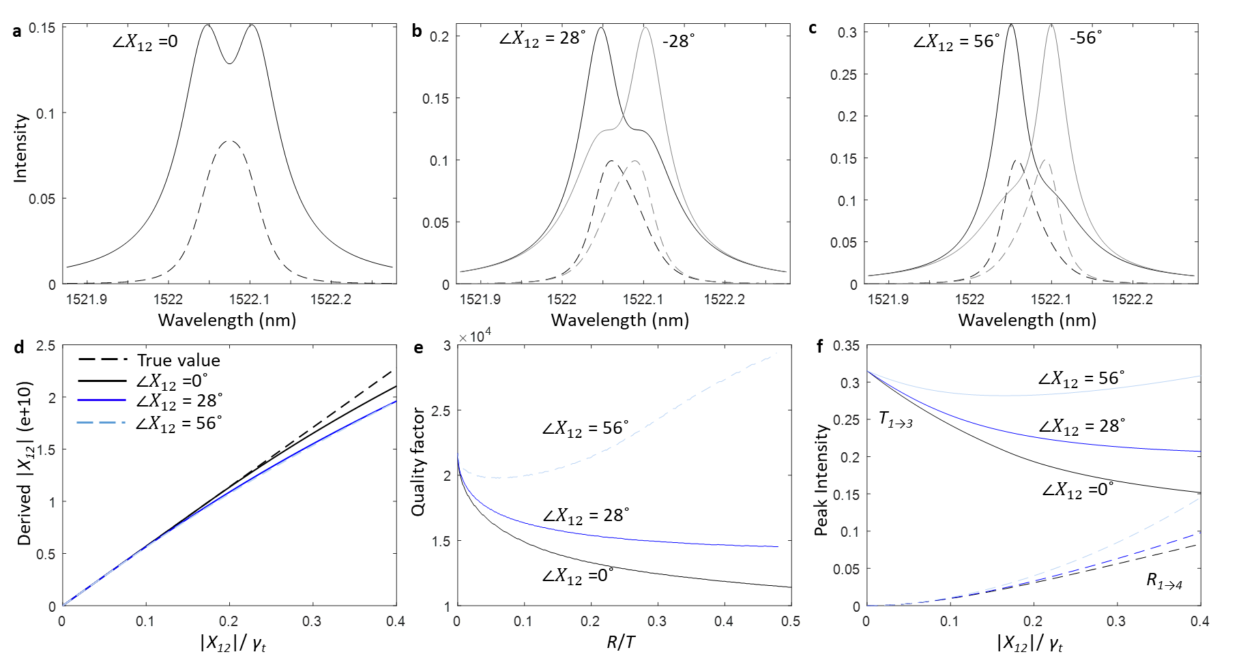
Fig. S6. $χ_{12}$ phase dependent spectra. (a-c) Transmission (solid curve) and reflection (dashed curve) dependent on $χ_{1}$ phase; (a) $<χ_{12}$ = 0˚, (b) $<χ_{12}$= 28˚, ($c) <χ_{12}$= 56˚. (d) Derived $χ_{12}$ versus the magnitude of $χ_{1}$ with different phase of $χ_{1}$, where $χ_{1}$ is derived based on Equation (S-10). (e) Quality factor (= $\frac{λ_{o}}{FWHM}$) versus the ratio of the reflection and transmission spectrum as increasing the magnitude of $χ_{1}$. (f) Peak intensity versus the magnitude of $χ_{12}$.
Section S4: Interpretation of the experimental data
For the completeness of the work, we show the transmission and reflection spectra for a set of MRRs with the same radius and notch depth, but varying notch width (W) (Fig. S7). We extracted the resonance wavelengths of four adjacent modes of a set of MRRs fabricated in the same run (Fig. S7a). Note that the resonance wavelength variations between devices is due to variations and imperfections in nanofabrication in a university cleanroom. The fabrication related resonance variation is reflected by all four modes as shown in Fig. S7a (e.g. W = 100 nm). We see the deterministic control of resonance wavelength (diagonal term in the Hamiltonian) for all four modes in the measured spectral range. We selected the first set of the resonance and analyzed the notch width dependent FWHM and empirical quality factors (Fig. S7b-c). The full transmission and corresponding reflection spectra are given in Fig. S7d-e.
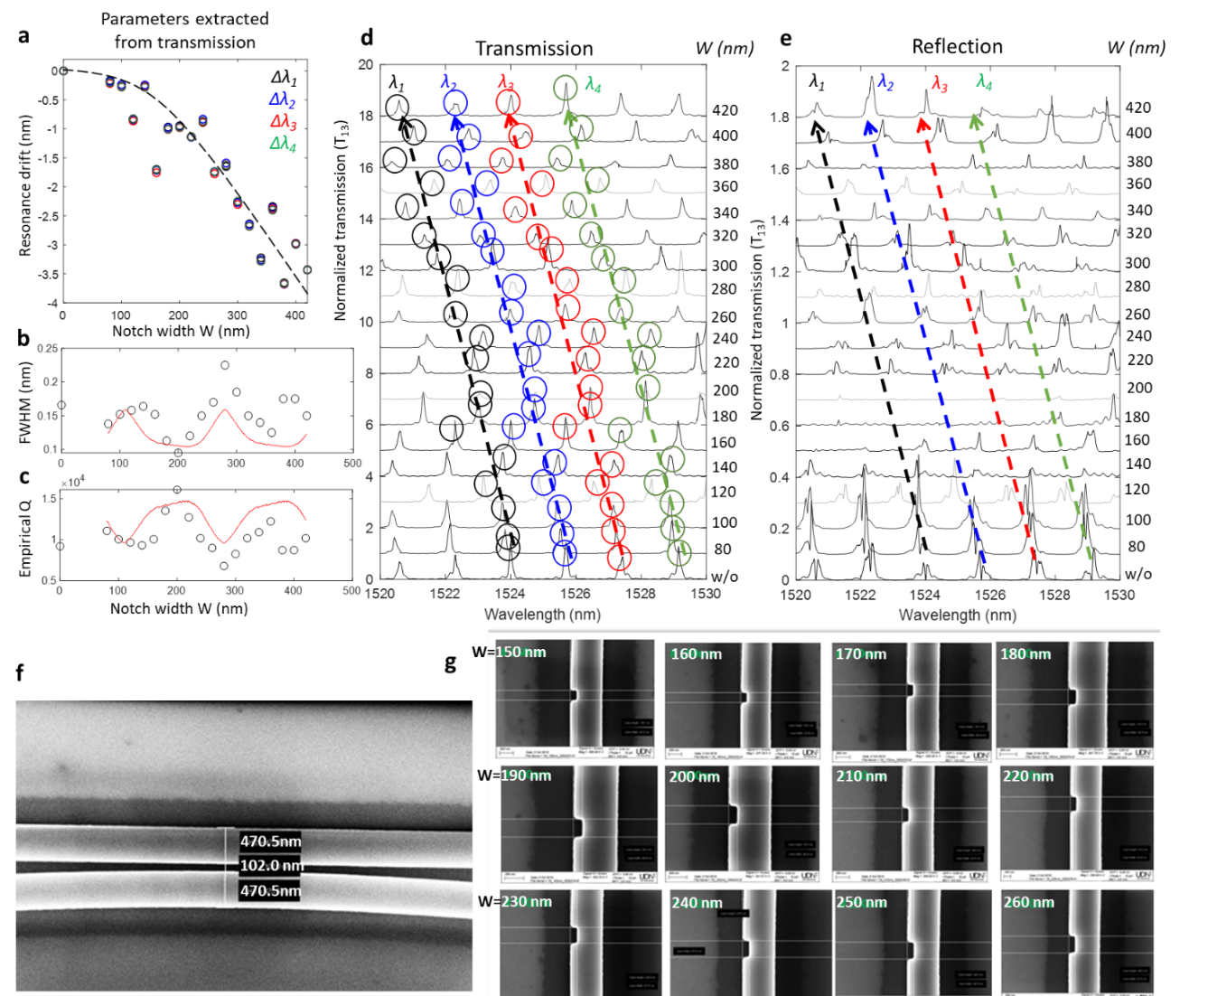
Figure S7. Measurement results of the set of MRRs with varying notch width. All the MRRs are fabricated on the same chip. Notch depths are fixed at 100 nm, but notch widths vary in the range 80-400 nm with increments of ΔW = 20 nm. (a) Notch width dependent resonance wavelength detuning for four adjacent modes, extracted from the transmission spectra in d. (b) Extracted FWHM and (c) empirical quality factor of the MRR, from the transmission spectra for the first mode. (d) Transmission and (e) reflection spectra of the set of MRRs. Offset of 1 is introduced in the transmission spectra and 0.1 for reflection spectra for clarity. (f) Scanning electron microscope image of the ring-waveguide region (fixed for all the MRRs) and (g) Mie scatterers with different widths (W) for the results shown in d-e.
Experimental loss rates in MRR: The empirical total loss is estimated from the linewidth of the device (W = 200 nm), where the mode-splitting is completely vanished. Estimated total loss (γ_{t}) was 62.97 GHz (Q_{t} ~19.59k). The intrinsic loss rate (γ_{o}) and coupling loss rates (γ_{c1}= γ_{c2}) are extracted by fitting the CMT model (equation S-6) into the experimentally measured transmission and reflection spectra. The nanofabrication limited radiation loss γ_{o} is estimated to be 13.321 GHz (Q_{in} = 78.36k). The coupling losses are γ_{c1} = γ_{c2} = 39.962 GHz (Q_{c} = 52.24k). Those values are applied for fitting the MRRs with varying W in Fig. 4a.
Mie scatterer width dependent backscattering coefficient: For the MRR with surface roughness only, we extract the r_{1b} = $19.6754e^{j(-1.1381)}$ GHz and r_{1f} = $17.5753e^{-j2.5381}$ GHz from the CMT fitting of the selected mode. By analyzing the spectra of the MRRs with varying Mie scatterer design, a constant Δ$φ$ (~ -0.265337radians) per incremental width (ΔW = 40 nm) of Mie scatterer is extracted. The result is consistent with our previous study [S8]. The CMT models in Fig. 4a reflect the geometry controlled complex backscattering coefficients.
Section S5: Comparison with other works
Table S1 provides a comparison of our device with other reported schemes for backscattering suppression effect. Suppression of backscattering has been demonstrated in whispering gallery mode resonators (WGMRs) [S9-S11] and topological photonic edge states [S12-S15]. The topological edge state relies on designed topology to achieve directional transport, with assistance of external applied magnetic field. In WGMRs, the suppression is achieved either by introducing scanning nanotip(s) into the mode volume of the resonator [S9, S10] or by utilizing time-reversal symmetry breaking using Brillouin scattering interactions [S11]. Ref [S9] uses an on-chip silica microtoroid resonator, Refs [S10] and [S11] utilizes silica rod and silica microsphere, respectively (These are not on-chip structures). Tapered fibers are used coupling light in and out of the resonators with coupling strength controlled by placing either the resonator or the tapered fiber on a piezo stage. As such, these systems do not lend themselves for building practical devices. The concepts should be translated into completely on-chip dynamically controlled structures. The device demonstrated in this paper addresses this issue. Our device is a silicon MRR fabricated in add-drop configurations with two side-coupled waveguides (i.e., fiber tapered coupling is replaced with on-chip silicon waveguides with gratings). Instead of scanning nanotips introduced into the mode volume of the resonator [S9, S10], we fabricate lithographically defined symmetric and/or asymmetric Mie scatterers to suppress backscattering and bring the system to an EP.
Table S1: Nano/micro-photonic structures for back reflection suppression.
Device structure | Suppression mechanism | Supp ratio | Notes | Footprint | Q
Silica microtoroid [S9] | Tuning silica nanotips positions by piezo stage | ~20 dB* | Mechanically fragile / not scalable/require post tuning | 10⁻⁸ m² | >10⁷
Silica rod [S10] | Tuning tungsten nanotip position by piezo stage | 34 dB | Mechanically fragile / not scalable/require post tuning | 10⁻⁶ m²  (bulk) | >10⁸
Silica microsphere [S11] | Tuning the Brillion scattering | NA | Mechanically fragile / not scalable/require post tuning | 10⁻⁸ m² (bulk) | >10⁷
Photonic crystal edge state [S12-S15] | Lithographically pre-defined topological photonic interface | < 10 dB*  [S15] | Stable / scalable / predefined | 10⁻¹⁰ m² | 10²  [S14]
MRR with single Mie scatterer [this work] | Lithographically pre-designed subwavelength defect geometry | 21.41 dB | Stable / scalable / predefined | 10⁻¹⁰ m² | 10⁵
* Values estimated from the given spectra with forward and backward excitations.
References:
[S1] Lumerical Inc https://support.lumerical.com/hc/en-us/articles/360034902433-Using-and-understanding-Mode-Expansion-Monitors (accessed on 3rd/July, 2021).
[S2] Wang, Tao. et al. Modeling of quasi-grating sidewall corrugation in SOI microring add-drop filters. Optics Commun. 282.17 3464-3467 (2009).
[S3] Lumerical Inc https://support.lumerical.com/hc/en-us/articles/360034382374-Tips-for-adding-surface-roughness-to-structures (accessed on 3rd/July, 2021).
[S4] Kippenberg, T. J. et al. Modal coupling in traveling-wave resonators. Opt. Lett. 27, no. 19 1669-1671 (2002).
[S5] Wiersig, J. Enhancing the sensitivity of frequency and energy splitting detection by using exceptional points: application to microcavity sensors for single particle detection. Phys. Rev. Lett. 112, 203901 (2014).
[S6] Wiersig, J. Sensors operating at exceptional points: general theory. Phys. Rev. A 93, 033809 (2016)
[S7] Chen, W. et al. Exceptional points enhance sensing in an optical microcavity. Nature 548, no. 7666 192-196 (2017).
[S8] Wang, Z. et al. On-chip wavefront shaping with dielectric metasurface. Nature commun. 10, no. 1 1-7 (2019).
[S9] Peng, B. et al. Chiral modes and directional lasing at exceptional points. PNAS 113, 6845-6850 (2016).
[S10] Svela, A.Ø. et al. Coherent suppression of backscattering in optical microresonators. Light: Sci. & Appl. 9(1), pp.1-8.
[S11] Kim, S., Taylor, J. M. & Bahl, G. Dynamic suppression of Rayleigh backscattering in dielectric resonators. Optica 6, 1016–1022 (2019).
[S12] Shalaev, M.I., Walasik, W., Tsukernik, A. and Xu, Y., Litchinitser, N. M., Robust topologically protected transport in photonic crystals at telecommunication wavelengths. Nat. Nanotech. 14, 31-34 (2019).
[S13] He, X.T. et al. A silicon-on-insulator slab for topological valley transport, Nat. Commun. 10, 872 (2019).
[S14] Qi, Z. et al. Electrical tunable topological valley photonic crystals for on-chip optical communications in the telecom band. Nanophotonics 11, 4273-4285 (2022).
[S15] Barik, S. et al. A topological quantum optics interface, Science 359, 666-668 (2018).

