Supplementary Materials for

A Large Field-of-view, Single-cell-resolution Two- and Three-Photon Microscope for Deep and Wide Imaging

Aaron T. Mok et al.

Correspondence: tm624@cornell.edu; wangty@bu.edu ; cx10@cornell.edu

This document includes:
Supplementary Figs. 1 to 15
Supplementary Table 1 to 3
Supplementary Note 1 to 2
Supplementary Video 1 to 6

Supplementary Fig. 1
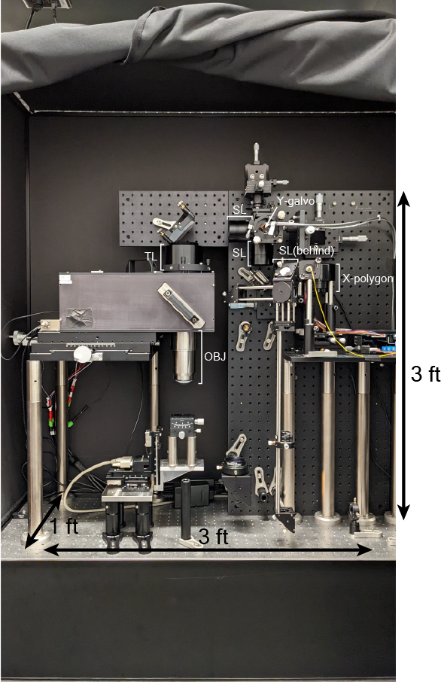

Photo of DEEPscope. The dimensions of the DEEPscope are ~3 ft x 3 ft x 1 ft feet. SL(behind) indicates the position of a SL that is behind a mirror mount. SL: scan lens, TL: tube lens, OBJ: objective.

Supplementary Fig. 2
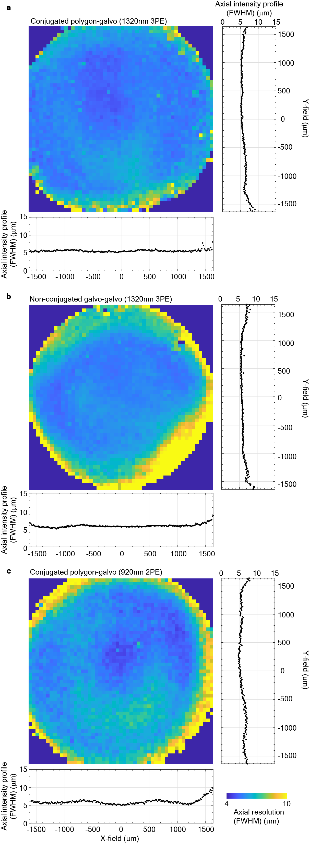
Characterization of the axial resolution of DEEPscope across the field of view (FOV) by axial scanning of a 500-nm thin fluorescent film of Rhodamine B (RhB) dye.

a Full-width half-maximum (FWHM) of the axial intensity profiles of DEEPscope across the FOV measured by axial scanning of the thin fluorescent film with 1320-nm three-photon excitation (3PE). The scan engine consists of a pair of conjugated polygon-scanner and a galvo-scanner.

b FWHM of the axial intensity profiles of DEEPscope across the FOV measured by axial scanning of the thin fluorescent film with 1320-nm 3PE. The scan engine consists of a pair of closely spaced galvo-scanners without relay lenses between the two galvo-scanners.

c FWHM of the axial intensity profiles of DEEPscope across the FOV measured by axial scanning of the thin fluorescent film with 920-nm two-photon excitation (2PE). The scan engine consists of a pair of conjugated polygon-scanner and galvo-scanner.

Supplementary Fig. 3
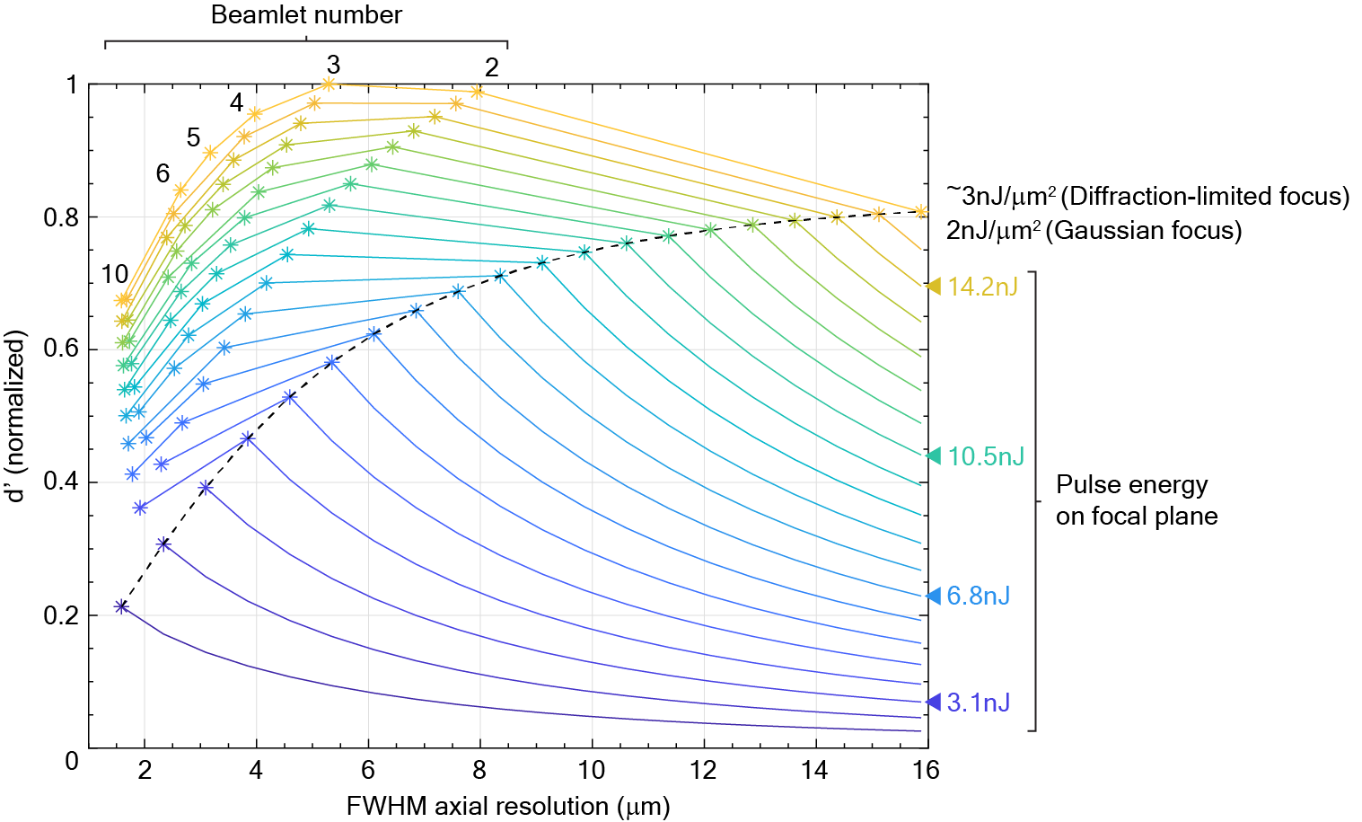

Simulation result of the relative d’ value with different excitation parameters for 1320-nm 3P imaging.

Due to limitations by the excitation source, optical system losses, and variations in signal strength across the imaging FOV, imaging 600 μm depth is best realized by a two-beamlets approach with total pulse energy of ~15 nJ at the focal plane. This can accommodate the signal variation across the large FOV and ensures that neurons located in the dim regions are also captured.

Normalized d’ values are shown for the excitation of a 5-μm radius sphere using different focal spot size (i.e., FWHM axial resolution) and pulse energy at the focal plane. Pulse energies are fixed for each line with the same color. Black dashed line shows the target pulse fluence at 2 nJ/μm² with a 60 fs pulse at the focal point, which corresponds to 10% excitation saturation of GCaMP6 (i.e., the probability of excitation per pulse per molecule is 10% at the focal point). Each asterisk shows the d' value when splitting the beam into different number of beamlets. The color of the asterisks corresponds to the sum of the pulse energy of all the beamlets (indicated on the right side of the graph). For all asterisks, the pulse fluence of each beamlet is fixed at 2 nJ/μm² (i.e., the target pulse fluence set by excitation saturation). For a diffraction-limited focus, this fluence would be around 3 nJ/μm².

Supplementary Fig. 4
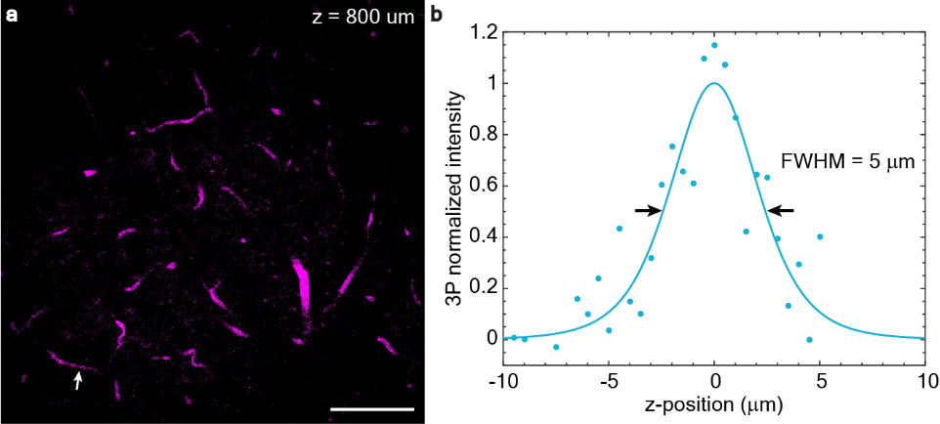

Measurement of 1320-nm 3P axial resolution in-vivo

a Image of fluorescein-labeled vasculature of a GCaMP6s-expressing transgenic mouse (TIT2L-GC6s-ICL-tTA2, female, 25-week-old) at 800 μm below the brain surface taken with 1320-nm 3P excitation. Scale bar: 100 μm.

b Measurement of axial fluorescence intensity profile across the capillary blood vessel indicated by the white arrow in a, indicating the upper bound of the axial resolution to be ~ 5 μm.

Supplementary Fig. 5
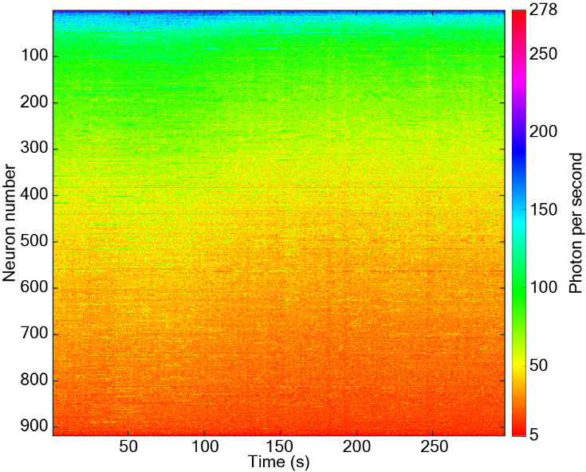

Raw data of neuronal activity traces with 3P DEEPscope.

The unprocessed activity traces of neurons in Fig. 3a. The signal of each neuron (in photons/neuron/second) was plotted against time, at the original 4 Hz recording frame rate, without any temporal down-sampling or low-pass filtering. The average photons per neurons per second among these 917 neurons is 58.

Supplementary Fig. 6
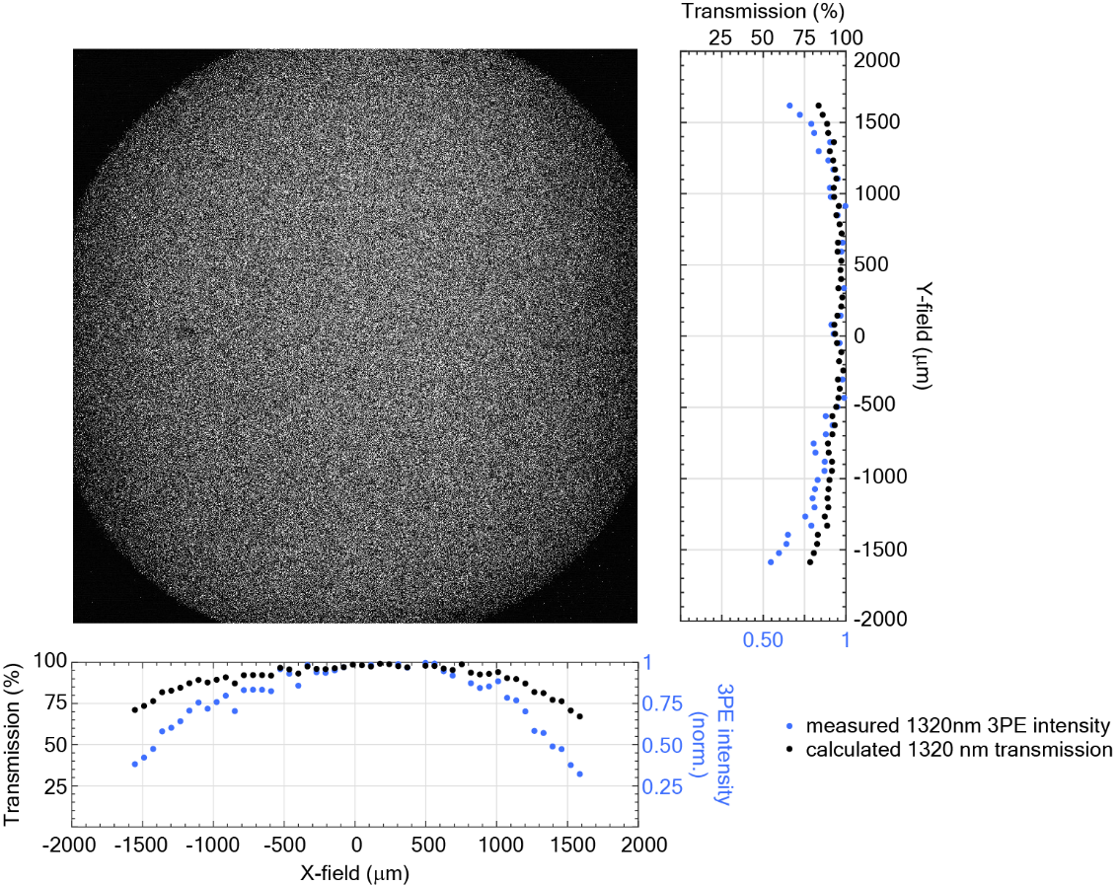

Normalized optical transmission of DEEPscope across the FOV at 1320 nm

Transmission measurement of DEEPscope using a fluorescent dye pool (F36915, Thermo Fisher). The image was acquired by underfilling the polygon scanner and the objective to achieve a uniform axial resolution at ~20 μm across the entire FOV. The measured X-profile and Y-profile of the image showed the normalized 1320-nm 3P fluorescence intensity along the X- and Y- directions (blue dots). The transmission at 1320 nm (black dots) was calculated by taking the cubic root of the measured data.

Supplementary Fig. 7
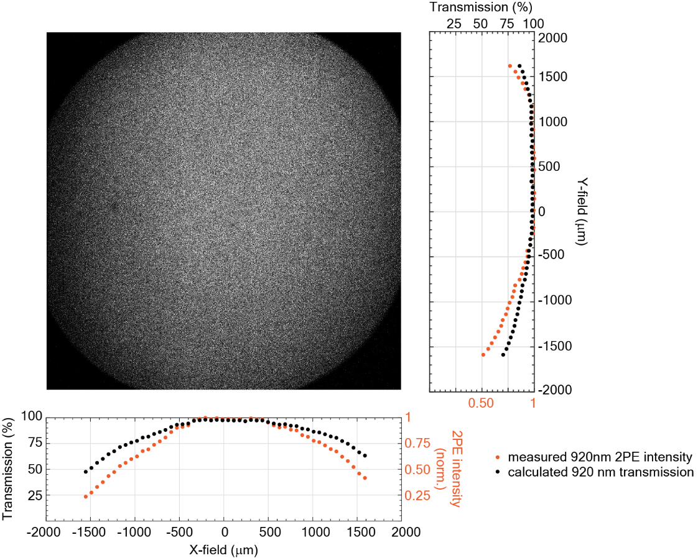

Normalized optical transmission of DEEPscope across the FOV at 920 nm

Transmission measurement of DEEPscope using a fluorescein dye pool (F36915, Thermo Fisher). The image was acquired by underfilling the polygon scanner and objective to achieve a uniform axial resolution at ~20 µm across the entire FOV. The measured X-profile and Y-profile of the image showed the normalized 920-nm 2P fluorescence intensity along the X- and Y-directions (orange dots). The transmission at 920 nm (black dots) was calculated by taking the square root of the measured data.

Supplementary Fig. 8
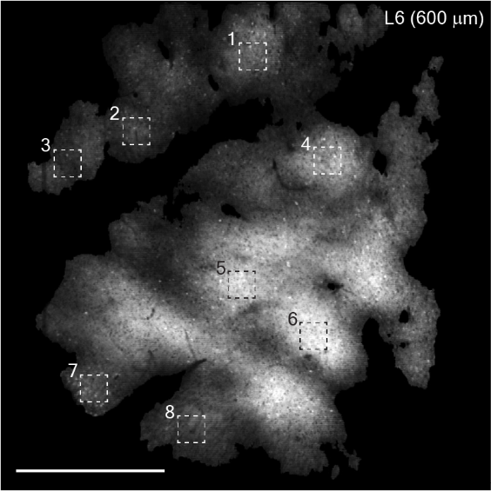

Signal intensity variation across the FOV for Figure 3a

The grayscale intensity values measured in the eight marked regions within the FOV are: (1) 6217, (2) 4052, (3) 2853, (4) 9403, (5) 12163, (6) 13102, (7) 4487, and (8) 4158. The signal variation across these regions is approximately 4.6x (the highest value divided by the lowest value). Scale bar, 1 mm.

Supplementary Fig. 9
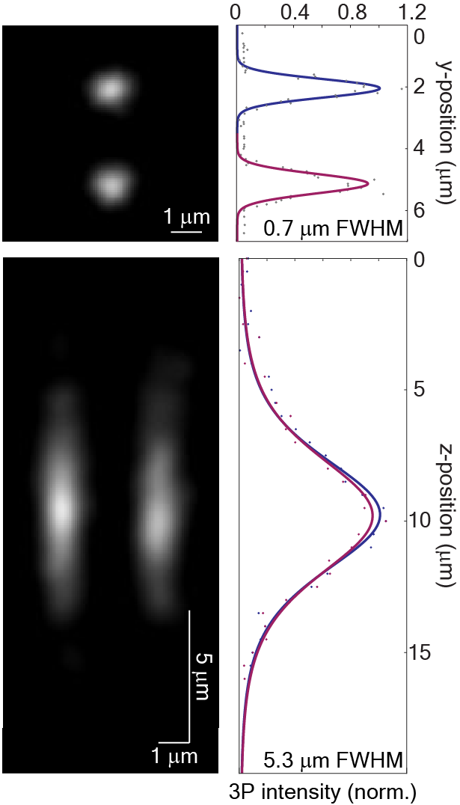
Measured point-spread functions of the two beamlets generated by the beamlet generation delay line.

Two co-planar 3P foci with 5.3 μm axial resolution (FWHM) and 0.7 μm lateral resolution (FWHM) were created with the two beamlets at 1320 nm. The foci were ~3 μm apart along the Y axis.

Supplementary Fig. 10
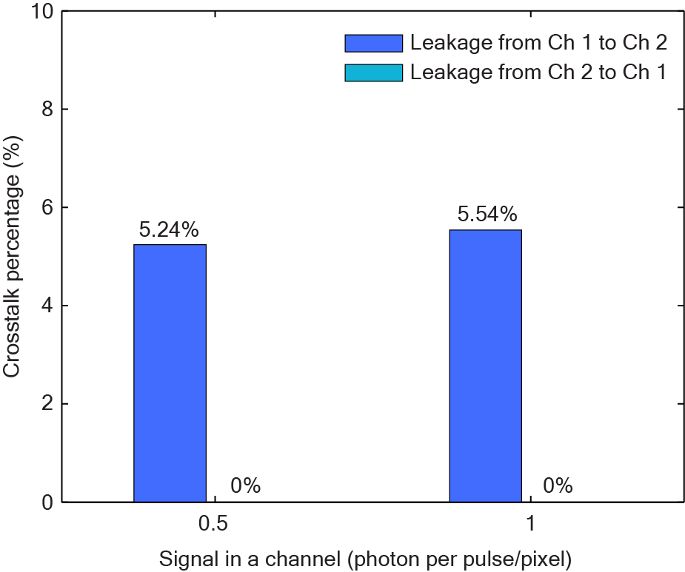

Crosstalk between the fluorescence signal generated by the two beamlets.

Measured crosstalk by imaging a fluorescein dye pool (F36915, ThermoFisher) with beamlet 1 or 2. The crosstalk percentage from Ch1 to Ch2 is calculated as the mean pixel intensity from Ch 2 divided by the mean pixel intensity from Ch 1 when beamlet 1 is on. The crosstalk percentage from Ch2 to Ch1 was calculated vice versa and is negligible. The PMT gain is ~10⁶ (0.9V control voltage). This crosstalk was mainly caused by the acquisition bandwidth of the DAQ card of 123 MHz sampling rate and input analog bandwidth of ~ 61.5 MHz.

Supplementary Fig. 11
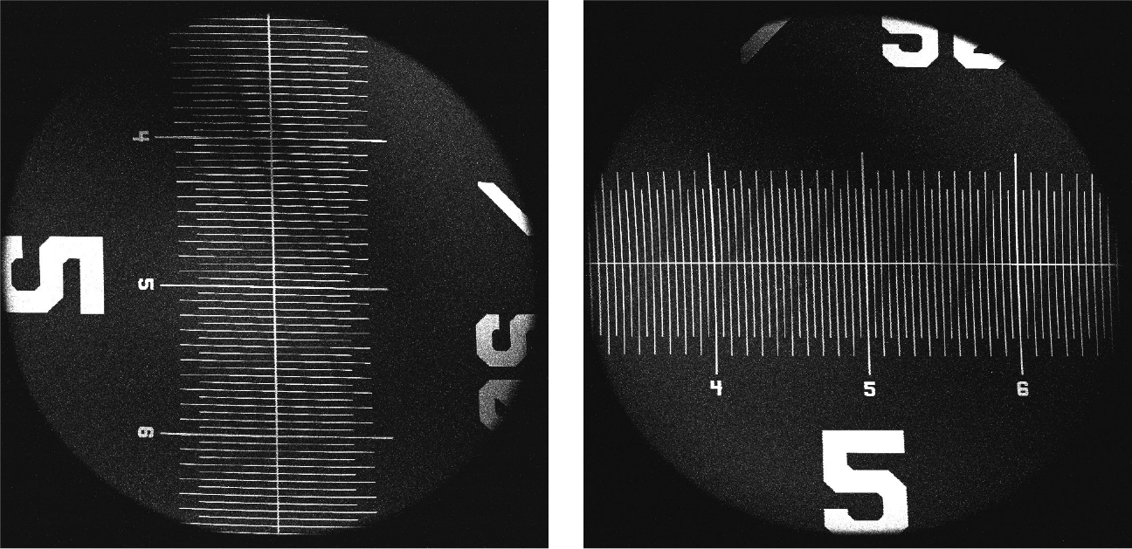

FOV measurement of DEEPscope

THG image of a stage micrometer (R1L3S1P, Thorlabs) obtained by the DEEPscope. It shows a FOV of around 3.5 mm in diameter.

Supplementary Fig. 12
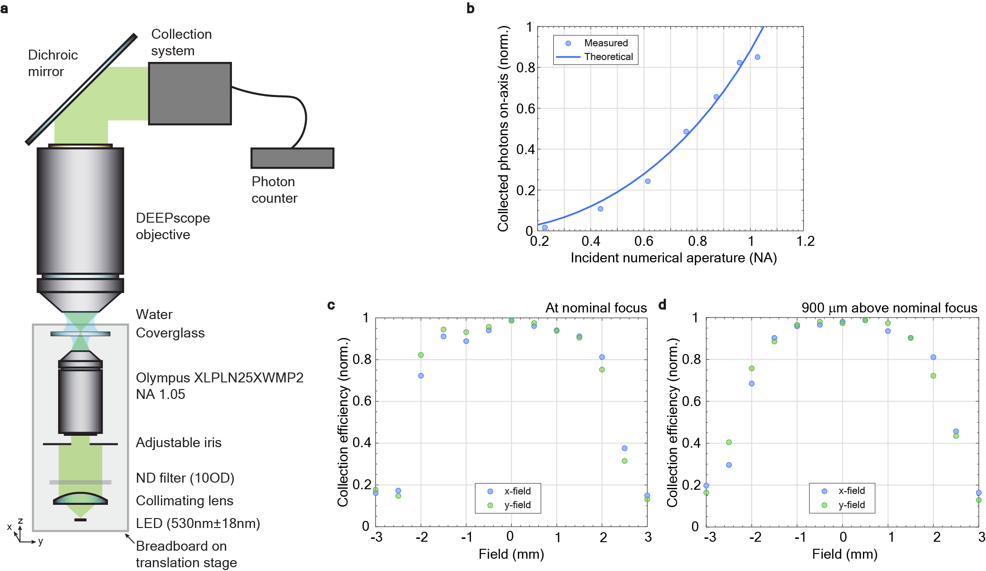

Collection efficiency of the DEEPscope objective lens

a. Measurement setup for the collection efficiency of DEEPscope objective lens.

b. Collected photons on-axis at different incident numerical apertures by varying the adjustable iris. It shows that the collected photons start to plateau when the incident numerical aperture is > 1.0, indicating that the collection NA is 1.0.

c. Relative collection efficiency at different field positions in the focal plane of the DEEPscope objective when the incident NA is 1.0.

d. Relative collection efficiency at different field positions of the DEEPscope objective at 900 μm above the nominal focal plane when the incident NA is 1.0.

Supplementary Fig. 13
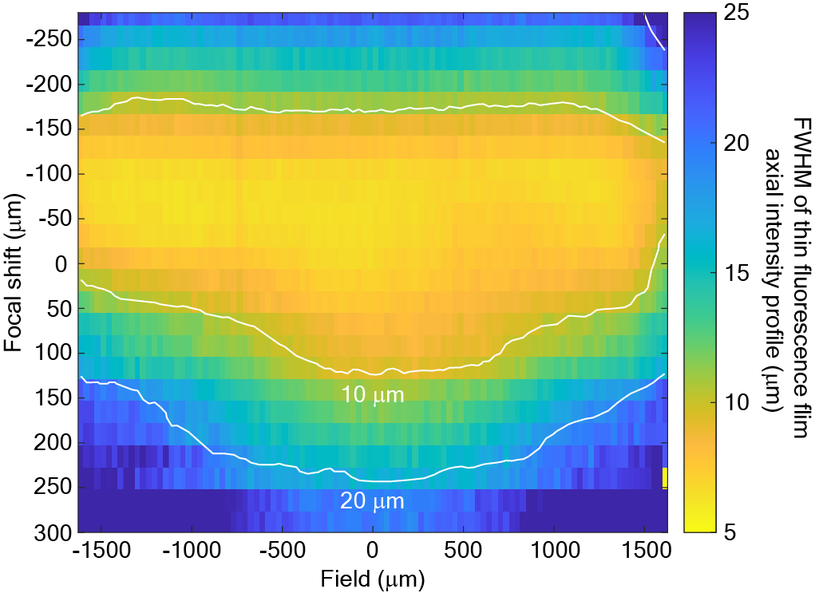

Axial resolution during remote focusing

FWHM of the axial intensity profile of a 500-nm thin fluorescent film of Rhodamine B dye with 920-nm 2PE across the FOV. The data is obtained by axial scanning at different focal positions during remote focusing. X-field and Y-field show similar results.

Supplementary Fig. 14
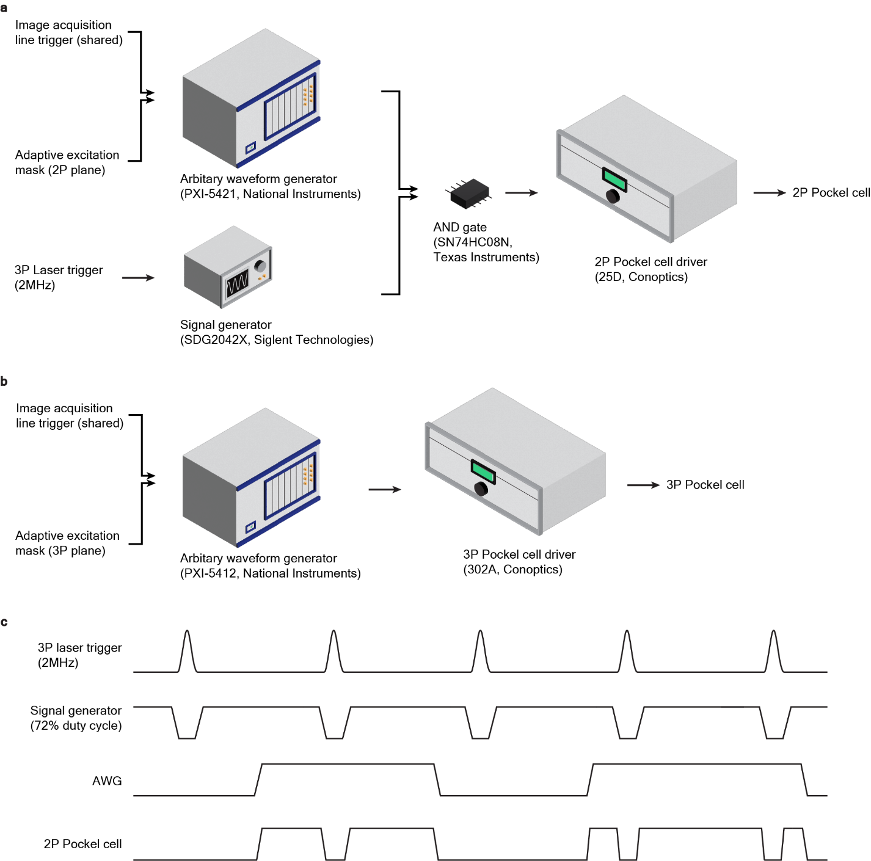

2P/3P multiplexing and dual adaptive excitation

a. Setup for 2P adaptive excitation. An AND gate (SN74HC08N, Texas Instruments) was used to combine 2P/3P multiplexing modulation signal and adaptive excitation modulation

b. Setup for 3P adaptive excitation

c. Timing diagram for 2P modulation

Supplementary Fig. 15
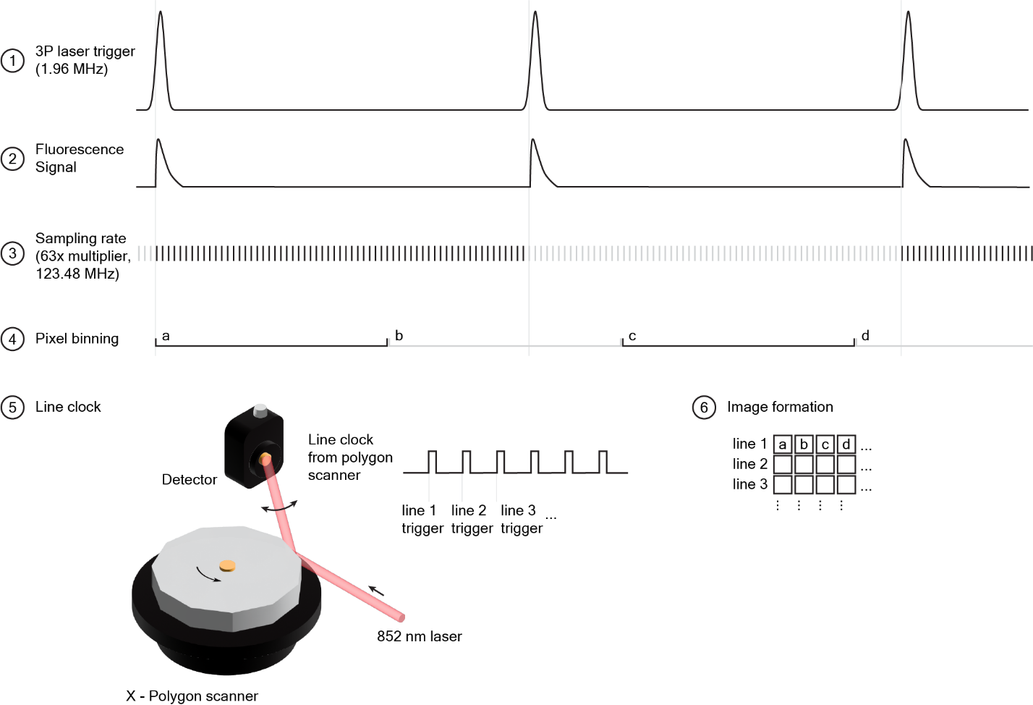

Sampling scheme of DEEPscope

The acquisition card is triggered by a laser operating at 1.96 MHz repetition rate, which is then multiplied by 63 to achieve a sampling rate of 123.48 MHz (the maximum sampling rate of our DAQ card). The samples are binned, forming a single pixel. A separate 852 nm laser (LP852-SF30, Thorlabs) and detector (DET10A2, Thorlabs) setup generates a line clock from the polygon scanner, which determines the timing for each line. The polygon scanner operates independently and is not synchronized with the laser.

Supplementary Table 1
List of customized components used for DEEPscope

Components | Vendor | Model number | Customization requirements
Polygon scanner | Nidec Copal Electronics | PT60SRG  Scanner: EX-1964  Driver: CX-771 | Variable rotation speed 7,000 – 30,000 rpm
Filters | Semrock  (AVR Optics) | FF470-DI01-77X108  FF705-DI01-77X108  FF580-FDI01-  77X108 | 77 mm x 108 mm dichroic mirrors
Objective | Special Optics | 54-22.5-15 | Excitation NA: 0.75  Collection NA: 1.0  FOV: 3mm  Effective focal length (EFL): 15 mm  Working distance: 2.8 mm + 0.17 mm BK7 coverslip  Excitation wavelengths: 1640-175 0nm, 1240-1380 nm, 1030-1050 nm, 910-930 nm  Emission wavelengths: 420 nm – 700 nm  No correction collar needed  Refocusing is sufficient for switching wavelength windows  Coverslip thickness +/- 0.070mm is acceptable by refocusing the lens
Tube lens | Special Optics | 54-22.5-200 | Entrance pupil diameter: 22.5mm  EFL: 200mm
Scan lens | Special Optics | 56-S60-44T | EFL: 60mm  Scan Angle: +/-20 deg
Collection system | Special Optics | 54-30.5-65 | Fluorescence Collection box with lenses for Hamamatsu PMT H15460-40
Photomultiplier tube (PMT) | Hamamatsu | H15460-40 | Built-in pre-amplification removed*  Signal cable with BNC connector*  Low dark count (<10,000 per second)  * A new model H15461-40-01 have these requirements built-in.
Galvo-mirror | ScannerMax  (Pangolin Laser) | Saturn 9B | 10-mm aperture mirror on Saturn 9B
Software | MBF Bioscience | ScanImage Premium | Capability to split the signal from a physical channel into >6 virtual channels using temporal demultiplexing*  Polygon scanner compatibility*  * These features are already integrated into the new version

Supplementary Table 2

Acquisition parameters for deep and large FOV two- and three-photon imaging shown in this work
Fig. | 2P/  3P | Imaging depth | Imaging FOV | Power on sample | Duty cycle of adaptive excitation | Number of pixels | Laser repetition rate | No. of beamlets | Frame Rate of the scanner
2 | 3P | 100 – 1,048 μm | 3.23 x 3.23 mm² | < 130mW |  | 4116 x 4116 | 2 MHz
3a | 3P | 600 μm | 3.23 x 3.23 mm² | 119 mW | 53% | 1030 x 1030 | 2 MHz | 2 | 4 Hz*
3d | 3P | 930 μm | 550 x 550 μm² | 120 mW |  | 512 x 512 | 1 MHz |  | 4.3 Hz
4a | 2P | 480 μm | 3.23 x 3.23 mm² | 130 mW |  | 1042 x 1042 | 80 MHz |  | 5.7 Hz
4b | 2P | 480 μm | 3.23 x 1 mm² | 130 mW |  | 4862 x 1490 | 80 MHz |  | 4 Hz
5 | 3P & | 600 μm | 3.23 x 3.23 mm² | 97 mW | 46% | 1030 x 1030 | 2 MHz | 2 | 11 Hz*
 | 2P | 320, 340, 360, 380, 400 μm | 3.23 x 3.23 mm² | 75 mW | 62% | 1030 x 515 | 80 MHz |  | Cycle:  2.2 Hz
6 | 3P | 0 – 1,090 μm | 3.23 x 3.23 mm² | < 120mW |  | 4123 x 4123 | 2 MHz
Supplementary Video
1,2 | Same as Fig. 2
3 | Same as Fig. 3a
4 | Same as Fig. 3d
5,6 | Same as Fig. 6
*effective frame rate ~ 2.6 Hz, see discussion section.

Supplementary Table 3

Comparison of LFOV multiphoton microscopes with simultaneous 2P and 3P imaging capability

 | DEEPscope  3P | DEEPscope  3P | DEEPscope  2P | DEEPscope  high-res 2P | DEEPscope  2P+3P | DEEPscope  3P  Structure | Cousa  2P | Cousa  3P  Structure | Cousa  3P  Structure | Hybrid microscope  2P | Hybrid microscope  2P | Hybrid microscope  3P | Hybrid microscope  2P + 3P
Operating wavelength  (nm) | 910-930; 1,030-1,050  1,240-1,380; 1,640-1,750 |  |  |  |  |  | 800 – 1,300 nm |  |  | Imaging data shown 960nm and 1300 nm
Max. supported FOV  (mm) | 3.5 dia. |  |  |  |  |  | 3 x 3 |  |  | -
Imaging FOV  (mm²) | 3.23 x 3.23 | 0.55 x 0.55 | 3.23 x 3.23 | 3.23 x 1 | (3P) 3.23 x 3.23  (2P) 3.23 x 3.23 | 3.23 x 3.23 | 1.7 x 1.7 | 2 x 2 | 0.7 x 0.7 | 0.69 x 0.75 | 1 x 1 | 0.34 x 0.34 | (3P) 0.34 x 0.34  (2P) 0.72 x 0.67
Scanner | Polygon-  Galvo + beamlets | Galvo-Galvo | Polygon-Galvo | Polygon-  Galvo | Polygon-  Galvo + beamlets | Polygon-  Galvo | Resonant Galvo-Galvo |  |  | Resonant Galvo-Galvo
Lateral sampling (µm) | 3.1 | 1.1 | 3.1 | 0.67 | (3P) 3.1 x 3.1  (2P) 3.1 x 6.3 | 0.8 | - | - | 1.1 | 5 | 5 | 3.4 | 3.4
PSF (µm)  Lateral x axial | 0.7 x 5.3 |  |  |  |  |  | - | - | 0.69 x 5.84 | 5 x 15 |  | 1.5 x 9.4 | (3P) 1.5 x 9.4  (2P) 5 x 15
Neuron labeling | Transgenic mouse |  |  |  |  |  | Transgenic mouse |  |  | Virus injection
Imaging depth  (µm) | 600 | 930 | 480 | 480 | (3P) 600  (2P) 320-400 | 1,048 | 250 | 730 | 945 | 0 – 600 | 0 - 600 | 1,220 | (3P) 950 – 1,100  (2P) 100 - 700
Power on sample  (mW) | 119 | 120 | 130 | 130 | (3P) 97  (2P) 75 | 130 | 80 | - | - | - | - | 190 | -
Frame rate (Hz) | 4* | 4.3 | 5.7 | 4 | (3P) 11*  (2P) 2.2 cycle | - | 15.6 | - | - | 16.7 vol. | 5.1 vol. | 78 | (3P) 4.6 vol.  (2P) 13.8 vol.
Microscope  transmission (%) | ~15 |  |  |  | (3P) ~15  (2P) ~15 | ~15 | - |  |  | -
Reference | -
*effective frame rate ~ 2.6 Hz, see discussion section
vol. = volume
PSF = point-spread function

Supplementary Note 1

During deep 3P imaging (Fig. 3a), the measured fluorescence signal is 58 photons/neuron/second (Supplementary Fig. 5), which corresponds to a d' value ~2.3. This represents a true positive rate of 87.7% and a false positive rate of 12.3% for neuronal spike detection. The d’ value is calculated using the equation derived by [1],
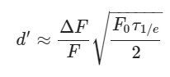
where 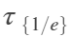 is the 1/e decay time, 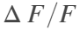 is the peak fluorescence change of a single-action-potential-induced calcium spike, and 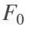is the baseline brightness of the neuron. We used the parameters for GCaMP6s (~ 30% and ~ 2 s from [2]).

In conventional 3P microscope, d’~3 is typically obtained in the same GCaMP6s transgenic mice line used in this study, which corresponds to a true positive rate of 93% and a false positive rate of 7% for neuronal spike detection [3]. These calculations show only a small reduction of d’ during LFOV 3P imaging.

In Figure 3a, the average power on the sample is 119 mW, which is the power after applying adaptive excitation with a 53% duty cycle, specifically blocking regions with large blood vessel shadows. Consequently, the original power without adaptive excitation in the region of interest is 224.5 mW (119 mW / 53%). At a 4 MHz repetition rate, this corresponds to 56 nJ per laser pulse. Assuming a scattering length of 300 µm in the sample [3], the pulse energy at the focus when imaging at a depth of 600 µm is approximately 7.6 nJ.

Using the equation from [4], we can estimate the photons detected per laser pulse in imaging GCaMP6s-expressed neurons. The equation is shown as follow:
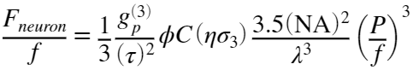
where 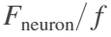 is the fluorescence detection rate (photon/pulse), is the laser repetition rate,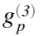is a dimensionless quantity that describe temporal coherence of the laser that depends on the laser pulse shape, is the FWHM of laser pulse width, 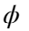is the detection coefficient, is the concentration of the fluorophore, 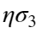is the 3-photon absorption cross-section, is the numerical aperture, 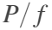 is the pulse energy at the focus. The parameters we used are as follows: = 0.51; = 60fs; = 3.5%; = 264 nM; = 3x 10⁻⁸² cm⁶s²; =0.58. An infinite dye volume is assumed. ,, are from [3]. The detection efficiency is calculated using the empirical model of fluorescence profile on the brain surface [5] and the measured collection efficiency across the FOV (Supplementary Fig. 12). is measured by second-order interferometric autocorrelation. The above equations give 6.6 fluorescence photon/pulse detected.

The number of laser pulses per pixel per second can be calculated as: $\frac{1.96 \text{MHz }\text{⋅}\text{ 2 beamlets }⋅70\%}{1030 \text{px}⋅1030 \text{px }\text{⋅}\text{ 4 Hz}}\sim 2.6$ . Assuming that each neuron occupies around 9 pixels (considering a 10 µm neuron with the 3.14 µm per pixel), the photon count per neuron per second is expected to be: 6.6 photon per pulse x 2.6 pulse per pixel per second x 9 pixels per neuron = 154 photons per second per neuron.

The difference between the calculated value and the measured value of 58 photons per second per neuron (averaged over all neurons) could be attributed to factors such as variations in scattering length, power transmission, and optical aberration across the FOV. For example, the calculated number represents a perfect diffraction limited focus without any aberration, while it is known that aberration exists and reduces the 3P signal when imaging deep. As demonstrated in Supplementary Figure 8, the signal intensity as represented by the gray level varies by approximately 4.6x across the FOV, indicating that the measured average value of 58 photons per second per neuron falls within the range of signal variability during in-vivo imaging.

1. B. A. Wilt, J. E. Fitzgerald, and M. J. Schnitzer, "Photon shot noise limits on optical detection of neuronal spikes and estimation of spike timing," Biophys. J. 104, 51–62 (2013).
2. T. W. Chen, T. J. Wardill, Y. Sun, S. R. Pulver, S. L. Renninger, A. Baohan, E. R. Schreiter, R. A. Kerr, M. B. Orger, V. Jayaraman, L. L. Looger, K. Svoboda, and D. S. Kim, "Ultrasensitive fluorescent proteins for imaging neuronal activity," Nature 499, 295–300 (2013).
3. T. Wang, C. Wu, D. G. Ouzounov, W. Gu, F. Xia, M. Kim, X. Yang, M. R. Warden, and C. Xu, "Quantitative analysis of 1300-nm three-photon calcium imaging in the mouse brain," Elife 9, e53205 (2020).
4. C. Xu and W. W. Webb, "Multiphoton Excitation of Molecular Fluorophores and Nonlinear Laser Microscopy," in Topics in Fluorescence Spectroscopy, J. R. Lakowicz, ed. (Springer, Boston, MA, 2002), Vol. 5, pp. 471–540.
5. E. Beaurepaire and J. Mertz, "Epifluorescence collection in two-photon microscopy," Appl. Opt. 41, 5376–5382 (2002).

Supplementary Note 2

Alignment procedures for beamlet delay line

The following outlines the alignment procedure for the beamlet delay line, using the provided layout and symbols:

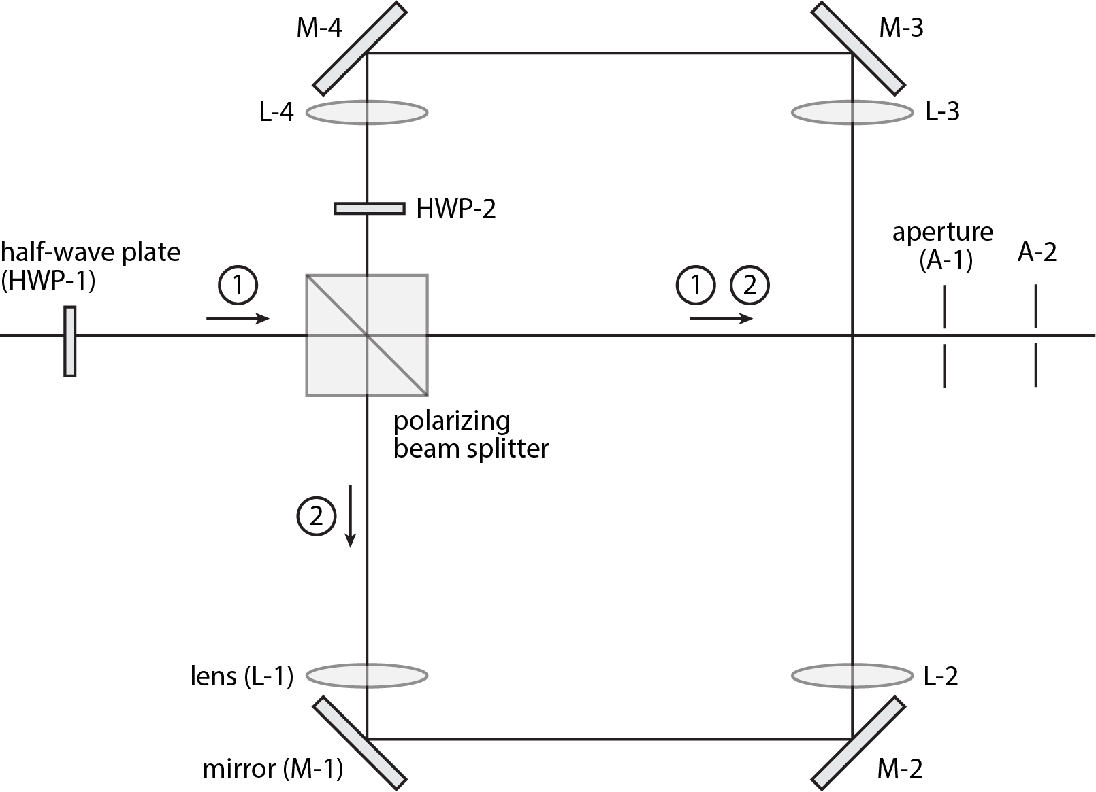

- Position all mirrors (M-1 to M-4) to establish the desired temporal delay between pulses, and ensure the cavity length is equal to 8x the focal length of the lenses (L-1 to L-4).
- Adjust the half-wave plates (HWP-1 and HWP-2) so that beam 1 and beam 2 have equal power.
- Align the mirrors and the polarizing beam splitter (PBS) to ensure that light paths 1 and 2 perfectly overlap and pass through apertures A-1 and A-2, as depicted in the diagram.
- Install lenses L1-L4 in an 8f configuration, ensuring that all lenses have the same focal length for beam divergence control.
- Fine-tune the lenses to maintain the overlap of beam 1 and beam 2 as they pass through apertures A-1 and A-2.
- Align the beams through the multiphoton microscope imaging path.
- Perform imaging of fluorescent beads, using one of the fluorescence beads as a reference. Adjust mirrors M-1 and M-2 to achieve the desired separation of the beamlets by measuring the distance separating the two images of the fluorescence bead.

Supplementary Video 1 (link)
Mouse brain imaging stack with 3.23 x 3.23-mm² scan field from 100 to 1,048 μm below the brain surface. The stack was acquired with 4116x4116 pixels per slice and 4 μm axial step size. The images show fluorescence signal (green) from neurons expressing GCaMP6s and THG signal (magenta) from a GCaMP6s transgenic mouse.

Supplementary Video 2 (link)
3D rendering of the images in Supplementary Video 1

Supplementary Video 3 (link)
Spontaneous activity recorded from GCaMP6s-labeled neurons at cortical L6, 600 μm below brain surface with 3.23 x 3.23-mm² scan field at 4 Hz (scanning frame rate) with 1030 x 1030 pixels per frame. Playback is sped up by 30x. Structural stack is shown to indicate the position of EC. The images show fluorescence signal (green) from neurons expressing GCaMP6s and THG signal (magenta) from a GCaMP6s transgenic mouse. Activity recording is shown in gray scale.

Supplementary Video 4 (link)
Spontaneous activity recorded from GCaMP6s-labeled neurons in SP layer of CA1 region of the hippocampus at 930 μm below brain surface from a GCaMP6s transgenic mouse. Activity was recorded with a FOV 550 μm x 550 μm at 4.3 Hz frame rate. Playback is sped up by 30x. Kalman-filtered video (left) and DeepCAD-processed video (right) are shown.

Supplementary Video 5 (link)
Zebrafish imaging stack with 3.23 x 3.23-mm² scan field from 0 to 1,090-μm below the top surface of the skull bone. The stack was acquired with 4123x4123 pixels per slice and 10 μm axial step size. The images show fluorescence signal (green) from neurons expressing GCaMP6s and THG signal (magenta) from neural fibers.

Supplementary Video 6 (link)
3D rendering of the stack from depths of 400 μm to 1,090 μm in Supplementary Video 5.

