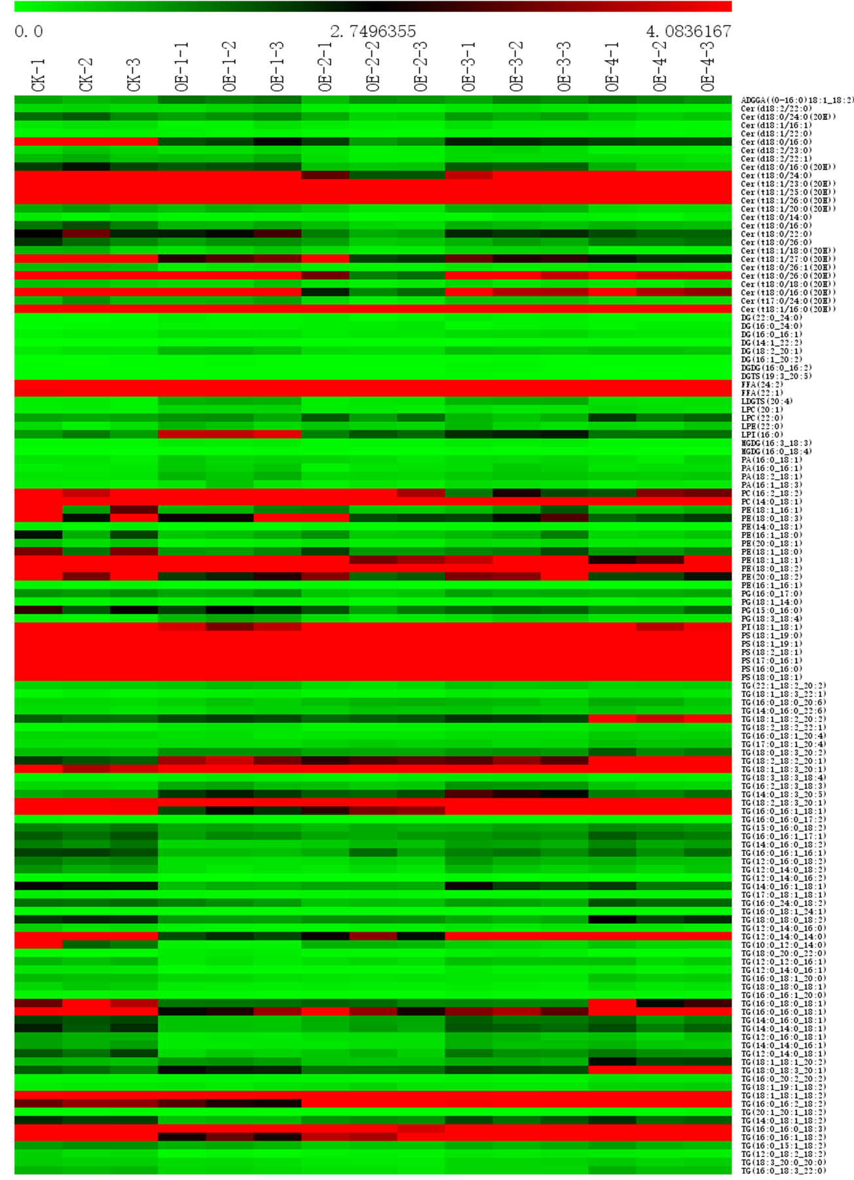

Fig. S12. Contents of long-chain fatty acids in TLR3-OE A. annua plants. The contents of long-chain fatty acids were measured by LC–MS/MS. LDGTS, lyso-diacylglyceryltrimethylhomoserine; ADGGA, acyl diacylglycerol glucuronic acid; DGDG, disaccharide diglycerides; ADGGA, acyl diacylglycerol glucuronic acid; FFA, free fatty acids; DG, diglyceride; MGDG, monosaccharide diglycerides; PA, phosphatidic acid; DGTS, diacylglyceryltrimethylhoserine; Cer, ceramide; PC, phosphatidylcholine; PE, phosphatidylethanolamine; PI, phosphatidylinositol; PS, phosphatidylserine; TG, triglyceride; PG, phosphatidylglycerol. Green indicates low abundance; red indicates high abundance.

