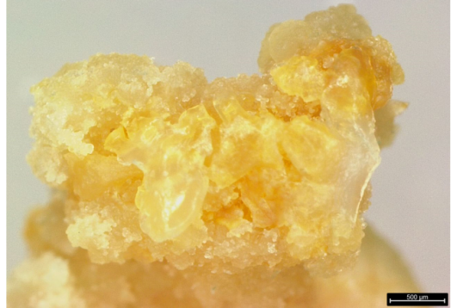
Fig. S1. Control calli cannot be stained.

