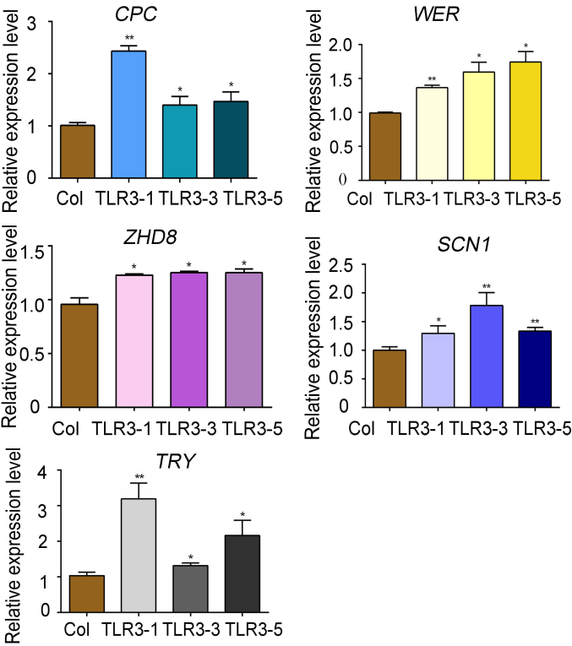

Fig. S3. Genes involved in trichome development and root hair development expression levels in TLR3-OE Arabidopsis lines. Data are means SD (n = 3). Asterisks indicate significant differences between TLR3-OE lines and Col-0 by Student’s t-test. (*, P < 0.05; **, P < 0.01.)

