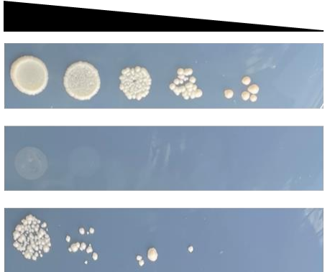
ΔTLR3’-BD+AD
ΔTLR3-BD+AD
TLR3-full-BD+AD

Fig S7. The TLR3 gene was divided into three segments: full-length amino acids, 1-111 amino acids and 112-206 amino acids, and the self-activation detection of the three-segment gene.

