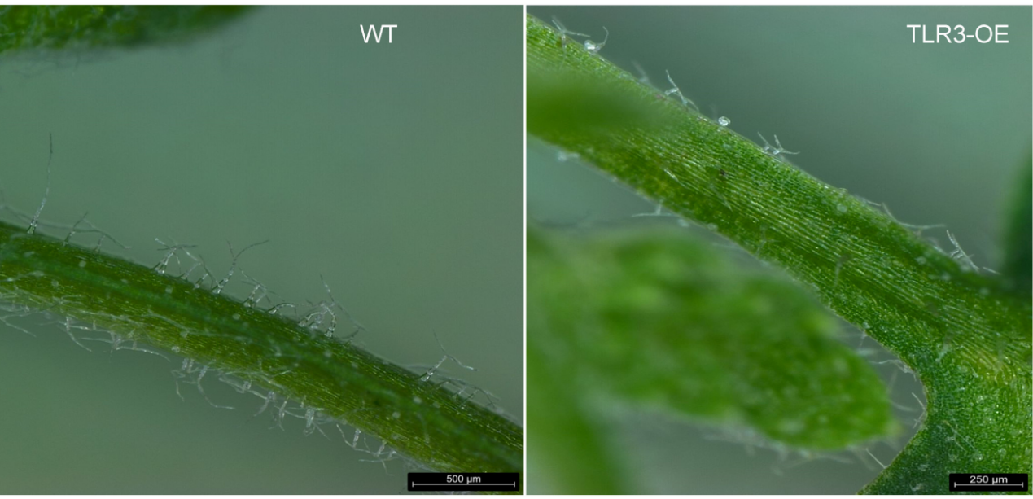

Fig. S9. Appearance of glandular and non-glandular trichomes on the surface of TLR3-OE A. annua leave petioles.

