Supplementary information
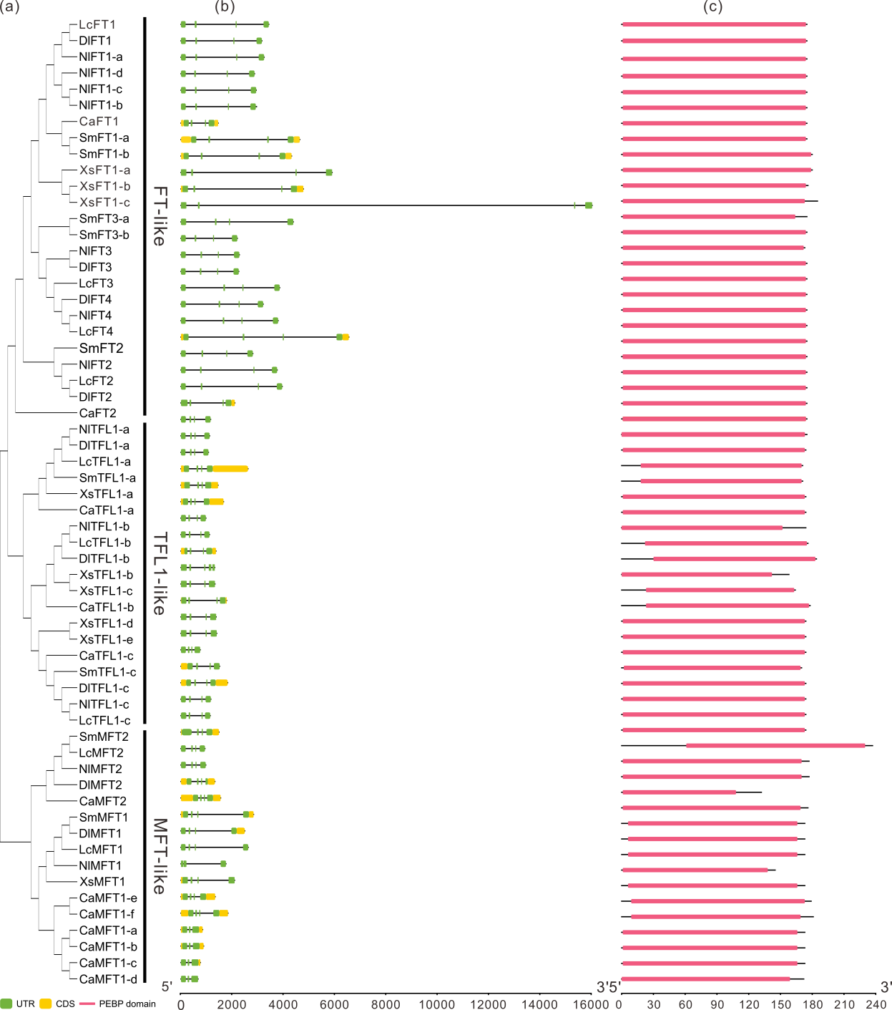
Figure S1. Gene structures and domain of PEBP genes in six Sapindaceae species.
(a) Phylogenetic tree of 60 PEBP protein sequences generated by using Neigbour-joining Tree method. (b) Gene structures of PEBP genes family members across 6 Sapindaceae species. Exons are represented by green boxes, introns are indicated by black lines, and UTRs are denoted by yellow boxes. (c) Analysis of sequence conservation in the PEBP protein domains across 60 PEBP genes.

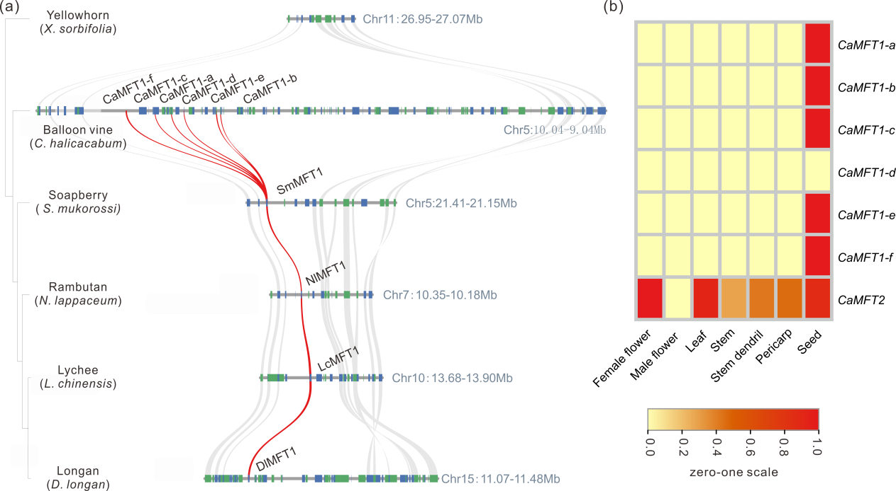

Figure S2. The synteny of Balloon vine MFT1 genes among 6 Sapindaceae species and the tissue-specific expression patterns of MFT genes in balloon vine.
(a) The synteny across lychee, longan, rambutan, soapberry, yellowhorn and balloon vine of MFT1 genes. The gray lines connect syntenic blocks. The MFT1 gene pairs are linked with red curves. (b) The expression patterns of MFT genes across various tissues of the balloon vine.
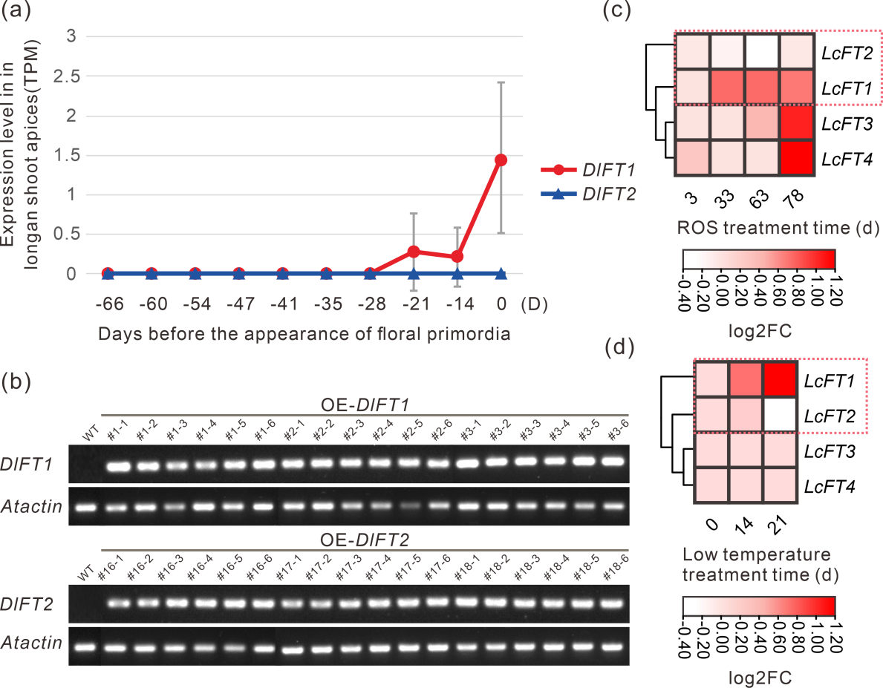
Figure S3. Partial amino acid sequence alignment of PEBP family members and the expression profiles of FT-like genes.
(a) The expression patterns of DlFTs during flower induction in longan shoot apices were analyzed through RNA-seq. (b) The semi-quantitative reverse transcription polymerase chain reaction (semi-qRT-PCR) was performed to detect overexpression in transgenic plants. (c) and (d) Expression profiles of 4 LcFTs in response to ROS treatment (Lu et al. 2020) and low temperature (Zhang et al. 2017) during floral induction according to the RNA-seq data in leaves of lychee. TPM was used to indicate gene expression levels or transcript accumulated levels. The log₂ ratio of fold change (log2FC) of the gene expression value between control and treatment was calculated according to the treatment timepoint.
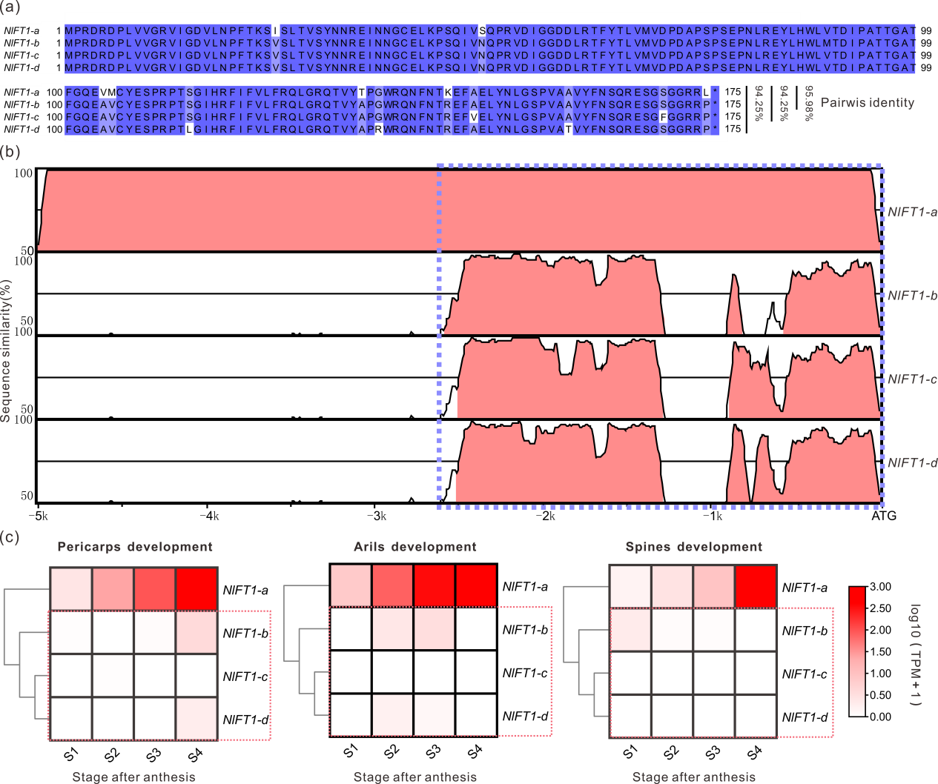
Figure S4. The Sequence alignment of 4 NlFT1s in rambutan.
(a) Amino acid identity comparisons of the protein sequences of the four NlFT1s. (b) Conservation analysis of Rambutan FT1 Promoter Sequences. Pairwise alignment of FT1 promoter sequences from four Rambutan FT1 genes linked to upstream 5.0-kb using mVISTA (Brudno et al. 2003). The Graphical output displays the similarity of base pairs within a sliding window spanning 75 bp, ranging from 50 to 100%. The four conserved promoter sequences of rambutan NlFT1 genes are demarcated with purple dashed lines. (c) Expression pattern of 4 NlFT1s genes during pericarps, arils, spines development, respectively.
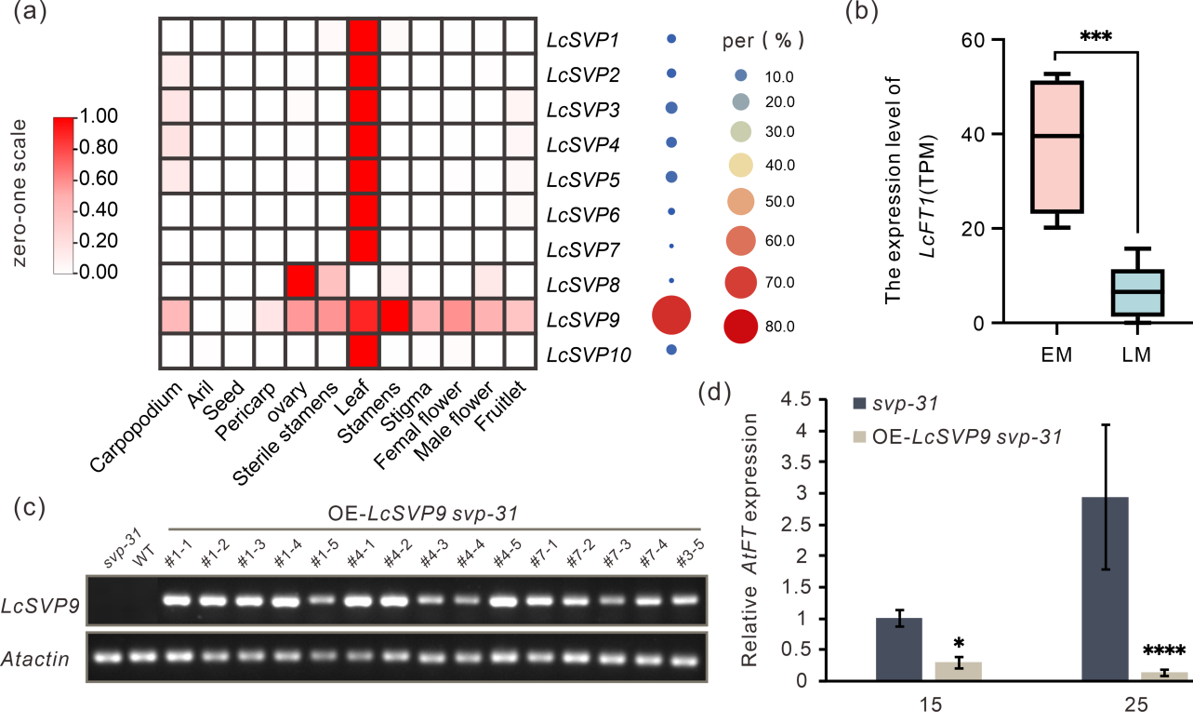
Figure S5. The expression level of LcSVPs and LcFT1 genes
(a)The expression level of lychee SVP genes across different tissues. The size of the circles represents the expression proportion of SVP genes. (b) The expression levels of LcFT1 in the leaves of different early-maturing (EM) lychee varieties, including four representative varieties ('FZX', 'CZ', 'CSN', and 'XFZ'), as well as late-maturing (LM) ones ('LYX', 'NMC', 'MGL', 'GW', 'HZ', and 'ZNX'). (c) The expression levels of LcSVP9 in LcSVP9 transgenic plants. (d) Expression of AtFT in leaves of long-day-grown svp-31 mutants and LcSVP9 overexpression plants during (day 15 and day 25) reproductive development.
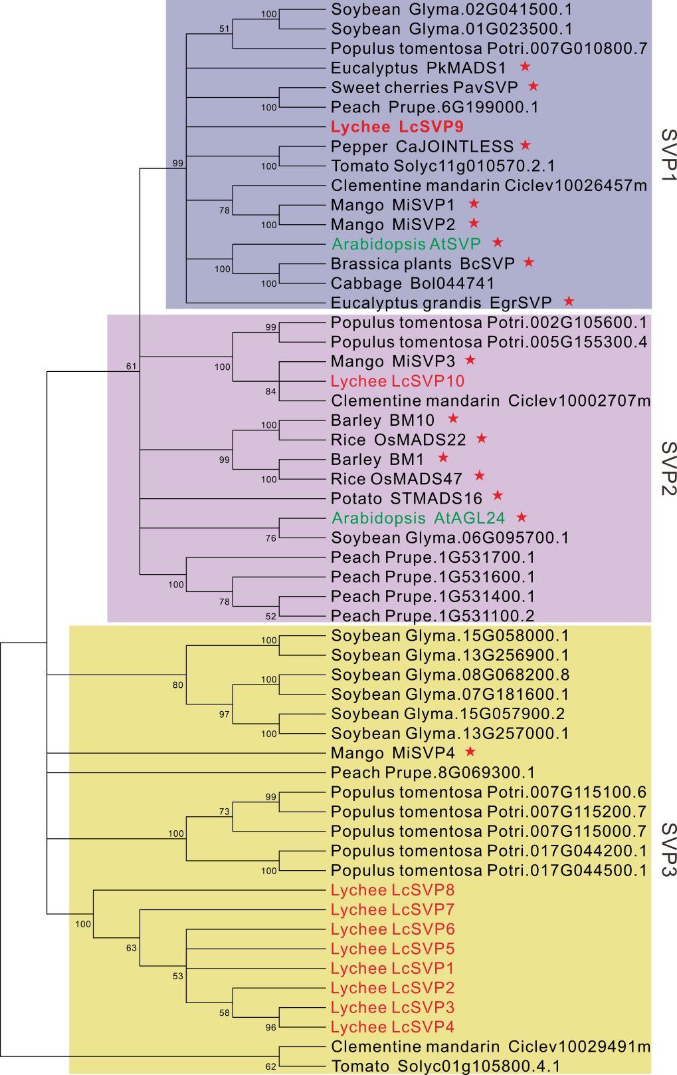
Figure S6. Phylogenetic tree of typical SVP genes in eudicots.
Group SVP1 in purple background; Group AGL24/SVP2 in light purple background; Group SVP3 in yellow background. Red star indicates floral transition function characterized by generating transgenic plants. Additionally, other SVP genes have been identified through research conducted by Liu et al (2018).

Table S1. PEBP genes identified in six Sapindaceae species.
Species | Gene ID | name
Lychee  (Litchi chinensis) | LITCHI002331.m1 | LcFT1
Lychee  (Litchi chinensis) | LITCHI002335.m1 | LcFT2
Lychee  (Litchi chinensis) | LITCHI002334.m1 | LcFT3
Lychee  (Litchi chinensis) | LITCHI006928.m1 | LcFT4
Lychee  (Litchi chinensis) | LITCHI009311.m1 | LcTFL1-a
Lychee  (Litchi chinensis) | LITCHI018838.m1 | LcTFL1-c
Lychee  (Litchi chinensis) | LITCHI024460.m1 | LcTFL1-b
Lychee  (Litchi chinensis) | LITCHI023105.m1 | LcMFT1
Lychee  (Litchi chinensis) | LITCHI029325.m1 | LcMFT2
Longan  (Dimocarpus longan) | Dil.05g001470.1.t1 | DlFT1
Longan  (Dimocarpus longan) | Dil.05g001570.1.t1 | DlFT2
Longan  (Dimocarpus longan) | Dil.05g001540.1.t1 | DlFT3
Longan  (Dimocarpus longan) | Dil.06g006560.1.t1 | DlFT4
Longan  (Dimocarpus longan) | Dil.08g015500.1.t1 | DlTFL1-a
Longan  (Dimocarpus longan) | Dil.13g008920.1.t1 | DlTFL1-b
Longan  (Dimocarpus longan) | Dil.14g009880.1.t1 | DlTFL1-c
Longan  (Dimocarpus longan) | Dil.15g013870.1.t1 | DlMFT1
Longan  (Dimocarpus longan) | Dil.07g017920.1.t1 | DlMFT2
Rambutan  （Nephelium lappaceum） | Nl06g13640.mrna1 | NlFT1-b
Rambutan  （Nephelium lappaceum） | Nl06g13650.mrna1 | NlFT1-c
Rambutan  （Nephelium lappaceum） | Nl06g13660.mrna1 | NlFT1-d
Rambutan  （Nephelium lappaceum） | Nl06g13670.mrna1 | NlFT1-a
Rambutan  （Nephelium lappaceum） | Nl06g13690.mrna1 | NlFT2
Rambutan  （Nephelium lappaceum） | Nl06g13680.mrna1 | NlFT3
Rambutan  （Nephelium lappaceum） | Nl13g09360.mrna1 | NlFT4
Rambutan  （Nephelium lappaceum） | Nl10g10020.mrna1 | NlTFL1-a
Rambutan  （Nephelium lappaceum） | Nl15g07240.mrna1 | NlTFL1-b
Rambutan  （Nephelium lappaceum） | Nl11g07990.mrna1 | NlTFL1-c
Rambutan  （Nephelium lappaceum） | Nl16g04710.mrna1 | NlMFT2
Rambutan  （Nephelium lappaceum） | Nla_Dil.15g013870.1.t1_1 | NlMFT1
Soapberry  （ Sapindus mulorossi） | whz_003057-RA | SmFT1-a
Soapberry  （ Sapindus mulorossi） | whz_003092-RA | SmFT1-b
Soapberry  （ Sapindus mulorossi） | whz_003088-RA | SmFT3-a
Soapberry  （ Sapindus mulorossi） | whz_003094-RA | SmFT3-b
Soapberry  （ Sapindus mulorossi） | whz_003087-RA | SmFT2
Soapberry  （ Sapindus mulorossi） | whz_008129-RA | SmTFL1-a
Soapberry  （ Sapindus mulorossi） | whz_026519-RA | SmTFL1-c
Soapberry  （ Sapindus mulorossi） | whz_012860-RA | SmMFT1
Soapberry  （ Sapindus mulorossi） | whz_002139-RA | SmMFT2
Yellowhorn  （Xanthoceras sorbifolium） | EVM0022396.1 | XsFT1-a
Yellowhorn  （Xanthoceras sorbifolium） | EVM0012685.1 | XsFT1-b
Yellowhorn  （Xanthoceras sorbifolium） | EVM0021328.1 | XsFT1-c
Yellowhorn  （Xanthoceras sorbifolium） | EVM0023266.1 | XsTFL1-a
Yellowhorn  （Xanthoceras sorbifolium） | EVM0000974.1 | XsTFL1-b
Yellowhorn  （Xanthoceras sorbifolium） | EVM0017724.1 | XsTFL1-c
Yellowhorn  （Xanthoceras sorbifolium） | EVM0019799.1 | XsTFL1-d
Yellowhorn  （Xanthoceras sorbifolium） | EVM0020336.1 | XsTFL1-e
Yellowhorn  （Xanthoceras sorbifolium） | EVM0005806.1 | XsMFT1
Balloon vine  (Cardiospermum halicacabum) | Ca01G06980.t1 | CaFT1
Balloon vine  (Cardiospermum halicacabum) | Ca01G06970.t1 | CaFT2
Balloon vine  (Cardiospermum halicacabum) | Ca04G10990.t1 | CaTFL1-c
Balloon vine  (Cardiospermum halicacabum) | Ca05G26900.t1 | CaTFL1-a
Balloon vine  (Cardiospermum halicacabum) | Ca02G09830.t1 | CaTFL1-b
Balloon vine  (Cardiospermum halicacabum) | Ca05G10880.t1 | CaMFT1-a
Balloon vine  (Cardiospermum halicacabum) | Ca05G10820.t1 | CaMFT1-b
Balloon vine  (Cardiospermum halicacabum) | Ca05G10900.t1 | CaMFT1-c
Balloon vine  (Cardiospermum halicacabum) | Ca05G10870.t1 | CaMFT1-d
Balloon vine  (Cardiospermum halicacabum) | Ca05G10830.t1 | CaMFT1-e
Balloon vine  (Cardiospermum halicacabum) | Ca05G10910.t1 | CaMFT1-f
Balloon vine  (Cardiospermum halicacabum) | Ca07G12370.t1 | CaMFT2

Table S2. Detailed information of PEBP genes from 46 seed plant species.
No. | Species | Homologs | NCBI accession
1 | Alpine rock-cress  (Arabis alpina) | AaTFL1-1 | BAK31016.1
1 | Alpine rock-cress  (Arabis alpina) | AaTFL1-2 | BAK31017.1
2 | Common bean  (Phaseolus vulgaris) | PvTFL1y | ABR53777.2
3 | Barley  (Hordeum vulgare) | HvFT1 | ADW82818.1
3 | Barley  (Hordeum vulgare) | HvFT2 | QOL02402.1
3 | Barley  (Hordeum vulgare) | HvFT3 | ABD75336.2
4 | Apple  (Malus domestica) | MdTFL1 | NP_001280887.1
4 | Apple  (Malus domestica) | MdTFL1-2 | NP_001280794.1
4 | Apple  (Malus domestica) | MdFT2 | NP_001280810.1
4 | Apple  (Malus domestica) | MdCENa | NP_001280813.1
4 | Apple  (Malus domestica) | MdCENb | NP_001280940.1
5 | Potato  (Solanum tuberosum) | StTFL1 | ABC24691.1
5 | Potato  (Solanum tuberosum) | StSP3D | BAV67096.1
5 | Potato  (Solanum tuberosum) | StSP6A | BAV67095.1
6 | Clustered gentian  (Gentia natriflora) | GtTFL1 | BAK40196.1
7 | Chrysanthemum  (Chrysanthemum spp.) | CsFTL3 | ACX48949.1
8 | Pumpkin  (Cucurbita maxima) | Cm-FTL1 | ABI94605.1
8 | Pumpkin  (Cucurbita maxima) | Cm-FTL2 | ABI94606.1
9 | Lombardy poplar  (Populus nigra) | PnTFL1 | BAG12897.1
9 | Lombardy poplar  (Populus nigra) | PnFT1 | BAG12899.1
9 | Lombardy poplar  (Populus nigra) | PnFT2 | ABW73563.1
10 | Purple false brome  (Brachypodium distachyon) | FTL1 | AHB63017.1
10 | Purple false brome  (Brachypodium distachyon) | FTL2 | XP_003564300.1
11 | Soybean  (Glycine max) | Dt1 | ADF31195.1
11 | Soybean  (Glycine max) | GmMFT | NP_001236894
11 | Soybean  (Glycine max) | GmFT2a | NP_001240185.1
11 | Soybean  (Glycine max) | GmFT4 | NP_001276224
11 | Soybean  (Glycine max) | GmFT5a | NP_001239994.1
12 | Tomato  (Solanum lycopersicum) | SP | NP_001233974.2
12 | Tomato  (Solanum lycopersicum) | SFT | NP_001308081.1
13 | Rice (Oryza sativa) | RFT1 | NP_001408117.1
13 | Rice (Oryza sativa) | Hd3a | NP_001408118.1
14 | Sugarcane  (Saccharum spp.) | ScTFL1 | AEO72025.1
14 | Sugarcane  (Saccharum spp.) | ScFT1 | AHZ46121.1
15 | Snapdragon  (Antirrhinum spp.) | CEN | Q41261.1
16 | Dancing lady orchid  (Oncidium gowerramsey) | OnTFL1 | AIU44253.1
16 | Dancing lady orchid  (Oncidium gowerramsey) | OnFT | AIG63003.1
17 | Fig (Ficus carica) | FcFT1 | BAL22281.1
18 | Grapevine (Vitis vinifera) | VvTFL1A | ACY80737.1
18 | Grapevine (Vitis vinifera) | VvFT | ABF56526.1
19 | Japanese apricot  (Prunus mume) | PmTFL1 | AEO72021.1
19 | Japanese apricot  (Prunus mume) | PmFT | BAH82787.1
20 | Onion (Allium cepa) | AcFT1 | AGZ20207.1
20 | Onion (Allium cepa) | AcFT2 | AGZ20208.1
21 | Onion (Allium cepa) | AcFT4 | AGZ20210.1
22 | Kiwifruit (Actinidia spp.) | Kiwifruit CEN | AGK89940.1
23 | Lettuce (Lactuca sativa) | LsFT | BAK14369.1
24 | Sugar beet  (Beta vulgaris) | BvFT1 | ADM92608.1
24 | Sugar beet  (Beta vulgaris) | BvFT2 | ADM92610.1
25 | London plane  (Platanus acerifolia) | PaFT | AIG92770.1
26 | Black cherry  (Prunus serotina) | PsTFL1 | AEO72024.1
27 | Lotus japonicus | Ljcen1 | AAQ93599.1
27 | Lotus japonicus | LjFT | AFK38383.1
28 | Maize (Zea mays) | ZCN8 | AYA59799.1
28 | Maize (Zea mays) | ZCN2 | ABX11004.1
29 | Medicago  (Medicago truncatula) | MTFTa1 | AEI99551.1
29 | Medicago  (Medicago truncatula) | MtFTb1 | AEI99553.1
29 | Medicago  (Medicago truncatula) | MtFTc | AEI99555
30 | Orange (Citrus sinensis) | CsTFL | BAN13572.1
31 | Pea  (Pisum sativum) | PsFTa1 | ADZ05704.1
31 | Pea  (Pisum sativum) | PsFTa2 | ADZ05700.1
31 | Pea  (Pisum sativum) | PsFTb1 | ADZ05701.1
31 | Pea  (Pisum sativum) | PsFTb2 | ADZ05705.1
31 | Pea  (Pisum sativum) | PsFTc | ADZ05706.1
31 | Pea  (Pisum sativum) | PsTFL1a | AAR03725.1
31 | Pea  (Pisum sativum) | PsTFL1c | AAQ20811.1
32 | Peach (Prunus persica) | PpTFL1 | BAI99732.4
33 | Pear  (Pyrus spp.) | PpTFL1-2 | BAD10968.1
33 | Pear  (Pyrus spp.) | PcTFL1-1 | BAD10963.1
33 | Pear  (Pyrus spp.) | PcTFL1-2 | BAD10969.1
34 | Phalaenopsis orchid  (Phalaenopsis hybrid) | PhFT | AFS60093.1
35 | Pharbitis (Ipomoea nil) | PnFT1a | BAG12899.1
35 | Pharbitis (Ipomoea nil) | PnFT2a | BAD01561.1
36 | Physic nut  (Jatropha curcas) | JcFT | AHX74040.1
37 | Poplar  (Populus spp.) | PtFT1 | AFU08239.1
37 | Poplar  (Populus spp.) | PtFT2 | AFU08240.1
37 | Poplar  (Populus spp.) | PopMFT | XP_002321507.1
38 | Ryegrass  (Lolium perenne) | LpTFL1 | AAG31808.1
39 | Strawberry  (Fragaria vesca) | FvFT1 | AEP23098.1
40 | Rose (Rosa spp.) | RoKSN | ADO64261.1
41 | Satsuma mandarin  (Citrus unshiu) | CiFT | BAA77836.1
42 | Sunflower  (Helianthus annuus) | HaFT1 | QIN85644.1
42 | Sunflower  (Helianthus annuus) | HaFT4 | ADO61927.1
43 | Tobacco  (Nicotiana tabacum) | NtFT1 | AFS17369.1
43 | Tobacco  (Nicotiana tabacum) | NtFT2 | AFS17370.1
43 | Tobacco  (Nicotiana tabacum) | NtFT3 | AFS17371.1
43 | Tobacco  (Nicotiana tabacum) | NtFT4 | AFS17371.1
44 | Spring orchid  (Cymbidium spp.) | CgFT | ADI58462.1
45 | Wheat  (Triticum aestivum) | TaMFT | BAK78909.1
45 | Wheat  (Triticum aestivum) | TaFT | BBD19637.1
46 | Arabidopsis  (Arabidopsis thaliana) | AtATC | NP_180324.1
46 | Arabidopsis  (Arabidopsis thaliana) | AtTFL1 | AT5G03840.1
46 | Arabidopsis  (Arabidopsis thaliana) | AtBFT | XP_002864769.1
46 | Arabidopsis  (Arabidopsis thaliana) | AtFT | AT1G65480.1
46 | Arabidopsis  (Arabidopsis thaliana) | AtTSF | NP_193770.1
46 | Arabidopsis  (Arabidopsis thaliana) | AtMFT | NP_173250.1

Table S3. Cis-regulatory elements analysis of 2.5-kb upstream promoter region of DlFT1, LcFT1 and NlFT1 predicted by MAST and PlantCARE.
No. | Name of the elements | Core Sequences | Functional description (Xu et al. 2011; Yin et al. 2016) | DlFT1_{pro}^{In-321} | DlFT1_{pro}^{Del-321} | LcFT1_{pro} | NlFT1_{pro}
1 | AAGAA-motif | GAAAGAA | Unknown | 0 | 1 | 0 | 0
2 | ABRE | ACGTG | Cis-acting element involved in theabscisic acid responsiveness. | 1 | 0 | 1 | 0
3 | ACE | CTAACGTATT | Cis-acting element involved in light responsiveness | 0 | 1 | 1 | 0
4 | AP-1 | TGAGTTAG | Stress response element cis-acting regulatory element | 0 | 0 | 0 | 2
5 | AT1-motif | AATTATTTTTTATT | part of a light responsive module | 0 | 0 | 2 | 0
6 | AT-rich element | ATAGAAATCAA | binding site of AT-rich DNA binding protein (ATBP-1) | 0 | 0 | 1 | 0
7 | Box 4 | ATTAAT | Part of a conserved DNA module involved in light responsiveness | 1 | 2 | 8 | 6
8 | Box III | atCATTTTCACt | protein binding site | 0 | 0 | 1 | 0
9 | CAAT-box | CAAT | Common cis-acting element in promoter and enhancer regions | 12 | 52 | 59 | 59
10 | CArG-box | CC[A/T]6GG | Binding motifs for MADS domain proteins  involved in flower formation | 1 | 0 | 0 | 0
11 | CArG-box | CC[A/T]7G/C[A/T]7GG | Binding motifs for MADS domain proteins  involved in flower formation | 0 | 1 | 2 | 2
12 | CGTCA-motif | CGTCA | Cis-acting regulatory element involved in the MeJA-responsiveness | 0 | 0 | 1 | 2
13 | chs-CMA2a | TCACTTGA | Part of a light responsive element | 0 | 1 | 0 | 1
14 | circadian | CAAAGATATC | Cis-acting regulatory element involved in circadian control | 0 | 0 | 1 | 0
15 | ERE | ATTTTAAA | Ethylene-responsive element | 1 | 1 | 1 | 1
16 | Gap-box | CAAATGAA(A/G)A | Part of a light responsive element | 0 | 0 | 0 | 1
17 | GATA-motif | AAGATAAGATT | Conserved in light-regulated and  tissue-specific expression genes | 0 | 0 | 1 | 0
18 | GATT-motif | CTCCTGATTGGA | part of a light responsive element | 0 | 1 | 1 | 0
19 | G-Box | CACGTT | Cis-acting regulatory elementinvolved in light responsiveness. | 1 | 0 | 1 | 0
20 | G-box | CACGTC | ubiquitous, cis-acting DNA  regulatory element | 0 | 0 | 0 | 1
21 | G-box | TAACACGTAG | ubiquitous, cis-acting DNA  regulatory element | 0 | 1 | 0 | 1
22 | GCN4_motif | TGAGTCA | Controlling seed-specific expression of the genes | 1 | 0 | 0 | 0
23 | GT1-motif | GGTTAA | light responsive element | 0 | 1 | 2 | 1
24 | HD-Zip 1 | CAAT(A/T)ATTG | element involved in differentiation of the palisade mesophyll cells | 0 | 0 | 1 | 0
25 | I-box | TGATAATGT | Part of a light responsive element | 0 | 1 | 0 | 0
26 | LAMP-element | CTTTATCA | part of a light responsive element | 0 | 0 | 0 | 1
27 | LTR | CCGAAA | cis-acting element involved in low-temperature responsiveness | 0 | 0 | 2 | 0
28 | MBSI | aaaAaaC(G/C)GTTA | MYB binding site involved in flavonoid biosynthetic genes regulation | 0 | 0 | 0 | 1
29 | MYB | CAACAG | Function as transcriptional activators in ABA-inducible gene  expression under drought stress | 0 | 2 | 2 | 0
30 | MYB | CAACTG | Cis-acting element involved in drought responsiveness | 0 | 2 | 6 | 2
31 | MYB | TAACTG | Function as transcriptional activators in ABA-inducible gene  expression under drought stress | 0 | 0 | 0 | 1
32 | MYB-like sequence | TAACCA | Function as transcriptional activators in ABA-inducible gene expression under drought stress | 0 | 0 | 2 | 0
33 | MYC | CAATTG | Drought and ABAresponses | 2 | 0 | 0 | 1
34 | MYC | TCTCTTA | Cis-acting element involved in drought responsiveness | 0 | 1 | 1 | 1
35 | MYC | CATTTG | Drought and ABA responses | 0 | 2 | 0 | 4
36 | MYC | CATGTG | Cis-acting element involved in drought responsiveness | 0 | 0 | 1 | 2
37 | TATA-box | TATATA | Core promoter element around 30 of transcription start | 21 | 71 | 130 | 62
38 | TCA | TCATCTTCAT | Salicylic acid responsive element | 0 | 1 | 1 | 0
39 | TCA-element | TCAGAAGAGG | Salicylic acid responsiveness | 0 | 1 | 1 | 0
40 | TCCC-motif | TCTCCCT | Part of a light responsive element | 0 | 0 | 1 | 0
41 | TCT-motif | TCTTAC | Part of a light responsive element | 0 | 0 | 1 | 1
42 | TGACG-motif | TGACG | Cis-acting regulatory element involved in the MeJA-responsiveness | 0 | 0 | 2 | 4
43 | W box | TTGACC | Binding site for WRKY transcription factor | 0 | 1 | 0 | 2
44 | WRE3 | CCACCT | A wound-responsive element | 0 | 2 | 2 | 1
45 | WUN-motif | TAATTACTC | A wound-responsive element | 0 | 0 | 1 | 0
46 | WUN-motif | TTATTACAT | Wound-responsive element | 0 | 0 | 0 | 1

Table S4. Cis- regulatory elements analysis of 2.5-kb upstream promoter region of four NlFT1s predicted by MAST and PlantCARE.
No. | Name of the elements | Core Sequences | Functional description (Xu et al. 2011; Yin et al. 2016) | NlFT1-a_{pro} | NlFT1-b_{pro} | NlFT1-c_{pro} | NlFT1-d_{pro}
1 | AP-1 | TGAGTTAG | Stress response element | 2 | 1 | 1 | 1
2 | TATA-box | TATATAAA | Core promoter element around 30 of transcription start | 133 | 106 | 126 | 141
3 | Box 4 | ATTAAT | Part of a conserved DNA module involved in light responsiveness | 6 | 5 | 6 | 7
4 | CAAT-box | CAAT | Common cis-acting element in promoter and enhancer regions | 61 | 48 | 51 | 51
5 | CGTCA-motif | CGTCA | Cis-acting regulatory element involved in the MeJA-responsiveness | 2 | 1 | 2 | 1
6 | chs-CMA2a | TCACTTGA | Part of a light responsive element | 1 | 1 | 1 | 1
7 | ERE | ATTTTAAA | Ethylene-responsive element | 1 | 1 | 2 | 1
8 | Gap-box | CAAATGAA(A/G)A | Part of a light responsive element | 1 | 1 | 1 | 1
9 | GT1-motif | GGTTAAT | Light responsive element | 1 | 2 | 2 | 2
10 | LAMP-element | CTTTATCA | Part of a light responsive element | 1 | 1 | 1 | 1
11 | MBSI | aaaAaaC(G/C)GTTA | MYB binding site | 1 | 1 | 1 | 1
12 | MYBR | CAACCA | Function as transcriptional activators in ABA-inducible gene  expression under drought stress | 2 | 2 | 2 | 2
13 | MYBR | TAACTG | Function as transcriptional activators in ABA-inducible gene  expression under drought stress | 1 | 3 | 1 | 2
14 | MYC | CATTTG | Drought and ABA responses | 1 | 1 | 1 | 1
15 | MYC | TCTCTTA | Cis-acting element involved in drought responsiveness | 1 | 1 | 1 | 1
16 | MYC | CATGTG | Cis-acting element involved in drought responsiveness | 2 | 1 | 1 | 1
17 | MYC | CAATTG | Cis-acting element involved in drought responsiveness | 1 | 1 | 1 | 1
18 | TCT-motif | TCTTAC | Part of a light responsive element | 1 | 1 | 1 | 1
19 | TGACG-motif | TGACG | Cis-acting regulatory element involved in the MeJA-responsiveness | 4 | 2 | 4 | 2
20 | W box | TTGACC | Binding site for WRKY transcription factor | 1 | 1 | 1 | 1
21 | WRE3 | CCACCT | Unknown | 1 | 1 | 1 | 1
23 | CArG-box | CC[A/T]7G/C[A/T]7GG | Binding motifs for MADS domain proteins  involved in flower formation | 2 | 1 | 1 | 1
24 | WUN-motif | TTATTACAT | Wound-responsive element | 1 | 1 | 1 | 1
25 | WUN-motif | TAATTACTC | Wound-responsive element | 0 | 1 | 1 | 1
26 | MYBR | CAACAG | Function as transcriptional activators in ABA-inducible gene  expression under drought stress | 0 | 1 | 1 | 1
27 | MYBR | TAACCA | Function as transcriptional activators in ABA-inducible gene  expression under drought stress | 0 | 1 | 1 | 1
28 | ARE | AAACCA | Cis-acting regulatory element essential for the  anaerobic induction | 0 | 1 | 1 | 1

Table S5. Resequenced lychee accessions ^{(Hu et al. 2022).}
Accession name | Acc. ID | Status | Geographic origin | Fruit maturation period
YNW01 | YNW01 | Wild | Pingbian | Extremely early maturing
YNW02 | YNW02 | Wild | Pingbian | Extremely early maturing
YNW03 | YNW03 | Wild | Pingbian | Extremely early maturing
YNW04 | YNW04 | Wild | Jianshui | Extremely early maturing
YNW05 | YNW05 | Wild | Yuanyang | Extremely early maturing
YNW06 | YNW06 | Wild | Yuanyang | Extremely early maturing
YNW07 | YNW07 | Wild | Yuanyang | Extremely early maturing
YNW08 | YNW08 | Wild | Yuanyang | Extremely early maturing
VNW01 | VNW01 | Wild | Vietnam | Extremely early maturing
VNW02 | VNW02 | Wild | Vietnam | Extremely early maturing
VNW03 | VNW03 | Wild | Vietnam | Extremely early maturing
VNW04 | VNW04 | Wild | Vietnam | Extremely early maturing
GXDXW01 | GXDXW01 | Wild | Daxin | Extremely early maturing
GXDXW02 | GXDXW02 | Wild | Daxin | Extremely early maturing
Sanyuehong | SANYH | Cultivated | Guangdong | Extremely early maturing
Wengzao | WZ | Cultivated | Guangdong | Extremely early maturing
Guizao | GZ | Cultivated | Guangxi | Extremely early maturing
Hemaoli | HML | Cultivated | Yunnan | Extremely early maturing
Shuidong | SD | Cultivated | Guangdong | Early maturing
Siyuehong | SIYH | Cultivated | Guangdong | Early maturing
Zhongshanzhuangyuanhong | ZSZYH | Cultivated | Guangdong | Early maturing
Feizixiao | FZX | Cultivated | Guangdong | Early maturing
Caikengrouwa | CKRW | Cultivated | Fujian | Early maturing
Guiwei | GW | Cultivated | Guangdong | Late-maturing
Hehuadahongli | HHDHL | Cultivated | Guangdong | Late-maturing
Hexiachuan | HXC | Cultivated | Guangdong | Late-maturing
Huaizhi | HZ | Cultivated | Guangdong | Late-maturing
Liuyuexue | LYX | Cultivated | Guangdong | Late-maturing
Maguili | MGL | Cultivated | Guangdong | Late-maturing
MS48 | MS48 | Cultivated | Guangdong | Late-maturing
Nuomici | NMC | Cultivated | Guangdong | Late-maturing
Lingshanxiangli | LSXL | Cultivated | Guangxi | Late-maturing
Siliangguo | SLG | Cultivated | Guangxi | Late-maturing
Niuxinli | NXL | Cultivated | Hainan | Late-maturing
Wuheli | WHL | Cultivated | Hainan | Late-maturing
Yuanhe | YH | Cultivated | Hainan | Late-maturing
Zili | ZL | Cultivated | Hainan | Late-maturing
Ziniangxi | ZNX | Cultivated | Hainan | Late-maturing
Edanli | EDL | Cultivated | Hainan | Late-maturing
HNW01 | HNW01 | Wild | Wenchang | Late-maturing
HNW02 | HNW02 | Wild | Anding | Late-maturing
HNW03 | HNW03 | Wild | Hainan | Late-maturing
HNW04 | HNW04 | Wild | Wanning | Late-maturing
HNW06 | HNW06 | Wild | Sanya | Late-maturing
GXBBW01 | GXBBW01 | Wild | Bobai | Late-maturing
GXBBW02 | GXBBW02 | Wild | Bobai | Late-maturing
GXBBW03 | GXBBW03 | Wild | Bobai | Late-maturing

Table S6. Detailed information on the functional validation of SVP genes in 10 plant species.
Species | Homologs | NCBI accession
Pepper  （Capsicum annuum） | CaJOINTLESS | JQ698661
Sweet cherries  （Prunus avium） | PavSVP | XM_021955223
Mango  （Mangifera indica） | MiSVP3 | OP561443
Mango  （Mangifera indica） | MiSVP4 | OP561444
Mango  （Mangifera indica） | MiSVP1 | MZ542518
Mango  （Mangifera indica） | MiSVP2 | MZ542519
Potato  (Solanum tuberosum) | STMADS16 | NP_001275284.1
Brassica plants  ( Brassica rapa) | BcSVP | Q06AL8
Barley  (Hordeum vulgare) | BM10 | EF043040.1
Barley  (Hordeum vulgare) | BM1 | AJ249141.1
Rice  (Oryza sativa) | OsMADS22 | NP_001388916.1
Rice  (Oryza sativa) | OsMADS47 | NP_001388995.1
Eucalyptus  (Paulownia kawakamii) | PkMADS1 | AF060880
Eucalyptus grandis | EgrSVP | AY263809
Arabidopsis  (Arabidopsis thaliana) | AtAGL24 | OAO97218.1
Arabidopsis  (Arabidopsis thaliana) | AtSVP | OAP09056.1

Table S7. SVP genes identified in different species genome.
Species | Gene ID | Name/clade
Lychee  (Litchi chinensis) | LITCHI001246 | LcSVP1
Lychee  (Litchi chinensis) | LITCHI001247 | LcSVP2
Lychee  (Litchi chinensis) | LITCHI001248 | LcSVP3
Lychee  (Litchi chinensis) | LITCHI001249 | LcSVP4
Lychee  (Litchi chinensis) | LITCHI001250 | LcSVP5
Lychee  (Litchi chinensis) | LITCHI001251 | LcSVP6
Lychee  (Litchi chinensis) | LITCHI001252 | LcSVP7
Lychee  (Litchi chinensis) | LITCHI001256 | LcSVP8
Lychee  (Litchi chinensis) | LITCHI007230 | LcSVP9
Lychee  (Litchi chinensis) | LITCHI010652 | LcSVP10
Soybean  (Glycine max) | Glyma.02G041500.1 | SVP1
Soybean  (Glycine max) | Glyma.01G023500.1 | SVP1
Soybean  (Glycine max) | Glyma.13G257000.1 | SVP2
Soybean  (Glycine max) | Glyma.08G068200.8 | SVP3
Soybean  (Glycine max) | Glyma.15G058000.1 | SVP3
Soybean  (Glycine max) | Glyma.15G057900.2 | SVP3
Soybean  (Glycine max) | Glyma.07G181600.1 | SVP3
Soybean  (Glycine max) | Glyma.13G256900.1 | SVP3
Soybean  (Glycine max) | Glyma.06G095700.1 | SVP3
Tomato  （Solanum lycopersicum ） | Prupe.6G199000.1 | SVP3
Tomato  （Solanum lycopersicum ） | Solyc01g105800.4.1 | SVP3
Mandarin  (Clementine mandarin) | Ciclev10026457m | SVP1
Mandarin  (Clementine mandarin) | Ciclev10002707m | SVP2
Mandarin  (Clementine mandarin) | Ciclev10029491m | SVP3
White poplar  （Populus tomentosa） | Potri.007G010800.7 | SVP1
White poplar  （Populus tomentosa） | Potri.002G105600.1 | SVP2
White poplar  （Populus tomentosa） | Potri.005G155300.4 | SVP2
White poplar  （Populus tomentosa） | Potri.007G115100.6 | SVP3
White poplar  （Populus tomentosa） | Potri.017G044200.1 | SVP3
White poplar  （Populus tomentosa） | Potri.007G115200.7 | SVP3
White poplar  （Populus tomentosa） | Potri.017G044500.1 | SVP3
White poplar  （Populus tomentosa） | Potri.007G115000.7 | SVP3
Peach  （ Prunus persica） | Solyc11g010570.2.1 | SVP1
Peach  （ Prunus persica） | Prupe.1G531400.1 | SVP2
Peach  （ Prunus persica） | Prupe.1G531600.1 | SVP2
Peach  （ Prunus persica） | Prupe.1G531700.1 | SVP2
Peach  （ Prunus persica） | Prupe.1G531100.2 | SVP2
Peach  （ Prunus persica） | Prupe.8G069300.1 | SVP3
Cabbage  (Brassica oleracea) | Bol044741 | SVP1

Table S8. qRT-PCR primer sequences.
Abbreviation | Gene ID | Forward primers（5ˊ→3ˊ） | Reverse primers（5ˊ→3ˊ）
Dlactin | Dil.11g013910.1 | TGCTATCCTTCGGTTGGACC | CGGACGATTTCCCGTTCAG
DlFT2 | Dil.05g001570.1 | ATGAGAGCCCCAGACCAACTGT | ATTCACTGTCTGCCTGCCTT
DlFT1 | Dil.05g001470.1 | TGAGCTCAAACCCTCTCAGA | ACCGGAGATCCAAGGTTGTA
LcSVP9 | LITCHI007230 | GTTCTTTGCGATGCCGATGT | AACCTGGTGTAGTTGCTGTTCTC
AtActin | AT5G09810 | GCTGACCGTATGAGCAAAGA | GATCCTCC GATCC AGAC ACT
AtFT | AT1G65480 | AGGTGACTAATGGCTTGGATCTAA | GGAGATATTCTCGGAGGTGAGG

