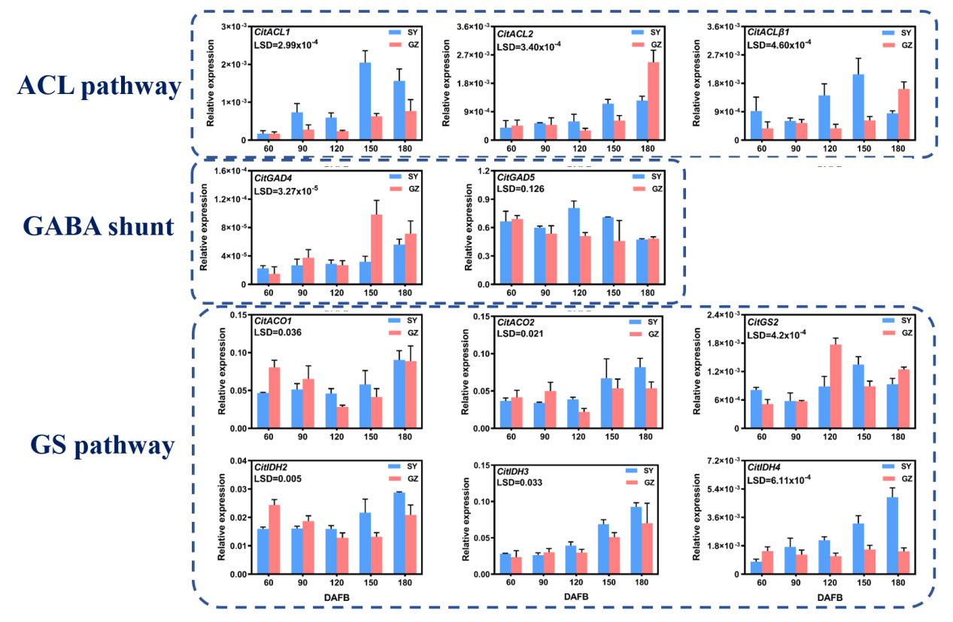
Fig. S1 Expression patterns of 10 citric acid degradation-related genes in 'SY' and 'GZ' fruits during developmental stages. Error bars represent the standard error (n = 3). LSD values were calculated at p = 0.05.

Fig. S2 Correlation analysis between citric acid content and gene expressions. CitACO3 (A), CitIDH1 (B), CitGS1 (C), and CitGATA7 (D). Statistical significance was determined by two-tailed test (*p < 0.05, **p < 0.01, ***p < 0.001).

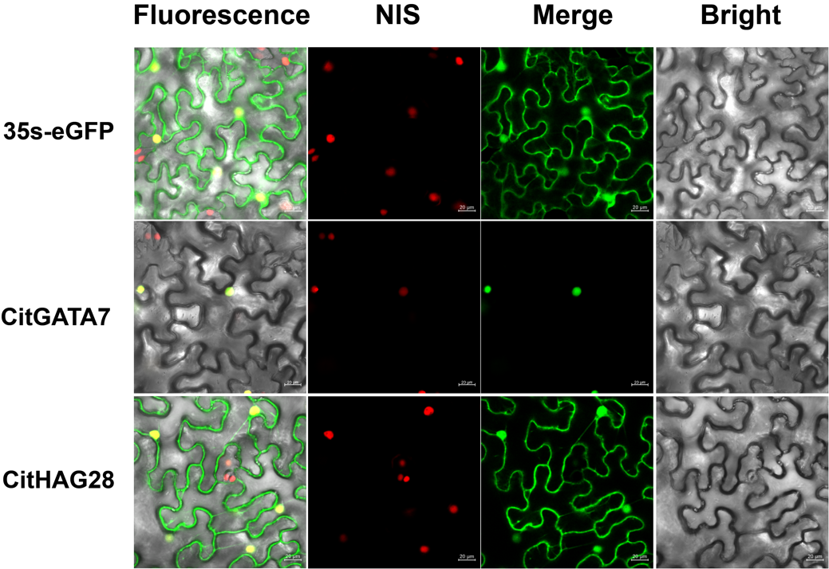
Fig. S3 Subcellular localization analysis of CitGATA7 and CitHAG28 in transgenic Nicotiana benthamiana leaves. 35s-eGFP serves as a positive control. Bar = 20 μm.
Fig. S4 GUS staining analysis in citrus callus of the control, CitGATA7-OE and CitHAG28-OE. The blue coloration indicates positive citrus callus successfully transformed with the pCAMBIA1301 vector.

Fig. S5 The level of H4ac around the promoter (P1) and near the TSS (P2) of CitACO3, CitIDH1, and CitGS1. (A) CitHAG28-OE citrus callus; (B) CitGATA7-OE citrus callus. Error bars indicate the standard error (SE) (n = 3).

