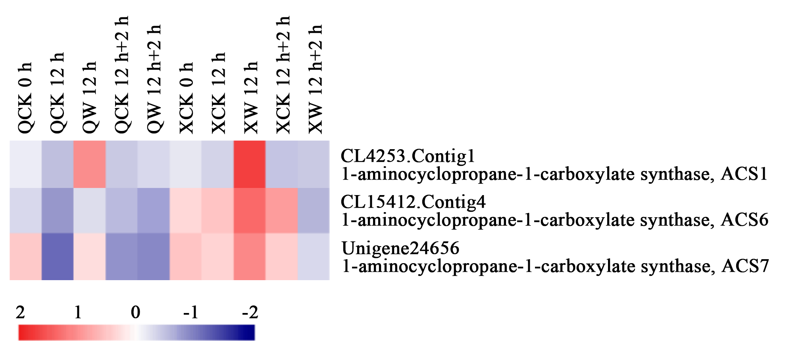
Figure S1 Heatmap analysis of DEGs in 'Qinglu' and 'Nannong Xuefeng' related to ACS genes (Zhao et al., 2018). The bar represents the scale of the expression levels of each gene (log₂FPKM, fragments per kilobase of transcript per million fragments mapped) in each sample, as indicated by red/blue rectangles. Red rectangles represent the high of genes expression, and blue rectangles represent low level of gene expression. Q: ‘Qinglu’; X: ‘Nannong Xuefeng’. CK: control; WL: waterlogging. W 12 h: waterlogging treat for 12 h; W 12 h+2 h: waterlogging 12 h followed by 2 h reoxygenation recovery.

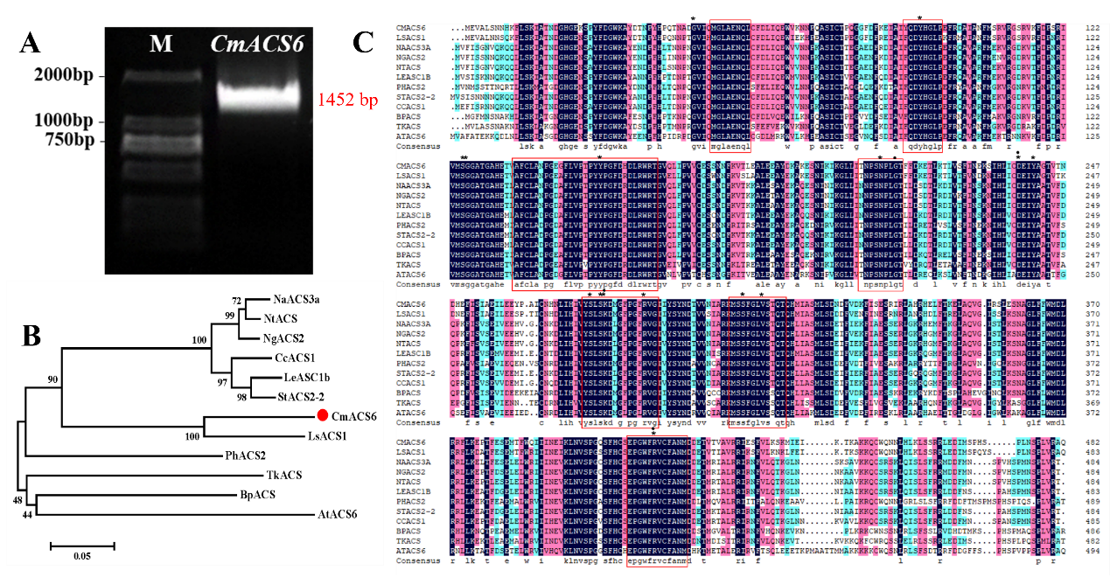
Figure S2 Cloning of CmACS6 and characterization of CmACS6 protein in chrysanthemum. A, DNA gel electrophoresis results of CmACS6 gene cloning. M: DL2000. B, Phylogenetic tree of CmACS6 and its homologs from various plant species. Note: LsACS1 (Lactuca sativa, AAP14019); NaACS3a (Nicotiana attenuate, AAR99392); NgACS2 (Nicotiana glutinosa, AAC83147); NtACS (Nicotiana tabacum, CAA06288); LeASC1b (Lycopersicon esculentum, AAB17279); PhACS2 (Pelargonium hortorum, AAB70885); StACS2-2 (Solanum tuberosum, WDV57381); Capsicum chinense CcACS1 (BAG30909); BpACS (Betula platyphylla, UVJ47666); TkACS (Trichosanthes kirilowii, ALR99803); AtACS6 (Arabidopsis thaliana, GAY39182). C, Multiple sequence alignment analysis of the amino acid sequences of CmACS6, LsACS1, NaACS3a, NgACS2, NtACS, LeACS1b, PhACS2, StACS2-2, CcACS1, BpACS, TkACS and AtACS6.

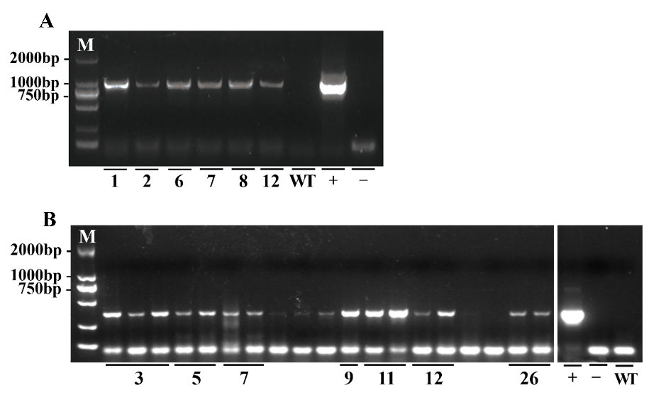
Figure S3 Identification of CmACS6 transgenic lines. A, CmACS6-like overexpression lines. B, CmACS6-like silensing lines. M: DL2000. Numbers represent different transgenic lines. +: Positive control; -: Negative control; WT: Wild-type ‘Jinba’.

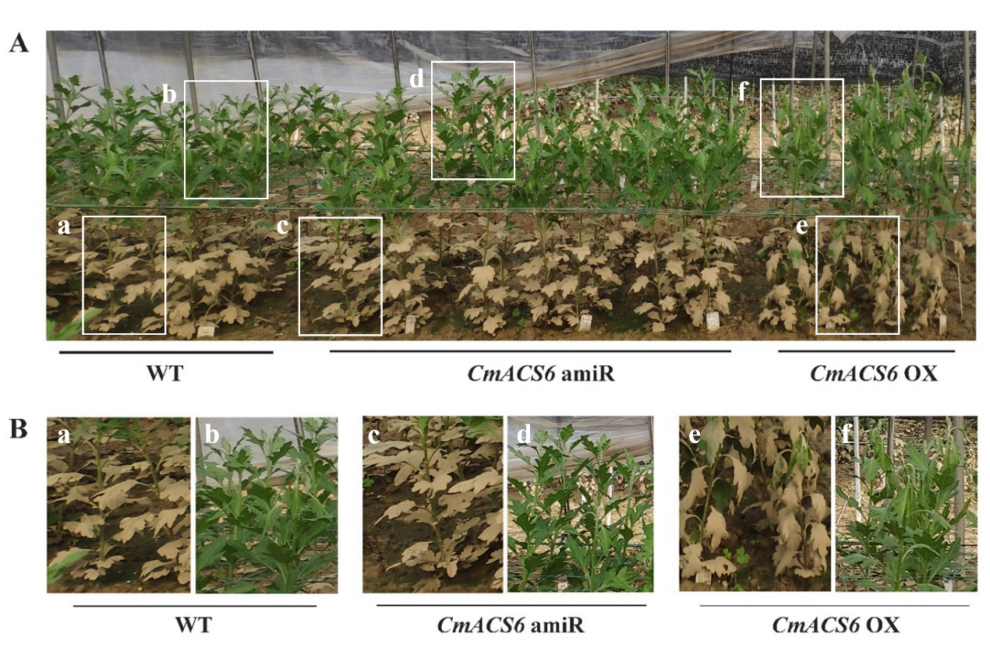
Figure S4 The performance of CmACS6 transgenic lines under inundation conditions. A, Phenotypes of CmACS6 transgenic lines in inundation. Bar: 10 cm. B, Local enlarged graph of figure A. Different lowercase letters indicate the different magnification areas. The yellow coloration of the lower middle portion of the plant leaves is a result of immersion in muddy water during water logging and is not due to waterlogging stress injury. WT: wild type; CmACS6 amiR: CmACS6 amiRNA lines; CmACS6 OX: CmACS6 overexpression lines.

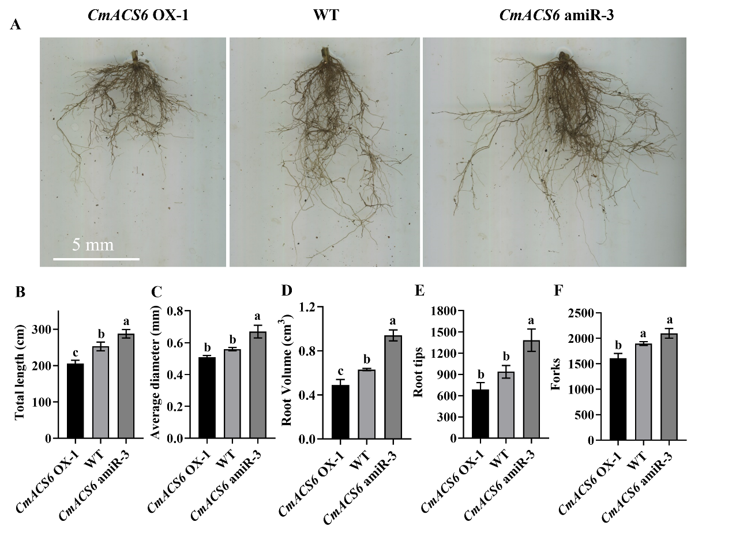
Figure S5 The root system of CmACS6 transgenic lines after waterlogging. A, Phenotypes of roots after waterlogging. Bar: 5 cm. B-F, Data analysis of root conditions after waterlogging. B, Total length of roots. C. Average diameter of roots. D. Root Volume. E, Numbers of root tips F, Numbers of root forks. WT: wild type; CmACS6 amiR: CmACS6 amiRNA lines; CmACS6 OX: CmACS6 overexpression lines. Error bars refer to standard deviation (SD, n = 3). Different lowercase letters indicate significant differences at P < 0.05 (ANOVA, Turkey’s correction).

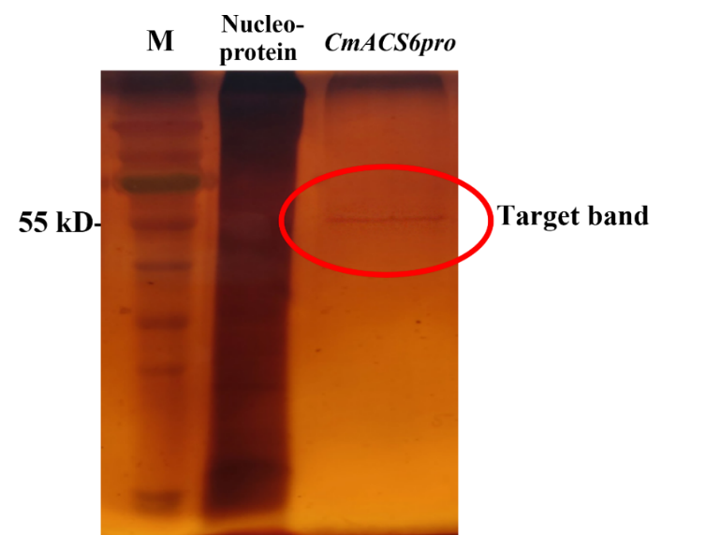
Figure S6 SDS-PAGE analysis of DNA affinity trapping. M: Marker；Nucleoprotein: Nucleoprotein；CmACS6pro: Cis-element 3 in CmACS6pro.

