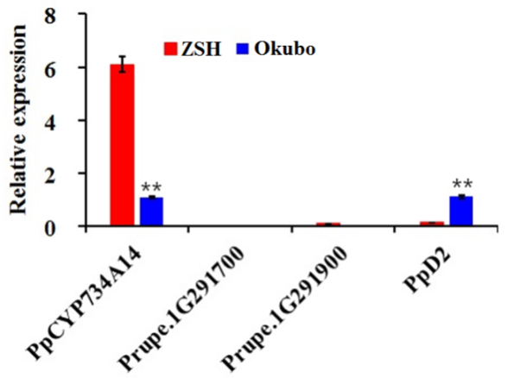
Fig. S1. Expression of BR-related genes in ZSH and Okubo targeted by DEMs.

