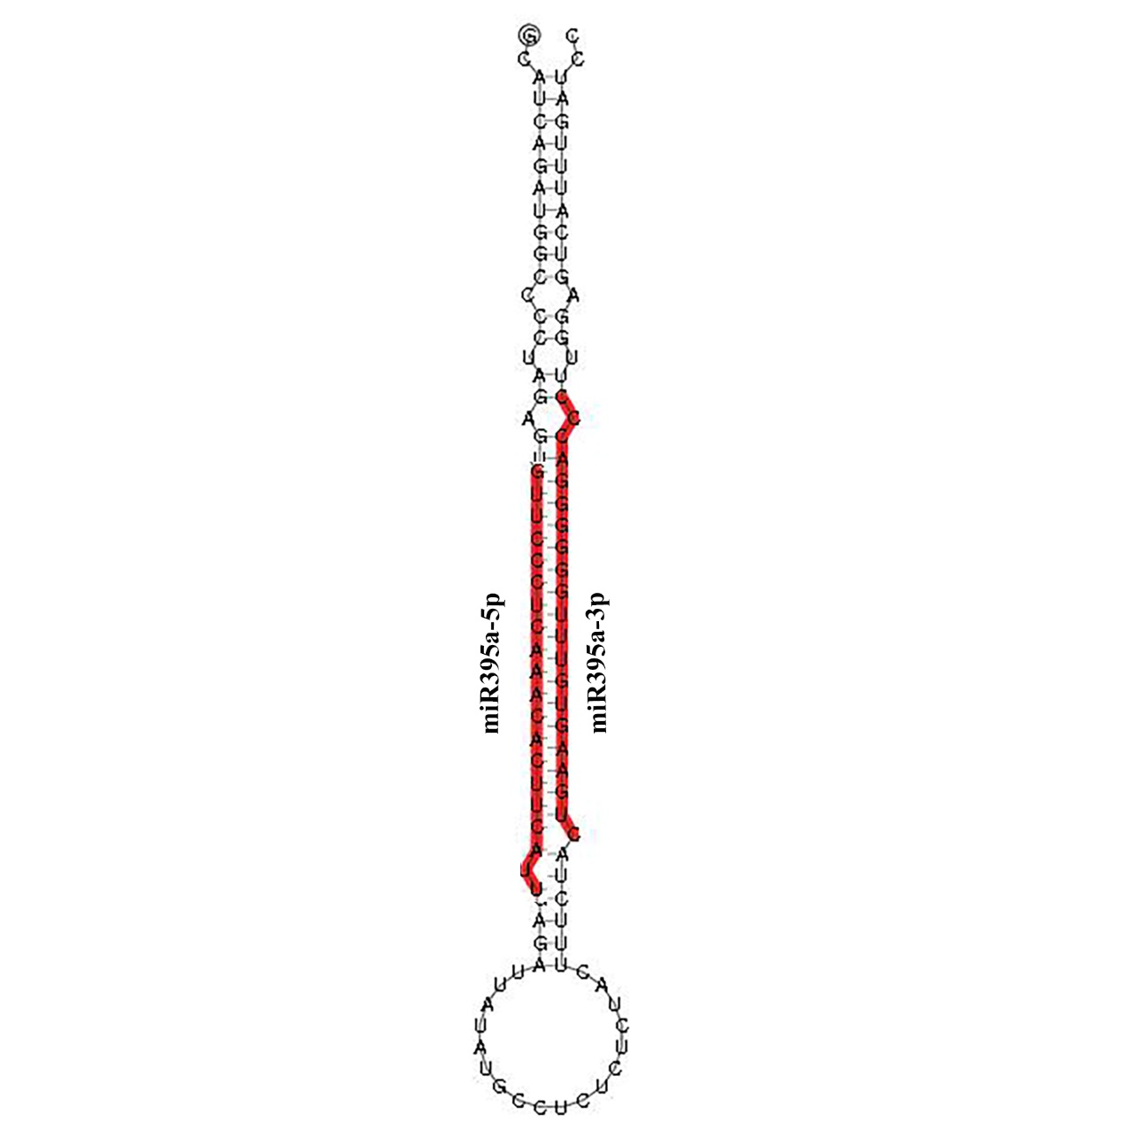
Fig. S2. The structure of pre-miR395a. The red highlighted sequence represent mature miR395a-3p and miR395a-5p generated from the 3'-arm and 5'-arm of pre-miR395a respectively.

