A negative feedback cascade controlling jasmonate-induced nicotine biosynthesis revealed by an in-plate nicotine assay
Qing Xu¹, Ke Xu¹, Haihui Cao¹, Yulong Gao², Peng Li³, Wenjing Wang¹, Yong Chen³, Michael P. Timko⁴, Zhongfeng Zhang¹, Bingwu Wang^{2,}*, and Hongbo Zhang^{1,}*
¹Key Laboratory of Synthetic Biology of Ministry of Agriculture and Rural Affairs, Tobacco Research Institute, Chinese Academy of Agricultural Sciences, Qingdao 266101, China;
²Yunnan Academy of Tobacco Agricultural Sciences, Kunming 650021, China;
³Beijing Life Science Academy (BLSA), Beijing 102209, China;
⁴Department of Biology, University of Virginia, Charlottesville, Virginia 22904, USA.

Author for correspondence:
Hongbo Zhang, PhD
Tobacco Research Institute, Chinese Academy of Agricultural Sciences, Qingdao 266101, China
Email: zhanghongbo@caas.cn
ORCID: 0000-0002-6072-9747

Bingwu Wang, PhD
Yunnan Academy of Tobacco Agricultural Sciences, Kunming 650021, China
Email: bwwang76@hotmail.com
ORCID: 0000-0002-2234-503X

SI-1 Supplementary materials and methods

Plant materials and growing conditions
Tobacco (Nicotiana tabacum L. cv TN90) was used for gene expression assays and transgenic plant development. Plants expressing HA-tagged NtMYC2a (NtMYC2a-OE) were generated as described previously. To construct NtODC1 and NtADC1 overexpression binary vectors, coding sequences of NtODC1 (GenBank Accession: NW_015934162) and NtADC1 (GenBank Accession: NM_001325624) were amplified and cloned into the pENTR-D-TOPO vector (Invitrogen, Carlsbad, USA). The resulting constructs were subsequently introduced into the binary vector pMDC-attR-Flag via Gateway recombination, yielding pMDC-NtODC1-Flag and pMDC-NtADC1-Flag. These vectors were introduced into TN90 tobacco via Agrobacterium-mediated transformation (Bian et al., 2022) to generate plants overexpressing NtODC1-Flag (NtODC1-OE) and NtADC1-Flag (NtADC1-OE), respectively. These lines were crossed with NtMYC2a-OE plants to obtain hybrids co-expressing NtMYC2a with either NtODC1 or NtADC1. Primers used for cloning are listed in Table S1. Tobacco plants transformed with empty vector were used as control.
For the in-plate nicotine production assay (IPNPA), tobacco seeds were surface-sterilized with 5% bleach containing 0.1% Tween 20, germinated on MS medium containing Kanamycin (for NtMYC2a-OE plants), Hygromycin (for NtODC1/NtADC1-OE plants), or both antibiotics (for hybrids) at 23 °C under a 14-h-light/10-h-dark photoperiod for 14 days. Then, the antibiotic resistant plants were transferred onto MS medium plates containing 60 mM N (N-normal) or 120 mM N (N-rich), supplemented with 0 µM (mock) or 3 µM MeJA (treatment), and cultured for an additional 15 days. NH₄NO₃ was selected for N supplementation for it is a common inorganic nitrogen for MS medium and provides both ammonium (NH₄⁺) and nitrate (NO₃⁻). Tissues above the cotyledons (including cotyledons and aerial parts) were collected for nicotine measurement, while tissues below the cotyledons (hypocotyl and roots) were harvested for gene expression analysis at designated time points. For topping treatment, tobacco plants were pot-grown for 16 weeks until flowering. Middle internodal leaves were collected before and after topping for nicotine extraction and quantification.

Nicotine measurement
Nicotine content was measured as described previously with minor modifications (Zhang et al., 2012). Briefly, dried leaf samples were ground to a fine powder, and 0.1 g was alkalized with 1 mL of 10% (w/v) NaOH and extracted with 5 mL ethyl acetate for 2 min with shaking. Nicotine was quantified using an Agilent 7890A gas chromatograph equipped with a DB-5MS column. A nicotine standard (Sigma-Aldrich) was used for calibration.

RNA extraction and qRT-PCR
Total RNA was extracted using TRIzol reagent (Invitrogen, Carlsbad, USA) and reverse-transcribed into cDNA using the PrimeScript First-Strand cDNA Synthesis Kit (TaKaRa, Japan). qRT-PCR was performed on a QuantStudio 5 Real-Time PCR System (Thermo Fisher Scientific, Waltham, USA) with ChamQ Universal SYBR qPCR Master Mix (Vazyme, Nanjing, China). Primers were designed from conserved regions of target genes (Table S1). NtActin was used as the internal reference (Zhang et al., 2012). Five biological replicates were analyzed for each gene.

Electrophoretic mobility shift assay
The coding sequence of NtMYC2a was amplified and cloned into the pET28b vector (Novagen, Madison, USA) via Nco I and Xho I sites for expression of His-tagged protein in E. coli BL21. DIG-labeled double-stranded probes containing G-box elements from the NtODC1 and NtADC1 promoters were synthesized by Sangon Biotech (Shanghai, China). EMSA was performed as described (Bian et al., 2022), and signals were detected using the DIG High Prime DNA Labeling and Detection Starter Kit (Roche). Probe sequences are listed in Table S1.

Transactivation assay
Transactivation assays were performed as described (Bian et al., 2022). Truncated promoter fragments of NtODC1 (–1374, –990, and –850 bp) and NtADC1 (–1994, –1550, –1341, and –1042 bp) were cloned into the pBT10-GUS vector and introduced into A. tumefaciens LBA4404. Twenty-day-old control and NtMYC2a-OE seedlings were infected with reporter-containing Agrobacteria and co-cultivated on MS medium with 100 µM acetosyringone for 2 days in darkness, then transferred to medium containing 250 mg/L cefotaxime for 3 days. GUS staining and activity assays were performed as described (Bian et al., 2022). GUS activity was quantified using a 4-methylumbelliferone (MU) standard and expressed as pmol MU/min/mg protein. Primers for promoter amplification are listed in Table S1.

ChIP assay
ChIP (chromatin immunoprecipitation) was performed as described (Bian et al., 2022). Briefly, 1 g of leaves from 4-week-old seedlings was cross-linked in 20 mL 1×PBS buffer containing 1% formaldehyde (v/v) for 15 min under vacuum, quenched with glycine at concentration of 0.125 M, and ground into a powder in liquid nitrogen after three time washing with 1×PBS buffer. Chromatin was sheared by ultrasonication sonicated and immunoprecipitated with anti-HA antibody (Roche, Mannheim, Germany) and ssDNA/protein G agarose. Precipitated DNA was quantified by qPCR with primers flanking G-box regions, and NtActin was used as the internal control. Primers are listed in Table S1.

Statistical analysis
Statistical analysis was performed using Microsoft Excel based on the data of five biological replicates for each assay. Statistically significant differences were assessed by one- or two-way ANOVA followed by Tukey’s test or Student’s t-test as indicated. Data are presented as mean ± SD.

SI-2 Supplementary figures
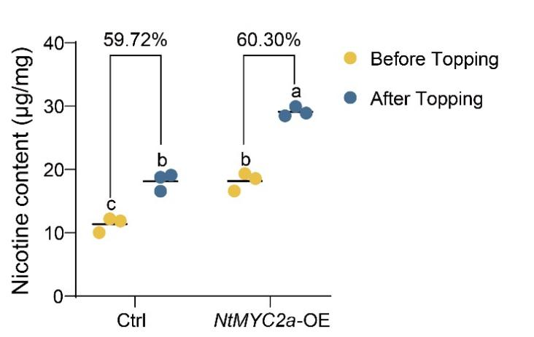
Figure S1 Nicotine content of control (Ctrl) and NtMYC2a-OE plants before and after topping. Plants were cultured with 75kg N per acre. The topping-induced nicotine increase is indicated by percentage. Presented data for each genotype are from three independent lines. Lowercase letters indicate significant differences (Tukey's test, P < 0.05).
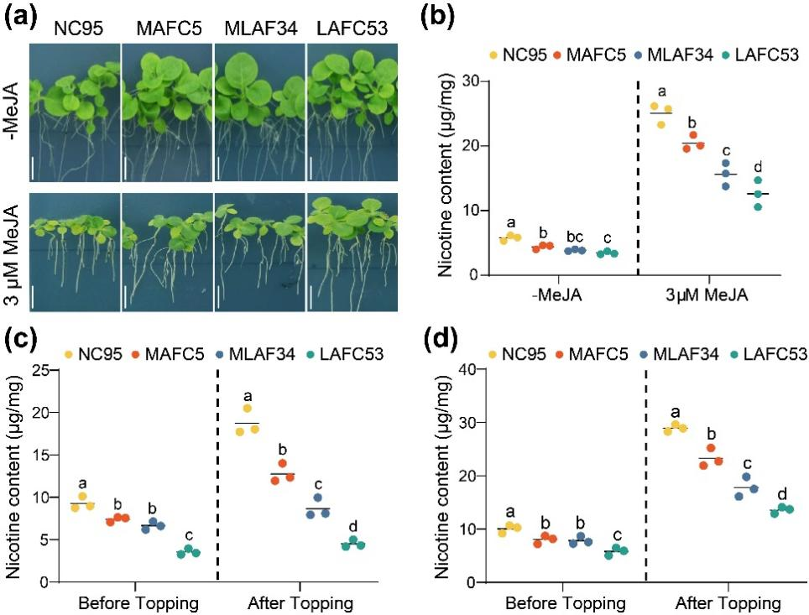
Figure S2 Nicotine contents of in-plate and field cultured nic mutants. (a) In-plate cultured nic mutants without (Mock) or with MeJA treatment. Bar represents 0.5 cm. (b) Nicotine contents of in-plate cultured nic mutants without (Mock) or with MeJA treatment. (c) Nicotine contents of field cultured nic mutants with 75kg N per acre. (d) Nicotine contents of field cultured nic mutants with 150kg N per acre. Field experiments were performed at Qingdao, China. NC95, wild type; MAFC5, Nic1nic2; MLAF34, nic1Nic2; LAFC53, nic1nic2. Lowercase letters indicate significant differences (Tukey's test, P < 0.05).
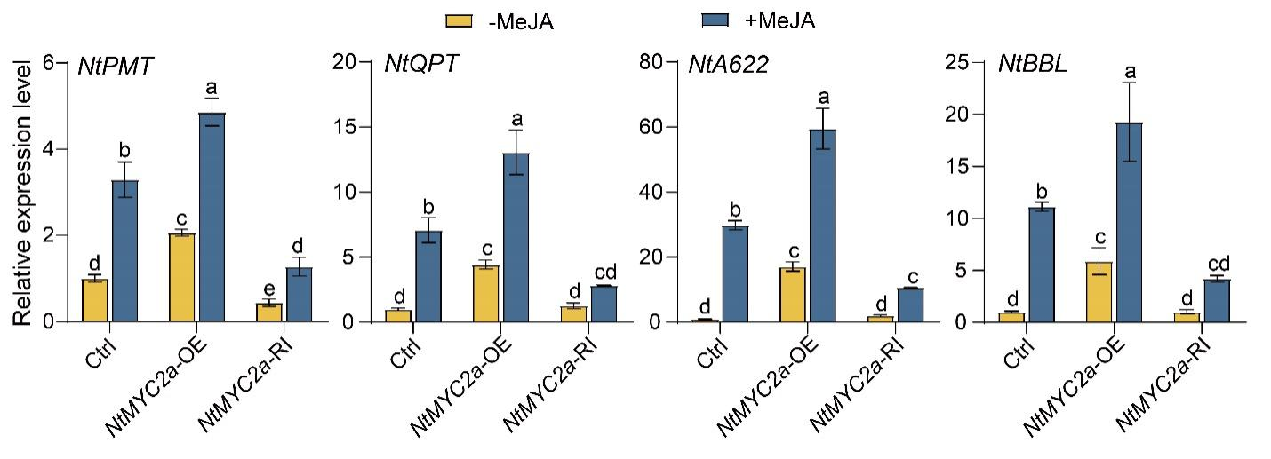
Figure S3 Relative expression of nicotine biosynthetic genes in Ctrl (empty vector transformed), NtMYC2a-OE and NtMYC2a-RI plants. Expression in Ctrl plants without MeJA was set to 1. −MeJA, untreated; +MeJA, MeJA-treated. Presented data for each genotype are from three independent lines. Lowercase letters indicate significant differences (Tukey’s test, P < 0.05).
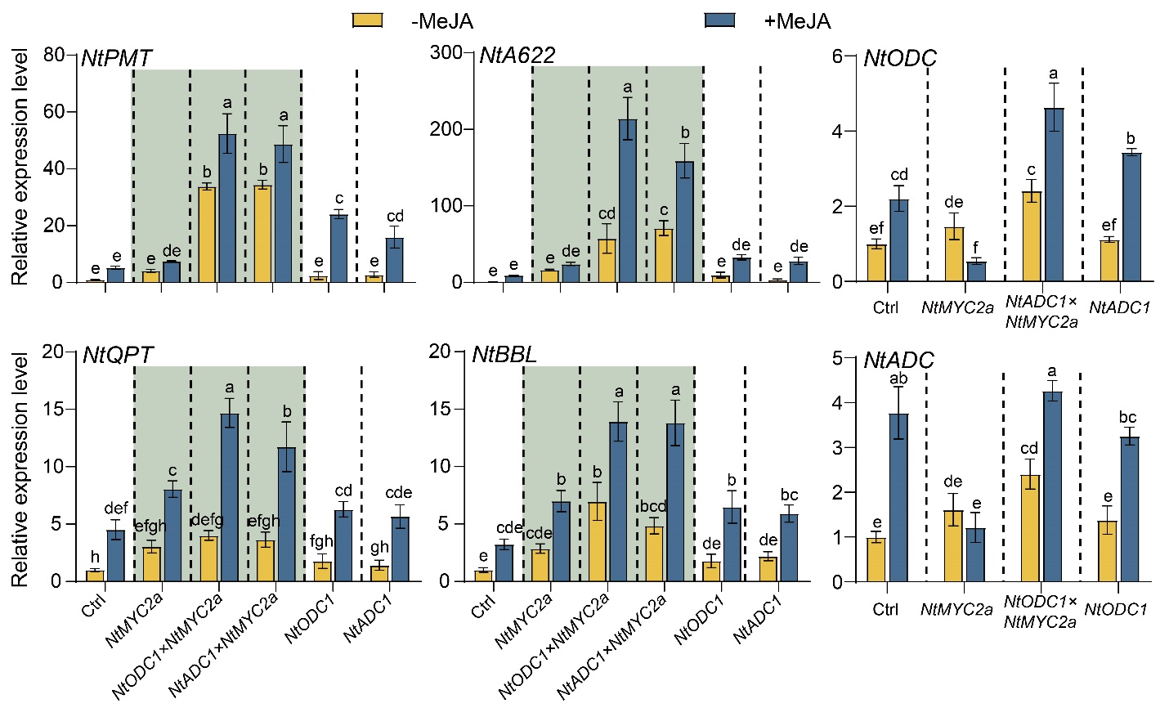
Figure S4 Relative expression of nicotine biosynthetic genes in plants under N-normal condition. Expression in Ctrl plants without MeJA was set to 1. −MeJA, untreated; +MeJA, MeJA-treated. Presented data for each genotype are from three independent lines. Lowercase letters indicate significant differences (Tukey’s test, P < 0.05).
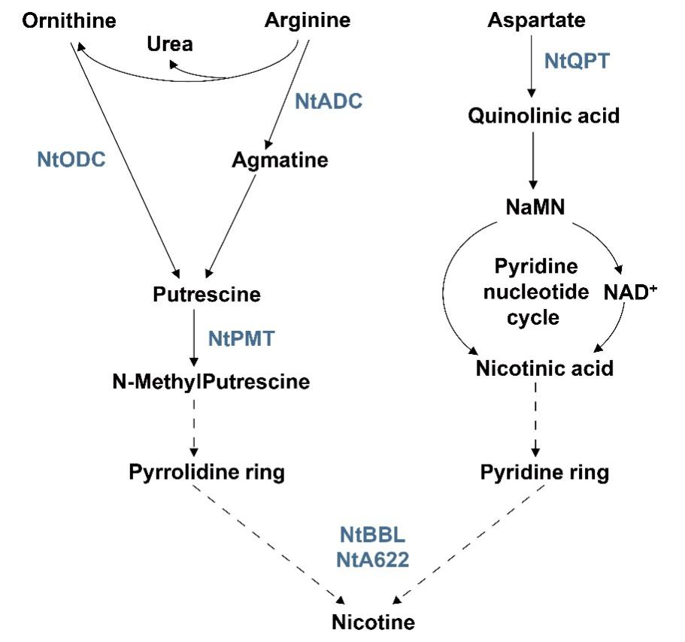
Figure S5 Schematic diagram of the nicotine biosynthetic pathway. Key enzymes of the pathway are highlighted in blue color. NtODC, ornithine decarboxylase; NtADC, arginine decarboxylase; NtPMT, putrescine methyltransferase; NtQPT, quinolinic acid phosphoribosyltransferase; NtBBL, berberine bridge enzyme-like; NtA622, PIP-family oxidoreductase.

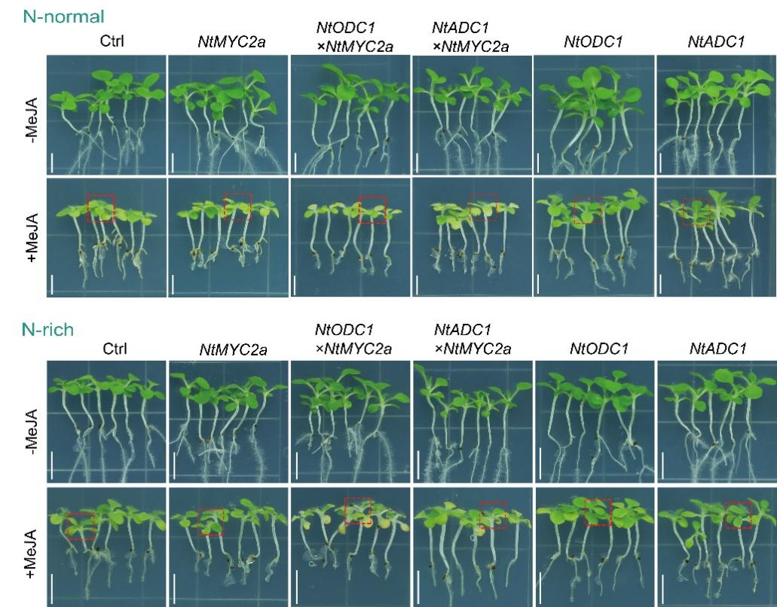
Figure S6 Representative phenotype of in-plate-cultured tobacco plants under N-normal and N-rich conditions. Ctrl, empty vector transformed. Areas in red rectangles are shown in Figure 1e with magnification. Bar = 0.5 cm.
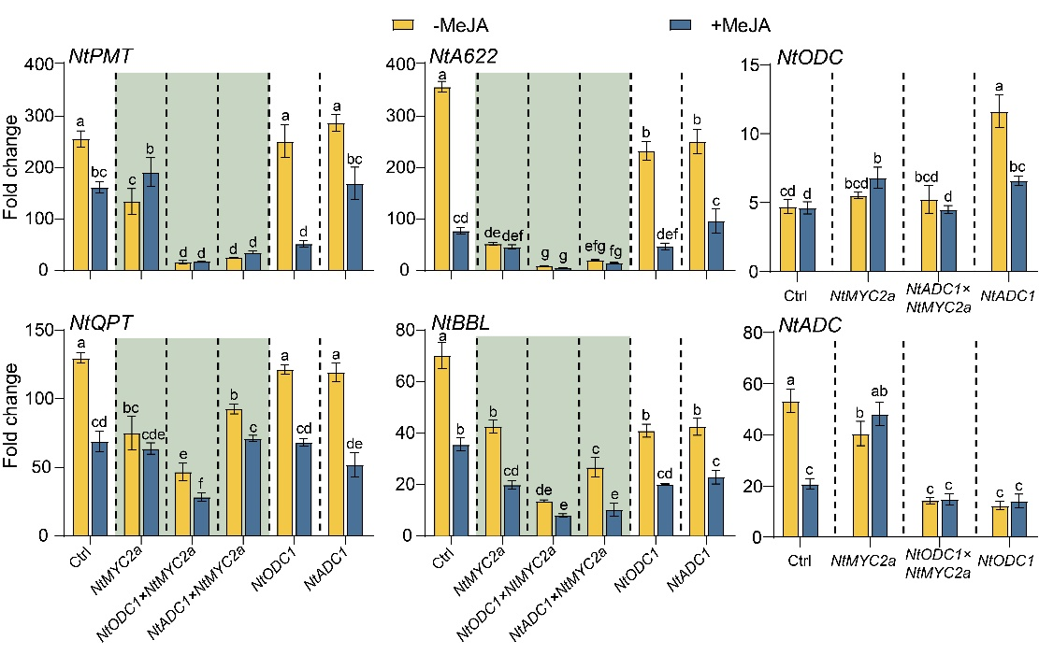
Figure S7 Fold change of nitrogen-enhanced expression of nicotine biosynthetic genes. Values are calculated by comparing the relative gene expression in plants under N-rich condition with that under N-normal condition. −MeJA, untreated; +MeJA, MeJA-treated. Presented data for each genotype are from three independent lines. Lowercase letters indicate significant differences (Tukey’s test, P < 0.05).
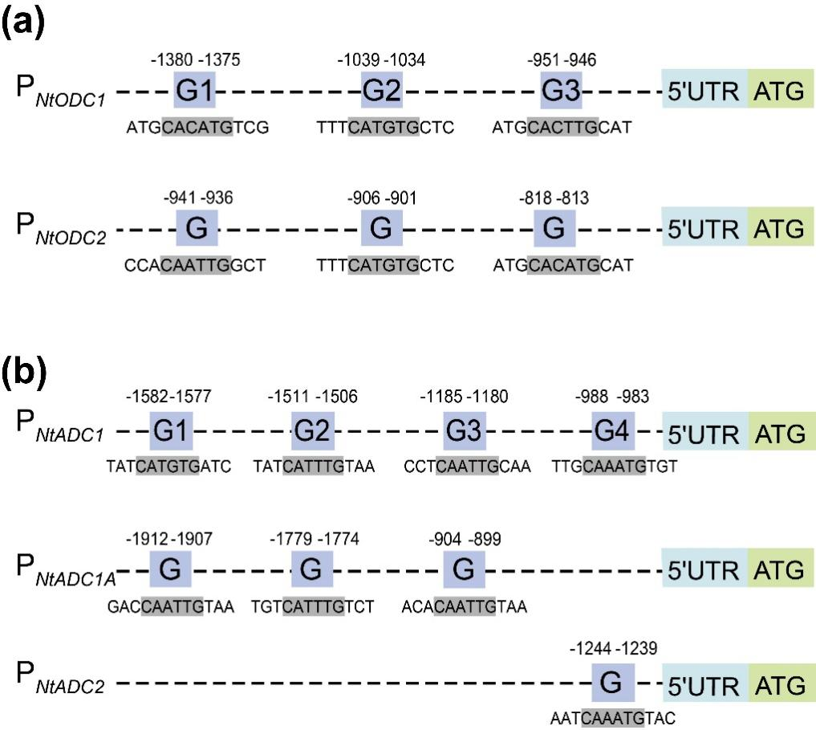
Figure S8 Analysis of G-boxes in the promoters of NtODC (a) and NtADC (b) homologues. G-boxes (gray colored) and the flanking sequences are shown, and the positions of G-boxes in promoters are indicated. Gene accessions at NCBI GenBank are as followings: NtODC1 (Gene ID: 107801491), NtODC2 (LOC107815922), NtADC1 (LOC107796783), NtADC1A (Gene ID: 107774919), and NtADC2 (LOC107767963).

SI-3 Supplementary tables
Table S1 Primers used for gene cloning and qRT-PCR.
Primers for gene cloning
NtODC1 | AAAGGCGCGCCATGGCCGGCCAAACAA  AAAGCGGCCGCGCTTGGATAAGCATA
NtADC1 | AAAGGCGCGCCATGCCGGCCCTAGGTT  AAACCGCGGAGCAGTGCAATAGGACC
NtMYC2a | TAAGAAGGAGATATACCATGGATGACTGATTACAGCTTACCCACCA  GTGGTGGTGGTGGTGCTCGAGGCGTGTTTCAGCAACTCTGGA
Primers for qRT-PCR
NtODC | ACCCGAAATCCGAACTCTTGCTC  CCGCTGCCGATGTGGAAGG
NtADC | CTCGGCTATGCCTTCTCTCG  AGATCCGGAGACCCAATGGA
NtPMT | TGGGAAGGTTCTGACTTTGGATGG  ACCAATTCCTCCGCCGATGATC
NtQPT | AAGCCACCAGCACACCCAAC  TCGTCGCCTTACAAGTCACATCTC
NtBBL | TGCTGCTGATAATGTCGTTGATGC  CCGCCGCCACCTCTGATTG
NtA662 | GCTGCATCACTCTTCGCTCTAAAG  TTTGTCTCTAGGAGGGGTTTTGGC
NtActin | CCACACAGGTGTGATGGTTG  GTGGCTAACACCATCACCAG
Nucleotide sequences of EMSA probes (One strand shown for each, bases of complementary replacement are underlined)
PrODC1-G1 | CAAATCTAGGATTCTATATATGCACATGTCGAAACTTTAAATATTTAAT
PrODC1-G2 | TTCCCTAAGATCCACATTTTTCATGTGCTCTTTTCTTTCTTTATCCCG
PrODC1-G3 | GGCTAAGCAAAACAAATCATGCACTTGCATCTCTATTTTAGTATGAGT
PrODC1-mG1 | CAAATCTAGGATTCTATATATGATAGCCTCGAAACTTTAAATATTTAAT
PrODC1-mG2 | TTCCCTAAGATCCACATTTTTTCGTGACTCTTTTCTTTCTTTATCCCG
PrODC1-mG3 | GGCTAAGCAAAACAAATCATGTCAGCTCATCTCTATTTTAGTATGAGT
PrADC1-G1 | AAAACTAATTAATTAATCTATCATGTGATCCCCACTATGTATTTTTAA
PrADC1-G2 | CACTATATTAAGAGTGGTTATCATTTGTAATGGAGAGACATACACACA
PrADC1-G3 | TACATAGCACAATAGCACCCTCAATTGCAAAAGTCCAAAGCCAAGGGT
PrADC1-G4 | TGTTTATACTCAATTTTTTTGCAAATGTGTCTAAAATGATAGGACTTG
PrADC1-mG1 | AAAACTAATTAATTAATCTATTCGTGAATCCCCACTATGTATTTTTAA
PrADC1-mG2 | CACTATATTAAGAGTGGTTATTTACGTTAATGGAGAGACATACACACA
PrADC1-mG3 | TACATAGCACAATAGCACCCTATCTGACAAAAGTCCAAAGCCAAGGGT
PrADC1-mG4 | TGTTTATACTCAATTTTTTTGACGTAATGTCTAAAATGATAGGACTTG
Primers for GUS
NtODC1-P1-F | TCCCCGCGGGGATCCTGACGCAGTATGGGTGTGTAT
NtODC1-P2-F | TCCCCGCGGGGAGGTATATGCTTTGTTCTGAGATGC
NtODC1-P3-F | TCCCCGCGGGGACCGAGATTTGAAAATAAAATAAAT
NtODC1-R | CCAAACAAAGGAAGAAAACAGAGA
NtADC1-P1-F | TCCCCGCGGGGACGGAAATTCATATCGTTTCTC
NtADC1-P2-F | TCCCCGCGGGGACTCAAAATGGGATTCCCCCAC
NtADC1-P3-F | TCCCCGCGGGGAGGGTTGCATTCATTTCTTTTA
NtADC1-P4-F | TCCCCGCGGGGACCTCGCATAGATTTACCTTCT
NtADC1-R | CTCTTCTTCTTCTGTTAAAGAATC
Primers for ChIP-qPCR
NtODC1-G1 | CGCGGCCATAAATATGTTAGCA
NtODC1-G1 | TCGTCGTTTTACAATAAACTCAAGT
NtODC1-G2 | AGTTGGCTGTCCTTTCCCTA
NtODC1-G2 | GCTTAGCCAGCCTCTTTCTCT
NtODC1-G3 | TTAGAGAAAGAGGCTGGCTAAG
NtODC1-G3 | TCTCTGATTAAAGGCGAGAACATTT
NtADC1-G1+G2 | TGCGGAAATCACGACTTGAA
NtADC1-G1+G2 | TGAATGTGTGTATGTCTCTCCAT
NtADC1-G3 | ACCACGTATTTTTAGAACTGCGT
NtADC1-G3 | GGAACCCTTGGCTTTGGACT
NtADC1-G4 | ACTGAAGAACAATAGCCTCGCA
NtADC1-G4 | TTTGCAAGTCCTATCATTTTAGACA
NtActin | CCACACAGGTGTGATGGTTG
NtActin | GTGGCTAACACCATCACCAG

