Supplementary Material
Table.1 Some examples of structural instability caused by collapsible soils.
Earthwork | Location | Description | Reference
Earth dam | Idaho, USA | Collapse of Teton dam resulting from a permeable loess used in the core. | Smalley (1971)
Highway embankments | South Africa | Deformation, cracking and failure of highway embankments resulting from wetting-induced collapsing. | Booth (1977)
Compacted fill in a canyon | Southern California | Failure of buildings constructed on compacted fill. | Lawton et al. (1992)
Airport Runways | Heathrow, UK | Evidence provided for a calcareous Aeolian loess layer (Langley silt) near the Heathrow airport. | Rose et al. 2000 and Jefferson et al. 2003, in Langroudi (2014)
Buildings and pavements | New Mexico | Damage caused by differential settlement of a commercial building due to watering nearby landscape. | Houston et al (2001)
Road Embankment | Near Pentalia, southwest Cyprus | Road embankment failure resulting from inundation/sliding of calcareous subgrade. | Hadjigeorgiou et al. (2006)
Industrial installations | Kazakhstan | Occurrence of calcareous loess deposits in Northwest Kazakhstan, South of the River Ural, Karachaganak gas field. | Roohnavaz et al. 2011, in Langroudi (2014)
Houses, Factory, Estates, General Hospital, and Clifford’s Tower | Ilkston, West Aukland, Brighton, North Tyneside, and York, respectively (in the UK) | Founded on different kinds of non-engineered fills mainly opencast coal mining backfills, which collapsed following flooding after many years of placement. | Watts and Charles (2015)

Microstructure of collapsible soils
A modelled collapsible structure is shown as Figure 1. In spite of the general belief that suction, clay, CaCO₃ and other salts provide support for the open structure of collapsible soils, some collapsing soils have been reported to gain support by grain mineral-to-mineral contact (see Figure 2) where platy grains predominate and clay-size grains are widely scattered (Derbyshire and Mellors, 1988).

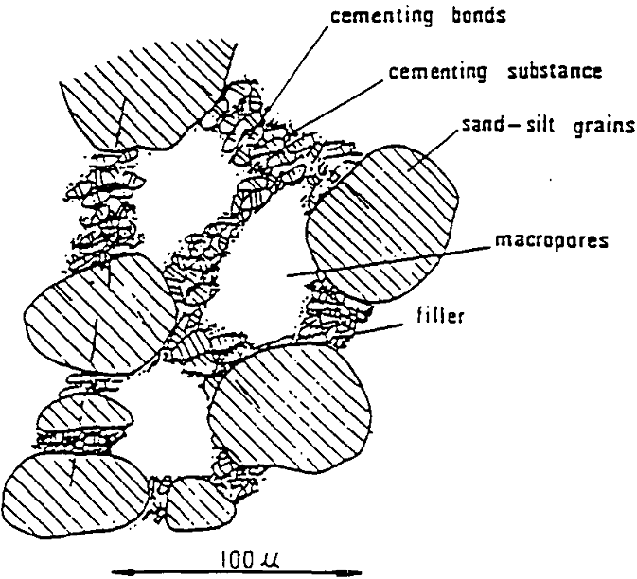
Figure 1 Microstructure model of a collapsible loess deposit as suggested by Tan 1988 (after Assallay (1998))

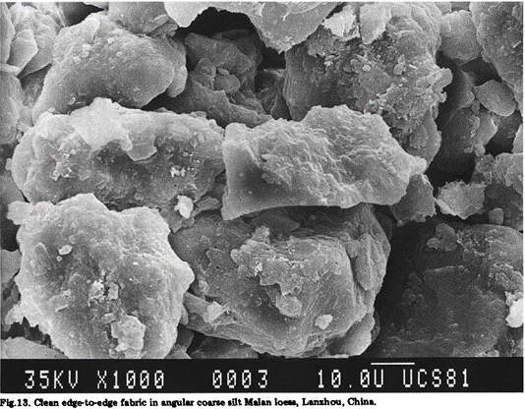
Figure 2 Clean edge-to-edge fabric in angular coarse silt Malan loess (Derbyshire and Mellors, 1988)

The understanding of the open flocculated structure of soils compacted dry of optimum has contributed to the understanding of soil collapsibility from a microstructural perspective. Scholars have adopted recent advances in techniques like X-ray diffraction, scanning electron microscope (SEM), and mercury intrusion porosimetry (MIP) to study the microstructure of collapsible soils, and its effect on the mechanical behaviour of such soils and found the techniques useful (Li et al., 2016).
According to Li et al. (2016), the literature reports image processing programs developed for extracting from digital images, information relating to soil grains and pores as follows: the Scion (Fang et al., 2013a, b); Videolab (Shi et al., 1995); Mirage (Sha and Chen, 2006; Chen and Sha, 2009a, b); MATLAB (Wang et al., 2011; Mao et al., 2004) and Photoshop (Zhang et al., 2009). These techniques and programs provide strong support for understanding collapse from microstructure information. Commonly used of these techniques are SEM (for acquiring digital images) and MIP (for studying porosity) (Al-Mukhtar et al., 1996; Simms and Yanful, 2001, 2002; Romero and Simms, 2008 cited in Li et al. (2016)).

2. Types of bonding in collapsible soils (loess) and structural bond transformation
Natural loess soils predominate the study of collapsible soils. However, the collapse mechanisms for natural (both loess and others) and artificial collapse soils are similar. It is possible that the proposed (Yang, 1989 in El Howayek et al. (2011) and Osipov and Sokolov (1995)) loess bond types (Table 2 and Table 3 and Figure 3) could provide a general understanding for other collapsible soils. Loess bonding can be of various types. The proposal according to Yang 1989 (Table 2), recognises two types of bonds: hydro-stable bonding and hydro-labile bonding. Hydro-stable bonding is where the bonding strength does not apparently decrease with water while hydro-labile bonding is easily broken down in contact with water.
Osipov and Sokolov (1995), on the other hand, identified four different bonding elements with varying bonding strength, as summarized in Table 3. The weakest being identified as that provided by molecular force. It decreases with increasing water saturation. Bonding by capillary force and ionic-electrostatic force are of similar magnitude, nevertheless, capillary forces only exist at degrees of saturation between 0.35 and 0.80 while ionic-electrostatic force is unstable in the presence of water. The strongest bonding strength can be created by cementation bridges resulting from chemical materials like salts (e.g., CaCO₃), aluminium and sesquioxides of irons. The water resistance of the bonding forces depends on the types of chemical materials. The transformation of structural bonds in loess under varying degrees of water saturation is presented in Figure 3.

Table 2 Classification of loess bonding types by Yang 1989 (adapted from El Howayek et al. (2011))
Hydro-stable bonding | Hydro-labile bonding
Calcium carbonate  Hydrous calcium sulfate  Ferrous oxide and ferrous hydroxides  Hydro-stable secondary mica  Secondary zeolite | Strongly soluble salts  Clay cementing agent  Flocculant  Non-flocculant  Hydro-labile secondary mica

Table 3 classification of structural bonds in loess (adapted from Osipov and Sokolov (1995).
Forces | Strength of contact between two particles, N | Resistance to water
Molecular  Capillary  Ionic-electrostatic  Chemical | 5 x 10⁻¹⁰ to 10⁻⁸  6 x 10⁻⁸ to 10⁻⁷  5 x 10⁻⁸ to 4 x 10⁻⁷  5 x 10⁻⁷ to 5 x 10⁻⁶ | Gradually decrease with increase of water saturation  Only exists at degree of saturation between 0.35 – 0.8  Unstable  Unstable, stable

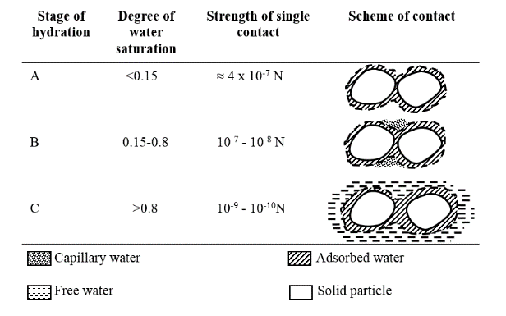
Figure 3 Structural bonds transformation in loess under water saturation (redrawn after Osipov and Sokolov (1995)).

Osipov and Sokolov (1995), and Klukanova and Frankovska (1995) described two very similar sequences of collapse following wetting. This can be better appreciated if put side by side as in Table 4 below. Seven stages were involved according to Osipov and Sokolov, but six stages according to Klukanova and Frankovska.
Table 4 reveals that collapse process is both chemically and mechanically driven, depending on soil mineralogy and perhaps the nature of wetting fluid. Nevertheless, over the years the collapse phenomenon has been exclusively described on the bases of soil mechanics principles; and basic systems (e.g. USCS) for geotechnical characterisation of soils have not considered dissolvable components (e.g. CaCO₃) of soils (Sterianos (1988); Lamas et al. (2002)). Thus, almost ignoring the chemical behaviour of the soil.
Table 4 Comparison of collapse sequences according to Osipov and Sokolov (1995), and Klukanova and Frankovska (1995).
Stage | Osipov and Sokolov (1995) | Klukanova and Frankovska (1995
1 | Formation of hydrated films of adsorbed water and subsequent increase in inter-particle distance | Disintegration of clay coating units, connectors, and aggregates
2 | Destruction of less water-resistant aggregates | Dissolution and migration of carbonates within the pore network
3 | Destruction of most tubular micropores (small to medium) | Migration of clay
4 | Disappearance of capillary forces | Reduction in carbonate content
5 | Structural collapse | Further compression of soil
6 | Consolidation | Formation of new microfabric of novel basic relations in which clay aggregates and matrix units replace the coating and connector units
7 | Formation of new contacts

Considering the arguments around the mechanism of collapse in collapsible soils as related to their inter-particle bonding element, one key aspect not fully considered in the literature is the rate at which collapse may occur. This factor is a function of type and form of bonding element, the chemistry of wetting fluid and the rate of wetting. CaCO₃ bonding for instance, can exist as three different polymorphs (calcite, aragonite or vaterite) with different solubility. Therefore, considering these as individual bonding elements in relation to the chemistry of wetting fluid will enhance the understanding of their impact on collapsibility.

References
Assallay, A.M. (1998) Structure and hydrocollapse behaviour of loess. Doctoral dissertation, Loughborough University.
Booth, A.R. (1977) 'Collapse settlement in compacted soils'. CSIR Research Report 324, National Institute for Transport and Road Research 13, pp. 1 – 34.
Derbyshire, E. and Mellors, T.W. (1988) 'Geological and geotechnical characteristics of some loess and loessic soils from China and Britain: a comparison', Engineering Geology, 25(2-4), pp. 135-175.
El Howayek, A., Huang, P.-T., Bisnett, R. and Santagata, M.C. (2011) 'Identification and behavior of collapsible soils'. Joint Transportation Research Program Technical Rep. Series Rep. SPR-3109, Indiana Dept. of Transportation and Purdue Univ., West Lafayette, IN.
Hadjigeorgiou, J., Kyriakou, E. and Papanastasiou, P. (2006) A road embankment failure near Pentalia in southwest Cyprus. In International conference on the stability of Rock Slopes in open pit mining and civil engineering. S44. The South African Institute of Mining and Metallurgy, Cape Town, pp. 343–352.
Houston, S., Houston, W., Zapata, C. and Lawrence, C. (2001) 'Geotechnical engineering practice for collapsible soils', Geotechnical & Geological Engineering, 19(3-4), pp. 333-355.
Klukanova, A. and Frankovska, J. (1995) 'The Slovak Carpathians loess sediments, their fabric and properties', in Genesis and Properties of Collapsible Soils. Springer, pp. 129-147.
Lamas, F., Irigaray, C. and Chacón, J. (2002) 'Geotechnical characterization of carbonate marls for the construction of impermeable dam cores', Engineering Geology, 66(3–4), pp. 283-294.
Langroudi, A.A. (2014) Micromechanics of collapse in loess. University of Birmingham.
Lawton, E.C., Fragaszy, R.J. and Hetherington, M.D. (1992) 'Review of wetting-induced collapse in compacted soil', Journal of geotechnical engineering, 118(9), pp. 1376-1394.
Li, P., Vanapalli, S. and Li, T. (2016) 'Review of collapse triggering mechanism of collapsible soils due to wetting', Journal of Rock Mechanics and Geotechnical Engineering, 8(2), pp. 256-274.
Osipov, V.I. and Sokolov, V.N. (1995) 'Factors and Mechanism of Loess Collapsibility', in
Derbyshire, E., Dijkstra, T. and Smalley, I.J. (eds.) Genesis and Properties of Collapsible Soils. Dordrecht: Springer Netherlands, pp. 49-63.
Smalley, I.J. (1971) '“In-situ” theories of loess formation and the significance of the calcium-carbonate content of loess', Earth-Science Reviews, 7(2), pp. 67-85.
Sterianos, B. (1988) Geotechnical properties of carbonate soils with reference to an improved engineering classification. University of Cape Town.
Watts, K. and Charles, J.A. (2015) Building on fill: geotechnical aspects. IHS BRE Press.

