Additional file 1
In Additional file 1, the outputs of the proposed slab track design model performed by the author for the critical load cases (AREMA -A2- and EN -E2-) applied on the most common slab track systems are illustrated.
  - BÖGL slab track design model outputs (AREMA A2)
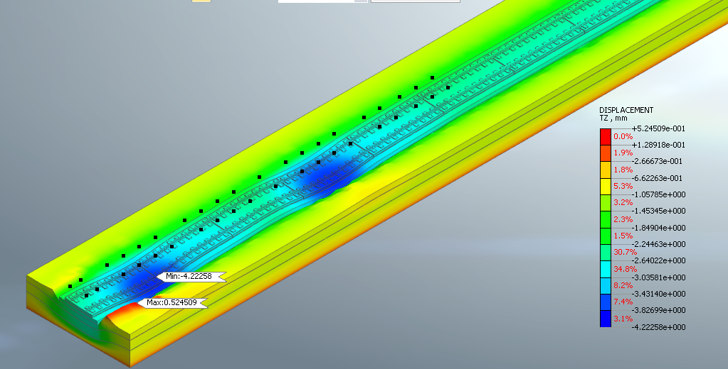
Appendix A-1:Rail displacement for BÖGL slab track (AREMA A2).
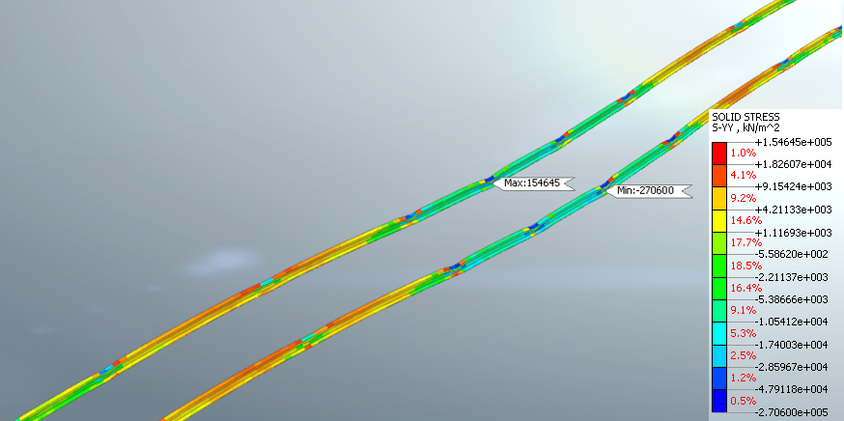
Appendix A-2 Rail vertical stress for BÖGL slab track (AREMA A2).
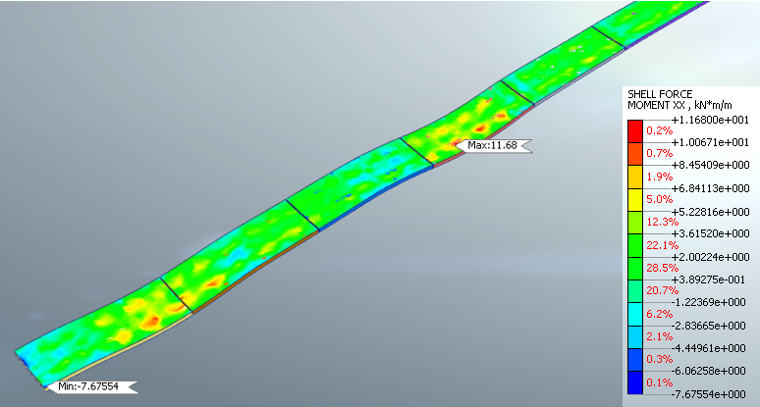
Appendix A-3: Bending Moment M_{xx} in slabs for BÖGL slab track (AREMA A2).
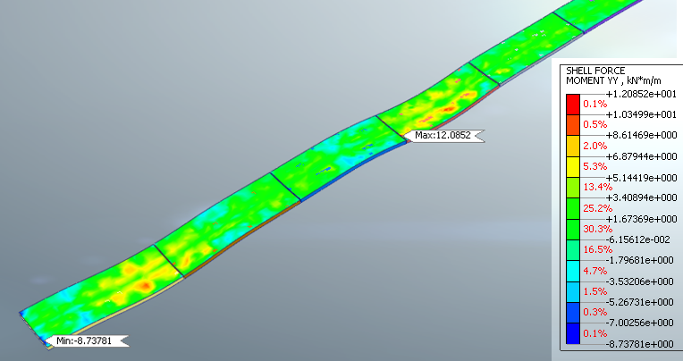
Appendix A-4: Bending Moment M_{yy} in slabs for BÖGL slab track (AREMA A2).
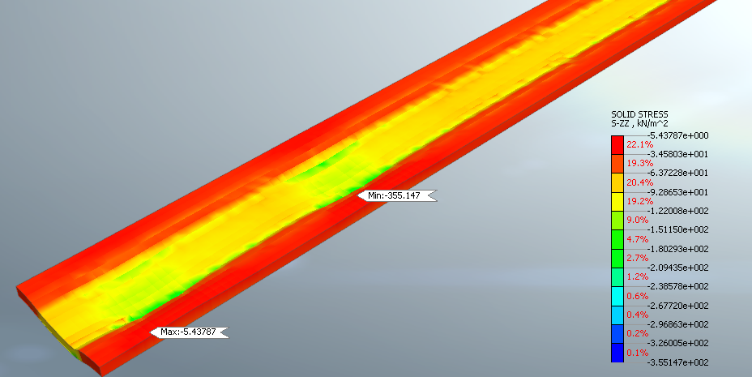
Appendix A-5: Replacement vertical stresses for BÖGL slab track (AREMA A2).
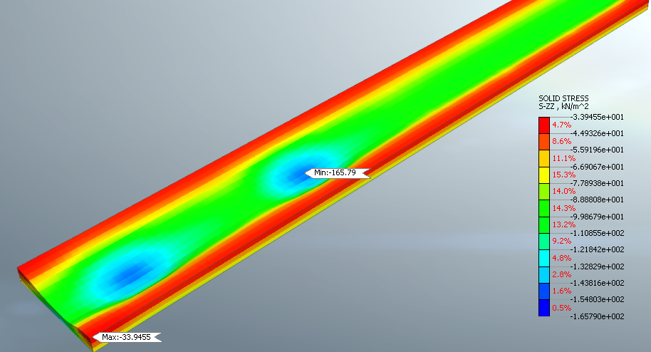
Appendix A-6: Subgrade vertical stresses for BÖGL slab track (AREMA A2).

  - BÖGL slab track design model outputs (EN E2)
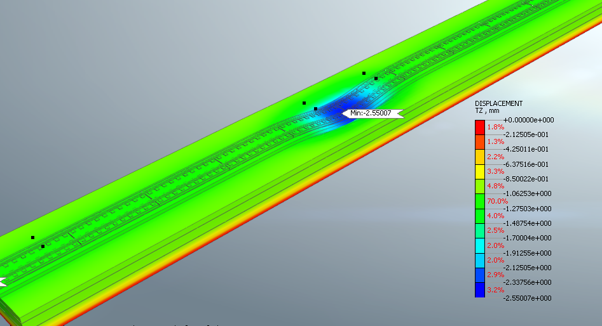
Appendix A-7: Rail displacement for BÖGL slab track (EN E2 ).
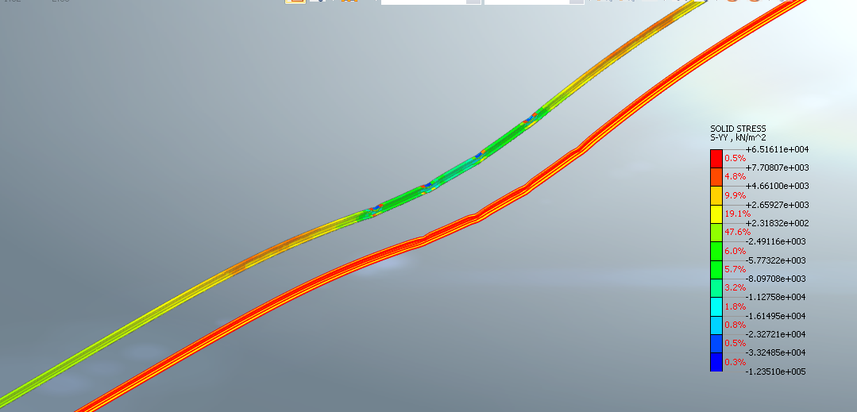
Appendix A-8: Rail vertical stress for BÖGL slab track (EN E2).

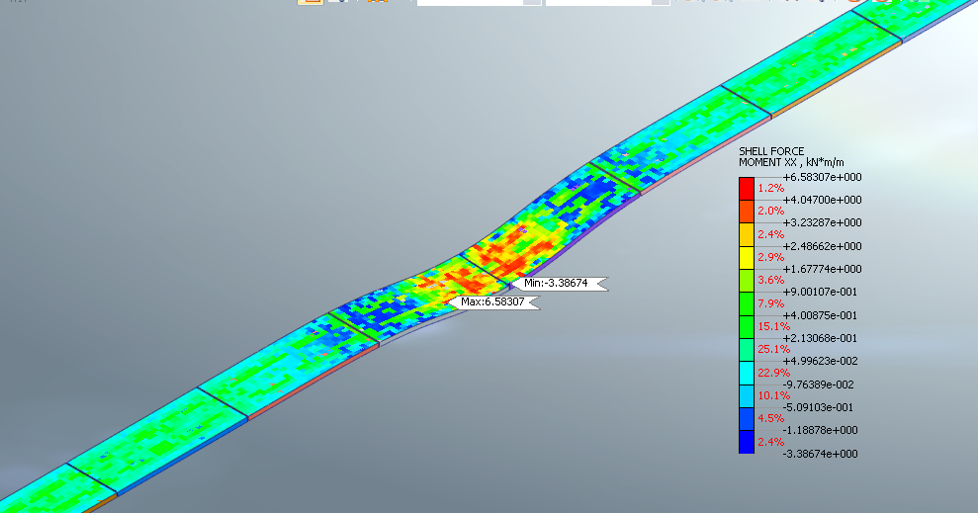
Appendix A-9: Bending moment Mxx in slabs for BÖGL slab track (EN E2).
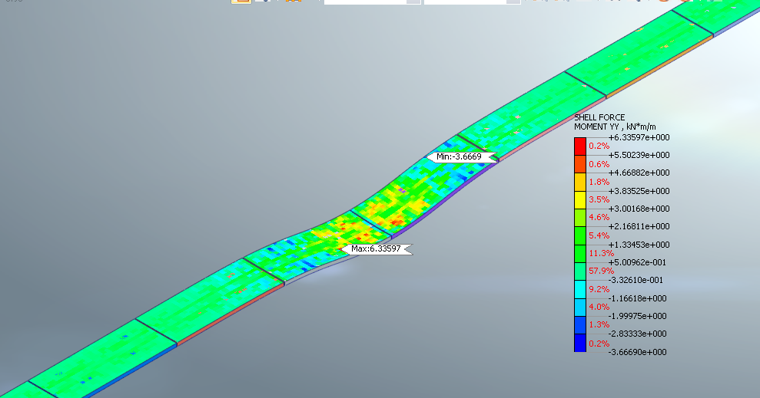
Appendix A-10: Bending moment Myy in slabs for BÖGL slab track (EN E2).
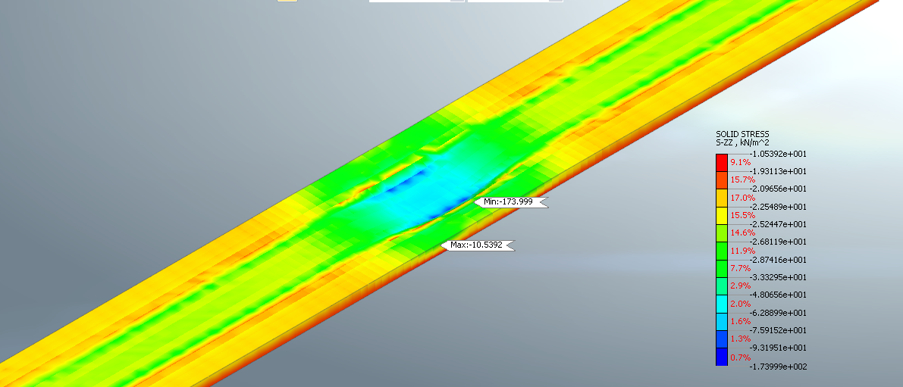
Appendix A-11: Replacement vertical stress for BÖGL slab track (EN E2).
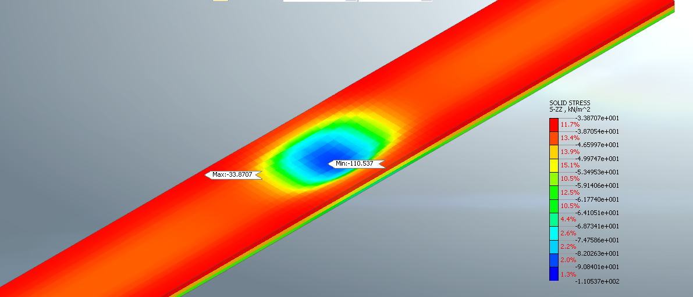
Appendix A-12: Subgrade vertical stress for BÖGL slab track (EN E2).

