Appendix A
Table A1. System Operating Parameters.
Unit | Parameter | Value
MGT | ${\text{P}}_{\text{MT}\text{,}\text{max}}$ (kW) | 300
MGT | $${\text{ζ}}_{\text{MT}}$$ | 0.30
MGT | ${\text{Q}}_{\text{gas}}$ (kWh /m³) | 10
MGT | ${\text{c}}_{\text{gas}}$ (CNY/m³) | 2.5
MGT | ${\text{k}}_{\text{MT}}$ (CNY/kWh) | 0.20
Biomass Generation Unit | ${\text{P}}_{\text{bio}\text{,}\text{max}}$ (kW) | 500
Biomass Generation Unit | ${\text{Q}}_{\text{mat}}$ (kcal/kg) | 3200
Biomass Generation Unit | ${\text{c}}_{\text{mat}}$ (CNY/t) | 300
Biomass Generation Unit | ${\text{k}}_{\text{bio}}$ (CNY/kWh) | 0.45
Biomass Generation Unit | $${\text{η}}_{\text{bio}}$$ | 0.65
Grid Interaction | ${\text{P}}_{\text{grid}\text{,}\text{max}}^{\text{buy}}$ (kW) | 1500
Grid Interaction | ${\text{P}}_{\text{grid}\text{,}\text{max}}^{\text{sell}}$ (kW) | 500
Grid Interaction | $${\text{η}}_{\text{AC}\text{-}\text{DC}}\text{、}{\text{η}}_{\text{DC}\text{-}\text{AC}}$$ | 0.95
ESS | ${\text{E}}_{\text{s}}^{\text{N}}$ (kWh) | 3000
ESS | ${\text{P}}_{\text{es}\text{,}\text{max}}^{\text{c}\text{h}\text{a}}$ (kW) | 800
ESS | ${\text{P}}_{\text{es}\text{,}\text{max}}^{\text{dis}}$ (kW) | 800
ESS | $${\text{η}}_{\text{es}}^{\text{c}\text{h}\text{a}}\text{、}{\text{η}}_{\text{es}}^{\text{dis}}$$ | 0.90
ESS | ${\text{k}}_{\text{es}}$ (CNY/kWh) | 0.05
DR Load | ${\text{P}}_{\text{exe}\text{,}\text{max}}$ (kW) | 300
DR Load | ${\text{P}}_{\text{cut}\text{,}\text{max}}$ (kW) | 300
DR Load | ${\text{k}}_{\text{u}}$ (CNY/kWh) | 0.30
EV | ${\text{E}}_{\text{bat}\text{,}\text{n}}$ (kWh) | 60
EV | ${\text{P}}_{\text{r}\text{ate}\text{,}\text{n}}^{\text{c}\text{h}\text{a}}$ (kW) | 7
EV | ${\text{P}}_{\text{r}\text{ate}\text{,}\text{n}}^{\text{d}\text{is}}$ (kW) | 3.3
EV | $${\text{SOC}}_{\text{max}\text{,}\text{n}}$$ | 0.80
EV | $${\text{SOC}}_{\text{min}\text{,}\text{n}}$$ | 0.20
EV | $$\text{N}$$ | 100
EV | ${\text{η}}_{\text{ev}}^{\text{c}\text{h}\text{a}}$、${\text{η}}_{\text{ev}}^{\text{dis}}$ | 0.95
EV | ${\text{N}}_{\text{cyc}\text{,}\text{ref}}$ (cycles) | 5000
EV | ${\text{c}}_{\text{bat}}^{\text{unit}}$ (CNY/kWh) | 500
Market Trading | ${\text{λ}}_{\text{c}}$ (CNY/t) | 70
Market Trading | ${\text{λ}}_{\text{ccer}}$ (CNY/t) | 100
Market Trading | ${\text{λ}}_{\text{gec}}$(CNY/MWh) | 50
Market Trading | $${\text{β}}_{\text{ccer}}$$ | 0.50

Table A2. TOU Electricity Price Parameters.
 | Time Period | Purchase Price  (CNY/kWh) | Selling Price  (CNY/kWh)
Valley Period | 00:00-10:00 | 0.29 | 0.20
Flat Period | 12:00-14:00, 19:00-24:00 | 0.71 | 0.50
Peak Period | 10:00-11:00, 14:00-15:00,  17:00-19:00 | 1.19 | 0.83
Critical Peak Period | 11:00-12:00, 15:00-17:00 | 1.48 | 1.00

Appendix B

Pareto Analysis of the Multi-objective Optimization Results
To analyze the trade-off between the two optimization objectives, the ε-constraint method is employed to obtain representative Pareto solutions. The load regulation objective $F_{L}$is imposed as a constraint, while the optimization objective cost $F_{cost}$is minimized within the feasible region of the original dispatch model:
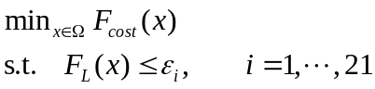 | (B1)
where $Ω$denotes the feasible region of the original dispatch model, and $ε_{i}$represents different load-regulation constraint levels. Twenty-one $ε$levels are uniformly selected between $F_{L}^{min}$and $F_{L}^{ref}$defined in Section 4.2.3 to obtain representative Pareto solutions.

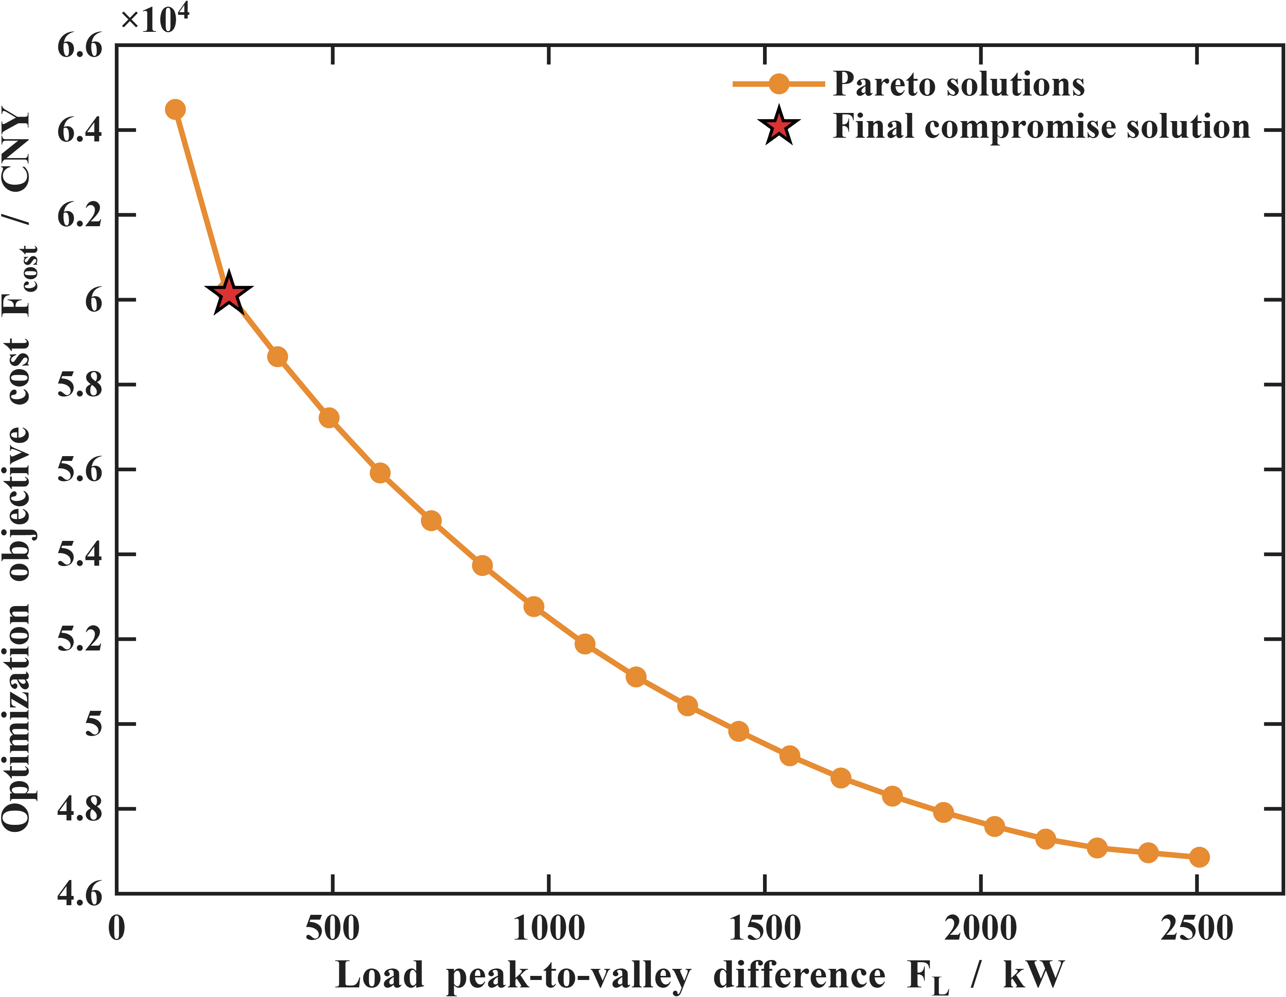 | 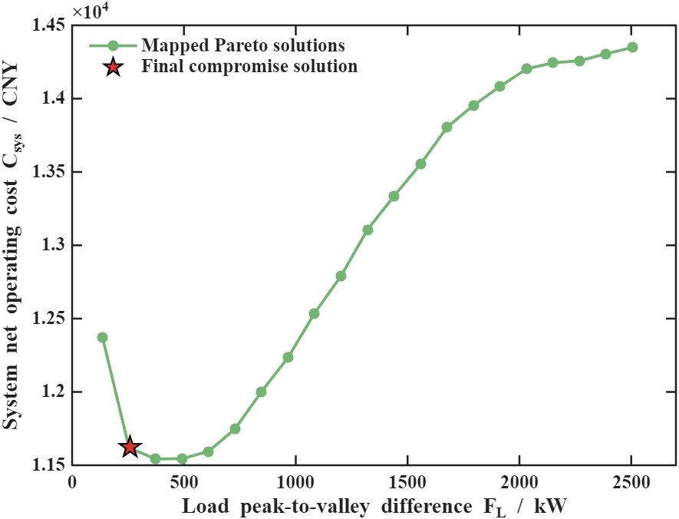
(a) Pareto front in the objective space | (b) Economic evaluation of Pareto solutions
Figure B1. Multi-objective trade-off analysis

As shown in Fig. B1(a), the optimization objective cost $F_{cost}$gradually decreases as the allowable load peak-to-valley difference increases, indicating a clear trade-off between the two optimization objectives. Fig. B1(b) further evaluates the same scheduling solutions using the system net operating cost $C_{sys}$adopted in the result statistics. It should be noted that $F_{cost}$and $C_{sys}$have different cost-accounting scopes. In particular, the CERF-based carbon-responsibility guidance cost is introduced as an internal low-carbon guidance term in the optimization objective and is excluded from the system net operating cost used for result statistics. Therefore, Fig. B1(b) presents the corresponding economic performance of the Pareto schedules rather than an additional Pareto front.

