File S4. End-to-End Demonstration Case

Table 1. Participant Questionnaire Responses.
Parameter | Response
Space Typology | Bedroom
Spatial Scale | Small / Intimate (1 People)
Color Palette | Neutral (Beige, Cream, Taupe)
Design Style | Modern
Natural Lighting | Soft & Filtered
Wall Treatment | Smooth Matte Paint
Flooring Material | Wood
Furniture Morphology | Soft, Rounded (Curves, Arches)
Air Quality | Natural & Fresh (Open Windows, Fresh Flowers)
Biophilic Integration | Minimal (One or Two Potted Plants)
Emotional Mood | Cozy & Relaxing
Wall Art | Minimal Graphic Prints
Storage Configuration | Mixed
Window Configuration | Floor-to-Ceiling Glass Wall
Ceiling Height | Standard Height
Assembled Composite Prompt | "A bedroom, a small, intimate space designed for one occupant. A neutral color palette with beige, cream, and white tones, expressed through a modern design. Filled with soft, filtered natural light, highlighting smooth, matte painted walls and wood flooring. The room is furnished with furniture featuring soft, rounded edges and curves. The air feels fresh and natural, featuring fresh-cut flowers and open windows, with only minimal plant life, such as one or two small potted trees. The overall emotional mood is cozy and relaxing, complemented by minimal graphic prints on the walls. Storage is handled through a mix of open and concealed solutions. Floor-to-ceiling glass windows bring in natural light, and a standard height ceiling completes the space. Highly realistic architectural interior rendering, professional interior design visualization."
Generated Design Output | 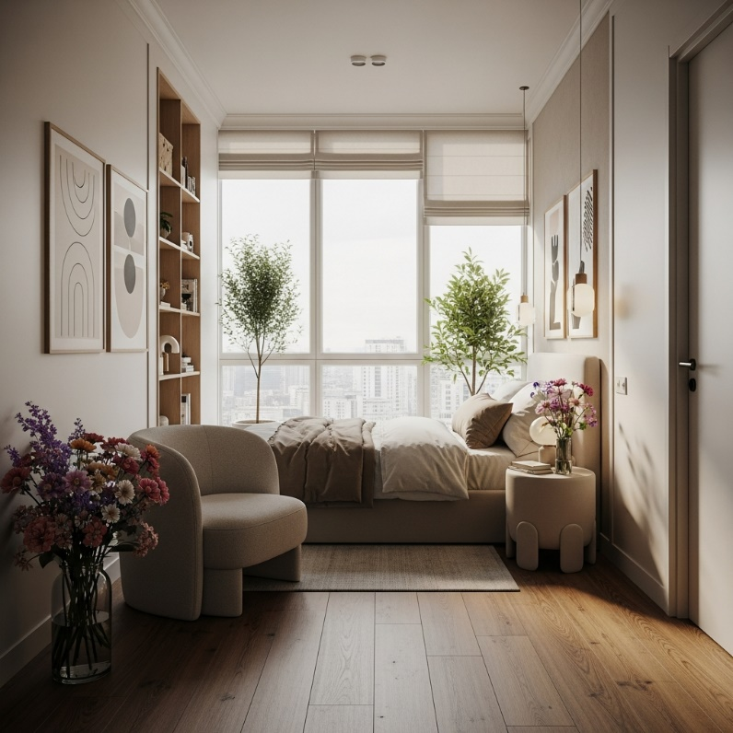

Table 2. Participant Characteristics.
Category | Response
Gender | Female
Age | 25–34
Country | Egypt
Profile | Profile A

Table 3. Participant Evaluation Scores.
Item | Response
Q1 | 4/5
Q2 | 4/5
Q3 | 5/5
Q4 | 4/5
Q5 | 5/5
Q6 | 4/5
Q7 | 5/5
Q8 | 3/5
Q9 | 4/5
Q10 | 4/5
Q11 | I liked the room overall, especially the colors and the calm atmosphere, it feels comfortable and suits most of my preferences. It wasn't exactly how I imagined it, though; I expected something a bit warmer and more personal. Overall, the design feels appealing and well organized.
The demonstration case illustrates the framework's translation logic in practice. As outlined in Table 3, high ratings on layout appropriateness (Q5 = 5) and visual coherence (Q7 = 5) correspond to prompt elements directly traceable to the participant's stated preferences. The neutral palette, wood flooring, and floor-to-ceiling glass windows specified in the questionnaire were all incorporated into the generated design. The comparatively lower score on image-match to the imagined design (Q8 = 3) illustrates the same dissociation observed at the aggregate level: atmospheric and material parameters (palette, lighting, flooring, window type) are rendered with high fidelity, while the identity-expressive parameter — minimal graphic wall art — appears in the generated image in a form the participant did not fully anticipate, consistent with the pattern in which identity-expressive parameters show the greatest resistance to precise translation. This is corroborated by the participant's open-ended response, which specifically attributed the imagery mismatch to a lack of perceived warmth and personalization — directly echoing the identity-expressive dimension the Expectations Alignment construct is designed to capture. The construct-level ordering in this single case (Atmospheric Coherence > Emotional Comfort > Overall Satisfaction > Expectations Alignment) reproduces the aggregate hierarchy exactly, grounding the statistical results in a concrete, auditable instance of the full pipeline. This single case does not substitute for the aggregate statistical results reported for the main sample.

