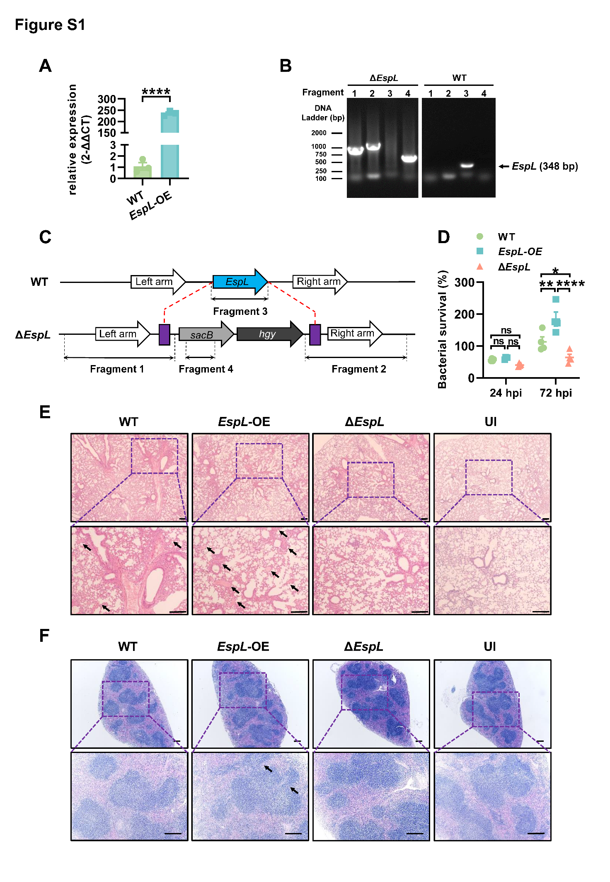
Figure S1 (A) Analysis of the mRNA expression of EspL in wild-type H37Ra and the EspL-OE strain. ****P < 0.0001 (unpaired t-test). (B) Verification of the knockout of the EspL gene. Fragment 1 was amplified by EspL-Up1200-F and p0004s-inner-R to confirm the homologous exchange of the left arm; Fragment 2 was amplified by p0004s-inner-F and EspL-Dn1000-R to confirm the homologous exchange of the right arm; Fragment 3 was amplified by EspL-ORF-F and EspL-ORF-R to confirm the knockout of EspL; Fragment 4 was amplified by SacB-F and SacB-R to confirm the insertion of SacB into Mtb genome. The arrow indicated the PCR band of EspL. Primers used for PCR verification are listed in Table S1. (C) Schematic model for the principles of homologous exchange and the genomic location of PCR fragments in (B). Red dash lines and purple blocks indicate the position where the homologous exchange has happened. Black dash lines and double-headed arrows indicate the location of 4 PCR fragments. (D) Percentage of viable bacteria in (Fig. 1C). The CFUs at 24 hpi and 72 hpi were divided by the CFUs at 0 hpi to calculate the survival percentage. P > 0.05, not significant (ns); *P < 0.05; **P < 0.01; ***P < 0.001; ****P < 0.0001 (two-way ANOVA). (E) Representative H&E (hematein and eosin)-stained lung sections of mice in (Fig. 1D) at week 2. Scale bars, 200 μm. (F) Representative H&E (hematein and eosin)-stained spleen sections of mice in (Fig. 1E) at week 1. Scale bars, 200 μm.

