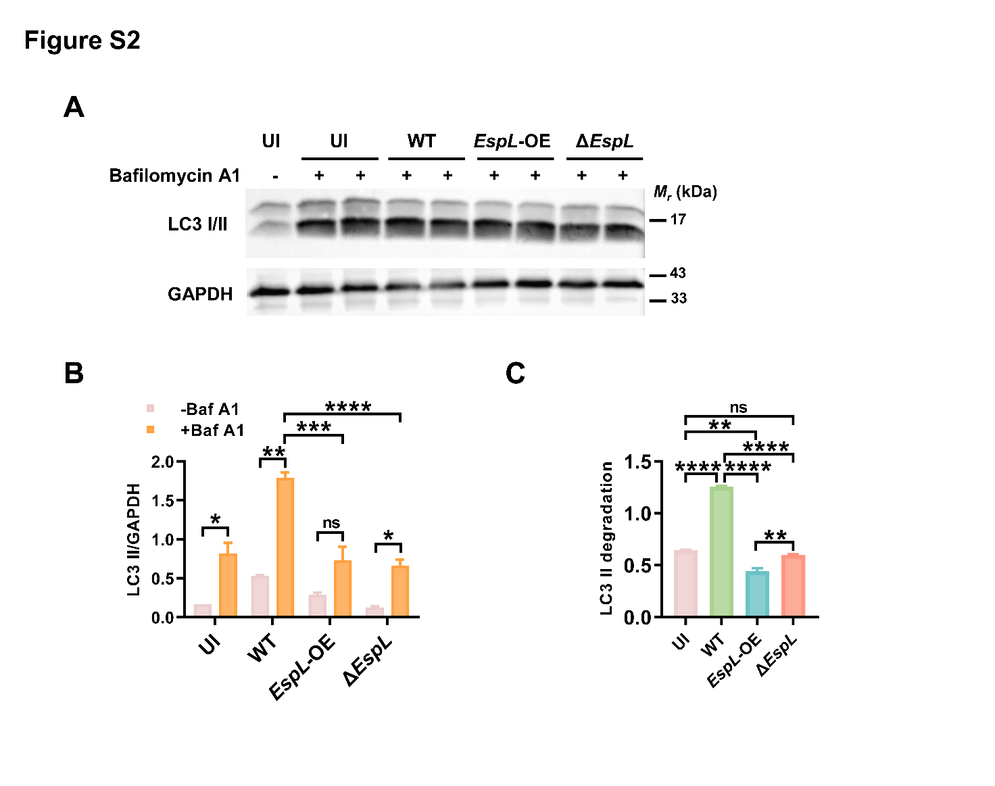
Figure S2 (A) THP-1 cells were infected with the wild-type H37Ra, EspL-OE or ΔEspL strain at MOI = 10 for 24 h. Bafilomycin A1 (Baf A1, 100 nM) was added 3 hours before cells were harvested for immunoblot analysis of LC3 I/II expression. The experiment was repeated once. (B) The ratio of the intensities of the LC3 II to GAPDH bands in Baf A1-treated and untreated THP-1 cells. P > 0.05, not significant (ns); *P < 0.05; **P < 0.01; ***P < 0.001; ****P < 0.0001 (two-way ANOVA). (C) The differences of LC3 II intensities between Baf A1-treated and untreated groups. The results indicate the amount of LC3 II degraded in lysosomes. P > 0.05, not significant (ns); *P < 0.05; **P < 0.01; ***P < 0.001; ****P < 0.0001 (one-way ANOVA).

