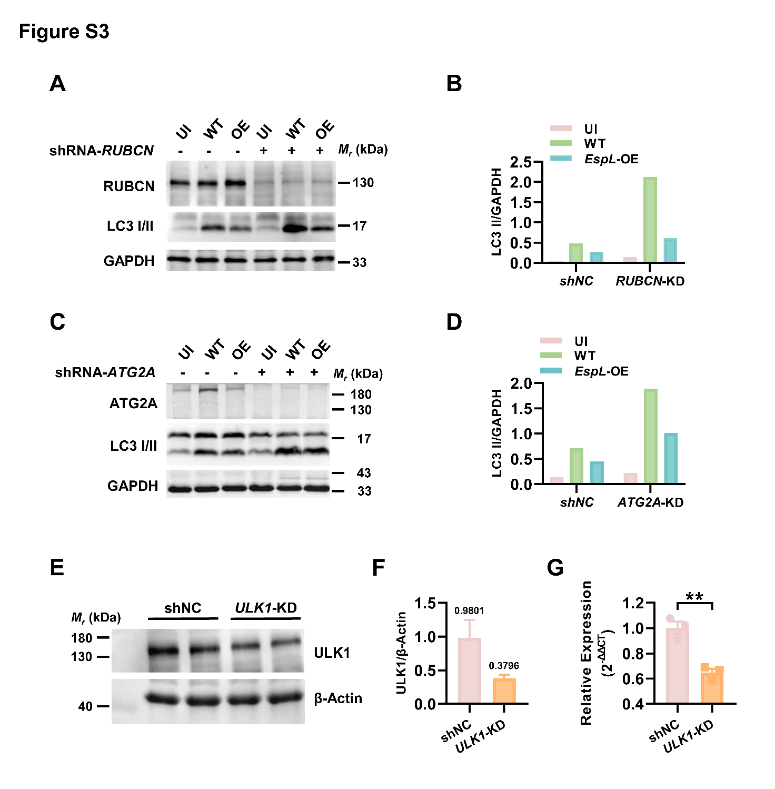
Figure S3 (A) shNC or RUBCN-KD THP-1 cells were infected with the wild-type H37Ra or EspL-OE strain (MOI = 10) and analyzed by western blotting for RUBCN, LC3 and GAPDH. The experiment was repeated two times. One representative image is shown. (B) The ratio of the intensities of LC3 II to GAPDH. (C) shNC or ATG2A-KD THP-1 cells were infected with the indicated Mtb strains (MOI = 10) and analyzed by western blot for ATG2A, LC3 and GAPDH. The experiment was repeated two times. One representative image is shown. (D) The ratio of the intensities of LC3 II to GAPDH. (E) Detection of ULK1 protein levels in shNC or ULK1-KD THP-1 cells by western blotting. The experiment was repeated two times. One representative image is shown. (F) The ratio of the intensities of ULK1 to β-Actin. Numbers above the bars indicate the mean values. (G) Analysis of the ULK1 mRNA expression in shNC or ULK1-KD THP-1 cells. **P < 0.01 (unpaired t-test).

