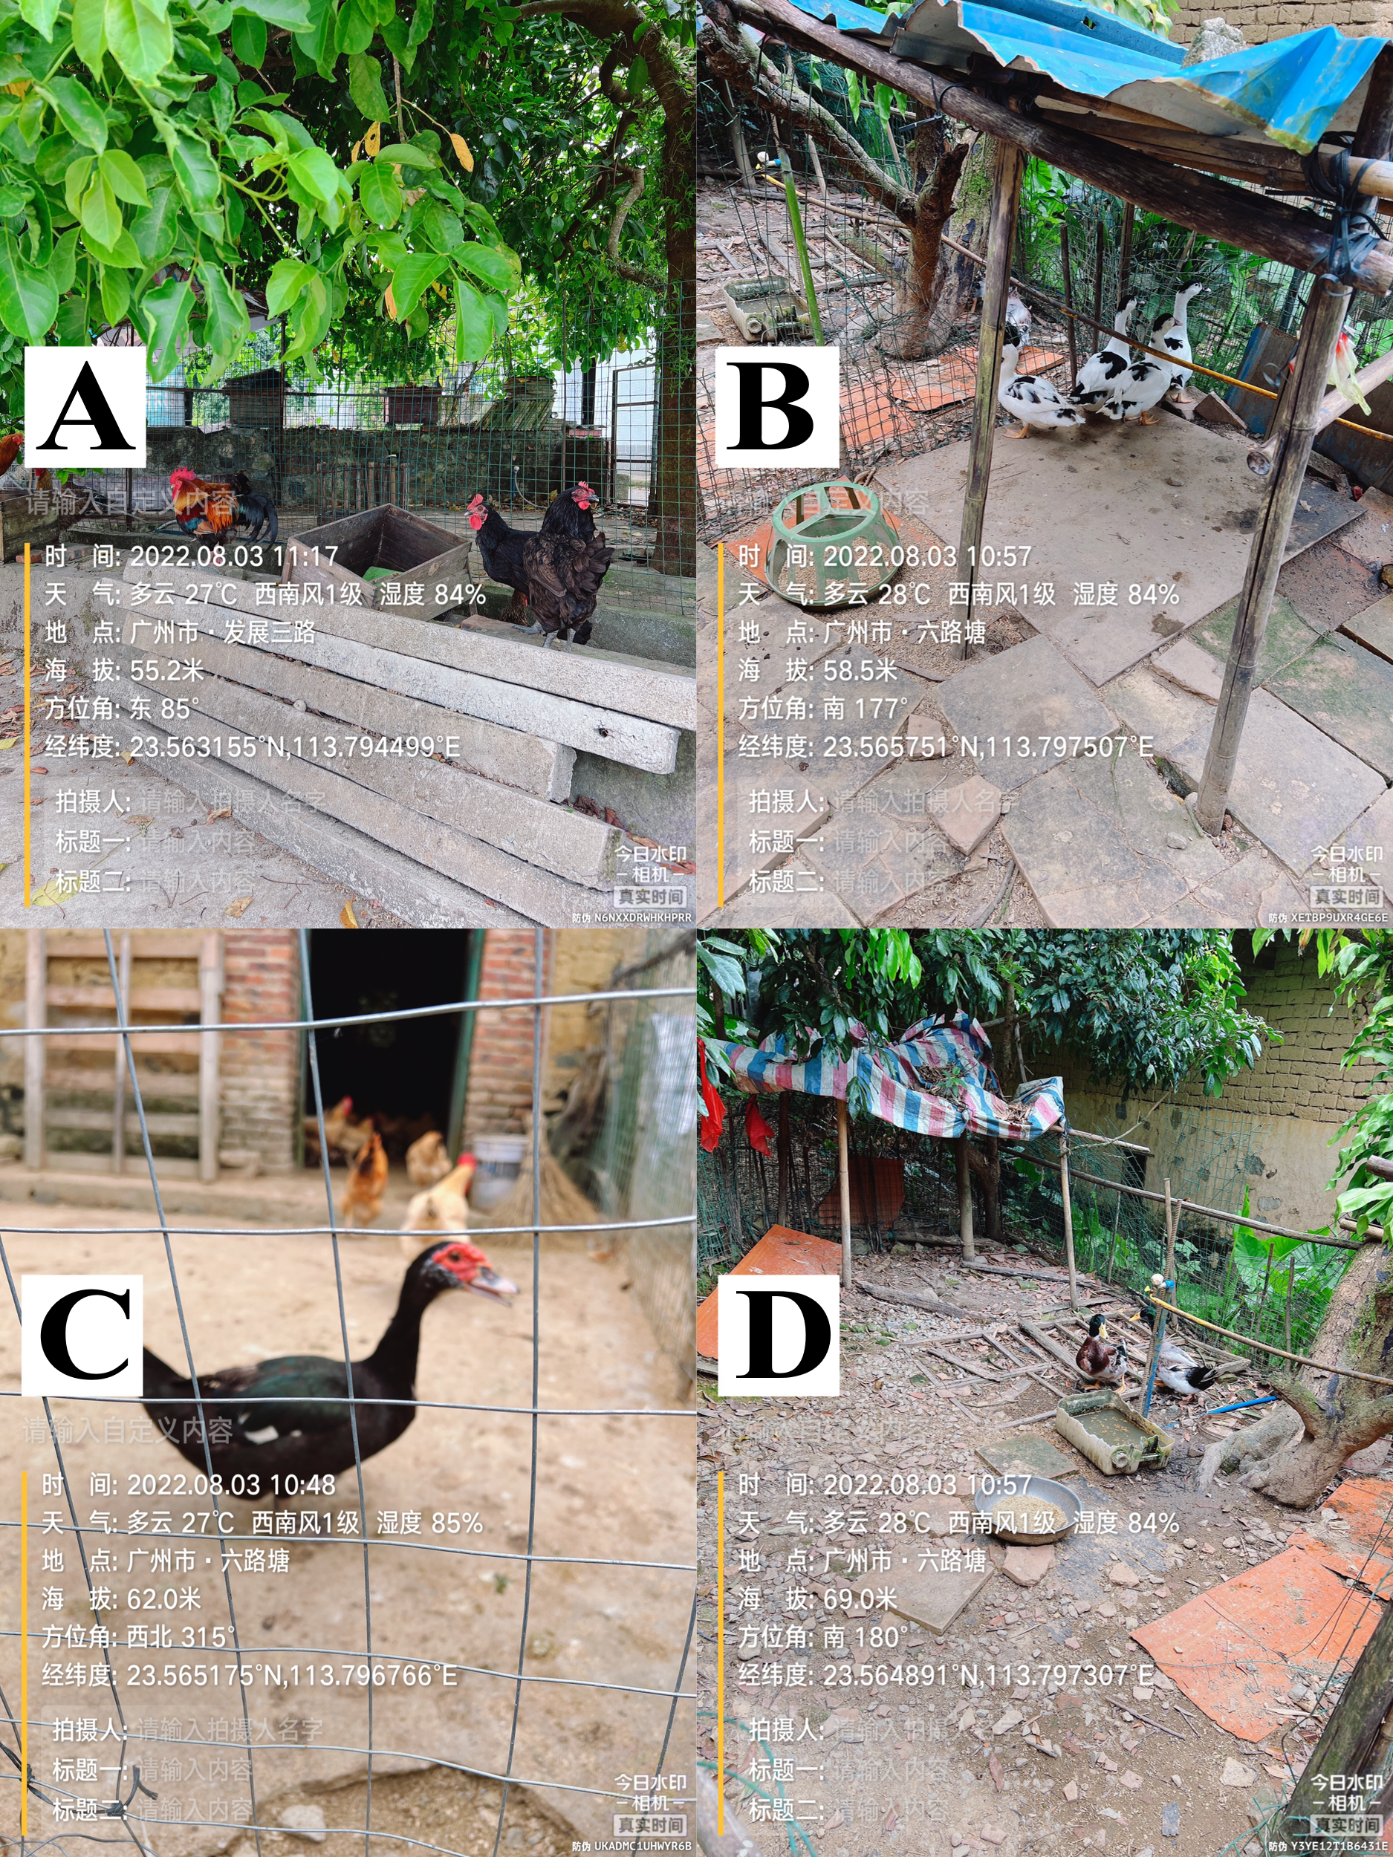
Figure A1. Photos of poultry sampling in Guangzhou city. The text in the image translates to: Time: August 3, 2022, 10:48, Weather: Partly cloudy, 27℃, southwest wind, 1st level, humidity 85%, Location: Liulu Tang, Guangzhou City, Altitude: 62.0 meters, Latitude and Longitude: 23.565175N, 113.796766E.A: Silkie chicken; B: Duck; C: Peking duck; D: Mallard duck.
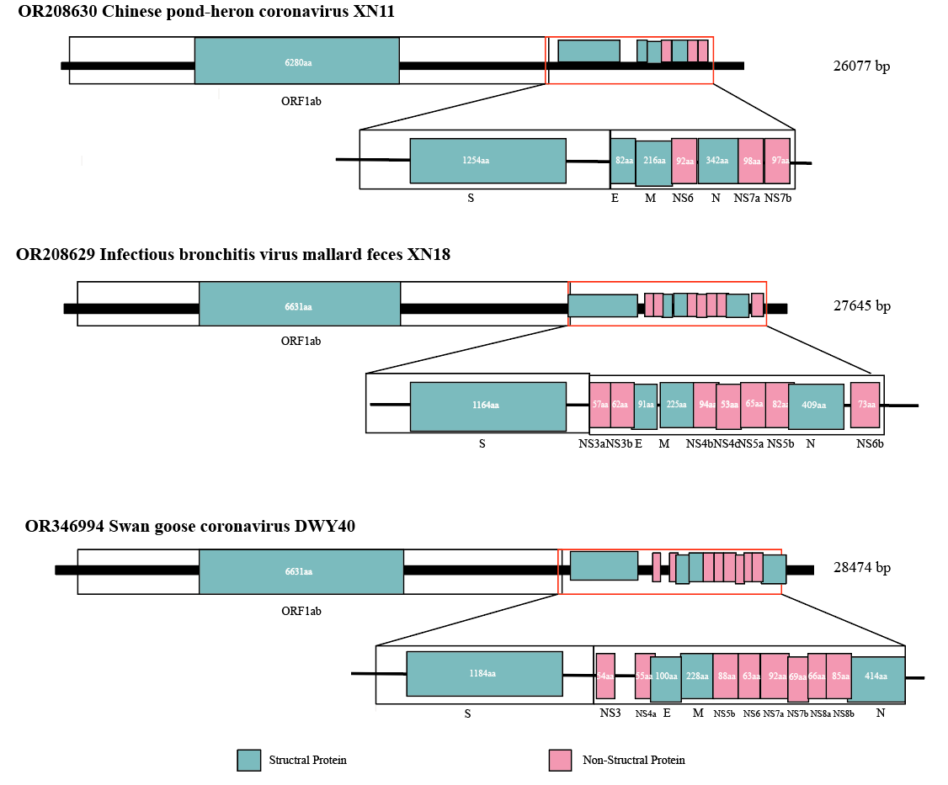Figure A2. Genome organization and putative coding regions of XN11, XN18 and DWY40. The viral genome segments that contained the predicted viral protein were presented with length beside. Structural viral proteins were marked with cyan and Non-Structural viral were marked with pink, respectively.

Figure A3. Phylogenetic tree of complete S1 nucleotide sequences (1456 nt) of representative IBVs. The Mallard IBV XN18 was marked by red triangle.

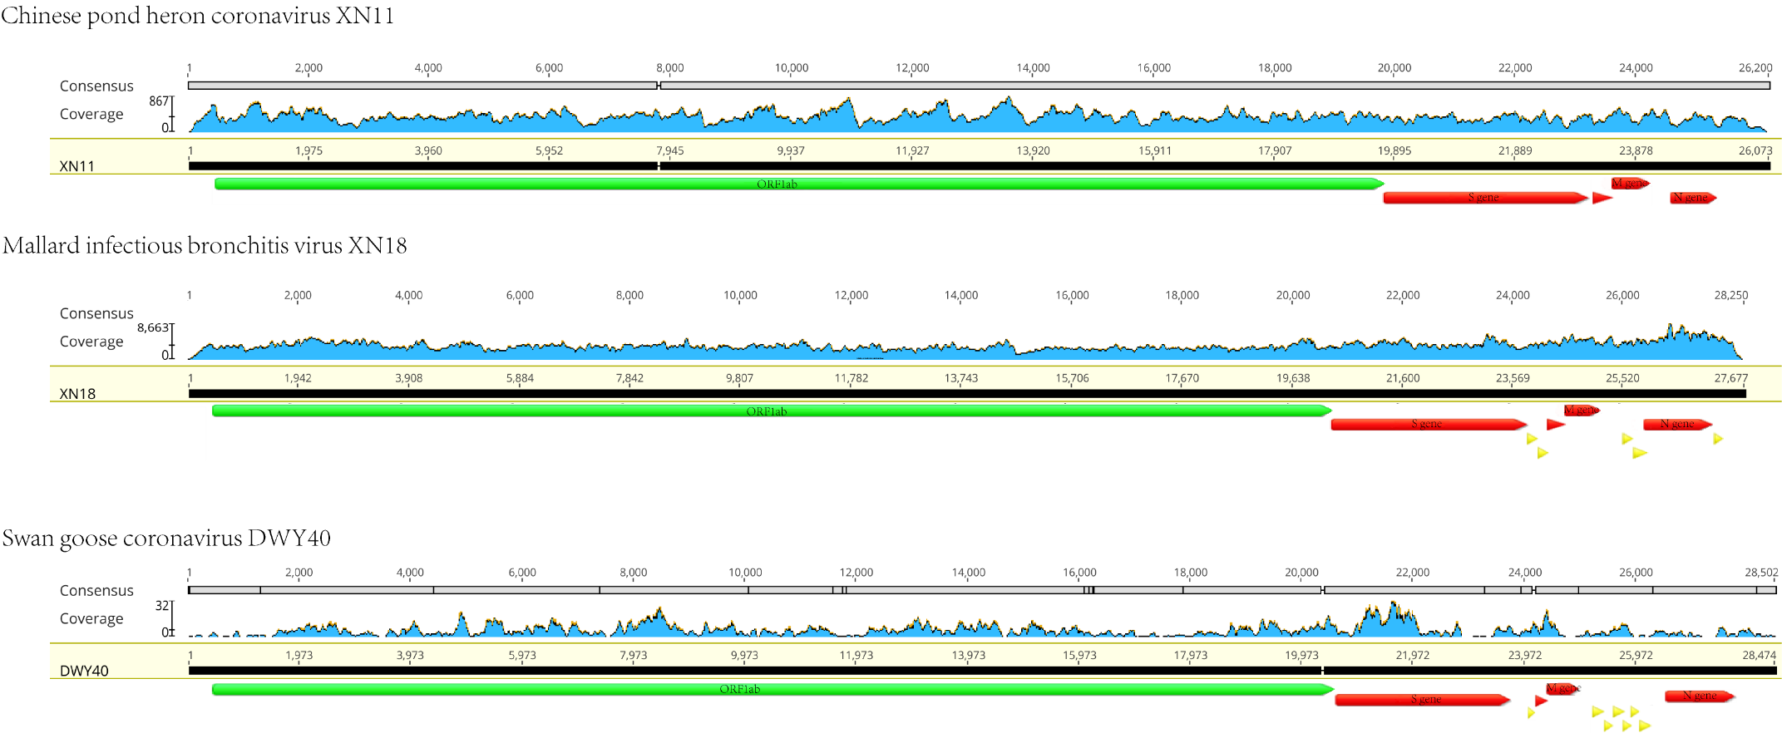
Figure A4. Schematic representation, coverage, and annotation of genomes of coronaviruses found in wild and domestic birds in Guangdong. Y axis represents the sequencing depth.
Table A1. Primers for sample test and species identification.
Sequence name | Primer | Length (bp) | TM（℃）
Primers for sample test
Hu-F | AARTTYTAYGGHGGYTGG | 668 | 52
Hu-R | GARCARAATTCATGHGGDCC | 668 | 52
Poon-F | GGTTGGGACTATCCTAAGTGTGA | 440 | 48
Chu-06R1 | CCATCATCAGATAGAATCATCAT | 440 | 48
Primers for species identification
L6615 | CCTCTATAAAAAGGTCTACAGCC | 1300 | 51
H7956 | GGGTAGTCCGAGTATCGTCG | 1300 | 51
BirdF1 | TTCTCCAACCACAAAGACATTGGCAC | 750 | 45
BirdR1 | ACGTGGGAGATAATTCCAAATCCTG | 750 | 45
AvesF | GCATGAGCAGGAATAGTTGG | 668 | 45
AvesR | AAGATGTAGACTTCTGGGTG | 668 | 45

Table A2. Primers for obtain the complete viral genomes.
Sequence name | Position | Forward primer | Reverse primer
XN11-CoV | 22099~23401 | TCATCACCGGAAGACTTGC | TGTCTTGCTGCATACCCTC
DWY40-CoV | 1~2165 | ATCATACTCACCTTGCCTTG | CACTAACGCCTTCAACTTG
DWY40-CoV | 2545~3917 | AGCACAGACACTACCTAGT | CTGCCTGCTTATTACGAGC
DWY40-CoV | 3225~4847 | CCATACGTGAACAAGAAGCGAG | ATTATAAGAAATAGCCTGTGTC
DWY40-CoV | 4782~6243 | TCTCTATGGATGACAGTAGTG | AAGTCTGCCATAGTGTAACC
DWY40-CoV | 6114~7869 | AACGTCGTGTAATGTCTAC | AAGACCATCATAGCATAGGC
DWY40-CoV | 8566~10562 | TGGTGATGAATGGCAGAATG | GAGCCAAGACATCTTCATAAG
DWY40-CoV | 10175~12874 | ATACACTTATTGCTGGTATTGG | ACCTATCGTCAACACAATCG
DWY40-CoV | 14226~16812 | CTTGTCTGATGATGGTGTTG | GCCAATCCAACCTCTAAC
DWY40-CoV | 16354~19313 | GTAGATTCATCGCAAGGTTC | TTATGAGGCACGCACATTG
DWY40-CoV | 19127~21899 | AATCTGGTTGGCGTAGTG | ATTGAATCTGCTCCATCTG
DWY40-CoV | 21439~23589 | CACTATGCTTGCTGATGG | CATGTATGCAGCAGAGTGAC
DWY40-CoV | 23516~26531 | GATGATGATGTAGTAGGTGAAC | GGACAAGGAACTGGAAG
DWY40-CoV | 26282~28474 | CTCTGTGAAGTTCGCATTC | CGCTCTAACTCTATACTAGC

Table A3. Information of 128 Samples collected for this study.
Cities | collected time | Species name | Family | No. Samples
Guangzhou | 2022.12.3 | Common Blackbird | Turdidae | 2
Guangzhou | 2022.12.3 | Spotted Dove | Columbidae | 1
Guangzhou | 2022.12.3 | Common Tailorbird | Cisticolidae | 1
Guangzhou | 2022.12.3 | Black-collared Starling | Sturnidae | 1
Guangzhou | 2022.6.1 | Siberian Crane | Gruidae | 11
Guangzhou | 2022.9 | Grey Heron | Ardeidae | 3
Guangzhou | 2022.9 | Oriental Turtle Dove | Columbidae | 1
Guangzhou | 2023.1 | Great Egret | Ardeidae | 3
Guangzhou | 2023.1 | Great Cormorant | Phalacrocoracidae | 2
Jiangmen | 2022.6. | Little Egret | Ardeidae | 6
Jiangmen | 2022.6. | Chinese Pond Heron | Ardeidae | 2*
Jiangmen | 2022.6. | Black-crowned Night Heron | Ardeidae | 1*
Jiangmen | 2022.6. | Red Junglefowl | Phasianidae | 2
Jiangmen | 2022.6. | Mallard | Anatidae | 1*
Jiangmen | 2023.1.11 | Yellow-browed Warbler | Phylloscopidae | 2
Jiangmen | 2023.1.11 | Oriental Turtle Dove | Columbidae | 21
Jiangmen | 2023.1.11 | Spotted Dove | Columbidae | 1
Jiangmen | 2023.1.11 | Black-crowned Night Heron | Ardeidae | 1
Jiangmen | 2023.1.11 | White-browed Laughingthrush | Leiothrichidae | 1
Jiangmen | 2023.1.11 | Rufous-capped Babbler | Timaliidae | 1
Jiangmen | 2023.1.11 | Grey-backed Thrush | Turdidae | 2
Guangzhou | 2022.4.29 | Common Hill Myna | Sturnidae | 1
Guangzhou | 2022.4.29 | Black-necked Swan | Anatidae | 1
Guangzhou | 2022.4.29 | Chinese Hwamei | Leiothrichidae | 1
Guangzhou | 2022.4.29 | Mute Swan | Anatidae | 1
Guangzhou | 2022.4.29 | Toco Toucan | Ramphastidae | 1
Guangzhou | 2022.4.29 | Indian Peafowl | Phasianidae | 1
Guangzhou | 2022.4.29 | Great Hornbill | Bucerotidae | 1
Guangzhou | 2022.4.29 | Black-and-white Mannikin | Estrildidae | 1
Guangzhou | 2022.4.29 | Golden Pheasant | Phasianidae | 1
Guangzhou | 2022.4.29 | Reeves's Pheasant | Phasianidae | 1
Guangzhou | 2022.4.29 | Temminck's Tragopan | Phasianidae | 1
Guangzhou | 2022.4.29 | Silver Pheasant+Swinhoe's Pheasant | Phasianidae | 10
Guangzhou | 2022.4.29 | Alexandrine Parakeet+Yellow-crowned Amazon+Green-cheeked Parakeet+Grey Parrot+Red-and-green Macaw+Blue-and-yellow Macaw | Psittaculidae+Psittacidae | 5
Guangzhou | 2022.4.29 | Wreathed Hornbill+Silvery-cheeked Hornbill | Bucerotidae | 4
Guangzhou | 2022.4.29 | Emu+Southern Cassowary+Common Ostrich | Casuariidae+Struthionidae | 5
Guangzhou | 2022.6.2 | Buceros bicornis+Rhyticeros undulatus+Anthracoceros albirostris | Bucerotidae | 2
Guangzhou | 2022.6.2 | Black-necked Swan | Anatidae | 2
Guangzhou | 2022.6.2 | Swan Goose | Anatidae | 1*
Guangzhou | 2022.6.2 | Red-crowned Crane | Gruidae | 2
Guangzhou | 2022.8.3 | chicken | Phasianidae | 6
Guangzhou | 2022.8.3 | duck | Anatidae | 3*
Guangzhou | 2022.7.26 | chicken | Phasianidae | 1
Guangzhou | 2022.7.26 | duck | Anatidae | 1
Guangzhou | 2022.7.26 | goose | Anatidae | 1
Guangzhou | 2020.10.18 | chicken | Phasianidae | 5
Guangzhou | 2022.9.6 | chicken | Phasianidae | 3*
*: means one sample is positive when tested for coronaviruses though PCR.
Table A4. Information of six positive Samples discovered in this study.
Genbank No. | Positive sample | SRA No. | Species name | Scientific name
OR346994 | DWY40* | SRR27462178 | Swan goose | Anser cygnoides
OR208629 | XN18* | SRR27462180 | Mallard | Anas platyrhynchos
OR195692 | XN12 |  | Black-crowned night heron | Nycticorax nycticorax
OR208630 | XN11* | SRR27462178 | Chinese pond heron | Ardeola bacchus
OR195691 | BY1 |  | Chicken | Gallus gallus domesticus
OR160350 | ZC7 |  | Duck | Anatidae
*: means the sample has passed the RNA quality control.

Table A5. Genome organization of the three viral genomes.
 | Name | start | stop | frame | aa
CPCoV XN11 | ORF1a | 482 | 11311 | +2 | 3610
CPCoV XN11 | ORF1ab | 482 | 19323 | +2，+1 | 6280
CPCoV XN11 | S | 19305 | 23069 | +3 | 1254
CPCoV XN11 | E | 23069 | 23317 | +2 | 82
CPCoV XN11 | M | 23310 | 23960 | +3 | 216
CPCoV XN11 | 6 | 23960 | 24238 | +2 | 92
CPCoV XN11 | N | 24248 | 25276 | +2 | 342
CPCoV XN11 | 7a | 25277 | 25573 | +2 | 98
CPCoV XN11 | 7b | 25583 | 25876 | +2 | 97
IBV XN18 | ORF1a | 520 | 12351 | +1 | 3944
IBV XN18 | ORF1ab | 520 | 20414 | +1, +3 | 6631
IBV XN18 | S | 20365 | 23859 | +1 | 1164
IBV XN18 | 3a | 23859 | 24032 | +3 | 57
IBV XN18 | 3b | 24032 | 24220 | +2 | 62
IBV XN18 | E | 24207 | 24482 | +3 | 91
IBV XN18 | M | 24503 | 25180 | +2 | 225
IBV XN18 | 4b | 25181 | 25465 | +2 | 94
IBV XN18 | 4c | 25386 | 25547 | +3 | 53
IBV XN18 | 5a | 25544 | 25741 | +2 | 65
IBV XN18 | 5b | 25738 | 25986 | +1 | 82
IBV XN18 | N | 25929 | 27158 | +3 | 409
IBV XN18 | 6b | 27167 | 27388 | +2 | 73
SGCoV DWY40 | ORF1a | 521 | 11941 | +2 | 3807
SGCoV DWY40 | ORF1ab | 521 | 20025 | +2, +1 | 6501
SGCoV DWY40 | s | 20009 | 23563 | +2 | 1184
SGCoV DWY40 | 3 | 23556 | 23720 | +3 | 54
SGCoV DWY40 | 4a | 24235 | 24402 | +1 | 55
SGCoV DWY40 | E | 24362 | 24664 | +2 | 100
SGCoV DWY40 | M | 24661 | 25347 | +1 | 228
SGCoV DWY40 | 5b | 25347 | 25613 | +3 | 88
SGCoV DWY40 | 6 | 25610 | 25801 | +2 | 63
SGCoV DWY40 | 7a | 25809 | 26087 | +3 | 92
SGCoV DWY40 | 7b | 26029 | 26238 | +1 | 69
SGCoV DWY40 | 8a | 26222 | 26422 | +2 | 66
SGCoV DWY40 | 8b | 26419 | 26676 | +1 | 85
SGCoV DWY40 | N | 26604 | 27848 | +3 | 414

Table A6. Amino acid differences between Mallard IBV XN18 (OR208629) and OQ749506 Gammacoronavirus sp. DLSL21 calculated by the software SnapGene v2.3.2a.
Protein | Position
ORF1ab | K6Q, M128L, A130F, C131R, P141S, T142S, S178N, F183L, I227V, I285T, P328S, I385V, K404R, N455T, F464L, A514S, S562F, A571V, F609L, T611I, K672R, P753L, V799A, I852L, F855V, D902E, P913S, E977G, I988T, D1071E, K1076R, Q1081H, T1143I, V1174A, I1228T, L1302F, Y1338H, F1378L, V1411A, A1425V, A1443V, G1458V, K1476Q, D1490E, F1507I, I1530T, E1532D, P1549S, V1560I, S1588P, S1611P, S1629T, V1647A, F1730V, F1734L, V1738F, S1771F, H1938Q, I2026T, N2149K, I2269V, S2271G, S2275G, C2290F, D2454G, V2492I, S2532P, M2654N, I2656T, C2659V, A2662G, F2673L, S2682C, D2687E, E2690D, V2723H, M2765V, A2788S, S2832G, S2836N, H2848G, I2852T, R2932K, M2956Y, L2986F, I3009V, A3055T, I3120L, T3135A, Y3149F, V3192I, I3305V, I3308T, V3369I, D3492E, I3619T, D3642E, V3659A, V3672L, V3770I, C3814I, V3913I, S3921L, E4020A, E4032Q, I4113T, Y4207F, L4373S, Y5297L, Y6072H, F6106L, D6196G, G6319V, S6320C, T6576V.
S | E55R, V60G, D64A, P87S, A95S, S117N, S140F, F142V, A217V, Y324H, Q525R, F565S, M1004T.
Eª | T67I, N91K, N92, K93, S94, I95, P96, N97, F98, Q99, D100, V101, Q102, R103, D104, K105, L106, H107, P108.
M | E4A, I44S, L46F, A81V, F91L, I101C, S143A.
N | S7A, S80G, V179A, Q207H, N235G, K264R, Q286R, T299R, R301E, S342P, R345K, G350A.
3b | H25Y, S46G.
4b | L11F, Y25H, K47N, Q56K, A64V, D68A, K71N, N77T, Q90H.
4c | K3M, M6T, R7K, T9P, R13K, A17V, Y19C, L21P, S22I, E25G, V38I.
5a | V11F, F48V, D61N.
5b | G23E, E54D, I57L, D58H, D61N, H70Q, H76P, S80L.
a: The amino acid changes because an early stop codon is underlined.

