Supplementary Information

Additional file 1
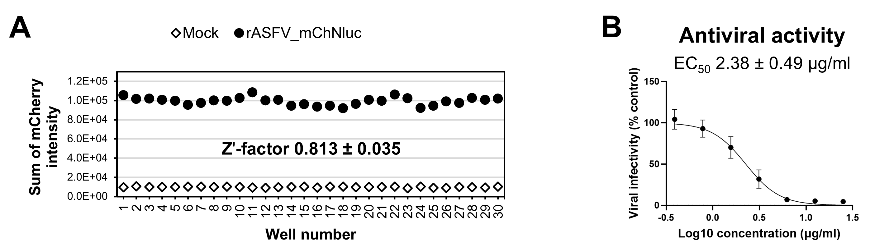
Fig. S1 ASFV screening system using a fluorescence microplate reader. A MA104 cells in a 96-well plate (30 wells) were infected with rASFV_mChNluc and incubated for 48 h. mCherry fluorescence intensity was quantified using the PerkinElmer EnSight Multimode Plate Reader in well-scan mode (3 × 3 grid, bottom read), with an excitation wavelength of 587 nm and an emission wavelength of 610 nm. Mock represents uninfected control (30 wells). Z′-factor values from three independent experiments are shown. B MA104 cells were infected with rASFV_mChNluc and treated with serial dilutions of AraC for 48 h. mCherry fluorescence intensity was measured using the PerkinElmer EnSight Multimode Plate Reader. DMSO-treated infected cells were used as the 100% infectivity control. Data are presented as mean ± SD from four independent experiments. The EC₅₀ value was estimated by nonlinear regression of dose–response curves using GraphPad Prism.

