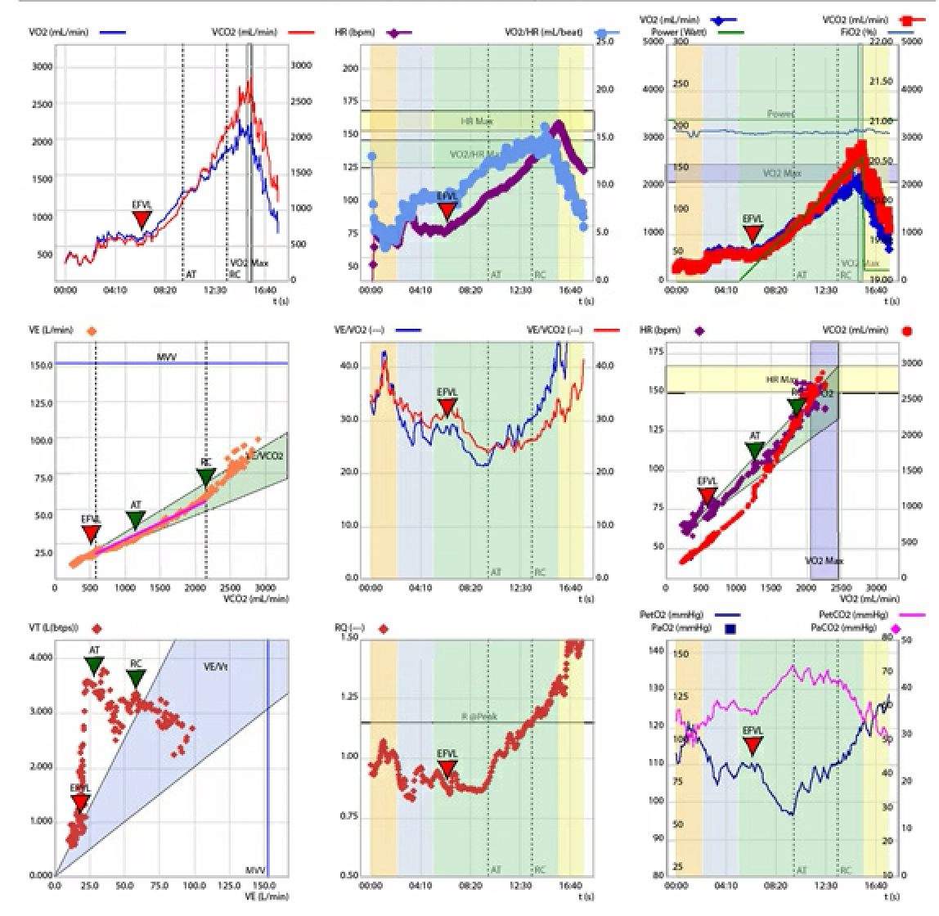

Traditional 9 panel plot of a control participant exhibiting good exercise tolerance.
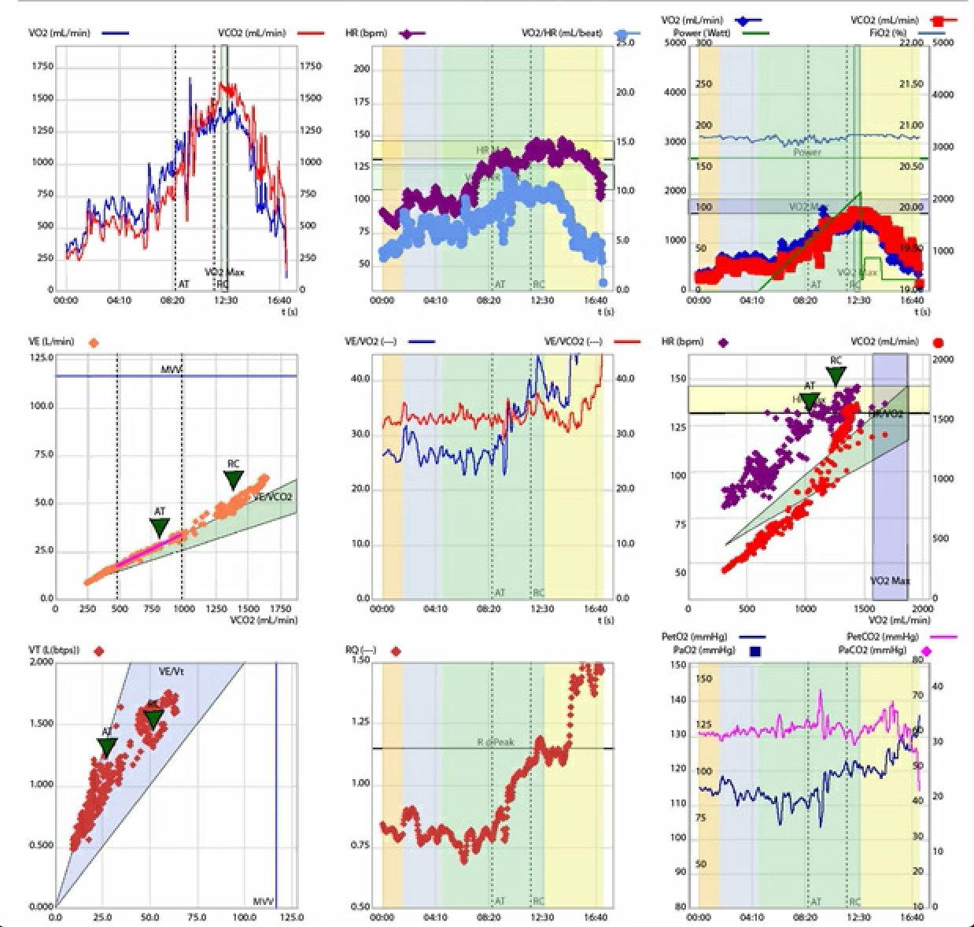

Traditional 9 panel plot of a patient with moderate aortic stenosis exhibiting reduced exercise tolerance

