Supplementary figures
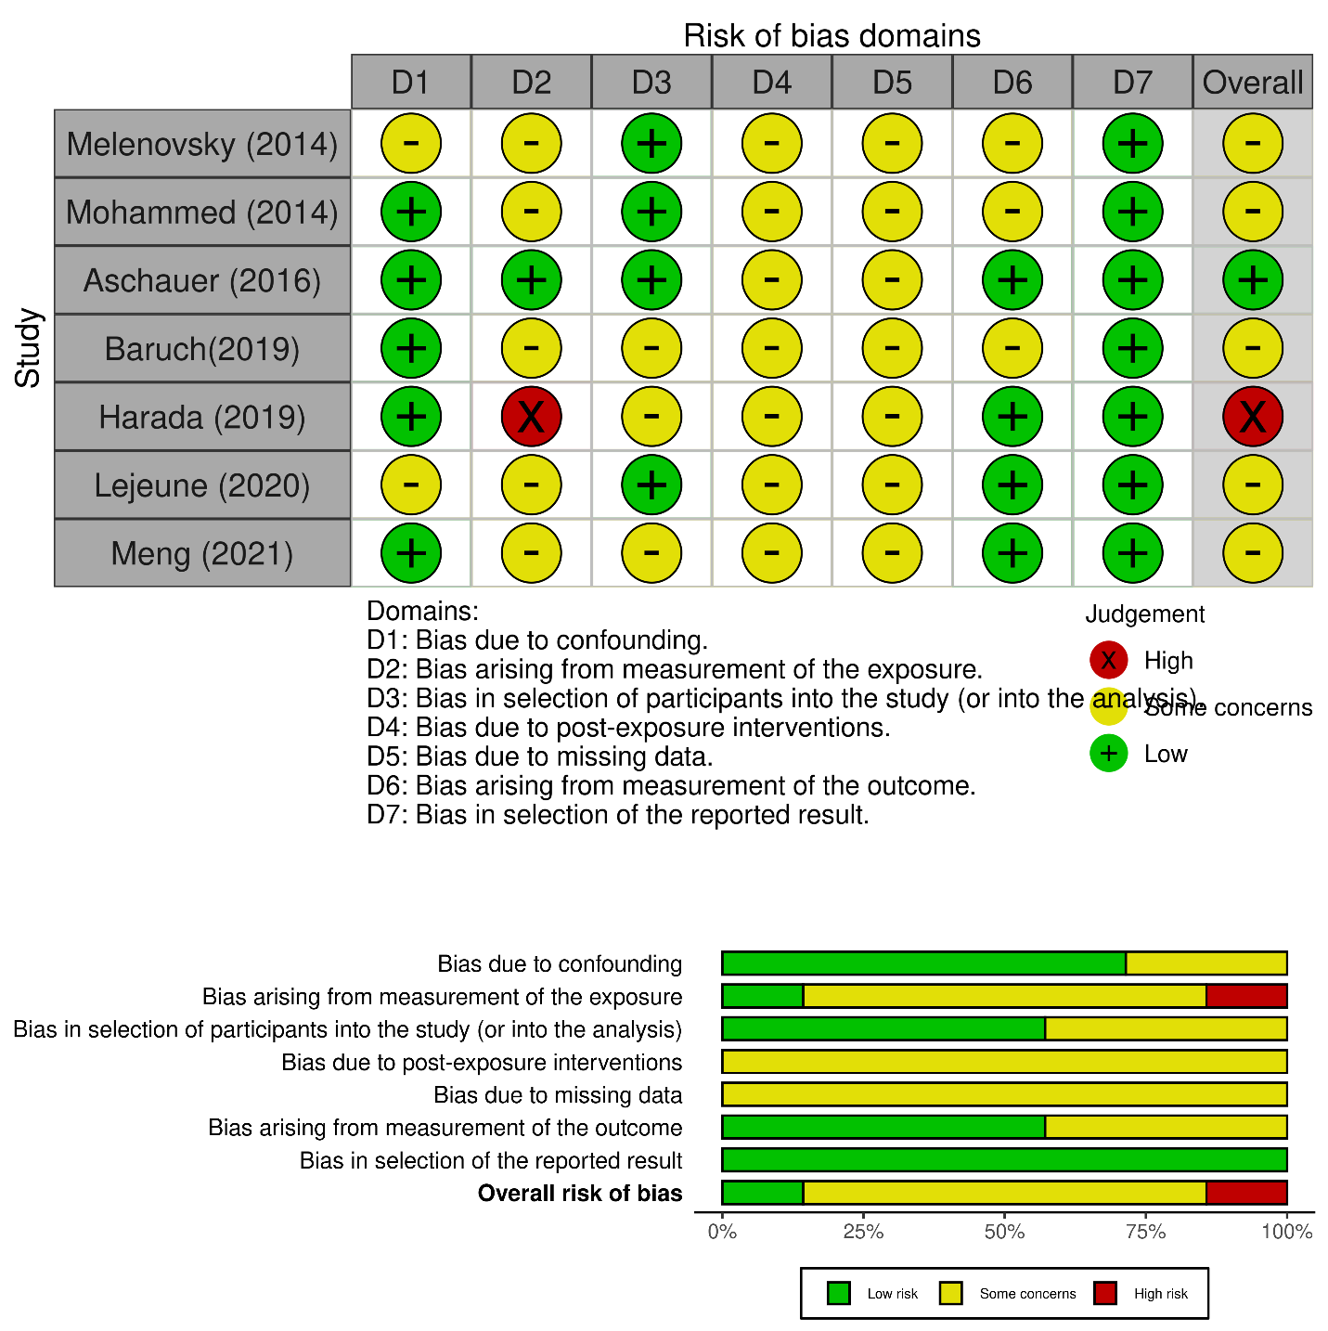

Supplementary Figure 1- The summary of risk of bias assessment using the ROBINS-E tool

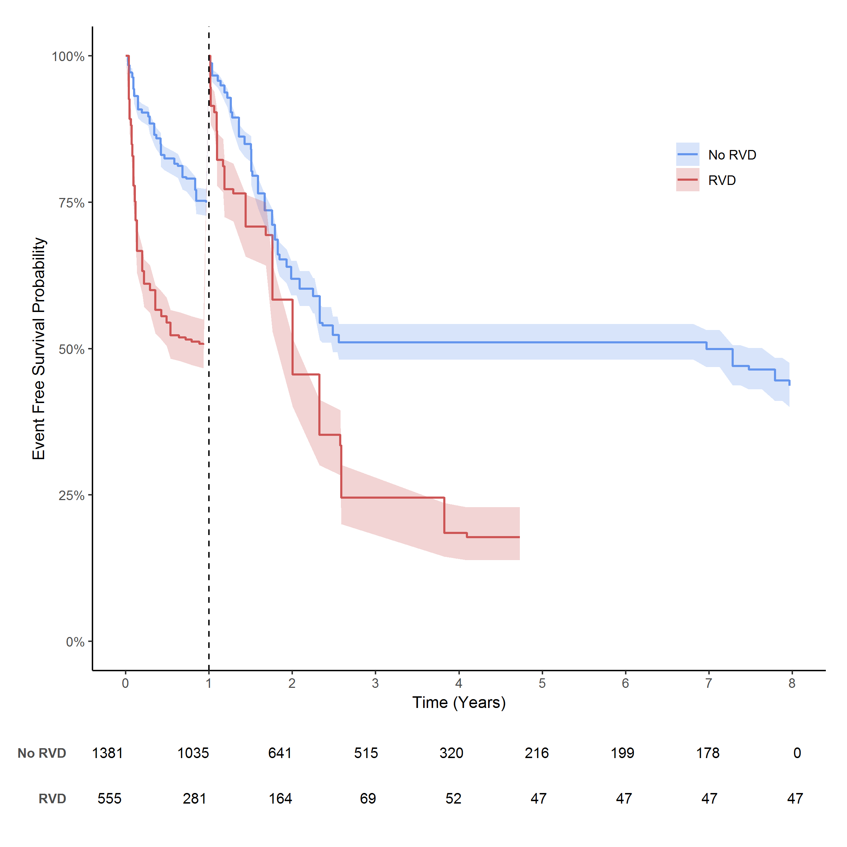
Supplementary Figure 2- One-year landmark analysis. In the first year of follow-up, the event-free survival in patients with RVD dropped more sharply compared to patients without RVD.

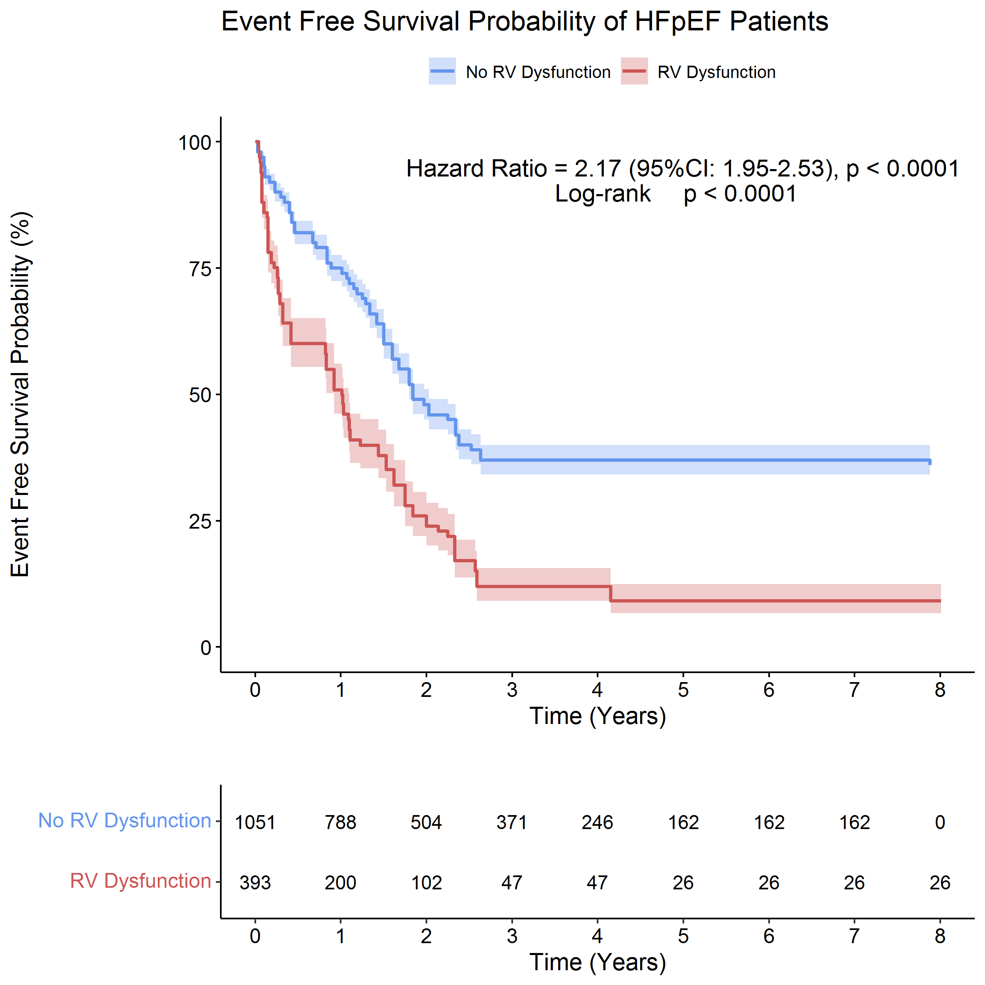

Supplementary Figure 3- Subgroup analysis on event-free survival in studies defined RVD with echocardiographic parameters. The results show a significant difference between patients with and without RVD.

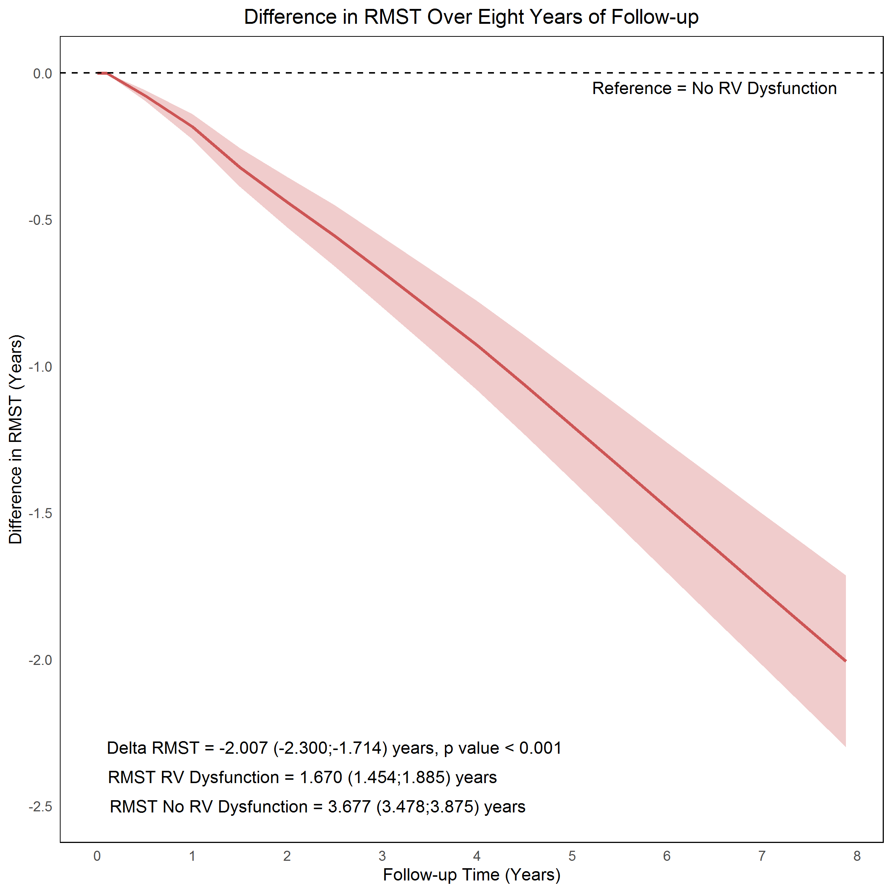

Supplementary Figure 4- The difference trend in Restricted Mean Survival Time over eight years of follow-up between patients with and without right ventricular dysfunction in subgroup patients with an echocardiographic definition of RVD.

