Use of Oxiris membrane in real-world clinical practice in critical care patients: a multicenter observational study from the Italian OxirisNet registry
Gianluca Villa^{1,2,*}, Antonio Fioccola¹, Matteo Cecchi², Caterina Scirè Calabrisotto², Diego Pomarè Montin², Silvia De Rosa^{3,4}, Giulia Scoccia⁵, Andrea Manno⁵, Lorenzo Tofani⁶, Clemente Santorsola⁷, Francesco Patera⁸, Alessandro Capitanini⁹, Marco Vittorio Resta¹⁰, Fiorenza Ferrari¹¹, Massimiliano Greco¹², Fabrizio Rossi¹³, Zaccaria Ricci^{2,14}, Claudio Ronco¹⁵, Stefano Romagnoli^{1,2}, on behalf of the OxirisNET registry working group^{ζ}

Supplementary material

Index

Page

Appendix I………………………………………………………………………………………………………3
Table S1……………………………………………………………………………………………………………6
Table S2……………………………………………………………………………………………………………7
Figure S1………..…………………………………………………………………………………………………8
Figure S2……………………………………………..……………………………………………………………9
Figure S3………………………………………………..………………………………………………………..10
Figure S4………………………………………………..………………………………………………………..11

Appendix I. The OxirisNET registry working group. The authors have been listed in alphabetic order.
Alessio Altomare³⁵; Marco Anderloni²⁸; Elena Angeli²; Andrea Ballin¹⁸; Matteo Brivio²⁴; Paolo Boninsegni²²; Vittorio Bocciero¹; Francesco Caccavale²¹; Alessandro Capitanini9; Matteo Cecchi¹; Carlo Coniglio³³; Francesco Coppolino²³; Alberto Corona⁷; Luigi d'Auria11; Silvia De Rosa^{3;4}; Luca di Girolamo¹⁰; Katia Donadello^{27;28}; Elena Fanfani²²; Fiorenza Ferrari¹¹; Antonio Fioccola¹; Lorenzo Fontanarosa²; Ilaria Godi¹⁸; Leonardo Gottin^{28;37}; Massimiliano Greco¹²; Glauco Salvatore Juliano³⁶; Sergio Lassola⁴; Francesco Magiotti¹; Raffaele Mandarano¹⁹; Andrea Manno⁵; Emilpaolo Manno¹⁷; Paola Marino³¹; Gaetano Mautone¹⁰; Tommaso Meconi²⁰; Santo Morabito³⁴; Giuseppe Olivo¹⁹; Maria Caterina Pace²³; Francesco Patera⁸; Vittorio Pavoni²⁰; Valentina Pistolesi³⁴; Diego Pomarè Montin¹; Vincenzo Pota²³; Federico Prato²⁹; Marco Vittorio Resta¹⁰; Zaccaria Ricci^{1;13}; Stefano Romagnoli^{1;2}; Claudio Ronco^{14;15}; Fabrizio Rossi⁵; Giuseppe Rotondo¹⁷; Sara Samoni¹; Pasquale Sansone²³; Clemente Santorsola⁷; Caterina Scirè Calabrisotto¹; Giulia Scoccia⁵; Daniela Sechi³²; Gianluca Spinelli¹⁰; Marco Tengattini³⁰; Eleonora Terreni¹; Marika Claire Theriault¹⁶; Ivo Tiberio¹⁸; Lorenzo Tofani⁶; Franco Turani^{25;26}; Gianluca Villa^{1;2}; Brunilda Xhaferi⁹.

Affiliations
- Department of Health Sciences, Section of Anesthesiology, Intensive Care and Pain Medicine, University of Florence, Florence, Italy
- Department of Anesthesia and Intensive Care, Section of Oncological Anesthesia and Intensive Care, AOU Careggi, Florence, Italy
- Centre for Medical Sciences - CISMed, University of Trento, Trento, Italy
- Anesthesia and Intensive Care, Santa Chiara Hospital, APSS Trento, Italy
- Department of Information Engineering, Computer Science and Mathematics, Center of Excellence DEWS, University of L'Aquila, L'Aquila, Italy
- Department of Statistics, Computer Science, Applications, University of Florence, Florence, Italy.
- Accident and Emergency and Anaesthesia and Intensive Care Medicine Department, Esine and Edolo Hospitals, ASST Valcamonica, Brescia, Italy
- Department of Internal Medicine, Division of Nephrology, Dialysis and Transplantation, Santa Maria Della Misericordia Hospital, Perugia, Italy
- Unit of Nephrology, San Jacopo Hospital, Pistoia, Italy.
- Unit of General Anesthesia and Intensive Care, IRCCS Polyclinic San Donato, San Donato M.se Milan, Italy
- Department of Anesthesia and Intensive Care Unit, I.R.C.C.S., San Matteo Hospital and University of Pavia, Pavia, Italy
- Department of Anesthesiology and Intensive Care, Humanitas University, IRCCS Humanitas Research Hospital, Rozzano, Italy
- Department of Anesthesia and Critical Care, Meyer Children’s Hospital, IRCCS, Florence, Italy
- International Renal Research Institute of Vicenza (IRRIV), San Bortolo Hospital, Vicenza, Italy
- Department of Medicine, University of Padua, Padua, Italy
- UOC Anesthesia and Reanimation, Cristo Re Hospital, Roma, Italy
- S.C. Anesthesia and Reanimation, Maria Vittoria Hospital, ASL Città di TorinoTurin, Italy
- Department of Anesthesiology and Intensive Care, Padua University Hospital, Padua, Italy
- Division of General Cardiology, Department of Cardiothoracovascular Medicine, Careggi Teaching Hospital, Florence, Italy
- Anesthesia and Intensive Care Unit, Emergency Department and Critical Care Area, Santa Maria Annunziata Hospital, Bagno a Ripoli, Florence, Italy.
- Critical Care Medicine and Anaesthesiology, Intensive Care Unit, Department of Emergency, Sacro Cuore di Gesù Hospital, Benevento, Italy.
- SOC Anesthesia e Reanimation, San Giovanni di Dio Hospital, Florence, Italy
- Department of Woman, of Child, and General and Speciality Surgery, Luigi Vanvitelli University of Campania, Naples, Italy
- Emergency and Critical Care Medicine Department, Papa Giovanni XXXIII Hospital, Bergamo, Italy
- Intensive Unit Care, Aurelia Hospital, Roma, Italy
- Intensive Unit Care, European Hospital, Roma, Italy
- Anesthesia and Reanimation B BR, AOUI-University Hospital Integrated Trust of Verona, Verona
- Department of Surgery, Dentistry, Gynecology and Paediatrics, University of Verona, Verona
- Intensive Care Unit, Department of Emergency Medicine, Maggiore della Carità University Hospital, Novara, Italy
- Intensive Care Unit, ASL BI –Degli Infermi Hospital, Ponderano, Biella, Italy
- Postoperative Intensive Care Unit, San Giovanni Addolorata Hospital, Roma, Italy
- Intensive Care Unit, SS Annunziata Hospital, Sassari, Italy
- ICU Department, Maggiore Hospital, Bologna, Italy
- Hemodyalysis Unit Department of Internal Medicine and Medical Specialties, AOU POliclinico Umberto I, Roma, Italy
- Department of Medicine and Surgery, University of Milan Milan, Italy
- Department of Anesthesia and Intensive Care Unit, IRCCS Centro Cardiologico Monzino, Milano, Italy
- Cardio-Thoracic Anaesthesia and Intensive Care, AOUI-University Hospital Integrated Trust of Verona, Verona

Table S1 Association between overtime trends of patients’ clinical variables during the first three days of treatment and short-term mortality

 | Absolute value |  | Time |  | Interaction (x 1 hour)
 | OR [95% CI] | p | OR [95% CI] | p | OR [95%CI] | p
SOFA score | 1.17 [1.10 – 1.25] | < 0.0001 | 0.96 [0.93 – 0.98] | 0.004 | 1.01 [1.01 – 1.02] | 0.03
PaO₂/FiO₂ ratio | 0.98 [0.98 – 0.99] | < 0.0001 | 1.00 [0.98 – 1.02] | 0.76 | 0.99 [0.99 – 0.99] | 0.05
A-aO₂ gradient | 1.01 [1.01 – 1.01] | < 0.0001 | 0.96 [0.94 – 0.98] | < 0.0001 | 1.01 [1.01 – 1.01] | 0.002
MAP | 0.97 [0.96 – 0.99] | 0.0008 | 1.04 [1.01 – 1.07] | 0.05 | 0.99 [0.99 – 0.99] | 0.005
VIS | 1.01 [1.01 – 1.01] | 0.0003 | 1.00 [0.99 – 1.01] | 0.08 | 0.99 [0.99 – 0.99] | 0.21
Creatinine  Urine Output | 0.93 [0.84 – 1.03]  1.01 [0.94 – 1.06] | 0.21  0.82 | 0.98 [0.97 – 0.99]  0.97 [0.97 – 0.98] | 0.0009  < 0.0001 | 1.00 [0.99 – 1.01]  0.99 [0.99 – 1.00] | 0.82  0.33
Bilirubin | 1.23 [1.03 – 1.46] | 0.02 | 0.97 [0.96 – 0.98] | < 0.0001 | 1.01 [1.01 – 1.01] | 0.01
Platelets | 0.99 [0.99 – 0.99] | 0.05 | 0.98 [0.97 – 0.99] | 0.008 | 1.00 [1.00 – 1.00] | 0.35
GCS | 0.90 [0.84 – 0.96] | 0.002 | 0.98 [0.97 – 0.99] | 0.05 | 1.00 [0.99 – 1.01] | 0.36
Lactate | 1.41 [1.07 – 1.86] | 0.01 | 0.96 [0.94 – 0.98] | 0.0003 | 1.01 [1.01 – 1.02] | 0.01
WBC | 1.00 [0.98 – 1.02] | 0.84 | 0.97 [0.96 – 0.98] | < 0.0001 | 1.01 [1.01 – 1.01] | 0.03
PCT | 1.00 [0.99 – 1.01] | 0.86 | 0.97 [0.96 – 0.98] | < 0.0001 | 1.01 [1.01 – 1.01] | 0.007
CRP | 1.00 [0.99 – 1.02] | 0.30 | 0.97 [0.96 – 0.98] | < 0.0001 | 1.01 [1.01 – 1.01] | 0.05
PaCO₂ | 1.05 [1.03 – 1.07] | < 0.0001 | 0.97 [0.94 – 0.99] | 0.05 | 0.99 [0.99 – 1.00] | 0.51
pH | 0.001 [0.0002 – 0.01] | < 0.0001 | 1.61 [0.87 – 2.35] | 0.16 | 0.98 [0.94 – 1.02] | 0.14
Bicarbonates | 0.96 [0.91 – 1.01] | 0.16 | 1.02 [0.98 – 1.07] | 0.24 | 0.99 [0.99 – 1.00] | 0.06

Table S1. Output of multiple logistic regression analysis used to explore differences in overtime trends of patients’ clinical variables during the first three days. Legends: OR, Odds Ratio; CI, Confidence Intervals; SOFA, Sequential Organ Failure Assessment; PaO₂/FiO₂ ratio, ratio of arterial partial pressure of oxygen on inspired fraction of oxygen; A-aO₂ gradient, alveolo-arterial gradient of oxygen; MAP, Mean Arterial Pressure; VIS, Vasoactive Inotropic Score; GCS, Glasgow Coma Score; WBC, White Blood Cell count; PCT, procalcitonin; CRP, C-Reactive Protein; PaCO₂, arterial partial pressure of carbon dioxide; pH, potential of hydrogen.

Table S2 Most relevant features (with relative loading > 0.1 in absolute value) determining the three principal components.
Features | Loading
PC-1
ICU admission for Kidney support | 0.3100
Renal support for acid-base correction | 0.2337
Renal support for metabolic burden control | 0.2290
Cognitive impairment | 0.2212
Mechanical ventilation | -0.2152
Postoperative admission | 0.2085
Renal support for uremic control | 0.1929
Abdominal infection | 0.1848
ICU admission for Cardiovascular support | 0.1829
PC-2
Postoperative admission | -0.3017
Vasopressor requirements | -0.2858
Norepinephrine dose | -0.2806
ICU admission for Cardiovascular support | -0.2506
Renal support for fluid overload | -0.2318
Abdominal infection | -0.2162
Cognitive impairment | 0.2181
Mechanical ventilation | -0.1808
Chronic kidney disease | 0.1474
Renal support for metabolic burden control | -0.1299
PC-3
Renal support for uremic control | -0.3932
Postoperative admission | 0.3749
Respiratory infection | -0.2917
Renal support for acid-base correction | -0.2855
Renal support for metabolic burden control | -0.2002
Abdominal infection | 0.1927
Renal support for fluid overload | -0.1680
Urea (mg/dl) | -0.1173

Table S2. Most relevant features determining the three principal components. Legends: PC, Principal Component; ICU, Intensive Care Unit; mg, milligrams; dl, deciliters.

Figure S1 Overtime trends of adjunctive clinical variables during extracorporeal blood purification.
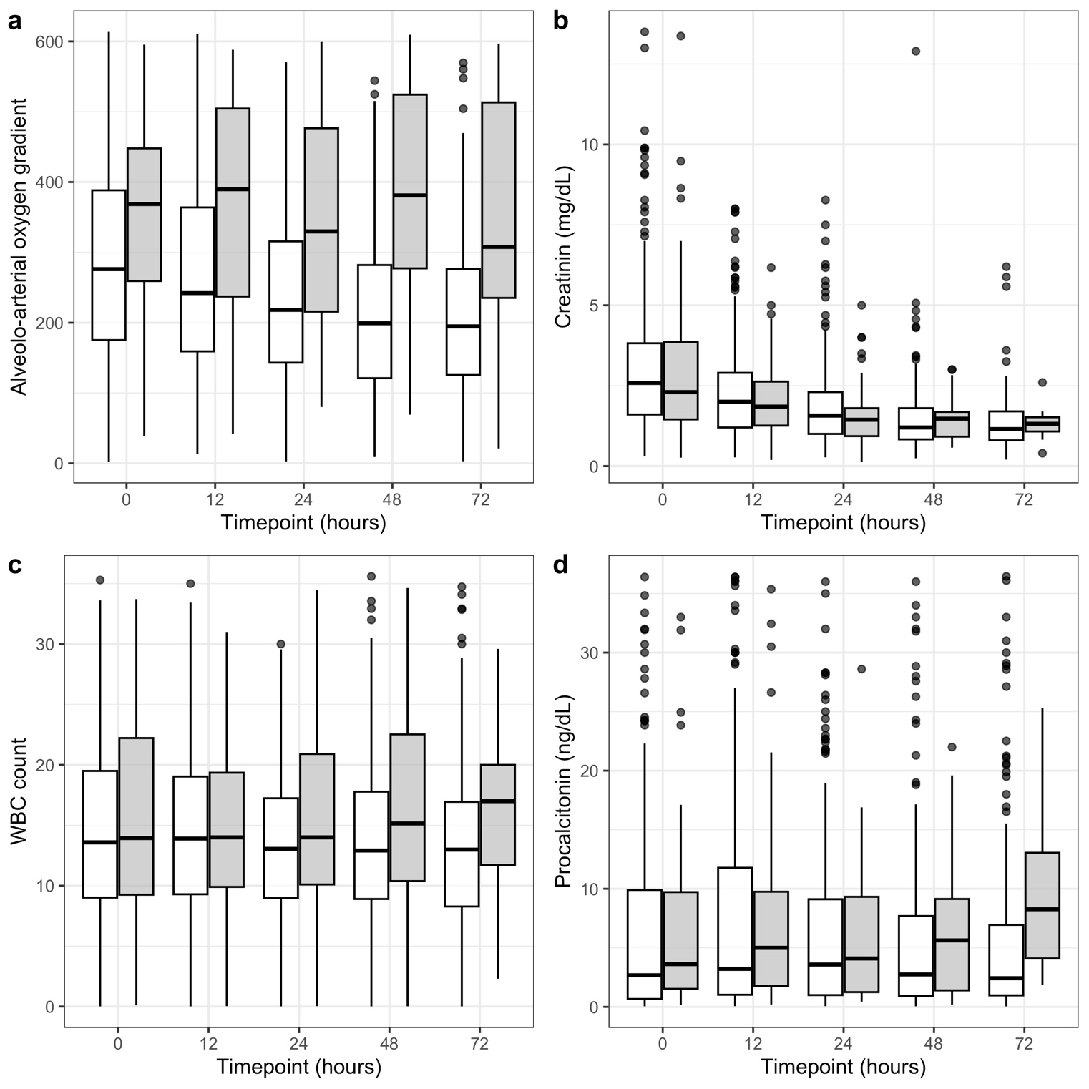
Figure S1. Overtime trends of adjunctive clinical variables during extracorporeal blood purification. Panel a: Alveolo-arterial oxygen gradient; Panel b: Creatinine (mg/dL); Panel c: WBC count; Panel d: Procalcitonin (ng/dL).

Figure S2 Principal components distribution among clusters.
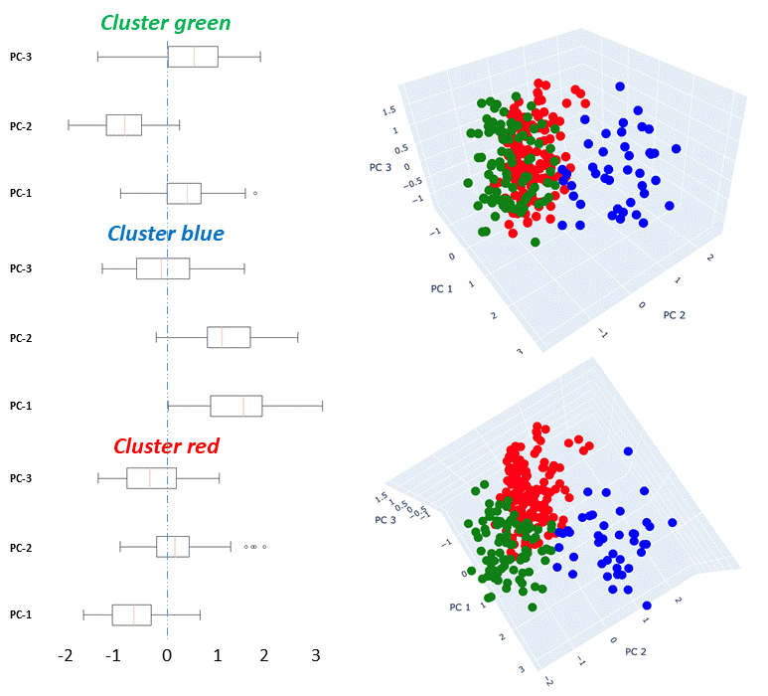
Figure S2. Box-plots (left) display the distribution of the three principal components (PC1–PC3) across the Green, Blue, and Red clusters. Scatter plots (right) show the three-dimensional representation of patients in the principal component analysis (PCA) space, with each point corresponding to an individual patient colored according to cluster assignment. This visualization highlights the separation between clusters and the relative contribution of principal components to patient stratification.

Figure S3 SOFA Score at EBP initiation for patients in each cluster.
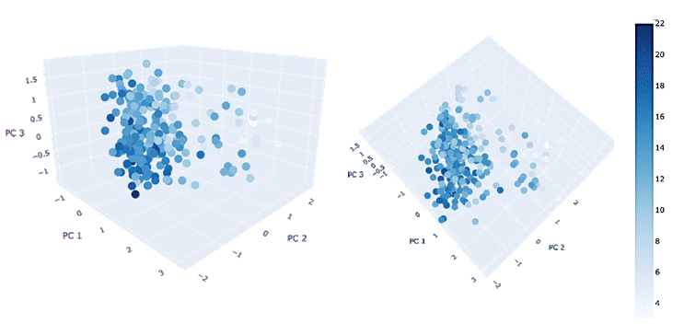
Figure S3. SOFA Score at EBP initiation for patients in each cluster. This figure presents the Sequential Organ Failure Assessment (SOFA) score at the initiation of extracorporeal blood purification (EBP) for patients within the identified clusters. The observed 4-day mortality rates after EBP initiation for each cluster were: 16.70% for the Blue Cluster, 30.8% for the Red Cluster, and 21.3% for the Green Cluster. Legends: EBP, Extracorporeal Blood Purification; SOFA, Sequential Organ Failure Assessment.

Figure S4 SOFA score variation over time.
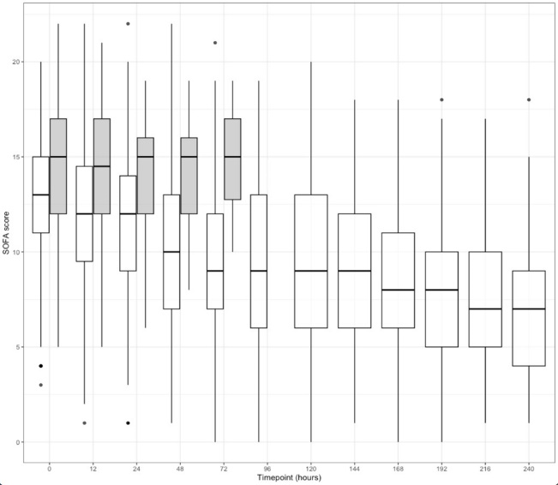
Figure S4. Box-plots represent Sequential Organ Failure Assessment (SOFA) scores at serial timepoints in survivor patients (white boxes) and non-survivor patients (grey boxes). Non-survivors are reported up to 96 hours from treatment start, consistent with the Methods.

