Figure S1. CONSORT flow diagram
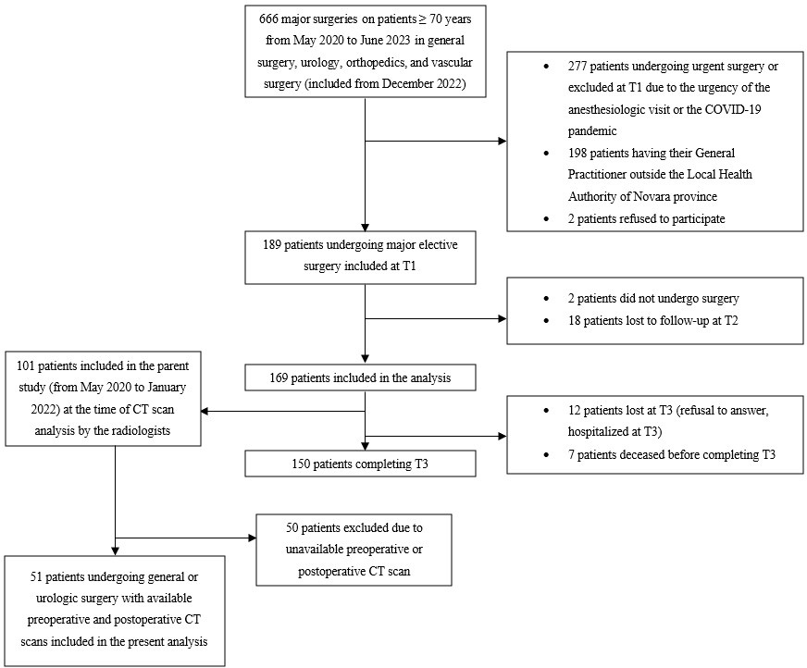

Flow diagram depicting patient inclusion in the parent study and the reasons for exclusion (right), as well as patient inclusion in the present analysis (left). Patients for whom either preoperative or postoperative CT scans were unavailable were excluded from the analysis.
Abbreviations: COVID-19: coronavirus disease 2019.

Methods
Computed tomography (CT) examinations were performed using a Philips Ingenuity 128-slice CT scanner. Images were reconstructed with a slice thickness of 5 mm. To reduce potential beam-hardening artifacts related to metallic materials, the Metal Artifact Reduction for Orthopedic Implants (O-MAR) technique was used when appropriate. Muscle attenuation measurements were performed on the venous phase of the CT examination, acquired 70 seconds after intravenous administration of iodinated contrast medium (Iomeron 400 mg/mL). The reference range for post-contrast muscle attenuation was established based on measurements obtained in healthy individuals with preserved muscle mass, in whom attenuation values ranged from 50 to 60 Hounsfield units (HU). Both preoperative and postoperative CT protocols included a baseline non-contrast acquisition followed by the venous-phase acquisition described above. Manual segmentation of the psoas muscle was performed at the level of the L3 vertebral body using standard orthogonal planes. Measurements were independently performed by two readers with different levels of experience. The first reader was an experienced radiologist with five years of experience in body imaging, while the second reader was a third-year radiology resident. Both readers were blinded to the main clinical and procedural variables of the study, including the type of surgical procedure, the interval between surgery and CT acquisition, the overall duration of hospitalization, and the measurements obtained by the other observer.

Table S1. Postoperative Complications Experienced by the Patients
All patients
N=51
Postoperative complications, patients, N (%) | 22 (43)
Postoperative complications, events, N (%) | N=30
Class I  Class II  Class III  Class IV  Class V | 0  12 (40)  10 (33)  6 (20)  2 (7)
Complications, N (%)
Pulmonary embolism  Bleeding  Anastomotic dehiscence  Gastrointestinal occlusion/ischemia  Pancreatitis  Sepsis  Death before hospital discharge | 2  12  5  4  3  2  2

Abbreviations: N: number

Table S2. Univariable regression analysis assessing the impact of preoperative low TPI on postoperative outcomes
Variables | Postoperative complications  (yes vs no) |  | ICU admission  (yes vs no) |  | Hospital length of stay (days)
 | RR | 95%CI | RR | 95%CI | β (SE) | 95%CI
Preoperative low TPI | 1.58 | (0.41 to 6.1) | 0.37 | (0.04 to 3.33) | -3.87 (3.66) | (-11.23 to 3.49)

Relative risks (RRs) and 95% confidence intervals (CIs) are reported for postoperative complications and ICU admission. For hospital length of stay, results are reported as linear regression coefficients (β), standard errors (SEs), and 95% CIs. Low TPI was defined as a TPI below the sex-specific 25th percentile of the study population at preoperative CT scan.
Abbreviations: CI: confidence interval; ICU: intensive care unit; p: p-value; RR: relative risk.

Table S3. Univariable and multivariable linear regression analyses of factors associated with the magnitude of the change in TPI from preoperative to postoperative CT
Variables | Postoperative TPI reduction
 | β | 95% CI | β | 95% CI
Sex (M vs F) | 0.24 | -0.18; 0.66 | 0.25 | -0.26; 0.76
Type of surgery
Lower digestive tract vs urologic | -0.30 | -0.79; 0.19 | -0.13 | -0.61; 0.35
Upper digestive tract vs urologic | 0.01 | -0.55; 0.56 | -0.29 | -0.95; 0.37
Postoperative complications (yes vs no) | 0.05 | -0.40; 0.50 | -0.28 | -0.76; 0.20
ICU admission (yes vs no) | 0.67 | 0.12; 1.23 | 0.55 | -0.12; 1.22
Hospital length of stay (days) | 0.02 | 0.01; 0.04 | 0.01 | -0.01; 0.03
Comorbidities (yes vs no) | -0.67 | -1.45; 0.12 | -0.46 | -1.20; 0.28
Anesthesia duration, minutes | 0.00 | 0.00; 0.00 | 0.00 | 0.00; 0.00
Pre-operative TPI, cm²/m² | 0.31 | 0.14; 0.49 | 0.35 | 0.13; 0.58
Time from surgery to postoperative CT, months | 0.51 | 0.18; 0.83 | -0.01 | -0.03; 0.02

Table S3 reports the univariable and multivariable linear regression analyses of demographic, clinical, surgical, and perioperative factors associated with the magnitude of postoperative TPI reduction. Regression coefficients (β) and 95% confidence intervals (CIs) are presented.
Abbreviations: CI: confidence interval; CT: computed tomography; F: female; ICU: intensive care unit; M: male; p: p-value; TPI: total psoas index.

