Additional file 3. Satterplots with a quadratic curve between cardiometabolic health markers which showed to have U-shaped relationship between 7-day SD of bedtime in data from 3,698 middle-aged birth cohort participants.

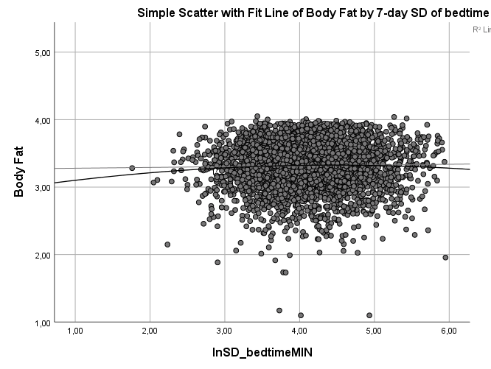

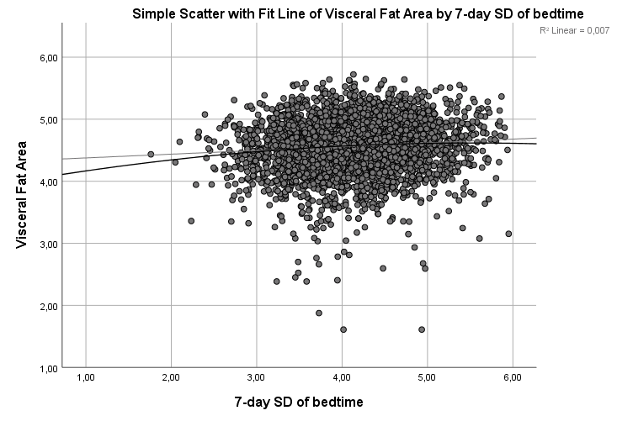

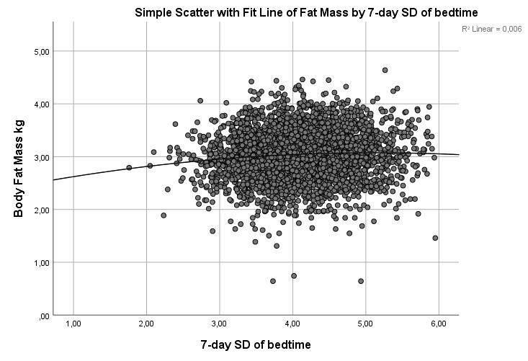

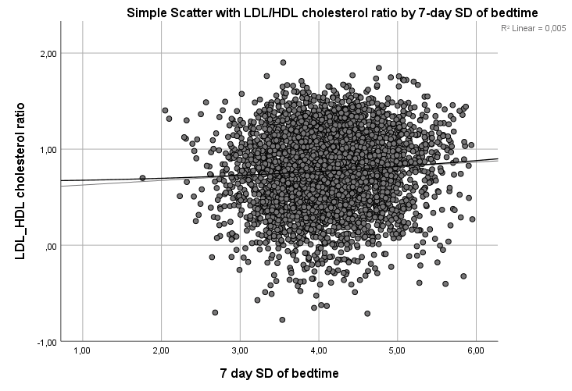

Suppl. Material. Scatterplots with a quadratic curve between cardiometabolic health markers which showed to have U-shaped relationship between 7-day SD of wake-up time in data from 3,698 middle-aged birth cohort participants.

