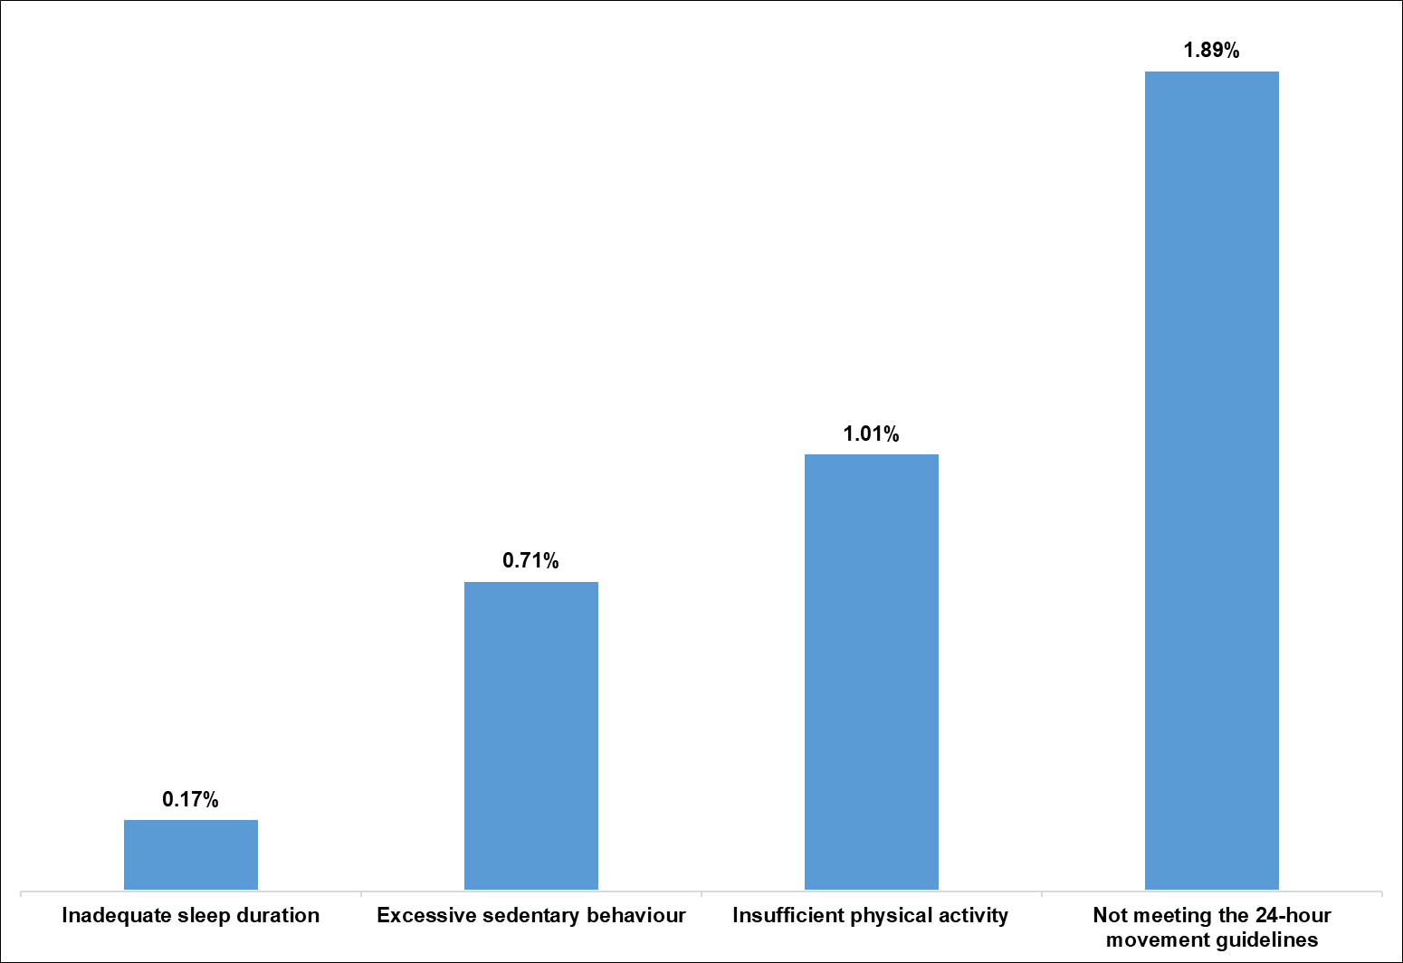
Supplementary figure 2. Direct costs of movement behaviours in Canada expressed as the percentage of national healthcare cost

