Supplemental 1: Broad app categorisation based on Google Play Store genreId classifications

R script:

df <- df %>%
mutate(
app_category = case_when(
grepl("^GAME_", app_category) ~ "Games", # Takes all genreIds that start with Game
app_category %in% c("VIDEO_PLAYERS") ~ "Video Players (e.g. YouTube)",
app_category %in% c("ENTERTAINMENT", "COMICS", "MUSIC_AND_AUDIO",
"BOOKS_AND_REFERENCE", "SPORTS") ~ "Entertainment",
app_category %in% c("LIFESTYLE", "BEAUTY", "FOOD_AND_DRINK",
"HOUSE_AND_HOME", "PARENTING", "SHOPPING",
"NEWS_AND_MAGAZINES") ~ "Lifestyle",
app_category %in% c("SOCIAL", "COMMUNICATION", "DATING", "EVENTS") ~ "Social & Communication",
app_category %in% c("BUSINESS", "FINANCE", "PRODUCTIVITY",
"TOOLS", "PERSONALIZATION", "ART_AND_DESIGN",
"AUTO_AND_VEHICLES", "PHOTOGRAPHY") ~ "Productivity & Business",
app_category %in% c("HEALTH_AND_FITNESS", "MEDICAL") ~ "Health",
app_category == "EDUCATION" ~ "Education",
app_category %in% c("TRAVEL_AND_LOCAL", "MAPS_AND_NAVIGATION", "WEATHER") ~ "Travel & Local",
# If none of the above match or genreId is NA, categorize as NA (shouldn't happen)
TRUE ~ NA
)
)

Supplemental 2: Participant-level distributions of the percentage of smartphone use occurring during inactive (grey) and active (green) non-sedentary behaviour across valid days. Values represent the percentage of each participant’s total smartphone use occurring in each behavioural context. Horizontal lines denote medians and diamonds denote means; boxes represent interquartile ranges and whiskers indicate the 5th and 95th percentiles. Group boxplots to the right of each figure summarise the distribution of participant-level medians at the group level.
Inactive behaviour:
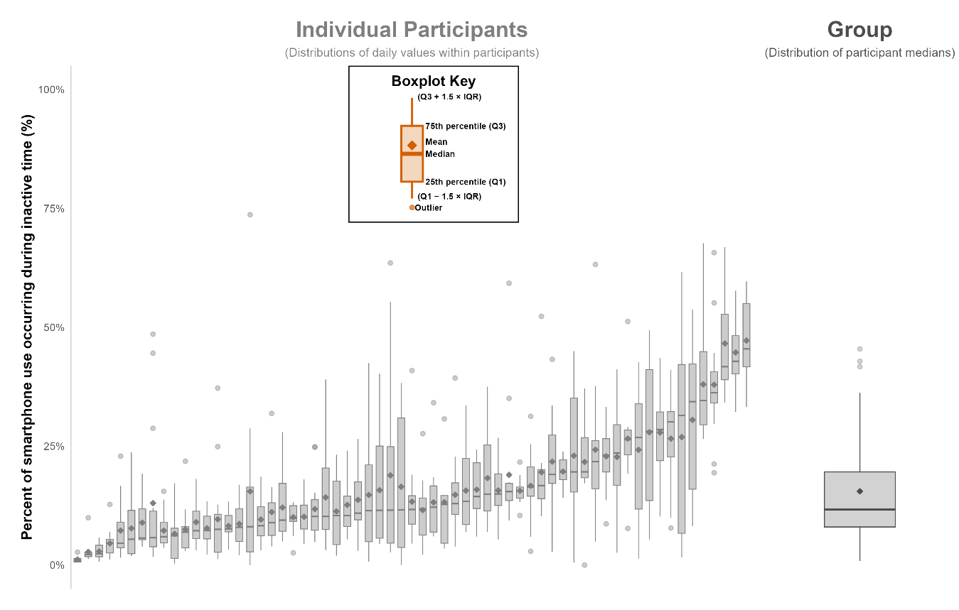
Active behaviour:
