Table S1
Unadjusted Associations With Meeting Overall Movement Behaviour Guidelines and Individual
Recommendations by Demographics
Movement guideline | Demographic variable | Coefficient (B) | SE | OR (95% CI)
Overall guidelines | Sex
Overall guidelines | Male ª
Overall guidelines | Female | 0.09 | 0.18 | 1.10 (0.78, 1.55)
Overall guidelines | Location
Overall guidelines | Urban | 0.22 | 0.18 | 1.26 (0.89, 1.79)
Overall guidelines | Rural ª
Overall guidelines | Age | -0.02 | 0.01 | 0.98 (0.95, 1.00)
Overall guidelines | Parental education
Overall guidelines | Tertiary/university education ª
Overall guidelines | Other | -0.71 | 0.23 | 0.49 (0.31, 0.77)
Overall guidelines | Racial background
 | White (e.g., European descent) | -0.11 | 0.21 | 0.90 (0.60, 1.36)
 | Other ª
Sleep (accelerometer-estimated) | Sex
Sleep (accelerometer-estimated) | Male ª
Sleep (accelerometer-estimated) | Female | 0.15 | 0.18 | 1.16 (0.81, 1.66)
Sleep (accelerometer-estimated) | Location
Sleep (accelerometer-estimated) | Urban | -0.31 | 0.19 | 0.73 (0.51, 1.06)
Sleep (accelerometer-estimated) | Rural ª
Sleep (accelerometer-estimated) | Age | -0.04 | 0.01 | 0.96 (0.93, 0.98)
Sleep (accelerometer-estimated) | Parental education
Sleep (accelerometer-estimated) | Tertiary/university education ª
Sleep (accelerometer-estimated) | Other | -0.13 | 0.22 | 0.88 (0.58, 1.35)
Sleep (accelerometer-estimated) | Racial background
Sleep (accelerometer-estimated) | White (e.g., European descent) | 0.17 | 0.21 | 1.19 (0.78, 1.80)
Sleep (accelerometer-estimated) | Other ª
Moderate- to-vigorous physical activity | Sex
Moderate- to-vigorous physical activity | Male ª
Moderate- to-vigorous physical activity | Female | -0.99 | 0.32 | 0.37 (0.19, 0.68)
Moderate- to-vigorous physical activity | Location
Moderate- to-vigorous physical activity | Urban | -0.23 | 0.31 | 0.80 (0.43, 1.45)
Moderate- to-vigorous physical activity | Rural ª
Moderate- to-vigorous physical activity | Age | 0.07 | 0.02 | 1.08 (1.03, 1.13)
Moderate- to-vigorous physical activity | Parental education
Moderate- to-vigorous physical activity | Tertiary/university education ª
Moderate- to-vigorous physical activity | Other | 0.13 | 0.37 | 1.13 (0.57, 2.46)
Moderate- to-vigorous physical activity | Racial background
Moderate- to-vigorous physical activity | White (e.g., European descent) | 0.25 | 0.34 | 1.28 (0.64, 2.44)
Moderate- to-vigorous physical activity | Other ª
Sedentary behaviour | Sex
Sedentary behaviour | Male ª
Sedentary behaviour | Female | 0.01 | 0.16 | 1.01 (0.73, 1.39)
Sedentary behaviour | Location
Sedentary behaviour | Urban | 0.41 | 0.17 | 1.51 (1.09, 2.09)
Sedentary behaviour | Rural ª
Sedentary behaviour | Age | -0.01 | 0.01 | 0.99 (0.96, 1.01)
Sedentary behaviour | Parental education
Sedentary behaviour | Tertiary/university education ª
Sedentary behaviour | Other | -0.77 | 0.21 | 0.46 (0.30, 0.69)
Sedentary behaviour | Racial background
Sedentary behaviour | White (e.g., European descent) | 0.05 | 0.19 | 1.05 (0.72, 1.55)
Sedentary behaviour | Other ª
Note. Unadjusted logistic regression showing the associations among demographic variables and meeting 24-hour movement guidelines (n = 627). CI = confidence interval. Sleep and physical activity are derived from accelerometer data, while sedentary time (screen time and restrained time) is based on parent report. Bolded results are significant at p < .05.
ªReference group for statistical comparisons.

Figure S1
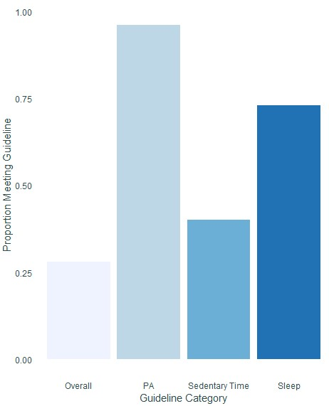
Proportion of Males Meeting Each Movement Behaviour Guideline
Note. PA = Physical Activity. Sleep and physical activity (moderate-to-vigorous and total physical activity) are derived from accelerometer data, while sedentary time (screen time and restrained time) is based on parent report.

Figure S2
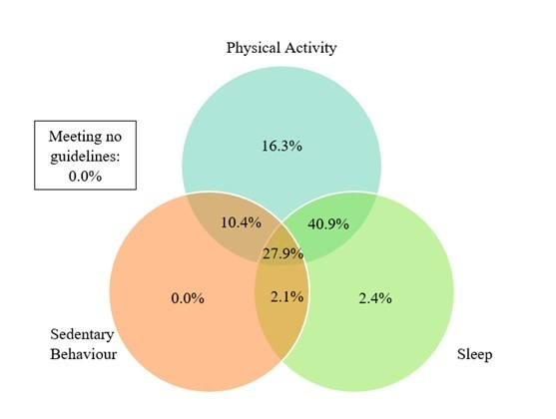
Prevalence of Males Meeting Individual and Combinations of Movement Behaviour Guidelines
Note. Sleep and physical activity (moderate-to-vigorous and total physical activity) are derived from accelerometer data, while sedentary time (screen time and restrained time) is based on parent report. Values in each circle sum to the prevalence of males meeting the respective movement behaviour guideline (sleep: 73.3%, physical activity: 95.5%, sedentary behaviour: 40.4%).

Figure S3
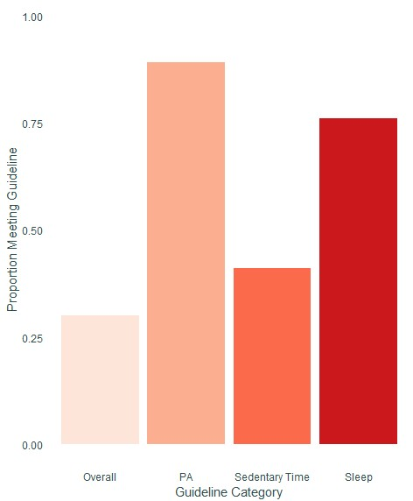
Proportion of Females Meeting Each Movement Behaviour Guideline
Note. PA = Physical Activity. Sleep and physical activity (moderate-to-vigorous and total physical activity) are derived from accelerometer data, while sedentary time (screen time and restrained time) is based on parent report.

Figure S4
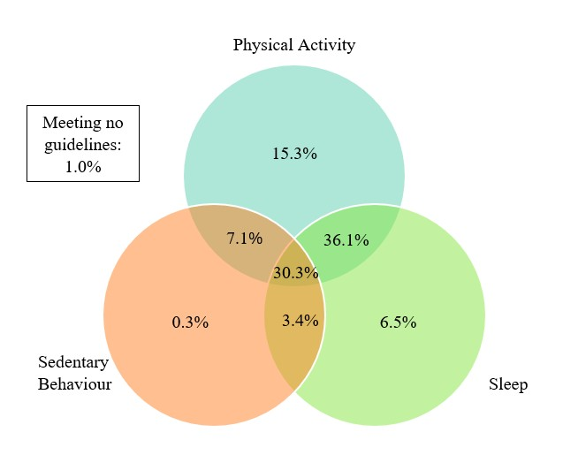
Prevalence of Females Meeting Individual and Combinations of Movement Behaviour Guidelines
Note. Sleep and physical activity (moderate-to-vigorous and total physical activity) are derived from accelerometer data, while sedentary time (screen time and restrained time) is based on parent report. Values in each circle sum to the prevalence of females meeting the respective movement behaviour guideline (sleep: 76.2%, physical activity: 88.8%, sedentary behaviour: 41.2%).

Figure S5
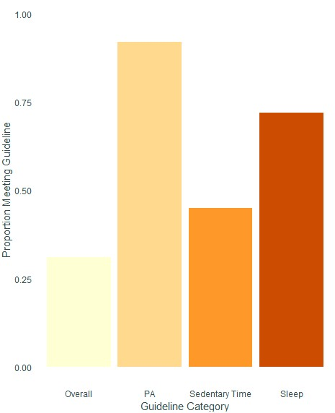
Proportion of Urban Children Meeting Each Movement Behaviour Guideline
Note. PA = Physical Activity. Sleep and physical activity (moderate-to-vigorous and total physical activity) are derived from accelerometer data, while sedentary time (screen time and restrained time) is based on parent report.

Figure S6
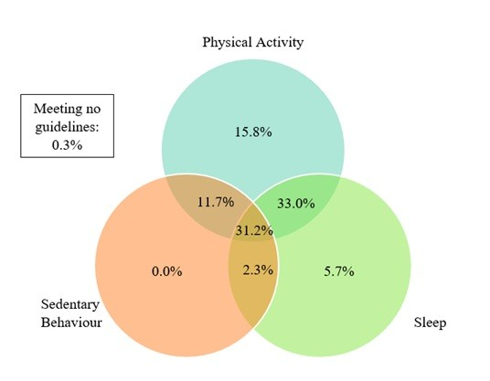
Prevalence of Urban Children Meeting Individual and Combinations of Movement Behaviour Guidelines
Note. Sleep and physical activity (moderate-to-vigorous and total physical activity) are derived from accelerometer data, while sedentary time (screen time and restrained time) is based on parent report. Values in each circle sum to the prevalence of urban children meeting the respective movement behaviour guideline (sleep: 72.2%, physical activity: 91.7%, sedentary behaviour: 45.3%).

Figure S7
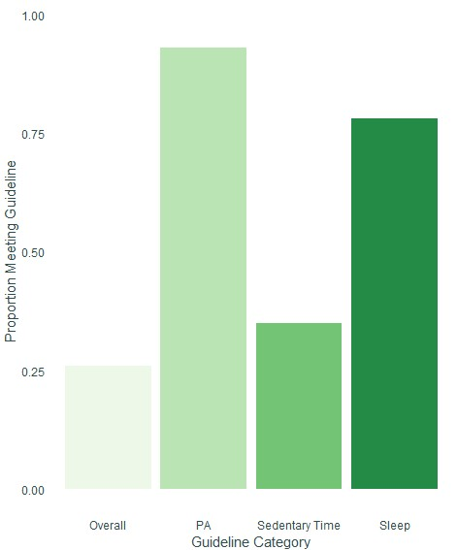
Proportion of Rural Children Meeting Each Movement Behaviour Guideline
Note. PA = Physical Activity. Sleep and physical activity (moderate-to-vigorous and total physical activity) are derived from accelerometer data, while sedentary time (screen time and restrained time) is based on parent report.

Figure S8
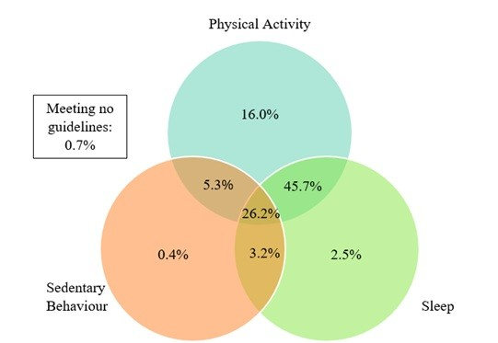
Prevalence of Rural Children Meeting Individual and Combinations of Movement Behaviour Guidelines
Note. Sleep and physical activity (moderate-to-vigorous and total physical activity) are derived from accelerometer data, while sedentary time (screen time and restrained time) is based on parent report. Values in each circle sum to the prevalence of rural children meeting the respective movement behaviour guideline (sleep: 77.7%, physical activity: 93.3%, sedentary behaviour: 35.1%).

Figure S9
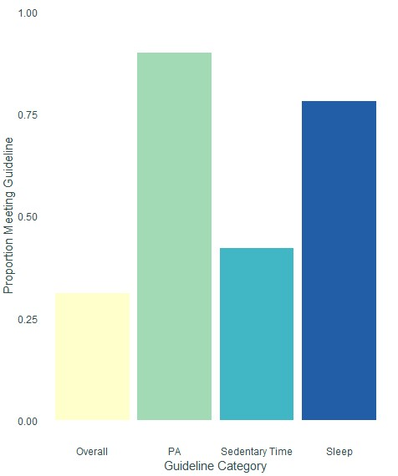
Proportion of 3-Year-Old Children Meeting Each Movement Behaviour Guideline
Note. PA = Physical Activity. Sleep and physical activity (moderate-to-vigorous and total physical activity) are derived from accelerometer data, while sedentary time (screen time and restrained time) is based on parent report.

Figure S10
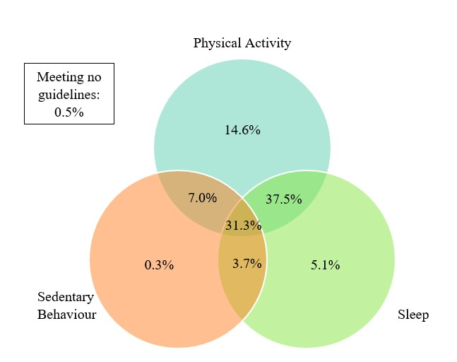
Prevalence of 3-Year-Old Children Meeting Individual and Combinations of Movement Behaviour Guidelines
Note. Sleep and physical activity (moderate-to-vigorous and total physical activity) are derived from accelerometer data, while sedentary time (screen time and restrained time) is based on parent report. Values in each circle sum to the prevalence of 3-year-old children meeting the respective movement behaviour guideline (sleep: 77.5%, physical activity: 90.4%, sedentary behaviour: 42.3%).

Figure S11
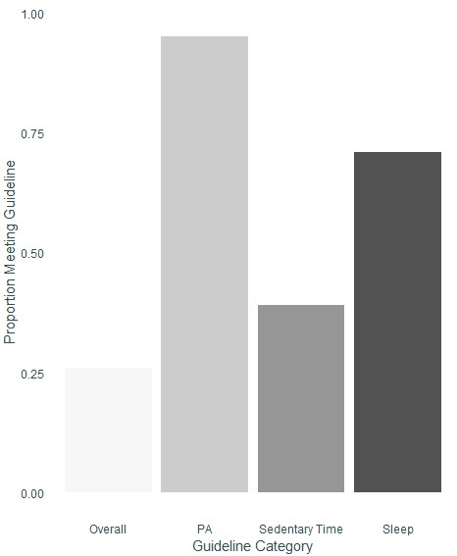
Proportion of 4-Year-Old Children Meeting Each Movement Behaviour Guideline
Note. PA = Physical Activity. Sleep and physical activity (moderate-to-vigorous and total physical activity) are derived from accelerometer data, while sedentary time (screen time and restrained time) is based on parent report.

Figure S12
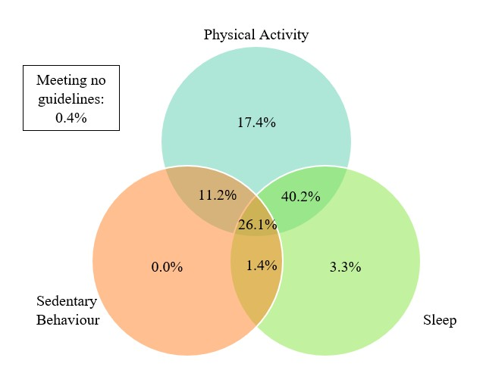
Prevalence of 4-Year-Old Children Meeting Individual and Combinations of Movement Behaviour Guidelines
Note. Sleep and physical activity (moderate-to-vigorous and total physical activity) are derived from accelerometer data, while sedentary time (screen time and restrained time) is based on parent report. Values in each circle sum to the prevalence of 4-year-old children meeting the respective movement behaviour guideline (sleep: 71.0%, physical activity: 94.9%, sedentary behaviour: 38.8%).

Table S2
Associations With Meeting Overall Movement Behaviour Guidelines and Individual Recommendations by Demographics (1 Valid Day)
Movement guideline | Demographic variable | Coefficient (B) | SE | aOR (95% CI)
Overall guidelines | Sex
Overall guidelines | Male ª
Overall guidelines | Female | 0.18 | 0.18 | 1.19 (0.84, 1.69)
Overall guidelines | Location
Overall guidelines | Urban | 0.09 | 0.19 | 1.09 (0.76, 1.57)
Overall guidelines | Rural ª
Overall guidelines | Age | -0.04 | 0.01 | 0.96 (0.94, 0.99)
Overall guidelines | Parental education
Overall guidelines | Tertiary/university education ª
Overall guidelines | Other | -0.65 | 0.24 | 0.52 (0.32, 0.82)
Overall guidelines | Racial background
 | White (e.g., European descent) | 0.05 | 0.21 | 1.05 (0.70, 1.60)
 | Other ª
Sleep (accelerometer-estimated) | Sex
Sleep (accelerometer-estimated) | Male ª
Sleep (accelerometer-estimated) | Female | 0.23 | 0.16 | 1.26 (0.93, 1.72)
Sleep (accelerometer-estimated) | Location
Sleep (accelerometer-estimated) | Urban | -0.17 | 0.17 | 0.85 (0.61, 1.17)
Sleep (accelerometer-estimated) | Rural ª
Sleep (accelerometer-estimated) | Age | -0.05 | 0.01 | 0.95 (0.93, 0.98)
Sleep (accelerometer-estimated) | Parental education
Sleep (accelerometer-estimated) | Tertiary/university education ª
Sleep (accelerometer-estimated) | Other | -0.14 | 0.19 | 0.87 (0.60, 1.27)
Sleep (accelerometer-estimated) | Racial background
Sleep (accelerometer-estimated) | White (e.g., European descent) | 0.05 | 0.19 | 1.05 (0.72, 1.52)
Sleep (accelerometer-estimated) | Other ª
Moderate- to-vigorous physical activity | Sex
Moderate- to-vigorous physical activity | Male ª
Moderate- to-vigorous physical activity | Female | -0.83 | 0.27 | 0.43 (0.25, 0.72)
Moderate- to-vigorous physical activity | Location
Moderate- to-vigorous physical activity | Urban | 0.01 | 0.27 | 1.01 (0.59, 1.72)
Moderate- to-vigorous physical activity | Rural ª
Moderate- to-vigorous physical activity | Age | 0.06 | 0.02 | 1.07 (1.02, 1.11)
Moderate- to-vigorous physical activity | Parental education
Moderate- to-vigorous physical activity | Tertiary/university education ª
Moderate- to-vigorous physical activity | Other | 0.08 | 0.33 | 1.08 (0.58, 2.13)
Moderate- to-vigorous physical activity | Racial background
Moderate- to-vigorous physical activity | White (e.g., European descent) | 0.30 | 0.30 | 1.35 (0.73, 2.42)
Moderate- to-vigorous physical activity | Other ª
Sedentary behaviour | Sex
Sedentary behaviour | Male ª
Sedentary behaviour | Female | 0.12 | 0.15 | 1.13 (0.84, 1.53)
Sedentary behaviour | Location
Sedentary behaviour | Urban | 0.27 | 0.16 | 1.31 (0.95, 1.80)
Sedentary behaviour | Rural ª
Sedentary behaviour | Age | -0.02 | 0.01 | 0.98 (0.95, 1.01)
Sedentary behaviour | Parental education
Sedentary behaviour | Tertiary/university education ª
Sedentary behaviour | Other | -0.66 | 0.20 | 0.52 (0.35, 0.76)
Sedentary behaviour | Racial background
Sedentary behaviour | White (e.g., European descent) | 0.24 | 0.19 | 1.27 (0.88, 1.84)
Sedentary behaviour | Other ª
Note. Multivariable logistic regression showing the associations among demographic variables and meeting 24-hour movement guidelines, adjusted for children’s racial background, parental education, and study site. Wear time criteria of a minimum of 1 valid day (n = 759). CI = confidence interval. Sleep and moderate-to-vigorous physical activity are derived from accelerometer data, while sedentary time (screen time and restrained time) is based on parent report. No associations were included for total physical activity, as all children met these recommendations. Bolded results are significant at p < .05.
ªReference group for statistical comparisons.

Table S3
Associations With Meeting Overall Movement Behaviour Guidelines and Individual Recommendations by Demographics (2 Valid Days)
Movement guideline | Demographic variable | Coefficient (B) | SE | aOR (95% CI)
Overall guidelines | Sex
Overall guidelines | Male ª
Overall guidelines | Female | 0.14 | 0.17 | 1.16 (0.82, 1.63)
Overall guidelines | Location
Overall guidelines | Urban | 0.01 | 0.18 | 1.01 (0.71, 1.45)
Overall guidelines | Rural ª
Overall guidelines | Age | -0.02 | 0.01 | 0.98 (0.95, 1.00)
Overall guidelines | Parental education
Overall guidelines | Tertiary/university education ª
Overall guidelines | Other | -0.67 | 0.23 | 0.51 (0.32, 0.80)
Overall guidelines | Racial background
 | White (e.g., European descent) | 0.08 | 0.21 | 1.08 (0.72, 1.66)
 | Other ª
Sleep (accelerometer-estimated) | Sex
Sleep (accelerometer-estimated) | Male ª
Sleep (accelerometer-estimated) | Female | 0.15 | 0.16 | 1.16 (0.84, 1.60)
Sleep (accelerometer-estimated) | Location
Sleep (accelerometer-estimated) | Urban | -0.22 | 0.17 | 0.80 (0.57, 1.13)
Sleep (accelerometer-estimated) | Rural ª
Sleep (accelerometer-estimated) | Age | -0.02 | 0.01 | 0.98 (0.95, 1.00)
Sleep (accelerometer-estimated) | Parental education
Sleep (accelerometer-estimated) | Tertiary/university education ª
Sleep (accelerometer-estimated) | Other | -0.21 | 0.19 | 0.81 (0.55, 1.19)
Sleep (accelerometer-estimated) | Racial background
Sleep (accelerometer-estimated) | White (e.g., European descent) | 0.46 | 0.19 | 1.58 (1.09, 2.29)
Sleep (accelerometer-estimated) | Other ª
Moderate- to-vigorous physical activity | Sex
Moderate- to-vigorous physical activity | Male ª
Moderate- to-vigorous physical activity | Female | -0.87 | 0.28 | 0.42 (0.24, 0.72)
Moderate- to-vigorous physical activity | Location
Moderate- to-vigorous physical activity | Urban | 0.02 | 0.29 | 1.02 (0.57, 1.80)
Moderate- to-vigorous physical activity | Rural ª
Moderate- to-vigorous physical activity | Age | 0.06 | 0.02 | 1.06 (1.02, 1.11)
Moderate- to-vigorous physical activity | Parental education
Moderate- to-vigorous physical activity | Tertiary/university education ª
Moderate- to-vigorous physical activity | Other | 0.18 | 0.35 | 1.20 (0.62, 2.48)
Moderate- to-vigorous physical activity | Racial background
Moderate- to-vigorous physical activity | White (e.g., European descent) | 0.53 | 0.31 | 1.70 (0.91, 3.12)
Moderate- to-vigorous physical activity | Other ª
Sedentary behaviour | Sex
Sedentary behaviour | Male ª
Sedentary behaviour | Female | 0.13 | 0.16 | 1.14 (0.84, 1.56)
Sedentary behaviour | Location
Sedentary behaviour | Urban | 0.28 | 0.17 | 1.32 (0.96, 1.83)
Sedentary behaviour | Rural ª
Sedentary behaviour | Age | -0.02 | 0.01 | 0.98 (0.96, 1.01)
Sedentary behaviour | Parental education
Sedentary behaviour | Tertiary/university education ª
Sedentary behaviour | Other | -0.67 | 0.20 | 0.51 (0.34, 0.76)
Sedentary behaviour | Racial background
Sedentary behaviour | White (e.g., European descent) | 0.25 | 0.19 | 1.34 (0.92, 1.96)
Sedentary behaviour | Other ª
Note. Multivariable logistic regression showing the associations among demographic variables and meeting 24-hour movement guidelines, adjusted for children’s racial background, parental education, and study site. Wear time criteria of a minimum of 2 valid days (n = 724). CI = confidence interval. Sleep and moderate-to-vigorous physical activity are derived from accelerometer data, while sedentary time (screen time and restrained time) is based on parent report. No associations were included for total physical activity, as all children met these recommendations. Bolded results are significant at p < .05.
ªReference group for statistical comparisons.

