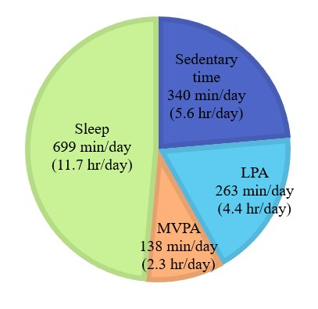
Figure S1
Goldilocks Day for Inhibition in Males
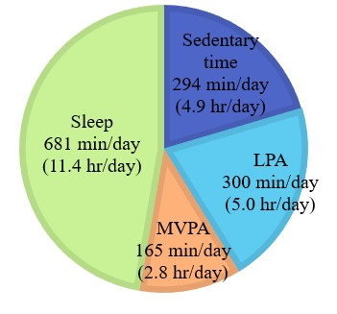
Note. LPA = Light Physical Activity. MVPA = Moderate-to-Vigorous Physical Activity. Closed to 1,440 minutes (24 hours).
Figure S2
Goldilocks Day for Working Memory in Males
LPA = Light Physical Activity. MVPA = Moderate-to-Vigorous Physical Activity. Closed to 1,440 minutes (24 hours).
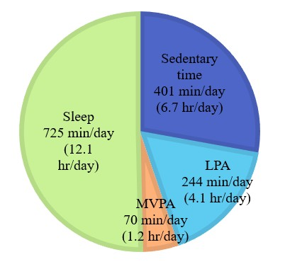
Figure S3
Goldilocks Day for Inhibition in Urban Children
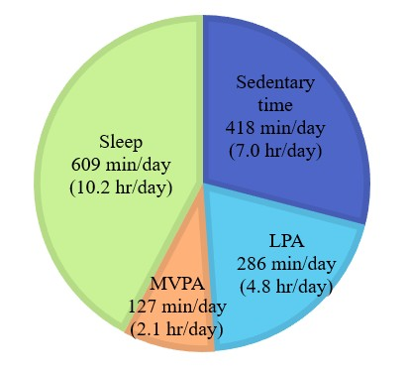
Note. LPA = Light Physical Activity. MVPA = Moderate-to-Vigorous Physical Activity. Closed to 1,440 minutes (24 hours).
Figure S4
Goldilocks Day for Working Memory in Urban Children
LPA = Light Physical Activity. MVPA = Moderate-to-Vigorous Physical Activity. Closed to 1,440 minutes (24 hours).
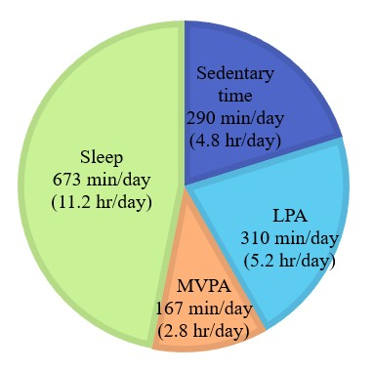
Figure S5
Goldilocks Day for Inhibition in Rural Children
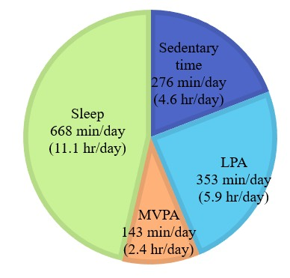
Note. LPA = Light Physical Activity. MVPA = Moderate-to-Vigorous Physical Activity. Closed to 1,440 minutes (24 hours).
Figure S6
Goldilocks Day for Working Memory in Rural Children
LPA = Light Physical Activity. MVPA = Moderate-to-Vigorous Physical Activity. Closed to 1,440 minutes (24 hours).
Table S1
Associations Between Parental Education, Racial Background, and Cognitive Outcomes by Subgroup
 |  | Go/No-Go (inhibition) |  |  | Mr. Ant (working memory)
Subgroup | Demographic variable | Coefficient (B) | SE | p-value | Coefficient (B) | SE | p-value
Full dataset | Parental education | -0.05 | 0.02 | .01 | -0.06 | 0.09 | .50
Full dataset | Racial background | 0.00 | 0.02 | .94 | 0.16 | 0.09 | .07
Males | Parental education | -0.06 | 0.03 | .02 | -0.13 | 0.11 | .26
Males | Racial background | -0.02 | 0.03 | .52 | 0.11 | 0.12 | .98
Urban | Parental education | -0.04 | 0.03 | .17 | -0.07 | 0.14 | .60
Urban | Racial background | 0.00 | 0.03 | .12 | 0.21 | 0.12 | .07
Rural | Parental education | -0.07 | 0.03 | .01 | -0.14 | 0.13 | .26
Rural | Racial background | -0.02 | 0.04 | .54 | -0.03 | 0.13 | .83
Note. Unadjusted linear regression showing the associations between parental education, racial background, and cognitive outcomes. Bolded results are significant at p < .05.

