Supplemental Material for Winbush et al., Comparison of smartphone- and Fitbit-derived measures of physical activity in a large sample under naturalistic conditions

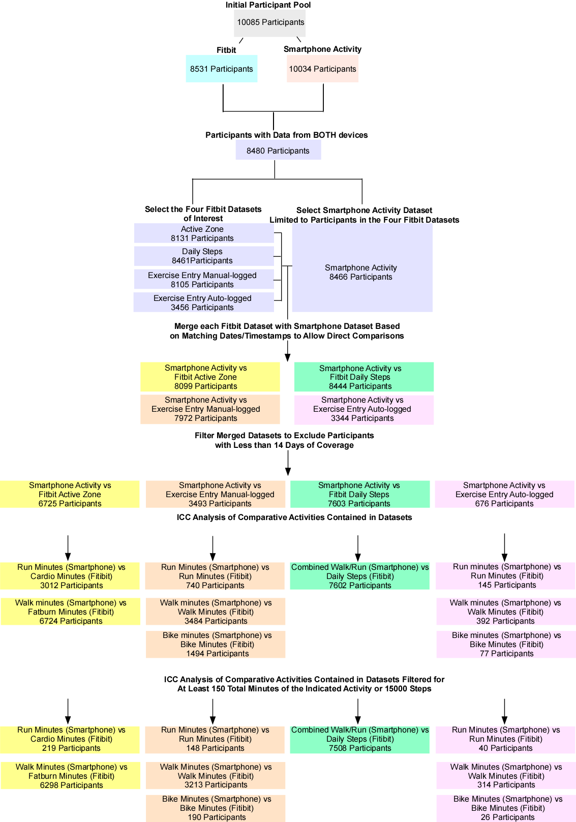
Supplemental Figure 1 Flowchart summary of datasets, participants comprising each dataset, and methods utilized in our study. Methods are indicated in bold text. Boxes indicating related datasets sharing the same features have the same color.

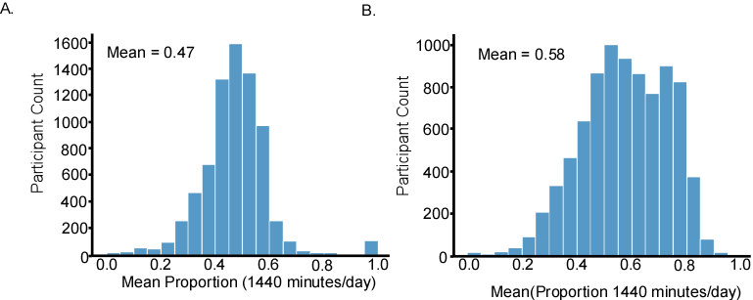
Supplemental Figure 2. Distribution of mean proportion of minutes per day (out of a total of 1440) for which a participant had data from (A) their Fitbit device or (B) smartphone activity data across all participants. Note that for fitbit data in (A), data is based on 7429 out of the available 8480 participants due to device limitations, while data in (B) are for all 8480 participants with data available from both devices.

Supplemental Table 1. Participant coverage data (in days) for each of the five datasets. For Smartphone activity data, coverage in summaries of 5-minute bins are also present and shown in parentheses.
Dataset | Count | Mean Coverage | Std | Min | Max
Fitbit Overall | 8480 | 26.44 | 2.59 | 1 | 27
Exercise-entry auto-logged (Fitbit) | 3456 | 8.00 | 6.98 | 1 | 27
Exercise-entry manually-logged (Fitbit) | 8105 | 13.45 | 7.87 | 1 | 27
Active-Zone (Fitbit) | 8131 | 22.29 | 5.38 | 1 | 27
Daily-Steps (Fitbit) | 8461 | 25.94 | 3.43 | 1 | 27
Activity (Smartphone) | 8480 | 25.13(4390.12) | 5.68 (1700.47) | 1 (1) | 28 (8049)

Data Coverage/Missingness Across Devices
Our initial starting pool contained 10085 participants. Of those, data from 8531 participants had at least one day of data from a Fitbit wearable used to produce the Fitbit datasets, 10034 participants had smartphone activity data. We focused on the 8480 participants that had data from both devices (Figure 1). For Fitbit data overall, participants have up to 27 days of potential data with missing days likely due to the device not being worn (i.e., charging). However, within each of the Fitbit datasets, missing days of data are likely to stem from participants failing to engage in a physical activity recorded in the corresponding dataset or other technical issues. For example, a participant will have missing days in the Fitbit active zone dataset if, on those days, their heart rate fails to reach one of the targeted heart rate zones. Likewise, a participant will have missing days in the Fitbit exercise-entry manual-logged data if the user fails to log activities specific to that dataset on those days.
We examined data coverage in these contexts (smartphone activity data, Fitbit overall, Fitbit Active-Zone, Fitbit Daily-Steps, and exercise-entry data (auto and manual-logged). For smartphone activity data, we assessed coverage based on counts of the number of missing bins out of the total of 8064 bins available for each participant. For Fitbit wearable data, coverage was assessed based on the number of missing days out of the 27 available days for which data was potentially present for each user separately for each of the four datasets.
Supplementary Table 2. Multiregression results comparing gender categories to data-missingness
Gender(Female reference)
Overall Fitbit Coverage | Coef | P-value
Genderqueer/Transgender | -0.044 | 0.469
Male | -0.028 | 0.260
Not Disclosed | -0.178 | 0.593
Fitbit Daily-Steps | Coef | P-value
Genderqueer/Transgender | 0.010 | 0.961
Male | -0.101 | 0.238
Not Disclosed | 0.327 | 0.787
Fitbit Active-Zone | Coef | P-value
Genderqueer/Transgender | 0.974 | 0.003
Male | -0.320 | 0.020
Not Disclosed | -0.871 | 0.628
Fitbit Exercise-entry manually-logged | Coef | P-value
Genderqueer/Transgender | -0.204 | 0.668
Male | -4.121 | <0.001
Not Disclosed | 2.248 | 0.407
Fitbit Exercise-entry auto-logged | Coef | P-value
Genderqueer/Transgender | 1.862 | 0.009
Male | -0.961 | <0.001
Not Disclosed | -1.01 | 0.698
Smartphone Activity
Genderqueer/Transgender | -0.199 | 0.001
Male | -0.462 | <0.001
Not Disclosed | 0.277 | 0.396

Supplementary Table 3. Multiregression results comparing racial categories to data-missingness
Race(Caucasian reference)
Overall Fitbit Coverage | Coef | P-value
American Indian/Native American | 0.142 | 0.193
Asian | 0.036 | 0.596
Black/African American | -0.063 | 0.242
Native Hawaiian/P.Islander | -0.203 | 0.464
Not Disclosed | 0.033 | 0.646
Multi-racial | 0.193 | <0.001
Fitbit Daily-Steps | Coef | P-value
American Indian/Native American | 0.645 | 0.084
Asian | 0.530 | 0.022
Black/African American | -0.170 | 0.358
Native Hawaiian/P.Islander | -0.553 | 0.561
Not Disclosed | 0.011 | 0.963
Multi-racial | 0.501 | 0.004
Fitbit Active-Zone | Coef | P-value
American Indian/Native American | 1.670 | 0.005
Asian | 0.757 | 0.040
Black/African American | 0.167 | 0.576
Native Hawaiian/P.Islander | -0.073 | 0.961
Not Disclosed | 0.714 | 0.073
Multi-racial | 0.814 | 0.004
Fitbit Exercise-entry manually-logged | Coef | P-value
American Indian/Native American | 2.031 | 0.021
Asian | -2.121 | <0.001
Black/African American | 1.318 | 0.003
Native Hawaiian/P.Islander | -1.142 | 0.615
Not Disclosed | -0.600 | 0.305
Multi-racial | 1.635 | <0.001
Fitbit Exercise-entry auto-logged | Coef | P-value
American Indian/Native American | 0.708 | 0.557
Asian | -1.088 | 0.148
Black/African American | -0.379 | 0.51
Native Hawaiian/P.Islander | -0.598 | 0.848
Not Disclosed | 0.378 | 0.593
Multi-racial | 0.447 | 0.45
Smartphone Activity | Coef | P-value
American Indian/Native American | 0.277 | 0.011
Asian | -0.375 | <0.001
Black/African American | 0.233 | <0.001
Native Hawaiian/P.Islander | -0.305 | 0.271
Not Disclosed | -0.013 | 0.859
Multi-racial | 0.160 | 0.002

Supplemental Table 4. Effect size summaries for all Smartphone and Fitbit comparisons in this study
Comparison | Count | Mean ICC | Std | Min ICC | Max ICC | 95% CI
Running minutes (Phone) vs Cardio minutes (Fitbit) | 3012 | 0.15 | 0.32 | -0.52 | 0.99 | 0.14-0.16
Walking minutes(Phone) vs Fatburn minutes (Fitbit) | 6724 | 0.21 | 0.29 | -0.62 | 0.97 | 0.20-0.22
Combined Walking Running (Phone) vs Daily Steps (Fitbit) | 7602 | 0.49 | 0.28 | -0.52 | 0.98 | 0.48-0.50
Walk (phone) vs walk (Fitbit exercise entry-manual logged) | 3484 | 0.37 | 0.32 | -0.72 | 0.99 | 0.36-0.38
Run (phone) vs Run (Fitbit exercise entry-manual logged) | 740 | 0.45 | 0.42 | -0.78 | 1.0 | 0.42–0.48
Bike (phone) vs bike(Fitbit exercise entry-manual logged) | 1494 | 0.25 | 0.43 | -0.76 | 1.0 | 0.23-0.27
Walk (phone) vs walk (Fitbit) exercise entry-auto logged) | 392 | 0.26 | 0.34 | -0.61 | 0.98 | 0.23-0.30
Bike (phone) vs Bike (Fitbit exercise entry-auto logged) | 77 | 0.60 | 0.42 | -0.25 | 1.0 | 0.50-0.69
Run (phone) vs Run (Fitbit exercise entry-auto logged) | 145 | 0.38 | 0.41 | -0.55 | 1.0 | 0.31-0.45

Supplemental Table 5. ICC effect size summaries for all Smartphone and Fitbit comparisons in this study filtered to only include participants with at least 150 minutes total of the activities in question for the 27 day period, or, in the case of Daily Steps, at least 15000 steps total for the 27 day period.
Comparison | Count | Mean ICC | Std | Min ICC | Max ICC | 95% CI
Running minutes (Phone) vs Cardio minutes (Fitbit) | 219 | 0.48 | 0.36 | -0.52 | 0.99 | 0.44-0.53
Walking minutes(Phone) vs Fatburn minutes (Fitbit) | 6298 | 0.21 | 0.29 | -0.62 | 0.97 | 0.21-0.22
Combined Walking Running (Phone) vs Daily Steps (Fitbit) | 7508 | 0.49 | 0.28 | -0.52 | 0.98 | 0.49-0.50
Walk (phone) vs walk (Fitbit exercise entry-manual logged) | 3213 | 0.39 | 0.32 | -0.73 | 0.98 | 0.38-0.40
Run (phone) vs Run (Fitbit exercise entry-manual logged) | 148 | 0.71 | 0.33 | -0.55 | 1.0 | 0.65–0.76
Bike (phone) vs bike(Fitbit exercise entry-manual logged) | 190 | 0.76 | 0.31 | -0.76 | 1.0 | 0.72-0.81
Walk (phone) vs walk (Fitbit) exercise entry-auto logged) | 314 | 0.29 | 0.33 | -0.61 | 0.98 | 0.26-0.33
Bike (phone) vs Bike (Fitbit exercise entry-auto logged) | 26 | 0.71 | 0.33 | -0.16 | 1.0 | 0.58-0.83
Run (phone) vs Run (Fitbit exercise entry-auto logged) | 40 | 0.61 | 0.31 | -0.15 | 1.0 | 0.52-0.71

Fitbit devices using the study in order of release:
August 22, 2024: Pixel Watch 3:
October 11, 2023: Pixel Watch 2:
October 13, 2022: Pixel Watch 1
October 2023: Fitbit Charge 6
September 2022: Fitbit Versa 4, Fitbit Sense 2, Fitbit Inspire 3
August 2021: Fitbit Charge 5
April 2021: Fitbit Luxe
March 2021: Fitbit Ace 3
September 2020: Fitbit Versa 3, Fitbit Sense (1st gen), Fitbit Inspire 2
April 2020: Fitbit Charge 4
March 2019: Fitbit Ace 2, Fitbit Versa Lite, Fitbit Inspire HR
October 2019: Fitbit Versa 2
October 2018: Fitbit Charge 3
March 2018: Fitbit Charge 3, Fitbit Versa, Fitbit Ace (1)
September 2017: Fitbit Ionic
March 2017: Fitbit Alta HR
September 2016: Fitbit Charge 2, Fitbit Flex 2
March 2016: Fitbit Blaze
February 2016: Fitbit Alta
2015: Fitbit Surge
Fitbits Devices used in our study by Frequency:
Sense 1237 (September 2020)
Charge 5 1107 (August 2021)
Versa 2 876 (March 2019)
Versa 3 779 (September 2020)
Inspire 2 525 (March 2019)
Google Pixel Watch 502 (October 2022)
Sense 2 429 (September 2022)
Charge 4 391 (April 2020)
Luxe 328 (April 2021)
Versa 4 232 (September 2022)
Inspire 3 130 (September 2022)
Versa 46 (March 2018)
Versa Lite 34 (September 2020)
Ionic 1 (September 2017)

