SUPPLEMENTARY MATERIAL
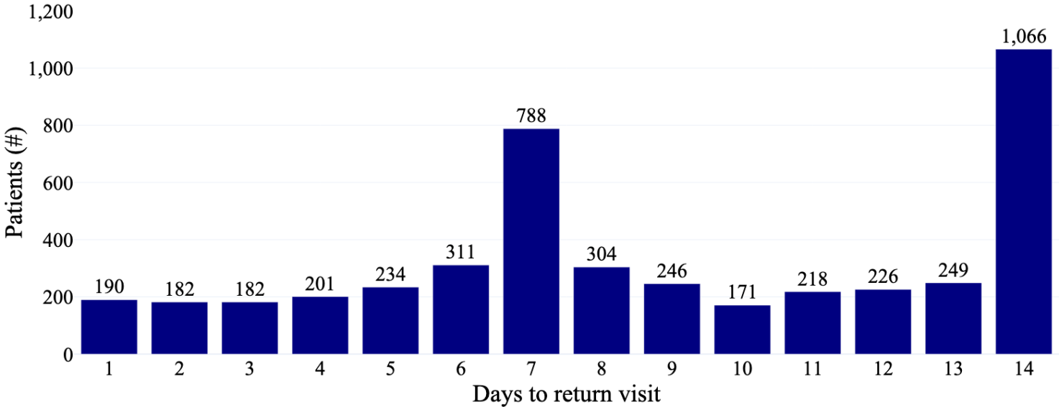
Supplementary Fig. 1: Distribution of the number of days to the return visit following the dental extraction visit.
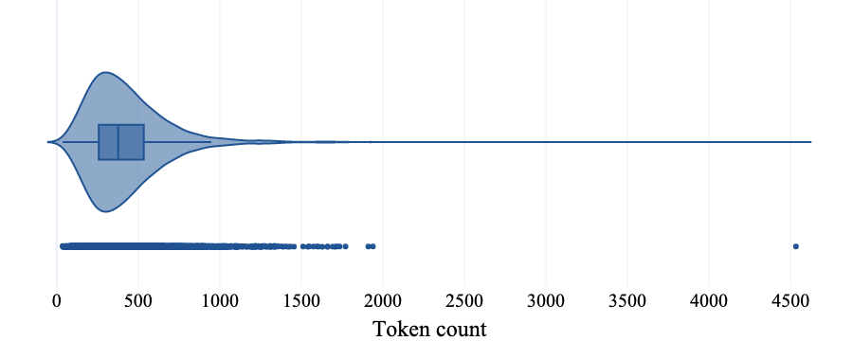
Supplementary Fig. 2: Distribution of the number of tokens in each document in the annotated corpus. Tokenization was performed using a trained English language model named en_core_web_lg v3.7.1 in the Python library spaCy v3.7.4.
Supplementary Table 1: The mean, (std), and [range] of precision, recall, and F1-score on the validation sets using a multiclass approach.
Model | Precision | Recall | F1-score
Bag-of-words logistic regression | 0.45 (0.02)  [0.41–0.47] | 0.43 (0.02)  [0.40–0.45] | 0.43 (0.01)  [0.41–0.45]
BERT large | 0.52 (0.03)  [0.49–0.56] | 0.51 (0.05)  [0.45–0.56] | 0.51 (0.03)  [0.46–0.55]

Supplementary Table 2: The mean, (std), and [range] of precision, recall, and F1-score for each class on the validation sets using a multiclass approach.
Class | Performance metric | Bag-of-words logistic regression | BERT large (uncased)
No complications  (n = 3,864) | Precision | 0.91 (0.01)  [0.89–0.92] | 0.95 (0.02)  [0.93–0.97]
No complications  (n = 3,864) | Recall | 0.94 (0.01)  [0.93–0.95] | 0.95 (0.02)  [0.93–0.97]
No complications  (n = 3,864) | F1-score | 0.92 (0.00)  [0.92–0.92] | 0.95 (0.01)  [0.94–0.96]
Complications – unplanned visit  (n = 627) | Precision | 0.70 (0.03)  [0.66–0.74] | 0.87 (0.04)  [0.83–0.92]
Complications – unplanned visit  (n = 627) | Recall | 0.65 (0.03)  [0.62–0.69] | 0.73 (0.09)  [0.62–0.84]
Complications – unplanned visit  (n = 627) | F1-score | 0.67 (0.02)  [0.65–0.69] | 0.79 (0.05)  [0.73–0.83]
Complications – planned visit  (n = 248) | Precision | 0.19 (0.09)  [0.07–0.29] | 0.24 (0.09)  [0.14–0.35]
Complications – planned visit  (n = 248) | Recall | 0.12 (0.06)  [0.05–0.21] | 0.38 (0.14)  [0.20–0.54]
Complications – planned visit  (n = 248) | F1-score | 0.14 (0.06)  [0.06–0.22] | 0.29 (0.10)  [0.16–0.43]
Unknown  (n = 17) | Precision | 0.00 | 0.00
Unknown  (n = 17) | Recall | 0.00 | 0.00
Unknown  (n = 17) | F1-score | 0.00 | 0.00

Supplementary Table 3: The mean, (standard deviation), and [range] of precision, recall, and F1-score on the validation sets for the logistic regression binary classifier using text-only, text with structured demographic data, and text with structured demographic and medical history data.
Model features | Precision | Recall | F1-score
Text only | 0.83 (0.02)  [0.81–0.84] | 0.80 (0.02)  [0.76–0.83] | 0.81 (0.01)  [0.79–0.83]
Text and structured demographic data | 0.83 (0.02)  [0.80–0.85] | 0.80 (0.02)  [0.78–0.83] | 0.81 (0.01)  [0.80–0.83]
Text, structured demographic, and medical history data | 0.82 (0.02)  [0.80–0.84] | 0.79 (0.02)  [0.76–0.82] | 0.80 (0.01)  [0.78–0.82]

Supplementary Table 4: Document distribution by binary class for each of the five validation sets. Each validation set contained 500 unique documents.
Validation set | Complications – unplanned visit | Other
1 | 63 (13%) | 437 (87%)
2 | 58 (12%) | 442 (88%)
3 | 76 (15%) | 424 (85%)
4 | 70 (14%) | 430 (86%)
5 | 77 (15%) | 423 (85%)

Supplementary Table 5: The mean, (standard deviation), and [range] of the macro-averaged precision, recall, and F1-score on the validation sets using a binary approach.
Model | Precision | Recall | F1-score
Bag-of-words logistic regression | 0.83 (0.02)  [0.81–0.84] | 0.80 (0.02)  [0.76–0.83] | 0.81 (0.01)  [0.79–0.83]
BioBERT | 0.91 (0.05)  [0.87–1.00] | 0.90 (0.06)  [0.86–1.00] | 0.90 (0.06)  [0.86–1.00]
Bio+Clinical BERT | 0.92 (0.05)  [0.85–1.00] | 0.89 (0.07)  [0.82–1.00] | 0.90 (0.06)  [0.86–1.00]
RoBERTa | 0.90 (0.02)  [0.89–0.93] | 0.89 (0.02)  [0.87–0.91] | 0.90 (0.01)  [0.88–0.91]
BERT large | 0.89 (0.03)  [0.86–0.92] | 0.88 (0.03)  [0.84–0.91] | 0.89 (0.02)  [0.85–0.91]

Supplementary Table 6: Statistical significance testing was conducted using McNemar's test on model pairs.
Model pair | p-value
BERT large, BioBERT | 0.919
Bio+Clinical BERT, RoBERTa | 0.547
BioBERT, Bio+Clinical BERT | 0.431
BERT large, Bio+Clinical BERT | 0.284
BioBERT, RoBERTa | 0.113
BERT large, RoBERTa | 0.069
Bag-of-words logistic regression, BioBERT | 0.002
Bag-of-words logistic regression, BERT large | 0.001
Bag-of-words logistic regression, Bio+Clinical BERT | 0.000
Bag-of-words logistic regression, RoBERTa | 0.000

Supplementary Table 7: Pairwise accuracy scores based on model predictions on all validation sets indicating the correlation of predictions per document between pairs of models.
Model pair | Accuracy
BioBERT, Bio+Clinical BERT | 0.966
BERT large, RoBERTa | 0.964
BERT large, BioBERT | 0.961
BioBERT, RoBERTa | 0.960
Bio+Clinical BERT, RoBERTa | 0.956
BERT large, Bio+Clinical BERT | 0.954
Bag-of-words logistic regression, BERT large | 0.929
Bag-of-words logistic regression, RoBERTa | 0.926
Bag-of-words logistic regression, BioBERT | 0.924
Bag-of-words logistic regression, Bio+Clinical BERT | 0.920

